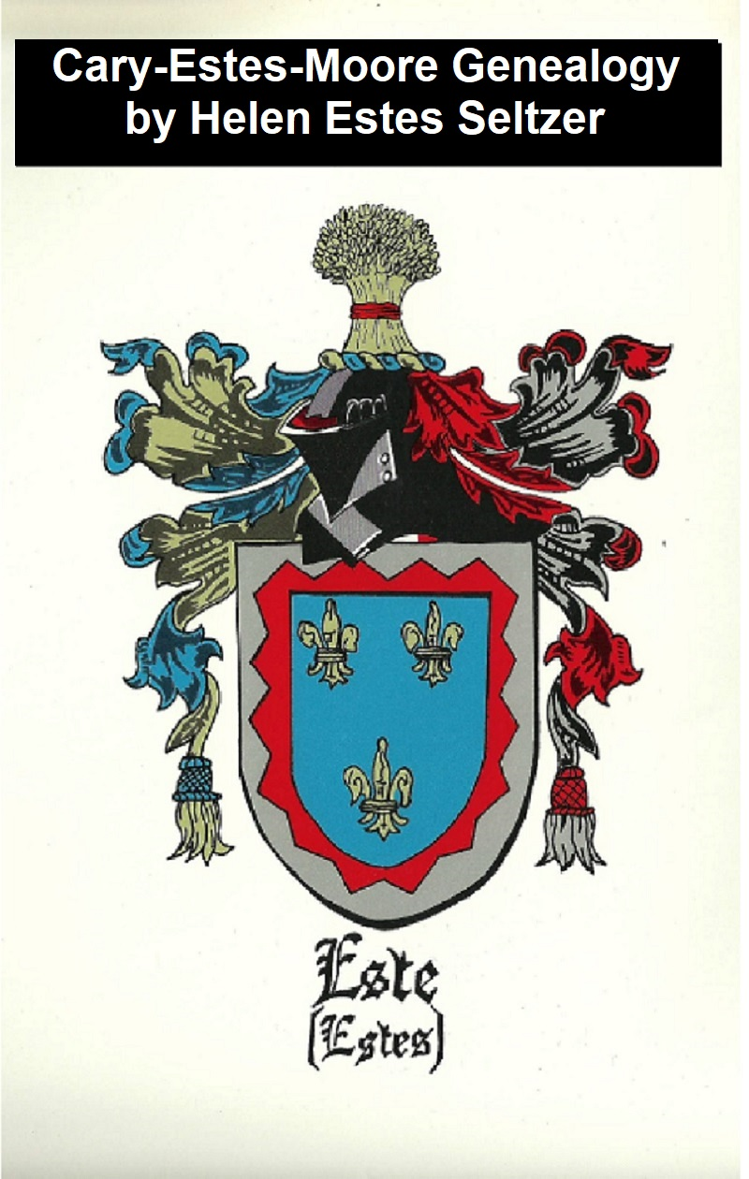
THE CARY-ESTES-MOORE GENEALOGY

Written and Compiled by HELEN ESTES SELTZER
Published 1981, updated 2018 by her son Richard Warren Seltzer, jr.

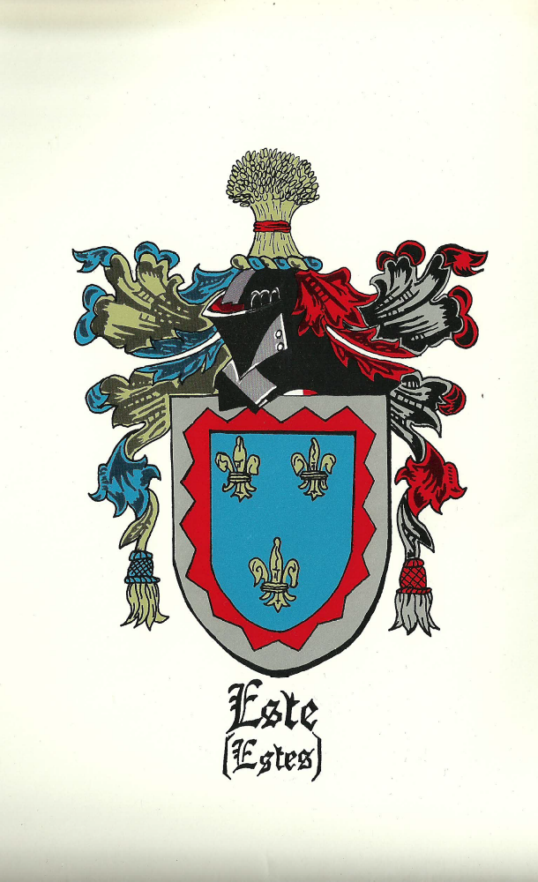

Copyright © 1981 by Helen Estes Seltzer
Library of Congress Card Number 79-54001
ISBN 0-931968-01-1
Typeset by Richard Warren Seltzer, Sr. and Jr.
Dustjacket by Henry Altmann
Design by Henry Altmann, Maxine Sorokin, and Richard Warren Seltzer, Jr.
Updated 2018 by her son Richard Warren Seltzer, Jr.

Published by Seltzer Books. seltzerbooks.com
established in 1974, as B&R Samizdat Express
offering over 14,000 books
feedback welcome: seltzer@seltzerbooks.com

The companion book, The Cary-Estes Genealogy (from 1939) is available online at http://www.seltzerbooks.com/caryestes.doc

For other information related to genealogy, see http://www.seltzerbooks.com/genealogy.html

Please send updates and corrections to me at seltzer@seltzerbooks.com Richard Seltzer

Abbreviations

Foreword

How to Trace Your Ancestral Line

Estes Listings

Estes Activities and Accolades

Estes History, Legends, and Documents

Estes Connections

Cary Listings

Cary History and Legends

Moore Listings

Moore History and Connections

Family Album (pictures)

Bibliography

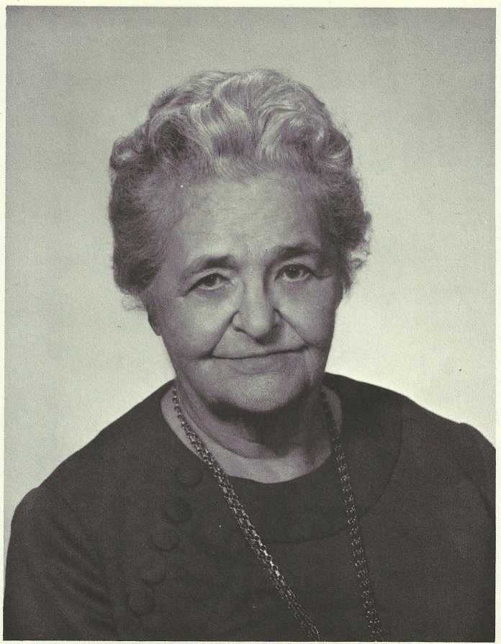

THIS BOOK IS DEDICATED TO AUNT SALLIE ESTES, a warm gracious Christian Southern lady, the matriarch of our Albert Monroe Estes Family Line; because she embraces all generations in her knowledge and love of her family members, Estes and Moore, past and present, and she shared this vast knowledge with all of us for this book; but mostly because she has shown great love and hospitality to this Northern niece all through the years, and is “Home” to me and my family in the Homeland of my Tennessee ancestors.

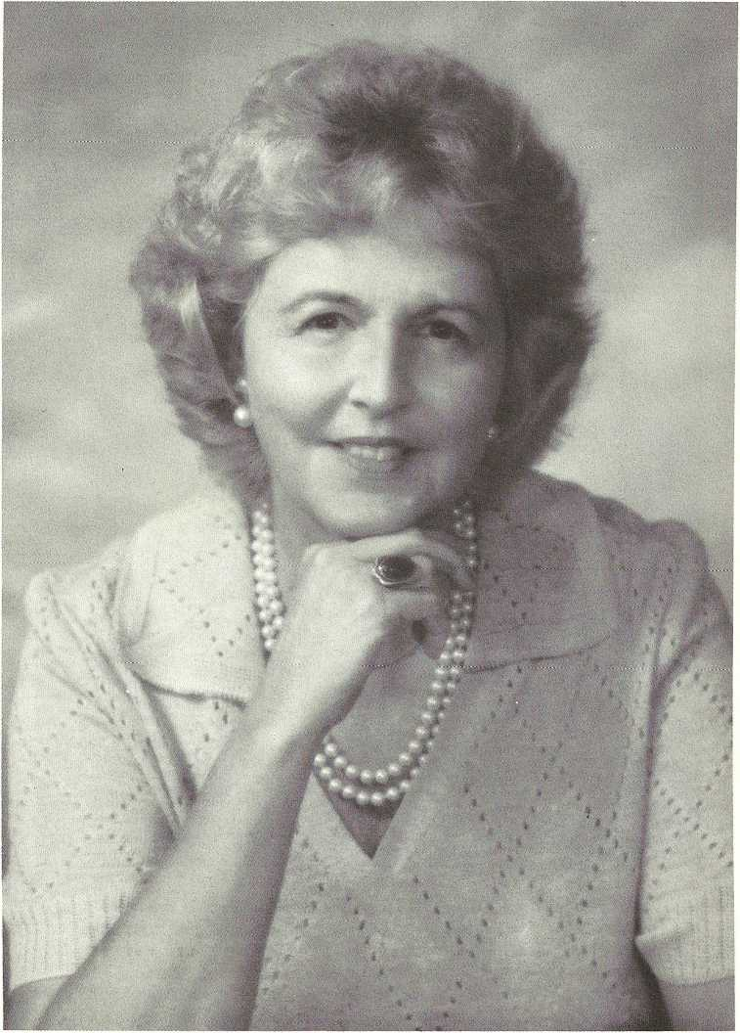
Helen Estes Seltzer

Acknowledgments
My first acknowledgments go to cousins May Folk Webb and Patrick Mann Estes, who dedicated many decades of their lives to researching and writing the original CARY-ESTES GENEALOGY, without which this book would never have come into being.

Thanks to my son, Richard, who encouraged me to research and write it and directed every step of the publishing, and to my husband, Dick, for the support and financial backing without which it could never have become a reality. I also want to thank my husband and my daughter, Sallie Estes, for putting up with my obsessive behavior these past five years. They both gave the book first place in my life.

Being a candidate for membership in the National Society of Colonial Dames in America, concurrently with writing this genealogy, I was able to uncover information that will benefit us all. I discovered that some of the generations given in the CARY-ESTES GENEALOGY showing our direct descent from the original Cary immigrant, Miles, were not thoroughly documented. Mrs. Albert O. Barrett, of Devon, Pa., a genealogist assigned to me by the Philadelphia branch of the Society, prodded me to go, in person, to the source, the Virginia State Library, in Richmond, and dig out the documents which give concrete proof of this lineage. These documents are included in the “History and Documents” segments of this book. Mrs. Barrett was a hard taskmaster, but I persevered and did find the documents after several trips. Because of her, this book is a more valuable and authentic research tool for others needing this documentation.

Librarians from the Huntingdon Valley, Pa.; Montgomery County, Norristown, Pa., branch; the Free Library of Philadelphia, Logan Square branch; Pennsylvania Historical Society, Philadelphia, Pa.; the Shipley School, Bryn Mawr, Pa.; the Philadelphia College of Art; and the Virginia State, Richmond, Va., Libraries must be acknowledged for their help in my research efforts. But one librarian stands out above all the others involved. She is Lia Hemphill, Head of the Reference Department of the Ludington Library of Bryn Mawr, Pa. From arranging an inter-library loan of a pristine copy of the CARY-ESTES GENEALOGY for our reprint, up to the last day of getting data for the CARY-ESTES-MOORE GENEALOGY bibliography, she was always courteous, willing to give of herself, with the added dimension of being very interested and enthusiastic about my research and the publications of the books.

The alumni associations of Yale University and the University of Alabama were also very cooperative. It seems miraculous to me that from one name and address of a Snedecor alumnus from the latter university, the hundreds of cousins from the Judge Bedford Mitchell Estes branch of the family were able to be listed here.

Many family members sent supplementary materials and photographs, at times duplicating those sent by others. In the main body of the book I have acknowledged those whose items were received first. The following is a sampling of those, not credited elsewhere in the text, who sent substantial information on their family branches:

Albert Monroe (5) Estes Line: Mr. Russell G. Evans and Mr. and Mrs. Warner Moore Estes, of Ripley, Tenn.; and Mrs. James Roy Carson, and Mr. Albert E. Dykes, of Nashville, Tenn.

Mary Noel (7) Estes Line: Mr. Thomas E. Moody, IV, of San Antonio, Texas, and Mr. James Shelton Moody, of Plant City, Fla. Elisha (3) Estes Line: Mrs. Samuel G. Slaughter, Jr., of Lynchburg, Va.

Patrick Mann (8) Estes Line: Mrs. Joseph P. Lawrence, of Nashville, Tenn.

(Carey) Estes Kefauver: Ms. Gail Estes Kefauver, of San Francisco, Calif.

Cary Family - Blair Line: Mr. P. Blair Lee, of Philadelphia, Pa. Moore Family - Green Hill Line: Mrs. Bennett Gram, of Columbia, Pa.

But the most important acknowledgment of all is to the individual family members who took time from their busy lives to fill out the Ancestor and Descendant Charts I mailed to them. With the concerted effort of all, we should be able to have our book updated every five years, or whenever enough material has accumulated to warrant publication. Please keep the data coming and report immediately whenever births, marriages, and deaths occur in your families. And I’ll also be happy to receive clippings about these events and also about outstanding achievements in your families for possible inclusion in the next “Activities and Accolades”.

Thank you, everyone!

Abbreviations
- K.A., also known as
b., bom
- B.C., British Broadcasting Corporation bro., brother
bur., buried
C-E, CARY-ESTES GENEALOGY
cem., cemetery
Co., County, Company
Col., Colonel, Colonial
cr. Kt. Bach., crown Knight Bachelor
Ct., Circuit
d., died
dau., daughter
dist., district
Ed.D., Doctor of Education
Esq., Esquire
est., estate
ex.,.executor
Ind., Independence
LDS, Latter Day Saints
md., married
M.P., Member of Parliament
ms., manuscript
mil., militia
no., number
pub., published
quar., quarterly
RLDS, Reformed Latter Day Saints R.M.C., Royal Marine Corps unmd., unmarried W.B., Will Book

Foreword
There are many American families with the names Cary, Estes, and Moore. Numerous genealogy books have been written on all three. This book focuses on one branch of each family and traces them from the earliest known ancestors to the present generation.

All three families came to America in the seventeenth and eighteenth centuries. The Carys came from England; the Estes from Italy, by way of England; and the Moores from Scotland.

The earliest known record of the name Cary was in the “Doomsday Book”, written in 1086 by edict of William the Conqueror. It lists the Manor of “Kari” in the Parish of St.

Giles in the Heath, Devonshire, near Lancaster, closeby the border of Cornwall, and also a Somersetshire Manor named “Cari”.

When the members of the Estes family use Cary as a given name, they almost invariably spell it “Carey.” On page 14 of THE CARY FAMILY IN ENGLAND, the author, Henry G. Cary, of Boston, Mass, tells that his father added the“e” to the family name in 1820. Many American Carys adopted this new spelling.

The Estes family descends from the House of d’Este, dukes of Ferrara in Renaissance Italy. From Italy our progenitors emigrated to England, then to Wales, and from there to Virginia.

The Moore family name probably derived from the moors of Scotland, from which this family emigrated to Ireland and Wales during the reign of James I of England. The Celtic spelling is “More”; the Welsh spelling is “Mwr”; and the English is “Moore.”

The Europe that our progenitors left behind was dominated politically by England and France, and spiritually by religion and science, or faith and reason, sometimes in uneasy truce, and sometimes in open war. It was the time of PILGRIM’S PROGRESS and of Newton, of Cromwell, Milton, Louis XIV, Racine, Corneille, Moliere, Dryden and Alexander Pope. We know that Miles Cary came to Windmill Point, Virginia from Bristol, England in the early 1640’s, that Abraham Estes was in Virginia by 1704, and that Shields Moore landed in Maryland from Wales in 1732. There is no record of their having come as a result of religious persecution. The early Carys were members of the Church of England in colonial Virginia, one being a vestryman of Bruton Church in Williamsburg, where his name may still be seen on the pew reserved for his family. The religious leanings of the early Estes are not documented and, although there are records of all their marriages, what churches they attended is not mentioned.

On the other hand, many of the Moores, from the earliest days in America, have been prominent members and ministers of the Methodist Church.

Perhaps our immigrant ancestors, like so many others, came to make their fortunes. There was a strict law of primogeniture in Europe at that time - the eldest son inherited all the property.

Not being the eldest sons in their families, they probably thought the New World, even with all its risks, offered more opportunity than the Old. In any case, they all became respected, landed gentlemen whose progeny married into the leading families of Virginia.

How many people were living in America and in the various colonies to which these ancestors immigrated? When Miles Cary arrived in America in the early 1640’s, the population of Virginia was around 10,500 — a very small, select group, most of whom were of English stock. By 1704, when the earliest known Estes is recorded as being in Virginia, that colony’s population was just over 53,000 - still relatively few. When Shields Moore landed in Maryland in 1725, the population of that colony was around 78,600. In 1690 there were only a quarter of a million people in all of the colonies; but by the time of the American Revolution, there was a population of over two and a half million. Up to 1680, nine-tenths of the colonists were of English stock.

Miles, the first Cary in America, owned and lived in many large homes in Virginia, some of winch are still standing. He also owned large tracts of land. The two hundred acres in King and Queen County, Virginia, which Abraham Estes owned in 1704 pales in comparison with the holdings of Miles; yet Abraham s grandson, Benjamin, married a Thorp, granddaughter of William Triplett, close friend of George Washington, and Benjamin’s grandson married Unity Fontaine, great-granddaughter of Patrick Henry. Shields Moore’s descendants married into such prominent families as the Masons, the Yates, the Menefees and the Hills. His grandson,

John, married a daughter of Green Hill, a landed gentleman, an officer in the Revolutionary War, and a founder of the Methodist Church in America. Green Hill’s North Carolina home, “Moorland,” is still extant, and is open to the public.

While this book traces three families, most of the material deals with the Estes family in America. The Estes section of THE CARY-ESTES GENEALOGY (C-E) followed the descendants of Elisha (3) and Benjamin (3), grandsons of Abraham (1) Estes of King and Queen County, Virginia, and sons of Abraham (2) Estes, Jr. But Abraham (1) had more than one son - in fact, he had nine children. In this book, we are dedicated to including descendants of as many of those children as can be found and documented. We want this genealogy and all future editions of it to be as comprehensive a record of the descendants of the original Abraham as is possible.

In this edition, we add descendants of the fifth child, Robert (2) and of the eighth, Elisha (2). Also, one line from the third child, Thomas (2), appears in “Estes Listings Appendix”. Furthermore, we add descendants of Abraham (3) Estes, III, the first son of Abraham, Jr.

Like C-E, this book deals mostly with descendants of one son of Benjamin (3), Joel (4), whose marriage to Sarah Langhorne Bates connects us with the Carys of Virginia. This book updates those listings and also those of Abraham (2), Jr.’s fourth son, Elisha and those of Joel’s brothers, Triplett (4) and Benjamin (4).

As for Sarah Langhorne Bates’ Cary line, we endeavored to update all the lines from the CARY-ESTES GENEALOGY, and to include all documented descendants from the original ancestor, Miles. But we had success with only one line, the Blair family, descendants of Judith (8) Cary Bell’s daughter, Judith Cary (9) Bell, who married Nathaniel Gist. In addition, an appendix to the Cary Listings provides partial information on lines from two otlier children of Miles, Miles, Jr. and Bridgett.

Joel (4) Estes’ grandson Louis Powhatan (6) Estes married Eliza Mildred (5) Moore, connecting us with the Moore family. Many of Eliza:s ancestors and descendants are included here.

We will continue to update this information and to gather additional information on other lines. In about five years, or whenever we have accumulated enough material to warrant publication, we will assemble another volume to supplement this one.

How To Trace Your Ancestral Line

First find your name in the index and turn to the page indicated. Under the paragraph about your parents, you will see your first name and the first names of all your siblings, in the order of your birth. Immediately below that paragraph, you are listed again, in greater detail. The number preceding your given name indicates the order of your birth. This number may be a small Roman numeral or an Arabic numeral. These two numbering systems are used for alternate generations to make it easier to immediately recognize differences of generation.

In any case, immediately before your family name is another number in parentheses indicating the generation, numbered from the earliest documented direct ancestor (Estes -- Abraham; Cary - William of Bristol, England; Moore -- Shields). Under the Estes family you will find listed basic facts regarding descendants of Abraham (2), Jr., Robert (2), Elisha (2) and Thomas (2), followed by a collection of biographies, obituaries, and news items about outstanding achievements and family gatherings. Then come family history, legends, and documents, such as birth, marriage and death certificates, wills, and land deeds -- important for proving one’s ancestry to join such patriotic organizations as the Daughters of the American Revolution. “Estes Family Connections” provides information on some of the families that have married into the Estes family, for example, the Tripletts of Virginia. (All of Benjamin (3) Estes’ descendants are directly descended from those Tripletts). Much of the information regarding “connections” came from documents and family Bibles. It is recorded here to help others in their research into other family lines.

The Cary and Moore sections of this book each consist of listings of family members up to the present time, plus, in the case of Cary, family history and documents, and, in the case of Moore, family history and family connections.

Estes Listings
Abraham (1) Estes, who owned two hundred acres in King and Queen County, Virginia in 1704, and died Nov. 21, 1720, is our earliest direct ancestor of record. Every Estes listed in this book can trace himself/herself back to him.

The CARY-ESTES GENEALOGY (abbreviated here C-E) by May Folk Webb and Patrick Mann Estes, supplies a detailed account of the family from 1704 up to 1939. This book includes some new material that has been uncovered regarding our early ancestors, and then brings the family history up to 1980. In the case of ancestors about whom no new material was available, we include here just the name; the reader should consult C-E for further details. Where new material was found, even if only a date, we have carried over other data on that individual from C-E to provide a meaningful context.

Abraham (1) Estes married Barbara (last name unknown) and had nine children: Abraham, Jr., Samuel, Thomas, Richard, Robert, John, Moses, Elisha, and Barbara. In this book we shall be concerned with the descendants of only four of them: Abraham, Robert, Elisha, and Thomas. (There is a genealogy published in 1973 by Carl O. Estes of Storm Lake, Iowa, covering the line of descendants from Thomas that leads to Carl, ESTES BROTHERS - KENTUCKY TO IOWA).
Abraham (2) Estes was born about 1697 and died in Caroline County, Virginia in July 1759. The first child of his first marriage was Abraham (3).

DESCENDANTS OF ABRAHAM (3) ESTES

(Material on Abraham (3) Estes and his descendants was supplied by James Bartlett (9) Estes of Kansas City, Mo.)

i Abraham (3) Estes, b. 1717, Va.; d. after 15 Jan. 1780, Spotsylvania Co., Va.; md. Ann (Clarke?). Children: 1 Elijah; Richard; 3 Moses; 4 Fielding; 5 Nancy; 6 Thomas; 7 John; 8 Samuel; 9 Sarah.

7 John (4) Estes, b. 1755, Spotsylvania Co., Va.; d. after 22 July 1808, Fayette Co., Ky.; soldier in Cont. Army; md. Nancy Ann Montague, (dau. of Clement and Ann Bartlett Montague of Spotsylvania Co., and granddaughter of Wm. Bartlett of St. Geo. Parish, a descendant of Wm. the Conqueror) b. in Spotsylvania Co., Va.; d. Fayette Co., Ky. Children: i Nancy Bartlett; ii Middleton; iii John; iv Clement; v Abraham; vi Mary “Polly”; vii Elizabeth; viii Bartlett.

iv Clement (5) Estes served in War of 1812; shot 7 times in Battle of River Basin; Col. Allen’s Regt. 18 Jan. 1813;
P.O.W. 22 Jan. 1813.

viii Bartlett (5) Estes, b. 31 Mar. 1794, Fayette Co., Ky.; d. 10 July 1880, Clay Co., Mo.; Charter Member Masonic Lodge, Liberty, Mo. (Bartley); md. Elizabeth Higgins, b. 1795, Va.; d. after 1870, Clay Co., Mo. Children: 1 Permilia; 2 John A.; 3 Abraham; 4 Benjamin F.; 5 Patsy; 6 Elizabeth.

3 Abraham (6) Estes, b. 20 Jan. 1823, Fayette Co., Ky.; d. 15 July 1864, Clay Co., Mo.; was bugler in Col. Doniplame’s (?) 1st Mounted Regt. in Mexican War; killed near Liberty, Mo. by Federal soldiers after he killed 5 of them; last of his family line to have slaves; md. 22 Jan. 1850, Sarah Elizabeth Clinkenbeard (?), b. 26 Nov. 1831, Ky.; d. 5 Nov. 1895, Clay Co., Mo. Children: i James Bartley; ii Harriet; iii Mary Ann; iv Allen Luke; v Elizabeth; vi John; vii Lee E.

i James Bartley (7) Estes, b. 7 June 1851, Clay Co., Mo.; d. 13 Oct. 1922, Clay Co., Mo.; md. 19 July 1877, Texanna Susan Bandy, b. 19 May 1861, Bedford Co., Va.; d. 5 Feb 1938, Clay Co., Mo. Children: 1 Abraham Richard; 2 Ann Elizabeth; 3 Ruth; 4 Wayne Ezra.

1Abraham Richard (8) Estes, b. 6 Sept. 1878.
4 Wayne Ezra (8) Estes, b. 13 July 1889, Clay Co., Mo.; d. 2 Sept. 1969, Kansas City, Jackson Co., Mo.; md. 27 Oct. 1923, Clarice Ada Pace, b. 11 Nov. 1900, Corning, Iowa; Clarice now living in Raytown, Jackson Co., Mo. Children: i James Bartlett; ii Charles A.; iii Maryann; iv Richard Wayne.

1 James Bartlett (9) Estes, Kansas City, Mo.; b. 6 Sept. 1924, Wyandotte Co., Kans.; served in U.S. Navy, WWII and in Korean War; md. (1) Ida M. Bird, b. 23 Mar. 1928, Texas Co., Mo. Children: 1 Jerry Alan; 2 Wanda Joyce.

James Bartlett (9) Estes md. (2) Catherine R. Cave. Child: 3 James Bartlett.

James Bartlett (9) Estes md. (3) Maxine A. Setter (Ballew) a widow.

Children of James Bartlett (9) Estes and Ida M. Bird:
1 Jerry Alan (10) Estes, Mountain View, Texas Co.,
Mo,, b. 7 June 1948, Texas Co., Mo.; md. Jeanie K. Beasley, b. 26 Mar., 1950, Colo. Children: i Jeremy Alan; ii Johnathan Eric.

i Jeremy Alan (11) Estes, b. 21 Oct. 1970, Texas Co., Mo.
ii Johnathan Eric (11) Estes, b. 20 July 1972, Texas, Co., Mo.

2 Wanda Joyce (10) Estes, Moutain View, Texas Co., Mo., b. 17 May 1950, Texas Co., Mo.

Child of James Bartlett (9) Estes and Catherine R. Cave:
3 James Bartlett (10) Estes, Fort Worth, Texas, b. 7 Nov. 1957, Kansas City, Jackson Co., Mo.

James Bartlett (9) Estes also has two step children of his third wife Maxine A. Setter (Ballew): Kenneth L. and Kathleen L. Ballew.

Wayne Ezra (8) Estes md. Clarice Ada Pace. We continue with their fourth child, Richard Wayne:
iv Richard Wayne (9) Estes, b. 6 Sept. 1937.

Abraham (6) Estes md. Sarah Elizabeth Clinkenbeard. We continue with the listing of their 4th child, Allen Luke:

iv Allen Luke (7) Estes, b. 6 Sept. 1856.

Abraham (2) Estes married twice. We have covered descendants of Abraham (3), a child of his first marriage. We now list the descendants of two children of his second marriage, to Elizabeth, whose last name is not known: Elisha (3), the fourth child, and Benjamin (3), the sixth. As the format of this book follows strict chronological order, the listings of all the descendants of Elisha (3) and Benjamin (3) will be covered before we list those of Robert (2), the fifth child, and Elisha (2), the eighth child of Abraham (1) Estes.

DESCENDANTS OF ELISHA (3) ESTES
[son of Abraham (2), Abraham (1)]

Elisha Estes served in the Second Virginia Regiment under Col. Alexander Spotswood and Capt. Francis Taylor (C-E p. 106). His descendants, therefore, are eligible for the patriotic societies for those descended from Revolutionary War servicemen.

iv Elisha (3) Estes md. Catherine Tompkins. Children: 1 Christopher Tompkins; 2 Mary T.; 3 Joyce R.; 4 Elizabeth Good- loe; 5 Elisha Beauford (or Beaufort).

1 Christopher Tompkins (4) Estes md. (1) Jane C. Howard. Children: i Sarah Jane; ii Catherine T.; iii William H.; iv Mary Patterson; v John Howard; vi Christopher T. vii Lucie Gwynne (Gwynn or Gwyne); viii Elizabeth T.

Christopher Tompkins (4) Estes md. (2) 2 Jan. 1838, in the Methodist Church in Lovingston, Va., Martha J. Morgan. Children: ix Morris Kent; x Annie H.; xi Ella K.xii Lena; xiii Elisha; xiv Christopher; xv Robert. (Lucie Howard Carter’s family material states that there were eight children, but only seven were listed).

Children of Christopher (4) Tompkins Estes and Jane C. Howard:
i Sarah Jane (5) Estes, b. 8 Apr. 1823.
ii Catherine T. (5) Estes, b. 16 July 1824; md. 184—, Lovingston, Va., R.G.N. Winfree of Chesterfield Co., Va.
iii William H. (5) Estes, b. 3 Feb. 1826; md. 14 Apr.
1847, Roseathea Hickok, dau. of Patrick Hickok.
iv Mary Patterson (5) Estes, md. 4 Jan. 1846, Lovingston, Va., James Forbes, M.D. (son of John and Elizabeth Forbes of Richmond, Va.)
v John H. (5) Estes, b. 3 Mar. 1830; md. Nannie Perkins.
vi Christopher T. (5) Estes, b. 14 Nov. 1832.
vii Lucie Gwynn (5) Estes, b. 19 Apr. 1834, Lovingston, Va.;d. 10 Aug. 1935 (101 years old); her home in Lovingston, Va. is still standing; md. 10 June 1857 Halifax Co., Va., Dr. Egbert Granville Vaughan,
b. 14 Feb. 1815, Amelia Co., Va.; d. 9 July 1888, Lynchburg, Va. Children: 1 James Oscar; 2 Beaufort Estes; 3 Mattie; 4 Jane Howard; 5 Garland Estes; 6 Nannie.

1 James Oscar (6) Vaughan, b. 7 Apr. 1858, Halifax, Va., md. Clifford Kiser.
2 Beaufort Estes (6) Vaughan, b. 1859, Halifax, Va.; d. 15 Feb. 1935.
3 Mattie (6) Vaughan, b. Halifax, Va., 1865 or 1866.
4 Jane Howard (6) Vaughan, b. 6 Aug. 1865, Halifax, Va.; d. 22 Dec. 1939; md. Charles Carter Hudson, 1895. Child: 1 Mildred.

i Mildred (7) Hudson, md. C.R. Pettyjohn of Lynchburg, Va.

5 Garland Estes (6) Vaughan, b. 1870, d. July 1926, Lynchburg, Va.; md. Marian Yancey Jackson, b. 1880; d. 10 July 1916, Lynchburg, Va. Several children, among them: i Rosa; ii Marian.

i Rosa (7) Vaughan, Lynchburg, Va., b. 22 Jan. 1903, Lynchburg, Va. Retired social worker; md. (1)2 Jan. 1926, William Joseph Allen, Sr., (son of Charles Pollard and Minnie Chitty Allen) b. 1 May 1900, Birmingham, Ala.; d. 22 Oct. 1960. Children: 1 Marian Vaughan; 2 William Joseph; 3 Phillipa Ball.

Rosa (7) Vaughan md. (2) Guy Dirom; sans issue.

1 Marian Vaughan (8) Allen, Petersburg, Va., b. 20 Nov. 1926, Petersburg, Va.; md. 26 Feb. 1949, Petersburg, Va., Marshall Johnson, homebuilder, b. 4 July 1921, Petersburg, Va. Children: i Kimbrough Epes, ii Marshall

i Kimbrough Epes (9) Johnson, b. 18 Nov. 1949, Petersburg, Va.; md. Capt. Warren C. Wagner, Ft. Knox, Ky.
ii Marshall (9) Johnson, Jr., b. 1 Feb. 1953, Petersburg; salesman; unmd.

2 William Joseph (8) Allen, Jr., Raleigh, N.C., b. 27 Dec. 1932, Richmond, Va., in securities sales with E.F. Hutton & Co.; md. 29 Oct. 1960, Florence, Ala., Sherrod King, b. 28 Apr. 1938, Florence. Children: i William Joseph, III; ii Susan Irvine.

i William Joseph (9) Allen, III, b. 28 May 1963, New York, N.Y.
ii Susan Irvine (9) Allen, b. 24 Jan. 1966, Greensboro, N.C.

3 Phillipa Ball (8) Allen, Chester, Va., b. 16 July 1939, Petersburg, Va.; Planner - State Dept. of Welfare; md. 15 Oct. 1960, Petersburg, William Guy Smith, III, b. 21 Feb. 1939, Dinwiddie Co., Va., elementary school principal. Children: i Elizabeth Stratford; ii Allen Clay.

i Elizabeth Stratford (9) Smith, b. 23 Jan. 1964, Petersburg, Va.
ii Allen Clay (9) Smith, b. 17 June 1966, Petersburg.
ii Marian (7) Vaughan, Louisville, Ky., b. 10 July 1916, Lynchburg, Va., Asst. Mgr., TV Traffic Dept., WAVE-TV Louisville, Ky.; unmd.

6 Nannie (6) Vaughan, b. 24 June 1873, Danville, Va.; md. 14 Oct. 1897, Lynchburg, Va., David Halbert Howard, (son of John Milton and Rhoda Jane Allison Howard of Wythe Co., Va.) b. 19 July 1865, Wythe Co., Va.; d. 5 Aug. 1925, Lynchburg, Va. Children: i Lucie; ii Nannie Vaughan; iii Rhoda; iv David Halbert; v Estes Vaughan.

i Lucie (7) Howard, Lookout Mt., Tenn., b. 4 July 1900, Lynchburg, Va., md. 21 Sept. 1929, John Otey Carter, Jr., b. 5 Jan. 1890, Pulaski, Tenn. Child: Lucie Estes.

1 Lucie Estes (8) Carter, b. 17 Aug. 1933, Chattanooga, Tenn.; md. 6 Sept. 1958, Chattanooga, Tenn., Gerry Underwood Stephens. Children: i Lucie Howard; ii Allison Ward; iii Gerry Underwood, Jr.

i Lucie Howard (9) Stephens, b. 10 Nov. 1959.
ii Allison Ward (9) Stephens, b. 24 Feb. 1961.
iii Gerry Underwood (9) Stephens, Jr., b. 7 Sept. 1963.

ii Nannie Vaughan (7) Howard, Lynchburg, Va., b. Mar. 1902, Lynchburg; d. 14 Oct. 1959; md. 24 June 1923, Christopher Winfree Ryan. Children: 1 Christopher Winfree, Jr.; 2 Nancy Vaughan; 3 Elizabeth Howard.

1 Christopher Winfree (8) Ryan, Jr., Eugene, Ore., b. 24 Oct. 1934; md. Child: i Elizabeth Howard., i Elizabeth Howard (9) Ryan, b. 27 Mar. 1943.

2 Nancy Vaughan (8) Ryan, Tel Hashomer, Ramat Gan, Israel, b. 29 Apr. 1937, Richmond, Va., teacher of English as a second language to adults; sings in a professional choir; plays piano; md. 15 Apr. 1962, Tel Aviv, Israel, Leacliaim Naggan, M.D., specialist in epidemiology, amateur violinist, b. 20 Feb. 1936, Tel Aviv, Israel. Children: i Laora; ii Barak; iii Tamar.

i Laora (9) Naggan, b. 2 Sept. 1965, Boston, Mass.
ii Barak (9) Naggan, b. 22 July 1967.
iii Tamar (9) Naggan, b. 4 Sept. 1968.

3 Elizabeth Howard (8) Ryan, Fort Lewis, Wash., md. — Mathewson.

iii Rhoda (7) Howard, Lynchburg, Va., b. 30 Jan. 1905, Lynchburg; md. 13 Apr. 1932, Samuel Garland Slaughter, Jr., b. 21 May 1898, Lynchburg, was employed by Frances I. Dupont - investments; d. Apr. 1970. Children: 1 Rhoda Jane; 2 Samuel Garland, III; 3 Nancy Vaughan; 4 David Howard.

1 Rhoda Jane (8) Slaughter, Lynchburg, Va., b. 3 Nov. 1933, Lynchburg; md. at Concord, N.C., 3 Nov. —, Walter Nelson Webber, Jr., Lynchburg.

2 Samual Garland (8) Slaughter, III, Birmingham, Mich., b. 9 May 1936, Chief Engineer at Ford Motor Co.; md. 25 June 1960, Lansdowne, Pa., Katherine Abbott, b. 22 Feb. 1936, Lansdowne, a teacher. Children: i Samuel Garland, IV; ii Claire; iii Beth.

i Samuel Garland (9) Slaughter, IV, b. 11 Nov. 1962, St. Louis, Mo.
ii Claire (9) Slaughter, b. 6 Nov. 1964, Birmingham, Mich.
iii Beth (9) Slaughter, b. 23 Jan. 1968, Birmingham, Mich.

3 Nancy Vaughan (8) Slaughter, Huntington, N.Y., b. 1 June
1939, Lynchburg, Va.;md. 27 May 1967, Lynchburg, Robert Arnold Gay, b. 15 Dec. 1938, Brooklyn, N.Y. stockbroker; partner in specialist firm, Gay and Co. on N.Y. Stock Exchange. Children: i Robert Slaughter; ii and iii twins Charles Richard Sherman and Willis Richardson Slaughter.

i Robert Slaughter (9) Gay, b. 21 Dec. 1968, Huntington, N.Y.
ii and iii (twins) Charles Richard (9) Sherman Gay and Willis Richardson Slaughter (9) Gay, b. 27 Sept. 1971, Huntington, N.Y.

4 David Howard (8) Slaughter, Richmond, Va., b. 10 Nov. 1944, Lynchburg, Va.; computer programmer at State Police, Richmond; md. 9 July 1966, Lexington, Va., Frances Wilcox Butt, b. 13 Sept. 1944, Suffolk, Va.; Latin teacher. Children: i Frances Garland; ii Leanora Wilcox.

i Frances Garland (9) Slaughter, b. 11 Sept. 1972.
ii Leanora Wilcox (9) Slaughter, b. 31 Mar. 1976, Richmond, Va.

iv David Halbert (7) Howard, Jr., b. 23 June 1906; d. 26
Apr. 1936, Ph.D. Cornell Univ., teacher at Davidson College, N.C.
v Estes Vaughan (7) Howard, b. 7 May 1911; d. 12 June 1931, at age 20 in car accident. Was an honor student at the Univ. of Va. at the time. Excellent musician.

Children of Christopher Tompkins (4) Estes and Martha J. Morgan:
x Annie H. (5) Estes, md. the Rev. William I Hunter.
xi Lena (5) Estes, md. C.B. Cutler.
xv Robert (5) Estes, md. Mary Hobday.

Elisha (3) Estes md. Catherine Tompkins. We continue with the listings of their fifth child, Elisha Beauford:
5 Elisha Beauford (4) Estes, b. 2 Aug. 1802; d. 5 Jan. 1887; md. 10 Jan. 1828, Matilda R. Garland, b. 22 Oct. 1803; d. Dec. 1870. Children: i Mary Elizabeth; ii Elisha Beauford; iii Cousin Pomp (?); iv James Boyd; v Henry Tompkins; vi Garland.

i Mary Elizabeth (5) Estes, b. 1 May 1829; d. Oct. 1829.
ii Elisha Beauford (5) Estes, b. 22 Dec. 1830; d. 1903.
iv James Boyd (5) Estes, b. 31 Aug. 1833; d. 23 Dec. 1843.
v Henry Tompkins (5) Estes, b. 17 Dec. 1836; d. 2 Dec. 1843
vi Garland (5) Estes, b. 11 Aug. 1840; d. Apr. 1854.

DESCENDANTS OF BENJAMIN (3) ESTES
[son of Abraham (2), Abraham (1)]

Benjamin Estes furnished provisions for soldiers of the Continental Army. The document proving his service is in the Lunenburg Co., Va. Public Service Claims. Therefore, his descendants are eligible for membership in the National Society, Daughters of the American Revolution and other similar patriotic organizations. A copy of this proof may be obtained from the Virginia State Library, Richmond, Va.

Benjamin (3) Estes’ wife, Cecelia Rebecca Thorp, connects us with the Tripletts, Adam Thoroughgood (a distinguished colonial leader), and two Lord Mayors of London. She was also the great, great granddaughter of Gerard Fowke (also known as Gerald) who built Gunston Hall, home of George Mason, author of the Bill of Rights. The Fowkes were cousins of the Masons. See "Estes Family Connections” for details.

vi Benjamin (3) Estes, md. Cecelia Rebecca Thorp (Thorpe)
Children: 1 Triplet; 2 Joel; 3 John; 4 Benjamin; 5 Thomas; 6 William; 7 Edward; 8 Elisha; 9 Thorp; 10 Nancy; 11 Elizabeth; 12 Lucy; 13 Cecelia; 14 Sarah; 15 Martha.

1 Col. Triplet (or Triplett) Thorpe (4) Estes, b. 1773; d. 8 Dec. 1857, at Olde Lynesville, N.C.; md. (1) Elizabeth Gibson of Fauquier Co., Va., bapt. 17 Apr. 1878, Lawrenceville, Va., the Rev. Robert White officiating; md. three times, but children of only first marriage; moved to Granville Co., N.C. soon after War of 1812; was “Capt. Triplet T. Estes of the Eighth Regular Va. Militia”; about 1819 moved from Charlottesville to Fredericksburg; in 1832 was living in Dinwiddie Co., Va., probably Petersburg. Children: i Charlotte M.; ii William Triplett.

i Charlotte M. (5) Estes md. Col. John Hargrove. Children: There were fourteen. Only one known is Triplett, who was killed in the Civil War.
ii William Triplett (5) Estes, M.D., b. Aug. 1834; d. 26 Aug. 1877, Granville Co., N.C.; md. 8 June 1859, Lawrenceville, Va., the Rev. James Andrew Riddick (an uncle of the bride) officiating, Louisa Alston Riddick, dau. of Joseph Alston Riddick and Martha Harrison Lashley, b. 2 Nov. 1837; d. 9 Feb. 1877. Children: 1 Margaret Riddick; 2 William Triplett; 3 Joseph Riddick; 4 Benjamin Lashley; 5 Louis; 6 Bessie Gibson; 7 Marion

1 Margaret Riddick (6) Estes, “Maggie”, b. 27 July 1861; d. 5 Jan. 1919 at “Home Place”, Wylliesburg, Va.; md. May 1892, Henderson, N.C., John William Ponton; b. 10 Sept. 1851, Rice, Va.; d. 26 June 1921, Saxe, Va. Children: i John William; ii Joseph Estes; iii Mary Elizabeth; iv Frances Sarah; v Robert Edward Lee; vi Cooper Downey.

i John William (7) Ponton, Jr., b. 19 May 1893, Henderson, N.C.; d. 19 June 1978, Woodbury, N.J.; grad. V.P.I. Class 1917; was a salesman; md. 25 Dec. 1926, Coral Gables, Fla., Alma Rode, b. 17 Mar. 1900, Swedesboro, N.J.; she was a bookkeeper before marriage. Children: 1 John William, III; 2 Charlotte; 3 Patricia.

1 John William (8) Ponton, III, “Jack” known as John William Ponton, Jr., Media, Pa., b. 27 Nov. 1930, Swedesboro, N.J.; Vice-President of Sales, Watkins Leasing Co., Chester, Pa.; md. 24 Apr. 1954, Joan Garson, b. 1 Nov. 1929, Phila., Pa. Children: i Victoria Joan; ii Virginia Rode.

i Victoria Joan (9) Ponton, “Vickey”, b. 22 Mar. 1957, Phila., Pa.
ii Virginia Rode (9) Ponton, “Ginger”, b. 19 May 1964.

2 Charlotte (8) Ponton, Allendale, N.J., b. 14 Aug. 1935, Swedesboro, N.J.; nutritionist; md. 7 June 1958, Woodbury, N.J., Martin Meredith Frey, “Muff’, b. 27 Dec. 1932, Union Beach, N.J.; Pres. Cronite Co. Children: i Martin Meredith, Jr.; ii John Rutledge.

i Martin Meredith (9) Frey, Jr., b. 24 June 1959, Jersey City, N.J.; college student; Freshman year Univ, of Del., at present matriculating at Brigham Young Univ., Salt Lake City, Utah.
ii John Rutledge (9) Frey, b. 3 Nov. 1963, Englewood, N.J.

3 Patricia (8) Ponton, “Pat”, Ramsey, N.J., b. 12 Nov. 1939, Woodbury, N.J.; teacher; md. 16 May 1964, Woodbury, Robert Frederick Zimmermann, “Bob”, b. 15 Nov. 1938, New Brunswick, N.J.; pilot; past member S.A.R.; Swiss descent. Children: i Peter Totten; ii Susan Elizabeth.

i Peter Totten (9) Zimmermann, b. 23 Sept. 1966, Phila., Pa.
ii Susan Elizabeth (9) Zimmermann, b. 23 Sept. 1966, Phila.

ii Joseph Estes (7) Ponton, b. 3 Oct. 1895, Henderson, N.C.; md. Bertha Smith, Stone, Ky.; ended in divorce. Children: 1 Joseph Estes, Jr.; 2 Virginia May.

1 Joseph Estes (8) Ponton, Jr., Saxe, Va., b. 13 Aug. 1930, Huddy, Ky.; md. Patricia Williams, “Patsy”, b. 7 Apr. 1938, Farmville, Va. Children: i Joseph Estes, III; ii Terry Lee.

i Joseph Estes (9) Ponton, III, b. 14 June 1962, Farmville, Va.
ii Terry Lee (9) Ponton, b. 14 Sept. 1965, Farmville.

2 Virginia May (8) Ponton, Wylliesburg, Va., b. 1 Sept. 1931, Wylliesburg; md. E.T. Newcomb, “Billy”. Child: David Wade.

i David Wade (9) Newcomb.

iii Mary Elizabeth (7) Ponton, “Eliza”, b. 11 Nov. 1897; d. Aug. 1974; md. Al. E. Smith; sans issue.
iv Frances Sarah (7) Ponton, “Fannie”, Wylliesburg, Va., b. 4 June 1899, Chase City, Va.; attended Longwood and Madison Colleges; retired teacher; unmd. Frances Ponton raised her nephew and niece, Joseph Estes Ponton, Jr. and Virginia May Ponton.
v Robert Edward Lee (7) Ponton, “Bob,” Drakes Branch, Va. b. 24 Aug. 1901, Wylliesburg, Va.; lumberman and wood pallet manufacturer; md. 29 Dec. 1941, Elkton, Mich., Avis L. Severn, b. 18 May 1920 Elkton, Mich.; linotype operator. Children: 1 Robert Severn; 2 Margaret DeVinney.

1 Robert Severn (8) Ponton, Drakes Branch, Va., b. 29 Nov. 1943, Richmond, Va.; elec. eng. and wood pallet manufacturer; took over father’s business in 1976; md. Lucile Murrie Bates, b. 26 Aug. 1947, Danville, Va., Children: i Robert Severn, Jr.; ii Charles Bates.

i Robert Severn (9) Ponton, Jr., “Rob”, b. 25 Dec. 1968, Melbourne, Fla.
ii Charles Bates (9) Ponton, “Chuck”, b. 25 July 1974, Melbourne.

2 Margaret DeVinney (8) Ponton, Salem, Va., b. 2 Nov. 1946, Richmond, Va.; grad, from Stratford, Danville, Va.; md. 10 Sept. 1967, George Woodson Shorter of Aspen, Va.; elec. eng. in management, Gen’l Elec., Salem. Children: i Margaret Paige; ii George Brent; iii Jonathan Edward.

i Margaret Paige (9) Shorter, “Paige”, b. 18 Aug. 1972, Roanoke, Va.
ii George Brent (9) Shorter, “Brent”, b. 24 Jan. 1976, Roanoke.
iii Jonathan Edward (9) Shorter, b. 2 Nov. 1977, Roanoke.

vi Cooper Downey (7) Ponton, Southbury, Conn., b. 11 May 1905, “Home Place”, Wylliesburg, Va., A.B. Wm.and Mary College, Williamsburg, Va. 1926; retired, 1973, from Sales Promotion with C.B. Fleet Co., Lynchburg, Va., in N.Y. City and Westchester Co., N.Y.; md. 19 Aug. 1933; Fredericksburg, Va., First Bapt. Church, Bapt. and Episcopal ministers officiating, Virginia Bragdon Melton, dau. of Bernard Lee and Mary Elizabeth Bragdon Melton of Fredericksburg, Va., b. 8 Mar. 1908, Fredericksburg; A.B. Wm. and Mary College, 1929; Kappa Alpha Theta; M.S. in Social Work, Smith College; certified social worker; in family service and private practice 17 years (1956-1973); family lived in Scarsdale, N.Y. 35 years; now summer in Wellfleet, Cape Cod, Mass.; winter in Pompano Beach, Fla. Children: 1 Cooper Riddick; 2 Elizabeth Bragdon.

1 Cooper Riddick (8) Ponton, b. 17 May 1936, Lenox Hill Hosp., N.Y. City; parents then living in Forest Hills, N.Y.; A.B. Hamilton College, Clinton, N.Y. 1958; Delta Kappa Epsilon; Masters Degree in Library Science, Columbia Univ.; occupation, book publishing; employed as a librarian; md. 17 Aug. 1957, at her parent’s home, nr. Katonah, Westchester Co., N.Y., Elizabeth Hope Franklin, “Betty”, dau. of Clyde Ray Franklin, M.D. and Winifred Louise Hope Franklin, M.D.; attended Smith College; A.B. Barnard College; marriage ended in divorce 1963. Children: i Lance Downey; ii Franklin Hope.

i Lance Downey (9) Ponton, “Bob”, “Robin”, “Robbie”, Salt Lake City, Utah, b. 25 Sept. 1958, Columbia Pres. Hosp., N.Y. City.
ii Franklin Hope (9) Ponton, b. 28 Nov. 1960, Columbia Pres. Hosp., N.Y. City; student at Univ, of Western Ky.

2 Elizabeth Bragdon (8) Ponton, “Lybeth”, “Lisa”, Concord, Calif.; now known as “Lisa Lawrence”, b. 7 July 1938, Lenox Hill Hosp.; parents then living in Forest Hills, N.Y.; A.B. Wm. and Mary College, 1960; Kappa Alpha Theta; md. 9 June 1962, Chapel of Riverside Church, N.Y. City, Henry Stanley Freynik, Jr. of Pa.; M.S. from M.I.T.; nuclear physicist; marriage ended in divorce 1968; sans issue.

William Triplett (5) Estes md. Louisa Alston Riddick. We continue with the listings of his 2nd child, William Tripplet, Jr.:
2 William Triplett (6) Estes, Jr., b. 14 Nov. 1863, Townsville, Granville, Co., N.C., d. 22 Oct. 1944, Franklin, Warren Co., Ohio, bur. at Woodside Cemetery; Pres. Estes Tobacco Co., Franklin, Ohio; resident there 27 yrs.; md. Lucy Henderson Bullock, “Lulie”, dau of Capt. Richard Henderson and Elizabeth Macon Martin Bullock, b. 9 Nov. 1867, Henderson, Vance Co., N.C.; d. 8 June 1960 (age 92); town of Henderson, N.C., named for paternal grandmother’s family. Children: i Henderson; ii Robert Gilmore; iii Edward Triplett.

i Henderson (7) Estes, b. 3 Nov. 1892, Henderson, N.C.; d. 7 Sept. 1967, Middletown, Butler Co., Ohio; prominent lawyer in Ohio; md. (1) Gwendolyn Johnston or Johnson, of Bedford, Mass.; marriage ended in divorce. Child: Johnston. Henderson Estes md. (2) 9 Feb. 1938, Hamilton, Ohio, Marguerite Jones; sans issue.
ii Robert Gilmore (7) Estes md. Elenore Carney. Children: 1 Adelaide; 2 William Gilmore.

5 Louis (6) Estes, b. 12 Aug. 1870, Va., d. Sept. 1961, Decatur, Ga.; migrated from Va. to Atlanta, Ga. and founded Estes Surgical Supply Co.; see “Activities and Accolades”; md. 12 June 1895, Newburyport, Mass., Zaretta Potter, b. 8 Aug. 1870, Newburyport, Mass.; d. 12 Sept. 1944, Decatur, Ga. Children: i Zaretta Louise; ii Louis Schultz; iii Charlotte Manila; iv Norma Evelyn; v Gretchen Adele.

i Zaretta Louise (7) Estes, Atlanta, Ga., b. 22 Sept. 1896; md. 1 Jan 1916, Decatur, Ga., Eugene A. Brooks, b. 8 June 1891, Atlanta; d. 20 Oct. 1953, Atlanta. Children: 1 Eugene Estes; 2 Mary Zaretta; 3 Alice Louise; 4 John Louis.

1 Eugene Estes (8) Brooks, b. 7 Jan. 1917, Decatur, Ga.; agent with The Equitable Life Assurance Soc. of the U.S.; md. 29 Oct. 1942, Atlanta, Ga., Jean Dennison, b. 4 Dec. 1919, Atlanta, Ga. Children: i Eugene Dennison; ii Robert Burns; iii William Estes.

i Eugene Dennison (9) Brooks, Atlanta, Ga., b. 1 Sept. 1951, Atlanta, Ga.; purchasing agent with Fischback & Moore.
ii Robert Burns (9) Brooks, Greenville, S.C., b. 16 Mar. 1954, Atlanta, Ga.; employed by Appalachian, Health Systems, Greenville.
iii William Estes (9) Brooks, Atlanta, Ga., b. 24 Nov. 1955; student at Univ, of Ga.

2 Mary Zaretta (8) Brooks, Decatur, Ga., b. 11 June 1918; A.B. Fine Arts Univ, of Ga., 1952; md. 22 Oct. 1942, Atlanta, Ga., Thomas Edwin Garner, “Ed”, b. 29 July 1919, Luxomni, Ga.; grad. Ga. Tech.; Sigma Chi; architect. Children: i Thomas Edwin, Jr.; ii Alice Zaretta; iii Anne Brooks.

i Thomas Edwin (9) Garner, Jr., Atlanta, Ga., b. 19 Feb. 1947, Atlanta, grad. Ga. Tech.; Sigma Alpha Epsilon; an engineer; md. Julie Studer of Columbus, Ohio.
ii Alice Zaretta (9) Garner, Reading, Mass., b. 17 June 1950; grad. Medical College of Ga.;md. Thomas J. Saroka.
iii Anne Brooks (9) Garner, b. 16 Sept. 1958, Atlanta, Ga.; student at Univ, of Ga., Athens.

3 Alice Louise (8) Brooks, b. 27 July 1920; no information available from family.
4 John Louis (8) Brooks, Decatur, Ga., b. 7 Nov. 1928, Atlanta, Ga.; engineer; md. 4 Aug. 1956, Atlanta, Ga. Carolyn Sims, b. 8 Feb. 1934, Atlanta, Ga.; teacher. Children: i Susan Carolyn; ii John Louis, Jr.; iii Dana Sims; iv Elizabeth Zaretta.

i Susan Carolyn (9) Brooks, b. 24 July 1958, Atlanta, Ga.
ii John Louis (9) Brooks, Jr., b. 16 Feb. 1960, Atlanta, Ga.
iii Dana Sims (9) Brooks, b. 17 Apr. 1963, Atlanta, Ga.
iv Elizabeth Zaretta (9) Brooks, b. 13 May 1966, Atlanta, Ga.

ii Louis Schultz (7) Estes, Atlanta, Ga. b. 22 Apr. 1898, Atlanta, Ga.; Chairman of the Board Emeritus, Estes Surgical Co.; md. 14 Jan. 1920, Atlanta, Ga., Park St. Meth. Church, Virginia Roy Collier, b. 9 Aug. 1898, Atlanta, Ga.; d. 4 Feb. 1978, Decatur, Ga.; a talented musician. Child: Louis Collier.

1 Louis Collier (8) Estes, Atlanta, Ga., b. 18 Aug. 1921, Atlanta, Ga.; Pres. Estes Surgical Supply Co.;md. 11 June 1948, Decatur, Ga., First Bapt. Church, Anne Hagerty, b. 9 May 1926, Valdosta, Ga.; teacher; Media Specialist. Children: i Anne Coile; ii Leonora Collier.

i Anne Coile (9) Estes, b. 17 Oct. 1955, Atlanta, Ga.; grad, cum laude, Univ, of Ga., 1977; student at Emory Univ. Law School.
ii Leonora Collier (9) Estes, b. 23 July 1957, Atlanta, Ga.; employed in the business office Anesthesiology Dept., Emory Univ. Clinic; md. Thomas Bradford Hutton.

Louis (6) Estes md. Zaretta Potter. We continue with the listings of his fourth child, Norma Evelyn.
iv Norma Evelyn (7) Estes, b. 29 Dec. 1902; md. 27 Oct. 1925, Alan S. Renfrew of Decatur, Ga. Children: 1 Martha Jane; 2 Marjorie Spaulding; 3 Alan Spaulding.

1 Martha Jane (8) Renfrew, b. 27 Oct. 1927, d. Nov. 26, 2017.
2 Marjorie Spaulding (8) Renfrew, b. 4 Nov. 1929.
3 Alan Spaulding (8) Renfrew, Jr., b. 9 Sept. 1936.
4 Charlotte (8) Renfrew, b. Aug. 1939

v Gretchen Adele (7) Estes, md. 12 Nov. 1927, August C. Ware at Decatur, Ga. Children: 1 William; 2 Gretchen Estes; 3 Janet.

1 William (8) Ware, b. 3 Dec. 1928.
2 Gretchen Estes (8) Ware, b. 12 July 1930.
3 Janet (8) Ware, b. 8 June 1935.

DESCENDANTS OF JOEL (4) ESTES AND SARAH LANGHORNE (10) BATES

[Joel (4) Estes, son of Benjamin (3), Abraham (2), Abraham (1)] [Sarah Langhorne (10) Bates, dau. of Elizabeth Cary (9) Bell Bates, Judith (8) Cary Bell, Henry (7) Cary, Henry (6), Miles (5), John (4), William (3), Richard (2), William (1)]

Joel Estes served in the War of 1812. He was “Capt. of Co. Vol Riflemen in 43rd Regt. Va. Mil, attchd to 4th Regt. Va. Mil. in War of 1812; Muster Roll dated Norfolk, Va., 9-16-1813 - 10-15-1813. (Archives and Ms. Section, Tenn. State Library, Nashville, Tenn.) His marriage to Sarah Langhorne Bates connects the Estes family to the Carys of Virginia. Photos of Joel and Sarah’s home "Estes Hall” appear elsewhere in this book.

2 Joel (4) Estes md. (1) Sarah Langhorne Bates. Children: i Albert Monroe; ii Moreau Pinckney; iii Henry Cary; iv Virginia Thorp; v Eliza Jane; vi Cornelia Sarah Rebecca; vii Judith Bell; viii Sarah Ann.

Joel (4) Estes md. (2) Mary Lee Wilson (Sharpe), widow of William Sharpe. Child: ix Bedford Mitchell.

DESCENDANTS OF ALBERT MONROE (5) ESTES
[son of Joel (4), Benjamin (3), Abraham (2), Abraham (1)]

i Albert Monroe (5) Estes, b. 19 Nov. 1804, Bedford Co., Va.; d. 22 Dec. 1863; bur. Pickett family cemetery, Lauderdale Co., Tenn, (on a farm presently owned by Mr. Jamie Elder; stone is still standing); md. (1) 22 Nov. 1832, Haywood Co., Tenn., Elizabeth Alston Pickett, dau. of Matthew and Sarah Alston Pickett, b. 16 Dec. 1811; d. 16 Nov. 1843. Children: 1 Sarah Elizabeth; 2 Pocahontas; 3 Albert Monroe, Jr.; 4 Annie Lynne;
5 Thomas Hale. Only two children had issue: Albert Monroe, Jr. and Thomas Hale.

Albert Monroe (5) Estes md. (2) Mildred Colman. Child: 6 Louis Powhatan.

Albert Monroe (5) md. (3) Marcia Burton Owen (Holman) a widow. Child: 7 William Lawrence.

Children of Albert Monroe (5) Estes and Elizabeth Alston Pickett:

3 Albert Monroe (6) Estes; served in Civil War; was Pvt., in Co. D, 7 (Duckworth’s Tenn. Cavalry. Confederate); his name appears on a Roll of Prisoners of War, dated 11 May 1865, Gainesville, Ala.; md. Belle Gates (see “Estes Family Connections”). Children: i Annie Lynne; ii William Gates; iii Lizzie; iv Albert Monroe, Jr.

iv Albert Monroe (7) Estes, Jr., md. Sallie (7) Estes, dau. of Louis Powhatan (6) Estes and Eliza Mildred (5) Moore, b. 1 Jan. 1888, christened “Sarah” but later name changed to “Sallie”; this book is dedicated to Sallie Estes. (See Dedication, “Estes Activities and Accolades” and her listing under the Louis Powhatan (6) Estes line). Child: Lena Gates.

1 Lena Gates (8) Estes, b. 17 Feb. 1913, Haywood Co., Tenn.; d. 28 Nov. 1972, Palm Beach, Fla.; bur. Oakwood Cemetery, Brownsville, Tenn.; attended Univ, of Tenn.; md. 16 Oct. 1935, Norman Stanley Smith. Children: i Norman Estes; ii Harry Clarence.

i Norman Estes (9) Smith, Atlanta, Ga., b. 18 Nov. 1949, Wash., D.C.; A.B. Univ, of N.C. 1962; J.D. Univ, of N.C., 1971; attorney; md. (1) 12 Aug. 1962, Epsom, N.C., Annie Jo Smith, b. 17 Dec. 1939, Rocky Mount, N.C.; divorced 1975. Children: 1 Eric Estes; 2 Betsy Elaine.

Norman Estes (9) Smith, md. (2) 10 Apr. 1977, Atlanta, Ga., Frances Anne White, b. 24 Dec. 1946, Waycross, Ga.; B.S. Ed. Ga. Southern, Statesboro, Ga.; M. Ed. Ga. State, Atlanta. Child: Kelly Ann.

Children of Norman Estes (9) Smith and Annie Jo Smith:
1 Eric Estes (10) Smith, b. 29 Aug. 1964, Neubrueke, West Germany.
2 Betsy Elaine (10) Smith, b. 6 Aug. 1969, Louisburg, N.C.

Child of Norman Estes (9) Smith and Frances Anne White:
3 Kelly Ann (10) Smith, b. 25 May 1979.

ii Harry Clarence (9) Smith, Eden, N.C., b. 13 May 1942, Wash., D.C.; pastor of North Fork Baptist Church; md. 30 May 1964, High Point, N.C., Joy Watkins, b. 5 Oct. 1943, Henderson, N.C. Children: 1 James Stanley; 2 David Scott.

1 James Stanley (10) Smith, b. 30 Apr. 1967, Bethesda, Md.
2 David Scott (10) Smith, b. 20 Dec. 1968, Bethesda, Md.

5 Thomas Hale (6) Estes, md. (1) Emma C. Powell. Children: i Mattie V.; ii Thomas Hale, Jr.

i Mattie V. (7) Estes md. A.J. Parker. Child: Patrick Mann.

1 Patrick Mann (8) Parker, b. 25 July 1900, Brownsville, Tenn.; d. 7 May 1977; (see “Activities and Accolades”); md. 10 Sept. 1928, Durhamville, Tenn., Elizabeth Fisher, b. 11 Nov. 1908, Durhamville; school teacher. Children: i Martha Joy; ii Patrick Mann, Jr.

i Martha Joy (9) Parker, Durham, N.C., b. 4 Oct. 1929, Durhamville, Tenn., grad, of Maryville College, Maryville, Tenn.; md. 10 July 1951, St. Paul’s Meth. Church, Durhamville, Orval Stewart Wintermute, of Scranton, Pa., b. 20 Nov. 1927; degrees from Maryville College, McCormick Seminary, Johns Hopkins Univ.; teaches religion and Semitic languages at Duke Univ., Durham, N.C. Children: 1 Philip Michael; 2 Walter; 3 Elizabeth Joy.

1 Philip Michael (10) Wintermute, b. 24 June 1959, Durham, N.C.
2 Walter (10) Wintermute, b. 14 Aug. 1961, Durham, N.C.
3 Elizabeth Joy (10) Wintermute, b. 20 Sept. 1963, Durham, N.C.

ii Patrick Mann (9) Parker, Jr., Ripley, Tenn., b. 25 Nov. 1935, Jackson, Tenn.; a farmer; md. Martha Ruth Hendren, b. 21 June 1935. Children: 1 William Andrew; 2 Elizabeth Ann.

1 William Andrew (10) Parker, Ripley, Tenn., b. 10 Dec. 1954; md. 30 Mar. 1975, St. Henry’s Catholic Church, Nashville, Tenn., Mary Anne Liebhart, dau. of Mrs. Clara Johnson Liebhart and the late Mr. Kenneth Walter Liebhart, b. 20 June 1955, Nashville; grad, of St. Cecilia Academy; attended Univ, of Tenn, in Knoxville. Children: i Franklin Andrew; ii Patrick A.D.

i Franklin Andrew (11) Parker, b. 18 June 1976.
ii Patrick A.D. (11) Parker, b. 9 May 1979.

2 Elizabeth Ann (10) Parker, b. 9 May 1956, Lauderdale Co., Hosp., Ripley, Tenn.; dental hygienist; md. 3 Feb. 1979, First United Meth. Church, Ripley, Billy Edward Chipman, b. 11 Oct. 1951, Lauderdale Co. Hosp., Ripley; building contractor.

Albert Monroe (5) Estes, md. (2) Mildred Colman. Child: 6 Louis Powhatan.

DESCENDANTS OF LOUIS POWHATAN (6) ESTES AND ELIZA MILDRED (5) MOORE

[Louis Powhatan (6) Estes, son of Albert Monroe (5), Joel (4), Benjamin (3), Abraham (2), Abraham (l)]
[Eliza Mildred (5) Moore, dau. of Smith William (4), John (3), Risdon (2), Shields (1)]

Eliza Mildred Moore’s marriage to Louis Powhatan (6) Estes connects this branch of the Estes family to the Moore family. All of their descendants are also direct descendants of Shields Moore, the original Moore immigrant, and are directly descended from Miles Cary, the original Cary immigrant to America.

In addition, descendants of Eliza Mildred Moore are direct descendants of Green Hill, a major in the Revolutionary War. His home, “Moorland”

is still extant, in Louisburg, N.C. and is open to the public. (See “Moore History and Family Connections”).

6 Louis Powhatan (6) Estes, M.D., grad. Thomas Jefferson Univ., Phila., Pa., in 1871; a landowner and physician in Haywood Co., Tenn; md. Eliza Mildred Moore, “Lily”. Children: i Mary Moore; ii Mildred Colman; iii Smith William; iv Belle; v Laurence Bradford; vi Sallie; vii Warner Moore.

i Mary Moore (7) Estes, b. 23 Nov. 1876, Haywood Co., Tenn.; d. 25 Aug. 1965, Jacksonville, Fla.; md. 4 Apr. 1900, Russell Gaston Evans, of Brownsville, Tenn., b. 20 June 1872; d. 2 Aug. 1937; was Ruling Elder Pres. Church of the U.S. Children: 1 Louis Estes; 2 Miriam; 3 Annie Mann; 4 Russell Gaston, Jr.; 5 Martha Virginia.

1 Louis Estes (8) Evans; b. 22 Apr. 1901, Brownsville, Tenn.; d. 1 Dec. 1967, St. Genevieve, Mo., his last pastorate; Presbyterian Minister; never md.

2 Miriam Estes (8) Evans, Nashville, Tenn.; b. 18 Oct. 1902; md. 28 June 1924, Nashville, Tenn., James Roy Carson, son of James Alonza and Lou Etta Waggoner Carson of Chapel Hill, Tenn.; b. 25 Mar. 1903, Chapel Hill, Tenn.; d. 25 June 1932, Nashville, Tenn. Children: i James Roy, Jr.; ii Betty Estes.

i James Roy (9) Carson, Jr.; b. 1 Oct. 1927, Nashville, Tenn.; served in U.S. Marine Corps, 1945-49; Chief of Crew Schedule Operations for American Airlines in Nashville, Tenn.; md. 3 Sept. 1950, Nashville, Katherine Ferguson, dau. of William T. and Jean Sterling Ferguson, both born in Scotland and immigrated to Nashville in 1928. Children: 1 James Roy, III; 2 Mary Catherine; 3 John Robert.

1 James Roy (10) Carson, III, Nashville, Tenn., b. 15 Mar. 1952, Franklin, Tenn.; B.A. Austin Peay State Univ., Clarksville, Tenn.; is a coach in the metro, school system in Nashville; md. 1 Sept. 1971, Nashville, Tenn., Deborah McNeil, dau. of Donald and Lorene Johnston McNeil; b. 23 July 1952, Paducah, Ky.; attended Paducah Community College. Child: Baron Lee.

i Baron Lee (11) Carson, b. 30 June 1972, Nashville.

2 Mary Catherine (10) Carson, b. 25 Mar. 1955, Nashville; in nurses training at Bapt. Hosp., Nashville.
3 John Robert (10) Carson, b. 12 Jan. 1966, Nashville.

ii Betty Estes (9) Carson, Orlando, Fla., b. 4 June 1930, Nashville; attended Peabody College; md. 14 Mar. 1953, Westminster Pres. Church, Nashville, Tenn., Robert Burkhalter, (son of John and Emma Foster Burkhalter of Springfield, Tenn.) b. 27 July 1926, Spring- field, Tenn.; B.S. Peabody College; Masters, Peabody; law degree from Emory Univ.; mgr. Fla. office of American Credit Indemnity Co. Children: 1 Steven Carson; 2 Sally Crawford.

1 Steven Carson (10) Burkhalter, b. 14 Apr. 1956, Orlando, Fla.; B.A. Fla. State; is planning law career; md. 22 Mar. 1976, Orlando, Harriet Haines, b. 6 June 1956, Orlando; grad, of Fla. State Univ.

2 Sally Crawford (10) Burkhalter, b. 25 Feb. 1960, Orlando; student at Berry College, Rome, Fla.

4 Russell Gaston (8) Evans, Jr., Ripley, Tenn.; b. 28 Nov. 1912, Brownsville, Haywood Co., Tenn.; farmer; owner, mgr. Hurricane Hill Fish Farm, Ripley; served in South Pacific WW II; church soloist, choir dir., Elder and teacher of Men’s Bible Class, First Presbyterian Church, Brownsville; md. 3 June 1951, Ripley, Margaret Leigh Drake, dau. of George Johnston and Sue Gregory Eggleston Drake, b. 16 Mar. 1916, Hurricane Hill, Lauderdale Co.; piano teacher; organist at First Pres. Church; outstanding musician. Child: George Drake.

i George Drake (9) Evans, Martin, Tenn., b. 5 Oct. 1952, Brownsville; employed by Production Credit Administration - lending institution for farmers; md. 1 Sept. 1974, Nashville, Lisa Lamar Prentice; teacher of retarded children.

5 Martha Virginia (8) Evans, b. 16 May 1916, Brownsville, Tenn.; d. 21 June 1974, Jacksonville, Fla., bur. Brownsville, md. (1) 1943, Marion, Ark., John F. King; sans issue; md. (2) Sterling O. Connally, Tupelo, Miss.; sans issue.

Louis Powhatan (6) Estes md. Eliza Mildred Moore. We continue with the listings of his third child, Smith William:

iii Smith (or Smythe) William (7) Estes, md. Mae (or May) Griffith. Children: 1 John Griffith; 2 Lily Margaret; 3 Lewis Stanley; 4 Virginia Griffith; 5 Agnes Griffith; 6 Helen Isabella; 7 Mildred Elizabeth.

1 John Griffith (8) Estes, b. 27 Sept. 1907, Phila., Pa.; d. 30 Nov. 1961, Phila.; bur. West Laurel Hill Cemetery, Bala Cynwyd, Pa.; served in Army WW II; unmd.

2 Lily Margaret (8) Estes, “Lillian”, Phila., Pa.; b. 12 Dec. 1908, Phila.; noted for her culinary skills - see Appendix; md. 24 July 1929, Phila., William Norris Moyer, Jr., son of William Norris and Bessie Mill Moyer, b. 29 Aug. 1906, Phila.; now retired from Pennsylvania State Government; was fingerprint expert. Children: i Betty Jane; ii William Norris, III.

i Betty Jane (9) Moyer, “B.J.”, Phila., Pa., b. 14 Apr. 1932, Phila.; medical sec’y seven years previous to marriage; active in Bethany Lutheran Church, Roxborough, Phila.; sings in choir; serves her community in many ways. On the Board of the Roxborough Memorial Hosp.; on Home and School Board; Sec’y of Davis Bldg. Supply Co., Phila.,; md. 2 June 1956, Phila., Paul William Knittel, Jr., son of Paul William and Marie Miller Knit- tel of Phila.; b. 5 June 1921; Phila.; served in Navy WW II; V-7 Columbia Univ.; Lt. Comdr., USNR; B.S. Univ. of Pennsylvania, 1943; Pres, of Davis Bldg. Supply Co. Children: 1 Paul William, III; 2 David John.
1 Paul William (10) Knittel, III, b. 28 June 1957, Phila.; student at Drexel Univ., Phila.; capt. and voted most valuable player on Roxborough H.S. tennis team; outstanding tennis star in Phila. competition; has many trophies.
2 David John (10) Knittel, b. 24 May 1963, Phila.; Student at Roxborough High School; cited for heroism details in appendix; received many trophies for soccer and baseball championships.

ii William Norris (9) Moyer, III, “Billy”, Zionsville. Pa. b. 24 Oct. 1935, Phila., Pa.; Test Desk Technician, Bell Telephone Co.; md. 26 July 1958, Phila., Blanche Elizabeth Wilkerson, dau. of Ira and Mary Lea Langford Wilkerson, b. 19 Feb. 1939. Children: 1 William Norris, IV; 2 Craig Wilkerson; 3 Scott Alan.

1 William Norris (10) Moyer, IV, “BUI”; b. 21 Jan. 1959, Phila.; student at Penna. State Univ., Univ. Park, Pa.
2 Craig Wilkerson (10) Moyer, b. 28 July 1960, Phila.; student at Lehigh Co. Community College, Schnecks
3 Scott Alan (10) Moyer, b. 13 Feb. 1966, Abington, Pa.; student at Emmaus Jr. H.S., Emmaus, Pa.

3 Lewis Stanley (8) Estes, b. 31 Mar. 1911, Phila., Pa.; d. 9 Aug. 1978, Phila.; was blessed with a beautiful tenor voice; sang in St. Martin’s in the Field Episcopal Church, Chestnut Hill, Phila., Pa. twenty years - boys’ choir to adult choir; md. 14 Apr. 1940, Elkton, Md., Jean Brulinski, b. 18 June 1922, Phila., Pa. Children: i Joan Mae; ii Robert Lewis; iii Jeanette Louise.

i Joan Mae (9) Estes, Phila., Pa., b. 4 Aug. 1941, Phila.; operator, data processing; md. 12 Feb. 1966, Phila., Harry Hober, Jr., b. 20 Sept. 1940, Phila.; served in Vietnam; shear operator. Children: 1 Michelle; 2 Harry, III; 3 Jason Estes.

1 Michelle (10) Hober, b. 10 Dec. 1967, St. Mary’s Hosp. Phila.; a champion gymnast in her age group; came in second in recent Amateur Athletic Union District Meet.
2 Harry (10) Hober, III, b. 9 Dec. 1970, St. Joseph’s Hosp. Phila.; takes dancing lessons.
3 Jason Estes (10) Hober, b. 10 Feb. 1973.

ii Robert Lewis (9) Estes, b. 7 June 1947, Phila.; md. Kathleen McLean. Children: 1 Lewis Joseph; 2 Robert Lewis, Jr.

1 Lewis Joseph (10) Estes, b. 21 Nov. 1974, Phila., Pa.
2 Robert Lewis (10) Estes, Jr., b. 8 June 1978.

iii Jeanette Louise (9) Estes, b. 19 Sept. 1957, Phila., Pa.; md. 28 Apr. 1979, Phila., Edmund Witalec, (son of Louis and Helen Stodonoly Witalec of Phila., Pa.); M/M in US Marine Corps; stationed in N.C.

4 Virginia Griffith (8) Estes, “Jinney”, Abington, Pa., b. 13 Jan. 1914, Phila., Pa.; at age 16 mothered three younger sisters when mother died in 1930; was talented thespian before marriage; md. 12 June 1937, Phila., Edward Robert Jacoby, Jr., (son of Edward Robert and Catherine Melissa Wallace Jacoby), b. 27 June 1914, Phila., Pa.; d. 1 Jan. 1974. Children: i Wayne Robert; ii Virginia Mae.

i Wayne Robert (9) Jacoby, Lansdale, Pa., b. 24 Sept. 1940, Phila.; B.S. Ed. Plymouth State College, Plymouth, N.H., 1964; M.Ed. Temple Univ., Phila., 1969; M.A. Lehigh Univ., Bethlehem, Pa., 1977; high school history teacher; co-founder and project director of Global Educational Motivators (GEM), Oreland, Pa., a school devoted to fostering understanding of world interdependence; md. 13 Aug. 1966, Cheltenham, Pa., Joanne Jordan, dau. of George and Elsie Irvin Jordan of Cheltenham, Pa.; B.S. Kutztown State College, Kutztown, Pa., 1965; M.Ed. Temple Univ., 1969; reading teacher. Child: adopted daughter, Leslie Ann.
ii Virginia Mae (9) Jacoby, “Ginney”, Willow Grove, Pa., b. 26 Jan. 1945, Phila.; hobby - ceramics; md. 16 Oct. 1965, Phila., Charles Thomas Coffman, son of Charles and Isabella Fuhrmeister Coffman, b. 18 Apr. 1945, Phila.; printer. Children: 1 April Lynne; 2 Amy Dayle.

1 April Lynne (10) Coffman, b. 22 Apr. 1968, Phila.; catcher on Upper Moreland Softball League.
2 Amy Dayle (10) Coffman, b. 5 June 1971, Phila.

5 Agnes Griffith (8) Estes, Phila., Pa., b. 20 Aug. 1915, Phila., Pa.; md. 3 Sept. 1938, Phila., George John Meyers (son of George John and Susan McGettigan Meyers) b. 23 May 1916, Phila.; retired printer. Children: i George John, III; ii James Lewis; iii Patricia Agnes; iv David George John.

i George John (9) Meyers, III, Warminster, Pa., b. 28 June 1939, Phila., Pa.; a warehouseman for Sears, Roebuck Co.; md. 22 May 1971, Phila., Kathleen Julia Pierson (dau. of Edward Thomas and Mary Bridget Toner Pierson; Mrs. Pierson was bom in County Louth, Ireland), b. 19 Sept. 1946, Phila.; grad. St. Basil Academy, Fox Chase, Phila., Pa.; grad. Manor Jr. College, Fox Chase, Phila., Pa.; grad. Gwynedd Mercy College, Gwynedd Valley, Pa.; Asst. Exec. Sec’y Amer. Federation of TV and Radio Artists and Screen Actors Guild; substitute teacher for special learning disabilities, Centennial School Dist., Bucks Co., Pa.; family are members of Nativity of Our Lord Church, Warminster, Pa. Children: 1 Gregory Edward; 2 Patrick John.

1 Gregory Edward (10) Meyers, b. 15 Feb. 1973, Rolling Hill Hosp., Cheltenham, Pa.
2 Patrick John (10) Meyers, b. 31 Oct. 1979, Rolling Hill Hosp., Cheltenham, Pa.

ii James Lewis (9) Meyers, “Jim”, Philadelphia, Pa., b. 23 Apr. 1944, Phila.; served in Vietnam War on aircraft carrier Enterprise; Chief Petty Off., USNR, instructor and Chief of Damage Control and Nuclear Biological Chemical Warfare; grad. Spring Garden College, Chestnut Hill, Pa., Meeh. Engrg. Technology; md. 27 July 1968, Phila., Pa., Doris Marie Gilhool, (dau. of James F. and Marie Swanick Gilhool), b. 29 Oct. 1942, Phila., Pa. Children: 1 Diane Marie; 2 James Lewis; 3 Maryanne; 4 Rosemary.

1 Diane Marie (10) Meyers, b. 9 June 1969, Phila.
2 James Lewis (10) Meyers, b. 22 Jan. 1971, Phila.
3 Maryanne (10) Meyers, b. 8 Oct. 1975, Phila.
4 Rosemary (10) Meyers, b. 8 Feb. 1978, Phila.

iii Patricia Agnes (9) Meyers, “Patti”, Folcroft, Pa., b. 25 Nov. 1947, Phila., Pa.; very active in civic and school affairs; pres, of Folcroft Middle School Band Parents Assn.; md. (1) 27 Nov. 1964, Darby, Pa., Joseph Michael Mauriello. Child: Michael Joseph.

Patricia Agnes (9) Meyers md. (2) 20 Nov. 1970, Charles Francis Castagna, (son of Alfonso Peter and Dorothy Ann Margaret Schindeldecker Castagna of Phila. Pa.), b. 7 Jan. 1946, Phila., Pa. Children: 2 Lisa; 3 Felicia.

Child of Patricia Agnes (9) Meyers and Joseph Michael Mauriello:
1 Michael Joseph (10) Mauriello (now legally adopted by second husband and bearing his name, “Castagna”), b. 29 Apr. 1966; plays trumpet in the school band.

Children of Patricia Agnes (9) Meyers and Charles Francis Castagna:
2 Lisa (10) Castagna, b. 20 Dec. 1971, Phila.
3 Felicia (10) Castagna, b. 9 Nov. 1973, Phila.

iv David George John (9) Meyers, b. 6 Apr. 1955, Phila., Pa.; d. 6 July 1975, as the result of a tragic motorcycle accident; a handsome, personable young man, loved and mourned by all who knew him.

6 Helen Isabella (8) Estes, Huntingdon Valley, Pa., b. 31 Jan. 1920, Phila., Pa.; compiler and author of CARY-ESTES- MOORE GENEALOGY; grad. Peirce Jr. College, Phila.; attended Temple Univ., Phila., Pa., Univ. of Md. and Plymouth State College, Plymouth, N.H.; B.A. (English) Goddard College, Plainfield, Vt.; former English teacher, cert, in Vt. and Penna.; member of Nat’l Soc. Colonial Dames of America, Phila. Chap. D.A.R., Amer. Assn, of Univ. Women, League of Women Voters; on Board of Directors of Alumnae Assn. Phila. H.S. for Girls; md. 5 June 1944, Redeemer Lutheran Church, Phila., Pa., Richard Warren Seltzer, fson of Warren Ray and Lillian Leona Daly Seltzer) b. 5 June 1923, Washington, D.C.; B.A. Univ. v. of Md.;M.S. Univ. of Penna.; Ed.D. Univ. of Md.;ret. Supt. of schools. Children: i Richard Warren, Jr.; ii Sallie Estes.

i Richard Warren (9) Seltzer, Jr., West Roxbury, Mass., b. 23 Feb. 1946, Clarksville, Tenn.; grad. Yale Univ., cum laude, 1969; M.A. (comparative literature) U. of Mass., 1972; author; ebook publisher; web site http://www.seltzerbooks.com; employee communications editor and Internet Evangelist, Digital Equipment Corp. 1979-1998; md. 28 July 1973, Barbara Anne Hartley (dau. of Charles Francis and Mary Elizabeth Wilson Hartley of Boston, Mass.), b. 20 Feb. 1950; youngest of 6 children; grad. Girls’ Latin School, Boston, Mass.; B.A. (English) Albertus Magnus College, New Haven, Conn.; M.A. (early childhood education) Boston State College; Bd. of Dirs.,Family Connection; CPR (cardio-pulmonary-resuscitation) instructor; Bd. of Dirs., Boston Southern Dist. Council for Children (Office for Children). Children: 1 Robert Richard Hartley; 2 Heather Katherine Hartley; 3 Michael Richard Hartley; 4 Timothy Richard Hartley

1 Robert Richard Hartley (10) Seltzer, b. 29 July 1975, Boston, Mass., Milton Academy 1993, BS Yale 19997, MBAWharton and MS U. of Penn. md. Aug. 10, 2002 in Boston, MA Stacey Deneberg b. July 18, 1976, BS and MS Yale 1998, MBA Wharton. Children: i Adela Rose, ii Lila Pearl

i Adela Rose (11) Seltzer b. Nov. 9, 2007
ii Lila Pearl Seltzer b. May 27, 2010

2 Heather Katherine Hartley (10) Seltzer, b. 13 Aug. 1977, Boston, Mass.
3 Michael Richard Hartley (10) Seltzer, b. 14 June, 1980, Boston, Mass.
4 Timothy Richard Hartley (10) Seltzer, b. 5 Oct., 1989, Boston, Mass.

ii Raven (Sallie Estes) (9) Seltzer, b. Jan. 8, 1964.The Shipley School, 1981; B.A. Mount Holyoke College, 1986, M.A. University of Southern California, School of Cinema-TV, 1993; MCPHS University/New England School of Acupuncture, Master of Acupuncture degree, 2017; Diplomate in Acupuncture, Nationally Board Certified in Acupuncture, Licensed to practice in MA and NC. Currently in practice at Best Acupuncture (bestacupuncture.com) a private clinic in Cornelius, NC. She is also a Certified Yoga Educator, training other yoga teachers. Her first book, Get Your Low Back on Track: 30 Days to a Healthy Spine, was published in 2008; a program for healing the spine through therapeutic yoga practice. Five years later, the updated edition was published under a new name: Back to Balance: Heal Your Spine, Heal Your Life. She is also a Reiki Master in the Usui Tradition, an Ayurvedic Yoga Specialist and former massage therapist. When not teaching or practicing Chinese medicine, Raven is a speaker/presenter at Health & Wellness Events and Yoga Conferences.

7 Mildred Elizabeth (8) Estes, Somers Pt., N.J., b. 20 July 1922, Phila., Pa.; member of Jr. League, D.A.R., and Grace Lutheran Church, Somers Point, N.J.; md. (1) Mar. 1943, Phila., Pa., James Glisson Brinton, of Jenkintown, Pa.; killed in action in Italy WWII; 2nd Lt. Engr. Corps; sans issue; md. (2) Walter Taney Rowland, (son of Albert Theodore Betson and Harriet Ogden Wellington Rowland), b. 30 Dec. 1917, Prospect Park, Pa.; d. 16 Sept. 1969, Somers Pt., N.J.; master yacht builder; salesman for Elisha-Webb & Son Co., yachting equip. Children: i Joyce Lynne; ii Gay Diane; iii Lawrence Walter.

Mildred Elizabeth (8) Estes md. (3) 10 Nov. 1975, James Joseph Kleiner of Pleasantville, N.J.; sans issue.

Children of Mildred Elizabeth (8) Estes and Walter Taney Rowland:
i Joyce Lynne (9) Rowland, Woodbury, N.J., b. 14 Mar. 1949, Somers Point, N.J.; attended Temple Univ., Phila., Pa.; md. 26 Jan. 1974, Somers Point, N.J., Richard Emery Brown, (son of the late Thomas Edward Brown and Emma Kiefer Brown of Phila.); b. 24 Mar. 1949, Phila.; B.A. in Bus. Admin, from Temple Univ., 1971; Pres, of Versatech, Inc., of Delran, N.J. installing racquetball and synthetic flooring for sports facilities. Children: 1 Keith Richard; 2 Pamela Lee.

1 Keith Richard (10) Brown, b. 22 Dec. 1976, Woodbury, N.J.
2 Pamela Leigh (10) Brown, b. 18 Sept. 1979, Woodbury, N.J.

ii Gay Diane (9) Rowland, Ocean City, N.J., b. 23 Mar. 1951, Somers Point, N.J.; B.S. Trenton State College, Trenton, N.J.; member of the National Honor Society; kindergarten teacher in Crestlea Park School, Linwood, N.J.; currently taking graduate work at Fairleigh Dickinson Univ., Rutherford, N.J.; md. 30 Sept. 1978, Somers Point, John Larry Blohm, son of James Russell and Janice Kendricks Blohm, b. 22 May 1948, Mansfield, Ohio, grad, of Bridgewater College, Bridgewater, Va.; phys. ed. teacher at Ocean City Intermediate School; football and basketball official and baseball umpire.

iii Lawrence Walter (9) Rowland, “Larry”, b. 4 Feb. 1955, Somers Point, N.J.; Lance Corp, in the U.S. Marine Corps; stationed at the Marine Corps Air Station, Beaufort, S.C.; grad, with honors, Cape May Voc- Tech School, Cape May, N.J.; attended Atlantic Community College, Mays Landing, N.J.; md. 11 Oct. 1975, Ocean City, N.J., Deborah Ann Foglio, dau. of Leonard Joseph and Dorothy Ann McLaughlin Foglio of Ocean City, b. 6 Oct. 1954, Somers Pt.

Louis Powhatan (6) Estes md. Eliza Mildred (5) Moore. We continue with the listings of their 4th child, Belle:

iv Belle (7) Estes b. 1883, d. 1938, md. (1) James Minos Dykes. Children: James Minos, Jr.; 2 Albert Estes.

iv Belle (7) Estes b. 1883, d. 1938 md. (2) 23 Dec. 1926, Judge Lee Brock, of Nashville, Tenn.; sans issue.

Children of Belle (7) Estes and James Minos Dykes:
1 James Minos (8) Dykes, Jr., b. 3 Nov. 1905, Nashville, Tenn.; d. 31 Aug. 1972, Chapel Hill, N.C.; md. 23 Nov. 1935, Frances Davis Henry, (dau. of John Elmore and Elizabeth Agnes Bosley Henry) b. 25 Dec. 1910, Chicago, Ill. Children: i Elizabeth Bosley; ii James Lee Estes.

i Elizabeth Bosley (9) Dykes, Irvington-on-Hudson, N.Y., b. 20 Dec. 1942, Wash., D.C.; grad. Agnes Scott College, Decatur, Ga.; md. 28 May 1970,
New York, N.Y., Gerald Leitzes, b. 6 Jan. 1930, New York, N.Y. Children: 1 Cary Estes; 2 Sarah Bosley.

1 Cary Estes (10) Leitzes, b. 7 Apr. 1972, Tarrytown, N.Y.
2 Sarah Bosley (10) Leitzes, b. 25 Mar. 1975, Tarrytown, N.Y.

ii James Lee Estes (9) Dykes, Durham, N.C., b. 11 Jan. 1945, Coral Gales, Fla.; attended Univ. of N.C.; Duke Seminary; serving part-time ministry in Grace Fellowship (charismatic); supervisor trainee; licensed pastor (Methodist); md. 17 Jan. 1972, Grand Forks, N.D., Pamela Joy Denton, b. 21 Mar. 1952, Reigate, Surrey, England; was nurse before marriage. Children: 1 Joanna Lee; 2 Christopher Caleb.

1 Joanna Lee (10) Dykes, b. 3 Apr. 1974.
2 Christopher Caleb (10) Dykes, b. 12 Jan. 1978, Durham, N.C.

2 Albert Estes (8) Dykes, Nashville, Tenn., b. 10 Sept. 1910, Nash ville, Tenn.; ret. civil engr.; retired from Nashville Dist. Corps of Engrs., U.S. Army, Chief of Planning; md. 6 Oct. 1934, Franklin, Ky., Louise Allen, b. 14 Mar. 1913, Centerville, Tenn. Children: i Sally Estes; ii Nancy Louise.

i Sally Estes (9) Dykes, Huntington, W.Va., b. 6 Apr. 1939, Nashville, Tenn.; B.S. Univ. of Tenn.; M.S. Sp. Ed. Marshall College, Huntington, W.Va.; school teacher; md. 15 Aug. 1961, Lamar, Colo., Thomas Walker, b. 18 Oct. 1935, Nashville, Davidson Co., Tenn.; U.S. Corps of Engrs.; this marriage ended in divorce. Children: 1 Travis Anne; 2 Allison Leigh.

1 Travis Anne (10) Walker, b. 31 Mar. 1962, Nashville, Tenn.; student; member of National Honor Society.
2 Allison Leigh (10) Walker, b. 22 Oct. 1963, Nashville, Tenn.; student; member National Honor Society.

ii Nancy Louise (9) Dykes, Fredericksburg, Va., b. 23 Feb. 1945, Nashville, Tenn.; school teacher; md. 27 Aug. 1966, Nashville, Claude Hunter Ryan, Jr., b. 6 June 1943, Pascagoula, Miss.; d. Aug. 1979, car accident; U.S.M.C. officer, pilot. Children: 1 Pamela Michele; 2 Scott Hunter Dykes.

1 Pamela Michele (10) Ryan, b. 1 Sept. 1968, Pensacola, Fla.
2 Scott Hunter Dykes (10) Ryan, b. 13 Apr. 1974, Birmingham, Ala.

v Laurence Bradford (7) Estes, b. 25 Oct. 1885; d. 9 May 1962, at his home, “Oaklawn”, Haywood Co., Tenn.; bur. Oakwood Cemetery, Brownsville, Tenn.; md. 11 Apr. 1917, Lidy Kate King, b. 13 Oct. 1890. Children: 1 Kathryn King; 2 Laurence Bradford, Jr.; 3 & 4 Mary Williams and Thomas King (twins); 5 Warner Moore.

1 Kathryn King (8) Estes, b. 18 Aug. 1919, in home of parents, “Oaklawn”, Haywood Co., Tenn.; attended Athens College, Athens, Ala.; degree in foreign languages from Maryville College, Maryville, Tenn.;md. (1) 22 Mar. 1942, Bushnell, Fla., Paul Owens Treadwell, b. 21 Feb. 1917, Ashland, Ala.; in Air Force; marriage terminated Apr. 1954. Children: i Paula Elizabeth; ii Thomas Michael; iii Victoria Louise; iv David Estes.

Kathryn King (8) Estes md. (2) Robert Arnold Nix, 15 Sept. 1954, Albuquerque, N.M.; sans issue.

Children of Kathryn King (8) Estes and Paul Owens Treadwell:
i Paula Elizabeth (9) Treadwell, Tallahassee, Fla., b. 10 Oct. 1943, Brownsville, Tenn.; attended school in Cheney, Wash.; degree in music from Murray Univ., Murray, Ky.; secretary; md. 17 June 1967, Durhamville, Tenn., David Waterbury Henne; doctorate in music from Univ. of Fla. Children: 1 Elizabeth Anne; 2 Lisa Christine.

1 Elizabeth Ann (10) Henne, b. 17 Feb. 1971, Tallahassee, Fla.
2 Lisa Christine (10) Henne, b. 8 Jan. 1973, Tallahassee, Fla.

ii Thomas Michael (9) Treadwell, Baltimore, Md., b. 26 Feb., 1947, Napa, Calif.; attended college in Spokane and N.C.; grad, degree in Indus. Engr.,
Baltimore College.
iii Victoria Louise (9) Treadwell, Minneapolis, Minn., b. 24 June 1948, Belleville, Ill.; degree in sociology from Univ. of Mont.; air line stewardess for Western Airlines.

iv David Estes (9) Treadwell, Spokane, Wash., b. 19 Apr. 1952, Albuquerque, N.M.; degree in philosophy from Eastern Wash. State.

2 Laurence Bradford (8) Estes, Jr., Nashville, Tenn., b. 6 Aug. 1922, Haywood Co., Tenn.; md. 6 Aug. 1949 in the T.A. Freeman home, Brownsville, Tenn., Eldora Gilbert, b. 6 Aug. 1922, Haywood Co., Tenn.;lab. tech. Children: i Laurence Bradford, III; ii Freeman Haralson; iii Elizabeth Ann; iv Michael Gilbert.

i Laurence Bradford (9) Estes, III, b. 26 Mar. 1951 Haywood Co. Hosp., Brownsville, Tenn.
ii Freeman Haralson (9) Estes, b. 20 June 1952, Haywood Co. Hosp., Brownsville; md. 2 June 1979, Memphis, Barbara Anne Vaughn, dau. of Mr. and Mrs. S.C. Vaughn of Memphis.
iii Elizabeth Ann (9) Estes, b. 30 Jan. 1960, Meth. Hosp., Memphis, Shelby Co., Tenn.
iv Michael Gilbert (9) Estes, b. 9 May 1967, St. Joseph Hosp., Memphis.

3 Mary Williams (8) Estes, b. 10 Apr. 1925, Haywood Co., Tenn.; md. (1) 27 Mar. 1949, St. Paul’s Meth. Church, Durhamville, Tenn., by Rev. James L. Bagby, Earl Akes, O.D.; b . 27 May 1927, Mansfield, Ark.; d. 8 June 1971; Child: i Earl Alton, Jr. There is an adopted daughter, May Kay (now Mrs. Dan Barnes).

Mary Williams (8) Estes md. (2) 24 Aug. 1972, Dr. Carl H. Haws; sans issue; this marriage ended in divorce.

Child of Mary Williams (8) Estes and Earl Akes:
i Earl Alton (9) Akes, Jr., b. 21 Dec. 1951, Jackson, Tenn., md. 3 Dec. 1977, Nashville, Tenn., Nela Downing, b. 18 Apr. 1942.

4 Thomas King (8) Estes, b. 10 Apr. 1925, Haywood Co., Tenn., d. 24 Dec. 1943 in service to his country in WW II; stationed on Destroyer USS Leary; torpedoed in the North Atlantic.
5 Warner Moore (8) Estes, b. 15 May 1927, in family home, “Oaklawn”, Haywood Co., Tenn.; ret. from So. Central Bell Telephone Co.,; md. (1) Shirley Turner; this marriage ended in divorce. Child: Cynthia Ann.

Warner Moore (8) Estes, md. (2) 16 Feb. 1963, Joanne Stanley (Anderson). There are two stepchildren: Robert Lauren and Lori Jane Anderson. Child of Warner Moore (8) Estes and Shirley Turner:

i Cynthia Ann (9) Estes, b. 31 Dec. 1956, Greenville, Miss.; employed in florist shop, Covington, Tenn.

vi Sallie (7) Estes, b. 1 Jan. 1888, d. 1981 christened “Sarah” but later name changed to “Sallie”; this book is dedicated to Sallie Estes (see Dedication), md. Albert Monroe (7) Estes, Jr., son of Albert Monroe (6) Estes and Belle Gates (see his listing in this book). Child: Lena Gates.

1 Lena Gates (8) Estes, b. 17 Feb. 1913, Haywood Co., Tenn.; d. 28 Nov. 1972, Palm Beach, Fla.; bur. Oakwood Cemetery, Brownsville, Tenn.; attended Univ, of Tenn.; md. 16 Oct. 1935, Norman Stanley Smith. Children: i Norman Estes; ii Harry Clarence.

i Norman Estes (9) Smith, Atlanta, Ga., b. 18 Nov. 1949, Wash., D.C.; A.B. Univ, of N.C. 1962, J.D. Univ, of N.C., 1971; attorney; md. (1) 12 Aug. 1962, Epsom, N.C., Annie Jo Smith, B. 17 Dec. 1939, Rocky Mount, N.C.; divorced 1975. Children: 1 Eric Estes; 2 Betsy Elaine.

Norman Estes (9) Smith, md. (2) 10 Apr. 1977, Atlanta, Ga., Frances Anne White, b. 24 Dec. 1946, Waycross, Ga.; B.S. Ed., Ga. Southern, Statesboro, Ga.; M.Ed. Ga. State, Atlanta, Ga. Child: 3 Kelly Ann.

Children of Norman Estes (9) Smith and Annie Jo Smith:
1 Eric Estes (10) Smith, b. 29 Aug. 1964, Neubrueke, West Germany.
2 Betsy Elaine (10) Smith, b. 6 Aug. 1969, Louisburg, N.C.

Child, of Norman Estes (9) Smith and Frances Anne White:
i Kelly Ann (10) Smith, b. 25 May 1979.

ii Harry Clarence (9) Smith, Virgilina, Va., b. 13 May 1942, Wash., D.C.; pastor of North Fork Baptist Church; md. 30 May 1964, High Point, N.C., Joy Watkins, b. 5 Oct. 1943, Henderson, N.C. Children: 1 James Stanley; 2 David Scott.

1 James Stanley (10) Smith, b. 30 Apr. 1967, Bethesda, Md.
2 David Scott (10) Smith, b. 20 Dec. 1968, Bethesda, Md.

vii Warner Moore (7) Estes, b. 6 Jan. 1890, Haywood Co., Tenn.; d. 9 Mar. 1973, mgr. GMAC auto service for 40 yrs.; md. (1) Ethel Smith; sans issue; md. (2) 24 Feb. 1940, Clarks dale, Miss., Lavern Dean, b. 8 Feb. 1913, Weir, Choctau Co., Miss.; a sales person. Child: James Warner.

1 James Warner (8) Estes, “Jimmy”, Syracuse, N.Y.; b. 8 Jan. 1944, Memphis, Tenn.; musician - teacher; md. (1) 17 Feb. 1968, Mobile, Ala. and divorced July 1, 2000 in Fort Lauderdale, Florida, Rosemary Elzen, b. 10 Sept. 1945.; musician - teacher; both teaching and working on Ph.D.’s at Univ. of Miami, Coral Gables, Fla. Children: i David Alexander; ii Abigail Marie. md. (2) Joanna Christine Stagliano Marcy 7, 2003. no children

Children of James Warner (8) Estes and Rosemary Elzen:
i David Alexander (9) Estes, b. 31 July 1968, Decatur, Ill. (With Danielle Summerall had child: 1 Michael Andrew Eggers). md. (1) Etta Louise Snoke Sept. 1992, divorced 2012. child: Zachary. md. (2) Leslie Pina Aug. 2015, no children

Child of David Alexander (9) Estes and Danielle Summeral.

1 Michael Andrew (10) Eggers b. Jan. 10, 1987. Based on DNA test changed his last name to Estes in 2014.md. Michelle Lutz, July 26, 20114 in Daytona Beach, Florida. Daughter: i River Lily

i River Lily (11) Estes b. Jan. 6, 2015.

Child of David Alexander (9) and Etta Louise Snoke.

2 Zachary (10) Estes b. April 16, 2003

ii Abigail Marie (9) Estes, b. 13 Aug. 1973, Syracuse, N.Y. md. William Miranda, Fort Lauderdale, Florida 1997, divorced 2015. Children: 1 James Alexander Estes 2 Anthony Charles, 3 Nicholas Monroe

1 James Alexander Estes Miranda b. May 19, 1997
2 Anthony Charles Miranda b. May 17, 1999
3 Nicholas Monroe Miranda b. Oct. 12, 2003

This concludes the listings of descendants of Eliza Moore. For her ancestry, see the Moore family.

Child of Albert Monroe (5) Estes and Mrs. Marcia Burton Owen (Holman):
7 William Lawrence (6) Estes, b. 28 Nov. 1855; d. 1940; noted surgeon; md. Jeanne Wynne. Children: i Jeanne Wynne; ii William Lawrence, Jr.; iii Marcia Burton; iv Anna Barnard; v Margaret Owen; vi Edward Wynne.

ii William Lawrence (7) Estes, Jr., b. 1 Mar. 1885, Bethlehem, Pa.; d. 15 June 1971; prominent surgeon; md. 11 June 1913, Wash., D.C., Anne Greble; sans issue.
iii Marcia Burton (7) Estes, Richmond, Va., b. 8 Nov. 1889, Bethlehem, Pa., md. 10 Dec. 1917, Bethlehem, Pa., Lloyd C. Taylor. Child: Lloyd C., III.

1 Lloyd C. (8) Taylor, III, b. 31 Dec. 1924, Richmond, Va.; d. 1977; professor of history, Texas A. & M.; unmd.

iv Anna Barnard (7) Estes, Bethlehem, Pa., b. 27 Aug. 1891, Bethlehem, Pa.; md. 11 June 1913, Bethlehem, Pa., Justin Evans Williams, b. 11 Aug. 1892, Swansea, Wales; grad. N.E. Conservatory; musician; sans issue.
vi Edward Wynne (7) Estes, Virginia Beach, Va., b. 6 Sept. 1899, Bethlehem, Pa.; industrial eng.; md. (1)13 Sept. 1929, Phila., Pa., Julia P. Houston, (dau. of Wm. Houston of Phila.) b. 12 Aug . 1901, Swarthmore, Pa. This marriage ended in divorce, 13 Oct. 1951. Children: 1 Patricia H.; 2 William L., III.

Edward Wynne (7) Estes md. (2) 11 Dec. 1953, Pittsburgh, Pa., Sally L. Stouffer; sans issue.

Children of Edward Wynne (7) Estes and Julia P. Houston:
1 Patricia H. (8) Estes, Pittsburgh, Pa., b. 28 Aug. 1931, Phila., Pa.; md.— June 1952, Bethlehem, Pa., Lewis A. Waterman, Jr., b. 6 Aug. 1929, Providence, R.I.; industrialist. Children: i Lisa; ii Deborah; iii Winthrop Edward.

i Lisa (9) Waterman, b. 19 Mar. 1955, Providence, R.I.; attending graduate school.
ii Deborah (9) Waterman, b. 1 Apr. 1957, Pittsburgh, Pa.; college student.
iii Winthrop Edward (9) Waterman, b. 18 Feb. 1959, Hartford, Conn.; college student.

2 William Lawrence (8) Estes, III, New York, N.Y., b. 25 Jan. 1934, Phila., Pa., investment counsellor; md. 25 Apr. 1970, New York, N.Y., Barrie W. Landauer, B. 17 Apr. 1935, New York; choreographer; sans issue.

DESCENDANTS OF MOREAU PINCKNEY (5) ESTES
[son of Joel (4), Benjamin (3), Abraham (2), Abraham (1)]

Moreau Pinckney (5) Estes, second son of Joel (4) Estes, was a plantation owner in Haywood Co., Tenn. (See “History, Legends, and Documents”).

The co-authors of the CARY-ESTES GENEALOGY, the late May Folk Webb (Mathesia Bell Folk in the listings) of New York City, and the late Patrick Mann Estes, Sr., of Nashville, Tenn., both of whom spent decades researching the Carys and the Estes, are descendants of Moreau Pinckney Estes.

ii Moreau Pinckney (5) Estes, md. (1) Mary Quarles Noel. Children: 1 Martha Cornelia; 2 Mary Frances; 3 Moreau Pinckney, Jr.; 4 Joel Henry; 5 Thomas Ewell; 6 Lucie Quarles; 7 Edward Carey; 8 Albert Carey; 9 Sarah Belle; 10 Francis Marion.

Moreau Pinckney (5) Estes, md. (2) Katherine Van Buren Sherrod; sans issue.

Children of Moreau Pinckney (5) Estes and Mary Quarles Noel:
1 Martha Cornelia (6) Estes, md. Henry Bate Folk. Children: Edgar Estes; ii Mary Frances; iii Benjamin Moreau; iv Henry Bate; v Reau Estes; vi Carey Albert; vii Joseph Wingate; viii Mathesia Bell; ix Humphrey Bate; x Lucile Cornelia.

i Edgar Estes (7) Folk md. Lizzie Handly. Children: James White; 2 Annie White; 3 Edgar Estes, Jr.; Cornelia; 5 Joseph Henry.

2 Annie White (8) Folk md. Wayne Franklin Murphy. Children: i Betty Ann; ii Wayne Farrington. ii Wayne Farrington (9) Murphy, Nashville, Tenn., b. 30 Nov. 1930; broker-mgr. of realty firm, Nashville; md. Mary Louise Lea, b. 20 April 1938. Children: 1 Wayne Farrington, Jr.; 2 William Folk; Steven Estes; 4 Timothy Russell; 5 John Randolph; 6 Warner Lea; 7 Woods Foster.

1 Wayne Farrington (10) Murphy, Jr., b. 30 May 1954; musician.
2 William Folk (10) Murphy, b. 6 June 1956; college student.
3 Steven Estes (10) Murphy, b. 18 Oct. 1959; florist.
4 Timothy Russell (10) Murphy, b. 18 Apr. 1961; U.S. Marine Corps.
5 John Randolph (10) Murphy, b. 22 Mar. 1964.
6 Warner Lea (10) Murphy, b. 24 Dec. 1975.
7 Woods Foster (10) Murphy, b. 12 Nov. 1977.

3 Edgar Estes (8) Folk, Jr., md. Minta Holding. Child: Edgar Estes, III.

i Edgar Estes (9) Folk, III, a doctor in Wake Forest, N.C.

4 Cornelia (8) Folk md. Lemuel Birthright Stevens, (son of Philip Henry and Misniah Birthright Stevens, of Nashville, Tenn.). Children: i boy, unnamed (b. and d. Nov. 1931); Lemuel Birthright, Jr.; iii Cornelia Folk.

ii Lemuel Birthright (9) Stevens, Jr., Nashville, Tenn., b. Aug. 1933, Nashville, Tenn.; Pres, of Gray and Dudley Co., md. 8 Apr. 1961, Nashville, Tenn., Caroline Ann Boyd, b. 14 Mar. 1940, Nashville, Tenn. Children: 1 Carey Boyd; 2 Lemuel Birthright, III; 3 Caroline Boyd.

1 Carey Boyd (10) Stevens, b. 26 July 1962, Nashville.
2 Lemuel Birthright (10) Stevens, III, b. 29 July 1963, Nashville.
3 Caroline Boyd(10) Stevens, b. 18 Feb. 1968, Nashville.

5 Joseph Henry (8) Folk, b. 9 Feb. 1905, Nashville, Tenn.; d. 14 Sept. 1976, Danielsville, Ga.; md. Charlotte Conner. Children: i Charlotte; ii Joseph; iii Benjamin.

v Reau Estes (7) Folk, b. 21 Sept. 1865, Haywood Co., Tenn.; d. 8 Feb. 1948, Nashville, Tenn.; md. Nannie Dudley Pilcher, b. 18 Feb. 1876, Nashville, Tenn.; d. Sept. 1951, Nashville, Tenn. Children: 1 Winston Estes Pilcher; 2 Judith Dudley; 3 Reau Estes, Jr.

1 Winston Estes Pilcher (8) Folk, Old Lyme, Conn. b. 10 Nov. 1901, Nashville, Tenn.; grad. U.S. Naval Academy, 1923; served in WWII; attained rank of Rear Adm.; now ret.; md. (1)6 June 1931, Wash. D.C., Pauline Lewis Brown. Children: i Floy Lewis; ii Reau Estes, II. This marriage ended in divorce 3 June 1971.

Winston Estes Pilcher (8) Folk, md. (2) 17 July 1971, Janet Woolcott Atkins Guitar, widow of Rear Adm. Estil Guitar; sans issue.

Children of Winston Estes Pilcher (8) Folk and Pauline Lewis Brown:
i Floy Lewis (9) Folk, Knoxville, Tenn., b. 3 Jan. Long Beach, Calif. Unmd.
ii Reau Estes (9) Folk, Brunswick, Me., b. 25 Aug. Long Beach, Calif.; Lt. Comdr. U.S. Navy; md. 31 July 1965, Dallas, Tex., Carole Ann Cushing. Children: 1 Katherine Ann; 2 Suzanne.

1 Katherine Ann (10) Folk, b. 6 May 1969, Moffet Field, Calif.
2 Suzanne (10) Folk, b. 19 Apr. 1973, Moffet Field.

2 Judith Dudley (8) Folk, b. 31 July 1912, Nashville, Tenn.; an advertising executive; d. 22 Feb. 1951, Bermuda; md. 17 Apr. 1937, Nashville, John Marks Templeton , of Nassau, Bahama Islands, b. 29 Nov. 1912; founder of Templeton Prize for Progress in Religion; investment counsellor. Children: i John Marks, Jr.; ii Anne Dudley; iii Christopher Winston.

i John Marks (9) Templeton, Jr., “Jack”, Bryn Mawr, Pa., b. 19 Feb. 1940, New York, N.Y.; Pediatric Surgeon; md. 2 Aug. 1970, Fort Lee, N.J., Josephine Joan Gargiula, “Pina”, b. 19 Mar. 1940, Capri, Italy; an anesthesiologist. Children: 1 Heather Erin; 2 Jennifer Ann.

1 Heather Erin (10) Templeton, b. 20 April 1976, Portsmouth Naval Hospital, Va.
2 Jennifer Ann (10) Templeton, “Jenner”, b. 28 July 1978, Phila., Pa.

ii Anne Dudley (9) Templeton, Tucson, Ariz. b. 9 May 1942, New York, N.Y.; a general surgeon; unmd.
iii Christopher Winston (9) Templeton, Jamestown, N.D., b. 1 Sept. 1948, New York, N.Y.; religious counsellor; unmd.

3 Reau Estes (8) Folk, Jr., b. 6 Jan. 1917, Nashville, Tenn.; d. 27 Jan. 1973; an attorney in Nashville; md. 12 June 1944, Seattle, Wash., Elinor H. Johnson, b. 9 Apr. 1917, Alhambra, Calif.; radio announcer. Children: i Rozanne Elizabeth; ii John Winston.

i Rozanne Elizabeth (9) Folk, Norfolk, Va., b. 11 Aug. 1955, Nashville, Tenn.; WAVE, U.S. Navy, rank of seaman; enlistment ends May 1981.
ii John Winston (9) Folk, Nashville, Tenn., b. 18 Mar. 1957, Nashville, Tenn.; welder and metal worker; unmd.

Martha Cornelia (6) Estes md. Henry Bate Folk. We continue with the listings of their 6th child, Carey Albert;
vi Carey Albert (7) Folk, b. 2 Dec. 1867, Brownsville, Tenn.; d. June 1957; md. Emma Harrison Gates, b. 5 Aug. 1871, Jackson, Tenn.; d. 22 June 1954, Nashville, Tenn. Children: Virginia Sinclair; 2 Robert Gates; 3 Eleanor Lewis; 4 Jane Carey.

1 Virginia Sinclair (8) Folk md. Ewing Griffin. Children: i Ewing, Jr.; ii Emily Carey.
2 Robert Gates (8) Folk, md. Rosemary Poindexter Pelham; last known address: El Paso, Tex. Children: Robert Gates, Jr.; ii Rosemary Pelham.
3 Eleanor Lewis (8) Folk, b. 25 Dec. 1904; d. 25 Feb. 1964, Nashville, Tenn., md. 24 June 1930, Robert Eugene McNeilly, b. 2 May 1901, Nashville, Tenn.; d. 25 July 1957, Nashville. Children: Robert Eugene, Jr.; ii Carey Folk.

i Robert Eugene (9) McNeilly, Jr., Kingsport, Tenn., b. 4 Aug. 1932, Nashville, Tenn.; in the printing business; md. 15 Oct. 1955 Mary Katherine Gordon, (dau. of Dr. J.O. and Ruby Thomas Gordon), b. 17 Mar. 1934, Memphis, Tenn. Children: 1 Robert Eugene, III; 2 Caroline Clark; 3 Eleanor Folk.

1 Robert Eugene (10) McNeilly, III; Nashville, Tenn., b. 27 Oct. 1956, Bad Canstadt, West Germany, while father was serving in the U.S. Army.
2 Caroline Clark (10) McNeilly, Nashville; b. 30 July 1958, Nashville.
3 Eleanor Folk (10) McNeilly, b. 23 Aug. 1961, Nashville.

ii Carey Folk (9) McNeilly, Columbia, S.C., b. 9 Oct. 1934, Nashville, Tenn.; mgr. of acctng.; md. (1)8 Feb. 1958, Atlanta, Ga., Gwynn Lanier, b. 26 Sept. 1935, Atlanta. Children: 1 Carey Folk, Jr.; 2 Claudia Lanier. This marriage ended in divorce, Sept. 1967.

Carey Folk (9) McNeilly md. (2) 19 Aug. 1970, Nashville, Tenn., Mary Gracie Clayton, b. 2 Apr. 1938, Nashville. Child: 3 John Gates.

Children of Carey Folk (9) McNeilly and Gwynn Lanier:
1 Carey Folk (10) McNeilly, Jr., b. 12 Mar. 1960, Atlanta, Ga.
2 Claudia Lanier (10) McNeilly, b. 30 Mar. 1962.

Child of Carey Folk (9) McNeilly and Mary Gracie Clayton:
3 John Gates (10) McNeilly, b. 21 Mar. 1971, Nashville, Tenn.

4 Jane Carey (8) Folk, Shelbyville, Tenn., b. 13 Feb. 1911, Nashville, Tenn.; retired; taught speech correction 17 years, Bedford Co. Tenn. public schools; md. 28 Dec. 1935, Nashville, Tenn., Robert McGill Thomas of Shelbyville, Tenn.; hosiery mfr., b. 27 Aug. 1906; d. 30 June 1967. Children: i Robert McGill, Jr.; ii Carey Gates.

i Robert McGill (9) Thomas, Jr., New York, N.Y., b. 9 May 1939, Shelbyville, Term.; attended Webb School and Yale Univ.; reporter N.Y. TIMES; md. 24 Feb. 1962, New York City (Staten Island), Joan Elizabeth Lynch, b. 17 June 1936, New York City (Staten Island); Vassar grad.; magazine researcher; nursery school teacher; legal asst. Children: identical twins, 1 David Folk; 2 Andrew Lynch.

1 David Folk (10) Thomas, b. 19 Feb. 1964, New York, N.Y.; student, Trinity School, N.Y.
2 Andrew Lynch (10) Thomas, b. 19 Feb. 1964, New York; student, Trinity School., N.Y.

ii Carey Gates (9) Thomas, Birmingham, Ala., b. 9 July 1944, Tenn.; attended Randolph Macon College; B.A. Birmingham Southern, 1966; md. 14 Aug. 1965, Shelbyville, Tenn., William Lyle Hinds, Jr., b. 8 Sept. 1938, Montgomery, Ala.; grad, the Citadel, 1960; L.L.B. Univ. of Va., 1965; attorney. Children: 1 William Lyle, III; 2 Jane Carey; 3 Robert Gates; 4 Carey Martin.

1 William Lyle (10) Hinds, III, b. 29 May 1968, Birmingham, Ala.
2 Jane Carey (10) Hinds, b. 17 Apr. 1970; d. 21 Apr. 1970, Birmingham, Ala.
3 Robert Gates (10) Hinds, b. 24 Apr. 1971, Birmingham, Ala.
4 Carey Martin (10) Hinds, b. 25 Sept. 1976, Birmingham, Ala.

viii Mathesia Bell (7) Folk, “May”, b. 5 July 1873, Brownsville, Tenn.; d. 1 July 1958, New York, N.Y.; bur. in Folk family lot in Brownsville, Tenn.; md. James Avery Webb, b. July 1868, Ripley, Tenn. Sans issue. May Folk Webb co-authored the CARY-ESTES GENEALOGY.

ix Humphrey Bate (7) Folk, b. 26 July 1875, Brownsville, Tenn.; d. 15 Apr. 1939, Nashville, Tenn.;md. 23 Jan. 1906, Midway, Ky., Ruth Parrish, b. 25 Oct. 1879, Midway, Ky., d. Feb. 1955, St. Augustine, Fla. Children: 1Margaret Emily Magofin; 2 Humphrey Estes.

1 Margaret Emily Magofin (8) Folk, b. 21 June 1907, d. 29 Sept. 1968, Midway; md. 12 Nov. 1929, Nashville, Tenn., Hilliard D. Phillips, b. 16 Aug. 1905; d. 11 Jan. 1951, St. Augustine, Fla. Children: i Mary Ruth; ii Hilliard Folk.

i Mary Ruth (9) Phillips, Youngstown, Ohio, b. 8 Dec. 1932, Nashville, Tenn.; md. 10 Sept. 1950, St. Augustine, Fla., Jim Neil Moreland, b. 6 Dec. 1931, Detroit, Mich.; engineer; Director of Corporate Research and Engineering, Rockwell International. Children: 1 Rebecca Folk; 2 Deborah Niel; 3 James Edward; 4 David Allen.

1 Rebecca Folk (10) Moreland, Baltimore, Md., b. 24 Dec. 1951, Gainesville, Fla.; employed by Industrial Health Services; M.S. in Public Health.
2 Deborah Niel (10) Moreland, Powhatan, Va., b. 17 Aug. 1954, Schenectady, N.Y.; student T.C. Williams Law School, Univ. of Richmond; md. David M.
Russell.
3 James Edward (10) Moreland, b. 16 July 1956, Roanoke, Va.; student Emory and Henry College, Emory, Va.
4 David Allen (10) Moreland, b. 14 Aug. 1960, Roanoke, Va.; student Univ. of Richmond, Richmond, Va.

ii Hilliard Folk (9) Phillips, Nashville, Tenn., b. 16 June
1934, Nashville; Civil Engineering; md. 27 Feb. 1960, Lookout Mt., Tenn., Sylvia Anderson, b. 29 Nov. 1937, Chattanooga, Tenn.; teacher. Children: 1 Michael Ward;
2 Tedford Folk; 3 Nancy Kimbrough.

1 Michael Ward (10) Phillips, b. 11 Nov. 1960, Knoxville, Tenn.
2 Tedford Folk (10) Phillips, b. 3 Feb. 1962, Knoxville.
3 Nancy Kimbrough (10) Phillips, b. 8 Feb. 1963, Jacksonville, Fla.

2 Humphrey Estes (8) Folk, b. 23 Sept. 1909, Livingston, Ala.; retired banker; md. 29 July 1930, Franklin, Ky., Martha Rodgers, b. 27 Feb. 1913, Memphis. Children: i Martha Rodgers; ii Humphrey Estes, Jr.

i Martha Rodgers (9) Folk, Memphis, Tenn., b. 20 Aug. 1931, Memphis; owner of “La Boutique”, a speciality shop; md. 12 Aug. 1952, Memphis, Charles Cleveland Drennon, Jr. Children: 1 Catherine Weller; 2 Charles Cleveland, III

1 Catherine Weller (10) Drennon, b. 13 Nov. 1955, Nashville, Tenn., md. 30 Aug. 1974, Marvin Alf Reed. Child: i Marvin Alf, Jr.

i Marvin Alf (11) Reed, Jr., b. 24 Apr. 1978.

2 Charles Cleveland (10) Drennon, III, b. 9 Feb. 1957, Memphis, Tenn.

ii Humphrey Estes (9) Folk, Jr., Memphis, Tenn., b. 9 Feb. 1936, Memphis; president of construction co., md. 12 Feb. 1956, Catherine Prest. Children: 1 Humphrey Estes, III; 2 Michael; 3 Christopher; 4 Carey.

1 Humphrey Estes (10) Folk, III, b. 2 Oct. 1955, Nashville.
2 Michael (10) Folk, b. 1 Apr. 1960, Nashville.
3 Christopher (10) Folk, b. 8 Mar. 1963, Memphis.
4 Carey (10) Folk, b. 28 Aug. 1966, Memphis.
x Lucile Cornelia (7) Folk, b. 8 Sept. 1878, Orysa, Lauderdale Co., Tenn.; d. 24 Mar. 1951, bur. 25 Mar. Oakwood Cemetery, Brownsville, Tenn.; md. 30 May 1901, Brownsville, Tenn., Dr. Allen Ennis Cox, b. 11 May 1872, Honea Path, S.C.; d. Aug. 1954. Child: Allen Estes, “Jr.”
(although different middle name).

1 Allen Estes (8) Cox, Jr., Memphis, Tenn., b. 4 Nov. 1902, Milan, Tenn.; B.A. Vanderbilt, 1923; L.L.B. Yale Law School 1926; retired attorney, firm of Waring, Walker and Cox after 48 years; md. (1) 10 Feb. 1931, Jackson, Tenn., Hortense Beare, b. 17 Nov. 1906, Jackson; d. 23 Oct. 1956. Children: i Allen, III; ii Robert Lee; iii Mary Reiney.

Allen Estes (8) Cox, Jr., md. (2) 10 Mar. 1961, Margaret Tayloe Forkin, Memphis, Tenn.; sans issue.

Children of Allen Estes (8) Cox, Jr. and Hortense Beare:
i Allen (9) Cox, III, Memphis, Tenn., b. 26 Dec. 1932, Memphis, Tenn.; plantation operator in Arkansas; md. 7 Dec. 1963, Jackson, Tenn., Sally Sanders, b. Mar. 1940, Jackson, Tenn. Child: 1 Allison Beare. This marriage ended in divorce, 1968.

1 Allison Beare (10) Cox, Columbus, Ga., b. 24 Sept. 1965, Memphis, Tenn.

ii Robert Lee (9) Cox, Memphis, Tenn., b. 20 Dec. 1935, Memphis, Tenn.; B.A. and L.L.B. Univ. of Va.; atty.; partner of firm Waring, Cox, Sklar, Allen, Chafetz & Watson; md. Children: 1 Robert; 2 Scott; 3 Carey.

iii Mary Reiney (9) Cox, Wash., D.C., b. 12 Nov. 1937, Memphis, Tenn.; law student; md. 30 Apr. 1960, Memphis, Tenn., Sandford Garner, Jr., b. 16 June 1924, Henning, Tenn.; clergyman, Rector Christ Church, Georgetown, Wash., D.C. (Episcopal). Children: Sandford, III; James Allen; 3 Robert Reiney.

1 Sandford (10) Garner, III, b. 12 Nov. 1961, Kenosha, Wis.
2 James Allen (10) Garner, b. 9 Feb 1963, Kenosha, Wis.
3 Robert Reiney (10) Garner, b. 11 July 1965, Knoxville, Tenn.

Moreau Pinckney (5) Estes md. Mary Quarles Noel. We continue with their 4th child, Joel Henry:

4 Joel Henry (6) Estes, md. (1) Martha Ann Mann. Children: i Mary Noel; ii Austin Mann; iii Joel Henry, Jr.; iv Nora Bell; v Patrick Mann; vi Lucy Cornelia; vii Moreau Pinckney; viii Martha Ann.

Joel Henry (6) Estes md. (2) Mildred Henry Anderson. Children: ix Edmund Anderson; x Emily Day.

Joel Henry (6) Estes md. (3) Minnie Landrum Bacon; sans issue.

Children of Joel Henry (6) Estes and Martha Ann Mann:
1 Mary Noel (7) Estes, b. 8 Nov. 1863, family home “Estes Hall”, Haywood Co., Tenn.; d. 8 June 1948, Plant City, Fla.; md. Thomas Edwin Moody; (see “Family Connections”). Children: 1 Thomas Edwin, Jr.; 2 Henry Shelton; 3 Patrick Mann; 4 Gladys Elizabeth; 5 Gray Estes.

1 Thomas Edwin (8) Moody, Jr., (known as “Sr.”),
“Mr. Edwin,” b. 8 Sept. 1885, —Tenn.; d. 23 June 1948, Boone, N.C.; md. Dec. 1909, Anna Louise Herron, dau. of Samuel and Martha Patton Herron, b.
12 Aug. 1881; d. 28 Feb. 1965, Plant City, Fla.; came from Trezevant, Tenn.; was teacher in Plant City, Fla. public schools. Children: i Thomas Edwin, III; ii Frank Herron; iii James Shelton; iv Martha Louise.

i Thomas Edwin (9) Moody, III, b. 12 Oct. 1910; md. 6 Apr. 1933, Mary Groover Knowles, b. 24 Feb. 1914, White Springs, Fla.; d. 28 Sept. 1975, Plant City. Children: 1 Thomas Edwin, IV; 2 Julia Ann; David Patrick; 4 Samuel Herron.

1 Thomas Edwin (10) Moody, IV, “Tern”, San Antonio, Tex., b. 11 Feb. 1935, Gainesville, Fla.; grad. Fla. State Univ.; with F.B.I. - Special Agent; md. 15 Feb. 1959, Plant City, Fla., Cynthia Percy, b. 25 Mar. 1940, Framingham, Mass. Children: i Pamela Ann; ii Cynthia Lynn; iii Thomas Edwin, V.

i Pamela Ann (11) Moody, b. 13 Oct. 1960, Plant City, Fla.; student - Lamar Univ., Beaumont, Tex.
ii Cynthia Lynn (11) Moody, b. 25 May 1964, Plant City.
iii Thomas Edwin (11) Moody, V. “Ted”, b. 27 Apr. 1968, San Antonio, Bexar, Tex.2 Julie Ann (10) Moody, b. 13 May 1937, Plant City, Fla.; grad. Fla. Southern College; teaches at Bryan Elem. Sch., Plant City; md. 16 Nov. 1958, First Pres. Church, Plant City, Charles H. Hearn, Jr., b. 12 Feb. 1935, Plant City banker. Children: i Catherine Ann; ii Charles David.

i Catherine Ann (11) Hearn, b. 17 Aug. 1959, Plant City.
ii Charles David (11) Hearn, b. 19 Apr. 1961, Plant City.

3 David Patrick (10) Moody, b. 30 Dec. 1942; d.— 1954.
4 Samuel Herron (10) Moody, Houston, Tex., b. 12 June 1948; grad. Ga. Inst, of Tech.; auditor for Blue Cross, Blue Shield; md.— 1970, Elizabeth Sherman. Child: Elizabeth Helen.

ii Frank Herron (9) Moody, b. 23 Nov. 1911, Plant City, Fla.; see Appendix for biographical data; md. Hazel Orell Wiggins, dau. of Fred Roebuck and Edith Hull Wiggins; b. 23 Jan. 1913. Children: 1 Kay; 2 Frank Estes; 3 Gail; 4 John H.

1 Kay (10) Moody, Plant City, Fla., b. 30 May 1934, Plant City; elem. school teacher; md. (1) 27 Nov. 1953, Plant City, Charles Thomas Johnson, Jr., b.June 1931, Plant City; d. 10 Aug. 1975; was with Moody & Moody Ins. Agency. Children: i Mary Kathryn; ii Patricia Gail; iii Charles Thomas, III.

i Mary Kathryn (11) Johnson, b. 1 Mar. 1957; student at Fla. State Univ.
ii Patricia Gail (11) Johnson, b. 7 Oct. 1958, Plant City; student - Stetson Univ.
iii Charles Thomas (11) Johnson, III, b. 5 Aug. 1965, Plant City; student - Marshall Jr. High.

2 Frank Estes (10) Moody, Sarasota, Fla., b. 29 Aug. 1935; grad. Fla. State Univ.
3 Gail (10) Moody, Plant City, b. 11 Sept. 1936; grad. Fla. Southern College.
4 John H. (10) Moody, Bradenton, Fla., b.—; grad. Furman Univ.

iii James Shelton (9) Moody, b. 29 Dec. 1915; md. 29 Nov. 1939, Irma Cone, (dau. of Elijah William and Edna Henrietta Story Cone). Children: 1 Carole Ann; 2 James Shelton, Jr.; 3 William Cone.

1 Carole Ann (10) Moody, Melbourne, Fla., b. 13 Jan. 1943, Tampa, Fla.; B.A. and M. Ed., Univ. of Fla.; instructor, Fla. Inst, of Tech.; md. 22 Apr. 1967,
Naval Air Base Chapel, Jacksonville, Fla., Wesley W. Shelton, Jr., b. 6 Aug. 1941, San Diego, Calif.; B.S., M.S.E.E., Ph.D. Univ. of Fla.; professor Fla. Inst. Tech, (electrical engineering). Children: i Mark Wesley; ii Stephanie Anne. There is an adopted dau., Jennifer Christine.

i Mark Wesley (11) Shelton, b. 10 Nov. 1970, Gainesville, Fla.
ii Stephanie Anne (11) Shelton, b. 11 July 1975, Syracuse, N.Y.

iv Martha Louise (9) Moody, Plant City, Fla., b. 5 Feb. 1920; md. Joel Brand Lasiter, (son of Joel Tyler and Frances Steckley Lasiter). Children: 1 Patricia Louise; 2 Margaret Gray.

1 Patricia Louise (10) Lasiter, b. 21 July 1944.
2 Margaret Gray (10) Lasiter, b. 11 June 1947.

2 Henry Shelton (8) Moody, Bradenton, Fla., b. 16 Apr. 1892; d. summer 1980; was mgr. of Southeast Manatee Nat’l Bk., Fla.; md. Sept. 1917, Annie Luke; sans issue.
3 Patrick Mann (8) Moody, b. 21 Feb. 1890, d. 1974; mgd. Moody & Moody Ins. Agcy. - 1913-1974; md. 5 Dec. 1919, Ida Caroline Parks, b. 22 Oct. 1893; sans issue.
4 Gladys Elizabeth (8) Moody, b. 18 Aug. 1894; d. 7 Dec. 1974; md. 14 June 1922, William Reece Smith, son of Israel Jefferson and Dolly Lee Smith, b. 23 Mar. 1894. Child: William Reece, Jr.

i William Reece (9) Smith, Jr., b. 19 Sept., 1925, Athens, McMinn Co., Tenn.; attorney; md. 3 Aug. 1963, Tampa, Fla., Marlene Medina, b. 19 Feb. 1934, Tampa, Hillsborough Co., Fla.; homemaker, Chairman of Bd. of Trustees, Hillsborough Community College. Child: William Reece, III.

1 William Reece (10) Smith, III, b. 3 Apr. 1966.

Joel Henry (6) Estes md. Martha Ann Mann. We continue with the listings of their 5th child, Patrick Mann:
v Patrick Mann (7) Estes, b. 27 Jan. 1872, Haywood Co., Tenn.; d. 16 Feb. 1947; killed in car collision with train; co-author of CARY-ESTES GENEALOGY; md. Gray McLaughlin, b. 10 Nov. 1875, Nashville, Tenn.; d. 25 Nov. 1943. Children: 1 Elizabeth Warner; 2 Martha Noel; 3 Patrick Mann, Jr.

1 Elizabeth Warner (8) Estes, b. 4 Dec. 1902, Nashville, d. 31 Mar. 1965; md. (1)31 Dec. 1924, William Waller, Jr., b. 28 Oct. 1898. Child: i William, Jr.

Elizabeth Warner (8) Estes, md. (2) 22 Apr. 1930, Will Polk Kirkman, b. 2 Aug. 1901. Child: ii Patricia Estes.

ii Patricia Estes (9) Kirkman, Nashville, Tenn., b. 1 Mar. 1931, Nashville, md. Jesse Maxwell Overton Colton. Children: 1 Elizabeth Estes; 2 Jesse Maxwell Overton, Jr.

2 Martha Noel (8) Estes, Nashville, Tenn., b. 17 Feb. 1905, Nashville, Tenn.; md. (1) 19 Oct. 1927, Nashville, Tenn., Sydney Frazer Keeble, b. 25 Nov. 1903; d. 5 Dec. 1947. Children: i Sydney Frazer, Jr.; ii Gray McLaughlin.

Martha Noel (8) Estes md (2) Joseph Pinckney Lawrence; sans issue.

Children of Martha Noel (8) Estes and Sydney Frazer Keeble:
i Sydney Frazer (9) Keeble, Jr., Nashville, Tenn., b. 30 Sept. 1928, Nashville; Sr. V.P. Life and Casualty Ins. Co.; also an attorney; md. 29 Aug. 1959, Sheila Broderick of Muncie, Ind. Children: 1 Grace Barrett; 2 Patrick Mann; 3 Anne Gray McLaughlin.

ii Gray McLaughlin (9) Keeble, b. 18 Oct. 1930, Nashville, Tenn.; md. 18 Apr. 1952, Robert Windslow Bolster. Children: 1 Martha Estes; 2 Katherine Tarkington; 3 Robert Windslow, Jr.

3 Patrick Mann (8) Estes, Jr., b. 8 Feb. 1912, Nashville, Tenn., ‘ B.A. Univ. of Va.; L.L.B. Vanderbilt Univ.; served in WW II; achieved rank of major; md. 16 Nov. 1960, Caroline Jones Boyd, a widow with three children.

vii Moreau Pinckney (7) Estes, III, b. 16 Mar. 1876, Haywood Co., Tenn.; md. (1) 14 Sept. 1904, Gallatin, Tenn., Clarabel Turner; d. 1905; md. (2) Lula B. Epperson. Child: Clara Clarke.

Moreau Pinckney (7) Estes, III md. (3) 26 Apr. 1916, Lillian Cole. Child: 2 Moreau Pinckney, IV.

Child of Moreau Pinckney (7) Estes, III and Lula B. Epperson:
1 Clara Clarke (8) Estes, b. 18 Aug. 1912.

Child of Moreau Pinckney (7) Estes, III and Lillian Cole:
2 Moreau Pinckney (8) Estes, IV, Brentwood, Tenn., b. 10 Oct. 1917, Nashville, Tenn.; atty.

Children of Joel Henry (6) Estes and Mildred Henry Anderson:
ix Edmund Anderson (7) Estes, md. Rose Matlock. Child: Joel Henry, III.

1 Joel Henry (8) Estes, III, b. 9 Nov. 1911, Haywood Co., Tenn., d. 8 Feb. 1967, Ruston, La.;md. (1) 16 May 1936, Margaret Claire Zeller; md. (2) 15 Feb. 1952,
Ruth Pott, b. 17 Apr. 1924, Rayville, La.; Office Mgr. Ruston, La. Water & Light Dept. Children: i Joel Henry, IV; ii Edmund Anderson.

i Joel Henry (9) Estes, IV, b. 7 Jan. 1954, Winnsboro, La.; grad, student pursuing M.S. in Elec. Engr., La. Tech. Univ.

ii Edmund Anderson (9) Estes, b. 17 Oct. 1955, Winnsboro, La.; in U.S. Navy.

Moreau Pinckney (5) Estes md. Mary Quarles Noel. We continue with the listings of their 6th child, Lucy Quarles:
6 Lucie Quarles (6) Estes, md. Charles Stephens Olin Rice. Children: i Mary Irene; ii Charles Stephens Olin, Jr.; iii Louisa Linerieux; iv Marion; v Ernest; vi Moreau Ewell; vii Mattie Sue; viii Shadrack; ix Lucie Quarles; x Ralph Estes; xi and xii twins, a boy and a girl.

v Ernest (7) Rice, b. 31 Aug. 1872, Lauderdale Co., Tenn.; md. 20 Dec. 1902, Dyersburg, Tenn., Katherine Klyce. Children: 1 Katherine Estes; 2 Ernest, Jr.; 3 Henry.

1 Katherine Estes (8) Rice, b. 30 Dec. 1904, Dyersburg, Tenn.; d. 13 Apr. 1965, Nashville, Tenn.; md. 15 Jan. 1929, Harold Gladstone Lowe, b. 31 Aug. 1900, Nashville, Tenn.; d. 8 July 1969, Franklin (now Brentwood) Tenn.; Pres. Oil Corp., realtor, trustee, farmer, businessman. Children: i Harold Gladstone, Jr.; ii Katherine Rice.

i Harold Gladstone (9) Lowe, Jr., Nashville, Tenn, b. 3 Aug. 1933, Nashville, Tenn.; professional news photographer; now with Tenn. State govt.; md. (1) Ann Poteat; this marriage ended in divorce, 1965. Child: 1 Harold Guy.

Harold Gladstone (9) Lowe, Jr. md. (2) Beverly C. Armstrong; sans issue; md. (3) Linda Brown (Logan), b. 29 Dec. 1939, Columbia, Tenn.; sec’y to Pres., Castner-Knott Co. (dept. stores); sans issue.

Child of Harold Gladstone (9) Lowe, Jr. and Ann Poteat:
1 Harold Guy (10) Lowe, B. 23 July 1958; name changed to Guy Wade in Fla.
ii Katherine Rice (9) Lowe (uses maiden name), AKA Katherine Rice Lowe-Ebersole, (“Kitty”), b. 3 Jan. 1936, Nashville, Tenn.; opera and concert singer; portrait artist; writer; travel agent; now full-time minister Lord’s Chapel, Nashville, Tenn. and shares ministry at Faith Chapel, Huntsville, Ala.; md. 9 Apr. 1955, West End Meth. Church, Nashville, Raymond Arthur Ebersole, Jr., b. 28 Oct. 1932, Easton, Pa.; worked for NASA on space rockets; marriage ended in divorce, May 1956. Child: Donald Rice.

1 Donald Rice (10) Ebersole, “Don”, Naples, Fla.; name changed (1) to Donald Rice Lowe-Ebersole, Aug. 1969, (2) to Donald Rice Lowe, June 1973; mgr. of a Radio Shack (div. of Tandy Corp.); md. 16 June 1979, Garden of the Moorings Pres. Church, Naples, Fla., Joyce Ann Baumgardner, (dau. of William Oscar and Jo An Baumgardner, of Naples, Fla.)

2 Ernest (8) Rice, Jr., md. Gladys Work. Child: Ernest, III.
3 Henry Klyce (8) Rice, b. 2 May 1912, Dyersburg, Tenn.; d. 19 July 1968; farmer-landowner; md. 15 Jan. 1938, St. John’s Episcopal Church, Tampa, Fla., Susanne Hampton Brown, b. 17 Feb. 1912, Pensacola, Fla. Children: i Eleanore Hampton; ii Susanne Estes; iii Henry Klyce, Jr.

i Eleanore Hampton (9) Rice, Dyersburg, Tenn., b. 5 June 1941, Nashville, Tenn.; gift shop owner; md. 20 May 1961, Bobby Gerald Dean, b. 28 Oct. 1936, Dyersburg; communications engineer. Children: 1 Elizabeth Hampton; 2 Robert Williamson.

1 Elizabeth Hampton (10) Dean, b. 25 Sept. 1963, Dyersburg.
2 Robert Williamson (10) Dean, b. 3 May 1967, Dyersburg.

ii Susanne Estes (9) Rice, Lakeland, Fla., b. 16 Feb. 1945; md. Allen.
iii Henry Klyce (9) Rice, Jr., Dyersburg, Tenn., b. 28 Aug. 1950; farmer - landowner.

Lucie Quarles (6) Estes md. Charles Stephens Olin Rice. We continue with the listings of their 6th child, Moreau Ewell:
6 Moreau Ewell (7) Rice, md. Daisy Anderson. Children: 1 Ewell Linerieux; 2 Charles Stephens Olin, III; 3 Alice Anderson; 4 Moreau Ewell; 5 David John; 6 Infant dau.

2 Charles Stephens Olin (8) Rice, III, b. 21 June 1903; md. Amelia Young, Memphis, Tenn. Child: Charles Stephens Olin, IV.

i Charles Stephens Olin (9) Rice, IV.

3 Alice Anderson (8) Rice, b. 21 June 1907; unmd.
4 Moreau Ewell (8) Rice, Jr., b. 11 Dec. 1910; md. Eula Estelle Walker. Children: i Jo Ann; ii Susan Walker.

i Jo Ann (9) Rice, Rockford, Md., b. 16 Nov. 1935, Brownsville, Tenn.; md. 2 Feb. 1957, Knoxville, Tenn., Boyd Smith Koffman, (son of James and Martha Hockaday Koffman), b. 17 Sept. 1929, Bellglade, Fla. Children: 1 Boyd Moreau; 2 Steven Harrison; 3 Andrew David; 4 Katherine Elizabeth.

1 Boyd Moreau (10) Koffman, b. 21 July 1960, Santa Maria, Calif.
2 Steven Harrison (10) Koffman, b. 14 July 1961, Santa Maria.
3 Andrew David (10) Koffman, b. 12 May 1964, Santa Maria.
4 Katherine Elizabeth (10) Koffman, b. 20 Oct. 1967, St. Louis, Mo.

ii Susan Walker (9) Rice, Brownsville, Tenn., b. 11 Aug. 1942, Brownsville, Tenn., md. 28 Feb. 1969, Atlanta, Ga., Charles Edward Scott, son of Mr. and Mrs. Wayne Duvall Scott, b. 22 Sept. 1931, Paducah, Ky. Children: 1 Tamara Walker; 2 David Wayne.

1 Tamara Walker (10) Scott, b. 29 July 1973, Atlanta, Ga.
2 David Wayne (10) Scott, b. 19 June 1976, Jackson, Tenn.

5 David John (8) Rice, Henning, Tenn., b. 31 Oct. 1914, unmd.

Lucie Quarles (6) Estes md. Charles Stephens Olin Rice. We continue with their 7th child, Mattie Sue:
vi Mattie Sue (7) Rice, b. 28 June 1876; d. 27 June 1929; md. Orysa, Tenn., Clarence Mott Walker, son of Thomas Jefferson and Bettie Sweet Walker of Dyersburg, Tenn., b. 9 Dec. 1868, Upper Finley Rd., Dyersburg; was Superintendent of Schools, Dyersburg. Children: 1 Thomas Jefferson; 2 Charles Rice; 3 Lucie Estes.

1 Thomas Jefferson (8) Walker, b. 7 Dec. 1900, Dyersburg, Tenn.; farmer; md. 26 June 1928, Dyersburg, Annabel Draper Bratton, b. 9 June 1905, Dyersburg. Children: i Annabel; ii Thomas Jefferson, Jr.

i Annabel (9) Walker, Birmingham, Ala., b. 13 Apr. 1929, Dyersburg, Tenn.;md. 20 Dec. 1949, Dyersburg, Tenn., R.B. Johnson, b. 22 May 1923, Lauderdale Co., Tenn.; mechanical engineer. Children: 1 Russell Bratton; Jeffrey Walker; 3 Melinda Ann.

1 Russell Bratton (10) Johnson, Nashville, Tenn., b. 12 Apr. 1952, Birmingham, Ala.; statistician for insurance company; md. 3 Sept. 1977, Laura Lynn Padgett.
2 Jeffrey Walker (10) Johnson, b. 11 Dec. 1963, Birmingham, Ala.
3 Melinda Ann (10) Johnson, b. 21 Mar. 1968, Birmingham, Ala.

ii Thomas Jefferson (9) Walker, Jr., Gainesville, Fla., b. 24 July 1931, Dyer Co., Tenn.; professor; md. 2 May 1959, Tifton, Ga., Jane Dorothy Beck, b. 25 May 1933, Monroe, Mich.; stable manager. Children: 1 Rose Ann; 2 William Thomas.

1 Rose Ann (10) Walker, b. 10 Apr. 1961, Gainesville, Fla.
2 William Thomas (10) Walker, b. 30 Mar. 1963, Gainesville, Fla.

2 Charles Rice (8) Walker, b. 3 Oct. 1909, Dyersburg, Tenn.; professor of Eng. Univ. of Tenn., Knoxville; md. 12 June 1938, Ripley, Tenn.; Roberta Emily Durham, dau. of Mr. and Mrs. Robert W. Durham of Ripley, b. 18 Dec. 1910, Ripley; homemaker; former school teacher and social worker. Children: i Charles Rice, Jr.; ii Robert Dean.

i Charles Rice (9) Walker, Jr., b. 25 Nov. 1942, Memphis, Tenn.; traffic engineer West Palm Beach Co., Fla.; md. 7 Aug. 1965, Knoxville, Tenn., Patricia Lynn Johnson, b. 6 Jan. 1944, Knoxville, Tenn. Children: 1 Patrice Ellen; 2 Carol Elaine.

1 Patrice Ellen (10) Walker, b. 6 Sept. 1971, Toledo, Ohio.
2 Carol Elaine (10) Walker, b. 26 July 1974, Toledo.

ii Robert Dean (9) Walker, Brookline, Mass., b. 30 Dec. 1947, Boston , Mass.; computer engineer Kentron, Ltd.; md. 20 Nov. 1971, Petersham, Mass., Dianne Elizabeth Patrick (uses hyphenated last name: “Patrick-Walker”); b. 23 Mar. 1950, Waltham, Mass.

3 Lucie Estes (8) Walker, Savannah, Tenn., b. 24 Mar. 1913,
Dyersburg, Tenn.; md. 8 Oct. 1938, First Meth. Church, Dyersburg, Henry Eugene Williams, b. 21 June 1914, Savannah, Tenn.; owner Williams Ins. Agency; first 13 years of marriage family lived in Knoxville, then moved to Savannah. Children: i Katherine Jo; ii Henry Eugene, Jr.

i Katherine Jo (9) Williams, Hartsville, Tenn., b. 4 Feb. 1941, Knoxville, Tenn.; interviewer - State of Tenn., Dept. of Employment Security; md. 28 Dec. 1971, Savannah, Tenn., Philip H. Ivey, b. 22 May 1950, Parsons, Tenn.; Asst. Mgr. Western Auto Store; former newspaper editor. Children: 1 Jeffrey Haywood; 2 Lucie Kate.

1 Jeffrey Haywood (10) Ivey, b. 24 Oct. 1973, Jackson, Tenn.
2 Lucie Kate (10) Ivey, b. 13 June 1977, Lebanon, Tenn.

ii Henry Eugene (9) Williams, Jr., Savannah, Tenn., b. 19 Apr. 1945, Knoxville, Tenn.; Civil Engineer.

viii Shadrack (7) Rice, md. Lavinia Flournoy Read. Children: 1 Mary Irene; 2 Annie Flournoy; 3 Eugenia Read.

1 Mary Irene (8) Rice, b. 25 Jan. 1916, Durhamville, Tenn., d. 4 July 1971.
2 Annie Flournoy (8) Rice, b. 23 Aug. 1923, Durhamville; d. 14 July 1966.
3 Eugenia Read (8) Rice, b. 7 Dec. 1929, Lauderdale Co., Tenn.; teacher; md. 12 Apr. 1951, Durhamville, Tenn. William Gregg Eubanks, b. 9 Dec. 1928, Omaha, Ill.; rural letter carrier. Children: i William Gregg, Jr.; ii Shadrack Rice.

i William Gregg (9) Eubanks, Jr., b. 28 May 1954, Ripley, Tenn.; student Ill. College of Optometry, Chicago, Ill.; md. 22 May 1976, Katina Leigh Smith.
ii Shadrack Rice (9) Eubanks, b. 26 Nov. 1956, Eldorado, Ill.; student Murray State Univ., Murray, Ky.

x Ralph Estes (7) Rice md. (1) Rosa Lee Oldham. Child: 1 Cornelia Linerieux.

Ralph Estes (7) Rice md. (2) 28 May 1919, Haywood Co., Tenn., Myra Landrum Bacon, b. 24 Oct. 1886, Fulton, Tenn., d. 18 Oct. 1978, Dyersburg, Tenn. Children: 2 Ralph Estes, Jr.; 3 Milton Bacon; 4 Mary Ann Lindsay.

Child of Ralph Estes (7) Rice and Rosa Lee Oldham:
- Cornelia Linerieux (8) Rice, Des Moines, Iowa, md. 16 Feb. 1937, Chicago, Ill., Stephen Hopkins, b. 15 Aug. 1913, Chicago, Ill.; newspaper publisher (Marshfield New- Herald); Exec. Vice-Pres., newspapers, Forward Communications Corp. Children: i Stephen Fenton; ii Lea Oldham

i Stephen Fenton (9) Hopkins, Des Moines, Iowa, b. 22 Aug. 1938, Marshfield, Wis.; promotion magazine publishing, successful Farming Magazine, Meredith Pub.; md. 26 Sept. 1970, Missoula, Mont., Nancy Ann Benson, b. 23 Oct. 1944, Missoula, Mont.; consulting dietitian and free-lance writer; former assoc, food editor, BETTER HOMES AND GARDENS magazine. Child: Eden Ann.

1 Eden Ann (10) Hopkins, b. 28 May 1972, Des Moines, Iowa.

ii Lea Oldham (9) Hopkins, Bethesda, Md., b. 21 July 1945, Marshfield, Wood Co., Wis.; television reporter and Anchor Person WRC-TV, Wash., D.C.; md. 27 Sept. 1969, Marshfield, Wis., Durke Glynn Thompson, b. 5 Aug. 1942, Wash., D.C.; attorney, partner in firm Goldberg & Thompson. Child: Laetitia Taryn.

1 Laetitia Taryn (10) Thompson, “Tisha”, b. 23 Mar. 1977, Wash., D.C.

Children of Ralph Estes (7) Rice and Myra Landrum Bacon:
- Ralph Estes (8) Rice, Jr., Idaho Falls, Idaho, b. 22 Mar. 1920, Dyersburg, Tenn.; nuclear reactor engineering (mech.); md. 13 July 1947, Lebanon, Tenn., Hallie Decker Martin, b. 20 May 1924, Nashville, Tenn.; teacher. Children: i Patricia Jean; ii Karen Estes.

i Patricia Jean (9) Rice, Kenai, Alaska, b. 12 June 1951, Harvey, Ill.; microbiologist - medical technician; md. to Nelson.
ii Karen Estes (9) Rice, b. 7 May 1956, Idaho Falls, Idaho, employed in fish and wildlife management.

3 Milton Bacon (8) Rice, Dyersburg, Tenn., b. 19 July 1925, Dyersburg, Tenn.; grad. Duke Univ., 1950; Bronze Star - WW II.
4 Mary Ann Lindsay (8) Rice, Bristol, Va., b. 20 Sept. 1928, Dyersburg, Tenn.; elementary school librarian; md. 22 Aug. 1951, Dyersburg, Tenn., David Wayland Charlton, Jr. (son of the Rev. David and Charlotte Savory Charlton, Meth. minister, retired, Goldsboro, N.C., originally from Va.); b. 20 May 1926, Roanoke, Va.; Meth. minister; Dir. of Alcohol and Drug Services, Bristol Mental Health Ct. Children: i Joy Carol; ii David Wayland, III; iii Ralph Rice.
i Joy Carol (9) Charlton, Chicago, Ill., b. 18 Dec. 1952, Charlotte, N.C.; student - Northwestern Univ.; working on Ph.D. in Sociology.
ii David Wayland (9) Charlton, III; b. 17 Dec. 1956, Statesville, N.C., student - Emory and Henry College.
iii Ralph Rice (9) Charlton, b. 30 Apr. 1963, Winston- Salem, N.C.

Moreau Pinckney (5) Estes md. Mary Quarles Noel. We continue with their 8th child, Albert Carey:
8 Albert Carey (6) Estes, md. Leonora Perry Mann. Children: i Phredonia Bradford; ii Ewell Moreau; iii Albert Carey; iv Jefferson Mann; v Leonora Perry.
i Phredonia Bradford (7) Estes, b. 26 Aug. 1873, Brownsville, Tenn.; d. 30 Apr. 1948, Knoxville, Tenn.; md. 14 Jan. 1897, Brownsville, Robert Cooke Kefauver (son of Jacob Peter and Nancy Rieves Cooke Kefauver); b. 25 Aug. 1870, Madisonville, Tenn., d. 19 Feb. 1958, Madisonville, Tenn. Children: 1 Elizabeth; 2 Robert Fielding; 3 Carey Estes; 4 Nancy Rieves; 5 Leonora Mann.

3 Carey Estes (8) Kefauver, b. 26 July 1903, Madisonville, Tenn.; d. 10 Aug. 1963, Wash., D.C.; attorney; Congressman; distinguished Senator; Democratic candidate for Vice-Pres. of the U.S. in 1956; Who’s Who in America, Vol. 29, 1956-57, p. 1373; Who Was Who, 1961-70, Vol. 6, p. 618; author of several books; (see “Activities and Accolades”); md. 8 Aug. 1935, Glasgow, Scotland, Nancy Patterson Pigott, b. 21 Jan. 1911, Glasgow, Scotland; d. 20 Nov. 1967, Wash., D.C.; talented artist; Children: i Eleanor Cooke; ii Diane Carey; iii Gail Estes. There is an adopted son, David, who lives with his family on the Kefauver Plantation in Madisonville, Tenn.

i Eleanor Cooke (9) Kefauver, “Lindsay”, San Francisco, Calif., b. 24 Oct. 1941, Wash., D.C.; art historian; unmd.
ii Diane Carey (9) Kefauver, San Francisco, Calif., b. 19 Dec. 1947, Wash., D.C.; Program Dir., Calif., Democratic Party; unmd.
iii Gail Estes (9) Kefauver, San Francisco, Calif., b. 7 Oct. 1950, Wash., D.C.; editor’s assistant; unmd.

4 Nancy Rieves (8) Kefauver, Knoxville, Tenn., b. 10 Jan. 1907, Madisonville, Monroe Co., Tenn.; md. 24 Oct. 1942, Madisonville, Tenn., George Leroy Fooshee, b.
12 Aug. 1911, Sparta, Tenn.,; motel owner; now retired. Children: i George Estes; ii Nancy Elizabeth.

i George Estes (9) Fooshee, Knoxville, Tenn., b. 27 Apr. 1944, Knoxville.
ii Nancy Elizabeth (9) Fooshee, Studio City, Calif., b. 22 Dec. 1946, Knoxville, Tenn.; high school science teacher; actress - has done some commercial television and movies.

5 Leonora Mann (8) Kefauver, New York City, b. 9 Apr. 1911, Madisonville, Tenn.; domestic science teacher; unmd.

iv Jefferson Mann (7) Estes md. Ruby Grace Wynne (dau. of George Washington and Ophelia Howard Wynne), b. 22 July 1882, Covington, Tenn., d. 8 July 1972, Studio City, Calif. Children: 1 Ada Virginia; 2 Ruby Grace; 3 Mary Leila.

1 Ada Virginia (8) Estes, movie name, “Virginia Bradford”, London, England, b. 18 Nov. 1900; silent movie actress (see “Activities and Accolades”); md. (1) Joseph Petrie Lyons; attorney, Memphis, Tenn. Child: i William Estes. Ada Virginia (8) Estes, md. (2) Frederick Minter of Hollywood, Calif. Child: ii Frederick, Jr.

Ada Virginia (8) Estes, md. (3) 18 Nov. 1935, Thomas Prentice; sans issue. Ada Virginia (8) Estes, md. (4) — Ward; sans issue.

Child of Ada Virginia (8) Estes and Joseph Petrie Lyons:
i William Estes (9) Lyons, North Hollywood, Calif., b. 1 Mar. 1922; musician; actor -- has appeared in some movies; unmd.

Child of Ada Virginia (8) Estes and Frederick Minter:

ii Frederick (9) Minter, Jr., Fullerton, Calif., b. 6 Dec. 1923; gynecologist; adopted by paternal grandparents; md. Children: 1 Ted Estes; 2 Mary Margaret; 3 Marian Gaye.

1 Ted Estes (10) Minter, b. 27 Oct-. 1950, Huntington Memorial Hosp., Pasadena, Calif.
2 Mary Margaret (10) Minter, b. 4 Dec. 1959, Huntington Memorial Hosp., Pasadena, Calif.
3 Marian Gaye (10) Minter, b. 13 Dec. 1960, Huntington Memorial Hosp., Pasadena, Calif.

2 Ruby Grace (8) Estes, Studio City, Calif., b. 7 Sept. 1901, Brownsville, Tenn.; nurse; operator of guest house; md. 24 Aug. 1924, Los Angeles, Calif. George Frederick Cannons (son of Sir Harry George and Annie West Cannons); b. July 8, 1896, London, Eng.; d. 27 Apr. 1972; was photographer for Mack Sennet in Hollywood; went to London and became prominent photographer there. Children: Annie Mae; ii Robert Estes; iii Winifred Joyce; iv Harry George; v Mary Edith; vi Melody.

Ruby Grace (8) Estes, md. (2) 24 June 1944, Los Angeles, Calif. Jens E. Jensen, b. 11 Nov. 1911, Hollywood, Calif., a Lockheed engineer. Child: vii Virginia Grey.

Children of Ruby Grace (8) Estes and George Frederick Cannons:
i Annie Mae (9) Cannons, Cornwall, Eng., b. 10 Sept. 1925, Los Angeles, Calif.; md. 6 Oct. 1948, Los Angeles, Stuart Henry Ball, b. 29 May 1922, Chelsea, London; landowner. Children: 1 Fredric Estes Joseph; 2 Julian Henry.

1 Fredric Estes Joseph (10) Ball, St. Agnes, Cornwall, Eng., b. 21 Oct. 1948, Van Nuys, Calif.; construction machine driver; md. 28 Aug. 1971, Pawlett, Somerset, Eng., Caroline Pope. Child: Ashley Steven.

i Ashley Steven (11) Ball, b. 28 Oct. 1978.

2 Julian Henry (10) Ball, b. 6 June 1959, Liskeard, Cornwall, Eng.; at Cardiff Univ. botany major.

ii Robert Estes (9) Cannons, b. 3 Mar. 1927, Los Angeles, Calif.; d. 26 Dec. 1947; md. Grace Bell. Child: Naomi Estes.

1 Naomi Estes (10) Cannons, Landford, Wiltshire, Eng., b. 3 Jan. 1948, Los Angeles, Calif.; md., London, Eng., Tim Bleaney. Children: i Sarah Grace Estes; ii Alice Mary Frazer; iii James Robert Frazer.

i Sarah Grace Estes (11) Bleaney, b. 3 July 1969, Richmond-on the Thames, England.
ii Alice Mary Frazer (11) Bleaney, b. 13 Mar. 1974, Richmond-on-the-Thames, England.
iii James Robert Frazer (11) Bleaney, b. 12 Mar. 1976, Richmond-on-the-Thames, England.

iii Winifred Joyce (9) Cannons, Cornwall, Eng., b. 9 Aug. 1928, Los Angeles, Calif., d. 23 Apr. 1966, Los Angeles; md. (1) London, Eng. Alex Ward. Children: 1 Mary Isabel; 2 Alice.

Winifred Joyce (9) Cannons, md. (2) 1959, London, Eng., Charles Mensinger; sans issue.

1 Mary Isabel (10) Ward, b. 30 May 1948; owns apparel shop “Count Down”, N.Y. City; travels extensively in business.
2 Alice (10) Ward, b. 20 June 1952, London, Eng.

iv Harry George (9) Cannons, b. 27 Mar. 1930, Glendale, Calif.; d. 12 Mar. 1972; md. (1) 1954, Dayton, Ohio, Diana Yeagle, b. 27 Mar. 1930, Glendale, Calif., d. in Paris; bur. at sea. Child: 1 Kathryn Estes.

Harry George Cannons md. (2) Dec. 1962, London, Eng., Ann Macintosh. Child: 2 Fergus Tracy.

Child of Harry George (9) Cannons and Diana Yeagle:
1 Kathryn Estes (10) Cannons, b. 3 Aug. 1955, River side, Calif.

Child of Harry George (9) Cannons and Ann Macintosh:
2 Fergus Tracy (10) Cannons, b. 3 Oct. 1963, Cadiz, Spain.

v Mary Edith (9) Cannons, Studio City, Calif., b. 28 Sept. 1933, Edgware, Middlesex, Eng.;unmd.
vi Melody (9) Cannons, Granada Hills, Calif., b. 13 June 1941, Liskeard, Cornwall, Eng., md. Apr. 1960, Roger Manley, b. 1940, Los Angeles. Children: 1 Kaye Lynn; 2 Joann.

1 Kaye Lynn (10) Manley, b. 6 Jan. 1962, Los Angeles, Calif.
2 Joann (10) Manley, b. 3 Feb. 1963, Los Angeles.

Child of Ruby Grace (8) Estes and Jens E. Jensen:
vii Virginia Grey (9) Jensen, Los Angeles, Calif, b. 12 Jan. 1945, Los Angeles, Calif.; md. John Fier; an artist and writer. Child: Bop Jensen.

1 Bop Jensen (10) Fier, “Hipsos Bop”, b. 5 June 1969, San Francisco, Calif.

3 Mary Leila (8) Estes, b. 11 Feb. 1904.

Albert Carey (6) Estes md. Leonora Perry Mann. We continue with the listings of their 7th child, Leonora Perry:
vii Leonora Perry (7) Estes md. Dr. Timothy Daniel Welch. Children: 1 Phredonia Estes; 2 Frances Rogers; 3 Olivia Bradford; 4 Richard Noel.

1 Phredonia Estes (8) Welch, Memphis, Tenn., b. 12 Feb. 1912, Ellisville, Jones Co., Miss.; teacher of business education, Memphis City Schools; unmd.
2 Frances Rogers (8) Welch, Memphis, Tenn., b. 16 July 1914, Ellisville, Jones Co., Miss.; M.A. and J.D. flaw) degrees; md. 26 Mar. 1938, Noel, Mo., Harry Eugene Guthrie, b. 13 Dec. 1916, Gentry, Ark.; salesman. Child: William Bradford.

1 William Bradford (9) Guthrie, Memphis, Tenn., b. 5 Dec. 1941, Memphis; salesman; md. at Memphis, Sandra Louise Taylor. Children: 1 Tonya Louise; 2 William Bradford, Jr.; 3 Tracey Eugene.

1 Tonya Louise (10) Guthrie, b. 6 Aug. 1961, Memphis, Tenn.
2 William Bradford (10) Guthrie, Jr., b. 17 Dec. 1962, Memphis.
3 Tracey Eugene (10) Guthrie, b. 22 Oct. 1964, Memphis.

3 Olivia Bradford (8) Welch, Winston-Salem, N.C., b. 4 May
1916, Ellisville, Miss.; Administrative Secretary; md. 27 Dec. 1947, Memphis, Tenn., Marcellus Clement Kirchner, b. 16 Jan. 1906, Wheeling, W. Va.; d. 16 Dec. 1971; was an electronics engineer; active in early radio and TV development. Child: Marcellus.

i Marcellus (9) Kirchner, “Marc”, b. 2 Aug. 1954, Winston-Salem, N.C., grad, student Cornell Univ.; recipient numerous awards - for both personal qualities and scholarship; unmd.

4 Richard Noel (8) Welch, Memphis, Tenn., b. 19 Nov. 1924,
Ellisville, Miss.; Sales Manager, Nord Photo; md. 13 Sept. 1957, at sea, between Rio de Janeiro and Santos, Brazil,Yolande Marie-Therese Kaufmann, b. 17 Apr. 1927, Falls Church, Va. Children: i Timothy Ransom; ii Kathleen Noel; iii Daniel Richard.

i Timothy Ransom (9) Welch, b. 29 Aug. 1958, Memphis, Tenn.; student, Vanderbilt Univ.
ii Kathleen Noel (9) Welch, b. 19 Nov. 1962, Memphis.
iii Daniel Richard (9) Welch, b. 10 Oct. 1966, Memphis.

Moreau Pinckney (5) Estes md. Mary Quarles Noel. We continue with the listings of their 10th child, Francis Marion:
10 Francis Marion (6) Estes md. (1) Sarah Fredonia Phillips. Children: i Francis Moreau; ii Grace

Francis Marion (6) Estes md. (2) 5 Aug. 1896, St. Louis, Mo., Nellie Hancock Stockton, b. 30 Mar. 1870, Houston, Tex.; d. 9 June 1943, New York, N.Y. Child: iii Stockton Marion.

Children of Francis (6) Marion Estes and Sarah Fredonia Phillips: i Francis Moreau (7) Estes, b. 15 Nov. 1880; d. 7 Aug. 1972; involved in mining gold and platinum in So. Amer.; md. (1) Mary Phelan. Child: 1 Marion Clayton.

Francis Moreau (7) Estes md. (2) Zula Nebhut (King), a widow; sans issue.

Child of Francis Moreau (7) Estes and Mary Phelan:
Marion Clayton (8) Estes, “Clayton”, b. 17 Jan. 1915; md. (1) 6 June 1932, Ensign Laurence Wm. Smythe, U.S. Navy; md. (2) 12 June 1935, El Paso, Tex., Lt. Ludwell Rector Pickett, U.S. Navy; md. (3) Scanlon,
M.D. Children: i Helen Clayton; ii William Dennis.

i Helen Clayton (9) Scanlon, Chappaqua, N.Y., md. June 1965, Timothy Byrne; Chevrolet dealer. Children: 1 Clayton; 2 Austin; 3 Timothy, Jr.; 4 Toby; 5 Jennifer; 6 Meghan; 7 Dennis Christopher.

1 Clayton (10) Byrne, “Cici”, b. 23 Mar. 1966.
2 Austin (10) Byrne, “Aussie”, b. 27 Mar. 1967.
3 Timothy (10) Byrne, “Timmy”, b. 6 July 1968.
4 Toby (10) Byrne, b. 21 Nov. 1969.
5 Jennifer (10) Byrne, b. 4 June 1972.
6 Meghan (10) Byrne, b. 8 Aug. 1973.
7 Dennis Christopher (10) Byrne, b. 6 July 1976.

ii William Dennis (9) Scanlon, Canal Zone, md. Dec. 1967, Evelyn Rogowski, “Evie”. Children: 1 Patrick; 2 Kelly Cleighton.

1 Patrick (10) Scanlon, b. 12 Sept. 1968.
2 Kelly Cleighton (10) Scanlon, b. 16 May 1977.

ii Grace (7) Estes, b. 19 Feb. 1883, St. Louis, Mo.; d. 19 Aug. 1960, Bradenton, Fla.; md. 26 Dec. 1907, St. Louis, Charles Thomas Smith; b. 27 July 1876; d. 18 Dec. 1960, Fredericktown, Mo.; ashes of both Grace Estes and Charles Thomas Smith are buried at Arlington Nat’l Cemetery. Child: Fairleigh Estes.

1 Fairleigh Estes (8) Smith, Dreamboat Island, Fla., md. Norma Barry McNab. Children: i Alexander Fairleigh Estes; ii Doris Grace Estes.

Fairleigh Estes (8) Smith, md. (2); sans issue.

Children of Fairleigh Estes (8) Smith and Norma Barry McNab:
Alexander Fairleigh Estes (9) Smith, Greenwich, Conn., b. 2 Feb. 1938, Cleveland, Ohio; stockbroker, E.F. Hutton &Co., N.Y., md. 15 Apr. 1961, Darien, Conn., Sheila O’Neill, b. 10 Apr. 1938, Bronxville, N.Y personnel placement mgr.; marriage ended in divorce; children live with mother. Children: 1 Mark Alexander; 2 Julia Grace; 3 Robert Francis Estes.

1 Mark Alexander (10) Smith, Westport, Conn., b. 21 Mar. 1962, N.Y. City.
2 Julia Grace (10) Smith, Westport, b. 5 Feb. 1964, N.Y.
3 Robert Francis Estes (10) Smith, b. 23 Sept. 1965, Norwalk, Conn.

ii Doris Grace Estes (9) Smith, Hohenweg, West Germany, b. 5 Feb. 1943, New Rochelle, N.Y.; Ph.D. candidate; md. 7 Oct. 1967, Pine Plains, N.Y., Burghard Ded- ner, b. 3 June 1942, Berlin, Germany; professor. Children: 1 Christopher Niels; 2 Stephen Andreas.

1 Christopher Niels (10) Dedner, b. 5 Jan. 1970, Bloomington, Ind.
2 Stephen Andreas (10) Dedner, b. 16 June 1972, Bloomington.

Child of Francis Marion (6) Estes and Nellie Hancock Stockton:
iii Stockton Marion (7) Estes, Chester, Conn., b. 16 Feb. 1898,
St. Louis, Mo.; d. 24 July 1979, Chester, Conn.; businessman and banker in New York City; md. 29 Dec. 1925, Homestead Plantation. Lake Providence, La., Cecilia Benjamin Slack (dau. of the Rev. William Samuel and Caroline Augusta Benjamin Slack), b. 23 Sept. 1901. Children:
Cecilia Benjamin; 2 Richard Stockton; 3 Joel Cutter.

1 Cecilia Benjamin (8) Estes, Pittsburgh, Pa., b. 21 Feb. 1928, Alexandria, La.; musician; board member and officer in several musical organizations; md. 20 Oct. 1956, New Orleans, La., Stefan Kruger, b. 19 Aug. 1926, Vienna, Austria; research scientist; sans issue.
2 Richard Stockton (8) Estes, Chester, Conn., b. 17 Sept. 1930, Alexandria, La.
3 Joel Cutter (8) Estes, San Diego, Calif., b. 9 July 1933, Alexandria, La.; lawyer; md. 25 Aug. 1960 New York, N.Y., Thayer Jennings Hobson, b. 1 Nov. 1938, New York. Children: i Cary Thayer (daughter); ii Eleanor Jennings; iii Isabelle Spotswood; iv Philip Stockton.

i Cary Thayer (9) Estes, b. 24 Sept. 1962, San Diego, Calif.
ii Eleanor Jennings (9) Estes, b. 18 Oct. 1964, San Diego.
iii Isabelle Spotswood (9) Estes, b. 15 May 1966, San Diego.
iv Philip Stockton (9) Estes, b. 15 July 1969, San Diego.

DESCENDANTS OF VIRGINIA THORPE (5) ESTES
[dau. of Joel (4), son of Benjamin (3), Abraham (2), Abraham (1)]

iv Virginia Thorpe (5) Estes md. Dr. Paca Wilson. Children: 1 William Pinckney; 2 Joel Estes; 3 Victoria Virginia; Paca; 5 Samuel Henry.

1 Major William Pinckney (6) Wilson, md. Leah America Cannon. Children: i Virginia Estes; ii Susan Agatha; iii Lula Victoria;
William Pinckney; v Newton Perkins; vi Ethel Cannon; vii Cannon Perkins; viii Lady Leah.

i Virginia Estes(7) Wilson, md. Edmond Brown Campbell. Children: 1 Leah America; 2 Edmond Brown.

1 Leah America (8) Campbell, md. Walter Kirkland Greene. Child: Jennie Campbell.

i Jennie Campbell (9) Greene, md. Alexander Mabry.

2 Edmond Brown (8) Campbell, md. Dorothy Dickman. Children: i Dorothy J.; ii Edmond Brown, Jr.

iii Lula Victoria (7) Wilson, md. Joseph Graham. Child: Leah America.

1 Leah America (8) Graham, md. Eugene Joseph Christian. Children: i Leah America; ii Eugene Joseph; iii Lula Essie.

2 Joel Estes (6) Wilson md. Isabelle Barbee. Children: i William Paca; ii Joel Estes, Jr.; iii Bland Y.; iv Anna; v Susie.

i William Paca (7) Wilson md. (1) Isora Morrison. Children: 1 Paul Malone; 2 Della Ford.

William Paca (7) Wilson md. (2) Franny Phillips. Children: Alfred Vernon; 4 Eula; 5 Carey Estes; 6 Walter Barbee; 7 Samuel; 8 Wiley; 9 Troy; 10 Karl; 11 Aileen.

Child of William Paca (7) Wilson and Isora Morrison:
1 Paul Malone (8) Wilson md. Hattie Reaves.

ii Joel Estes (7) Wilson, Jr. Child: C.E. Wilson.
iii Bland Y. (7) Wilson. Child: 1 Margaret.

1 Margaret (8) Wilson md. Dunlap Cannon. Children: 1 Dunlap, Jr.; 2 Bland; 3 Henry.

iv Anna (7) Wilson md. D.M. Lide.
v Susie (7) Wilson, md. W.A. Somervell. Children: 1 Inez; Totsie Anna.

2 Totsie Anna (8) Somervell, md. J.B. Robertson: Children: i James S.; ii Gilbert Spilman; iii Dorothy; iv Anna; v Eloise.

iii Dorothy (9) Robertson, md.—. Children: 1 Bar- bary; 2 Julia; 3 Gilbert, Jr.
iv Anna (9) Robertson, md. Tracy Rhudolph. Child: Wilhelmena.
v Eloise (9) Robertson, md. H.J. Purvis. Children: 1 Hoyt Somervell; 2 Ma Sue.

2 Ma Sue (10) Purvis, md. John—. Child: John, III.

Virginia Thorpe (5) Estes md. Dr. Paca Wilson. We continue with the listings of their 3rd child, Victoria Virginia:
3 Victoria Virginia (6) Wilson, md. William Burkley Mann. Children: i Lula Victoria; ii Myra Epps; iii William Burkley; iv Virginia Estes; v James Hervey; vi Paca Wilson; vii Samuel Henry; viii Ella Lee; ix Ida Brandon; x Emma Bell; xi Eva Johnson; xii Edna Earl; xiii Mamie P.

i Lula Victoria (7) Mann, md. William Alston Morrow. Children: 1 Myra Victoria; 2 Eddie; 3 Hervey B.; 4 John Walker.

1 Myra Victoria (8) Morrow, md. Bascom Gregory Green. Children: i Elizabeth; ii Mary Virginia; iii India.
2 Eddie (8) Morrow, md. John B. Johnston. Children: i
Lola Morrow; ii John Burford; iii Frances; iv Edward Myran.

i Lola Morrow (9) Johnston, md. E.L. McBride.
ii John Burford (9) Johnston, md. Ida Lessiter.
iii Frances (9) Johnston, md. Robert E. Cole.

4 John Walker (8) Morrow, md. Emilie Gattling. Children: i Louise; ii Virginia; iii William Alston; iv Emile.

ii Myra Epps (7) Mann, md. John K. Walker. Children: 1 James McGhee; 2 Vive.
J
1 ames McGhee (8) Walker, md. Mittie E. Knox. Children: i John Knox; ii James R.

i John Knox (9) Walker, md. Virginia LaNieve. Children: 1 John Knox, Jr.; 2 James Leslie; 3 Richard LaNieve.

ii James R. (9) Walker, md. Margaret Elizabeth Bulington. Children: 1 James McGhee, II; 2 Peggy Ruth.

2 Vive (8) Walker, md. Frank Gordon Bridges, Children: i Frank Gordon; ii John Walker; iii Myra Bell.

i Frank Gordon (9) Bridges, Jr. md. Jean Rhea Williamson. Child: Frank Gordon, III.
ii John Walker (9) Bridges md. Everett Harris.
iii Myra Bell (9) Bridges md. Willis Roswell Greer.

Victoria Virginia (6) Wilson md. William Burkley Mann. We continue with the listing of their 3rd child, William Burkley, Jr.

iii William Burkley (7) Mann, Jr. md. Pearl Parham. Children: 1 Anna Westwood; 2 William Burke; 3 John Westwood; 4 Estes Wilson; 5 Anna Victoria; 6 Pearl Parham.

3 John Westwood (8) Mann md. Louise Greenlaw. Children: i John Westwood, Jr.; ii Bill C.; iii Lon Greenlaw.

4 Estes Wilson (8) Mann, md. Virginia Jefferies. Children: Estes Wilson, Jr.; ii William Jefferies.

ii William Jefferies (9) Mann, Memphis, Tenn.; b. 14 Apr. 1933, Memphis; owner of hotels; md. 20 Aug. 1956, Memphis, Louise Slater, b. 7 May 1933, Memphis. Children: 1 Louise Slater; 2 Susan Jefferies; 3 Elizabeth Larson; 4 William Jefferies, Jr.

1 Louise Slater (10) Mann, b. 3 Sept. 1959, Memphis; student, Davidson College.
2 Susan Jefferies (10) Mann, b. 22 Aug. 1961, Memphis.
3 Elizabeth Larson (10) Mann, b. 12 Nov. 1962, Memphis.
4 William Jefferies (10) Mann, Jr., b. 9 June 1964, Memphis.

5 Anna Victoria (8) Mann, md. W.W. Campbell. Children: i Wm. Mann; ii Anna Pearl.

6 Pearl Parham (8) Mann, md. Ross H. McMillan.

iv Virginia Estes (7) Mann, md. Dr. John Thomas Herron. Children: 1 Stanford Morton; 2 John Thomas, Jr.; 3 Louise; 4 Burke Mann.

2 John Thomas (8) Herron, Jr., md. Alma Hughes. Children: i John Thomas, III; ii Ethelyn; iii Jennie; iv Marjory Lindsey.
3 Louise (8) Herron, md. Jeff Hunt. Children: i Stanford Herron; ii Dora Elizabeth; iii Virginia Mann; iv Gladys.
4 Burke Mann (8) Herron, md. Gladys Ford. Child: Burke Mann, Jr.

v James Hervey (7) Mann, md. Alice Lee Wright. Children: 1 Lola May; 2 & 3 (twins) Ida and boy, b. and d. same day; 4 James Hervey, Jr.; 5 William Wright; 6 & 7 (twins) Ethel Houston and Alice; 8 & 9 (twins) Andrew Nunn and Arthur Walt.

1 Lola May (8) Mann, md, Allen Z. Orto. Children: i Alice Elizabeth; ii Katherine Ewing; iii Charles Wilbur.

i Alice Elizabeth (9) Orto, md. Warren C. Means.
ii Katherine Ewing (9) Orto, md. Alex Lawton Green.

4 James Hervey (8) Mann, Jr., md. Louise Duncan. Children: i James Hervey, III; ii Martha Virginia; iii Donald Wright.
Ethel Houston (8) Mann, md. William Holder Kennedy,
Jr. Children: i William Holder, III; ii James Wright.

vii Samuel Henry (7) Mann md. (1) Mary C. Ramsey. Children:
1 Frances Ramsey; 2 Samuel Henry, Jr.; 3 Mattie W.

1 Frances Ramsey (8) Mann md. James H. Bussey. Children: i James H., Jr.; ii Mary Frances; iii Martha Mann; iv Sam Mann; v Wiliam Muir; vi Robert Nelson.
2 Samuel Henry (8) Mann, Jr. md. Vivian L. Moore. Children i Mary Elizabeth; ii Samuel Henry, III.
3 Mattie W. (8) Mann md. B. Frank King. Children: i Alice Letitia; ii Frank, Jr.

Victoria Virginia (6) Wilson md. William Burkley Mann. We continue with their 8th child, Ella Lee:
viii Ella Lee (7) Mann md. W.J. Northcross. Children: 1 Wilson James; 2 Marie Louise; 3 William James, Jr.; 4 Leon Mann.

1 Wilson James (8) Northcross, md. Mary Alma Van Trees. Children: i
Wilson James, Jr.; ii Elizabeth Harriett; iii John William.

i Wilson James (9) Northcross, Jr., Memphis, Tenn., b. 25 July 1916, Memphis; Exec. V.P. Wm. B. Tanner Co. (Adv.); md. 9 May 1941, Idlewild Pres. Church, Memphis, Jane Lee; homemaker; hobby - dabbling in writing. Children: 1 Wilson James, III; 2 Walter Van Trees; 3 Jordan Leon; 4 Victoria; 5 Stephen Paca.

1 Wilson James (10) Northcross, III, Memphis, Tenn., b. 14 Dec. 1942, Memphis; employed in engineering and drafting at Thermo Pac Co.
2 Walter Van Trees (10) Northcross, West Barnstable, Mass., b. 23 Aug. 1947, Memphis; Advertising Mgr., Puritan Clothing Stores.
3 Jordan Leon (10) Northcross, Memphis, b. 15 July 1949, Memphis; architect - La Grange Design Group.
4 Victoria (10) Northcross, Batesville, Ark., b. 1 Nov. 1952, Memphis; md. Rick Fletcher. Child: name not available.
5 Stephen Paca (10) Northcross, Montgomery, Ala., b.
14 Dec. 1953, Memphis; Assoc. Ed. Hatton Brown Co.

4 Leon Mann (8) Northcross, md. Mildred Ruth Arnold. Child: Margaret Mildred.

x Emma Bell (7) Mann, md. Absalom Knox. Children: 1 John; 2 Victoria Virginia; 3 Evan Mann; 4 James Hervey.

1 John (8) Knox, md. Adelaide Lois Bolles. Child: John Knox, Jr.
2 Victoria Virginia (8) Knox, md. Ebert Van Buren. Children: i Ebert, Jr.; ii James Knox; iii Virginia.
3 Evan Mann (8) Knox, md. Mercer G. Evans.
4 James Hervey Orr (8) Knox, md. Bess Weinstein. Child: Ann.

xii Edna Earl (7) Mann, md. William Crutcher, M.D. Children: 1 Virginia; 2 Evelyn.

1 Virginia (8) Crutcher md. Joe W. Clement. Children: i Joe W., Jr.; ii William Crutcher; iii Virginia Mann.
2 Evelyn (8) Crutcher md. Edwin Boren Mitchell, Jr. Child: Edna Ann.

Virginia Thorpe (5) Estes md. Dr. Paca Wilson. We continue with their 5th child, Samuel Henry:
5 Samuel Henry (6) Wilson md. Alice Hunter. Children: i Samuel Emmet; ii Minneola; iii Hunter; iv Walter Clyde; v Erby D. vi Alice V.; vii Leon Estes.

i Samuel Emmit (7) Wilson, b. 5 Nov. 1869, Jackson, Tenn.; d. 1 Jan. 1930, Jackson, Tenn.; md. 19 Dec. 1894, Louella Maude Whitehead, (dau. of John Thomas Whitehead of Jackson, Tenn.), b. 20 Sept. 1867, Jackson, Tenn.; d. Feb. 1930, Jackson, Tenn. Children: 1 a son, b. and d. day of birth; 2 Louella Whitehead; 3 Samuel Emmet, Jr.; John Thomas; 5 Estes Hunter.

2 Louella Whitehead (8) Wilson, b. 1 Jan. 1897, Jackson, Tenn.; d. 1960, Honolulu, Ha.; school teacher; md. 11 July 1923, Jackson, William Ridley Wills, II, son of Mann and Della Wills, of Brownsville, Tenn.; b. 4 Mar. 1897, Brownsville; d. 25 June 1959, St. Petersburg, Fla.; Rhodes Scholar from Vanderbilt Univ., Nashville, Tenn.; newspaper man - editor. Children: i Louella Wilson; ii William Ridley, III; iii Andrew Mann; iv David Womack; v John Thomas Thaddeus.

i Louella Wilson (9) Wills, “Tookie”, Orange Park, Fla., b. 14 July 1923; homemaker and artist; md. R. B. Willard.
ii William Ridley (9) Wills, III, New York, N.Y., b. 31 Oct. 1925, Memphis, Tenn.; architect.
iii Andrew Mann (9) Wills, Lakeland, Fla., b. 23 Jan. 1927, Memphis, Shelby Co., Tenn.; explosives engr. ( ret. from civil service ); md. 25 Dec. 1952, Colnbrook, Bucks, England, Iris Jean Green grass, b. 24 Aug. 1933, Harmingsworth, England. Children: 1 Andrew; 2 Marie Clair.

1 Andrew (10) Wills, b. 24 July 1954, Taplow, England; asst. mgr.
2 Marie Clair (10) Wills, b. 15 Aug. 1961, Bangkok, Thailand.

iv David Womack (9) Wills, Orlando, Fla., b. 24 Nov. 1931, Memphis, Tenn.; school teacher.
v John Thomas Thaddeus (9) Wills, Colonial Heights, Va., b. 27 Sept. 1933, Memphis; insurance broker.

3 Samuel Emmet (8) Wilson, Jr. md. Ada Jane Rogers. Child: Marnerleen.
5 Estes Hunter (8) Wilson, md. Kathleen Alberta Gammon. Children: i Estes Hunter, Jr.; ii Maurice Leon.

ii Minneola (7) Wilson, md. Andrew L. Todd. Children: 1 Evelyn Elizabeth; 2 Aaron Wilson; 3 Andrew L.
iv Walter Clyde (7) Wilson, md. Katherine Fowlkes. Children: 1 Fay; 2 Andrew Clyde; 3 Florence; 4 Vernon.

1 Fay (8) Wilson, md. Grady Ashley.
3 Florence (8) Wilson, md. John Harvey Quinn.

vi Alice V. (7) Wilson, md. Berry Wilson. Child: Helen.

1 Helen (8) Wilson, md. Paul Farrar.

vii Leon Estes (7) Wilson, md. Katherine Thornton. Children: 1 Wanda; 2 Philip.

DESCENDANTS OF ELIZA JANE (5), CORNELIA SARAH REBECCA (5), JUDITH BELL (5), AND SARAH ANN (5) ESTES
[daus. of Joel (4), Benjamin (3), Abraham (2), Abraham (1)]

v Eliza Jane (5) Estes md. Dr. W.B. Collins. Children: 1 Shadrack; 2 William Carey; 3 Moreau Pinckney; 4 Sarah Bell; Virginia Allie; 6 Cornelia Estes; 7 Anna Eliza.

vi Cornelia Sarah Rebecca (5) Estes md. William Sangster. Children: 1 Henry Carey; 2 Albert Estes.

1 Henry Carey (6) Sangster md. Minnie Rayner. Children: i Cornelia; ii Minnie Lou; iii Jennie Belle; iv Henry Raynor; v William Albert.

i Cornelia (7) Sangster md. W.P. Rose. Child: 1 Arthur Sangster.

1 Arthur Sangster (8) Rose md. Will Allen Byrnes.

ii Minnie Lou (7) Sangster md. Jesse Thomas Davis. Children: 1 Rosa Neal; 2 Jesse T.; 3 Henry Sangster; 4 Matilda Louise.

1 Rosa Neal (8) Davis md. Albert Walter Livingston. Children: i Albert Walter, Jr.; ii Margaret; iii Rosa Lucile; iv Minnie Lou.

i Albert Walter (9) Livingston, Jr. md. Penelope Bond on. Morton. Children: 1 Betty Bond; 2 Nancy.

ii Margaret (9) Livingston md. Elliot Hay.

iii Rosa Lucile (9) Livingston md. Lloyd Curlin Wilson. Children: 1 Rose Ann; 2 Barbara Louise.

2 Jesse T. (8) Davis, Jr. md. Mamie Anderson. Children: i Elizabeth; ii Mamie Celeste; iii Jesse Louise.

i Elizabeth (9) Davis md. Ford Ross. Child: 1 Jesse Davis.

3 Henry Sangster (8) Davis md. Clara Gosnell. Children: i Henry Gosnell; ii Clara Louise.

iv Henry Raynor (7) Sangster, md. Kate Booker. Child: 1 Katherine.

1 Katherine (8) Sangster md. Hilliard Coppedge.

Joel (4) Estes md. Sarah Langhorne Bates. We continue with the listings of their 7th child, Judith Bell:

vii Judith Bell (5) Estes, b. 10 Mar. 1821, Pittsylvania Co., Va.; d. 28 June 1903, Brownsville, Tenn.; bur. in family lot in Oakwood Cemetery, Brownsville; md. 6 Jan. 1846, Haywood Co., Tenn., John Bertie Moore, (son of Jeremiah and Margaret West Moore of Bertie Co., N.C.); b. 2 Feb. 1808, Bertie Co., N.C.; d. 2 June 1860, Mooreland Plantation, Haywood Co., Tenn. Children: 1 James West Estes; 2 Joel John; 3 Sallie Virginia.

1 James West Estes (6) Moore, b. 15 Dec. 1850, Mooreland Plantation, Haywood Co., Tenn.; d. 3 Feb. 1920, Brownsville, Tenn.; md. 8 Dec. 1874, Brownsville, Tenn., Mary Moore Wood, dau. of James Proudfitt and Anne Perkins Greene Wood, b. 12 Oct. 1853, Brownsville; d. 3 Jan. 1939, Memphis, Tenn. Children: i Annebel; ii Mary Virginia; Wood; iv James West Estes, Jr.

iv James West Estes (7) Moore, Jr., b. 8 Mar. 1887, Brownsville, Tenn.; d. 20 Jan. 1952, Nashville, Tenn.; md. 11 Aug. 1923, Frances Graham Rutland, (dau. of Edmund Graham and India Alexander Rutland), b. 31 Aug. 1902, Memphis, Tenn. Child: James Rutland.

1 James Rutland (8) Moore, b. 10 Feb. 1926, Memphis, Tenn.; small business administrator and planter; grows cotton, soybeans and pecan trees on “Mooreland”, founded in 1826 by John Bertie Moore; md. 26 June 1965, Gtn., Phila., Pa., Edith Hacker Shipley (see “Family Connections”) b. 1 Nov. 1936, Gtn., Phila., Pa.; taught seven years before marriage. Children: i James West Estes; ii Anne Strawbridge; iii John Rutland.

i James West Estes (9) Moore, III, b. 18 Sept. 1966, Nashville, Tenn.
ii Anne Strawbridge (9) Moore, b. 18 May 1968, Nashville, Tenn.
iii John Rutland (9) Moore, b. 16 May 1971, Nashville. Tenn.

viii Sarah Ann (5) Estes md. Charles Lewis Read. Child: 1 Sallie Lewis.

1 Sallie Lewis (6) Read md. George Booth Baskervill. Children: i John Tabb; ii James Read; iii Charles Read; iv William Hunt; v George Booth; vi Mary Taylor; vii John Pepper; viii Battle Malone; ix Margaret Lewis.

iii Charles Read (7) Baskervill md. Catherine Pendleton Quarles. Child: Latham.

iv William Hunt (7) Baskervill md. Kate Allen Taylor. Children: 1 Katherine Taylor; 2 Sarah Hunt.

1 Katherine Taylor (8) Baskervill md. Clyde Q. Sheely. Child: Clyde Q., Jr.

v George Booth (7) Baskerville, Jr., md. Mary Neal Hurt. Children: 1 William Hunt; 2 Margaret Malone.

vi Mary Taylor (7) Baskervill md. William Martin Green. Children: 1 Margaret Baskervill; 2 Sarah Lewis.

Child of Joel (4) Estes and Mary Lee Wilson (Sharpe): ix Bedford Mitchell.

DESCENDANTS OF BEDFORD MITCHELL (5) ESTES
[son of Joel (4), Benjamin (3), Abraham (2) Abraham (1)]

Bedford Mitchell (5) Estes, the ninth child of Capt. (War of 1812) Joel Estes, was an influential citizen in the South during the post Civil War period. He was active politically, serving in the State Legislature from Shelby Co., Tenn., and after the War was a mediator for the religious differences between the Northern and Southern branches of the Presbyterian Church.

Bedford's mother, Mary Lee Wilson (Sharpe), was a descendant of the Chews, Worthingtons, Lees and Wilsons of Maryland and Virginia.

ix Bedford Mitchell (5) Estes; attorney; judge; Chancellor of the 11th Chancery Division of Tenn., md. (1) Sarah Jane Johnson. Children: 1 Bedford Mitchell, Jr.; 2 Mary Lee; 3 Emily Alston; 4 Sallie Johnston; 5 Ione; 6 Kate.

Bedford Mitchell (5) Estes md. (2) Lizzie Guion. Children: 7 Lizzie; 8 Henry Witherspoon; 9 Morgan; 10 Blanche; 11 Flora.

Children of Bedford Mitchell (5) Estes and Sarah Jane Johnson:
3 Emily Alston (6) Estes, b. 31 May 1858, Memphis, Tenn.; d.
7 Sept. 1942, Tuscaloosa, Ala.; md. 22 Jan. 1880, the Rev. James Geo. Snedecor, b. 21 June 1855, Louisville, Winston Co., Miss.; d. 20 Nov. 1916, Decatur, Ga.; buried Tuscaloos^, Ala.; attorney; planter; Presbyterian minister. Children: i George Waddell; ii Elizabeth; iii Harriet; iv Ione; v Estes; Palmer Godden; vii James Gayle; viii Philip Alston.

i George Waddell (7) Snedecor, b. 20 Oct. 1881, Memphis, Tenn.; prof. Iowa State Univ., 1913-1958; d. 15 Feb. 1974, Amherst, Mass.; md. 29 Dec. 1908, Gertrude D. Crosier; b. 7 Nov. 1886; d. 21 Sept. 1966. Children: 1 Edward Crosier; 3 James George, II.

2 James George (8) Snedecor, II (never used II), Amherst, Mass., b. 9 June 1917, Ames, Iowa; grad. Iowa State College, 1939; Kappa Sigma; Zoology Prof, at Univ. of Mass., md. 8 Mar. 1944, Colorado Springs, Colo., Mildred Sample, b. 8 Dec. 1915, Bloomington, Ind. Children: i Sally; ii John.

i Sally (9) Snedecor, Charleston, S.C., b. 1 Mar. 1946, Ames. Iowa: md. 11 Nov. 1967, Amherst, Mass., Robert B. Hull, b. 1 May 1944; landscape planner. Children: 1 Jory Anson; 2 Jeremy Snedecor.

1 Jory Anson (10) Hull, Charleston, S.C., b. 4 Feb. 1971, New London, N.H.
2 Jeremy Snedecor (10) Hull, b. 14 Aug. 1974, Savannah, Ga.

ii John (9) Snedecor, Tucson, Ariz., b. 12 June 1949, Tucson, Ariz.; musician; md. Susan Arnold, b. 5 Dec. 1950; divorced 1971. Child: DavidS.

1 David S. (10) Snedecor, Amherst, Mass., b. 27 Feb. 1968.

ii Elizabeth (7) Snedecor, b. Pinella Co., Fla., 12 Mar. 1883; d. 30 Jan. 1936; md. 26 Apr. 1905, James A. Campbell, b. 5 Nov. 1874, Bullock Co., Ala.; d. 8 Sept. 1962, Decatur, Ga.; in 1911 founded J.A. Campbell Co., Food Brokers, Atlanta, Ga. Children: 1 James Alexander, Jr.; 2 Emily Estes; 3 Richard O’Neale; 4 William Bostwick.

1 James Alexander (8) Campbell, Jr., Savannah, Ga., b. June 1906, Atlanta, Ga.; B.S. Ala. Polytechnic Inst.; Kappa Sigma fraternity; was food broker with father’s firm - mgr. Savannah branch; now ret.; md. Carolyn Ball of Savannah, Ga.

2 Emily Estes (8) Campbell, b. 5 Nov. 1908; grad. Ga. State College for Women, 1930; md. 1 July 1961, Decatur, Ga., F.C. Boland; sans issue.

i Richard O’Neale (8) Campbell, b. 8 July 1912, Fitzpatrick, Ala.; d. 1 Dec. 1974, Dublin, Ga.; md. 8 Dec. 1937, Griffin, Ga., Margaret Elizabeth Joiner. Children: i Richard O’Neale, Jr.; ii James Alexander.

3 Richard O’Neale (9) Campbell, Jr., b. 24 Nov. 1938, Griffin, Spalding Co., Ga.; scout executive; md. 21 July 1967, Griffin, Doris Jeanette Goodwin, b. 12 Mar. 1944, Hart Co., Ga.; contractor. Children: 1 Victoria Elizabeth; 2 Tabitha Anne.

1 Victoria Elizabeth (10) Campbell, b. 17 Nov. 1968.
2 Tabitha Anne (10) Campbell.

ii James Alexander (9) Campbell, Griffin, Ga., b. 14 May 1943, Griffin, Ga.; ret. grocery broker; md. 1 Feb. —, Americus,Sumpter Co., Ga., Brenda Estelle Bass, b. Americus,Sumpter Co., Ga.; Child: James Alexander, Jr.

1 James Alexander (10) Campbell, Jr., b. 8 Nov. 1963, Americus,Sumpter Co., Ga.

4 William Bostwick (8) Campbell, Decatur, Ga., b. 4 Sept. 1918, Decatur, DeKalb Co., Ga.; grad. Ala. Polytech., 1940, md. (1) 8 May 1943, Decatur, Ga., Nancy Morris, b. 13 June 1923. Children: i William Bostwick, Jr.; ii Isabel; iii Cecelia; iv Eileen. This marriage ended in divorce.

William Bostwick (8) Campbell md. (2) 22 Sept. 1973, Sarah Smith; sans issue.

Children of William Bostwick (8) Campbell and Nancy Morris:
i William Bostwick (9) Campbell, Jr., Clarkston, Ga., b. 23 Jan. 1944, Decatur, Ga.
ii Isabel (9) Campbell, Conyers, Ga., b. 10 Nov. 1945; md. C.W. Allen.
iii Cecelia (9) Campbell, Tuscaloosa, Ala., b. 10 Mar. 1950.
iv Eileen (9) Campbell, Atlanta, Ga., b. 26 Mar. 1955.

Emily Alston (6) Estes md. the Rev. James George Snedecor. We continue with the listings of their 3rd child, Harriett:
iii Harriet (7) Snedecor, b. 18 Mar. 1885, Pinella Co., Fla.; d. 31 Mar. 1943, Aliceville, Ala.;md. 22 Jan. 1912, Tuscaloosa, Ala., Benjamin Hughes Somerville, b. 11 July 1881, Pickens Co., Ala.; d. 20 July 1937; planter and lumberman. Child: James Snedecor.

1 James Snedecor (8) Somerville, Aliceville, Ala., b. 21 Aug. 1916, Aliceville, Pickens Co., Ala.; retired postmaster of Aliceville, Ala.; md. 6 June 1942, Birmingham, Ala., Dora May Hodges, b. 2 Mar. 1918, Guntersville, Ala.; librarian. Children: i Mary Hughes; ii Lena Elizabeth.

i Mary Hughes (9) Somerville, Sandy Hook, Conn., b. 24 Jan. 1949, Tuscaloosa, Ala.; grad. Univ. of Wash., Seattle; md. Lawrence Thomas Love, M.D.; grad. Univ. of Wash., Seattle. Child: 1 Emily Estes.

1 Emily Estes (10) Love, b. 1 Oct. 1976, Wash. D.C.

ii Lena Elizabeth (9) Somerville, grad. Univ. of Ala., md. Hugh Holmes Summerville, Jr., grad. Miss. State Univ. Child: 1 Frank Murphy.

1 Frank Murphy (10) Summerville, b. 30 Nov. 1979.

iv Ione (7) Snedecor, b. 27 June 1886, Clarksville, Tenn.; d. 30 Dec. 1957, Tuscaloosa, Ala.;md. 17 Oct. 1911, Jesse Carlos Maxwell, b. 30 Sept. 1878, Tuscaloosa; d. 6 Feb. 1941, Tuscaloosa. Children: 1 Jesse Carlos, Jr.; 2 Mary Emily; 3 Ione; 4 James Snedecor; 5 Thomas Estes; 6 Palmer Snedecor.

1 Jesse Carlos (8) Maxwell, Jr. Decatur, Ga., b. 23 Sept. 1912, Tuscaloosa, Ala.; President of Kyle-Gifford Hill Inc. (Vulcan); md. 14 Dec. 1940, Tuscaloosa, Martha Campbell, b. 10 Aug. 1912, Lockhart, Ala. Children: i Jesse Carlos, III; ii Susan Maxwell.

i Jesse Carlos (9) Maxwell, III, Altomonte Springs, Fla., b. 4 Aug. 1950, Decatur, Ga.; landlord; apt. mgr. and investments; md. 17 Jan. 1976, Decatur, Susan Williams, b. 21 Feb. 1950, Memphis, Tenn.
ii Susan (9) Maxwell, Macon, Ga., b. 24 Mar. 1953, Ga. Baptist Hospital, Atlanta, Ga.; A.B. Mercer Univ. 1975; md. 31 Jan. 1976, Buena Vista, Ga., Alpha May Bond, Jr., b. 12 July 1930, Dumont, N.J.; A.B. Dartmouth College, 1952; M.A. Columbia Univ., 1953; Ph.D. Emory Univ. 1963; Prof, of Sociology, Mercer Univ. Child: Alice Campbell.

1 Alice Campbell (10) Bond, b. 9 May 1977, Medical Ctr., of Ga., Macon, Ga.

2 Mary Emily (8) Maxwell, b. 10 Mar. 1914, Tuscaloosa, Ala.;d. 18 Dec. 1964, Tuscaloosa; unmd.

3 Ione Snedecor (8) Maxwell, Tuscaloosa, Ala., b. 19 Mar. 1916, Tuscaloosa; secretary; md. 11 June 1938, Tuscaloosa, Joseph Clayton Hayes, b. 14 Feb. 1915, Tuscaloosa Co.; Funeral Director: Hayes Chapel Funeral Home, Tuscaloosa. Children: i Emily Ione; ii Mary Estes.
i Emily Ione (9) Hayes, Tuscaloosa, Ala., b. 3 Oct. 1942, Tuscaloosa; school teacher - secondary; md. 15 Feb. 1964, Aubrey Eugene Davis, b. 9 Mar. 1939, Tuscaloosa. Children: 1 Aubrey Eugene, Jr.; 2 Mary Emily; 3 Jo Anne.

1 Aubrey Eugene (10) Davis, Jr., b. 19 Jan. 1968.
2 Mary Emily (10) Davis, b. 11 Oct. 1969.
3 Jo Anne (10) Davis, b. 16 Apr. 1973.

ii Mary Estes (9) Hayes, Birmingham, Ala., b. 15 Jan. 1945, Tuscaloosa, Ala.; R.N. (Master’s Degree); md. James Donald Smith, Jr., b. Eutaw, Ala.; divorced 1 Oct. 1976. Children: 1 Estes Hayes; 2 James Donald,
III.

1 Estes Hayes (10) Smith, b. 1 Mar. 1970.
2 James Donald (10) Smith, III, b. 22 July 1974.

4 James Snedecor (8) Maxwell, Tuscaloosa, Ala., b. 20 Aug. 1917, Tuscaloosa; grad. Univ. of Ala., 1933; electrical engineer; Col. USA, Ret.; stationed at Pearl Harbor during Japanese attack; retired after 35 yrs. service; md. 7 June 1944, Eutaw, Ala., Margaret Alice Colson, b. 17 June 1918, Eutaw. Children: i James Snedecor, Jr.; ii Henry Palmer; iii Margaret Eleanor.

i James Snedecor (9) Maxwell, Jr., Austin, Tex., b. 19 June 1946, Tuscaloosa, Ala.; teacher; computer program consultant, Univ. of Texas; md. —; divorced. Child: Jeffrey Palmer.

1 Jeffrey Palmer (10) Maxwell, b. 10 Oct. 1973.

ii Henry Palmer (9) Maxwell, b. 14 Feb. 1951, Fort Benning, Ga.; student at the Univ. of Texas; unmd.
iii Margaret Eleanor (9) Maxwell, Tuscaloosa, Ala., b. 18 Nov. 1956, Fort Monroe, Va.; student Brewer State College, Tuscaloosa; unmd.

5 Thomas Estes (8) Maxwell, b. 6 July 1919, Tuscaloosa, Ala.; d. 4 Oct. 1962; killed in line of duty as Capt. Ala. Highway Patrol; md. Stephanie Dousky, b. 31 May 1914, New Milford, Conn. Children: i Thomas Estes, Jr.; ii John Francis.

i Thomas Estes (9) Maxwell, Jr., b. 26 Apr. 1943, — N.C.; an attorney. Children: 1 Heidi Marie; 2 Matthew Thomas.

1 Heidi Marie (10) Maxwell, b. 29 Dec. 1966.
2 Matthew Thomas (10) Maxwell, b. 3 Dec. 1969.

ii John Francis (9) Maxwell, South Merritt Island, Fla., b. 29 June 1950; part owner of a marina.

6 Palmer Snedecor (8) Maxwell, Birmingham, Ala., b. 25 Mar. 1925, Tuscaloosa, Ala.; mgr. Crawford & Co., insurance adjustors; md. 28 Nov. 1958, Tuscaloosa, Ala., Peggy Hinton, b. 18 Aug. 1928, Tuscaloosa; sec’y, Westinghouse Elec. Corp. Sans issue.

Emily Alston (6) Estes md. James George Snedecor. We continue with the listings of their 5th child, Estes:
v Estes (7) Snedecor, b. 21 Dec. 1887, Safety Harbor, Fla.; d. 15 May 1974; ret. 1969; md. (1) 29 Dec. 1914, Tuscaloosa, Ala., Julia Dearing Searcy, b. 24 July 1889; d. 2 Feb. 1919. Child: Katharin Searcy.

Estes (7) Snedecor md. (2) 19 Oct. 1920, Rachel King, b. 5 Apr. 1892, Salt Lake City, Utah; d. 15 Sept. 1977, Portland, Ore. Children: 2 Elliott King; 3 Estes, Jr.; 4 Phillip Alston, II.

Child of Estes (7) Snedecor and Julia Dearing Searcy:
1 Katharin Searcy (8) Snedecor, “Julie”, “Kay”, Portland, Ore., b. 21 Apr. 1917, Portland, Ore.; attended Mills College 3 yrs.; grad. Colorado College 1938; grad, studies Social Work, Univ. of Wash.; md. (1) 18 June 1940, Vincent Williams North, b. 14 July 1916; d. 19 Feb. 1943, Scarboro, Ill.; killed in a Boeing B-29 test flight crash. Child: i Julia Ann.

Katharin Searcy (8) Snedecor, md. (2) 24 Dec. 1944, William Keith Herrmann, b. 21 Feb. 1916; B.A. Univ. of Ore.; founded Portland Frozen Foods; member of Bd. of Dirs, of Nat’l Frozen Foods Assn. Children: ii Kirby Jean; iii Pamela Katharin; iv Margaret Ellen.

Child of Katharin Searcy (8) Snedecor and Vincent Williams North:
i Julia Ann (9) North, adopted by William Keith Herrmann, her stepfather, in 1947, b. 21 Feb. 1943; md. Brian Stephen Marts; grad. Univ. of Wash.

Children of Katharin Searcy (8) Snedecor and William Keith Herrmann:
ii Kirby Jean (9) Herrmann, b. 5 Mar. 1946; md. Stephen Anthony Smith. Children: 1 Heather Sunrise; 2 Cody River.

1 Heather Sunrise (10) Smith, b. 3 Oct. 1973.
2 Cody River (10) Smith, b. 13 Oct. 1976.

iii Pamela Katharin (9) Herrmann, b. 18 Oct. 1951; md. Thomas Roche Miles, Jr.; grad. Collison College, Calif. Children: 1 Erin Melinda; 2 Thomas Keith.

1 Erin Melinda (10) Miles, b. 13 Apr. 1973.

iv Margaret Ellen (9) Herrmann, b. 19 Aug. 1955; grad. Portland State Univ.; now attending Williamette Univ. Law School.

Children of Estes (7) Snedecor and Rachel King:
2 Elliott King (8) Snedecor, b. 11 May 1921, Portland, Ore., self-employed insur. claims adjuster - Snedecor Claim Service; md. (1) 27 Dec. 1959, Portland, Ore., Winifred Alice Young, b. 15 June 1920, South Bend, Ind. Children: i Carol Ann; ii Laura Lee; iii Philip Delno King. This marriage ended in divorce.

Elliott King (8) Snedecor, md. (2) 27 Dec. 1959, Portland, Ore., Gladys Anita Winn, b. 22 Mar. 1930, Denver, Colo. Children: iv Donald Winn; v Robert Estes.

Children of Elliott King (8) Snedecor and Winifred Alice Young:
i Carol Ann (9) Snedecor, El Toro, Calif, b. 28 Nov. 1944, South Bend, Ind.; md. 11 Apr. 1970, Tigard, Ore., John Charles Potter, b. 26 Apr. 1943, Bremerton, Wash.; computer analyst; consultant. Children: 1 Jennifer Dawn; 2 James Edmund; 3 David Estes.

1 Jennifer Dawn (10) Potter, b. 8 Aug. 1971, Santa Clara, Calif.
2 James Edmund (10) Potter, b. 14 Apr. 1975, Santa Monica.
3 David Estes (10) Potter, b. 20 Mar. 1979;

ii Laura Lee (9) Snedecor, West Linn, Ore., b. 10 Aug. 1946; md. (1)2 July 1965, Jerry Neil Hegar; ended in divorce, 1975; md. (2) Brooks.

iii Philip Delno King (9) Snedecor, Canby, Ore., b. 14 Sept. 1948, San Rafael, Calif.; salesman; md. 26 Mar. 1970, Goeppingen Germany, Ellen Doster, b. 30 May 1948, Faurndau, West Germany; secretary.

Carol Ann, Laura Lee, and Philip Delno King Snedecor were adopted by Fred Edmunds, Jr. 4 Apr. 1964, and Philip is now known as “Philip Edmunds. ”

Children of Elliott King (8) Snedecor and Gladys Anita Winn:
iv Donald Winn (9) Snedecor, b. 15 Feb. 1961, Portland, Ore.
v Robert Estes (9) Snedecor, b. 24 Feb. 1963, Portland, Ore.

3 Estes (8) Snedecor, Jr. “Pete”, Portland, Ore., b. 10 Apr. Portland; V.P. Portland Gen. Elec. Co.; md. 20 Dec. 1946, Tulare, Calif., Helen Lorraine Nielson, b. 28 June Tulare; in real estate sales. Children: i Barbara Johan- ne; ii Joy Lynn; iii Diane Constance.

i Barbara Johanne (9) Snedecor, Tigard, Ore., b. 14 Feb. 1948, Stanford, Calif.; ballet teacher and performer - Portland Ballet Co.; md. 24 Nov. 1968, First Presbyterian Church, Portland, Ore., Roger Dean Stalick, b. 30 Apr. 1947, Oregon City, Ore.; Assoc. Broker - Bullier & Bullier, Inc., commercial real estate. Children: 1 Adam Roger; 2 Peter Rian.

1 Adam Roger (10) Stalick, b. 8 Mar. 1974, Portland, Ore.
2 Peter Rian (10) Stalick, b. 15 Mar. 1977, Portland.

ii Joy Lynn (9) Snedecor, b. 11 Mar. 1950, Portland, Ore.; real estate salesperson; md. —, Michael Bidasolo.

iii Diane Constance (9) Snedecor, b. 4 Mar. 1955, Portland.

4 Phillip Alston (8) Snedecor, II, b. 11 Apr. 1926; an M.D., a surgeon and cancer specialist; md. 26 Dec. 1951, Sarah Ralston Clark, b. 14 Feb. 1928. Children: i Scott Phillip; ii Ann.

i Scott Phillip (9) Snedecor, b. 28 Nov. 1952.
ii Ann (9) Snedecor, b. 19 May 1957.

Emily Alston (6) Estes md. James George Snedecor. We continue with the listings of their 6th child, Palmer Godden:
vi Palmer Godden (7) Snedecor, b. Oct. 1891, Birmingham, Ala.; d. 17 Mar. 1963; was professional baseball player; unmd.

vii James Gayle (7) Snedecor, b. 11 June 1894, Avondale, Ala.; md. (1) 2 Sept. 1914, Mary E. Richards. Children: 1 Richard Gayle; 2 Evelyn Ione.

James Gayle (7) Snedecor md. (2) 11 Dec. 1950, Rose Knutson Jorstad.

Child of James Gayle (7) Snedecor and Mary E. Richards:
1 Richard Gayle (8) Snedecor, b. 30 Oct. 1921, Sioux City,
Iowa, d. 6 Dec. 1974.

viii Phillip Alston (7) Snedecor, b. 11 June 1901, Birmingham, Ala., d. 7 Aug. 1941; cost accountant; helped construct several large TVA dams; md. 6 Apr. 1931, Plainview, Ark., Wilna Frances West, b. 19 June 1904, Abbott, Ark.; d. 24 Feb. 1970; Girl Scout Exec. Sec’y - Ft. Smith, Ark. Children: 1 Phillip Alston, Jr.; 2 Wilna Frances.

1 Phillip Alston (8) Snedecor, Jr., Richardson, Tex., b. 30 June 1933, Ft. Smith, Ark.; B.S.E.E., Univ. of Ark.; data processing, data communications engineer; Dir. of Field Engrg., Danray. Children: i Phillip A., Ill; ii Mark Allen.

i Phillip A. (9) Snedecor, III, b. 12 June 1963, Poughkeepsie, N.Y.
ii Mark Allen (9) Snedecor, b. 30 Sept. 1964, Poughkeepsie.

2 Wilna Frances (8) Snedecor, Little Rock, Ark., b. 5 Feb. 1935, Pine Bluff, Ark.; interior decorator; md. 16 June 1956, Ft. Smith, Ark., Kent Greer Vestal, b. 15 Jan. 1933, Liftle Rock, Ark.; manufacturer of roofing materials; former wholesale florist - recently sold family business. Children: i Charles Howell; ii Kent Greer, Jr.; iii Medra Frances.

i Charles Howell (9) Vestal, b. 6 Sept. 1957, Little Rock, Ark.; student Univ. of Ark., Fayetteville.
ii Kent Greer (9) Vestal, Jr., b. 21 Oct. 1958, Little Rock; student Hendrix College, Conway, Ark.
iii Meddra Frances (9) Vestal, b. 1 Mar. 1963, Little Rock, Ark.

Bedford Mitchell (5) Estes md. Sarah Jane Johnston. We continue with the listings of their 4th child, Sallie Johnston:
4 Sallie Johnston (6) Estes, b. 29 May 1860, near Memphis, Tenn., d. 26 Sept. 1944, Hollywood, Calif., md. 11 Aug. 1881, James Clarence Bell, b. 10 Dec. 1852, Macon, Ga.; d. 7 Nov. 1893, Chicago, Ill. Children: i James Clarence; ii Katharin.

ii Katharin (7) Bell, b. 22 May 1892, Chicago, Ill.; retired - was life underwriter for Equitable Life Ins. Co. of U.S. since Jan. 1934.

Children of Bedford Mitchell (5) Estes and Lizzie Guion:
7 Lizzie (6) Estes, md. Harry L. Armstrong. Children: i Bedford Estes; ii Henry Guion.

i Bedford Estes (7) Armstrong, md. Mary Keeler. Children: 1 Virginia Elizabeth; 2 Guion.
1 Virginia Elizabeth (8) Armstrong, b. 8 Aug. 1918.
2 Guion (8) Armstrong, b. 15 Jan. 1920.

10 Blanche (6) Estes, b. 30 Oct. 1879; md. 10 Jan. 1904, George P. Phillips. Children: i Elizabeth; ii Sarah; iii George.

i Elizabeth (7) Phillips, Memphis, Tenn.; b. 17 May 1910, Memphis; md. 3 Mar. 1934, Memphis, Edward Bennet LeMaster, b. 4 Oct. 1898, Memphis; member of Board of Edward LeMaster Co. - Realtors. Children: 1 Elizabeth; 2 Edward Bennet, Jr.

1 Elizabeth (8) LeMaster, Memphis, Tenn., b. 20 Aug. 1936, Memphis; md. 12 June 1959, Memphis, David Louis Simpson, III, b. 1 May 1936, Memphis; attorney; Sec’y Con- wood Corp. Children: i David Louis, IV; ii Elizabeth LeMaster; iii Edward LeMaster.

i David Louis (9) Simpson, IV, b. 14 June 1962, Memphis.
ii Elizabeth LeMaster (9) Simpson, b. 9 May 1964, Memphis.
iii Edward LeMaster (9) Simpson, b. 19 Dec. 1967, Memphis.

2 Edward Bennet (8) LeMaster, Jr., Memphis, Tenn., b. 26 May 1938, Memphis; Pres. Edward LeMaster Co. - Realtors; md. 4 May 1963, Memphis, Camille Frierson, b. 30 June 1940, Memphis. Children: i Camille Frierson; ii Edward Bennet, III.

i Camille Frierson (9) LeMaster, b. 14 Mar. 1964, Memphis.
ii Edward Bennet (9) LeMaster, III, b. 29 Apr. 1968, Memphis.

ii Sarah (7) Phillips, b. 26 Aug. 1911, Memphis, Tenn.; d. 4 Dec. 1976; md. 8 Apr. 1937, Memphis, Pete Freeman Crenshaw, b. 10 Aug. 1908, Memphis; retired; sans issue.
iii George P. (7) Phillips, b. 28 Feb. 1918.

11 Flora (6) Estes, b. 16 June 1882, Memphis, Tenn.; d. 4 Sept. 1964, Dayton, Ohio; md. 2 Nov. 1904, Rowan Adams Greer, son of Janies M. and Betty Allen Greer, b. 9 Sept. 1881, Memphis; d. 24 Oct. 1945, Dayton. Children: i Rowan Allen, Jr.; ii David Carr; iii Janet Elizabeth.

i Rowan Allen (7) Greer, Jr. (used “Jr.” although different middle name), b. 27 Aug. 1907, Memphis, Tenn.; d. 13 Aug. 1967, Dayton, Ohio; A.B. Yale, 1928; md. 18 Apr. 1931, Janet Carr, dau. of Sylvester Fay and Gail Stevens Carr, b. 8 Feb. 1910, Buffalo, N.Y.; d. 18 May 1967, Day- ton. Children: 1 Rowan Allen, III; 2 David Carr; 3 Janet Elizabeth.

1 Rowan Allen (8) Greer, III, New Haven, Conn.; b. 17 Apr. 1934, Dayton, Ohio; professor at Divinity School Yale Univ.
2 David Carr (8) Greer, Dayton, Ohio, b. 14 Feb. 1937, Day- ton; attorney - Bieser Greer & Landis; md. 27 June 1959, Dayton, Barbara Ann Bennett, b. 24 July 1937, Ironton, Ohio. Children: i Thomas Carr; ii James Howell; iii Katherine Ann.

i Thomas Carr (9) Greer, b. 19 Apr. 1962, New Haven, Conn.
ii James Howell (9) Greer, b. 27 Apr. 1964, Dayton, Ohio.
iii Katherine Ann (9) Greer, b. 27 Apr. 1966, Dayton.

3 Janet Elizabeth (8) Greer, Glenview, Ill., b. 15 July 1938, Dayton, Ohio; teacher; md. 27 Dec. 1960, John H. Dynes, b. 28 Apr. 1938, Mt. Vernon, N.Y.; personnel mgr. Pfizer, Inc. Children: i William Rowan; ii Gail Elizabeth.

i William Rowan (9) Dynes, b. 3 Oct. 1962, Bad Can- stadt, Germany.
ii Gail Elizabeth (9) Dynes, b. 29 June 1964, Fort Sill, Okla.

ii Elizabeth Estes (7) Greer, Dayton, Ohio, b. 15 Aug. 1910, Memphis, Tenn.

Benjamin (3) Estes md. Cecilia Rebecca Thorp. We now continue with their 4th child, Benjamin (4) Estes.

DESCENDANTS OF BENJAMIN (4) ESTES
[son of Benjamin (3), Abraham (2), Abraham (1)

The descendants of Benjamin (4) Estes are eligible for membership in patriotic organizations connection with Revolutionary War service through his father, Benjamin (3) Estes; and through his mother, Cecilia Rebecca Thorp, are descended from Gerard Fowke (builder of Gunston Hall), the Tripletts of Virginia, Adam Thoroughgood, and two Lord Mayors of London. See “Family Connections”. Benjamin (4) was a Captain in the War of 1812.

4 Benjamin (4) Estes, md. (1) Susan Nowell, A.K.A. “Peggy Noel”; see “Family Connections” for Noel family data. Children: i Celia; ii Callie; iii Sarah Triplett; iv Martha.

4 Benjamin (4) Estes md. (2) Eliza Miller Dix, (dau. of Thomas and Lucy Miller Dix of Henry Co., Va.) Children: v James Dabney; vi Thomas Dix; vii Joseph H. viii Edward Harrison; ix Lucy Miller; x Emma Curd; xi Benjamin Estes, Jr.

Children of Benjamin (4) Estes and Susan Nowell:
i Celia (5) Estes, md. John Cross. Children: 1 John; 2 Callie; 3 William; 4 Benjamin.

iii Sarah Triplet (5) Estes, md. James Richardson. Children: 1 Margaret Ann; 2 Susan Payne; 3 William Benjamin; 4 Edmund; 5 Robert Payne; 6 Triplet Estes.

3 William Benjamin (6) Richardson, md. Martha Brown. Children: i James Estes; ii William Benjamin, Jr.

i James Estes (7) Richardson, md. Willie Butler. Children: 1 Jamie; 2 Martha.

ii William Benjamin (7) Richardson, Jr., md. Marie Lineberger. Children: 1 William Benjamin, III; 2 Marie.

6 Triplet Estes (6) Richardson, md. —. Child: i Madge.

i Madge (7) Richardson, md. Wallace B. Millner. Children: 1 Triplet Estes; 2 Wallace B.; 3 Margaret Lee.

3 Margaret Lee (8) Millner, md. Thomas Pettegrew. Children: i Anna Lee; ii Margaret.

Children of Benjamin (4) Estes and Eliza Miller Dix:
v James Dabney (5) Estes; was prominent physician, practicing at Cascade, Va. for 60 years; surgeon in the Civil War under Gen. Robt. E. Lee for four years; md. Nannie J. Steele; sans issue. Reared two nieces: Lucy Dix and Emma Bell Estes, daughters of his brother, Benjamin Estes, Jr.

viii Edward Harrison (5) Estes md. Unity Fontaine, great- granddaughter of Patrick Henry. Children: 1 Unity G.;2 Edward Harrison, Jr.; 3 James Dabney, II; 4 William Dix.

3 James Dabney (6) Estes, II, of Cascade, Va., md. Betty Price of Henry Co., Va. Children: i Thomas Starling; ii James Dabney, III; iii Mary Drewry; iv Betty Dabney.
4 William Dix (6) Estes, md. (1) Marion Holden. Children: i Dixie; ii Marion.

William Dix (6) Estes, md. (2) Frances Ballard Weaver (a widow). Child: iii Mary Elizabeth.

xi Benjamin (5) Estes, Jr., md. Bell Rodery Collier (widow) of Tenn. Children: 1 Lucy Dix; 2 Emma Bell.

1 Lucy Dix (6) Estes, b. 14 Mar. 1899, Palmersville, Tenn.; grad. Chatham Hall, Chatham, Va. 1916; grad. Salem College, Winston-Salem, N.C. 1920; md. 14 Dec. 1921, Cascade, Va. in home of Dr. James Dabney Estes, Harry Barnette Grimsley, son of George A. and Cynthia Tull Grimsley, b. 16 July 1891; d. at home in Georgia 1958; was in life insurance in N.C., first with Jefferson Standard, Greensboro, then Security Life and Trust, Winston Salem, N.C.; A.B. 1914 and Law Degree 1915, Univ. of N.C., Chapel Hill. Child: Cynthia Tull.

i Cynthia Tull (7) Grimsley, Watkinsville, Ga., b. 2 Mar. 1914, Greensboro, N.C.; grad. Salem Academy, Winston Salem, N.C.; in 1978 first woman elected to Nat’l Bd. of Cattle Assn., also to Ga. Board of Cattle Assn.; owner and operator of large cattle farm in Ga.; md. 31 Dec. 1943, Corpus Christi, Tex., Richard Brice Curtis, (son of Harry and Buford Brice Curtis); b. 4 Apr. 1921, St. Paul, Minn.; d. 1967 on board ship three days from Melbourne, Australia; Richard’s father was family founder of Curtis 1000, a paper company owned by him and 3 sons; recently merged with American Products Co.; attended Cornell U.; served in Navy Air Corps, WWII; finished 2 years of college in one, while operating ranch- grad. Univ. of Arizona; was owner and operator of Curtis Cattle Co.; home place called “Wrayswood”. Children: 1 Richard Brice, Jr.; 2 Cynthia Ann; 3 William Harry; 4 Lucy Caroline; 5 Margaret Elizabeth; 6 Thomas Russell.

1 Richard Brice (8) Curtis, Comer, Ga., b. 17 June 1945, Chicago, Ill.; with Bookcrafters, Fredericksburg, Va.; owns farm - sheep producer; md. Alice Hering. Child: Christie Necole.
2 Cynthia Ann (8) Curtis, Watkinsville, Ga., b. 8 July 1946, Tucson, Ariz.; grad. Univ. of S.C.; scout and 4-H leader; elected “Citizen of the Year” 1978 by Chamber of Commerce, Green Co., Ga.; md. Toombs DuBose Lewis (descendant of Gen. Toombs DuBose, Treas. of the Confederacy). Children: i Cynthia DuBose; ii Virginia Ann; iii Robert Toombs; iv William Duke.
3 William Harry (8) Curtis, b. 20 Oct. 1948; d. 1968.

4 Lucy Caroline (8) Curtis, winters in Gallatin Gateway, Montana, summers in Bozeman, Mont.; b. 31 Oct. 1953, Greensboro, Ga.; md. Athens, Ga., John Hymas, (son of Ron Hymas); dude rancher; owner and operator of several dude ranches. Child: Lillian Grace.

i Lillian Grace (9) Hymas, b. 29 June 1975.

5 Margaret Elizabeth (8) Curtis; b. 13 Oct. 1955, Greensboro, Ga.; grad. Woodward Academy, College Park, Atlanta, Ga.

6 Thomas Russell (8) Curtis, b. 29 Apr. 1962, Greensboro, Ga.

2 Emma Bell (6) Estes, b. 5 Apr. 1900, Palmersville, Tenn.; grad.
Chatham Hall, 1918; grad. Randolph-Macon Woman’s College, Lynchburg, Va., 1922; md. 30 June 1925, Cascade, Va., Collier Cobb, Jr., b. 23 Dec. 1893, Lilesville, N.C.; grad. Univ. of N.C., Chapel Hill; served in WW I, Eng. Corps; after war attended Royal Sanitary Institute, Manchester, England; founder of Collier Cobb & Associates (insurance); also in contracting and real estate. Children: i Collier, III; ii Nancy Estes.

i Collier (7) Cobb, III, Chapel Hill, N.C., b. 3 July 1928, Durham, N.C.; grad. McCallie School; A.B. Univ. of N.C. 1948; with Collier Cobb & Associates for 25 yrs.; now a realtor; md. (2) 5 Jan. 1966, Durham, N.C., Joyce Carolyn Roycroft, b. 7 Dec. 1934, Durham, N.C.; attended Univ. of S.C. 3 yrs.; second marriage for both; sans issue. There are three adopted children: Wesley Kenneth; Jennifer Ann; Bess Marie.

ii Nancy Estes (7) Cobb, Raleigh, N.C., b. 17 Sept. 1930, Durham, N.C.; grad. Randolph-Macon Woman’s College, 1952; md. 25 Nov. 1961, Chapel Hill, Edward Guerrant Lilly, Jr., b. 29 Oct. 1925, Lexington, Ky.; grad. Davidson College. Children: 1 Penelope Read; 2 Edward Guerrant, III; 3 Collier Cobb; 4 Steven Clay.

1 Penelope Read (8) Lilly, b. 2 Sept. 1962, Kinston, N.C.
2 Edward Guerrant (8) Lilly, III, b. 18 June 1964, Durham, N.C.
3 Collier Cobb (8) Lilly, b. 17 May 1967, Durham.
4Steven Clay (8) Lilly, b. 21 June 1969, Durham.

Benjamin (3) Estes md. Cecilia Rebecca Thorp. We now continue with their 6th child, William:
6 William (4) Estes md. Susan Shelton. Children: iAnn; ; ii William; iii Benjamin.

iii Benjamin (5) Estes md. 1858, Jessie Hicks. Children: 1 Jessie; 2 Sue; 3 William Lee; 4 Nellie; 5 Edward; 6 Elisha; 7 Sarah.

8 Elisha W. (4) Estes, md. Child: Thomas H.

10 Nancy (4) Estes md. Jesse Fears. Children: i Thomas; ii Albert; iii Nancy; iv Martha Ann; v Sarah; vi James.

Abraham (1) Estes md. Barbara —. We continue with the listings of their fifth child, Robert:

(The material on the descendants of Robert (2) Estes was compiled by William J. Curtis of Independence, Mo., and Frances Halloway of La Junta, Colo., and edited and rearranged for publication by Helen Estes Seltzer.)

DESCENDANTS OF ROBERT (2) ESTES
[son of Abraham (1)]

5 Robert (2) Estes, b. ca. 1695, King and Queen Co., Va.; d. 13 Apr. 1775; will made 15 Mar. 1770, Lunenburg Co., Va., proved 13 Apr. 1775, Will Bk. 2, p. 417; md. Mary —, b. 1698, Louisa Co., Va. Children: i Robert, Jr.; ii Elisha; iii George; iv Zachary; v Benjamin; vi Bartlett; vii Milly.
Robert (3) Estes, Jr., b. 1726, Louisa Co., Va.

ii Elisha (3) Estes, b. 1728, Louisa Co., Va.; md. Mary Stone Townsend, (dau. of Richard and Mary Stone, md. 1775), b. 1744, Va.; d. 1789, Va. Children: 1 Andrew; 2 John.

1 Andrew (4) Estes, b. ca. 1770 Lunenburg Co., Va.; md. 24 May 1802, Madison Co., Ky., Polly Gibson (or Gipson). Children: i Hickman; ii Townsend; iii Andrew; iv John; v Nancy; vi Susan; vii son, name unknown (b. between 1816 and 1820, Tenn.) (Documentation: John & Andrew Estes of Madison Co., Ky., gave power of atty. 11 Oct. 1806, recorded 8 Jan. 1807, to Thomas Townsend to recover their estate from their grandfather, Richard Stone, Lunenburg Co., Va. - Deed Bk. B, pp. 31A and 2A, Lunenburg Co., Va.; 1830 Cooper Co., Mo. Census, p. 201; 1860 Morgan Co., Mo. Census, pp. 88 and 166; 1840 Morgan Co., Mo. Census, p. 170; Will, Mo., to Polly Estes, a farm.)

i Hickman (5) Estes, b. 1804, md. Ky., Martha Rene. Children: 1 Elma; 2 Mary Ann; 3 and 4 two daughters, names unknown; 5 Martha; 6 Cindarilla; 7 Elizabeth Jane; 8 Aura Jane; 9 Elizabeth C.; 10 Andrew J.; 11 Catherine; 12 William D.; 13 Thomas J.

1 Elma (6) Estes, b. 1824, Ala.; md. ca. 1844, — Hinten. Children: four.

2 Mary Ann (6) Estes, b. 20 Aug. 1825; d. 26 Aug. 1909, Independence, Mo.; md. 11 Apr. 1850, St. Joseph, Mo., Josiah Curtis, (son of Thomas and Percy Baldwin Curtis); b. 5 Aug. 1830, Sheridan, Chautauqua Co., N.Y.; d. 25 Dec., 1910, Independence, Mo.; bur. Mound Grove Cem., Indep., Mo.; vet. of Mex. War and received pension; wintered where Pueblo, Colo, is now - was first settler there; served in Civil War - fought: in Battle of Lexington, Mo. against his brother, William, who fought for the Union. Children: i Mary Jane; ii Lucinda; iii child — d. in infancy; iv and v twins, Hickman Thomas and Martha P.; vi Walter Eugene; vii Josiah Mack; viii Nannie; ix Elizabeth W. “Bertie”; x William Andrew.

(The documentation for data on Mary Ann Estes and Josiah Curtis and their children is as follows: Latter Day Saints church records, Indep., Mo.; Mormon Battalion records; Josiah Curtis’ personal record; Indep. Examiner, 27 Aug. 1909 (Mary Ann’s obit.) and 29 Dec. 1910 (Josiah’s obit.); Kansas City Times,27 Aug. 1909 (Mary Ann’s obit); Josiah’s Elder’s license; Mary Jane’s obit, from Cameron, Mo. newspaper; Saints Herald obits, for H. T. Curtis and Nannie; Indep. Examiner, 16 Aug. 1934 (Martha’s obit.); Kansas City Star obits, for William and Serona (sp.?); Indep. Examiner and Saints Herald obits, of Josiah M. and Emma Curtis; 1860 DeKalb Co., Mo. Census, p. 29; 1880 Johnson Co., Mo. Census, p. 19; Family History by Josiah M. Curtis).

i Mary Jane (7) Curtis, b. 9 Sept. 1851, St. Joseph, Buchanan Co., Mo.; d. 10 Oct. 1941, Cameron, Clinton Co., Mo.; bur. DeKalb Co., Mo.; md. 1 July 1877, H. Caley James. Children: six.
ii Lucinda (7) Curtis, b. 28 Apr. 1853, DeKalb Co., Mo.; d. 17 Nov. 1855, DeKalb Co., Mo.; sans issue.
iv Hickman Thomas (7) Curtis, (twin to Martha) b. 9 Mar. 1857, Maysville, DeKalb Co., Mo.; d. 8 Aug. 1904, Holden, Johnson Co., Mo.; md. 1 Dec. 1880, Wakenda, nr. Regal, Ray Co., Mo., Frances Amanda Cato, b. 23 Feb. 1861, Monroe Co., Ala.; d. May 1931, Richmond, Ray Co., Mo. Children: 1 Mabel Ann; 2 Josiah Hickman; 3 Elbert Wm.; 4 Mary Elizabeth; 5 Tommy; 6 Walter Eugene; 7 James Norman; 8 Glaud Roger; 9 Fred.

1 Mabel Ann (8) Curtis, b. 6 Feb. 1882, Millville, Ray Co., Mo.; d. 6 June 1952; md. 12 May 1903, John Stufflebeam; d. 17 Mar. 1926. Child: i Mary Frances.

i Mary Frances (9) Stufflebeam, b. 29 July 1904, Holden, Johnson Co., Mo.; d.; md. 23 May 1922, Henrietta, Mo., Cecil Hutson, b. 30 July 1900, Henrietta, Mo.; d. 15 Mar. 1962. Children: 1 Edith Louise; 2 George Wm.; 3 Cecil Eugene; 4 Mary Frances.

1 Edith Louise (10) Hutson, b. 24 Sept. 1923, Henrietta, Ray Co., Mo.; md. 25 July 1943, Durwood Ellis White, b. 31 Jan. 1923. Children: i William Ellis; ii James Curtis; iii Patricia; iv Ralph W.
2 George William (10) Hutson, b. 19 July 1925; d. 13 Oct. 1962, La Junta, Colo.; md. Barbara Schaff. Children: Georgia Ann; ii Earl Dwayne.
3 Cecil Eugene (10) Hutson, b. 26 Oct. 1927; md. Stella Pierce. Children: i Curtis; ii Dennis; iii Gary.
4 Mary Frances (10) Hutson, b. 19 July 1931; md. 26 Oct., Raton, N.M., Herbert G. Halloway; b. 2 July 1905, Sharpsville, Mo.; sans issue.

Mary Ann (6) Estes married Josiah Curtis. We continue with their 5th child, Martha P.:
v Martha P. (7) Curtis (twin to Hickman) b. 9 Mar. 1857, nr. Maysville, DeKalb Co., Mo.; d. 15 Aug. 1934; bur. Mound Grove Cem., Indep., Jackson Co., Mo.; unmd.
vi Walter Eugene (7) Curtis, b. 12 Dec. 1858, nr. Maysville, De- Kalb Co., Mo.; d. 21 Aug. 1860; burned to death as small child playing with matches; bur. Maysville, DeKalb Co., Mo.
vii Josiah Mack (7) Curtis, b. 18 Oct. 1860, nr. Maysville, DeKalb Co., Mo.; d. 24 Jan. 1933, Indep., Jackson Co., Mo.; bur. Mound Grove Cem., Indep., Jackson Co., Mo.; md. (1) 26 May 1881, Johnson Co., Mo., Sidney French (dau. of Samuel E. and Louise Howe French) b. 19 Dec. 1862; d. 28 Sept. 1885; bur. Montserrat, Johnson Co., Mo. Child: Samuel Josiah.

Josiah Mack (7) Curtis md. (2) Emma Lavinia Bishop, (dau. of Charles A. and Annie Wieland Bishop), b. 24 Apr. 1866, Provo, Utah; d. 17 Jan. 1933, Indep., Jack- son Co., Mo.; bur. Mound Grove Cem., Indep., Jack- son Co., Mo.; Josiah ordained a teacher in Church of the Latter Day Saints 15 Aug. 1877; (see First 20 Yrs. History of the Latter Day Saints by M.W. Etzenhouser, p. 33). Children: 2 Violet Rosean; 3 Mack William;
Hickman Thomas; 5 Walter Elmer; 6 Emma Lavinia; Joseph Vernon; 8 Frank Wesley; 9 Mabie Elizabeth; 10 Bessie N aomi.

Child of Josiah Mack (7) Curtis and Sidney French:
1 Samuel Josiah (8) Curtis, b. 31 Mar. 1882, Montserrat, Johnson Co., Mo.; d. 15 Nov. 1951; bur. Indep., Jackson Co., Mo.; md. 22 May 1905, Jesse Evelyn Gillespie. Child: one.

Children of Josiah Mack (71 Curtis and Emma Lavinia Bishop:
2 Violet Rosean (8) Curtis, b. 12 Nov. 1887, Indep., Jackson Co., Mo.; d. 24 Sept. 1971; bur. St. Joseph, Buchanan Co., Mo.; md. 25 Dec. 1907 Michael Tracy. Children: eight.
3 Mack Wm. (8) Curtis, b. 15 Oct. 1889, Spokane, Wash.; d. 16 Jan. 1966; bur. Mound Grove Cem., Indep., Jackson Co., Mo.; md. 1 Jan. 1914, Bertha Brown. Children: three.
4 Hickman Thos. (8) Curtis, “Tom”, b. 16 Jan. 1892, Indep., Jackson Co., Mo.; d. 16 Dec. 1973; md. (1) 28 Feb. 1915, Edith Ruth Carmean. Children: seven.

Hickman Thos. (8) Curtis md. (2) 29 June 1955, Ethel M. Newcom (a widow); sans issue.

5 Walter Elmer (8) Curtis, b. 5 Apr. 1895, Portland, Ore.; d. Sept. 1968, Indep., Jackson Co., Mo.; md. (1) 15 Jan. 1920, Hazel Tigner. Children: two.

Walter Elmer (8) Curtis md. (2) 24 Dec. 1930, Pearl Freeman. Sans issue.

6 Emma Lavinia (8) Curtis, “Lavinia”, b. 16 Apr. 1897, Indep., Jackson Co., Mo.; d. 11 Aug. 1974; bur. Mound Grove Cem., Indep., Jackson Co., Mo.; md. 30 June 1914, Ernest Brown. Children: five.

7 Joseph Vernon (8) Curtis, “Joe”, b. 14 May 1899, Indep., Jackson Co., Mo., in the C.A. Bishop home; md. 30 Dec. 1933, Indep., Mo., Ruby Marie Davis (dau. of James Holm- strom and Ida Myrtle Randall Davis) b. 31 Jan. 1911, at Curtis Randall farm, Columbus, Kansas, Child: i William Joseph.

i William Joseph (9) Curtis, b. 16 July 1936, Indep., Jackson Co., Mo.; md. 18 Aug. 1962, Annette Marie Wagner.

8 Frank Wesley (8) Curtis, b. 21 Jan. 1901, Indep., Jackson Co. Mo.; md. 26 June 1927, Irene Lawton McKinley. Child: one.

9 Mabie Elizabeth (8) Curtis, b. 20 Nov. 1903, Indep.,Jackson Co., Mo.; md. 4 Aug. 1924, Kennie P. Paschall. Children: three.

10 Bessie Naomi (8) Curtis, b. 6 Nov. 1908, Indep., Jackson Co., Mo.; md. (1) 21 Aug. 1926, Earl Bevens. Child: one.

Bessie Naomi (8) Curtis md. (2) 30 July 1932, Joseph E. Cain; sans issue.

Bessie Naomi (8) Curtis md. (3) 3 Oct. 1970, Clifford Powell; sans issue.

Mary Ann (6) Estes married Josiah Curtis. We continue with their 8th child, Nannie:
viii Nannie (7) Curtis, b. 12 Sept. 1863, Versailles, Morgan Co., Mo.; d. 1 Aug. 1950, Kansas City; md. (1) 28 Feb. 1884, John W. Brackenbury (sp.?). Children: two.

Nannie (7) Curtis, md. (2) 11 Apr. 1904, Henry M. Gibbs; sans issue.

ix Elizabeth W. (7) Curtis, “Bertie,” b. 2 Aug. 1865, Elveston, Hancock Co., Ill.; d. 6 May 1950, Indep., Jackson Cd., Mo.; md. 7 Feb. 1886, Robert Adolph Bishop. Children: twelve.

x William Andrew (7) Curtis, b. 17 Mar. 1868, Denison, Tex.; d. 12 Mar. 1943, Kansas City, Mo.; bur. Mound Grove Cem., Indep., Jackson Co., Mo.; md. 31 May 1895, Sarena (sp?) Jane Frank. Children: four.

Hickman (5) Estes md. Martha Rene. We continue with their 5th child, Martha:
5 Martha (6) Estes, b. 1830, Cooper Co., Mo.; md. Henry Lewis.
6 Cindarilla (6) Estes, b. 1833, Cooper Co., Mo.; died young.
7 Eliza (6) Estes, b. 1836, Cooper Co., Mo.
8 Aura Jane (6) Estes, b. 1837, Cooper Co., Mo.
9 Elizabeth C. (6) Estes, b. 1838, Cooper Co., Mo.
10 Andrew J. (6) Estes, b. 1841, Cooper Co., Mo.
11 Catherine (6) Estes, b. 1843, Cooper Co., Mo.
12 William D. (6) Estes, b. 1845, Cooper Co., Mo.
13 Thomas J. (6) Estes, b. 1847, Cooper Co., Mo.

Andrew (4) Estes married Polly Gibson. We continue with their 2nd child, Townsend:
ii Townsend (5) Estes, b. ca. 1806, Ala.; md. Polly —, b. ca.
1806, Tenn.; d. 185O’s nr. Maysville, DeKalb, Mo. Children:
daughter, name unknown; 2 Margaret; 3 William M.; 4 Hickman; 5 Arthusa V.; 6 George; 7 Swanson; 8 John S. (Documentation: 1850, 1860 and 1880 DeKalb Co., Mo. Censuses; 1880, p. 29, Townsend lived in Dallas Twp., DeKalb Co., Mo., P.O. Maysville, Mo.; Townsend was in Cole Co. in 1830.)

2 Margaret (6) Estes, b. ca. 1829, Mo.
3 William M. (6) Estes, b. ca. 1832, Mo.; md. 1850, Sarah A. b. ca. 1837. Children: i Ephraim; ii Julia A.; iii Charles; iv Nancy; v William; vi John; vii Robert. (Documentation: 1860 DeKalb Co. Mo. Census, p. 29; 1870 DeKalb Co. Census, Adams Twp.; Wm. and Sarah lived in Dallas Twp., DeKalb Co., Mo., P.O. Maysville, Mo.)

i Ephraim T. Estes, b. 1858, nr. Maysville, DeKalb Co., Mo.
ii Julia A. (7) Estes, b. 1859, nr. Maysville, DeKalb Co., Mo.
iii Charles (7) Estes, b. ca. 1861.
iv Nancy (7) Estes, b. ca. 1862, nr. Maysville, DeKalb Co., Mo.
v William (7) Estes, b. ca. 1866, nr. Maysville, DeKalb Co., Mo.
vi John (7) Estes, b. ca. 1868, nr. Maysville, DeKalb Co., Mo.
vii Robert (7) Estes, b. 1870, nr. Maysville, DeKalb Co., Mo.

4 Hickman (6) Estes, b. 1834, Mo.; bur. Calif.; md. Alta Redmond; b. 1840; d. 1860. Child: Edmund.
(Documentation: DeKalb Co., Mo. Census, p. 15)
5 Arthusa (or Arthusia) V. (6) Estes, b. ca. 1836, Mo.
6 George (6) Estes, b. ca. 1838, Mo.
7 Swanson (6) Estes, b. ca. 1840, Mo.
8 John S. (6) Estes, b. ca. 1842, Mo.

Andrew (4) Estes married Polly Gibson. We continue with the listings of their third child, Andrew:
iii Andrew (5) Estes, b. 1808, Tenn.; md. Susan —. Children: 1
John; 2 son, name unknown; 3 Jasper; 4,5, and 6 daughters, names unknown; 7 boy, name unknown; 8 Sarah; 9 Malina; 10 Thomas; 11 Mary; 12 Susan A.; 13 Constantino; 14 Ariadore (sp?).
(Documentation: Morgan Co., Mo. Censuses - 1860 p; 166, 1840 p. 170; Andrew owned slaves in 1840 Census: 1 female 24-35 and two children under 10.)

1 John (6) Estes, b. 1829, Mo.; farmer; md. Mary —, b. 1826, Tenn. Children: i William; ii Cynthia; iii Mary; iv Theodotia; v Martha.
(Documentation: 1870 Morgan Co., Morgan Twp., Mo. Census p. 53; in 1870 John’s brother, Constantine, was living with him, also a Smyth (sp?) Estes and a California Estes, ages 28 and 18, b. Mo.)
i William (7) Estes, b. 1850, Mo.
ii Cynthia (7) Estes, b. 1854, Mo.
iii Mary (7) Estes, b. 1855, Mo.
iv Theodotia (7) Estes, b. 1860, Mo.
v Martha (7) Estes, b. 1864, Mo.

2 Boy, name unknown, b. 1831-35, Mo.; d. before 1860; md. Elvinia; sans issue.
3 Jasper (6) Estes, b. 1832, Mo.; farmer; md. Nancy___, b. 1839,
Mo. Child: John.
(Documentation: 1860 Morgan Co., Mo. Census, p. 167; not in 1870 Morgan Co., Mo. Census. Probably more children later.)
4-6 Three girls, names unknown, b. between 1831-35.
7 Boy, name unknown, b. between 1836-40.
8 Sarah (6) Estes, b. 1837.
9 Malina (6) Estes, b. 1838.
10 Thomas (6) Estes, b. 1843.
11 Mary (6) Estes, b. 1846.
12 Susan A. (6) Estes, B. 1847.
13 Constantino (6) Estes, b. 1850.
14 Ariadore (sp?) (6) Estes, b. 1852.

Andrew (4) Estes married Polly Gibson. We continue with their 4th child, John:
iv John (5) Estes, b. between 1811-1815, Tenn.
v Constantino (5) Estes, b. 1817, Tenn.; md. Elizabeth Ford, (dau. of John Ford), b. 1822. Children: 1 James R.; 2 Mary; 3 George; 4 John B. 5 Matilda A.; 6 Andrew; 7 Alfred M.; 8 Minerva J.; 9 Francis.
(Documentation: 1840 Morgan Co. Census, p. 170; 1860 Morgan Co., Mo. Census, p. Ill; 1870 Morgan Co., Mo. Census, Mill Creek Twp., p. 1; father of Elizabeth Ford, John Ford was a farmer; b. 1786, Tenn., was living with Constantino and Elizabeth; James R. (first child) in 1870 Morgan Co. Census, p. 22, Moreau Twp., was md. with no children, wife was 34.)

1 James R. (6) Estes, b. 1841, Morgan Co., Mo.; md. Luicilber (sp.?); in 1870 had no children.
2 Mary (6) Estes, b. 1843, Morgan Co., Mo.
3 George (6) Estes, b. 1847, Mo.; md. Florida —, b. 1850, Mo. Child: Jefferson

i Jefferson (7) Estes, b. 1862, Mo.
(Documentation: 1870 Census Morgan Co., Mo., Haugh Twp. p. 40).

4 John B. (6) Estes, b. 1849, Morgan Co. Mo.
5 Matilda A. (6) Estes, b. 1852, Morgan Co., Mo.
6 Andrew (6) Estes, b. 1854, Morgan Co., Mo.
7 Alfred M. (6) Estes, b. 1856, Morgan Co., Mo.
8 Minerva J. (6) Estes, b. 1859, Morgan Co., Mo.
9 Frances (6) Estes, b. 1861, Morgan Co., Mo.

Robert (2) Estes md. Mary —. We continue with their 3rd child, George:
iii George (3) Estes, b. 1730, Louisa Co, Va.; d. before 18 Feb. 1777; md. Mary —.
iv Zachary (3) Estes, b. 1733, Louisa Co., Va.; md. before 1769 tax list.
v Benjamin (3) Estes, b. 1 Jan. 1736, Louisa Co., Va.; md.
vi Bartlett (3) Estes, b. 1739, Louisa Co., Va.; estate inventoried 1796.
vii Milly (3) Estes, b. ca. 1742, Louisa Co., Va.; md. Fred Cox.

Abraham (1) Estes married Barbara —. We continue with their 8th child, Elisha:

DESCENDANTS OF ELISHA (2) ESTES
[son of Abraham (1)]

Information on the descendants of John Glover (5) Estes was supplied by Mary Estes (Shelby) Beckham of Philadelphia, Miss., editor and publisher of two genealogical periodicals, Estes Trails and The Ancestral CirdeMary writes: ‘‘All the information in this sketch was gathered from Census, Bible, and other family records. All has been proven as given.”

The information on the Charner (5) Estes line was supplied by Mamie Estes Bryan of Sunflower, Miss. She, Josie Worthy Holman, Stella Estes Hayes, and Venus Estes Robinson collected it over the years, beginning in 1954. In both cases, the information was edited and rearranged by Helen Estes Seltzer to fit this format.

8 Elisha (2) Estes, b. ___; d. between 28 Feb. 1781 and 30 Jan.
1782, Henry Co., Va., (Will Bk. 1, p. 54); md. Mary Ann —; d. Franklin Co., Va. (Will Bk. 7, June 1790); Elisha and Mary sold land, Lunenburg Co., Va. 1771-72, deeded 200 acres to William Estes 10 June 1767; Will in Henry Co. Children: i Elisha; ii Ambrose; iii Abraham; iv William; v-Richard; vi Joel; vii Sarah; viii Barbara; ix Elizabeth; x Mary; xi Rachel. (Note: another list gives a different sibling order).

i Elisha (3) Estes, d. ca. 1790; md. Frances —.
iv William (3) Estes, b. ca. 1735 (likely in Va.); d. 1807 between 11 Aug. and 4 Sept.; will probated on 4 Sept.; elected ensign Pittsylvania Co., Va. Militia 27 Sept. 1775 (later called Henry Co.); Revolutionary ancestor; took oath of allegiance 13 Sept. 1777; recorded Martinsville, Va. (See CARY-ESTES p. 133); md. Elizabeth —. Children: 1 Lyddal; 2 Sylvanus; 3 William, Jr.; 4 John; 5 Mary or Polly; 6 Peggie; 7 Bettie; 8 Sallie;
girl, name unknown.

1 Lyddal (4) Estes, 1763, Amelia Co., Va.; applied for a Rev. War pension at age 80, and living in Troup Co., Ga.; application reports his birthplace as Amelia Co. Va.; lived in Henry Co., Va. for a time, then on to S.C. before going to Troup Co., Ga.; was 87 in 1850 Census; md. Martha Thomason
7 Apr. 1789, according to N.C. archives marriage book; Martha was 80 yrs. old in 1850 Census.
2 Sylvanus (4) Estes, md. Nicy —, no will; estate administered by Nicy Estes and Joseph Carter, probated 6 Jan. 1823; died just prior to this; eight children; names listed in estate:
Moses B. Eger and Burwell Bishop.
3 William (4) Estes, Jr., b. 3 Jan. 1768, Va.; d. 17 Jan. 1853, Chester Co., S.C.; md. Sarah Timms (or Tims), dau. of Joseph and Mary Glover Tims, b. 13 Oct. 1776, S.C., d. 17 Apr. 1849; both buried in private burial grounds; above records from tombstones. Children: i Joseph; ii Elizabeth; iii John Glover; iv William Ellis, III; v Charner; vi Ferdinand; vii Amos Tims; viii James Alexander.

i Joseph T. (5) Estes, b. 16 Feb. 1798; md. 23 Jan. 1822, Elizabeth Rainey.
ii Elizabeth (5) Estes, b. 27 July 1799; d. 1849; bur. Calvary Church, Chester Co., S.C.; there were several children.
iii John Glover (5) Estes, b. 16 Jan. 1801, Chester, S.C.; d. 2 Feb. 1856, Itawamba Co., Miss.; bur. New Chapel Cem., nr. Nettleton. Miss.; md. 22 Oct. 1820, Mary Atkinson. Children: 1 James A.; 2 William I.; 3 Nancy E.;
Joseph F.; 5 Fielde L.; 6 John E.F.; 7 Sarah; 8 Amos A.; 9 Festus M.L.; 10 Mary E.

1 James A. (6) Estes, b. 27 Nov. 1822, Chester, S.C.; d. possibly Lee Co., Miss; md. (1) 19 Sept. 1843, Hannah Woodward, b. 15 Oct. 1823, Tenn.; d. ca. 1856, Newton Co., Miss. Children: i William Andrew Alexander LeGrande; ii John Aaron; iii Eli Charner; iv Lucinda Rebecca.

James A. (6) Estes md. (2) Martha —. Children: v Mary Ellen; vi James A.; vii Martha Ledora; viii Elmer Barcelona; ix Festus Marion Glover; x John Amos; xi Idar (Ida?) Alice.

Children of James A. (6) Estes and Hannah Woodward:
i William Andrew Alexander LeGrande (7) Estes, b. 16 July 1844, Tenn.; d. 1896, Newton Co., Miss.
ii John Aaron (7) Estes, b. 18 Dec. 1846, Tenn.; d.
Newton Co., Miss.

iii Eli Charner (7) Estes, b. 6 Jan. 1848, Ala.; d. 5 July
1926; bur. Pleasant Grove Cem., Little Rock, Newton Co., Miss.; md. 2 Jan. 1884, Mary Catherine Jones, (dau. of Thomas B. and Elizabeth Herrington Jones) b. 23 Apr. 1860, Neshoba Co., Miss.; d. 4 Oct. 1939, Meridian, Miss.; bur. Pleasant Grove Cem. Children:
1 Simpson Andrew Alexander; 2 Annie; 3 John T.;
Lemuel Winston; 5 Lucinda S.; 6 Walter Tims.

1 Simpson Andrew Alexander (8) Estes, b. 30 Dec. 1884, Little Rock, Newton Co., Miss.; d. 1 Mar. 1963, Meridian, Lauderdale Co., Miss.; bur. Rock Creek Cem., Little Rock, Miss.; md. (1) 20 Nov. 1904, Erma Bell Stanley. Children: i Mattie Mae; ii Thomas Lamar; iii Celeste Lee; iv Annie Pearl; v Percy Leon.

Simpson Andrew Alexander (8) Estes md. (2) Mar. 1926, Sallie Smith (Drake) (dau. of John Abner and Willie Beason Smith), b. 25 Feb. 1906. Children: vi Mary Ethel; vii Sallie Louise; viii Simpson Andrew, Jr.; ix boy, name unknown; x Norma Jean; xi Johnnie Mae.

Children of Simpson Andrew Alexander (8) Estes and Erma Bell Stanley:
i Mattie Mae (9) Estes, b. 4 Sept., 1905; d. 7 Dec. 1905.
ii Thomas Lamar (9) Estes, b. 11 Oct. 1907; d. 7 June 1932.
iii Celeste Lee (9) Estes, b. 39 July 1909; md. — Herrington.
iv Annie Pearl (9) Estes, b. 28 Aug. 1912; d. 1967.
v Percy Leon (9) Estes, b. 10 July 1915; d. 10 June 1967, Jackson, Miss.

Children of Simpson Andrew Alexander (8) Estes and Sallie Smith (Drake):
vi Mary Ethel (9) Estes, Philadelphia, Miss., b. 16 Dec.
1927, Meridian, Lauderdale Co., Miss.; md. (1) 7 Aug. 1945, Wilson Shelby, son of Evan Ross and Nora Elizabeth Parker Shelby. Children: 1 Mary Anne; 2 Wilson, Jr.; 3 Carol Jean; 4 James David; 5 Eloise Faye.

Mary Ethel (9) Estes md. (2) 25 Jan. 1970, E.E. “Pete” Beckham; sans issue.

Children of Mary Ethel (9) Estes and Wilson Shelby:
1 Mary Anne (10) Shelby, Portsmouth, Va., b. 12 Aug. 1948; md. Allan Conrad. Children: i Richard Joseph; ii Michelle Leigh.
2 Wilson (10) Shelby, Jr., b. 18 Mar. 1950; d. 28 Feb. 1967.
3 Carol Jean (10) Shelby, b. 1 May 1951; in Air National Guard.
4 James David (10) Shelby, Portsmouth, Va., b. 3 Mar. 1953; md. Linda McPeake. Child: i Robert Joseph.
5 Eloise Faye (10) Shelby, Philadelphia, Neshoba Co,, Miss., b. 23 Mar. 1955; md. Glen Payne of Meridian, Miss. Children: i Michael; ii Robert; iii Sherrie Lynn.

Simpson Andrew Alexander (8) Estes married (2) Sallie Smith (Drake). We continue with their second child, Sallie Louise:
ii Sallie Louise (9) Estes, b. 31 July 1929; md. — Roberts.
iii Simpson Andrew (9) Estes, Jr., b. 20 Apr. 1933.
iv boy, b. and d. 2 Mar. 1937
v Norma Jean (9) Estes, b. 14 Aug. 1938; md. — Phillips.
vi Johnnie Mae (9) Estes, b. Nov. 1943; d. 30 Dec. 1943.

Eli Charner (7) Estes married Mary Catherine Jones. We continue with their 2nd child, Annie:
2 Annie (8) Estes, b. 28 June 1886; md. — Crabtree; d.
3 John T. (8) Estes, b. 13 Aug. 1888; d.
4 Lemuel Winston (8) Estes, b. 31 May 1893; d. 19 Feb. 1964, Biloxi, Miss.; Vet. of WWI; d.
5 Lucinda S. (8) Estes, b. 20 Dec. 1894; md. — Huff; d.
6 Walter Tims (8) Estes, b. 26 Feb. 1898.

James A. (6) Estes married Hannah Woodward. We continue with their 4th child, Lucinda Rebecca:
iv Lucinda Rebecca (7) Estes, b. 2 Oct. 1849, Miss.; d. ca. 1850.

James A. (6) Estes md. Martha We continue with the 5th child,
Mary Ellen:
v Mary Ellen (7) Estes, b. 9 Oct. 1852.
vi James A. (7) Estes, b. 13 July 1854.
vii Martha Ledora (7) Estes, b. 9 Mar. 1857.
viii Elmer Barcelona (7) Estes, b. 18 Dec. 1858.
ix Festus Marion Glover (7) Estes, b. 3 June 1860.
x John Amos (7) Estes, b. 7 May 1864.
xi Idar (Ida?) Alice (7) Estes, b. 7 July 1867.

John Glover (5) Estes md. Mary Atkinson. We continue with their 2nd child, William I.:
2 William I. (6) Estes, b. 27 May 1824, Chester, S.C.
3 Nancy E. (6) Estes ,b. 5 Apr. 1826.
4 Joseph F. (6) Estes, b. 19 July 1828.
5 Fielde L. (6) Estes, b. 11 Feb. 1830.
6 John E.F. (6) Estes, b. 16 July 1832.
7 Sarah, “Sary” A. (6) Estes, b. 9 July 1835.
8 Amos A. (6) Estes, b. 8 Oct. 1837.
9 Festus M.L. (6) Estes, b. 2 June 1840.
10 Mary E. (6) Estes, b. 31 Mar. 1843.

William (4) Estes, Jr. married Sarah Timms. We continue with their 4th Child, William Ellis:
iv William Ellis (5) Estes, III, b. 27 June 1805; d.; md. 20 Jan. 1825, Nancy Kennedy.
v Chamer (5) Estes, b. 1 Sept. 1807, Chester Co., S.C.; d. 2 Dec. 1875, Winston Co., Miss.; md. 14 Oct. 1830, Elizabeth Wilkes, (dau. of William and Lydia Wilkes), b. 2 Nov. 1810; d. 17 Apr. 1878. Children: 1 Ferdinand; 2 William Ellis Wilkes; 3 Chamer, Jr.; 4 Sarah Ann; 5 Thomas A.; 6 Martha E.; 7 Lydia Emmaline Fielderbell; 8 Francis D.M.;
9 Amos T.A.; 10 George W.B.; 11 unnamed son.

(All the children of Chamer and Elizabeth who died before 1857 are buried in Calvery Cemetery, Chester Co., S.C. This family, along with others, left S.C. fall 1857 for the West, after Indians ceded all Miss, territory to the U.S. Charner and Elizabeth were members of Calvery Bapt. Church, Chester Co., S.C., then of Mt. Carmel Bapt. at Noxapater, Miss., later changed to Noxapater Bapt. Church. They settled on Young Crossing Rd., just beyond Tallahaga Creek, about 7 mi. from Louisville. Charner was too old for Civil War Service; so he stayed on the farm with his slaves. The farm was raided and ravished by Sherman. To support the family, Charner moved to Louisville and opened a grocery business. After the War he returned home and was able to live comfortably, but never made complete comeback.)

1 Ferdinand (6) Estes, b. 1 July 1831; d. 6 Nov. 1856.
2 William Ellis Wilkes (6) Estes, b. 15 June 1832, Chester Co., S.C.; d. 30 May 1906, Noxapater, Miss.; md. (1) 29 Dec. 1853, Mary Frances Gregory, b. 27 Oct. 1827; d. 14 Aug. 1867; (horse ran away with her -- never recovered; bur. with husband at Mt. Carmel Cemetery, Noxapater, Miss. Children: Chamer; ii George Thompson; iii Lucy Ann; iv Mary Willie; v Francis Marion.

William Ellis Wilkes (6) Estes md. (2) 27 Feb. 1868, Nancy Penelope Crow, (dau. of John Crow and wife, both bur. at Old Lebanon Pres. Church, 4 mi. west of Ackerman, Miss.), b. 27 Dec. 1848; d. 30 Apr. 1925. Children: vi John Wilkes; vii Samuel F.; viii Margaret E.; ix Myrtle Ada: x Mobley Quay; xi Lillie Viola; xii Lomie Elmo; xiii Lucretia Penelope; xiv Kittie Belle; xv Ruby O.

(William came to Winston Co., Miss, in 1857 with his parents and brothers. He settled a little north of Noxapater and spent the rest of his life there with his family. He met with 100-200 men at McElroy’s shop to form Company I, 35th Regt. of Miss. Volunteers, ‘‘Dixie Rebels”, Civil War; was selected 2nd Lt.; wounded and honorably discharged 1864. He was active in Noxapater Baptist Church: organized its first Sunday School and sat in the “a-men ” corner of church - front seats, right side.)

Children of William Ellis Wilkes (6) Estes and Mary Frances Gregory:
i Chamer (7) Estes, b. 28 June 1855, Chester Co., S.C.; d. 20 June 1900, S.E. Noxubee Co., Miss.; bur. Pleasant Ridge Cemetery, Macon, Miss.; first person buried in this burial ground; came to Winston Co., Miss, with parents, 1857; md. Oct. 1882, Noxubee Co., Macon, Miss., Fradonia Flemming, “Donie”. Children: 1 James Brady; 2 Alma; 3 Maggie Lee; 4 Birtha; 5 Wilkes; 6 Neppie; 7 Littleton Worthy; 8 Chamer.

ii George Thompson (7) Estes, “Tomp”, b. 25 Aug. 1857, Chester Co., S.C.; d. 26 Sept. 1899, Winston Co., Miss.; md. (1) 20 Oct. 1880, Electa Gunn, b. 7 May 1858; d. 3 Sept. 1892. Children: 1 Ethel; 2 Edwin; 3 Clanton. George Thompson (7) Estes md. (2) 3 Mar. 1893, Mollie Caperton. Children: 4 Myrtle; 5 George Ervin.

Children of George Thompson (7) Estes and Electa Gunn:
1 Ethel (8) Estes, b. 26 Aug. 1884, d. Edwin (8) Estes, b. 23 July 1887.
Clanton (8) Estes, b. 15 Sept. 1890.

Children of George Thompson (7) Estes and Mollie Caperton:
4 Myrtle (8) Estes, b. 4 Mar. 1894.
5 George Ervin (8) Estes, b. 26 Feb. 1897.

iv Mary Willie (7) Estes, b. 17 Aug. 1862, Winston Co., Miss.; d. 30 Aug. 1914, Union Co., S.C.; bur. at Beulah Bapt. Church; went to Union Co., S.C. early in life to live with mother’s sisters and lived there rest of life; md. 6 Jan. 1887, Alvin Gilmore. Children: 1 Aubry; 2 Clara; 3 William; 4 Ernest; 5 Lucy; Mary; 7 Alva.

1 Aubrey (8) Gilmore, b. 28 July.
2 Qara (8) Gilmore, b. 9 May 1890; d.
3 William (8) Gilmore, b. 11 Jan. 1892; d. 18 Jan. 1949.
4 Ernest (8) Gilmore, b. 21 June 1894; d.
5 Lucy (8) Gilmore, b. 8 July 1900.
6 Mary (8) Gilmore, b. 16 Nov. 1901; d.
7 Alva (8) Gilmore, b. 31 July 1907.

v Francis Marion (7) Estes, “Bud”, b. 20 Jan. 1866, Winston Co.,
Miss.; d. 5 Nov. 1945, Noxapater, Miss.; bur. Mt. Carmel Cemetery, Noxapater, Miss.; successful farmer, also surveyor; had large lake on farm used many years for Mt. Carmel Church baptisms; md. 29 Mar. 1894, Ellen Tamey Gallagher, (dau. of Charles and Eileen Tamey Gallagher); d. 7 Oct. 1950. Children: Stella Mae; 2 Charles Gullard; 3 William Vernon; 4 Pearl Venus; 5 Mamie Frances Marian; 6 James Tarnay; 7 George Thom;
Woodrow Wilson.

1 Stella Mae 68) Estes, b. 21 June 1895; d. 12 Mar. 1980; md. 1932, Eustace C. Haynes; grad. Bapt. Memorial Hosp., Memphis, Tenn.; registered nurse; sans issue.
2 Charles Gullard (8) Estes, b. 22 Apr. 1897; d. 1976; served in Hosp. Corps, U.S. Navy, WWI; employed by Prudential Life Insur. Co., Memphis, Tenn.; Deacon, Highland Hts. Bapt. Church; md. 9 May 1931, Daisie Brown, b. 9 Oct. 1901. Children: i Charles G.; ii Robert Marion.

i Charles G. (9) Estes, b. 7 June 1932; d. 28 Nov. 1944; accidental death.
ii Robert Marion (9) Estes, b. 16 Oct. 1933; served in Armed
Forces -- stationed in Italy; grad. Univ. of Tenn.; engineer with Bell Helicopter, Ft. Worth, Tex.; md. 4 June 1955, Carolyn Ann Hull, b. 11 June 1933.

3 William Vernon (8) Estes,'b. 2 July 1899; cattle and tree farmer; living on part of 1858 land of Wm. Ellis Wilkes (6) Estes; md. Oct. 1940, Mabel Littlejohn Reagan, b. 5 Mar. 1907; sans issue; stepdaughter: Lucille Reagan Crow.

4 Pearl Venus (8) Estes, b. 5 Sept. 1901, Winston Co., Miss.; md. 28 June 1924, Andrew Leroy Robinson, b. 23 Sept. 1899, Winston Co., Miss.; farmer and carpenter. Children: i Leroy Estes; ii Frances Elizabeth; iii Stella Jean; iv Richard Marion.

i Leroy Estes (9) Robinson, b. 13 July 1925; d. 17 Apr. 1956, Jennings, La.; served 2-1/2 yrs. AAF, WWII -- Gunner, Radio Operator on B-25; grad. Miss. State Univ., Geology, 1951; oil bus. La. and Tex.; killed in highway accident.
ii Frances Elizabeth (9) Robinson, b. 26 Apr. 1927; attended Miss. State, C.W.; md. 3 Aug. 1947, Albert Koones Halliday, Jr. b. 31 Dec. 1916; served U.S. Army WWII; discharged as Capt. Children: 1 Albert Koones, III; 2 Virginia Frances; 3 Andrew Joe; 4 Katherine Estes.

1 Albert Koones (10) Halliday, III, b. 8 Aug. 1949; served in Vietnam War; grad. Delta State Univ.; mgr. Union Bus Stn., Greenwood, Miss.; md. 28 Aug. 1976, Brenda Kaye Andrews, b. 8 Jan. 1958; attending Delta State I niv., accounting major. Child: i Albert Koones, IV.

1 Albert Koones (11) Halliday, IV, b. 25 Dec. 1978.
2 Virginia Frances (10) Halliday, b.* 14 Apr. 1952; grad. Miss. State, C.W., 1974 - Elementary Educ.; teacher, U.S. Dept. Defense, Hanau Elem. Sch., W. Germany.
3 Andrew Joe (10) Halliday, b. 9 Jan. 1957; attending Miss. State Univ., School of Engrg.
4 Katherine Estes (10) Halliday, b. 20 May 1959; attending Miss. State Univ., Interior Design major.

iii Stella Jean (9) Robinson, b. 24 Dec. 1930; grad. Miss. State,
C.W., 1952, Home Econ. major; was teacher in Miss., La., and Fla.; md. 24 Dec. 1958, Louis Carlton Wise; this marriage ended in divorce. Children: 1 Louis Carlton, Jr.; 2 Leroy Estes.

1 Louis Carlton (10) Wise, Jr., b. 8 May 1962, Gainesville, Fla.
Leroy Estes (10) Wise, b. 22 June 1963, Gainesville, Fla.
2 Richard Marion (9) Robinson, b. 16 May 1933; served in
Army Air Force Strategic Air Command - was B-36 tail gunner; grad. Miss. State Univ. 1959 in Ind. Management; 17 yrs. with Armstrong Tire & Rubber Co.; now with Dunlop Tire & Rubber Co., Huntsville, Ala.; md. 30 May 1957, Edna Sue Dickson; grad. Miss. State Univ.; bus. major. Children: David Michael; 2 Alan Wayne; 3 Anthony Eric; 4 Bethany Jane.

1 David Michael (10) Robinson, b. 29 May 1958.
2 Alan Wayne (10) Robinson, b. 31 Dec. 1960; attending Auburn School of Veterinary Medicine.
3 Anthony Eric (10) Robinson, b. 26 Jan. 1968.
4 Bethany Jane (10) Robinson, b. 13 Sept. 1971.

Francis Marion (7) Estes md. Ellen Tarney Gallagher. We continue with their 5th child, Mamie Frances Marion:
5 Mamie Frances Marion (8) Estes, Sunflower, Miss., b. 31 Jan. 1904; grad. Blue Mt. College, Blue Mt., Miss.; taught school in Miss, and retired; now Postmaster of Blaine, Miss.; married 25 Feb. 1931, Henry Marshall Bryan, b. 21 May 1898; d. May 1959.
6 James Tarney (8) Estes, b. 21 June 1907; d. Sept. 1979; was owner, operator of J.T. Estes Gin Co., and seed and fertilizer dealer, in Noxapater, Miss. Children: i James Therrel; ii Janice Christine.

i James Therrel (9) Estes, b. 18 July 1929; md. Dorothy Buskirk, b. 23 Feb. 1930. Children: 1 James Phillip; 2 Renela Sue.

1 James Phillip (10) Estes, b. 20 Dec. 1950; md. Leigh Wilson. Children: one son.
2 Renela Sue (10) Estes, b. 4 Nov. 1952; md. Harry Holt Lott, IIL Child: Harry Holt Lott, IV.

ii Janice Christine (9) Estes, b. 25 Dec. 1928; md. Maxey Dotson. Child: 1 Celeste.

7 George Thom (8) Estes, Mobile, Ala., b. 28 July 1910; served in WW II with Gen. Patton; worked for International Paper Co.; md. 20 Aug. 1941, Thelma West, b. 31 Mar. 1913; sans issue.
8 Woodrow Wilson (8) Estes, b. 7 Mar. 1913; employed by Coca Cola Bottling Co., Jackson, Miss.; md. 31 July 1939, Minnie Ethel White, b. 13 Aug. 1917. Children: i Wilma Glyn; ii Marian Clark; iii Rebecca Joe.

i Wilma Glyn (9) Estes, b. 7 July 1940; grad. Hinds Jr. College; airline stewardess.
ii Marian Clark (9) Estes, b. 13 Aug. 1942; served 4 yrs. in Women’s Air Corps; attended Millsaps College, Jackson, Miss.; with Welfare Dept., Rosedale, Miss.
iii Rebecca Joe (9) Estes, b. 20 Dec. 1955; attended Millsaps College, Jackson, Miss.

William Ellis Wilkes (6) Estes md. (2) Nancy Penelope Crow. We continue with their 6th child, John Wilkes Estes:
vi John Wilkes (7) Estes, b. 31 Jan. 1869, md. 1 Sept. 1892,
2 Eddie Yarbrough of Liberty Community, Winston Co., Miss. Children: 1 3 Floyd; 2 Hilda; 3 Lillie; 4 Gypsy; 5 Alvin; 6 Jay.

1 Floyd (8) Estes, b. 29 May 1893; d.; md. Booth Hutchins.
2 Hilda (8) Estes, b. 26 Oct. 1895; md. Cap Carter, M.D.
3 Lillie (8) Estes, b. 25 June 1898; d.; md. J.O. Hardwick.
4 Gypsy (8) Estes, b. 4 Mar. 1902; d.; md. name unknown.
5 Alvin (8) Estes, b. 28 Feb. 1905; d.; md. Florence —. One child.
6 Jay (8) Estes, md. Martha Kirkpatrick Carter of Chester Co., S.C., b. 23 Sept. 1868, S.C.; d. 14 Sept. 1940, Noxapater, Miss. Children: i Jewel; ii Sammie Lee; iii Kilburn; iv Clarence; v Clanton; vi Catherine; vii Thad.

i Jewel (9) Estes, b. 11 Feb. 1895; d.; md. Lloyd Flemming.
ii Sammie Lee (9) Estes, b. 21 Feb. 1899; d. 26 May 1926; md. Walter Bennett.
iii Kilburn (9) Estes, b. 16 Dec. 1901; d.; md. Pearl Woodruff.
iv Clarence (9) Estes, b. 21 Mar. 1904; d.
v Clanton (9) Estes, b. 13 Dec. 1907; d. 16 Mar. 1949; md. name unknown.
vi Catherine (9) Estes, b. 16 Sept. 1910; md. W.B. Hargrove.
vii Thad (9) Estes, b. 27 July 1914; d. Jackson, Miss.

x Mobley Quay (7) Estes, b. 23 July 1878; d. 5 May 1942;
Noxapater, Miss.; bur. Mt. Carmel Cemetery; md. (1)14 Jan. 1903, Daisy Chalk, dau. of Benj. P. and Alice Carter Chalk, b. 15 July 1884; d. 15 Oct. 1904, Noxapater, Miss.; bur. Mt. Carmel Cemetery. Child: 1 Roy.
Mobley Quay (7) Estes md. (2) 24 Dec. 1905, Mattie Chalk, sister of first wife, Daisy. Children: 2 Estelle; 3 Mildred; 4 Inez; 5 Mobley Quay, Jr.; 6 Daisy Mae; 7 Coline.

Child of Mobley Quay (7) Estes and Daisy Chalk:
1 Roy (8) Estes, b. 31 Oct. 1903; d. 11 Jan. 1943; md. 13 May 1925, Agnes Costello.

Children of Mobley Quay (7) Estes and Mattie Chalk:
2 Estelle (8) Estes, b. 26 Sept. 1906; md. Jodie Parker.
3 Mildred (8) Estes, b. 1 Mar. 1910, md. Hugh Little.
4 Inez (8) Estes, b. 25 Apr. 1912; d.; md. Wendell Truman Quinton. Children: three.
5 Mobley Quay (8) Estes, Jr., b. 9 July 1914; d. 5 Aug. 1959; md. Virginia Bourland,. Children: four.
6 Daisy Mae (8) Estes, b. 22 Sept. 1916; md. J.N. Cooper; had one adopted child.
7 Coline (8) Estes, b. 29 Sept. 1927; md. John Wesley Wright. Children: three.

William Ellis Wilkes (6) Estes md. (2) Nancy Penelope Crow. We continue with their 11th child, Lillie Viola:
xi Lillie Viola (7) Estes, b. 7 Dec. 1879, Winston Co., Miss; d. Mag nolia, Miss.; md. 26 June 1904, Winston Co., Miss., James Timothy Thomas. Children: 1 Pearl; 2 Opal; 3 James Timothy, Jr.; 4 Harvey Lee.

1 Pearl (8) Thomas, b. 3 May 1905.
2 Opal (8) Thomas, b. 11 Feb. 1907.
3 James Timothy (8) Thomas, b. 13 Dec. 1910.
4 Harvey Lee (8) Thomas, b. 23 May 1920.

xii Lomie Elmo (7) Estes, b. 17 Feb. 1882, Winston Co., Miss.; d. Mashulaville, Miss.; bur. at Bapt. Cemetery; md. (1)2 Nov. 1909, Macon, Miss., Sallie Hill (Vonkohn), a widow; they later moved to Mashulaville, Miss. Children: 1 Lester Aubrey; 2 William Elmo.

Lomie Elmo (7) Estes md. (2) 10 Nov. 1955, Macon, Miss., Mrs. Ruby Davis Fulton; sans issue.

Child of Lomie Elmo (7) Estes and Sallie Hill (Vonkohn):
1 Lester Aubrey (8) Estes, b. 27 Aug. 1910.

xiii Lucretia Penelope (7) Estes, “Crete”, b. 8 Aug. 1884, Winston
Co., Miss.; d. in Memphis, Tenn.; md. 24 Dec. 1911, Winston Co., Miss., Clyde Hathorn, b. 8 Aug. 1914; d. 19 Nov. 1944; killed in Battle of the Bulge; was Lt. in U.S. Army.
xiv Kittie Bell (7) Estes, b. 27 Apr. 1887, Winston Co., Miss.; md.
Robert Rose McKnight; she now lives in Fla. Children: 1 Ruby Reno; 2 Frances Catherine.

1 Ruby Reno (8) McKnight, b. 1 Feb. 1891, Winston Co., Miss., md. 4 Dec. 1905, James C. Penny of Newton Co., Miss.; she now lives in Ga. Children: i Frances E.; ii James Edward; iii Juanita.

i Frances E. (9) Penny, b. 7 Dec. 1906; d. 7 Dec. 1908.
ii James Edward (9) Penny, b. 21 Sept. 1909; d. 3 Aug. 1930.
iii Juanita (9) Penny, b. 19 Feb. 1913; d. 22 May 1958.

Charner (5) Estes md. Elizabeth Wilkes. We continue with their 4th child, Sarah Ann:
4 Sarah Ann (6) Estes, b. 10 Apr. 1835, Chester Co., S.C.; d.
15 Jan. 1897; md. 22 Oct. 1852, Chester Co., S.C., Littleton Worthy; moved to Miss, with Sarah’s parents and family in 1857; Littleton served with “Dixie Rebels”, Co. 1, 35th Miss. Inf. Regt. Confed. States Army; fought in north Miss., Vicksburg, Atlanta, Lovejoy Stn., and in Tenn.; mustered out at Mobile, Ala. Children: i Martha Elizabeth; ii Nancy L.; iii Louisa J.; iv Henrietta Eugenia; v Preston Beauregard; vi Lydia R.; vii Henry Co.; viii Amos Tims.

i Martha Elizabeth (7) Worthy, “Lizzie,” b. 12 Aug. 1853, Chester Co., S.C.d. 16 June 1935, Winston Co., Miss.; bur. at Mt. Carmel Cemetery, Noxapater, Miss.; md. John Ches- ley Wilkes, a second cousin, 15 Nov., Winston Co., Miss.; d. 28 Apr. 1917, Winston Co., Miss.; bur. at Mt. Carmel Cemetery, Noxapater, Miss.; was instrumental in organizing Calvary Bapt. Church, west of Louisville, Miss., named for his home church in S.C. Children: 1 Charles Augustus; 2 Sarah Ann; 3 Mary Viola; 4 Lula Belle; 5 Florence Alma; 6 Littleton Worthy; 7 Nannie Lela; 8
Henrietta Lila; 9 Leslie Lottie; 10 Grover Cleveland.

1 Charles Augustus (8) Wilkes, b. 19 June 1874; d. 6 May 1937; md. Alma Bennett.
2 Sarah Ann (8) Wilkes, b. 6 Jan. 1875; d. 17 Nov. 1962; md. Jesse Estes.
3 Mary Viola (8) Wilkes, b. 6 Mar. 1876; d. 7 Jan. 1964; md. Smith Boswell.
4 Lula Belle (8) Wilkes, b. 17 Oct. 1878; d. 6 Sept. 1964; md. William Kirkpatrick.
5 Florence Alma (8) Wilkes, b. 29 Oct. 1880; d. 2 Jan. 1939; md. Erin Craie.
6 Littleton Worthy (8) Wilkes, b. 1882; d. 1935; md. Evie Robinson.
7 Nannie Lela (Wilkes, b. 16 Jan. 1884; md. Lige Crow.
8 Henrietta Lila (8) Wilkes, b. 26 Mar. 1886; d.; md. William Caperton.
9 Leslie Lottie (8) Wilkes, b. 14 Oct. 1891; d.; md. Victor Humphries.
10 Grover Cleveland (8) Wilkes, b. 31 July 1888; d. 22 July 1889.

ii Nancy L. (7) Worthy, “Nannie,” b. 2 Dec. 1855, S.C.; d. 28 Mar. 1929, Miss.; bur. at Mt. Carmel Cemetery on Worthy Row; md. 9 Aug. 1876, William Marion Caperton; they lived in Bessemer, Ala.; Nannie, left a widow with six small children, was looked after by her father; later, when children were old enough to farm, he gave her 160 acres of land and built her a house on it. Children: 1 Blanche; 2 Henry Blewett; 3 Calhoun Caldwell; 4 William Preston; 5 Winston Jefferson; 6 Everett Davis.

1 Blanche (8) Caperton, b. 11 July 1877; d. in Calif.; md. George Cornwell.
2 Henry Blewett (8) Caperton, b. 13 Apr. 1879; d. 20 June 1956; md. Edna Webb.
3 Calhoun Caldwell (8) Caperton, b. 7 Aug. 1882; d. 20 July 1964; md. Ira Smith.
4 William Preston (8) Caperton, b. 7 Jan. 1884; md. Lila Wilkes.
5 Winston Jefferson (8) Caperton, b. 7 Nov. 1886; d. 14 Apr. 1946; md. Neppie Estes.
6 Everett Davis (8) Caperton, b. 22 July 1889; md. Annie Carter.

iii Louisa J. (7) Worthy, b. 9 Feb. 1857; d. 17 Apr. 1928; never md.
iv Henrietta Eugenia (7) Worthy, “Ret,” b. 22 May 1859, Miss.; d. 1921; bur. in Mt. Carmel Cemetery, Noxapater, Miss.; md. May 1882, John Madison Brown Triplett; always lived in vicinity of Liberty and Plattsburg, Miss.; John was cripplied. Children: 1 Carrie Victoria; 2 Mary Annie; 3 Oliver Boyd; 4 James Thomas; 5 unnamed infant daughter; 6 Preston Bluett; 7 Archie; 8 Canzada Wade.

1 Carrie Victoria (8) Triplett, b. 14 Feb. 1883; d. 10 July 1949; md. Earnest H. Carter, b. 17 May 1874, S.C.; d. Nov. 1952.
2 Mary Annie (8) Triplett, b. 14 Apr. 1884; d. md. 7 Feb. 1907, James Hawford Pendergrass, b. 6 July 1877; d. 8 Dec. 1920.
3 Oliver Boyd (8) Triplett, b. 31 Jan. 1887; d. 5 Sept. 1887.
4 James Thomas (8) Triplett, “Jim”, b. 7 Dec. 1889; d. 1951; md. Enez Germany.
5 Unnamed infant dau. b. Nov. 1891.
6 Preston Bluett (8) Triplett, b. 7 June 1893; d. 6 Dec. 1961.
8 Canzada Wade (8) Triplett, b. 20 Aug. 1900; d.; md. 20 Apr. 1923, Percy Bryant Hathom, “Hop”.

v Preston Beauregard (7) Worthy, “Pres,” b. 11 June 1861, Winston Co., Miss.; d. 20 Apr. 1941; md. 19 May 1889, Mary Ann McGee, “Mollie,” Children: 1 Henry; 2 Josie.

1 Henry (8) Worthy, b. 18 Mar. 1890; d. 14 Apr. 1892, of pneumonia.
2 Josie (8) Worthy, b. 14 June 1892; attended Blue Mt. College; worked for U.S. Gov. in WWI; md. 24 Mar. 1921, William Bruce Holman, b. 18 Oct. 1883; d. 25 Apr. 1947; hit by an automobile; grad. Ind. Veterinary College. Children: i Camille; ii William Bruce, Jr.

i Camille (9) Holman, b. 25 June 1924; md. — Fulton. Children: 1 Jeff; 2 Maryjo.
ii William Bruce (9) Holman, Jr., b. 25 Dec. 1926; md. Margaret Threadgill. Children: 1 Jane; 2 William Bruce, III.

1 Jane (10) Holman, b. 16 May 1970.
2 William Bruce (10) Holman, III, b. 16 Aug. 1971.

vi Lydia R. (7) Worthy, b. 24 July 1863; d. 2 June 1891; md. 30 Nov. 1883, James Washington Carter, of Plattsburg, Miss.; in mercantile business; early in marriage Lydia was stricken with cancer; moved to parents’ home for care. Child; Howard.

1 Howard (8) Carter, b. 22 Sept. 1884; d. Sturgiss, Miss.; md. twice; sans issue.

vii Henry C. (7) Worthy, b. 22 Aug. 1869; d. 23 Dec. 1872.
viii Amos Tims (7) Worthy, b. 9 Jan. 1871; d. 19 Dec. 1872.

Chartier (5) Estes md. Elizabeth Wilkes. We continue with their 5th child, Thomas A. Estes:
5 Thomas A. (6) Estes, b. 17 Jan. 1837; d. 20 Sept. 1914; bur. at Mt. Carmel Cemetery, Noxapater, Miss.; joined “Dixie Rebels”, Co. I, 35th Miss. Inf. Regt., Noxapater, Miss, (at McElroy’s shop with other kin); captured at Franklin, Tenn.; sent to Camp Douglas Prison Camp; developed chronic leg trouble rest of life from iron bands on legs in that camp; md. (1)1 May 1858, Mary Gibert Patty of Winston Co., Miss. Children: i Jennie McCoy; ii Ferdinand; iii Sarah Gibert; iv Francis Marion; v Jesse Patty.

Thomas A. (6) Estes md. (2) 4 July 1883, Elizabeth Gregory of Winston Co., Miss. Child: vi Charles Spurgeon.

Children of Thomas A. (6) Estes and Mary Gibert Patty:
i Jennie McCoy (7) Estes, b. 26 Apr. 1859; d. young.
ii Ferdinand (7) Estes, b. 14 Jan. 1861; d. Laurel, Miss.; left Winston Co. to live at Laurel when some of his siblings were still small; md. Lula Clark of Winston Co., Miss. Children: several.
iii Sarah Gibert (7) Estes, b. 23 Feb. 1863; d. 6 May 1899; md. William Kirkpatrick. Children: 1 Henry; 2 Jim; 3 Frank.

1 Henry (8) Kirkpatrick md. Ella Robinson.
2 Jim (8) Kirkpatrick md. Hassie Kelly. Children: three girls, one named Mary Frank is a missionary to Nigeria.
3 Frank (8) Kirkpatrick md. Mary G. Humphries. Child: girl, name unknown.

iv Francis Marion (7) Estes, b. 21 May 1868; d. at Crugar, above Greenwood, Miss. Child: Marvin C.
1 Marvin C. (8) Estes lived in the delta.
v Jesse Patty (7) Estes, b. 21 Jan. 1871; d. 12 Apr. 1942; md. Annie Wilkes. Children: 1 Velma Beatrice; 2 Jesse Myrtis.

1 Velma Beatrice (8) Estes, b. 23 Nov. 1895; d. Apr. 1957; grad. Miss. Southern; teacher in Noxapater and Louisville, Miss, primary schools.
2 Jesse Myrtis (8) Estes, b. 27 Sept. 1905; d. Apr. 1979; practical nurse; md. 10 June 1958, Ernist Ingram.

Child of Thomas A. (6) Estes and Elizabeth Gregory:
vi Charles Spurgeon (7) Estes, b. 19 Aug. 1884; d. close to Carthage, Miss.; md. (1) Lula Wood, b. 29 Sept. 1885; d. 19 Jan. 1919; sans issue; md. (2) Cora Deason. Child: Tom.

1 Tom (8) Estes; employed at Forest, Miss, radio station.

Chartier (5) Estes md. Elizabeth Wilkes. We continue with their 6th child, Martha E.
6 Martha E. (6) Estes, b. 11 Dec. 1838; d. 31 Aug. 1875; bur. at Noxapater, Miss.; md. 8 Oct. 1856, Chester Co., S.C., Pickens Butler Gregory; moved to Winston Co., Miss, in 1857 with rest of family; Pickens was farmer and Bapt. minister. Children: i Martha Elizabeth; ii James Benjamin; iii Sarah Elvira; iv Marion Adolphus; v Louisa Jan.; vi Sims.

i Martha Elizabeth (7) Gregory, b. 10 Nov. 1859.
ii James Benjamin (7) Gregory, “Ben”, b. 27 Jan. 1861; d. 29 Aug. 1897.
iii Sarah Elvira (7) Gregory, b. 8 May 1864.
iv Marion Adolphus (7) Gregory, “Dolf”, b. 28 Jan. 1866; d. 21 Jan. 1932.
v Louisa Jane (7) Gregory, “Lou”, b. 28 May 1867.
vi Sims (7) Gregory, b. 4 Jan. 1875.

7 Lydia Emmaline Fielderbell (6) Estes, b. 22 Mar. 1841, Chester Co., S.C.; d. 3 May 1910, Winston Co., Miss.; md. (1) 8 Nov. 1858, Thomas James Watts; d. 1862 nr. Tupelo, Miss.; was 1st Sgt. in Confederate Army; died while in Army, as the result of measles. Children: i Safronia; ii Tommie.

Lydia Emmaline Fielderbell (6) Estes, md. (2) 15 Dec. 1870, John Humphries Levern of Winston Co., Miss. Children: iii Hughes; iv Ernest; v Edward; vi Everett.

Children of Lydia Emmaline Fielderbell (6) Estes and Thomas James Watts:
i Safronia (7) Watts, b. 11 Mar. 1861; d. 1931; md. Robert L. Wood. Children: several.
ii Tommie(7) Watts, b. 19 Jan. 1863; md. a Flemming of Noxubee Co., Miss.

Children of Lydia Emmaline Fielderbell (6) Estes and John Humphries Levern:
iii Hughes (7) Levern, b. 21 July 1873; d. 14 Oct. 1935.
iv Ernest (7) Levem, b. 2 Apr. 1875; d. 5 June 1951.
v Edward (7) Levem, b. 31 Aug. 1877; d. 2 Jan. 1962; a twin.
vi Everett (7) Levem, M.D., b. 31 Aug. 1877; d. 15 Sept. 1949; 1949; a twin.

8 Francis D.M. (6) Estes, b. 23 Dec. 1842; d. Camp Douglas s Prison during Civil War.
9 Amos Tims (6) Estes, b. 15 July 1846, Chester Co., S.C.; d.
July 1909, Mt. Calm, Tex.; according to Bible record was bom “11 July”; he and wife lived in S.C. until 1870’s or early 1880’s; moved to Mt. Calm, Hill Co,, Tex.; had farm; then established a lifetime mercantile bus.; was bus. and civic leader in Mt. Calm, Tex.; md. 31 Dec. 1863, Permelia Estes Robinson of Choctaw and Oktibbeha Co., S.C. Children; i William Davis; ii Alexander E; iii Annie; iv Bettie; v Samuel Charner; vi Cora; vii Boyd; viii Edna; ix Joseph Edward; x Phara E.; xi Mattie L.

i William Davis (7) Estes, b. 1866; d. 1920.
ii Alexander E. (7) Estes, b. 1868; d. 1937.
iii Annie (7) Estes, b. 1869; d.
iv Bettie (7) Estes, b. 25 Aug. 1870; d. 8 Apr. 1901.
v Samuel Charner (7) Estes, “Bud”, b. 4 Mar. 1872; d. 13 May 1931.
vi Cora (7) Estes, b. 1873; d.
vii Boyd (7) Estes, b. 1875; d.
viii Edna (7) Estes, b. 1878; d.
ix Joseph Edward (7) Estes, b. 22 Aug. 1881; d. 22 Dec. 1956.
x Phara E. (7) Estes, b. 24 Nov. 1884; d. 29 Oct. 1906.
xi Mattie L. (7) Estes, b. 5 July 1888; d. 15 Jan. 1905.

William (4) Estes, Jr. md. Sarah Timms (or Tims). We continue with their 6 th child, Ferdinand:
vi Ferdinand (5) Estes, b. 30 June 1809; d. 9 Sept. 1825; bur. at Calvery Church, Chester Co., S.C.

vii Amos Tims (5) Estes, b. 16 Jan. 1813.
viii James Alexander (5) Estes, b. 23 May 1821; was merchant and planter before Civil War; md. Winifred Wilkes, sister of Elizabeth Wilkes Estes, b. about 1820. Children, according to 1850 Census: 1 Amos Tims; 2 Sarah E.; 3 William A.; 4 Margaret; 5 Martha.

William (3) Estes, md. Elizabeth —. We continue with their 4th child, John:
4 John (4) Estes, d. between 23 Mar. 1849 and 27 Apr. 1849; left will; md. Sarah —; he speaks of only one child: Permely Loveless.

i Permely Loveless (5) Estes, md. Alexander Roberson.

5 Mary or Polly (4) Estes md. John Carter. There were several children, including: Sylvanus; William; Blake A.

Sylvanus (5) Carter md. a dau. of William Wilkes.
William (5) Carter md. Mary Wilkes.
Blake A. (5) Carter, b. ca. 1804, md. a dau. of Reuben Wilkes.

6 Peggie (4) Estes md. Eli Gaither.

7 Bettie (4) Estes, b. 12 Jan. 1782; md. 12 Apr. 1798, John Lock hart, b. 5 Mar. 1770; d. 16 Nov. 1807. Children: i Aaron; Narcissa; iii Elizabeth.

i Aaron (5) Lockhart, b. 6 Apr. 1799.
ii Narcissa (5) Lockhart, b. 26 Apr. 1801.
iii Elizabeth (5) Lockhart, b. 24 Feb. 1805.

8 Sallie (4) Estes, b. 10 Dec. 1789; d. 1839; md. 25 Aug. 1803, Charles Walker; d. 11 Dec. 1838. Children: i Margaret E. Hardin; ii Adam T.; iii Sarah Caroline Oaine; iv William C.; v Mary Adeline; vi John Alexander; vii Polina Emeline; viii Elizabeth Harden; ix Martha Annis Abell.

(Charles Walker was the son of Adam Walker, b. before 1759 and d. after 1796. Adam’s wife was Priscilla or Roda Terry, md. 1779. Adam Walker was b. in Chester, Pa. and d. in Chester, S.C.; listed in the Rev. Roll of S.C. No. 493, Book 2. Service verified by certificate from Sec’y History Comm., S.C. First Census of the U.S., Chester Co., S.C.)

9 Girl, name unknown, md. —Clement. Child: William.

Elisha (2) Estes md. Mary Ann. We continue with their 5th child,
Richard (given as first child in another listing sent by Frances Halliday).
v Richard (3) Estes, md.; was living in N.C. in 1786.

Elisha (2) Estes md. Mary Ann. We continue with their 6th child, Joel:

DESCENDANTS OF JOEL (3) ESTES
[son of Elisha (2), Abraham (1)]

This line includes Joel (5) Estes for whom Estes Park in Colo, was named. It traces from Elisha (2) Estes to Mildred (7) Estes Hopwood. Jack Estes of Fredericksburg, Texas, supplied most of the information, based on a letter he received from Mildred Estes Hopwood. Additional material was sent in by Frances Halloway of La Junta, Colo.

vi Joel (3) Estes, b. 1741, in Va.; d. 1825, in Clay Co., Mo.; served in Rev. War, Talley Choice’s Co., under Major Geo. Waller; md. 15 Oct. 1770, in Va.; family moved to Madison Co., Ky. ca. 1800; sold home in Ky., Sept. 1818 and moved to Howard Co., Mo.; later Clay Co. was formed from part of Howard Co. Children: 1 Elisha; 2 Joel; 3 Peter Harris; 4 Elizabeth; 5 Littleberry; 6 John Harris; 7 William; 8 Spencer; 9 Mary Ann; 10 Henry Harris; 11 Nancy; 12 Thomas Harris; 13 Sarah.
(There is a discrepancy between the two lists of children submitted.
The other list shows Peter Harris as the second and Joel as the third.)

1 Elisha (4) Estes, b. 22 June 1771, in Va.; md. Nancy Harris.
2 Joel (4) Estes, b. 16 Mar. 1773, in Va.; d. 2 Jan. 1857; md. (1) Rachel Ward; md. (2) 9 Dec. 1793, Pittsylvania Co., Va., Mrs. Elizabeth Brawner (widow), Pittsylvania Co., Va.
3 Peter Harris (4) Estes, b. 6 Dec. 1774, in Va.; d. 1854; md. Esther Hiatt; both bur. Old Green Cem., Ave. K, 3 miles from Amazonia, Mo. Children: several, including Joel and Peter (b. 1808 in Ky.)

Joel (5) Estes, b. 25 May 1806, Madison Co., Ky.; d. Dec. 1875; md. 1827 in Va., Patsy Stollings (dau. of Jacob and Sarah Stollings), b. 6 July 1806, in Va.; d. 1884. Children: 1 Louey; 2 Hardin; 3 Philena; 4 Woodson; 5 Patsy Ann; 6 Newton; 7 Jasper; 8 Jesse; 9 Milton; 10 Sarah; 11 Mary Jane; 12 Francis Marion; 13 Joel, Jr.

(Documentation: Latter Day Saints Old Genealogies and History of Estes Park by Harold Marion Dunning; most info, placed in Latter Day Saints by Rose M. Estes, wife of Newton Davis Estes, oldest son of Milton. Mildred Estes Hopwood tells something of Estes Park: “Joel and Patsy had 13 children, one of whom, Francis Marion, is my grandfather. Francis Marion was 13 years old when he went with his father for the first time into what is now Estes Park -- on a hunting trip. When Francis Marion was 20, he left Estes Park, with his sister, Sarah, and brother Wesley Jasper, and went to. Sidney, Iowa. ”)

1 Louey (6) Estes (also sp. Looey or Lewey), b. 30 Sept. 1827.
2 Hardin (6) Estes, b. 2 Nov. 1828.
3 Philena (6) Estes, b. 20 Apr. 1830.
4 Woodson (6) Estes, b. 14 June 1832.
5 Patsy Ann (6) Estes, b. 12 Jan. 1834, Andrew Co., Mo.
6 Newton (6) Estes, b. 11 May 1835, Andrew Co., Mo.
7 Jasper (6) Estes, b. 11 Jan. 1837, in Mo.
8 Jesse (6) Estes, b. 18 Mar. 1838, in Mo.
9 Milton (6) Estes, b. 28 Mar. 1840, in Mo.; md. 11 or 17 Aug. 1861, Ft. Lupton, Colo., Mary Louise Flemming.
10 Sarah (6) Estes, b. 7 Oct. 1842, in Mo.; md. Mr. Hiatt.
11 Mary Jane (6) Estes, b. 8 Dec. 1844, in Mo.:.md. Christian Ruffner.
12 Francis Marion (6) Estes, b. 3 Sept. 1846, Andrew Co . Mo.; md. in Sidney, Iowa, Mary Caroline Hiatt. Children: several, including twins,

Reuben Marion and Charles Francis. Reuben Marion (7) Estes, d. Nov. 1914, in Okla.; md.; family migrated to Oklahoma after birth of first child. Children: Marjory and Mildred (only ones known).

Mildred (8) Estes, Visalia, Calif., md. — Hopwood.

13 Joel (6) Estes, Jr., b. 16 Oct. 1848, St. Joseph, Mo.; md. Martha Hannah.

Elisha (2) Estes md. Mary Ann. We continue with their seventh child, Sarah:
7 Sarah (3) Estes, md. Charles Hutchinson.
8 Barbara (3) Estes, md. Ambrose Holt; believed to have moved to Madison Co., Ky.
9 Elizabeth (3) Estes, md. Benjamin Evans.
10 Mary (3) Estes, md. Knight.

ESTES LISTINGS APPENDIX
To the best of our knowledge the previous listings are thoroughly documented. The following line, back to the third child of Abraham (1) Estes and Barbara, Thomas (2) Estes, has not been completely proven. Evelyn Joanne Mitchell Estes, of Gresham, Ore. is endeavoring to trace her husband, Charles Clifford Estes’ family branch back to Abraham (1). She has not yet been able to document the connection between fifth generation John Colman (5) Estes and sixth generation George Augusta (6) Estes. But the names of both these ancestors do appear in Barren and Metcalfe Co., Ky. Census rolls, as explained below:

DESCENDANTS OF THOMAS (2) ESTES
[son of Abraham (1)]

3 Thomas (2) Estes, b. 1697; d. 1744, Caroline Co., Va.; md. Ann —. Child: John.

John (3) Estes, b. 27 Dec. 1725, Caroline Co., Va.; d. 18 Apr. 1778, Caroline Co., Va.; md. (1) 11 Sept. 1746, Caroline Co., Va., Mary Marshall, b. 3 Mar. 1736; d. 12 June 1772. Child: Marshall.

Marshall (4) Estes, b. 6 Aug. 1755, Culpepper Co., Va.; d. 1810, Barren Co., Ky.; md., in Va., Martha Yates. Child: John Colman.

John Colman (5) Estes, b. 1785, Culpepper Co., Va.; d. between 1860 and 1870, probably Metcalfe Co., Ky.; md. 7 Apr. 1807, Culpepper Co., Va., Susannah Butler, b. 1790, d. after 1870. Child: George Augusta.

(Documentation: both John Colman Estes and George Augusta Estes appear in 1850, 1860, 1870 Barren and Metcalfe Co.,
Ky., Censuses. Also correspondence indicates that Geo. A. had a son named John Colman Estes.)

George Augusta (6) Estes, b. 5 July 1813, Va. or Ky.; d. 2 July 1864, Metcalfe Co., Ky.; md. (1) Amy Anna Whitlow, b. 4 Jan. 1817, Cum. Co., Ky.; d. 6 Oct. 1857, Barren Co., Ky.; md. (2) 12 Dec. 1858, Barren Co., Ky., Cynthia Malinda Peden, b. 19 July 1830, Barren Co., Ky.; d. 2 June 1915, Barren Co., Ky. Child: Edmon Harlin.

Edmon Harlin (7) Estes, b. 20 Oct. 1859, Barren Co., Ky.; d. 16 Nov. 1918, Hot Lake, Union, Ore.; md. 16 Mar. 1883, Barren Co., Ky., Mary Elizabeth Frank, b. 26 Mar. 1874, Barren Co., Ky.; d. 1945, Portland, Ore. Child: Charles Otis.

Charles Otis (8) Estes, b. 19 Aug. 1888, Wichita, Ks.; d. 15 June 1962, Portland, Multnomah, Ore. md. 19 Apr. 1914, Gardner Co., Dorothea Elizabeth Stack, b. 26 Jan. 1890, Chase Co., Ks.; d. July 1929, Portland, Multnomah, Ore. Child: Charles Clifford.

Charles Clifford (9) Estes, b. 8 Aug., 1920, Portland, Ore., Evelyn Joanne Mitchell, “Joanne” b. 23 Nov. 1921, Howard, Elk Co., KY

Estes Activities and Accolades

The “activities and accolades” are items about the Estes family doings and doers. Many hundreds of relatives sent information about group events and individual interests, hobbies, and honors. This representative selection gives a flavor of what our family is like, gives an over-all view, and shows the variety and scope of their accomplishments and activities. They are arranged in the same order as the Estes listings.

TRIPLETT THORPE (4) ESTES DESCENDANTS
Henderson (7) Estes, a great-grandson of Col. Triplett (4) Estes, was a distinguished lawyer in Middletown, Ohio, who also served as an assistant district attorney of that state. An Ohio state publication gives his biography and tells something of his mother’s family.
Henderson also receives accolades from his partner in law for over thirty years.
Louis (6) Estes, grandson of Triplett Thorpe, and his wife Zaretta Estelle Potter Estes, a couple loved and respect “by everyone in Decatur and Atlanta” are the subject of a letter from their granddaughter, Mary Zaretta (8) Brooks Garner.

HENDERSON (7) ESTES
Henderson Estes served as an assistant attorney general of Ohio in 1937 at “the Pleasure of the Attorney General”, according to the OFFICIAL ROSTER, FEDERAL, STATE, COUNTY OFFICERS, 1937, compiled by William J. Kennedy, Secretary of State. The following is a biographical account from the Ohio Reference Library, 1937, pp. 604-605:

HENDERSON ESTES, Middletown attorney, is a descendant of several prominent and influential families of the South, and has made for himself a place of prestige and honor in the Ohio community where he has been established in his profession for twenty years.

Mr. Estes was born at Henderson, North Carolina, November 3, 1892, and is a son of William T. and Lucy (Henderson) Estes, both families having originally been in Bedford County, Virginia, and later went to Vance County, North Carolina. Mr. Estes' great-great-grandfather was Judge Leonard Henderson, who served for many years as chief justice of the North Carolina Supreme Court.* A cousin of Mrs. Lucy (Henderson) Estes was Hon. John S. Henderson, whofor more than twenty years was United States congressman from North Carolina. She is a niece of the late Hon. A.M. Scales, a former governor of North Carolina, and a great-great-granddaughter of Nathaniel Macon, a man of great influence in North Carolina in the early history of the state. Mr. Estes' paternal great-grandfather was Capt. Triplet Estes, a soldier in the War of 1812. His paternal grandfather was a distinguished physician and surgeon in North Carolina, and in that state was born William T. Estes, who was educated there and made it his home until 1903, when he established the W.T. Estes Company, tobacco brokers, at Middletown, Ohio, moving in 1917 to Franklin, where he and Mrs. Estes still reside.

Excerpts from a letter, dated Nov. 21, 1977, from Henderson Estes’ law partner and friend, C.H. Taylor, of Hendersonville, N.C.:

Dear Mrs. Seltzer:

Your card to H.O. Finkleman, Attorney at Law, Middletown, Ohio, has been forwarded to me for attention. I could write a book about this "Southern Gentleman" if I had the time, though it is amazing how one's memory fades in his declining years.
I
met "Hen", as he was best known at Middletown, Ohio, in 1933. He was City Attorney at that time and a graduate of Washington and Lee Law School. I am also an attorney and at that time was looking for a connection to enter the practice of law. Hen and I opened a law office in the First National Bank in 1934 and remained together for about thirty-six years and until his death. Hen was born in Henderson, N.C. I knew his parents. His mother was a genuine Southern Lady. His father was in the tobacco business. . . .

Hen was married to a "court reporter" whose name I can't recall. . . . One son was born to them, whose first name I can't recall. They were divorced shortly after the son was born. . . . Hen remarried and no children were born to them. Her name was Marge Jones. . . .

Hen was called by friends "The Southern Gentleman." He was Assistant Attorney General of Ohio for two years, about 1938-40, though I can't recall the exact dates. He was Chairman of the Butler County, Ohio Democratic Party for many years. He was a strong Democrat and a good lawyer. . . .
Hen was an excellent public speaker and a good friend of mine. We were associated together all those years and there was never an argument of any kind about anything. . . .

Yours truly,
(Signed) C.H. Taylor

LOUIS (6) ESTES & ZARETTA ESTELLE POTTER ESTES
Zaretta Louise (7) Estes, daughter of Louis (6) Estes, married Eugene A. Brooks. Her daughter, Mary Zaretta (8) Brooks Garner, of Atlanta, Ga., supplied this information:

LOUIS (6) ESTES and ZARETTA ESTELLE POTTER
He [Louis (6) Estes] was a fine gentleman and I knew him well. He lived to be 91 and was loved and respected by everyone in Decatur and Atlanta. I lived with him for over a year during the war when my husband was over seas and I knew his gentle and kind ways. He was self-made and did well in the surgical supply business and was independent his life through. He was particularly close to my mother, Zaretta, since she was the daughter who was always near.

... his mother and father died very young... [their children] were adopted by different people and were separated all their lives. They really saw very little of each other. "Papa", as we called my grandfather, was adopted by a Mr. Bradine who was a land grader and helped to build the railroad from Cornelia Ga. to Franklin, N.C. and moved to Athens, Ga. He worked [Loui Estes] in a drug store there and thus became interested in drugs and surgical supplies. He moved to Atlanta with the Bradines arid lived on property as a young man that I now play golf on. His brother, Joe, had a dancing school in Atlanta and that is where he met my grandmother who was visiting her aunt in Atlanta. They had a happy life together. She [Zaretta] loved to travel and wore beautiful hats and was considered very beautiful. He loved to go fishing and spent much time in Florida - many winters.

ALBERT MONROE (5) ESTES DESCENDANTS
Patrick Mann (8) Parker was a dearly loved and highly respected citizen of Orysa, Tenn. His obituary gives a glimpse of this man, whose jovial presence seemed to light up any place he entered.
An Estes Family Reunion at Reelfoot Lake, Tenn., in August, 1977, was a very memorable event for all who came. Sallie (7) Estes, of Orysa, Tenn., arranged the entire affair. The setting was a lake formed when the Mississippi flowed backwards in 1819. Many of the cousins who came had never met before. The ones who came the greatest distance were the Gerald Leitzes family from Irvington-on-Hudson, N. Y. Included in “Activities and Accolades” is a list of all the Albert Monroe Estes family in attendance at that Reunion. At this event, the late Myra Bacon Rice (Mrs. Ralph Estes (7) Rice), of Dyersburg, Tenn., and Miss Alice (8) Rice, of Orysa, Tenn. supplied us with valuable information on the Moreau Pinckney (5) Estes branch of the family.
Items covering the Louis Powhatan (6) branch tell about “Sallie Estes Day”held in 1968. A gracious Southern lady, to whom this book is dedicated, Sallie (7) Estes was honored at her church for 50 years of service and leadership, particularly among the young people.
We also include here her recipe for a typically Southern dish enjoyed by the Estes family in Orysa, Tenn. It was “adopted” from the British during colonial times and, like the Estes, came to Tennessee by way of Virginia. There is a legend which tells how this good, hot, slightly sweet bread, “Sally Lunn ” got its name.
A sampling of the activities and accolades of the Philadelphia branch of the Estes family (descendants of Smith William (7) Estes) includes an account of their first Christmas Family Reunion, in 1979.
Smith’s eldest daughter, Lillian Estes (8) Moyer supplied a favorite “Northern” recipe. She is the matriarch of this branch and a superb cook. There follow two newspaper clippings about her grandson, David (10) Knittel, who at the age of 12 performed a brave life-saving act.
In the area of crafts and hobbies, George (9) Meyers, son of Agnes (8) Estes Meyers, has a houseful of trophies for designing and flying model airplanes ranging from small non-powered to huge highly intricate ones, motorized, and controlled from the ground.
The youngest child of Agnes (8) Estes Meyers, David John (9) Meyers, met with a tragic end as a result of a motorcycle-truck collision at age 19. He is eulogized in a poem.
Helen (8) Estes Seltzer’s husband and son, Richard Sr. and Jr., have had interesting and varied lives. Richard Sr. has served as a college dean and a school superintendent, is a retired colonel in the USAR, and is involved in such activities as acting in little theatre, playing his violin in community orchestras, and painting. Richard, Jr. has written children’s stories, plays, and an historical novel.
Smith William (7) Estes’ brother, Laurence Bradford (7) Estes, stayed in Tennessee and farmed the family land. He was a steward of St. Paul’s Church, near Ripley, where he served as a Sunday School Superintendent for 26 years. He was also active in the Farm Bureau. In letters, his son, Laurence Bradford (8) Estes, Jr., of Memphis, Tenn., gives some further biographical details, and a nephew, Albert Estes (8) Dykes, of Nashville, Tenn., praises his kindness to his tenant farmers during the Depression.
James Warner Moore (8) Estes and his wife now live in Coral Gables, Fla. Both are teaching and studying for Ph.D. ’s at the University of Miami. They have distinguished themselves in the music field, as evidenced by highlights of their accomplishments given in program notes from one of their concerts.
William Lawrence (6) Estes migrated from Tennessee to Bethlehem, Pa. He and his son, William Lawrence, Jr., became world-famous surgeons. The father’s account of his early life, written for his children, provides a vivid, detailed description of life on the plantation of our ancestor, Albert Monroe (5) Estes, in Haywood Co., Tenn., in the Civil War period.

PATRICK MANN (8) PARKER, SR.
Excerpts from the Obiturary of Patrick Parker, Sr. from THE LAUDERDALE COUNTY ENTERPRISE, Ripley, Tenn. May 13, 1977:

Born in Haywood County, he moved to Durhamville-Orysa at the age of 15. He was active in founding and carrying on the Durhamville-Orysa Community Improvement Club and led many of its most successful projects, including its self-improvement courses and its push for better rural telephone service. During World War II, he served on the county committee of the Agricultural Stabilization Conservation Service.

Many children knew him as "the chewing gum man," since he often handed out sticks to them.

ALBERT MONROE (5) ESTES FAMILY REUNION
Reel foot Lake, Tennessee August 8-12, 1977
(Organized and Directed by Sallie Estes)

Prepared by Albert Estes Dykes for this genealogy.

Participants by Families.

DESCENDANTS OF THOMAS HALE AND EMMA POWELL ESTES:
1. Martha Estes Parker, deceased.
a. Elizabeth Fisher Parker, widow of Patrick Mann Parker, Sr.
1 Martha Joy Parker Wintermute (Mrs. Orville S. Wintermute) daughter. Durham, N.C.
Walter Wintermute, son of Martha Joy.
Phillip Wintermute, son of Martha Joy.
Elizabeth Wintermute, daughter of Martha Joy.
2 Patrick Mann Parker, Jr., son of Patrick M. Parker, Sr., Ripley, Tenn.
Martha, wife.
William (Bill) Parker, son. Ripley, Tenn.
Mary, wife of William.
Franklin Andrew Parker, son of William (Bill) Parker.

DESCENDANTS OF LOUIS POWHATAN AND LILY MOORE ESTES:
1. Mary Moore Estes Evans, deceased
a. Miriam Evans Carson (Mrs. J. Roy Carson) daughter, Nashville, Tenn.
2 Mildred Coleman Estes Rice, deceased, (no offspring)
3 Smith William Estes, deceased.
a. Helen Estes Seltzer (Mrs. Richard Warren Seltzer, Sr.) daughter, Lancaster, Pa.
Richard Seltzer, husband.
Sallie Estes Seltzer, daughter of Helen.
4 Belle Estes Dykes Brock, deceased.
a Albert Estes Dykes, son, Nashville, Tenn.
Louise, wife.
1 Sally Dykes Walker, daughter, Huntington, W. Va.
Travis Anne Walker, daughter of Sally.
Allison Walker, daughter of Sally.
2 Nancy Dykes Ryan, daughter (Mrs. Claude H. Ryan) Waldorf, Md.
Claude H. (Bill) Ryan, husband.
Pamela Michele Ryan, daughter of Nancy.
Scott Hunter Dykes Ryan, son of Nancy.
b Frances Henry Dykes, widow of James M. Dykes, Jr.,Chapei Hill, N.C.
1 Betsy Dykes Leitzes (Mrs. Gerald) daughter, Irvington, N. Y.
Gerald Leitzes, husband.
Carey Estes Leitzes, daughter of Betsy.
Sarah Bosley Leitzes, daughter of Betsy.
5 Laurence Bradford Estes, deceased.
Lidy Kate King Estes, widow (Mrs. L.B. Estes, Sr.) Ripley, Tenn.
a. Warner Moore Estes, son, Ripley, Tenn.
Jo Anne, wife.
6 Sallie Estes (Mrs. A.M. Estes), Ripley, Tenn.
a. Norman S. Smith (husband of Lena Gates Estes, deceased)
Evangeline (second wife), Palm Beach, Fla. and Winston-Salem, N.C.
1 Norman Estes Smith, son of Lena Estes Smith, Atlanta, Ga.
Anne, wife.
Eric Smith, son of Norman E.
Betsy Smith, daughter of Norman E.
2 Harry C. Smith, son of Lena Estes Smith, Virgilina, Va.
Joy, wife.
Jimmie Smith, son.
Scott Smith, son.
7 Warner Moore Estes, deceased, (no representative).
Total number present including children 42.
Total number of families represented 16.

SALLIE (7) ESTES
THE STATES GRAPHIC, a newspaper of Brownsville, Tenn., Friday, July 12, 1968, issue, provides some biographical data on Sallie Estes (Mrs. Albert Monroe (7) Estes, Jr., reporting on “Sallie Estes Day.”

SALLIE (SALLY) ESTES Durhamville-Orysa News by Mrs. Warner Estes. . Sunday, July 7, was "Sally Estes" day at St. Paul's Methodist Church. It was a complete surprise when during the morning service it was announced by Roy Thompson, "This Is Your Life, Miss Sally." Ricky Pennington, MYF president pinned a beautiful orchid corsage on her shoulder. Many of Miss Sally's students during her 50 years as Sunday School teacher and MYF leader were there to wish her many happy years to come and especially to thank her for her wonderful years of help, encouragement and love, she had given each of her "children".

Mr. Pinkney Meacham of Ripley, Mrs. Richard Workman, Memphis, Mrs. Orvil Wintermute, Durham, N.C., Frank Thompson, Murray, Ky„ Pat Parker, Jr., took part in the program. A lovely, engraved silver casserole was presented Miss Sally by Mrs. Lewis Kirkpatrick, president of the Guild. Letters and telegrams sent by former students were read and presented to the honoree. Everyone in the community is indebted to the Guild for providing such a lovely tribute to a great lady. Out of town guests were Mr. and Mrs. Hilliard Crews, Memphis, Mr. and Mrs. Leonard Bryan, Cordova, Mr. and Mrs. MacWilliams, LeGrande Harvey, Brownsville, Miss Linda Hughes, Moscow, the Rev. King Dickerson and son, Mr. and Mrs. Frank Thompson, Murray, Ky., Mr. and Mrs. Jimmy Thompson, Union City, Mr. and Mrs. John Shires of Jackson, Mrs. Richard Workman, Memphis, Mr. and Mrs. Bill Lea, Brownsville, Mr. and Mrs. Billy Martin, Memphis, Mrs. E.L. Johnson, Memphis, Mrs. Charles Moore and Sonja, Ripley, the David McDonalds, Memphis, the Howell Jordons, Read and William of Henning. . . .

RISEN SALLY LUNN (from Virginia)
Sallie (7) Estes supplied this favorite recipe of the Estes family in Orysa, Tenn. We first tasted it at a dinner in “Oaklawn”, the Estes family homestead where it had been prepared by Lidy Kate King Estes (Mrs. Laurence Bradford (7) Estes, Sr.):
- whole eggs
’A cup sugar
1/2 cup butter (creamed)
2 cups milk (lukewarm)
1 envelope yeast
5 cups flour (about - more or less)
1 teaspoon salt

Dissolve yeast in ’4 cup warm water. Cream sugar and butter together. Add beaten eggs? Add warm milk then add sifted flour with salt. Batter should be the consistency of cake batter.
Beat well. Pour in large stem cake pan. Cover and let rise in warm place until about doubled in size.

Bake at once in preheated oven (350 degrees) until done - about 45-60 mins. Serve hot with melted butter or gravy.

The Nashville TENNESSEAN, Sunday, Jan. 16, 1977, in an article about the Sally Lunn recipe, gives this explanation of Who Was Sally Lunn?

Mary Lyles Wilson Miller, a cookbook author and famous cook herself, had an answer. She said Sally Lunn was an English peasant girl of many generations ago. She made and sold hot bread on the streets of London - and the good, hot, slightly sweet bread finally was known by her name - Sally Lunn

SMITH WILLIAM (7) ESTES FAMILY REUNION
On Sunday, Dec. 30, 1979, many members of the Smith William Estes family gathered at “Barn Hill”, home of Dick and Helen (8) Estes Seltzer, in Huntingdon Valley, PA. (a suburb of Philadelphia) for a buffet supper and a family Christmas celebration. Twenty-nine family members and one guest attended:

Betty Jane (9) Moyer and her husband, Paul William Knittel, Jr. of Roxborough, Phila., Pa., daughter of Lily Margaret (8) Estes and William Norris Moyer, Jr., also of Roxborough.
Virginia (8) Estes Jacoby, widow of Edward Robert Jacoby, of Abington, Pa. and her children and grandchildren:
Virginia Mae (9) Jacoby and her husband, Charles Thomas Coffman and their children:
April Lynne (10) and Amy Dayle (10)
Wayne Robert (9) Jacoby and his wife, Joanne Jordan Jacoby, who were adopting a daughter, Leslie Ann, the very next day.
A friend of Virginia, Leonard Dolphin, of Phila.
Agnes (8) Estes and her husband, George John Meyers, of Phila., Pa., and their children and grandchildren:
George John (9) Meyers and his wife, Kathleen Julia Pierson, of Warminster, Pa., and their children:
Gregory Edward (10) and Patrick John (10)
Patricia Agnes (9) Meyers and her husband, Charles Francis Cas- tagna, of Folcroft, Pa., and their children:
Michael Joseph (10), Lisa (10), and Felicia (10).
Helen (8) Estes and her husband, Richard Warren Seltzer, Sr., the host and hostess, and their daughter:
Sallie Estes (9).
Mildred (8) Estes and her husband, James Joseph Kleiner, of Somers Point, N.J., and Mildred's daughter and grandchildren:
Joyce Lynne (9) Rowland and her husband, Richard Emery Brown, of Woodbury, N.J., and their children:
Keith Richard (10) and Pamela Leigh (10).

LILY ESTES (8) MOYER
In the Philadelphia branch of the Estes family, Lily, (Mrs. William Norris Moyer, Sr.) is famous for her culinary skills -- especially her desserts - always made from “scratch”. Here is a family favorite:

DUTCH CHOCOLATE CAKE
Cream sugar and butter together. Add egg yolks and mix well. Sift flour, baking powder and salt together. Add dry ingredients alternately with sour milk and soda. Add cocoa-water mixture and mix well. Add vanilla. Fold in beaten egg whites. Pour in prepared pans and bake in moderate oven 375 degrees 40-45 minutes.
1% c. granulated sugar 2/3 c. butter 5 eggs separated 5 heaping tsp. cocoa
1 c. sour milk
dissolved in % c. boiling water
1 tsp. soda - dissolved in milk 3 c. flour
1 tsp. baking powder
1 tsp. vanilla pinch of salt

DAVID JOHN (10) KNITTEL
On May 22, 1975, when in the sixth grade at Levering School, David received the “Annual Merit Award for Outstanding Excellence in Service” from the Philadelphia Home and School Council. This was in recognition of an act of heroism performed by David, as described in a May, 1977 article in the ROXBOROUGH REVIEW, Phila., Pa.:

During the winter of 1975, on his way home from school, at lunchtime, a pupil slipped on the ice and was impaled on a fence with a spike in his neck. David ran to the injured student's aid. He lifted him off the fence, laid him down and ran for help. The school coordinator came and called a nearby policeman who quickly took the child to the hospital where he was treated and able to be released in a few hours because he received quick attention.

GEORGE JOHN (9) MEYERS, III
Excerpts from a BUCKS COUNTY COURIER TIMES, Levittown, Pa., article of Thursday, Aug. 11, 1977:

"I really got into it because I've always had the ambition to fly real airplanes but I never managed to get my license. At least this way, though, even if I don’t get to fly, my models do," he says.

Meyers.. . .spends an average of two hours per night working on his hobby, but for his trouble, has captured 90 trophies, mostly for first prize finishes, in flying his models.
Meyers explained that there are three area groups really devoted to model airplane flying. And he belongs to all three.

The first group, dubbed "SOTS", for Scale Old Times Society, is made up of 20 model airplane buffs whose forte is the scale or "peanut" model. These. ..average 10 by 12 inches... ."We make them by hand out of balsa wood and tissue. It usually takes about two weeks' worth of spare time to build one." Another group, of which Meyers is president, is the "Flying Bucks," a general interest group of model flyers, who use both gasoline powered engines and fishing-line-pullstrings to fly them. . . .
The third group is the Washington's Crossing Free-Flight Group. The airplanes this group flies usually average a wing span of 36 inches and are strictly gas- powered planes.

"You could say that this is the most intricate type of model flying. We build about 90 percent of each plane right from scratch. And we insure them in caseone should go out of control or crash.
Meyers has helped instruct model airplane classes at the Hatboro YMCA and has taken airplane demonstrations to area orphanages. And he's already started prepping son, Gregory,(4 yrs. old) for an interest in model-flying, and Gregory's very receptive.

"He only came in seventh," the elder Meyers reminisces, "but the winner was 12 years old - now that's a big age difference. But we'IT make a winner out of him yet."
Like father, like son. Little Gregory is already saying, "I'd rather be flying."

DAVID GEORGE JOHN (9) MEYERS
GOLIATH & DAVID
In Memoriam -- David George John Meyers,
b. April 6, 1955, d. July 6, 1975.
The truck and driver were Goliath;
David’s cycle his slingshot.
Face to face
They rounded the corner,
Motors blaring.
The millenium was different
So were the odds:
This was the machine age.
Born of parents nearing forty:
David,
A perfect physical-emotional culmination: Ever sweet and docile,
Eyes smiling,
A bold, yet shy, grin Crinkling his noble countenance.
He got his own head,
’Twas natural.
All melted ’neath the charm,
Carefully wielded for two decades On the anvils of handsomeness And diplomacy.
This David towered -
Unlike his Bible counterpart...
A full two inch above six.
Another fraction’d tipped His perfect image.

The height of the driver?
No matter.
Civilization ruled out God’s own criteria for battles.

Helen Estes Seltzer

HELEN (8) ESTES md. RICHARD WARREN SELTZER, SR.
RICHARD WARREN SELTZER, SR. Served in WW II, Counter-Intelligence; Colonel, USAR, Ret., Civil Affairs - after 35 yrs.; attended Gettysburg College, Tau Kappa Epsilon Fraternity; B.A. Univ. of Md., 1948; M.S. Univ. of Pennsylvania, 1951; Ed.D. Univ. of Md., 1957; in education 32 years; Vice Principal Wheaton High School, Wheaton, Md.; Field Dir. Md. State Teachers' Assn:
Asst. Dir. Univ. of Md., Baltimore; Academic Dean, Plymouth State College, N.H.; Supt. of several Penna. school districts; ten years at Lower Moreland Township Schools, Huntingdon Valley, suburban Phila. - developed it into a superior educational system - supervised building a new high school and middle school; President of Columbia Rotary Club; on Executive Bd. of Boy Scouts of America; Continental Chapter S.A.R.; Penna. Society Sons of the Revolution; Phi Delta Kappa; N.E.A.; member of St. John's Episcopal Church; Union League of Phila.; Mason; author of many articles in educational publications; accomplished thespian — on Executive Bd. of Actors Co. of Pennsylvania, Fulton Theater, Lancaster, Pa.; a violinist in community orchestra; hobbies include landscape painting in oils; Who's Who in American Education; Who's Who in the East.

RICHARD WARREN SELTZER, JR. Graduated from Holderness School, Plymouth, N.H., 1964; attended Brentwood School, Brentwood, Essex, England, 1964-65; B.A. Yale Univ. 1969, cum laude, English major; grad, student Yale, 1969-70, Comparative Literature; M.A. Univ. of Mass., Amherst, 1972, Comparative Literature; author of THE LIZAR D OF OZ, NOW & TH EN & OTHER TALES FROM OME, and THE NAME OF HERO (historical novel, first part of a trilogy to be published by J.P. Tarcher, Inc.); former editor of ELECTRONICS TEST MAGAZINE, Benwill Publishing, Boston, Mass.; now employee communications editor, Digital Equipment Corp., Maynard, Mass.

LAURENCE BRADFORD (7) ESTES, SR.
Laurence Bradford (8) Estes, Jr. provided these biographical details:
Dad was a farmer all of his life. He was a merchant (general merchandise) from 1922 until 1944. He served on the Haywood County (Brownsville, Tenn.) School Board for more than twenty years. ... Dad was very active in church and was always a judge or clerk in elections but never ran for any state or county office.

The following comments about Laurence Bradford Estes, Sr., come from a letter by Albert Estes (8) Dykes, of Nashville, Tenn., written in reference to the 1977 Estes Family Reunion at Reelfoot Lake, Tenn., Aug.. 1977:

Incidentally, we'll be within a few miles of Henning, Arthur [Alex] Haley's home. Maybe we could enlist his research abilities? Another Kunta Kinte... The TV [Roots] was quite interesting to us as to the slavery episodes, but the brutalities shown certainly did not show the compassion and kindnesses the plantation owners showed towards the slaves. I know our ancestors in West Tennessee treated theirs well. I personally witnessed how Uncle Lawrence Estes carried many of the "sharecroppers" through lean years when crops failed, without even money for necessities. This period, of course, was in the 1920's, far from the slavery days but still indicative of former years.

JAMES WARNER (8) ESTES
Biographical Notes from the program of the New York State School Music Association 41st Annual Directors’ Conference, held at West Genesee High School, Syracuse, N.Y., March 11, 1977, featuring James Warner Estes and his wife, Rosemary. (Permission granted for reprint here).

JAMES W. ESTES
Mr. Estes is a 1966 graduate of the University of Southern Mississippi. He. earned his M.S. in 1972 at the University of Illinois. Mr. Estes has studied trumpet with Vincent Cichowica, Chicago Symphony, and with Herbert Mueller, Ithaca College. Active as a professional musician, Estes is Principal Trumpet in the Lakeside Music Festival near Cleveland, Ohio; and First Trumpet in the Camillus Brass Quintet. He also appears occasionally with the Syracuse Symphony,
Since coming to West Genesee in 1970 as Instructor of Brass, Estes has also become Director of the Concert Band at West Genesee High School and the Concert Band at Camillus Junior High School. In 1976, he helped found the Central New York Brass Festival.
Mr. Estes is listed in OUTSTANDING YOUNG MEN OF AMERICA 1976 and in the Eighth Edition of INTERNATIONAL WHO'S WHO IN MUSIC AND MUSICIANS DIRECTORY.

ROSEMARY ESTES
Mrs. Estes is a 1967 graduate of Western Kentucky University. She received her M.M. degree from Ithaca College in 1975. Among her teachers have been Frank Brouk of the Chicago Symphony and John Covert at Ithaca College; in addition she has attended Master classes with Alan Civil.Mrs. Estes is a former first horn in the Springfield, Illinois Symphony, presently she is a member of the Camillus Brass Quintet, and appears frequently with the Syracuse Symphony.
A member of the staff of West Genesee Central Schools since 1970, Mrs. Estes teaches brass lessons as well as conducting the West Genesee High School Horn Choir. In 1975 Mrs. Estes established the Horn Choir which is made up of all hornists in grades 10-12. Six of the 11 member are Mrs. Estes private students.

WILLIAM LAWRENCE (6) ESTES, SR.
Edward Wynne (7) Estes, of Virginia Beach, Va., gave permission to include here the early life segment of the book DR. WILLIAM L. ESTES, 1855-1940, AN AUTOBIOGRAPHY, written by his father, a distinguished surgeon, and published in 1967, by his brother Dr. William Lawrence (7), Jr., in conjunction with St. Luke’s Hospital, Bethlehem, Pa. Dr. Estes describes in detail the operation of and life on the plantation of his father, Albert Monroe (6) Estes, in Haywood County, Tenn. This was the same land that was owned by the original pioneer from from Virginia to Tennessee, his grandfather, Captain Joel Estes.

I was born November the 28th 1855. My father, Albert Monroe Estes, had been married twice before and my mother once before they were united. My mother was the daughter of Dr. William Owen of Henrico County, Virginia.

Her mother was a Burton -- Margaret Burton, also of Virginia. My mother's maiden name was Marcia Burton Owen.

My father had five children from the first marriage and one from the second. My mother had two children, both daughters, from her first marriage. I was the only product of this last marriage. It is evident, therefore, that I was born into a large family.

At the time of my birth the children of my father's first marriage were all grown up, my mother’s daughters were adolescent. They were attending school away from home. All other children were living at home. The son of my father's second marriage was still a youth. Hence my infantile self was thrust into a big family of grown up children... and my advent was a source of rejoicing to my mother's daughters, the older of whom. Sister Sue, as soon as she returned from school, took upon herself the privilege of my early education and no doubt much of my physical care.

... My half-brother, Lewis [Louis Powhatan (6) Estes] the next youngest to me, acted as a sort of mentor and took some real interest in my welfare as soon as I was old enough to go about...
My mother's oldest daughter was destined to be very closely associated with me for many years. The second daughter died early in adult life.

I was born on my father's largest plantation - I think there were three or four plantations altogether. This homestead was located near the western border of Haywood County, Tennessee, about twelve miles from Brownsvilie, the county seat. There was another town or village about five miles away located westward in the adjoining county, Lauderdale. There were no other towns or villages within forty miles.

My father's homestead adjoined that of his brother Moreau, who migrated with him many years before from Virginia. These two brothers came from Bedford County, Virginia. (See Estes Genealogy). They settled about three miles from big Hatchie River on the highest land east of the river, just on the edge of the rich alluvial soil of the "river bottom", as it was called in the South. This part of West Tennessee was at the time very thinly settled. It was a little over fifty miles east of Memphis.

Our nearest neighbors, also planters, lived at least five miles distant from my father's and uncle's homesteads. The dirt roads were not well constructed and there were many creeks, few of which were bridged, so that social intercourse except between the two families, depended very largely on the season and weather conditions. Of a necessity, horseback transportation was the only possible all-year-round mode of getting about though my father owned a big carriage and two or three buggies and several farm wagons which members of the family never used. The carriage was exactly patterned after that of George Washington, which may be seen at Mt. Vernon to this day. A closed vehicle swung on springs which gave it a twofold motion, forward and backwards and to either side. It was drawn by two horses. On the road its motions accurately imitated those of a small steamer at sea; it pitched and it rolled. It was the terror of my childhood as I usually became seasick and felt nearly smothered in its interior.

My father and uncle were regarded as (and actually were) the richest planters of their region. How many acres of land my father owned I do not know but it must have been several thousand. He had, as far as I can recall, about one hundred and fifty negro slaves on the home Plantation. There was one white overseer on this farm and other white employees to manage and run the grist mill. I cannot recall that any of the grown children did any work or had any set duties to perform. The young ladies sewed or embroidered for themselves. My father and mother, however, worked hard. My father, beside holding the office of captain of militia, was one of the leading citizens and had much of the responsibility of the community, while at the same time he kept oversight and control of the plantations and mill.

My mother had direct control of the domestic affairs and the supervision of the health and sanitation of the slaves. This also included food, clothing and listing of supplies both for the family and slaves. This was a big job and a very responsible one. Also, she rendered first aid for injured slaves. I can very distinctly recall one case of a big buck negro who was kicked by an ox - a large slice of skin was torn upwards on one of his thighs. Very promptly he brought his injury to my mother for first treatment before the doctor arrived. The family physician lived at least five miles away and he had several plantations under his care. Naturally it always required some time for the doctor to respond to a call and as he might be at another Plantation further away it might be several hours before he could be reached and brought to the farm.

My father's home plantation was the best organized and equipped of any in the region. The slaves were organized into distinct squads with specific duties. There were cooks (always women) with a head cook, laundry maids, house maids, dairy maids, sewing maids (who I think were recruited from the housemaid ranks) carders and spinners and weavers. Most or much of the cloth for clothing the slaves wore was made on the farm. This meant preparation of the raw material as well as weaving the cloth and sewing the clothes. The only machinery used were cards, manipulated by hand, for separating and preparing the cotton and wool for spinning, spinning wheels and looms. One may wonder that I mentioned wool to be made into fabrics. My father bred a herd of sheep which supplied wool for clothing as well as mutton for the table. Of course there was always cotton in abundance.

There were hostlers, coachmen, carpenters, blacksmiths and field hands. Field hands were divided into plowers, hoers, teamsters and general utility hands. Both men and women worked in the fields. Over these a negro foreman functioned. He was considered a cruel taskmaster and required constant oversight. Over all the plantation activities was an overseer or manager - a white man from New England. Besides, there was an organization to manage and run the mill, which was both a grist and saw mill and was powered by steam. There was a white man who superintended the mill.
There were a number of saddle horses used only for riding, carriage horses or harness horses, and a large number of mules to do field and hauling work.

The homestead consisted of a frame central building, two stories high, with wings on either side, and a rear extension. There were large white pillars -in front which supported the roof of a porch. A whitewashed picket fence was located perhaps a little less than one hundred feet in front of the house, arranged in an oval and extending on either side of the house to the rear, expanding as it went backward and enclosing the slave nursery on the north, the kitchen and laundry and work rooms in the rear. Another picket fence running straight north and south in the rear separated a large kitchen garden from this oval enclosure and about one hundred and fifty feet further in the rear and back of this was a large orchard of apple, peach, pear and plum trees.

The orchard had almost every variety of fruit tree the region and climate would grow. I recall that the peaches were of many varieties and were luscious fruit. There were also grape vines arranged in large overhead arbors.

A gate in the center of the oval front fence let into a lawn or front yard. A brick paved walk led directly from this gate to the front porch. Posts and hitching racks for horses were located outside this front fence to the right as one approached the house. To the left a road led to the huge stables, which were surrounded by an enclosed yard or corral. At the rear of this corral was a large pond for watering the stock. The stables and corral were several hundred yards from the house. I cannot recall that there ever was any odor of the stables in the vicinity of the house.

A road led down from the hitching post area through a well-wooded park to the big front gate which formed the only entrance to the homestead. This big gate was almost a mile from the house.
To the right of the house in a separate division were the negro cabins, built in a long row, each, separate one-room cabins. They were made of logs with a chimney and fireplace and had a street in front. This negro village was about a quarter of a mile from the house. I do not remember how many cabins there were but as each couple married they were given a separate cabin. Unmarried men were located farthest away and occupied cabins somewhat separate from the others. As the negroes were encouraged to marry early there were few adult bachelors. The unmarried maid servants had quarters at the other end of the row of cabins nearest the house and beyond these was the nursery or nurseries for the negro babies. Old women who had much experience had charge of these nurseries which were almost on a level with the homestead and a little in front of what would be the line of the cabins.

Located perhaps two hundred feet from the homestead was a storehouse, one end of which was a large room called the smokehouse. Here meats - chiefly pork - were cured. The other room was a general storeroom for various supplies.

A gate in the rear fence led to the path which ended at the gin where the cotton was ginned and baled. This was about a half mile away, located toward the north. It was run by mule power. The gin was elevated on wooden pillars with a large platform on boards in front. This platform served as a favorite playground for all the children - me and the blacks. I have reason to remember this platform for I fell off it one day (it was perhaps six or eight feet high), my forehead came in contact with a sharp edge of one of the boards, and a long gash was cut in my forehead. I was soon rescued and carried, no doubt yelling lustily, to my mother, bleeding so profusely that she was very badly frightened. This time the doctor was hastily summoned and came as fast as his horse would carry him.

There was a blacksmith shop and a cooperage. It is evident, therefore, the homestead was prepared to do all the necessary repairs and the construction work for wagons and harness, as well as horseshoeing, and the manufacture of brooms, and a large number of baskets to receive and hold cotton and other products of the plantation.

While cotton was the major crop, a profusion of vegetables of many kinds was produced, as well as wheat, oats, potatoes, etc., and a large quantity of beef, mutton, poultry and turkeys. The region was full of game and there were no restrictions of game laws and hunting seasons.
The gristmill supplied flour and meal. The sawmill produced lumber and wood for fire. The mills supplied not merely enough lumber for the needs of the plantation as well as flour, meal and feed for the stock, but also lumber and flour and feed for the neighboring farms of the region, from which considerable income was received.

The family lived well and the negroes were well supplied with food and clothing. The young children were under the care of the old women and were housed during the day in special quarters and these old women were directed especially to see that proper food was supplied to the children and that they were regularly fed. My recollection is that there were very few instances of poor health and poor development. Children who were backward, particularly physical development, received special care - outdoor life and what we know now as physiotherapy. I recall a case of a girl baby who did not learn to walk until after the average age period. A special apparatus was made to furnish support, fastened under the upper extremities, and the child's lower extremities were left extended so that the feet came down to the ground. This support was attached to the end of a long beam and with the child suspended, the beam was rotated in a circle.

Thus the child was taught to step in the position of walking until finally it could take steps independently and bear the weight of its body. I presume this child had a mild case of rickets which soon, by careful feeding and outdoor life, recovered, and the child developed well and finally became a normal girl.

There were maids assigned to and specially trained for ladies' maids. These served in the house. Then there were young boys and young male slaves assigned to be servants to the young men. These took care of boots and shoes and clothing and acted as hostlers and attendants for them.
As soon as I was born, or at least as early as I can remember, a middle-aged Negro woman, strong and healthy, who had young children, was designated as my nurse, I think wet nurse as well as my constant attendant. She became my “Mammy". We became devoted to one another. As soon as I was old enough to go about independently it became my custom to breakfast with my mammy every Sunday morning. I would appear at her cabin early and she always had a breakfast prepared of things she knew I liked and she alone ate with me. When I was five or six years old, her youngest son, a boy a few years older than I, was appointed as my playmate and also to see to it that nothing happened to me and that I not be allowed to stray far from the house. While this boy was what some called my "whipping boy" - he was supposed to receive a whipping if any accident happened to me - I think that I received more whippings than the negro boy did. This boy was to be my special slave to care for and aid me in every way the balance of our lives.

Now as to whipping the slaves, I daresay the field hands were whipped now and then, although I did not see any of the punishment. The general overseer of the plantation was a New Englander and was said to be rather quick to punish the negroes and my father had to watch carefully, I was told, to prevent cruelty and unnecessary punishment. As a matter of fact, I can recall but one whipping. As I was very sensitive to what happened to the house servants and my mother was equally distressed by unkindness to them, I feel sure that whipping must have been a rare occurrence. The fact that the negroes who' had been in the family for a long time were devoted to my mother and myself and remained with us long after they were free, is proof they were not cruelly used nor whipped.

A typical day on the homestead was a follows: The field hands, hostlers, etc. arose at daybreak. The women immediately began the preparation of breakfast. Each family ate in its own cabin and the women of the family did the cooking. The men cut firewood, fed the horses and mules, then ate their breakfast. Then they got their teams, plows, or other necessary tools and left for the fields or wherever they were directed to work for the day. Young children were taken to the nursery and left in charge of the old women. If there was a nursing mother amongst the field hands she was made to return at the proper intervals to nurse her baby.

Milkmaids went out to an open shed to which the cows were called or driven. They milked the cows and carried the milk to the cooling room where it was placed in freshly drawn water from the well or in a subterranean cool room:we rarely had ice. The milk was strained and stored or placed in earthen jars to thicken and afterwards to be churned into butter. These maids then went to some other labor - such as spinning and weaving.

The skilled laborers - blacksmiths, carpenters, coachmen and millers - breakfasted and went to their respective places of labor. At sunup the men about the house made fires, if it were cold enough to require them, brought water for the gentlemen and the housemaids did similar offices for the young ladies. The cooks set about preparing breakfast. The kitchen was an entirely detached building located in the rear of the residence between it and the garden fence. This breakfast before the war on a well-ordered and well-to-do plantation was no light affair. A profusion of fruit in season, several kinds of hot bread freshly cooked, fried chicken or some game or sausage, spare ribs, pigs feet or pigs brain or liver, hot cakes, golden syrup or honey, coffee or milk - not tea. After breakfast the maids cleared the table, "did" the bedrooms and then settled to sewing or embroidering. My mother gave out all necessary supplies of all kinds for the day, inspected the negro quarters and overlooked the garden and directed cultivation of flowers.

The young people of the family went hunting, fishing or visiting or took horse back excursions. The family dined about 2 p.m. (a big meal) and had supper, the lightest meal of the day, usually "after dark". I do not recall exactly how the field hands were fed at noon. My impression is, if they were working some distance from their cabins, food was sent out to them in great baskets. At all events the field hands did not cook their own dinner on weekdays.

At sundown the hands returned from the fields and work houses, had supper in their own cabins after caring for the mules and horses. Then they had an hour or so for visiting and gossiping amongst themselves and so to bed.

Saturday nights and Sundays were the great days for the slaves. Then they gathered for singing, horseplay or going to church.

Of course, there were no bathrooms in those days. Our water supply came from a big deep well.
The water was brought to the surface by a rope, bucket, and windlass. To supply water from this well, several hundred yards from the house, necessitated carrying in large wooden buckets and was considerable labor, which was done by the houseboys or housemaids. The favorite way of carrying these buckets was on their heads and balanced so that it was not necessary to touch or hold them with the hands.

When the Civil War began May 1861, I was a little over five years of age. I still have a vivid recollection of the excitement, unrest and hubbub on the plantation. My two grown up half-brothers immediately volunteered and left for training in the army. The oldest one went into the cavalry and became a note sharpshooter. I think the younger one went into the infantry. They were both in the armies operating in Tennessee and Mississippi chiefly.

My father carried on the work of the farms as well as the conditions of the times permitted.
Situated as it was, away from any highway and outside the zone of active regular warfare, we were spared a great deal of the immediate hardship and distress of the area of large army operations and battles. But we were constantly exposed to raids, of irregular troops of both armies ("bushwhackers").

The plantation gradually went to pieces from attrition and thievery of these marauders. Our best horses were stolen first, then the mules went. Cattle and hogs were stolen and towards the end, some of the negroes who had come to the plantation by purchase a little before the war, deserted, usually taking a riding animal with them. Not one of the old servants, especially not one of those employed about the house in close service on the family, deserted.

Many acts of vandalism occurred. One of these was the destruction by fire of one whole year's cotton crop. This was done by a band of irregular troops. I think, too, this band claimed to belong to the South and it claimed it was ordered to burn the cotton in order to prevent its falling into the hands of Northern troops which were operating in West Tennessee.

One hundred and twenty-five bales of cotton of the best quality were burned. At this time cotton was selling for one dollar a pound. The average weight of a bale of this cotton was four hundred pounds, so I saw go up in smoke a crop worth fifty thousand dollars. The family was impoverished. I recall that no shoes could be bought for the negroes and food began to be hard to obtain.

It had been the custom of the plantation to lay in stocks of groceries and shoes, boots, etc., by wholesale. Barrels of sugar, sacks of green (unroasted) coffee beans, barrels of molasses, etc., were bought and brought to the Plantation. The wagons which carried the cotton to the market in the fall would return laden with cases of shoes, boots and other supplies for the slaves. Meat of all kinds was raised on the plantation. The negroes were well-clothed in the winter, but except for the house servants, they went barefoot in summer.Deprived of his stock and everything removable in the way of food stolen and carried away, his last dependence - the cotton crop burned, now an old man impoverished and broken, no wonder my father died promptly after contracting pneumonia the last year of the war.

After the death of my father, what was left of the estate was divided and apportioned by the executors. My mother retained one or two families of negroes.which had belonged to her before her marriage to my father. To me came our old coachman and his family, altogether about a dozen negroes. Given a choice of farms, my mother selected a farm of about five hundred acres located five miles from Brownsville, to the north of the town. Sister Sue named the place Hard Bargain. The farmhouse was out of repair and not large enough for our family, consisting of my mother, sister, and myself and - but this I did not know until later - my brother-in-law. My sister married about eight or nine months after we removed from the old homestead. Her marriage established a very mixed relationship: Her husband was the son of a Mr. Austin who had married my grandmother - my mother's mother — her second husband - and thus she seemed to marry her own and my uncle, though not al all related by blood to her. I always called him Uncle Albert. (He was Albert M. Austin).
We went to live for a time on another farm. It was located about twenty-five miles or more from the old homestead, something like twelve miles northwest of Brownsville. It was situated amongst woods and thickets in or near a creek bottom. Having enough open or arable land to employ our negroes and to raise an excellent crop, if we had only a sufficient number of mules and horses to plow and cultivate it. I think we had one wagon and a team of four mules.

Also we took along the family carriage which remained with us. Anyhow, we moved down there and lived in a small house, probably a log house, for a year or a little more. My sister named this place Coon Dance, a very apt name as there were innumerable coons in the lowlands about the place.
The year was drawing to a close. There were bushwhackers and marauding bands of irresponsible men moving about. The family was in constant danger not only of losing what little portable property we had left, but our lives. Old Bill, our former coachman, and now my negro, constituted himself our protector with his three or four boys who were then just about grown, and organized another family of negroes into the group of family protectors. Certain it is when a band of these marauders was reported in the neighborhood, he took charge of the place.

We had furniture and furnishings barely enough for the negroes who were in cabins near the main residence and for ourselves. We had a little household silver which I think my mother had old Bill bury somewhere on the place.

There we were, then, two women and a small boy, in the woods far away from any responsible white neighbor, in charge of negroes. These faithful servants did the work of the farm and stood ready at all times to protect their "white folks" and I believe they would have given their lives if necessary to save the family.

This state of isolation and danger no doubt hastened the marriage of my sister. This was solemnized in this little old house and Uncle Albert joined the family.

Of this period of life in Coon Dance I have few recollections except numerous scares on account of approaching marauders.

"Uncle Albert" was engaged in a cotton brokerage business with connections in St. Louis. He could not remain all the time at Coon Dance but spent as much time there as practicable. He hunted a good deal and supplied the table with birds and squirrels.

My active participation in the regimen of the farm was to find and drive the cows from their wandering pasturage to the enclosure about the house to be milked.

This I did on the back of a very active pony. How I came in possession of this pony I haven't the least recollection. I am not certain he did not come to us from the old homestead on account of the following occurrence: Uncle Albert had a beautiful sorrel mare which he loaned to my father just before his last illness. This was the only saddle horse my father had. He rode this mare to church at Durhamville, the village about five miles from home, tied the mare to a tree or hitching post and went into the church and remained to the end of a Baptist congregation service. After the service he went out to get his mare for the trip home. Instead of the beautiful slick spirited animal he had left out there, he found a miserable pony, apparently almost starved and exhausted with a sore back, galled by pressure of a saddle. His mare had been stolen and this wretched pony left in its stead. It is possible the pony I rode after the cows at Coon Dance was this same pony but restored to good condition. This small animal was the nimblest and knowingest cow pony I ever knew. I had no saddle and rode the pony bareback. The cattle roamed free through unfenced fields and woods, weeds, and underbrush so thick that I, on this little horse, could see only a very short distance ahead. Except for the general direction I did not know where the cows had gone. It was up to me and the pony to find these straying cows: they had no bell on them. This pony seemed to know where to look for the cows and lost little time in finding them, rounding them up and starting them towards home. I was eight years old and knew nothing specially about herding cows; there must have been a dozen or more in the herd. The pony seemed to know intuitively when one of the cows was about to bolt away from the course she should go. He would rush towards this brute head her off in the proper direction, and take her back to the herd and keep all of them together until they had reached home. If a cow loitered along, nibbling grass and did not attend strictly to the business in hand, namely getting back home, Mr. Pony would pounce on her and give her a nip with his teeth and start her going. He was as nearly a perfect cow driving pony as one could find. I don't remember ever to have fallen off the pony. He was not tricky but a very active and nimble little horse and we had to go through thick undergrowth and over fallen trees and very rough ground. I fancy he took good care of me as well as the cows.

I think in about a year the renovation and additions were sufficiently advanced so that we could go to Hard Bargain. I distinctly remember the work was not completed when we moved in for the floor was not laid in one of the rooms.

I remember this because in running across the bare sleepers I missed a step and fell between a pair and received a very severe bump on the forehead.

It was a rambling one-story wood house with cabins enough to accommodate all the negroes in about the same relative position and arrangement as they were at the old homestead, but many fewer cabins.

Here then, at Hard Bargain the family - my mother, Sister Sue and her husband and myself - settled. Old Bill in charge of the farm and farming operations. Uncle Albert took up a brokerage and cotton buying business in Brownsville five miles away. He rode in on horseback every morning and returned in the evening.

It was now at the close of the Civil War and Reconstruction Time had begun. The negroes knew they had been freed. They didn't know what to do with themselves. Freedom meant absolute license to some of them and immediate rise to equality with their former masters. It was a most trying period. Put in charge by the central federal government, the officials of state and county were as a rule not only foreign to the region, but entirely alien in sympathy and understanding. Carpetbagger rule was not as bad in West Tennessee as in the states immediately south of us. For a time there was complete chaos as regards the behavior of many of the negroes. There was, however, as far as I can recall, but one instance of trouble on our farm. A negro woman became insolent and talked of violence. It was our good fortune to have as commander of the garrison in Brownsville a level headed captain. Uncle Albert immediately reported the case to him, he took the trouble to come out himself immediately to investigate. I understand after looking into the matter he gave the woman a severe tongue lashing and told her he would see to it that she received an adequate physical thrashing if he heard again that she had forgotten herself. We had no more trouble with the negroes on the farm at any time. The former slaves who belonged to us begged to stay with us and work the farm. Indeed the negro foreman of my father's plantation asked to come to us with his family. He had fallen to the lot of one of the older children at the division after my father's death and had remained at the old homestead. Old Bill took charge of everything on the farm and kept a sharp eye and pretty firm discipline over the "hands".

I was now nine years old. I had never been in a school. I think my mother had taught me to read.
In the spring of 1865 a maiden lady organized a small school about three miles away from Hard Bargain. I was entered in this school and my education began.

Up to this time I wandered about learning a good deal practically concerning the appearance and habits of animals and birds. I must have become a good horseback rider. I had to learn to ride bareback and felt so at home on a horse or mule I was not afraid to race a pack of dogs which invariably ran out into the road and attacked me and my horse every time I passed the gate of a family that lived on the road about two miles from Hard Bargain

I am not sure now how long I continued in that little country school. Long enough to learn to read fairly well and do a little "ciphering". I walked to and from school morning and evening. I carried my lunch to school. After this I entered a large boys graded school (as far as the schools at that day were graded) located about six miles from Hard Bargain. My mother bought a horse and saddle and a good bridle for me. I rode six miles to and from morning and evening. My horse was what is called a cob by horsemen; a small compact bay youngster capable of considerable speed but especially of great endurance. A frisky and rather tricky little brute but not at all vicious Billy and I not only became fast friends but boon companions; we understood one another perfectly. After getting out of sight of home Billy would set off at a gallop and except when we were fording streams (there were two or three on the way to school) we kept up this gait usually all the way.

Billy would shy at almost anything or nothing and while at the gallop would spring from one side of the road to the other. Until I became accustomed to his tricks he nearly unseated me several times, but it was always in fun. He did not try to take advantage and run away with me. In that region near the end of November and December sudden cold spells, regular northers, sometimes occurred during rainstorms. One day Billy and I started home from school in a rain; it got colder and colder and soon the rain froze as it fell. By the time we reached home my overcoat and saddle housing were covered by a sheet of ice and when I tried to dismount at home I found I was frozen to the saddle. The ice had to be broken away before I could get down.

I continued in that school for two years, until we moved to Brownsville. Uncle Albert had bought a lot and built a brick bungalow far out on West Main Street. To this we moved. After this I attended a large coed school called the Brownsville Academy. Here I remained until 1871. Then I entered college, [Bethel College, Russellville, Ky.] not quite sixteen years old...

In the midst of my junior year I was bowled over by a violent attack of what was called cholera; it could not have been Asiatic or the violently infectious kind, however. I was taken home and was desperately ill for several weeks and I recovered very slowly and spent more than a year in trying to recover health.

During the year, besides going to some watering places or mineral spring resorts, I took up the study of logic under the tutelage of the Baptist clergyman in Brownsville with two other young men. One was a very clever young dentist, the other was my half-brother, Lewis [Louis Powhatan (6) Estes] who had begun the practice of medicine in Brownsville.

In the year or more in which I was recuperating I rode horseback a great deal and hunted much of the time. My mother bought a beautiful young horse, only three years old when he came to me, but thoroughly broken and trained to the saddle. He seemed to be a product of the fine Kentucky saddle breed of horses. He was a very restless youngster; my sister named him Fidget. I taught Fidget to stand or graze while I shot birds all about him and shot many times from his back.

I had completed all the required courses for graduation at Bethel before my sickness except English and Logic... I had elected to study medicine. To complete this account I will say I did this and years later applied for a degree and was awarded an A.M. ...

WILLIAM LAWRENCE (7) ESTES, JR.
Biographical information supplied by Edward Wynne (7) Estes, of Virginia Beach, Va. The source was not given, other than it is a “copy of a write-up which appeared in one of the Surgical Association publications after his death”:

WILLIAM LAWRENCE (8) ESTES, JR., M.D.
1885-1971
Dr. William L. Estes, Jr., M.D., of Bethlehem, Pennsylvania, a resident at the Mayo Clinic in 1910 and 1911, died in Saint Luke's Hospital in Bethlehem, Pennsylvania, on June 15, 1971, of arteriosclerotic heart disease and cardiac decompensation.

He was born in Bethlehem on March 1, 1885, the son of Jeanne W. Wynne Estes and Dr. William Lawrence Estes. The father, who died in 1940, was a lecturer in physiology and hygiene at Lehigh University in Bethlehem from 1883 to 1923, and was a founder, first superintendent and Chief Surgeon of Saint Luke's Hospital.

The son was graduated from Moravian Preparatory School in Bethlehem in 1901, and he then enrolled in Lehigh University. He received the degree of bachelor of arts in 1905. He next enrolled in the Johns Hopkins University School of Medicine, which granted him the degree of doctor of medicine in 1909. From September, 1909, to September, 1910, he was an intern in the Johns Hopkins Hospital.

He came to Rochester, Minnesota, on October 1, 1910, as a resident at the Mayo Clinic. His graduate sequence was concentrated on general medical and surgical diagnosis and urology, he was assigned to the surgical services of Dr. William J. Mayo, Dr. Charles H. Mayo and Dr. E. Starr Judd, and to the medical service of Dr. Henry S. Plummer.

He left the Mayo Clinic on December 5, 1911, to return to Bethlehem, where he was appointed medical advisor to Lehigh University, and in 1912 Chief of Staff of Saint Luke's Hospital, From 1920 to 1931 he was Adjunct Chief Surgeon. He was Chief Surgeon from 1931 to 1951 and he became Emeritus Chief Surgeon in 1957. In 1959 he was designated Director of Medical Education for Saint Luke's Hospital.

During World War I he was a member of the Medical Corps of the U.S. Army; he served with Mobile Operating Unit No. 1 of the American Expeditionary Force in France and was released to civil life in 1919 with the grade of major. In World War II he was in charge of the procurement of physicians for the armed forces from the eastern division of Pennsylvania, He was also a member of the national council of the United Service Organizations during that period.

In 1927 and 1928 he was President of the Alumni Association of the Mayo Graduate School of Medicine; in 1957 he gave the Judd-Plummer Memorial Lecture at the thirty-third annual meeting of that organization.

He became a fellow of the American College of Surgeons in 1920 and was one of the founders of the American Board of Surgery, Inc., in 1937. From 1942 to 1960 he was a member of the House of Delegates of the American Medical Association. In 1945 he was elected President of the Medical society of the State of Pennsylvania, and in 1958 he served as President of the American Association for the Surgery of Trauma. In 1950 he became Chairman of the Board of Governors of the American College of Surgeons; he was first vice president of the college in 1954 and president in 1957 and 1958. He also had been President of the Northampton County Medical Society. From
1945 to 1954 he was a lecturer in surgery in the University of Pennsylvania Graduate School of Medicine.

In 1940 he became a member of the Board of Trustees of Lehigh University. That university gave him the honorary degree of doctor of science in 1948. Moravian College awarded him the honorary degree of doctor of laws in 1958.

He was also a member of the American Association for the Advancement of Science, the American Surgical Association, the Southern Surgical Association, the International Society of Surgery, the New York Academy of Medicine, the Philadelphia Medical Club, the Philadelphia Pathological Society, the Lehigh Valley Medical Society, the Luzerne Valley Medical Society and the Society of the Sigma Xi.

He was married to Miss Anne Grible on June 11, 1913. She preceded him in death. A brother, Edward W; Estes, of Virginia Beach, Virginia; and two sisters, Mrs. Lloyd C. Taylor, of Richmond, Virginia; and Mrs. Justin E. Williams of Bethlehem, survive him.

James R. Eckman, M.D.

The following excerpts come from the NATIONAL CYCLOPEDIA OF AMERICAN BIOGRAPHY, v.g., 1943-46, p. 453. (Permission granted for reprint here).
ESTES, WILLIAM LAWRENCE, surgeon .... He was medical advisor to Lehigh University from 1912 to 1923 and to the Fountain Hill (Pa.) health board from 1919 to 1934. As a memorial to his father, who was a lecturer at Lehigh for forty years, in 1945 he provided the university with funds for improvements which will result in one of the outstanding collegiate biological laboratories in the country. . . . In the first World War. ... he served in France with mobile operating unit no. 1 in the Chateau Thierry, Marne-Vesle, St. Mihiel, Meuse-Argonne and Champagne campaigns.

MOREAU PINCKNEY (5) ESTES DESCENDANTS
REAR ADMIRAL WINSTON ESTES PILCHER (8) FOLK
Rear Admiral Winston Estes Pilcher (8) Folk, U.S. Navy, Ret., now resides in Old Lyme, Conn. The following are excerpts from an account of his long, illustrious naval career:
Rear Admiral Folk was in the Class of 1923, U.S. Naval Academy, Annapolis,
Md. He was commissioned Ensign June 7th of that year and advanced in grade until his retirement 1 July 1955, with the rank of rear admiral.

After graduation, he served on: the battleship WEST VIRGINIA, the light cruiser GALVESTON; the destroyer TOUCEY; EAGLE 35; and the light cruiser RALEIGH. Then he was ordered to the Naval Academy in 1930 for duty as company officer in the Executive Department. He had duty with the Asiatic Fleet starting in 1932, serving first as chief engineer on the PANAY, a gun boat and later as executive officer of MONOCACY, another gun boat. In 1934 he was ordered to the Philippines to serve as Assistant Asiatic Communication Officer at Los Banos, the Philippines.

Rear Admiral Folk again served at the Naval Academy from 1935-37, when he was assigned duty as assistant first lieutenant and damage control officer on the battleship USS CALIFORNIA. Three years later he did duty as a metero- logical officer at the Naval Air Station, Miami, Florida.
After Pearl Harbor Admiral Folk requested line duty and was finally granted in June, 1942, duty at Newport News, Va., in connection with fitting out USS BIRMINGHAM. He went aboard as first lieutenant and damage control officer when light cruiser was commissioned. BIRMINGHAM'S first combat assignment was Sicily. As a result of her Italian engagements she won the right to paint small German and Italian flags on her bridge; later, in the Pacific, BIRMINGHAM added numerous Japanese flags, and then became one of the few ships privileged to paint the flag of all three enemy nations on her bridge. Ordered to the Pacific, in August 1943, BIRMINGHAM participated in Tarawa and Wake Island. In October she engaged in the Solomons campaign and there she received her first battle damage. For outstanding service as damage control officer of the USS BIRMINGHAM during action on the night of November 8-9, 1943, Rear Admiral Folk received a letter of commendation with authorization to wear the Commendation Ribbon, from Admiral William F. Halsey, USN, Commander South Pacific Force, Pacific Fleet.

In January, 1944, Rear Admiral Folk became Executive Officer of BIRMINGHAM and in May 1944, BIRMINGHAM was back in action in the Shortland Islands. In June BIRMINGHAM participated in the amphibious assaults on Saipan, Guam, and Tinian in the Marianas.

BIRMINGHAM was then assigned permanently to Task Force 58, and participated in air strikes against Palau, the Philippines, Okinawa, and Formosa. BIRMINGHAM engaged in the Second Battle of the Philippine Sea on October 24, 1944. During this action, the carrier PRINCETON was mortally struck by a Japanese bomb and set ablaze. BIRMINGHAM was ordered to assist PRINCETON. In one of her attempts BIRMINGHAM drew alongside PRINCETON just as PRINCETON'S magazine exploded. The captain was wounded and Rear Admiral Folk assumed command of BIRMINGHAM. He rapidly organized the crippled ship and her company into a fighting unit, and was awarded the Combat Legion of Merit by Vice Admiral John Sidney McCain, USN, Commander, Second Carrier Rask Force, Pacific Fleet.

On December 1, 1944, Rear Admiral Folk was detached from BIRMINGHAM and then served as Commanding Officer of U.S. WOODFORD, AKA 86, until she was placed out of commission on May 1, 1946. He was WOODFORD'S only naval officer. WOODFORD operated in the Pacific on independent duty and in support of amphibious operations in the final phase of the war. After V-J Day, WOODFORD was assigned to the initial occupation of Japan.

On June 6, 1946, Rear Admiral Folk was assigned for duty as Deputy Director of Civil Relations, Office of Public Relations, Navy Department, Wash., D.C. In 1949 he served as Chief of the Navy Section for North Atlantic Treaty Defense Planning (Europe), a NATO assignment with JAMAG (Joint American Military Advisory Group).

In 1951 Rear Admiral Folk was offered duty as Senior American Naval Officer on the staff of the naval commander in Western Europe in SHAPE (Supreme Headquarters, Allied Powers Europe). He preferred command duty to staff duty and accepted an assignment as Commander United States Naval Activities, London, which duties he held until his retirement in July, 1954.

In addition to the Legion of Merit and the Commendation Ribbon, Rear Admiral Folk is entitled to the Purple Heart Medal, the Navy Unit Citation, the Yangtze Campaign Medal, the China Service Medal, the American Defense Service Medal, the American Area Campaign Medal, the European-African- Middle Eastern Area Campaign Medal with one battle star, the Asiatic-Pacific Area Campaign Medal with seven battle stars, the Philippine Liberation Ribbon with one battle star, the World War 11 Victory Medal, the Occupation Medal and the Korean War Medal.

ROBERT McGILL (9) THOMAS
Robert McGill (9) Thomas, a reporter with the NEW YORK TIMES, reminisces about his immediate family and genealogies in general:

I always marvel when I imagine how many hundreds of ancestors were living at, say, the time of Columbus, and I think a genealogy helps give us both an anchoring perspective and a daring imagination in looking forward to the time when we may have hundreds of descendants. How curiously comforting to know there is a Record where the children whose faces and laughter we can never know can resurrect us in their hearts through a name, a pair of dates, a place or two and perhaps a line. I wonder what future generations will make of mother's [Jane Carey (8) Folk] tease "histrionic talents" as reported about her on p. 183 in the CARY-ESTES GENEALOGY that puzzled me as a child (and prompted me to look it up). Behind it, the promise of a semi-professional career in Nashville; an almost Broadway fling (the telegram from the producer coming only after she had committed herself to my father and marriage); elocution teacher as a young wife; and, much later, in a twist, a career as school speech therapist.

For myself, I'm afraid I won't be the one we'll all claim kin to. (It was such a special, secret knowledge to know the first name dropped by Carey Estes Kefauver.) You asked for ancestor anecdotes, but I'm afraid my memories of my grandparents are hazy. Of my grandfather, [Carey Albert (7) Folk] who died when I was a toddler (and within a year of his second cousin. Smith [Smith William (7) Estes] if ! read your chart correctly) I recall only tweed, mustache, the aroma of cigar and the sound of a voice now but a fading echo.

I was impressed later by the knowledge that he employed an actual chauffer and read Latin with his feet on the fender. I remember my grandmother [Emma Harrison Gates Folk] better, as the perfect, delicate aristocratic lady, whose dignity was curried with humor and kindness. A regular visitor, she made me Cambridge tea, told me stories she'd heard as a girl and taught me stealing casino...

THE MOODY FAMILY
The Moody family’s influence has been felt in many phases of life in Plant City, Fla. since 1903. Biographical sketches, from a history of that community, on Mary Noel (7) Estes Moody, Thomas Edwin (8) Moody, Jr., Frank Herron (9) Moody, James Shelton (9) Moody, and Henry Shelton (8) Moody attest to their prominence and service.

Gladys Elizabeth (8) Moody’s son, William Reece (9) Smith, is one of the city’s outstanding citizens. His life is depicted in three different items:
(1) a Tampa, Fla., Chamber of Commerce newsletter; (2) notes from a program, “Wm. Reece Smith, Jr. Appreciation Day”; and (3) an article from a Plant City newspaper.

The next five biographical sketches are excerpted from PLANT CITY, ITS ORIGIN AND HISTORY by Quintilla Geer Bruton and D.E. Bailey, Jr., published by Valkyrie Press, Inc., St. Petersburg, Fla., 1977. (Permission for reprint here granted by Quintilla Geer Bruton.)

MARY NOEL (7) ESTES MOODY
Mrs. Moody had been extremely active in civic and church affairs in Athens and Lakeland and continued her activity in both areas in Plant City. She was a teacher in the Sunday School of the First Baptist Church for many years, served as president of the Women's Missionary Society. Continuously active in the Women's Club of Plant City, she served two terms as president. It was she who held the club together when it almost collapsed during World War II. And it was she who labored unceasingly to keep the club-sponsored public library in operation, devoting countless hours of her time to actual library work. Mrs. Moody served a term as vice-president of the Hillsborough County Federation of Women's Clubs, and was the organizer of the Junior Woman's Club of Plant City.

THOMAS EDWIN (8) MOODY, JR.
In 1903, Thomas Edwin Moody, Jr., organized the Moody Insurance Agency, which is still one of Plant City's leading businesses. His brother, Patrick Mann Moody, joined the business in 1913 and successfully managed the agency until his death in 1974, William Reece Smith became a partner in Moody and Moody in 1925 and became manaqer upon Pat's death.

Upon the death of Moreau Estes Moody, "Mr. Edwin" became president of the Hillsboro Bank and served until his death in 1948. He was a quiet and unassuming, but an extremely sincere, thoughtful and considerate individual. Upon his death, June 23, 1948, in an eulogy, his devoted service to the east Hillsborough community was summarized as follows: "In the bank, in civic groups, in this church (the First Baptist Church) which he loved second only to his God and to his family, he was the same gentle, generous, and helpful spirit. He was interested in every good word and work and no effort for the help of Plant City was denied his patronage.... His church honored him as she was honored by him... In every hour of jeopardy over the years, the gentle spirit of "Mr. Edwin" with colleagues of like mind have maintained the spirit in the bonds of peace."

FRANK HERRON (9) MOODY
Frank Herron Moody, second son of Thomas Edwin Moody and Anna Herron Moody, was born in Plant City, Florida, on November 23, 1911. He graduated, from the University of Florida with a BSBA degree in 1934. Upon graduation he began his banking career with the Hillsboro State Bank, was elected to serve first as a director in 1948 and then as president in 1963. He now holds the position of president and chairman of the board of Hillsboro Bank.

Frank Herron Moody has been active in the Florida Bankers Association. He served as chairman of the Agricultural Division and as a member of the board of directors of the association. Presently, he is a member of the board of directors of the South Florida Baptist Hospital. Recognizing the need for higher education for persons of all ages, he has actively promoted the Hillsborough Community College. He has served as president of the Chamber of Commerce, the Industrial Committee, and the United Fund. Because of his participation in community affairs he was selected to receive the award as Outstanding Citizen of Plant City in 1962: In Kiwanis International, he has served in many capacities and was elected as Governor of the Florida District in 1964. The Boy Scouts of America has awarded him the Silver Beaver Award. The Future Farmers of America has recognized him with the Honorary State Farmer degree. As an elder of the First Presbyterian Church, he has served as a delegate on two occasions to the General Assembly and as a moderator of Westminster Presbytery.

JAMES SHELTON (9) MOODY
Judge James Shelton Moody was born in Plant City December 29, 1914, third son of Thomas Edwin Moody, Jr., and Anna Louise Herron Moody. He was graduated, cum laude, from the University of Florida Law School in 1939 and began practice in his home town. The same year he married Irma Cone, a native of Georgia. In 1941 he formed a law partnership with John R. Trinkle. From 1943-1946 he served in World War II, with service in the Counter Intelligence Corps of the US Army in the European Theatre.

In 1948, he was elected to the state legislature, and served continuously until November 1957, when he was appointed a circuit judge of the Thirteenth Judicial Circuit of Florida, by Governor Leroy Collins. As chairman of the Appropriations Committee for three consecutive sessions, Representative Moody was instrumental in passage of legislation establishing the University of South Florida at Tampa, and procuring an eight-million-dollar appropriation for the initial construction program.

From 1953-1955, Representative Moody served on the Constitutional Revision Commission of Florida. He received the Jaycee's Good Government Award in 1957. In 1957 he was selected the most valuable member of the House of Representatives by the Florida news media. That same year he was named the most valuable legislator by both the Florida House and Senate. Governor Collins, in presenting these awards, stated: "You are one of the most completely dedicated men I have known. . . .Public office to you, Jim Moody, is indeed a public trust, a burning obligation to which you have applied, without flinching, your mind, your energies and your heart."

Judge Moody has distinguished himself on the bench, being selected to serve as President Judge of the Thirteenth Judicial Circuit from 1963 to 1965; chairman of the Circuit Judges' Conference of Florida from 1970-1971; and a judicial member of the Judicial Qualifications Commission of Florida from 1966- 1975, serving as vice-chairman in 1974-1975. His service to the Bench and Bar includes active participation on numerous committees of the Florida Bar and the Conference of Circuit Judges of Florida.

In Plant City he was the original promoter and joint organizer of the First Federal Savings and Loan Association 1954 (now Sunshine State Federal Savings and Loan Association). A member of the board of directors, he served as first chairman of the board. He has been a director of the Strawberry Festival Association since 1948, and was, until his resignation in 1975, a director of the Hillsboro Bank, and a director of the Plant City Golf and Country Club. He is an elder of the First Presbyterian Church of Plant City.

HENRY SHELTON (8) MOODY
In 1925, Edwin’s brother, Henry Shelton Moody, came to work in the Hillsboro State Bank, but after six months he moved to Bradenton to head a new bank there, the Manatee River Bank and Trust Company, now the Southeast Manatee National Bank.

WILLIAM REECE (9) SMITH
The TAMPA COMMERCE, newletter of the Greater Tampa Chamber of Commerce, Tampa, Fla., July 1977 issue had this lead-off article on Reece Smith:

CHAMBER TO HONOR REECE SMITH
Wm. Reece Smith, Jr., the much admired interim President of the University of South Florida, will be honored for his year in office during a Chamber sponsored luncheon at noon, July 29 at the Holiday Inn Central.

A well-known Tampa attorney. Smith was named interim president on Sept. 1, 1976, following the resignation of Dr. Cecil Mackey. A former president of The Florida Bar, Smith is president of Carlton, Fields, Ward, Emmanuel, Smith and Cutler, which has law offices in Tampa, Orlando and Pensacola.

As interim president, he was held in such high esteem that a large percentage of faculty members signed a petition asking permission to submit his name as a candidate for the permanent president. Students, staff and many state-level education and government officials joined in the draft-Smith movement. Smith did reconsider, but finally decided he would return to his law practice.
During his term of office. Smith was responsible for such achievements as saving the doctoral programs when there was a threat to remove them from USF. He believed so strongly that higher education should receive more funding that he registered as a lobbyist and went to Tallahassee several times during the 1977 legislative session to secure more dollars for the State University System as a whole and USF in particular.

Smith also has taken on the thorny issue of the autonomy of USF's regional campuses (St. Petersburg, Sarasota and Fort Myers), a complex problem for which it is difficult to find a single acceptable solution. Although the issue has not been resolved. Smith has used all of his talents to keep the various parties at peace while an acceptable solution is being sought.. . .

Friday, July 29, 1977 was Wm. Reece Smith, Jr., Appreciation Day at the University of South Florida. The program of events included a breakfast of the Alumni Association in the President’s dining room, luncheon with the Tampa Chamber of Commerce at Holiday Inn Central, and an All- University Party at the University Center ballroom; a Reece Smith Appreciation Dinner, hosted by the President’s Council, Council of Advisors,and Alumni Assn, in the University Center ballroom, and a USF Theatre Production, “Carnival” (with special dedication to President Smith) at the University Theatre. The following summary of Reece Smith’s accomplishments appeared in the program:

DEDICATION
Wm, Reece Smith, Jr., was appointed Interim President of the University of South Florida in September, 1976, by the Florida Board of Regents. A resident of Tampa since childhood, President Smith has served both his community and the University well through his capable and caring leadership as a prom inent attorney, University President, and active citizen. During his brief tenure at USF, President Smith has won the respect and support of faculty, staff and students through his precise logic, deep insight, and comfortable style of leadership. To honor his contributions, the faculty, staff, and students dedicate this day Wm. Reece Smith, Jr„ Appreciation Day.

The following is an article about Wm. Reece Smith, Jr., from the PLANT CITY OBSERVER, Wednesday, February 21, 1979, covering his nomination for the presidency of the American Bar Association, which is tantamount to election. The election took place in August 1979:

SUCCESS NO SURPRISE by Kathryn Cooke
It came as no surprise to many Plant Citizens that William Reece Smith, Jr. has received national acclaim by being nominated as 1980 president of the American Bar Association. ... the home folks who watched him grow to manhood knew he was headed for success.

Mrs. Nita Holmes, vice principal of Plant City High School in 1943, the year young Smith graduated, recalled that he was "outstanding; an excellent student scholastically and a good athlete."

"Reece was well-rounded and had varied interests," said the former school official. "He was active in all facets of the school's activities."

These sentiments were echoed by Mrs. Frances Hull who was Smith's 10th grade English teacher. "He was very bright, capable in every way," Mrs. Hull remembered. "I'm so proud of him ...."

His father, William Reece Smith, Sr., a Plant City insurance executive, did his best to keep from boasting about his son's ability and accomplishments.

Trying to camouflage the pride that glowed from his eyes, the father modestly allowed as how, "Reece was an average student" and then after a pause, affirming, "Oh, yes, he was chosen for membership in Phi Beta Kappa National Honor Fraternity, Blue Key Honorary at University of Florida, and Reece was a Rhodes Scholar at Oxford.

Still trying to be modest, the father admitted-that his son was a top football player for Plant City High School and as a back, played in the first Gator Bowl at Jacksonville, when he was a student at the University of South Carolina ... .

MOREAU PINCKNEY (5) ESTES DESCENDANTS (Continued)
Patrick Mann (7) Estes, co-author of the CARY-ESTES GENEALOGY, was eulogized in the House of Representatives of the United States in 1947 by our cousin, the late senator from Tennessee, (Carey) Estes (8) Kefauver. The text of Kefauver’s speech comes from the Congressional Record.
Patrick’s daughter, Martha Noel (8) Estes Lawrence’s philanthropic work in Nashville, Tenn. is described in a newspaper article.

PATRICK MANN (7) ESTES
From the CONGRESSIONAL RECORD -- Appendix, 1947, p. A877:
Mr, KEFAUVER, Mr. Speaker, in a tragic accident in Nashville, Tenn., February 17, the life of Patrick Mann Estes and four other prominent Nashvillians were taken. P.M. Estes, over a course of many years, was known and highly respected by not only the Members of the Tennessee delegation but by numerous Members of the Senate and House from other States. These Members join his countless friends and admirers in mourning his passing.

Mr. Estes was eminently successful in his own business of law and insurance. However, he devoted the larger part of his life in a diligent and unselfish effort to improve and build up his country, and especially the land of the South to which he was so devoted. We find inspiration and encouragement in his many deeds, and it is for that reason I take this occasion of paying respect to his life, character, and accomplishments.

Over a course of more than 50 years Mr. Estes stood at the forefront in the various campaigns to protect the American way of life and to give the people of the South an even chance in our national development. He was a pioneer in motor transportation facilities and he did much to foster the building of good highways in Tennessee and throughout the Nation. He helped to organ ize the Tennessee Good Roads Association and he later became its president. He fostered the organization of the Natchez Trace Association and through his untiring efforts he was able to get much accomplished toward building of the Natchez Trace. His devotion to this project knew no limits. He was always willing to accept responsibility. At one time he was a member of the Tennessee State Legislature. He was a vice president of the United States Chamber of Commerce. He was the national president of the Phi Kappa Sigma fraternity and his efforts and generosity are some of the reasons for the success of this national organization.

During his active and useful years, Mr. Estes kept well informed on Federal legislation and was quick to analyze the results of such legislation on the national economy. Frequently, as a private citizen, he would journey to Washington to discuss legislative bills with his friends in Congress. His viewpoint was alwavs that which would be of the most benefit for the Nation, the independent business, and the average citizen. He was persuasive and vigorous in presenting his position even though it might conflict with his own personal interests. An example of this laudable characterisitc can be found in his interest and work in strengthening the antitrust laws and in securing their more forceful execution. From a selfish viewpoint he probably would have bene- fitted by the monoDolistic trend, but his interest in the future of America and the small businessman caused him to be one of the most effective advocates of the strengthening of the Nation's antitrust program. In this connection he felt that the one immediate need was for Congress to amend section 7 of the Clayton Act so as to prevent one corporation from acquiring the assets of another when the result would be to create a monopoly. The original Clayton Act had prevented the acquisition of capital stock where a monopoly would result but monopolistic interests avoided this prohibition by simply acquiring the assets of their competitors. Mr. Estes in letters to me relative to the necessity of this amendment wrote: "I regard this amendment as of extreme importance, I see no advantage in the United States Government spending large sums of money to establish small business, when they will be gobbled up by the trusts as soon as they begin to make their weight felt. In the meantime consolidations have been going on steadily. You will notice in Time one of the most recent was the sale of the large California steel plant to United States Steel. Unless these matters are checked our form of government must necessarily be changed, which I would greatly regret.

These monopolies are very shortsighted in their course, for they constantly contrive by their greed for power and size to bring about a Governmental restriction, etc., of which they so greatly complain. But after all, it might be a wise policy from their standpoint for the reason that they can exist under restrictions, or mold them so as not too greatly hamper them, whereas they would be utterly destructive of the little man, and thus eliminate competition."

Mr. Estes in addition to his private business and his public interest was the scion of his family. He kept in close touch by personal visits and through correspondence with his many relatives throughout the country and he was always happy to give them friendly counsel or material assistance. He was indeed a lovable, capable, and useful man. The good things he did will leave a worthwhile imprint on the lives of many people and of many institutions in the generations to come.
One of the loveliest tributes to him was written in the form of a poem by a gracious relative, Mrs. May Folk Webb, of New York City, it is as follows:

A Tribute to Patrick Mann Estes, January 27, 1872 - February 16, 1947
He lives in the hearts of his fellow men,
By thoughts which he constantly gave to all.
In forgetting self to help other's needs,
And for faithful service to duty's call.
Those who knew him had words of praise and love,
For his quiet and gentle-mannered ways
Of lifting sorrow and of bringing cheer.
To brighten hours of dark laden days.
His deeds have built a monument so high.
That its lofty height is seen far and wide,
Shining with the tender love of his life.
Given in trust to those on the roadside.
Memory can never forget his life,
For it is deeply woven among friends,
And kindness to his family and kin.
Are written where gratitude never ends.
Yes, Patrick Mann Estes will ever live,
In affectionate heart of everyone.
To whom he brought blessings of happiness.
Through his great soul in tune with God's own son.
This is a feeble expression for one so honored
And beloved by thousands of friends.
—May Folk Webb.
February 25, 1947
[May Folk Webb co-authored, with Patrick Mann Estes, the CARY-ESTES GENEALOGY],

MARTHA NOEL (8) ESTES
Martha Noel Estes (Mrs. Jos. Pinckney Lawrence) was lauded for her civic leadership in this article of the TENNESSEAN, August 22, 1977:

Mrs. Martha Lawrence, the first woman to serve on the St. Thomas Hospital Association Board, has been re-elected a member of the board, according to James O'Hara, chairman of the board. She first joined the board in 1968 when Reber Boult was chairman. She serv ed two three-year terms.

MRS. LAWRENCE was a faithful volunteer for 12 years in the old St. Thom as Hospital in the early 1940's; And working with the Ladies of Charity she was instrumental in founding the St. Thomas Auxiliary.

The former Martha Estes, she is a native Nashvillian and has been a volunteer in many civic endeavors. She was president of the Nashville Junior League from 1932 until 1934 and president of the Ladies of Charity from 1947 until 1950. In the late 1930's she re-activated the Red Cross Motor Corps, which consisted of a small group of volunteer women who drove two-ton trucks, delivering blood to hospitals.

Mrs. Lawrence is presently serving on the governing board of Aquinas College and is an honorary member of St. Mary's Villa.

HER HUSBAND Joseph P. Lawrence was a principal in the electrical supply firm Hebrick and Lawrence before his retirement. The Lawrences live on Tyne Boulevard.
Mrs. Lawrence has two children by a previous marriage, Gray (Mrs. Robert) Bolster and Sydney Keeble, Jr.

She succeeds Arthur Reed to the Associate Board position. Reed has been named to the hospital's new Development Committee.

The Association Board is a group representing the area's business, religious and civic community, which meets in an advisory capacity to the hospital's board of directors and administrative staff.
St. Thomas Hospital is a 410-bed private, non-profit hospital operated by the Daughters of Charity of St. Vincent dePaul.

THE RICE FAMILY
Katherine Estes (8) Rice Lowe was a brilliant, talented woman who lived in Nashville, Tenn. during the exciting twenties. She mingled with writers well-known at her university, Vanderbilt, and designed beautiful buildings which stand today as testimony to her architectural abilities. She also left a novel which her daughter, Kitty Lowe-Ebersole, hopes to have published. We learn about Katherine Lowe in a letter from Kitty, who also sent information about her brother Harold.
Harold Gladstone Lowe, Jr., is a well-known Nashville news photographer who has earned numerous awards for his work. We include excerpts from his activities.
Donald Rice Lowe, Kitty’s son, has a souvenir cap, courtesy of cousin Senator Estes Kefauver, through the urgings of his mother, who spent many childhood summers with Estes at “Estes Hall”, built in 1825 by Joel (4) Estes. A picture of Don in his precious cap appears elsewhere in this book.
Thomas Jefferson (8) Walker, son of Mattie Sue (7) Rice, exemplified leadership throughout his life in farm organizations in Tennessee, and his tenacity for getting things done resulted in having a huge bridge constructed across the Mississippi River near Dyersburg. The only other way to get to Kentucky from that area is by a “ferry ” which consists of a wooden raft (reminiscent of Huckleberry Finn’s) which holds just a few cars. His community honored him for his efforts with a “Thomas Walker Day
Myra Landrum Bacon Rice, the second wife of Ralph Estes (7) Rice, represents Southern graciousness and love of family. She kept in touch throughout her long life (over 90 years) with all the cousins in the Moreau Pinckney line. Having lived at “Estes Hall”, a headquarters of that family branch, she knew them very intimately, since many visited and summered at this homestead. We read of Katherine Lowe, above, as having spent summers there with cousin Estes Kefauver, and, in a biography of Estes Kefauver later on, we read again of his summers at “Estes Hall”, referred to as “Uncle Joe’s” (Joel Henry (6) Estes). Myra’s mother, Minnie Landrum (Bacon), was the third wife of Joel Henry.
A biographical sketch, excerpts from an obituary, and a letter written about her by her pastor tell a small part of the story of the life of Myra Landrum Bacon Rice, one of the best loved of the Estes family ladies.

KATHERINE ESTES (8) RICE LOWE
Katherine Rice (9) Lowe-Ebersole wrote this biographical sketch about her mother:
My mother..., under her "nom de plume" of Katherine D'Este, was a member of the "Fugitives" -- a group of well-known writers at Vanderbilt University in the 1920's, of which she was the only contributing woman member. Her contemporaries and fellow members included John Crowe Ransom, Merrill Moore, and a number of others of lesser fame. She had nationwide circulation as a poet, contributing to well- known literary magazines of that period. Her one novel, which MacMillan accepted and sent back for re-write... was never re-submitted for publication. However, I, myself, am undertaking to edit it in her stead, and re-submit it for publication, as the story is timeless. There are also quite a few poems (also unpublished ) which I may edit as a follow-up, and even weave into it a biography of this fascinating, indomitable woman who earned world-wide recognition before her untimely death...

Momma was also a renowned architect. Many of the most beautiful houses in Nashville, built between 1930 and 1950, were designed by her, and co-signed by another architect, as she was not licensed. They are still copied today!

HAROLD GLADSTONE (9) LOWE, JR.
Excerpts from biographical notes contributed by his sister, Katherine Rice (9) Lowe-Ebersole:

He was a news photographer for THE NASHVILLE TENNESSEAN from 1960 to 1965. His work was published in LIFE, NEWSWEEK, U'S' NEWS &WORLD REPORT and TIME. A photo cover of U.S. NEWS & WORLD REPORT resulted in frequent assignments from that magazine. He was nominated for a Pulitzer Prize for a vote fraud story, was winner of THE TENNESSEAN'S President's Award (Best Picture) over 25 times and won first place in a spot news photo award in 1963. During this time he was their Correspondent and operated the Newspicture Bureau for UPI.
From 1965 to 1972 he was with WEM-TV as a newsman and sound cameraman. He reported and filmed many assignments in Washington, for NBC "Today" and "Nightly News" programs. He is one of the few photographers with clearance to photograph the President in the Oval Office. He filmed and edited a documentary that won him a Nashville Advertising Association "Diamond Award" in 1970.

From February 1973 to August 1976 he worked for WNGE-TV and WSIX radio, both in Nashville, and was a free lance photographer for THE TENNESSEAN. He was with WTVF-TV as a staff news photographer from August 1976 to June 1978. At present he is the Photographic Supervisor, Public Relations, Dept. of Employment Security, Nashville, Tenn.

DONALD RICE (10) LOWE
Katherine Rice (9) Lowe-Ebersole contributed this story about how her son got an “Estes Kefauver” coonskin cap. (See photo of Don “modeling” his hat elsewhere in this book).

You mentioned the late Estes Kefauver in your letter: he and Mama grew up together at her Grandma’s [Katherine Klyce Rice] farm down in Brownsville, Tennessee. They were close until Estes’ death and Mama [Katherine Estes Rice] and Nancy [Estes’ widow] were quite close and corresponded until Mama’s death. When Estes ran for the Presidency, his “trademark” was the ’coonskin cap. Don, my son, was captivated by the ’coonskin cap -- both of Estes and of Daniel Boone, his favorite TV hero of the time. So he, with Mama’s help, wrote Estes a letter requesting a ’coonskin cap. Estes sent it to him in the NEXT MAIL, much to Donny’s delight. Here’s a snapshot of him, posing in it, with his toy 30-30 Winchester. (He had the flu when it arrived.)

THOMAS JEFFERSON (8) WALKER
Thomas Jefferson Walker Day was celebrated March 19, 1973 in Dyersburg, Tennessee, culminating in a banquet in his honor at the Dyersburg State Community College. Here is a sampling of the press coverage of this event:

STATE GAZETTE, March 20, 1973 (permission granted for reprint here) BANQUET HONORS THOMAS WALKER . . . .Acting as master of ceremonies, James Putman, president of the Dyer County Farm Bureau, introduced guests who described Walker's affiliation with their individual organizations. . . . Above all other things, Walker was described as holding his devotion to God as the most important factor in his life.

When Putman finished his introduction of the guest of honor, Dr. H.J. Burkett, retired minister of the First Methodist Church of Dyersburg of which Walker was a member, was asked to speak. Burkett told those present that Walker had held positions on the board of trustees, the board of advisors, the building committee, the evangelism committee, and several posts in the church. Walker has also held several positions on the district and conference level in the Methodist Church, according to Dr. Burkett. . . .

Walker was presented with a proclamation from Mayor David Lanier naming March 19 as “Thomas J. Walker Day" and commending him on his community activities and contributions. . . .
At the end of the speeches of recognition, Walker was presented with a plaque and a sport coat and pair of trousers. Mrs. Walker was presented with a set of cut crystals. Both received the “thanks" of the people of Dyer County.

In his closing remarks, Putman quoted some remarks made'by Walker several years before, one of which read, "When we fail to perform the services that we were designed to surrender, we open the door to outside interference."
And another, "It's not enough to be against, what are you for?"

DYERSBURG MIRROR, March 22, 1973 (now STATE GAZETTE)
(permission granted for reprint here)

FARM BUREAU HONORS THOMAS J. WALKER
. . . . Graduate of the University of Tennessee, College of Agriculture, Class of 1922, Kappa Sigma; Wearer of the Toga, 1921; Scarabbean: Phi Kappa Phi; Editor Orange and White; Editor Tennessee Farmer; Pan-Hellenic Council; Ag. Club; Philo; Y.M.C.A. Council; Publication Council, Alpha Zeta; Phi Delta Epsilon; A.P.E, Carnival Staff 1920; Circus Staff 1920.

TENNESSEE FARM BUREAU NEWS, April 1973 (permission granted for reprint here)
TRIBUTE PAID TO LONG-TIME DYER AGRICULTURAL LEADER
Thomas J. Walker has been an influence on Tennessee and Dyer County Agriculture for over 50 years, and last month the Dyer County Farm Bureau decided to do something about it. In doing so, they involved just about every agricultural agency in the county and some from across the state.
Mr. Walker was a charter member and past president of the Dyer County Farm Bureau and has been a board member for many years. As a charter member, he helped in the organization work in-1934, and served as secretary until he was elected president in 1944.

He was the first president of the Tennessee Farmers Cooperative, and also served as president of the Dyer Farmers Co-op for many years. He has also served as president of the Tennessee Crop Improvement Association and a former member of the Tennessee Soil Conservation Committee.
He helped organize the Dyersburg Production Credit Association, served as as ASC committeeman, and as president of the Dyer County Fair Association.

Thomas Jefferson Walker, Sr. was also instrumental in having a bridge built over the Mississippi River, as noted in this article from the Friday, November 5, 1976 issue of the COMMERCIAL APPEAL of Memphis, Tenn. The interview reported here actually took place on the bridge itself. (Permission granted for reprint here).

Thomas J. Walker on his "Dream Bridge" as it Nears Completion TENNESSEE BRIDGE PLANNER LIVES TO SEE RIVER LINK BECOME REALITY by Jan Taylor
"Caruthersville wanted the bridge right at Caruthersville and Dyer County wanted it closer to them. We finally decided if we couldn't get together, we would never get a bridge. It was then we agreed to ask the U.S. Engineers to select the best site for the bridge." Thomas J. Walker
DYERSBURG, Tenn. -- Five men from Tennessee and five from Missouri met in 1949 to start planning and pushing for a bridge to link West Tennessee with the Missouri Bootheel.
Twenty-seven years and a lot of ferry rides later the Interstate 155 Mississippi River Bridge will be opened to traffic Dec. 1.

Just one of the first five Tennessee planners, Thomas J. Walker, 75, of Dyersburg, is alive to cross it.

"I had never given up hope that the bridge would be built," Walker said Thursday as he toured the one-third-mile-long bridge that cost $31 million. "There were times that we became mighty discouraged, but the need was there, and it increased through the years."
Walker was appointed by Gov. Gordon Browning to the first Tennessee-Missouri Bridge Commission and he remained for seven years.

"We were just a bunch of ordinary folks. I was a farmer and there were a couple of bankers and lawyers and one engineer. We didn't know anything about bridge building, but we were determined we would find a way to get one built."

Walker was a cousin and close friend of the late Sen. Estes Kefauver, who was interested in the bridge, and his farm was located 15 miles from the river.

"The river was a barrier to trade. You either had to take a ferry across the river, which many people refused to do, or travel 100 miles to Memphis or Cairo, III. to cross a bridge. Caruthersville is only 25 miles away, but many Dyer Countians had never been there," Walker said. . . .

The bridge crossing is located at Boothspoint in Dyer County, about 20 miles west of Dyersburg, and about 10 miles from Caruthersville, (the compromise reached between the two towns)
Opera star Marguerite Piazza and Tennessee Gov. Ray Blanton and Missouri Gov. Christopher'Kit' Bond will help dedicate the bridge Dec. 1.. ..

MYRA LANDRUM BACON RICE
Ralph Estes (7) Rice married Myra Landrum Bacon. These three items were sent by their son, Milton Bacon (8) Rice:

Excerpts from the STATE GAZETTE, Dyersburg, Tenn., Thurs. Oct. 19, 1978:
MYRA BACON RICE. . . .daughter of Thomas J. and Minnie Landrum Bacon. In 1889 after the death of her father in April 1887, the family, which included her brother, Milton Bacon, moved to Ripley, Tenn., to reside at "Grasmere" the home of Marshall Daniel Majors, who was married to a sister of her mother. She attended the Ripley city schools until the remarriage of her mother to Joel Henry Estes on Dec. 9, 1904, after which the family moved to "Estes Hall" in Haywood Co., Tenn. She attended Belmont College in Nashville and taught school in Haywood Co. until she married Ralph Estes Rice on May 28, 1919 and made Dyersburg, Tenn. her home until her death, just six days short of her 92nd birthday.

MYRA B. RICE. . . . served as Regent of the Key Corner Chapter of DAR, president of the Dyersburg Woman's Club and was a member of the Hillside Garden Club.

A letter to Milton Bacon Rice, dated Nov. 11, 1978:
Dear Milton: Your mother was indeed a very special person. There developed a wonderful relationship between us, and I was so grateful. This has happened with a few other persons across the years, and it becomes one of the joys of the Christian ministry.
Certain words come to mind when I think of Mrs. Rice: gentleness, alertness of mind, no deep prejudice - rather an openness to ideas and people, a natural courtesy and politeness. There are other words of description, but these let you know how she impressed me.
May God Bless You. May the years ahead be filled with joy because of the memories which are yours.

(Signed) Robert D. Bryant

ALBERT CAREY (6) ESTES DESCENDANTS
Senator (Carey) Estes (8) Kefauver has earned himself a place of honor in American history. The most illustrious of all the contemporary Estes, a biography of him, summarized here, gives a comprehensive portrait of the public and private lives of this famous, indomitable, American statesman. The summary recounts a childhood incident that helped shape his character, how he stood up to a political boss and the giants of industry, and how he believed in the “dignity of every human being. ”
His wife, Nancy Pigott Kefauver, was a talented artist, and, after the Senator’s death, was appointed by President Kennedy to select appropriate paintings and objets d’art for each of our embassies around the world (all by American artists). Some of Nancy’s background and accomplishments are depicted in excerpts from four newspaper articles.
Ada Virginia (8) Estes, (movie name, Virginia Bradford), left her native Memphis, Tenn. for Hollywood and stardom in the 1920’s. She made four films, starring in one and playing the second female lead in the other three. The NEW YORK TIMES review of her starring film, “The Wreck of the Hesperus” is quoted and summarized here. Lead-ins of the other three films are included to show the calibre of actors with whom she worked (leading men such as Ronald Coleman and Warner Baxter).
One of her films was the screen adptation of the well-known George Kelly play, CRAIG’S WIFE. Her love of another form of art, painting, won out over acting, and she abandoned a promising movie career for the life of an artist in London.
Virginia’s sister, Grace Estes, of Studio City, Calif, wrote that Virginia was said to have been the most beautiful woman in Hollywood. A photo of her appears elsewhere in this book. Grace wrote, “Virginia established three large apartments in London, quit the picture business during WWII, opening a place for our American soldiers. She now owns one guest house and one large studio. She is an artist as her beloved life work. She was with DeMille a few years - also at Universal Studios. ”
Francis Moreau (7) Estes had a fascinating career and a long life. He was a miner of gold, platinum and silver in South America, and lived to the age of 91. His widow writes a vignette about him.

(CAREY) ESTES (8) KEFAUVER
STANDING UP FOR THE PEOPLE, a biography of the late Senator Estes Kefauver by Harvey Swados, published by E.P. Dutton, N.Y., N.Y., is an intimate portrait of the man. A summary of the salient events of his life, as covered in this book, follows:

When Estes was eleven years old he and his older brother, Robert, and some other friends, were swimming in the Tellico River in Tennessee (not too far away from "Estes Hall" in Haywood Co., where Estes spent many summers). Robert, who was not as good a swimmer as Estes, started to go under and called out for help. But it was too late when Estes, who was swimming quite a distance away, reached him. Estes gave Robert artificial respiration, but got no response from the unconscious Robert. The boys carried the limp body home, and Robert died several days later.

Estes always thought he had to over-compensate to his parents because of their loss of Robert. From then on he seemed to spend more time in his room, studying to better himself, reading biographies and histories. Nearly fifty years after this tragedy, just a few days before his own death, Estes confided to a close member of his staff:

If there is anything to religion. . . I ought to see my brother Robert again. I suppose it's odd, but I wonder to myself, if we'd meet, would he be a grown man? (p.3) Well-heeded advice from his mother developed Estes' resilience, his gentleness, and his altruism:

She urged him to turn his stumbling blocks into stepping stones. . . .

She instilled in him the moral righteousness that served later as a kind of ethical base for his own brand of Populism. "Leave no tender word unsaid." she wrote to him. . . ."Do good while life shall last." (p. 6)

His first political experience came when he and his father nailed "HE KEPT US OUT OF WAR" posters in support of Woodrow Wilson on trees in his native heavily Republican Monroe County. That was in 1916, and the next year, on a trip to Washington with his mother, he met Cousin Joe Folk, [Joseph Wingate (7) Folk] the former Governor of Missouri.

To Folk's query on what he wanted to be, he answered decisively, "a lawyer". By high school his political goals were set. When signing a classmate's autograph book, he wrote under his name, "AMBITION - TO BE PRESIDENT." (p. 4)

Estes was constantly being accused of being a "darling of the Communists." Mr. Swados gives the details of one of these occasions and the amusing and caustic answer Estes had for his major antagonist, a political boss in Tennessee:

... an advertisement that appeared on June 10, 1948 in every newspaper in the state of
Tennessee (read): ESTES KEFAUVER ASSUMES THE ROLE OF A PET COON. (The above accusations were charged to Estes, Kefauver replied) "The coon is a clean animal; it washes its food before eating. The coon is an American animal; it is found nowhere else in the world. The coon is a courageous animal; it can lick its weight in dogs any day. A coon has rings around its tail. . . . But this is one coon that will never have a ring through his nose." He added, "The coon is an easy animal to domesticate, but a mighty hard little critter to put a collar on." But the clincher came when the candidate announced defiantly, "I may be a coon, but I'm not Mr. Crump's pet coon."(Mr. Crump was E.H. Crump, a political boss in Tennessee at that time), (p. 37)

Kefauver was a strong advocate for governmental reform. He thought Congress should be more responsive to the people's needs. He opposed the electoral college, calling it:
"a loaded pistol pointed at our system of government. . ; . It's continued existence.. . is a game of Russian roulette. Once the antiquated procedures trigger a loaded cylinder, it may be too late for the needed corrections."
(p. 25)

He was one of the "architects" of NATO and, as Chairman of the Senate Judiciary Committee's Subcommittee on Antitrust and Monopoly, attacked the auto industry, oil companies, the "electric block's conspiracy,"and the drug industry. His probings into the operations of the drug companies exposed the misuse of antibiotics, and forced drug companies to put warnings on these drugs. And, in the thalidomide expose. Senator Kefauver played the leading role. But he received more notoriety from his televised crime combatting role than from any of his other activities:

It had been one thing to read about faceless mobsters testifying before the committee as it moved from city to city. It was quite another to see them - and their political and law-enforcement buddies - on your television screen, squirming and wriggling under a barrage of questions from Halley, while Estes Kefauver, the MONITOR put it, scared the hell out of them, (pp.62 and 63)

It is ironic that the coonskin-capped mountain man, Davy Crockett, defeated our ancestor, Capt. (War of 1812) Joel Estes, the landed gentleman, for the Tennessee State Legislature in the early 1820's and, about a century and a quarter later, Joel's descendant, cousin Estes Kefauver, adopted Davy Crockett's coonsk.in cap as his political symbol.
Kefauver inadvertently did the late President Kennedy a favor by beating him out as the Democratic vice-presidential candidate to run with Adlai Stevenson in 1956 against the unbeatable General Eisenhower. Mr. Swados tells, how the defeat turned out to be a plus for Kennedy. It could have ruined his chances of becoming president four years later, had he won the nomination in 1956:

The lesson was not lost on John F. Kennedy, as he later revealed in an interview with columnist Bob Considine. . . . "Joe would have been the politician of the family, not me.. .

Joe would have beaten Estes Kefauver last summer for the Vice Presidential nomination, where I just missed. It would have been a Stevenson-Kennedy Ticket." He paused and grinned. "And Eisenhower would have knocked his brains out. Right now, Joe would be picking up the broken pieces of his political career." The young Senator paused again. "I guess I owe a lot to Estes," he said reflectively, (pp.114 and 115)

From Harvey Swados' portrait of Senator Estes Kefauver, one attribute stands out: his love, respect, and concern for all people. He’ saw:

... the dignity of every human being [as the] cement [that] was needed to bind men together. On that foundation he would have built a broader, more enduring government than this planet has ever seen. (p. 55)

NANCY PATERSON PIGOTT
(Carey) Estes (8) Kefauver married Nancy Paterson Pigott. These newspaper items were excerpted from material sent, by Nancy (8) Kefauver Fooshee, Estes’ sister, of Knoxville, Tenn.:

From the MADISONVILLE DEMOCRAT] May 22, 1935:
KEFAUVER—PIGOTT Announcement was made in Chattanooga Sunday by Mr. and Mrs. Stephen J. Pigott, of Glasgow/Scotiand, of the engagement of their daughter, Nancy Paterson, to Estes Kefauver, of Chattanooga. The marriage will be an event of late summer, taking place in Glasgow.
Miss Pigott spent the past fall in Chattanooga visiting her aunt, Mrs. John L. Hutcheson, and uncle, Samuel Thatcher Lewis. Her mother was the former Miss Mary Lewis, of Chattanooga.

Her father, formerly of New York, is a graduate of Columbia University. He.' is managing director of John Brown Co., Ltd., Clyde shipbuilders, Clydebank, Scotland, where the Cunard Liner, Queen Mary, is now under construction.

Miss Pigott was educated at the Park School of Glasgow. She attended the Glasgow School of Art, finishing with a D.A. degree and diploma of design and mural decoration. She studied art and drawing in Paris also studied in London, where she worked for the imperial teaching diploma in Greek, operatic and ball-room dancing.

LONG ISLAND PRESS, Sunday, April 24, 1966
WIDOWS MOLD NEW LIVES IN ADOPTED HOME
To stay or go home, that's the question for Washington widows. Many stay in seclusion or in the limelight, and many make new lives for themselves.

Such for example, was Nancy Kefauver, now a busy housewife, artist and State Department consultant.

By Kelly Smith, WASHINGTON (AP) — Mrs. Estes Kefauver walks up a narrow brick alley off embassy row, pushes aside a battered door and climbs steps to an artist's studio above an old garage.

She laughs, "Hi, everyone..." She dons a faded blue smock and picks up a paint brush. Ten years ago this lovely, green-eyed woman stood beside her husband in hope and heartbreak as the tall Tennessee senator traveled coast to coast with a handshake and a coonskin cap.

Those were the days when Kefauver was a household word a result of his investigations into organized crime, days of fighting for two presidential nominations, campaigning for vice president on the Adlai Stevenson ticket and finally, settling back into the Senate.

Suddenly, one August night in 1963, Kefauver died and his widow, Nancy, faced decisions:

WHETHER to return to Tennessee or remain in Washington, whether to further her husband's work (a widow often is offered her husband's unexpired term), whether to work and where, and eventually, how to mold and cope with a new identity. . . .

"I've been in Washington longer than I've been anywhere in my life," said Nancy Kefauver, reminiscing in an interview. She chose to stay where she and her lawyer husband first came in 1939.
She turned down suggestions that she succeed her husband in the Senate, saying, "My first responsibility is to my children. I am not trained or qualified for public office.

"THE AVERAGE wife isn't equipped to carry on. I was simply a housewife and an artist. I decided I had to work. I had to expand my (art) studio and teach fulltime - I had three children left to get through college."....,,.

NASHVILLE TENNESSEAN, Sunday, November 19, 1967:
MEET MRS. NANCY KEFAUVER; DRAB EMBASSY WALLS MADE RED HEAD BURN By Virginia Keathley, Woman's Editor

WASHINGTON -- The drab look of the walls of the American embassies in foreign countries almost made red haired, green eyed Nancy Kefauver explode when she visited them officially with her husband, the late Senator Estes Kefauver.

"They often looked so dreary, there was nothing to show someone applying for a visa what our country is like.. . ."

.... in January 1963 the President [Kennedy] appointed Nancy Kefauver the first Advisor on Fine Arts tor the Department of State.

PERSONAL FRIEND OF THE KENNEDYS — "I know President and Mrs. Kennedy very well and we used to talk about the lack of representation of our culture abroad. . . .

"The day I took office I was told that new chancelleries had been completed in Dublin and Mexico City. 'OK,' they said, we want American art on the walls of those buildings in two months."
Today, collections of examples of American art now grace the walls of 76 of 112 American embassies from Togo to Malta. Twenty-seven other embassies have requested collections. . . .
They [Nancy's office in the State Department] publish a monthly Program Progess bulletin which includes a message from Nancy Kefauver, news from each embassy, and three or four pictures...

. . . .The job begins with a request from an ambassador and subsequent discussions in which Mrs. Kefauver learns his personal tastes and he learns "that as he represents the United States in diplomacy, so he should represent the whole of the American contribution in art, not his personal taste", . . .

OBSERVE MANY TABOOS — NANCY SAYS, "There are taboos to be observed. A pig is a problem in Indonesia -- it's considered a filthy animal. No depressing photographs of bums in the Bowery. In the Middle East the bottom of the foot is an insult. No race riots - no graphic nudes in the Near East and no cows in India. . . ."

ADA VIRGINIA (8) ESTES
Ada Virginia Estes, (stage name Virginia Bradford) was a silent screen actress. According to NEW YORK TIMES FILM REVIEWS, published by the NEW YORK TIMES, with Arno Press, in 1970, she appeared in four films in the late 1920’s, all reviewed by Mordaunt Hall: (1) THE WRECK OF THE HESPERUS, her only starring film, suggested by Longfellow’s poem of the same name; then as the second female lead in three others: (2) CHICAGO, adapted from the play by Maurine Watkins; (3) TWO LOVERS, based on Baron Orczy’s novel of the same name; and (4) CRAIG’S WIFE, based on George Kelly’s play.

In THE WRECK OF THE HESPERUS, the rest of the cast were: Sam DeGrasse, Francis Ford, Frank Marion, Alan Hale, Ethel Wales, Josephine Norman, Milton Holmes, James Aldine and Budd Fine. It was directed by Elmer Clifton. In-his review of this film in the November 22, 1927 TIMES,
Hall says of director Clifton, “He shows imagination so far as his ship and storm are concerned, but when it comes to handling a human being, he causes them to obey and that’s all. It is quite obvious that Mr. Clifton might have elicited really worthy performances from some of his cast, for Virginia Bradford does exceedingly well in the circumstances...”

The Captain of the Hesperus, Slocum (Sam Degrasse) has problems with his daughter, Gale, (Virginia Bradford) whom he takes to sea “for company”, he also takes on board her lover for a three year stint as punishment for having tried to elope with his daughter. That was asking for trouble. The lover, John Hazzard (Francis Ford) leaps into the sea to escape and safely reaches shore. A tremendous storm comes up, and Hall in his review tells the strange tale of Hazzard’s rescue of the Captain’s daughter, “Gale is too dazed by her father’s actions, so terribly in love with Hazzard that she does not even move when water is tearing down the companionway. The Captain then performs the task of binding the girl to the mast, while Hazzard ashore is ingeniously arranging a rescue by means of a horse. Incidentally, this animal eyes Hazzard on two occasions in much the same way as the spectators may look at him when they perceive him going' forth in a supposedly raging sea after tying a rope to the horse.”

In CHICAGO, playing at the Gaiety Theatre, reviewed December 24, 1927, which was directed by Frank Urson, the cast of characters was: Phyllis Haver, Victor Varconi, Eugene Palette, VIRGINIA BRADFORD, Clarence Burton, Warner Richmond, T. Roy Barnes, Sidney D’Albrook, Otto Lederer, May Robson, Julia Faye, Robert Edeson, Viola Louie and others.

TWO LOVERS, at the Embassy Theatre, was reviewed March 21, 1928. Directed by Fred Niblo, the cast was: Vilma Banky, Ronald Colman, Noah Beery, Nigel de Bruller, VIRGINIA BRADFORD, Helen Jerome Eddy, Eugenie Bessefer, Paul Lukas, Fred Esmelton, Harry Allen, Marcella Daly,
Scott Mattraw and Lydia Yeamans Titus.

FRANCIS MOREAU (7) ESTES
In a letter from his second wife, Zula Nebhut Estes, we read supplemental biographical material on Francis Moreau Estes, who is covered in the CARY-ESTES GENEALOGY:
Frank was the superintendent of a mining company in South America, mining gold, platinum and silver. He gave a large amount of gold fish hooks that had been dredged while mining in South America to the Smithsonian Institution in Washington.

Frank was a tall handsome man and a healthy one. He lived to be 91 years old and was active until a few months before he passed away. He was a very smart man and a very sweet gentle one.

BEDFORD MITCHELL (5) ESTES DESCENDANTS

Emily Alston (6) Estes Snedecor, and her minister husband, Dr. George Snedecor, were pioneers for black evangelization and education in the South.
A bulletin from the black educational institution they actively supported all their lives (now part of the University of Alabama) gives some biographical data on these dedicated Christians.
Jesse Carlos (8) Maxwell, Jr., grandson of Emily and James Snedecor, is representative of the numerous businessmen in the Estes family. He advanced from a cement salesman to become the owner of over 20 plants.
He is now President of Kyle-Gifford-Hall, Inc., of Scottsdale, Ga. A brief outline of his life from high school graduation to date sums up his accomplishments.
Estes (7) Snedecor, Sr., a paraplegic from childhood, had an indomitable spirit, and led a distinguished, exemplary life, as evidenced in a brochure published by a clinic bearing his name.

JAMES GEORGE SNEDECOR
James George Snedecor married Emily Alston (6) Estes. The following material about him was sent by Harriet (7) Snedecor Somerville, of Aliceville, Ala.

It comes from an article “A Glance at the Past” in the STILLMAN BULLETIN, Stillman College, Tuscaloosa, Ala., April, 1976. She added this explanatory note: “Stillman was founded for the purpose of preparing black Presbyterians for the ministry.” (Permission for reprint here granted by Stillman Institute -- now a part of the University of Alabama).

The third period in Stillman's history was successfully guided by Dr. James G. Snedecor and Reverend W.E. Hutchinson. Dr. Snedecor became the Superintendent on October 1, 1903 after having served a pastorate in Birmingham at the Woodlawn Church. He had been a member of the Executive Committee of Colored Evangelization for several years and come to know the importance of the school. Dr. Snedecor's greatest challenge was the securing of financial support for the Institute which had grown from an enrollment of 6 and a faculty of 2 in 1816 to 72 students and 4 faculty by 1903. The PCUS Church had not fully become aware of its role in the support of Black people especially as it related to the Church. Much of Dr. Snedecor's time was spent visiting churches, and telling the Stillman story.

Wherever possible, he would ask for a free will offering for the College. Sometimes he would be accepted, but many times he would be turned down. Perhaps Dr. Snedecor's greatest contribution throughout his 13 years at Stillman was his awakening of the church to the fact that they owed a duty to Black people. Because of ill health, Dr. Snedecor resigned his position in the spring of 1916 and on November 20, 1916, he passed away...

The same BULLETIN tells that “Mrs. James G. Snedecor” [Emily Alston (6) Estes] came to the Institute as Dean of Women in 1922 and left in 1929, and that the Emily Estes Snedecor [nurses training school] Building was erected the year she retired, 1929.

JESSE CARLOS (8) MAXWELL, JR.
Jesse Carlos Maxwell, Jr. contributed this outline of his varied activities since high school graduation. He is representative of many successful business men in the Estes family:

Grad. Tuscaloosa High School, 1929; University of Ala., 1933; US Coast and Geodetic Survey (surveying Fla. to Me.), 1933-35; Hardaway Contractor Co. (engr. Tuscaloosa lock and dam on Warrior River), 1935-38; Alpha Portland Cement Co. (salesman, Ga.), 1938-40; drafted - US Air Force, basic tng. Atlantic City, OCS, Miami Beach, Fla., stationed Edmonton, Alberta, Canada, Discharged as Major, Mar. 1945-- Oct. 1941-Mar. 1945; Alpha Portland Cement Co. (Southern Sales Mgr.) 1945-50; Atlanta Concrete Pipe Co. (Exec. VP), 1950-56; sold Atlantic Concrete Pipe to Vulcan Materials Co., Birmingham, Ala. (Gen. Mgr. Concrete Pipe Div,), 1956-1967; formed Kyle, Inc. Jan. 1, 1968 and purchased Concrete Pipe Div. from Vulcan Materials Co. - division consisted of 14 concrete pipe plants in SE, also 4 concrete block and 4 ready- mix concrete plants; sold Kyle, Inc. to ARC America, a division of Goldfield Group of London, Eng., Feb. 1, 1976.

ESTES (7) SNEDECOR
This undated brochure about the Estes Snedecor, R. Memorial Amputee Clinic, of Portland, Ore., was supplied by Estes Snedecor, Jr. (Reprinted with permission of the Rehabilitation Institute of Oregon, Portland, Ore.)

ESTES SNEDECOR, SR. - ONE LEGGED, BUT NOT CRIPPLED Last month, the Portland Rotary Foundation donated more than $10,000 to the amputee clinic at Good Samaritan. The story of this donation and the man wh o inspired it began 90 years ago, at the close of the 19th century... In 1897, a ten-year-old boy named Estes Snedecor fell and bruised his hip severely. The child was bedridden for two years with osteomyelitis (infection of the bone) and finally, a railroad surgeon was called to amputate the boy's right leg at the hip.

In spite of his leg amputation, the boy went on to lead an active social and physical life and to become an accomplished lawyer and judge. It was said that Mr Snedecor had two philosophies regarding his amputation; "one legged, but not crippled" and "the loss of a leg does not necessarily put one's personality on crutches."

One of eight children of a Presbyterian minister, Mr. Snedecor was born in a log cabin near Safety Harbor, Fla. on Dec. 21, 1887. He received two degrees with honors from the University of Alabama at Tuscaloosa. Moving to Portland in 1910, Mr. Snedecor practiced law until his appointment as a U.S. Referee in Bankruptcy, a position he held until his retirement in 1969.

Mr. Snedecor was an active participant in Portland civic, social and legislative affairs. And although he never used a prosthesis, he was an avid sportsman as well. Mr. Snedecor enjoyed tennis, rowing, and swimming, and was an excellent golfer. He also enjoyed mountaineering and in 1911 climbed 11,000-foot Mt. Hood with the aid of a crutch.

On May 15, 1974, Estes Snedecor died at the age of 86. After his death, the Portland Rotary Foundation began a memorial fund in his honor. Mr. Snedecor had been an esteemed Rotarian and at age 33 had served as president of Rotary International, the youngest man ever to hold that office. Under the direction of Mr. Snedecor’s life-long friend, Edward C. Sammons, 10,350 was collected from volunteer donations. The money was given to the Good Samaritan Hospital Foundation to aid indigent patients at the Estes Snedecor, Sr. Memorial Amputee Clinic. The donation allows the purchase of artificial limbs for needy amputees who otherwise could not afford them.

Estes History, Legends, and Documents
THE ESTES FAMILY OF ITALY

Much has been written on the Dukes of Ferrara of the House of Este and their progeny, famous and infamous. Caius Activius, or Azzo, 390 A.D., is the first Este of record, but his proud renaissance descendants claimed much earlier ancestry. Just as Virgil concocted a pedigree for Augustus Caesar, tracing him back to Aeneas and the Trojan War, Ariosto traced the Estes back to Hector and Priam.
The Estes of the Renaissance were a fascinating, motley group, and their good and evil have been celebrated in many media: statuary, paintings, prose, poetry, and even piano compositions. The remains of three of their palatial homes are still extant and may be visited, and likenesses of Estes in statuary and paintings may be seen in some of the great museums of the world. The legendary opulence which surrounded them even prompted a modern luxury hotel in Italy to borrow the Este name for itself.
The CARY-ESTES GENEALOGY states that we are probably descended from Francesco Esteuse (Este), a natural son of Leonello (1407-1450) who “went to Burgundy and afterward to England. ” These words were written on the back of a portrait of him which in 1939 was in a collection of paintings of the Estes near Ferrara.
We endeavor with a few items to give an overview of this many-faceted, colorful family. They played a vital part in the history of Italy. Politically, they were Guelphs (supporters of the Pope), in conflict with the Ghibellines (supporters of the Emperor). Ippolito d’Este became a Cardinal; and Lucrezia Borgia, second wife of Alfonso d’Este, Duke of Ferrara, was the natural daughter of Pope Alexander VI. (Alfonso was her third husband).
The Estes were great patrons of the arts. Ercole d’Este I (1431-1505) had two daughters who were renowned for their beauty, Beatrice and Isabella. Portraits of them are in museums today. Isabella had her portrait painted by Leonardo da Vinci and Titian, and is thought by some art experts to have been the model for da Vinci’s world-famous “Mona Lisa” now at the Louvre in Paris.
After Ferrara was incorporated into the Papal States in 1598, the Estes still ruled Modena and Reggio, but, with Ferrara, the family lost its political power. Ercole d’Este III was the last duke. He was deposed in 1796 by the French and died in 1803. Maria Beatrice d’Este, his daughter, married Archduke Ferdinand of Austria, son of Emperor Francis I, who founded the House of Austria-Este. Their son and grandson, Francis IV and Francis V, ruled as dukes of Modena, Massa, and Carrara, when the Duchy of Modena was restored in 1815. Francis V was expelled in 1859, and in 1860 his territories were annexed to the Kingdom of Sardinia.
So the Estes had a long tenure in Italy. From their beginnings in 390 until the mid-19th century, over 14-1/2 centuries, the House of Este played a prominent role in the history of Italy and also in the founding of royal houses in other European countries.

From ART BULLETIN, V, we read of the statuary and other decorations in the Este castle at Ferrara, Italy.
At Tivoli, one finds the remains of two Este houses - one a castle and the other a villa. These are covered in a publication by the editors of REALITES magazine.
In a letter, the manager of the modern Villa d’Este dispels the myth that it, a luxury hotel, has any direct connection with the Este family.
To give a feeling for what kind of people the renaissance Estes were, we include three items: (1) the poem “My Last Duchess” by Robert Browning tells of a murder committed by one of the Dukes of Ferrara; (2) a poem by Ariosto, chief genealogist and poet of the Estes, written for their marriage, extolls Alfonso d’Este, Duke of Ferrara, and Lucrezia Borgia; and (3) a wall inscription from the Gastello Estense (Estes Castle) in Ferrara, in Latin, with its English translation, capsulizes some of the highlights of the history of the flamboyant Estes who lived within the castle walls.

ESTE CASTLE, FERRARA, ITALY
Passages from ART BULLETIN V 37 1955, PIRRO LIGORIO AND DECORATION OF THE LATE SIXTEENTH CENTURY AT FERRARA, pp. 167-175, published by Art Bulletin, 16 E. 52nd St., N.Y., N.Y. (Permission to reprint these passages was given by the author, David R. Coffin.)

In July 1577 the Ferrarese painter Bartolomeo Faccini was killed by falling from a temporary scaffolding set up in the court of the Este Castle at Ferrara. Faccini and his brother Girolamo had just completed decorating the four walls of the courtyard with frescoes depicting two hundred of the most notable members of the Este family which then ruled Ferrara. According to Cesare Cittadel- la, the Faccini had included a portrait of the contemporary duke, Alfonso II, with those of his ancestors. Since Alfonso II objected to the inclusion of his portrait, the artist had to erase it. It was only after all the scaffolding was removed that Bartolomeo Faccini discovered that he had forgotten to destroy the name and arms of the Duke which had been below this portrait. It was this which caused the erection of a temporary scaffolding from which Faccini plunged to his death.

Of these frescoes in the courtyard of the Castle there are preserved now only the faintest remains of three frescoes showing six noble Estes. Cittadella in the eighteenth century, although lamenting the condition of the frescoes at that time, does give a more complete description of the painting than can be made from the present remains: "Here as in chiaroscuro were painted various compartments divided by colonnades and frames, forming, as it were, many niches in which were painted standing portraits of these illustrious personages much greater than life size, done in a bright bronze color and highlighted with the greatest skill as if gilded statues, arranging two images in each division, and on the pedestals, painted beneath, are depicted their noble arms with the names of the Princes.
In 1641 the engraver Catarino Doino created in honor of the Duke of Modena a series of prints depicting the Estes rulers of Ferrara. According to his preface, Doino requested Antonio Cariola to contribute brief lives of the Estes to accompany the thirteen engravings. Each print is composed of a pair of portraits derived from the frescoes by the Faccini on the Castle at Ferrara. That these engravings are related to the frescoes at Ferrara is proven by the fact that the first print portraying Almerico and Tedaldo, the first and second marquises of Ferrara, resembles very closely the faded remains of the lower right panel still extant on the Castle.

Five years later, when a new edition of Gasparo Sardi's history of Ferrara was brought out, the frescoes again served as a source for another set of engraved portraits of the Este marquises and dukes which faced each chapter in the book. There are eleven of these illustrations containing twenty-two portraits.. ..

There is , however, more evidence for the reconstruction of these genealogical frescoes than just the seventeenth century engravings. In the Ashmolean Museum at Oxford are twenty-four drawings, each showing a pair of members of the Este family. They are full length figures standing before an architectural setting which generally includes columns, doors, and niches. In the niches are often depicted small statues of allegorical figures in classic guise. In addition to the Oxford drawings there are four drawings in the British Museum at London, which belong to the same series, and two privately owned in England.

At Florence in the Gabinetto dei Disegni of the (Jffizi there is a drawing of the same nature, but its height probably precludes its belonging to the same series as the English drawings. However, it is certainly a drawing by the same hand
and belongs to this project of a series of genealogical portraits of the Este family... .
There is no question that these drawings were executed by the sixteenth century Neapolitan artist and archaeologist Pirro Ligorio. . . .
Pirro Ligorio, who was born at Naples in 1513 or 1514, entered the service of Alfonso II d'Este, Duke of Ferrara, on December 1, 1568, as Ducal antiquarian to succeed Enea Vico.
His first contract with the Este family occurred when he was hired by Ippoli- to II d'Este, the Cardinal of Ferrara and uncle of Duke Alfonso II, as an antiquarian, in 1549. When the Cardinal of Ferrara had to retire to North Italy in 1555 in disfavor with Pope Paul IV, Ligorio soon turned up, in 1557, in the Papal service as Architect of the Vatican, a position which he held also under Pope Pius IV....
Among the drawings by Ligorio of the Este nobles two in the British Museum (nos. 1947-3-5-1 and 1947-3-5-2) correspond to the fragments of fresco preserv ed on the Este Castle at Ferrara. On the other hand, several of the Oxford and British Museum drawings have also been the source for the engravings by Doino and the illustrations in Sardi's history of Ferrara. For example, the British Museum drawing (no. 1947-3-5-2) with portraits of Fulco II and Bonfazio IV was used for the Sardi engraving of the Marquises Almerico and Tedaldo.
Ligorio, of course, did not execute the frescoes on the Ferrarese Castle depicting the members of the Este family. The painting itself, as we have seen,.was carried out by the Faccini brothers. However, Ligorio must have planned and arranged this series of portraits, and the drawings probably represent the remains of a manuscript, or possibly a scroll, which was presented to the Duke for his approval. It would require a learned man, such as the Duke's antiquarian, to select from Pigna's history of the Estes the personages who were to be depicted and to arrange them, as Ligorio has, in pairs, usually of brothers or father and son. That the historical source for these genealogical portraits of the Estes was the genealogical tree in the history of the family first published at Ferrara in 1570 by the Ducal Secretary G.B. Pigna is proven by the fact that Ligorio specifies a date in relation to an Este noble and notes it is his inscription below the picture only when Pigna does.
Originally there must have been one hundred drawings by Ligorio for the frescoes, since the inscription which formerly stood in the court below the painting specifies that two hundred nobles of the Este family were depicted. There are preserved, therefore, thirty-one of the original drawings, including the Florentine example, but an idea of some of the other portraits is furnished by the engravings.. . with the extant fragments of painting there are preserved at least seventy-two out of the original two hundred portraits.
The Este family of Ferrara had long been interested in the genealogy of their house, and legendary accounts of the origin of the family date back to the Middle Ages, In the thirteenth century Paolo Marro claimed that the Estes were descended from a Trojan prince Martus who attacked Milan.
.... In the late Quattrocento the nobility of Ferrara was so interested in French romances, such as TRISTAN and PALAMEDES, that they not only named their children after the heroes and heroines of these romances but desired their own versions of such tales. This is the source of inspiration of the great Ferrarese poems of Boiardo, Ariosto, and Tasso. In all these poems the authors introduce references to the genealogy of the Estes and their most notable deeds. So Boiardo in ORLANDO INNAMORATO specifies his Ruggiero as the ancestor of the Estes, and Ruggiero, in his turn, was descended from Hector of Troy. Later Boiardo describes a loggia decorated with the exploits of four of the Este rulers. Ariosto continues the story begun by Boiardo and in ORLANDO FURIOSO (Canto III) has the magician Merlino summon up for Bradamante the shades of the future nobles of the Este family as Vergil reveals in the AENEID the descent of Augustus from Aeneas. Finally Tasso has the wizard in GERUSALEMNE LIBERATA (Canto XVII) point out to Rinaldo his Este ancestry back to the Roman Caius Atius as it was depicted on a wondrous shield.

In the mid sixteenth century the Ducal secretary of Ercole II d'Este, Cinzio Giraldi, out of deference to his master, expanded the legendary genealogy of the Estes to include the ancient hero Hercules as ancestor of the family. Giraldi in his commentary on Ferrara and the Estes recounts the older legends of descent from the Trojan Antenor and even the Biblical Noah, but then he adds: "I can scarcely be persuaded that it (the Este race) had its origin from the ordinary beginnings of mortals. . . . Wherefore I come generally to the conclusion that I believe that the Este race (which we have developed more fully in Lydian meter in our Hercule) is descended from ancient Hercules. . . .
Hence I have always considered those who taught that the Este princes received their origin from the most noble family of Gauls much more correct than others thought, for I know that the ancient Hercules whom we believe to be the author of this race, having Conquered Gervon and overcome the Pyrenees, proceeded into Gaul. There he married Galata, daughter of the King of the Celts.... By her, Hercules had a son Galatis who, when he succeeded his grandfather in the kingdom (for Hercules went down into Italy from Gaul) wished the Celts to be called Gauls (Gallos) by the addition of the letter L to his name. I would believe that the royal families of Gaul come from his progeny.
Thence, I cannot deny, just as water comes together in a stream from a spring, comes this very noble Este family, which now among the others of Italy, however illustrious, occupies a princely rank, and I must agree with those who testify that this outstanding family has risen from the most illustrious nobility of the Gauls. But if this which is repeated above should seem much too much to some, 1 ask that this indulgence be given me, and I ask them to be no less fair to me, because I carry the origin of this famous family back to Hercules, than Roman antiquity was to Livy, since he testified that Mars was the progenitor of the family of Romulus, founder of the Roman Empire."
The ducal secretary of Alfonso II d'Este, G.B. Pigna,then published in 1570 his history of the Estes in which he mentions only briefly that the Estes were descended from the Trojans. Pigna, however, by means of a genealogical tree added to his book, as well as by the text, works out in an historical manner the continuous descent of the Estes from the Roman Caius Atius. This desire to prove their Roman ancestry provokes the Estes' great desire to collect and own all ancient Roman inscriptions, and some forgeries, which mention the family of Atius, since it was common belief that the name Este was derived from Atius.

As has been noted, Pigna's history is the source for Ligorio's genealogical drawings, but these drawings and frescoes derived from them are not the only example in the pictorial arts of the Este interest in their genealogy. Cinzio Gir- aldi relates that the painter Girolamo da Carpi painted for Ercole 11 a series of portraits of the Este rulers of Ferrara, commencing with Azzo IV, on the royal palace at Copparo. These paintings which were destroyed in 1808, were probably executed sometime between 1542 and about 1547. The dates of these two sets of genealogical portraits, one in the forties, the other in the seventies, correspond to one of the most troublesome political problems - although they had many - which bothered the Ferrarese rulers during the sixteenth century. This was the question of order of precedence particularly with the Medici rulers of Florence at the Papal, Imperial, and various royal courts of Europe. . ..

In the controversy regarding precedence the principal argument used by the Estes and feared by the Medici was the continuous lineage of the Estes as rulers of Ferrara and their earlier attainment than the Medici to the rank of Duke. It was on "the antiquity of family, the antiquity of the rank of Duke, the antiquity (as Santi reports) of the city of Ferrara, the nobility of the many great German houses related with that of the Este, and the antiquity of the states dependent and subject" to Alfonso 11 that the Estes rested their case. Vences- lao Santi has already shown how this quarrel regarding precedence was the motivating force for the numerous histories of Ferrara and of the Estes which appeared in the sixteenth century, and that it was particularly Pigna's history, published in 1570, which was the official Ferrarese instrument of propaganda for their cause. Actually Pigna's book was based upon the preliminary work of Girolamo Faletti, the Ferrarese ambassador at Venice, who died in 1564, Faletti had also begun a genealogical tree of the Estes which was completed by Pigna and published in 1565 in an engraving by Enea Vico. Pigna also relates that there was a decoration in the Ducal museum at Ferrara a large genealogical tree based upon the investigations of the earlier Ferrarese historian Alessandro Sardi on which were listed "those families of German princes, and the other nobles which there have been from the Roman republic until now." Not only were the diplomats, lawyers, and historians involved in the dispute but, as Santi notes, "as Pigna is the historian of the controversy, Tasso is the poet." Tasso's genealogical shield in the GERULSAL’EMNE LIBERATA is based upon the research of historians such as Alessandro and Gasparo Sardi, Cinzio Giraldi, and Faletti. In fact, after Pigna's death in 1575 Tasso attempted to succeed him as historian of the Estes. Although unsuccessful in this, the poet later wrote a dialogue, unpublished until the nineteenth century, entitled DELLA PRECEDENZA. Tasso's epic GERULSALEMNE is not his only poetry concerned with praise of the antiquity and nobility of the Estes, for the poet wrote two sonnets upon the genealogical paintings by the Faccini in the courtyard at Ferrara, and on December 10, 1581, Tasso wrote. . . "I am thinking of making a small poem about each qf the princes of the House of Este, who is depicted in the courtyard; I should like it, therefore, if you could send me the tree fo the House and the History of Pigna which is among my other books
The argument between the Medici and the Estes, although it ended in a rejection of the Ferrarese claims, influenced greatly, as Santi explains, the history of Europe during the late sixteenth century, the writing of history, and the study of genealogy.. . .

CASTELLO ESTENSE, TIVOLI, ITALY
Sallie Estes Seltzer supplied this data on the Este Castle in Ferrara, from GREAT HOUSES OF ITALY, by the Editors of REALITES, p. 264;

CASTELLO ESTENSE In 1385, after an uprising caused by fiscal problems, Niccolo II d'Este decided to erect a fortress which would enable him to dominate Ferrara and impose his will on the populace. Construction was entrusted to the famous military engineer Bartolino Ploti. Work progressed rapidly and at the close of the fourteenth century the Gastello was more or less as we see it today. Four main buildings frame a courtyard with a heavy square tower at each angle. One of these, known as the "lion tower," dates from before the castle and was once part of the Gate of the Lions in the city's ramparts. The Castello was modified in the sixteenth century after a fire in 1554 which destroyed its upper sections. The four main buildings were then raised a story under the direction of Gerolamo Carpi, and a marble balustrade replaced the original crenels (1) above the machicolation (2). It was then also that the towers were crowned with pavilions adorned with pilasters and niches. Finally, in 1570, Alfonso II topped these pavilions with small lantern-turrets designed by Alberto Schiatti.
- Battlement.
(2) A projecting gallery at the top of a castle wall supported by a row of corbeled arches, having openings in the floor through which stones and boiling liquids could be dropped on attackers.

VILLA D'ESTE: HISTORIC SITE, TIVOLI, ITALY
The ruins of the original Villa d’Este, a home much connected with the Este Family,are described in GREAT HOUSES OF ITALY, by The Editors of REALITES, pp. 205,206. Sallie Estes Seltzer supplied this information from her research on the subject.

VILLA D'ESTE Born in 1590, Ippolito d'Este was the son of Lucrezia Borgia (daughter of Pope Alexander VI) and Alfonso I, Duke of Ferrara. At the age of ten he was named archbishop of Milan and was made a cardinal at thirty. So precocious a career naturally led him to try to obtain the pontifical tiara. His ambition was unsuccessful, however, and as a consolation Pope Julius III appointed him governor of Tivoli in 1550.

The cardinal lost no time in commissioning the Neopolitan architect Pirro Ligorio to design a villa and lay outa garden. Five years were needed merely to arrange the site. In 1555 the election of the reformist Pope Paul VI obliged the cardinal to leave Rome and retire to Ferrara, but work on the villa was resumed on the death of the Pope in 1559. The villa was decorated by an entire team of artists headed by Federigo Zucchero, Livio Agresti and Girolamo Muziano. In 1572, when the cardinal died, work stopped, although both the villa and the garden were almost finished. Montaigne, who visited Tivoli on April 3, 1581, stated: "Here we can see the famous palace and garden of the cardinal of Ferrara. It is very handsome design but imperfect in several sections and the work is not being continued by the present cardinal." He admired the fountains and "this spouting of an infinite number of sprays controlled and hurled forth by a single spring, which can be moved from a great distance."
Cardinal Ippolito had left the villa to the cardinals of his family or, if there were none, to the College of Cardinals. His nephews, Luigi and Alessandro, thus succeeded him at Tivoli. When the latter died in 1624, the d'Este, now dukes of Modena, asked Pope Urban VIII to annul the will and give them the domain, and their request was granted. From that time on the villa was no longer inhabited and the gardens were left in a state of abandonment. During his journey to Italy, Fragonard was touched by their untended beauty and made anumber of drawings. At the close of the eighteenth century, on the death of the last Duke of Modena of the House of d'Este. Tivoli passed into the hands of Ferdinand Hapsburg, husband of Maria Beatrice d'Este. In 1866 the villa was given to the Cardinal of Hohenlohe, Grand Chaplain of the Vatican an important prelate who, on the eve of the Vatican Council, had dared ex press his hostility to the definition of the dogma of Pontifical Infallibility.
The Cardinal of Hohenlohe spent only a short time at Tivoli. But it was thanks to him that the villa enjoyed the presence of its most famous guest. Franz Liszt. In 1868 the cardinal had offered the pianist-composer, on whom he had conferred minor orders three years earlier, the use of a small apartment consisting of four rooms overlooking the gardens. Liszt made short visits, staying at the villa when he was in Rome before journeying on to Weimar or Budapest. He would stroll among the fountains, tossing the children small coins which his servant laid out for him for this purpose every morning. He immortalized the site in two piano compositions "To the Cypresses of the Villa D'Este" and "The Fountains of the Villa D'Este."

VILLA D'ESTE: LUXURY HOTEL, LAKE COMO, ITALY
The famous Villa D’Este in Italy has been thought by some to have a direct connection with our Este Family ancestors in Italy. A letter from the present owner of this luxury hotel explains that this is an erroneous assumption.

VILLA D'ESTE - 1873-1973, Cernobio - Lago Di Como - Italia August 20th, 1977.

Dear Mrs. Seltzer:

Thank you very much for your most interesting letter of July 28th which wa just received.
Before going into any detailed explanation of what can be done here we feel we must forewarn you that our Hotel has never had any connection whatever with the Este family; the name stems from a whim of Caroline of Brunswick, wife of King George the 4th, who was once the owner of the estate.
Also Caroline bore no connection with the d'Este family.
Mario Arrigo, Manager
GRAND HOTEL VILLA D'ESTE

A DUKE OF FERRARA AS PORTRAYED BY BROWNING
Browning’s first trip to Italy, in 1834, inspired him to write the following monologue. The speaker, an unnamed Duke of Ferrara, personifies some of the hardness and cruelty of the Renaissance. His listener is an intermediary sent by the father of his bride-to-be. The portrait is of his late wife, whom he just had quietly murdered.

Many scholars identify Nicola III d’Este (1384-1441) as the duke and Parisinia as the late wife. Others believe the duke is Alfonso d’Este and the bride-to-be is Lucrezia Borgia (1480-1519), natural daughter of Pope Alexander VI.

MY LAST DUCHESS
That's my last Duchess painted on the wall.
Looking as if she were alive. I call
That piece a wonder, now: Fra Pandolf's hands
Worked busily a day, and there she stands.
Will't please you sit and look at her? I said
"Fra Pandolf" by design, for never read
Strangers like you that pictured countenance.
The depth and passion of its earnest glance.
But to myself they turned (since none puts by
The curtain I have drawn for you, but I)
And seemed as they would ask me, if they durst,
How such a glance came there; so, not the first Are you to turn and ask thus. Sir, 't was not Her husband's presence only, called that spot Of joy into the duchess' cheek: perhaps Fra Pandolf chanced to say "Her mantle laps Over my lady's wrist too much," or "Paint Must never hope to reproduce the faint Half-flush that dies along her throat"; such stuff Was courtesy, she thought, and cause enough For calling up that spot of joy. She had A heart -- how shall I say? - too soon made glad,
Too easily impressed; she liked whate'er She looked on, and her looks went everywhere.
Sir, 't was all one! My favor at her breast,
The dropping of the daylight in the West,
The bough of cherries some officious fool Broke in the orchard for her, the white mule She rode with round the terrace - all and each Would draw from her alike the approving speech,
Or blush, at least. She thanked men, - good! but thanked
Somehow - I know not how - as if she ranked
My gift of a nine-hundred-years-old name
With anybody's gift. Who'd stoop to blame
This sort of trifling? Even had you skill
In speech -- (which I have not) -- to make your will
Quite clear to such an one, and say, "Just this
Or that in you disgusts me; here you miss.
Or there exceed the mark" - and if she let
Herself be lessened so, nor plainly set
Her wits to yours, forsooth, and made excuse,
-- E'en then would be some stooping; and I choose Never to stoop. Oh, sir, she smiled, no doubt,
Whene'er I passed her; but who passed without Much the same smile? This grew; I gave commands; Then all smiles stopped together. There she stands As if alive. Will 't please you rise? We'll meet The company below, then. I repeat.
The count your master's known munificence Is ample warrant that no just pretence Of mine for dowry will be disallowed;
Though his fair daughter's self, as I avowed
At starting, is my object. Nay, we'll go
Together down, sir! Notice Neptune, though,
Taming a sea-horse, thought a rarity,
Which Claus of Innsbruck cast in bronze for me!
Robert Browning

To get a feeling for what it was like to live in that primitive, precarious time, read the best-selling history, A DISTANT MIRROR by Barbara Tuchman. You might also check Machiavelli’s THE PRINCE. He develops his theory of the ideal ruler, based on the career of Lucrezia’s brother, Cesare Borgia, a man who did not allow any moral qualms to interfere with his ambition. This 16th century prince became a sort of model for twentieth century power politics.
Another interesting, though not particularly accurate account of this family and period, is the first volume of Alexander Dumas’ CELEBRATED CRIMES. This sensationalized account, with lurid tales of murder and lust, gave Lucrezia Borgia the reputation that has survived to the present day in popular legend.
Lucrezia does not deserve this reputation, according to some scholars.
Her life with Alfonso was a tranquil one. She was devoted to her children, and was charitable to the people of Ferrara, and the Court of Ferrara encouraged all the arts. She and Alfonso patronized poets, painters and humanists, among whom were the poet Ariosto and the painter Titian. Lucrezia and Alfonso had seven children, of whom four lived to adulthood: Ercolo II, Ippolito, Leonora, and Francesco.

VERSES ABOUT ALFONSO AND LUCREZIA BORGIA ESTE, DUKE AND DUCHESS OF FERRARA
Supplied by Sallie Estes Seltzer, the first of these poems is an example of the work of poets hired by the Este Family to sing their praises. This one was about their home, Castello Estense. The second poem, an inscription in that castle, tells something of the history of two Este women.

All things change. Ferrara which of old, girt round by lowly walls, on one side of the green river bank, on the other the marshy lagoon, in poverty held but slender resources, narrow houses and narrow temples of the Gods. . . . now stands out among the neighboring cities as much as Father Appennine among the vine-clad hills, or the Po among the rivers.

Ariosto, Epithalamium for the marriage of Alfonso d'Este and Lucrezia Borgia
Qui Parisina fu portata alia morte
Qui Volse i chiari occhi ridenti
Lucrezia Borgia regina di eleganze
(Here Parisina was put to death
Here were turned the clear and laughing eyes
Of Lucrezia Borgia, queen of elegance)

Inscription on the Castello Estense in Ferrara

THE ESTES FAMILY IN AMERICA
The American segment of the “Estes Family History, Legends and Documents” follows the chronological order of the “Estes Listings”. It starts with two newspaper articles about Abraham (3) Estes’ descendants. The first item consists of excerpts from the obituary of one of his progeny, Henry Estes, who was the epitome of the rugged, intelligent, Christian, Estes pioneer who blazed West from Virginia. The second item is an autobiographical sketch by Bartley (5) Estes (spelled “Bartlett” in the Listings) which capsulizes some of the history of his family branch.
Data about some of Elisha (3) Estes’ descendants is copied from the family Bible of Lucie Gwynne Estes, of Lovingston, Va.

From a weekly historical publication in Tennessee is excerpted the story of the first Estes of Haywood County, Tennessee,and their descendants.
It tells of how Joel was the “Johnny Appleseed” of the Tennessee cedar trees, bringing cedar saplings from Virginia to Haywood County, and provides history of other community leaders of Durhamville, also “kin ” to the Estes: the Rices, the Folkeses, and the Picketts.

Capt. Joel (4) Estes ran against Davy Crockett for the Tennessee State Legislature and was defeated. Excerpts from a book about early Tennessee history tells how he handled his campaign and quotes a letter from one of his supporters after the election.

Documentary material proving the descent of all Joel (4) Estes’ family from Miles, the original Cary immigrant, is included. These documents are supplemental to those that appear in the CARY-ESTES GENEALOGY. Cary documents appear in “Cary History and Legends” in this volume. These documents are valuable to all in this family line as proof of generations for membership in patriotic organizations through both Estes and Cary ancestors, such as Benjamin (3) Estes, our Revolutionary ancestor.

Historic Estes homes are described in a Dyersburg, Tennessee, newspaper report about an annual “pilgrimage ” to historic sites: We visit the replica of “Estes Hall”, Joel Estes’ home, and “Oaklawn”, home of Joel’s grandson, Dr. Louis Powhatan Estes. These brief vignettes give some thing of the history surrounding the homes and the names of the present owners.

A family legend is told in the words of the matriarch of the Tennessee Estes, Aunt Sallie (Mrs. Albert Monroe Estes, Jr.) It concerns gold, buried during the Civil War, which to this day has never been found.
The origin of the naming of Estes Road in Nashville, Tennessee, and the information that “Grayswood”, home of co-author of the CARY- ESTES GENEALOGY, Patrick Mann Estes’ estate is now a private school, are revealed in letters.

From a presentday namesake of “Moreau Pinckney Estes” we learn the legend of how Joel Estes’ son was given that name. Data from an encyclopedia gives credence to this story.

We include the wills of the last two sons of Abraham (1) covered in this book: Robert (2) and Elisha (2), and then conclude this section with some lists: (1) male members of the Estes family for whom there are marriage records for the years 1746 (the year Lunenburg County was formed from Brunswick County) to 1853; (2) the Grantors Index, Estes documents recorded in the various deed books; and (3) wills and estates for the Lunenburg Co. wills and estates for the years 1746-1900 from Circuit Court of Lunenburg Co., Va.

A t the very end we record a bit of trivia, including a list of towns in the U.S. named “Estes. ”

ABRAHAM (3) ESTES FAMILY
[son of Abraham (2), Abraham (1)]

HENRY H. ESTES
Henry H. Estes typifies the pioneer stock of our Estes ancestors. James Bartlett (9) Estes, of Kansas City, Mo., supplied this newspaper item:

From THE LIBERTY TRIBUNE, Liberty, Mo., Friday, Sept. 18, 1868: Death of Henry H. Estes, Esq.

"Old Uncle Henry Estes died today" -- such were the brief, yet suggestive words that were spoken to the people of this County on the 8th inst.

Of a purer, truer, or more honest man, that announcement is seldom, or never, made. Such men should not pass away unnoticed.

Mr. Estes was born in the State of Virginia on the 11th of May 1788. and had, therefore, at the time of his death, "by reason of strength," seen the suns of fourscore summers. He was a not unworthy son of that grand

Virginian stock of men of whom it is but simple justice to say that they are chivalric as Bayard, as the Douglas, tender and true, and brave as imperial Caesar. He was also of that pioneer race of Virginians who have subdued the wilderness from the banks of the James to the waters of the Missouri, and gemmed the broad land with towns and cities.

Mr. Estes accompanied his father from Virginia to Madison Co., Ky., in the year 1792, where he remained until 1816, when he removed to that part of Missouri, now known as Howard Co., whence in 1817 he passed over into Saline Co., and finally in 1819 settled in Clay Co., and here continued to reside until his death. In 1811, Mr. Estes joined the Old Baptist Church -- a community which embraces within its fold so many men of distinguished piety, -- and continued a consistent, earnest and devoted member of the same during the remainder of his life... He was one of the first white men who made their homes in this County...

In 1824, he was one of the Commissioners who located the town of Liberty. During all the years since those early days, his life has been one of activity and usefulness, and at the service of his friends and the public. He was, indeed, one of the patriarchs of the land, and a noble specimen of those hardy, self-denying, adventurous men who, at an early day, cut loose from civilization, and bravely pushing into the gloomy depths of the forest, cleared up and made beautiful the country we now enjoy. A conversation with Mr. Estes was always pleasant; it carried the mind back to the fresh and virginal days of Missouri. It caused one, in imagination, to see our fathers painfully tracing their way Westward, slowly felling the mighty oaks, and toiling on their little cleared patches of ground. You could observe the small openings in the woods expand into fields, -- residences succeed the stockade forts, - and villages take the places of Indian lodges...

No man ever passed through a long life of activity and intercourse with the world and preserved a more spotless reputation than Mr. Estes. He was of unsullied private character -- pure morals -- strict integrity -- and undoubted veracity... All his ways were those of peace and justice. He was a sincere, practical Christian, not relying on precept only, but teaching by example also. Mr. Estes was remarkable for his modesty, gentleness, and reverence for holy things. During the trying scenes of the war, no marauder dared to harm the venerable man: his age, his piety, his high reputation for honor and truth were to him as a shield, both day and night...

BARTLETT (or BARTLEY) (5) ESTES
The following autogiographical sketch is from a Clay Co., Mo., newspaper. The name and date of the paper are unknown. James Bartlett (9) Estes, of Kansas City, Mo., supplied this item.

I was born in Fayette County, Kentucky, on the 31st day of March, 1795. [NB - listings say "1794"] My father was a native of Spottsylvania County, Virginia, and settled in Kentucky at a very early day. My father and my two paternal uncles were soldiers in the Continental Army during the Revolutionary War. One of my uncles was wounded in seven different parts of his body in one battle. I had two brothers in the War of 1812, and both were in the battle of the River Raisin and there taken prisoners. They escaped the tomahawks of the Indians. -- One was subsequently in the battle of the Thames. I came to Clay County, Missouri, about 40 years ago; and have lived here ever since. I have been a Free-Mason more than 40 years. I have always been a whig and am disfranchised. Don't know why I am disfranchised.

ELISHA (3) ESTES FAMILY
Elisha’s son, Christopher Tompkins, married Jane Howard. Their daughter married Egbert Granville Vaughan, whose daughter married David Halbert Howard. And their daughter, Lucie Howard, married John Otey Carter.
It is Lucie Howard Carter, who now lives in Lookout Mountain, Tenn., who supplied much of the information about the Elisha Estes line.
From her family Bible and other family records, we were able to include many of her branch in the “Estes Family Listings. We were unable to locate the following family members:

BIRTHS
Great Grandchildren of Egbert G. and Lucie Gwynn Estes Vaughan:
Mary Jane Pettyjohn - Aug. 22, 1922 Marie C. Di Cristma - Sept. 6, 1923.
Harry Edward Di Cristma, Jr. - Nov. 11, 1925.
Estes Vaughan Gilly - Mar. 23, 1926.
Charles Raine Pettyjohn, Jr. - Mar. 26, 1926.
Gordon Vaughan Di Cristma - Aug. 21, 1927.
Margaret Clifford Gilly - Aug. 4, 1930.
Walker Pettyjohn - Apr. 1, 1931.
Robert Bruce Pettyjohn - Apr. 18, 1935.

MARRIAGES
J.O. Vaughan md. Clifford Kiser - Nov. 10, 1886, Atlanta, Ga.
Janie Howard Vaughan md. Charles Carter Hudson - Mar. 27, 1895. Garland Estes Vaughan md. Marian Yancey Jackson - Apr. 9, 1902.
Marie Cobbie Vaughan (dau. of J.D. Vaughan) md. Harry Edward
Di Cristma - Oct. 14, 1922.
Nellie Marian Vaughan (dau. of J.D. Vaughan) md. Chancey Morgan Tilden - Nov. 10, 1923.
Margaret Gwinn Vaughan (dau. of J.D. Vaughan) and George Balfour Gilly - June 30, 1925.

BIRTHS
Estes Vaughan Howard - May 7, 1911.
Grandchildren of E.G. Vaughan and L.G. Vaughan:
Cobbie Marie Kiser - b. Aug. 22, 1887.
Margaret Gwin Vaughan - b. June 15, 1900.
Twins: Mildred Bruce and Lucie Vaughan Hudson - b. Feb. 2, 1897.

Lucy Howard Carter also writes:
The house where Grandma (Lucie Gwynne Estes) was born was still standing in 1976 when I was last in Lovingston (Nelson Co., Va.)
I took my granddaughter, Lucie Howard Stephens, to see it.

HOWARD-VAUGHAN MARRIAGE DOCUMENTS
Supplied by Lucie (7) Howard Carter, Mrs. John Otey Carter, of Lookout Mt., Tenn., daughter of Nannie (6) Vaughan Howard, daughter of Lucie Gwynn (5) Estes Vaughan, daughter of Christopher Tompkins (4) Estes, son of Elisha (4). These are copies of marriage licenses and church marriage records:

This is to certify that David Halbert Howard and Nannie Vaughan were united by me in Holy Matrimony at the First Presbyterian Church on the 14th day of October, Lynchburg, Va., in the year of our Lord 1897, in the presence of (signed) F.T. McFaden, Pastor.
Virginia, City of Lynchburg to wit:

To any Person Licensed to Celebrate Marriages: You are hereby authorized to join together in the Holy State of Matrimony, according to the rites and ceremonies of your Church, or religious denomination, and the laws of the Commonwealth of Virginia, David Halbert Howard and Nannie Vaughan.

Given under my hand, as Clerk of the Corporation Court of Lynchburg this 13th day of October 1897, (signed) S.G. Wingfield, Clerk.

Time of marriage 1897 Octo. 14th, Lynchburg, Va.; Full Names of Parties Married, David Halbert Howard and Nanie Vaughan; Color, White; Age of Husband, Thirty-two years; Age of Wife, Twenty-four years; Condition of Husband single; Condition of Wife, single; Place of Husband’s Birth, Wythe Co., Va.; Place of Wife’s Birth, Lynchburg, Va.; Place of Husband’s Residence, same. Place of Wife’s Residence, same; Names of Husband’s Parents, J.M. and Rhoda Jane Howard; Names of Wife’s Parents, Egbert G. and Lucy Gwinn Vaughan; Occupation of Husband, Lawyer; Given under my hand this 13th day of October 1897, (signed) S.G. Wingfield, Clerk.

Minister’s Return of Marriage, I Certify That on the 14th day of October 1897 at First Pres. Ch., Lynchburg, Virginia I united in Marriage the above- named and described parties, under authority of the annexed License, (signed) F.T. McFaden, First Prs. Church. A copy, Teste: (signed) L.G. Sydner, Clerk.

BENJAMIN (3) ESTES FAMILY
THE EARLY TENNESSEE ESTES
Excerpts from the TENNESSEE HISTORICAL CHRONICLE, Week of March 28, 1977. (Permission to reprint here granted by Waggener-Walker Newspapers, Columbia, Ky.)

FOUNDED OVER 110 YEARS AGO; NAMED AFTER THOMAS DURHAM By Frank Greaves (1933)
One hundred and ten years ago Durhamville was founded and named after Col. Thomas Durham. Today the descendants of this man remain on the scene of that precinct's early activities. At the same time others settled in that section all of whom were remarkably distinguished for their patriotism and thrift....

Another pioneer family was Rice. This family's progenitors came to Orysa in 1832 from Marion District, S.C. Another remarkable family is that of Estes, descendants of Joel H. Estes, who first came to the Orysa settlement prior to 1823 to survey out the goodness of this new land. But it began to rain near the date of his arrival and rained 40 days and 40 nights, whereupon he returned disgusted to Virginia. However, the weather changed and in 1823 he returned and settled where his descendants now reside - at Orysa....

As the years passed, the Orysa community, where the Estes, Pickett and Rice families lived, instituted the Hatchie Academy. The first teacher was Prof. Case then Cook, then C.A. Folk, and then Mrs. Lee, of Fulton. Mrs. Lee, as were all was a highly educated woman and her memory is affectionately treasured in that community today.

Certainly there were and are other distinguished families connected with these communities, but those named seem to be the founders, and it is remarkable that the descendants of these families have so.long remained in one community as they have. They have the soil endeared by the memories of a century which has left the scars of battle with the monuments of love. Perhaps their affection for nature and desires to treasure its gift is expressed as well by an act of Joel Estes, the pioneer, as any other.

When he returned from Virginia in 1823 he brought a bundle of young cedar trees; tied them on his saddle, kept them protected and planted them at Orysa. These grew, bore seed, which the birds scattered about the country, until this section, wherein the cedar was not found, became beautified. So, perhaps, this tree which crowned the mountains of Virginia, became an ornament to the Western Valleys of Tennessee.

I saw him last at his post of duty with the frosts of 80 years upon his brow, a belligerent majority, but with walking cane raised, he thundered in the ears of his enemies: "When I am no longer here, you will have cause to remember me and what I say today, and that is, the power to tax is the power to destroy, and every bond you issue robs the future, increases the tax, and when injudiciously voted, destroys the government."

A few days ago I was listening to a heated debate over in Haywood county in that same courtroom. It was easy to recall the figure of the old judge, though, his spirit lips were dumb; easy to imagine his position, but the warrior of Orysa was no more.

But there arose another Orysa man and he, too, was an Estes. He, too, had something of the fire of battle in his eye. He, too, carried his point. I am wondering if the son is destined to take the lists against the field and call back the ghost of him who so often fought the battles of the forgotten man. Only the future can tell, But, this young Esquire Estes has that old idealism which has lighted the altars of the Orysa people since Joel Estes sat up his domicile under Virginia cedars.

Now and then we see - but seldom - communities like Durhamville and Orysa, where the glory of the place is not in piles of brick and parks and show, but is in the people; for they have what money cannot purchase - that spirit which comes partly from training, partly from heritance, and partly from God. It is the spirit of the ideal, the sinew of justice, the gospel of fair dealing.

Another thing about these two communities is the fact that these people have- adhered to the ancient ideals of life and government. Above the dollar mark they have written the word "justice" and obeyed every splendid rule that goes into the making of that word. It was instilled into them by old men whose forebears fled hither with English dissenteres, - French Hugenots, Italian nobility - in search for that dominion consecrated to the rights of man. Wars have come and passed and each has paid tribute from his fireside. Civic differences have a- risen in the sister counties - and they have stood sometimes with the minority - but always unflinching, always advocates.of the original principles of government.

Every community in Haywood county owes a debt of gratitude to Esq. J.H. Estes, deceased. A member of the county court, he never failed to attend if possible. During his feeblest years he would drive 20 miles through mud and snow, in the midst of winter, to stand - sometimes alone - in the midst of the court of justices to plead for the economy in expenditures and justice to the farmers. No political clique could claim him, no gesture of power awe, no flattery hush the fearless voice of the grand old gentleman who was too white and clean to obey the orders of those who sought to intimidate him.

JOEL (4) ESTES
From REMINISCENCES OF OLD TIMES IN WEST TENNESSEE by Joseph S. Williams:

Captain Joel Estes, a worthy and highly respectable citizen, north of Big Hatchie in Haywood, was a candidate [for the Tennessee State Legislature against Davy Crockett] The Captain was among the earliest emigrant settlers in the Big Hatchie country, a native of "the Mother of Presidents" in old times, and, withal I, a gen tleman of more than ordinary ability.
He sought to reach the hearts and minds of the voters of the district by addressing them through a lengthy circular, instead of taking the field and stump. [Davy Crockett did take to the stump, and then, of course, eventually got elected to the U.S. Congress]...

In justice to the memory of Captain Joel Estes, who was perhaps the most intellectual of the candidates in the field, it may not be inappropriate as a part of'the history of the times, to allow a place in these pages for the following, taken from the Jackson GAZETTE, a newspaper then published in Jackson, Madison county, by Colonel D.C. McLean. It appeared in the issue of that paper of the 15th of August, 1829. The election having been held on the first Monday of the same month.

"Mr. Editor: As the election is now over, perhaps it would not be amiss, nay, justice, to say what was the cause of Captain Estes not holding a better poll. A great excitement having been raised among the people by the friends of the two great political champions of the West, Colonels Crockett and Alexander, that a correct, mild and independent political course was swallowed up in the vortex of ambitious buzzing.
It is to be hoped that the time is not far distant when this electioneering mania will cease, and true merit, untrameled by party spirit, will assume her dignity of character.

[Signed] "A Voter."

ALBERT MONROE (5) ESTES
The following document establishes that Albert Monroe (5) Estes was the son of Joel (4) Estes:

MONDAY APRIL THE 3RD 1837
Moreau P. Estes Administrator of Estate of Joel Estes deceased, returned into the refunding Bonds of the several legatees, to wit M.P. Estes, A.M. Estes, Paca Wilson, M.B. Collins, Paca Wilson and Mary S. Estes, A.M. Estes guardian, which Several Bonds were ordered by the court to be recorded.

Clerk’s Certificate - True Copy. Form 28 McQuiddy Printing Co., Nashville, Tenn.
STATE OF TENNESSEE Haywood COUNTY I, Ann D. Medford of the said Haywood County do hereby certify that the foregoing excerpts from minutes is a full, ture, and perfect copy of the minutes recorded in Min. Book C, page 369 as same appears of record now on file in my office.
Witness my hand and official seal, at office in Brownsville, this the 24 day of May 1977
(Signed) Ann D. Medford
By (Signed) Elizabeth G. Carlton, D.C.

LOUIS POWHATAN (6) ESTES
The following two documents prove that Louis Powhatan (6) Estes was the son of Albert Monroe (5) Estes:

GUARDIANSHIP DOCUMENT County Court Monday, Sept. 8, 1866
Thomas A. Raynor) On motion Thomas A. Raynor was this day appointed Guardian) Guardian of Lewis Estes, minor orphan of A.M. Estes, Dec., Lewis Estes) Whereupon the said Thomas A. Raynor came into Court, entered into and acknowledged his bond in the sum of $10,000.00 with B.S. Boyd, George C. Porter and R.C. Scott, as his Securities, who severally acknowledged said bond in open court, which bond being approved by the court is ordered to be recorded.

STATE OF TENNESSEE, Haywood COUNTY
I, Ann D. Medford of said Haywood County, do hereby certify that the foregoing excerpts from minutes is a full, true, and perfect copy of minutes recorded in Minute Book I, page 213, as same appears of record now on file in my office. Witness my hand and official seal, at office in Brownsville, this 24 day of May ,1977.
(Signed) Ann D. Medford By (Signed) Elizabeth G. Carlton, D.C.

DIVISION OF SALE 1864, ESTATE OF ALBERT MONROE (5) ESTES
Monroe P. Estes Ads of Albert M. Estes
vs.
Marcia B. Estes & others

Be it remembered that this cause came on to be heard on this 8th day of Feb. 1864 before the worshipfull County Court for the County of Haywood and state of Tenn. on the Reports of the Commissioners appointed by this Court at the last Term thereof. The first of which Reports is in the following words and figures to wit, We the commisioners appointed by the court of Haywood County at the February term 1864 to divide and appropriate the slaves of A. M. Estes dec. mentioned in the order bv which we were appointed have met together and after being duly sworn have performed the duties assigned us as follows towit:

We have allotted to A.M. Estes lot No 1 towit: Lee, Mariah, Anderson, Mary Eliza, Harrison & Lemuel valued at $3,700.

To Marcia B. Estes Lot No2 towit Mariah, Henry, Betty, Ora, Bob, Elvira, Casesar valued $3,800.
To Sarah E. Estes lot No. 3 towit: Betty, Jacob, Fanny, Reuben & Major valued at $3,650.
To Lewis P. Estes lot No. 4 towit: Dinah, Jim, Martha, Ellen & Edmund, valued at $3,700.
To Thomas H. Estes lot No. 5 towit Silva, Alex, Martha, Sam, Lucius & Milly valued at $3,650.
To Pocahontas Estes lot No. 6 towit: Sally, Henderson, Peter, Jack, Allen, Tony & Ailsey valued at $4,250.
To Wm. Estes lot No. 7 towit: Ann, Washington, Daniel, Nancy & Henrietta valued at $3,650.

Ann L. Mann and her husband Pat Mann had received by advancement in the lifetime of the dec. the following named slaves towit: Judy, Esther, (indistinguishable), Elvira & Minerva val. $3,700.
We also charge the dividend of slaves allotted.

Clerk’s Certificate - True Copy
McQuiddy Printing Co.
Nashville, Tenn.

STATE OF TENNESSEE. Haywood COUNTY
I, Ann D. Medford of said Haywood County, do hereby certify that the foregoing excerpts from minutes is a full, true, and perfect copy of minutes recorded in Min. Book H, page 605,606 as same appears of record now on file in my office. Witness my hand and official seal, at office in Brownsville, this the 24 day of May, 1977.
(Signed) Ann D. Medford
By (Signed) Elizabeth G. Carlton, D.C.

HISTORIC ESTES HOMES

Descriptions and history of historic Estes homes are excerpted here from an article in the STATE GAZETTE, Dyersburg, Tenn., of Fri., Oct. 10, 1975, concerning a “Pilgrimage to these and other West Tennessee landmarks sponsored by the Lauderdale County Academy, Oct. 11 and 12 that year. (Permission granted for reprint here):

ESTES HALL: The home of Mr. and Mrs. E.L. Johnson, was built in 1913 and is a replica of the original Estes Hall, whicn was destroyed by tire. Built by Captain Joel Estes, a pioneer from Spotsylvania County, Va., in the year 1825*; the house is of Early American architecture. The heavy doors of the entrance hall, the mantle over the fireplace in the hall and west bedroom are part of the original building. One of the interesting features is the beautiful stairway leading to the upper floor broken by a restful landing beneath large double windows.

Mr. and Mrs. Johnson have recently made extensive improvements to be seen in the spacious den and the large master bedroom with adjacent bath. The house has been carpeted throughout and has a very modern kitchen and breakfast room.

OAKLAWN: The home of Mr. and Mrs. Warner M. Estes and Mrs. L. B. Estes has been in the Estes family since 1803 and was built on land that was a part of the original 5,000 acre tract granted to the Estes family from the North Carolina Territory. The house was started during the Civil War in 1865, but was not completed till 1868.

The lumber is of yellow poplar and the bricks were made on the farm. The sides are hand hewn and pegged together. Square nails were also used. Many of the window panes are poured glass instead of rolled glass of today.

Several pieces of furniture were brought to the home by Dr. Lewis Powhatan Estes and his bride. A pier mirror and bookcases are from the old Wesleyan Female College in Brownsville, where Mrs. L.B. Estes' grandfather was the founder and principal. Three generations of Estes have lived in the home.

THE STORY OF THE "BURIED GOLD"

A story about her great-grandfather, Albert Monroe Estes, as told to Helen Estes Seltzer by her Aunt Sallie (Mrs. Albert Monroe Estes, Jr.) in Ripley, Tenn., Aug. 17, 1977, during the Estes Family Reunion:

THE STORY OF THE "BURIED GOLD"
"Well, the way they told it to me was my grandfather, when he gathered his cotton crop, he got on the boat to take it to New Orleans. That was the only market they had and he went down. Didn't have a Memphis market - it was a small place.

"So, when he came back he had a high fever and was delirious and he came back home on the river boat and when he got home he kept trying to tell them something and they never found the money and it was during the War and they fig- gured that he had buried it. So many people were burying their fine silver and their money and everything else to keep the Yankees from finding it, and so they thought he must have buried it because they never found the money (from the cotton sale).

"So, after his death - he died before he could tell them anything about what happened to the money - but after his death people thought it was buried and they just dug and dug all over the place for that gold, but it has never been found.

"And we don't know that it was buried at all. It could have been that somebody robbed him coming back because the river traffic was very wild at that time."

Q. "Do you know the exact year this happened?"
A. "He died the last year of the Civil War."
Q. "How long before that was he ill?"
A. "He died just a few days - of pneumonia - after he came home from New Orleans. The Civil War was just finishing up - 1865.

ESTES ROAD

There is an “Estes Road” in Nashville, Tenn., named for Patrick Mann Estes, co-author of the CARY-ESTES GENEALOGY. Will P. Kirkman, husband of the late Elizabeth Warner Estes Kirkman, Patrick Mann Estes’ daughter, provided this explanation:

As to Estes Road, it was named for her [Elizabeth's] father, Mr. P.M.
Estes. It was built in part along one side of his home place ["Grayswood"], in the thirties by WPA workers. The man in charge of the roads at that time was a good friend of Mr. Estes, and this, I expect, was a good contributing fact. Not a very interesting reason, but a good name.

"GRAYSWOOD"
This former estate of Patrick Mann Estes, mentioned above, is now a private school, "Harpeth Hall", successor to "Ward Belmont", according to a letter from William Gates Ambrose, whose family married into the Estes: Belle Gates married Albert Monroe (6) Estes. William Ambrose is not an Estes, being descended from Belle's sister, Lena.

MOREAU PINCKNEY ESTES' NAME
Moreau Pinckney (8) Estes, IV, gave this telephone account of a family story passed down through the years about how the first Moreau Pinckney Estes was so named:
The "Moreau" is for a French General, a close friend of great-great-grandfather, Capt. (War of 1812) Joel Estes. General Moreau was one of a group of Napoleon's generals who had plotted against him. All the other generals were put to death by Napoleon, but because of his friendship for him, Napoleon spared Moreau's life and exiled him to America, where he met and became a close friend of ancestor, Joel Estes.

In checking the Columbia Encyclopedia, Second Edition, Columbia University Press, N.Y., 1960, on p. 1321 we find this account about General Moreau which coincides with the family story above. (Permission granted for reprint here).

Moreau, Jean Victor (1763-1813). French general in the French Revolutionary Wars. ... At the conclusion of the war Moreau began to oppose Bonaparte, and his name rallied republican sentiment. Informed of the royalist Cadoudal plot, he neither joined nor revealed it; after its discovery he was arrested and sentenced to imprisonment for two years. The sentence was commuted to exile which he spent in Spain and America. . . .

“Pinckney” was said to be drived from another close friend of Joel Estes, and he was thought to have been one of the South Carolina Pinckneys, but his exact identification has never been established.
In checking the Columbia Encyclopedia, as above, we found three Pinckneys covered on p. 1548, of whom the most likely candidate is Thomas (1750-1828), a major general in the War of 1812, who distinguished himself at Horseshoe Bend. (As mentioned earlier, Joel Estes was a captain in the War of 1812.)

ROBERT (2) ESTES
The Will of Robert (2) Estes is on file at the Lunenburg County Circuit Court in Virginia (Will Book 2, pages 417-419. The Will itself shows the name as “Estos”, but other records in the office show Robert’s name as “Estes”, according to W.R. Moore, clerk and Grace T. Marshall, deputy clerk of the court.

WILL OF ROBERT ESTOS, DECEASED
In the Name of God Amen, I Robert Estos of Lunenburg County being weak in Body but of sound mind and Perfect memory do make and ordain this my last Will and Testament in the form and manner following Imprimis I leave my body to be buried in such decent Christian manner as my Executors hereafter to be named shall think Suitable to my circumstances. Item I desire my said Executors to pay all my Just Debts out of my Estate for which Purpose I desire they will sell upon a reasonable credit all my Furniture and Stock with my tools and Plantation utensils and every other commodity except so much as shall be thought necessary for the finishing the crops intended to be made this year with my negroes which crops I intend shall go towards Paying my Debts. Item it is my Will that my Land whereon I now live and which is in the same Track whereon the Court house stands be sold by my Executors on such credit as they shall deem most advisable for commanding the best Price and so much of the money arising from such sale as shall be necessary for the completing of the Payment of my Debts shall be applyed that way and the Balance I leave to be equally divided amongst those to whom I give my negroes with the precaution I shall use regarding them being well convinced for many years that my sons Robert and Elisha will take care of their living and that my sons George, Benjami, Zachary, and Bartlett, and son in law Fredrick Cox who married my Daughter Milley have had an excessive turn for spending their livings. To prevent my said last mentioned sons from wasting or spending that moderate Estate which under Divine Providence I have got together by many years labour and Frugality, I do give and lend and divide my Negroes and the money arising from the sale of my Lands goods and Cattles after Paying my Debts in the following manner and form viz. It is my Will that my negroes with the negro boy Sam lent my son Robert and the negro woman and child lent Milley Cox and the increase and the money left after Paying my Debts be divided into as many equal Parts as I had children at my wifes decease that my sons Robert and Elisha have such of them an equal Part to do with as seemeth best to them. Item one equal part of said Negroes and money I lend to my son Georges wife and his children by her intending thereby that the said Part of my Estate shall be applied towards maintaining my said son Georges wife, and the maintaining supporting and bringup such of the young children my said Daughter in Law shall have by my said son as shall stand in most need thereof and in case my said son shall die before his wife (meaning that he carried with him when he moved from Virginia not knowing at this time whether she be dead or not and of course whether my said son be married again, tho I do not believe his Wife dead since she left these parts And it is for her benefit I entend this Will and another if she be dead) then the above mentioned equal Part of negroes and money be kept together for the above mentioned purpose til the youngest child my said Daughter in Law shall have by my said son shall arrive to the age of eighteen years at which time it is my Will that the said Part of my Estate and increase shall be equally divided amongst my son Georges children and his Widow, but in case she shall die before such childs coming of age, they it is will that the said Part of my Estate shall be equally divided as soon as may be amongst the children of my son George as shall be then living, and, at all events I do not mean to leave any Part of my Estate in the Power of my said son to spend but that his children have the intire benefit in case his wife as abovemeant shall be dead before him. Item one equal part of my said negroes and money I give to my son Benjamins wife and children in the same manner as that given to my son Georges wife and children. Item one equal part of my said negroes and money I give to my son Zachary's wife and children in the same manner as I gave my son Georges Wife and children. Item one equal Part of my said negroes and money I lend to my son Bartlett for which he must give security to my Executors for the return of it to be equally divided amongst my children or their representatives & in case he does not intirely refrain from Drunken- ess and Gaming but upon such reformation appearing to my Executors or to the Court of this County, then I give the said Part of my Estate to my said Son to do with it as seemeth best to him. Item To my Daughter Milley Cox I lend one equal Part of my said Negroes and money during life which said money and negroes I give to be equally divided at her decease amongst her children or their legal representatives, and my late wifes cloths and riding saddle I give to my said Daughter And do appoint my sons Robert and Elisha and my neighbour Thomas Tabb Executors of this my last Will and Testament Witness my hand and Seal this 15th day of March 1775.
Robert Estos (Seal)
Teste: William Gordon William Crymes Thomas Tabb
At a Court held for Lunenburg County the 13th day of April 1775.
The last Will and Testament of Robert Estos deed was exhibitted in
Court by Robert and Elisha Estes Two of the Executors therein named and was proved by the oaths of all the Witnesses thereto subscribed and ordered to be recorded. And on the motion of the said Exors who made oath according to Law certificate is granted them for obtaining Probate of the said Will in due form they giving Security, whereupon they together with security entered into and acknowledged bond for that purpose and Thomas Tabb the other Executor refused herein Court to join in Probate.
Teste: Wm. Taylor, CLC

ELISHA (2) ESTES
The Will of Elisha (2) Estes is found in Will Book 1 page 54, Henry Co., Va.

LAST WILL AND TESTAMENT OF ELISHA ESTES DEC'D
In the name of God Amen, I Elisha Estes of Henry Co Va. do make this my last will and testament, hereby revoking all wills and testaments by me before made and desire that this maybe regarded as my last will, I will give and bequeath to my son Elisha Estes, one negro man named David and one negro girl named Grace, with her increase to him and his heirs or assignees forever, I also give to my son Ambrose Estes, on negro boy named Daniel and one negro girl named Jude and her increase and a boy named George to him and his heirs and assignees forever. I also give to my son William Estes one negro named Dick and one named Robin to him and his heirs forever 1 also give to my son Richard Estes one negro named Phillip and one negro named Peter to him and his heirs or assignee forever I also desire that he shall have my negro fellow named Bristol and a negro named Hannah if he chooses to accept them on the following terms to witt the said negroes to be valued and he to pay unto each of my surviving children an equal proportion of what they shall be valued at reserving to himself a childs share of the said value and in case he should not choose to take them on the said terms that then any of my other children shall take them on the same terms. I also give to my son Joel Estes one negro named Joseph and one negro named Fanny with her increase also the tract of land I live on with the Appurtenence there unto belonging to him and his heirs and assigns forever. I also give to my daughter Sarah Hutchinson during her natural life time one negro girl named Fefe and at her cease she and all her increase be divided amongst her surviving children, to them and their heirs and assigns forever. I also give to my daughter Barbary Holt during her life time [text missingjand Ambrose Holt and his life time and their heirs and assigns forever. I also give to my daughter Elizabeth Evans one negro named Sara with her increase and one boy named Tom to her and her heirs and Assignes forever. I also give to my daughter Mary Night one negro girl named Rose and one boy named Will to her and her heirs and assignes forever and it is my desire that my wife (living) Mary Estes have the charge and disposal of my daughter Rachel Estes while my said wife lives and in case my said wife should die before my said daughter I do impower my said wife to dispose of by will the following negroes which I for the support of my said daughter during her naturel life either of my sons Richard or Joel (to Witt) John Jesse Nam and her increase from the date and that whoever of my sons shall have the care of my said daughter and the said negroes willed to them by my wife after my said daughters decease shall have and enjoy the same to them and their heirs and assignes forever But in case my said wife should not dispose of them by will, then that whoever of my sons (said) Richard or Jack who shall have the charge of said daughter when l she dies shall have all the said negroes left for her support but if said daughter should die before my wife that then my said wife may dispose of the said negroes as she sees pro per. I will also give to my said wife during her natural life the use of my plantation and Mill and I give her my stocks of Corn, household furniture to dispose of as she sees and thinks fit. I also give to her the following negroes whoile she lives (to wit) John, Peter, Jesse, Tom, Fannie Nam, and Grace and it is my will my said wife shall enjoy the said negroes while she lives and appoint my sons Elisha and Richard Executors of this my last will and testament This I declare my last will and Testament In witness whereof I have hereunto set hand and seal this thirteenth day of January one thousand Seven hundred and eighty two (1782)
Elisha Estes.
Probated Feb 28 1782

ESTES DOCUMENTS AT LUNENBURG CO., VA.
The following lists of Estes documents compiled by Grace T. Marshall, Deputy Clerk, Lunenburg Co., Va. Circuit Court, 23952, were supplied by Jack Estes of Fredericksburg, Tex. They are a valuable research source. Copies of these documents can be furnished by the Court Clerk for a fee of $3 a copy.

MARRIAGE RECORDS OF ESTES FAMILY 1746-1853
Estes, Bartlett & Susanna Estes, 13 Jan. 1791. Sur. Thomas Estes, p. 11 Estes, Benjamin, Jr. and Jean Hawkins, 25 Jan. 1796 by James Shelburne
WB4/160.
Estes, Edmund and Martha Gee Ragsdale, 9 Nov. 1814. Sur. Drury Gee; md.
Nov. 1814 By Matthew Dance, p. 27 and WB 7/124.
Estes, Edmund and Sally Walker, 30 June 1822. Sur. Wm. Parrott, Jr.; md.
"J" 1822 by Chas. Ogburn who states Sally Waller. P. 33 WB 10/182.
Estes, Elijah J. and Mary A. Hudson, 24 Oct. 1838. Sur. Jas. E. Hazlewood, p. 53.
Estes, Elisha and Lucy Blankenship, 29 Nov. 1806. Sur. Wm. Gee;^md. 3 Dec. 1806 by Matthew Dance, p. 21 and WB 6/181.
Estes, Henson and Martha Blankenship; md. 26 Dec. 1799 by James Shelburne. WB 5/51.
Estes, John of Lunenburg and Mary Estes, 23 Jan. 1778. Sur. John White, p. 5.
Estes, John and Elizabeth Pamplin, 9 Mar. 1804. Sur. Robt. Pamplin, p. 19. Estes, John and Patsey Locke, 7 Oct. 1806 by Joel Johns, p. 21 and WB 6/197. Estes, Lyddal B. of Lunenburg and Nancy A. Winn, 10 Mar. 1814. by Matthew
Dance, p. 27 and WB 7/124.
Estes, Matthew of Lunenburg and Martha Hawkins, 19 Oct. 1795. Sur. Sm. Wrenn, Jr. p. 15.
Estes, Thos. of Lunenburg and Anne Wilson, 13 Dec. 1792. Sur. Benjamin Estes, p. 13.
Estes, Wm. and Mary Jane Pilkington, 24 Jan. 1837. Sur. Martin Phillips, p. 53. Estes, Wm. H. and Martha T. Floyd, 12 Apr. 1847. Sur. Wm. D. Floyd, p. 63
GRANTER INDEX from 1746 (DB means Deed Book)
June 1768 - Elisha Estes, Sr. to Wm. Estes -- DB 11/5.
4 Dec. 1768 - Moses Estes to Richard Jones - DB 11/246.
July 1769 - Moses and Lurania Estes to Richard Jones - Dower Release - DB 11/27.
May 1770 - Wm. and Eliz. Estes to Daniel Gunn - DB 11/359.
Apr. 1772 - Elisha, Sr. and Mary Estes to Thos. Winn, Sr. DB 12/106.
Oct. 1772 - Elisha Estes, Sr. to Wm. Hatchett - DB 12/191.
Apr. 1777 - Elisha and Robt. Estes, Exors of Robt. Estes, Sr., dec'd to James Johnson - DB 13/14.
Mar. 1778 - Elisha and Robt. Estes, Exors of Robt. Estes, Dec'd to Nicholas Hopson - DB 13/92.
May 1778 - Elisha and Robt. Estes, Exors of Robt. Estes, Dec'd to Benjamin Estes - DB 13/136
14 May 1778 - Robt. Estes to John Beasley - DB 13/128.
14 Apr. 1785 - Prudence and Bartlet Estes, Fr. to Jesse Turner - DB 14/199. 12 June 1788 - Samuel Estes to Geo. King - DB 15/221.
Apr. 1789 - Rebecca and Samuel Estes to Geo. King - Dower Release DB
15/366.
Apr. 1793 - Thos. Estes to John White - DB 16/325.
Oct. 1793 - Abraham and Susanna Estes to Rinneson Tisdale - DB 16/400.
Jan. 1797 - Benj. Estes, Jr., Exor of Robt. Estes, Deed to Thos. Walker - DB 17/1348.
14 Feb. 1799 - Thos. Estes to Thos. Parson - DB 18/95.
14 Feb. 1799 - Benj. Estes, Jr., Exor of Robt. Estes, Dec'd to John Wrenn
DB 18/101A.
Feb. 1803 - Ann and Thomas Estes to Baxter and Miles Jordan - DB 19/147A.
9 Feb. 1804 - Bartlett Estes from Baxter and Miles Jordan - Release - DB 19/226
Feb. 1806 - Samuel Estes from Martha and John Wrenn - DB 20/164.
Feb. 1808 - Elisha Estes from Francis and John Inge - DB 21/149A.
4 Sept. 1816 - Edmund Estes from Edward and Jane Rudder - DB 24/148.
Jan. 1822 - Edmund Estes from James Fisher, Comr. (sp.?) John Ragsdale, dec'd.
19 Sept. 1825 - Polly and Robt. Estes from Sarah Estes - Deed of Gift - DB 26/487.
4 May 1839 - Wm. E. Estes from Peter W. Street - DB 31/275.
July 1840 - Edmund Estes from Joshua Coleman - Deed of Loan - DB 32/20.
Dec. 1842 - Thomas R. Estes from John Estes, Tr Deed - DB 33/14.
18 Mar. 1843 - Wm. E. Estes from Asa D. Dickinson, Tr., et al - Release
Deed - DB 33/105.
23 Sept. 1843 - Susanna N. Estes from Wm. H. Taylor - DB 33/194A.
22 Sept. 1846 -Wm. E. Estes from Eliza A. Pilkington, et al, Tr. Deed -
DB 34/150.
6 Mar. 1847 - Wm. E. Estes from Gillie M. Bacon - Tr. Deed - DB 34/218.
9 Dec. 1848 - Elijah I. Estes from Elizabeth and John I. Aikin - DB 34/477.
Dec. 1848 - Elijah I. Estes from Thomas R. Estes - Tr. Deed - DB 34/472.
Feb. 1850 - Harriett L. Estes, Bene from Wm. B. Estes, Tr. Deed - DB 35/20.
22 Jan. 1851 - Wm. Estes from Edmund C. and Thomas W. Winn - DB 35/132.
Feb. 1856 - Wm. E. Estes from Wm. M. Bagley - Tr. Deed - DB 36/8.
6 Oct. 1866 - T.R. Estes from R.H. Allen - Tr. Deed - DB 37/484.
Jan. 1868 - Wm. T. Estes from John J. Estes - DB 37/618.
18 Mar. 1843 - Mary Jane and Wm. E. Estes to Elisha B. Jackson
DB 33/106.
8 May 1843 - Eliza J. Estes to Susan R. and James W. Stokes, Gdn., et al. - Tr. Deed - DB 33/135.
Dec. 1846 - Wm. E. Estes to Edward R. Chambers, et al, Tr. Deed - DB 34/201.
15 Dec. 1848 - Thomas R. Estes to Drury H. Lett, et ai - Tr. Deed - DB 34/472.
Mar. 1849 - Wm. H. Estes to Tachainer (sp.?) Woodson, H., et al - Tr. Deed ■ DB 34/504.
24 Sept. 1849 - Eliza I. and Martha Estes to Samuel W. Bently - DB 34/561 11 Feb. 1850 - Wm. E. Estes to Thos. W. Winn, et al - Tr. Deed - DB
35/20.
6 Jan. 1855 - Mary Jane and Wm. E. Estes to Rufus Palmer - DB 35/564.
Oct. 1858 - Harriet and Wm. E. Estes, Comr. to Wm. W. Webb - DB 36/347.
Nov. 1859 - Wm. E. Estes to Jns. A. Stokes, et al. - Tr. Deed - DB 36/435.
WILLS AND ESTATES 1746-1900, (WB means Will Book)
1796 - Accounting of estate of Elisha Estes, WB 4/134.
1800 - Will of Benjamin Estes, Jr., WB 5/26A.
1796 - Inventory of Estate of Bartlett Estes, WB 4/136.
1819 - Inventory of Estate of Abraham Estes, WB 8/23.
1838 - Inventory of Estate of Sally Estes, WB 11/305.
1844 - Will of Thomas Estes - WB 12-203A.
1879 - Inventory of Estate of Elizah J. Estes, FOB6/310.
1861 - Accounting of Estate of William E. Estes, FOB3/194.
1864 - Inventory of Estate of Thomas R. Estes, FOB 4/100.
1791 - Will of Robert Estes, WB 3/387.
1781 - Inventory of Estate of George Estes, WB 3/87.
1775 - Will of Robert Estos, WB 2/417.

TOWNS NAMED "ESTES"

Jack Estes of Fredericksburg, Texas, supplied the following list of towns named “Estes”:

Estes, Franklin Co., Wash.
Estes, Rappahannock Co., Va.
Estes, Lincoln Co., Okla.
Estes, Pike Co., Mo.
Estes, Winston Co., Miss.
Estes, Metcalf Co., Ky.
Estesbrook, Mill-laca Co., Minn.
Estes Park, Colo.
And did you know that the "E." in Lydia E. Pinkham stands for Estes?

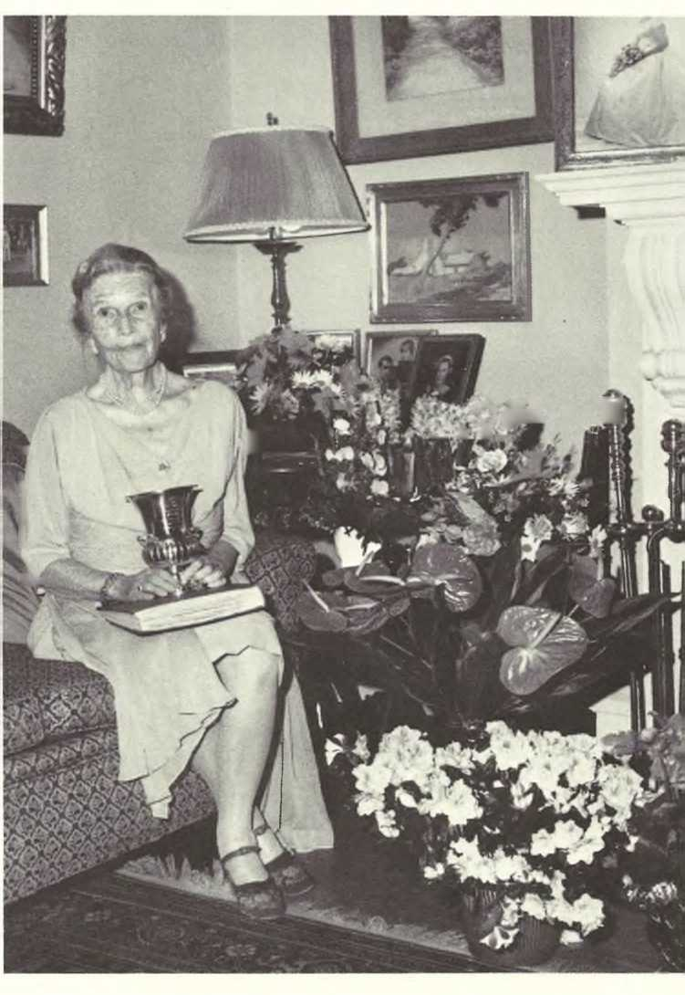

ANNA ESTES HACKER STRAWBRIDGE, at home, "Woodside," Philadelphia, Pa., on her 90th birthday, Feb. 20, 1970.
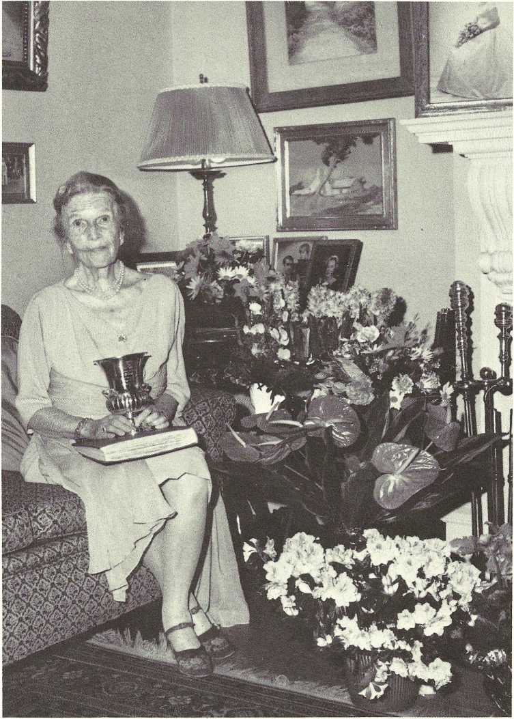

Estes Connections
The following “Family Connections ” evolved from the wealth of genealogical information received on past generations of those who married into the Estes family. They represent the work of dedicated genealogists (every family is said to have at least one) and include so many distinguished and interesting ancestors, we decided to include this sampling. Perhaps this information will spark your interest in further researching other family branches - a never-ending and intriguing venture. In each case the name of the Estes is given first, then “married”, then the name of the connecting spouse in capitals.

CONNECTIONS WITH THE ELISHA (3) ESTES BRANCH
Elisha (3) Estes married CATHERINE TOMPKINS. Catherine is a direct descendant of GEORGE READE of Gloucester Co., Va., a member of the York, Co., Va. Assembly.
Elisha Estes’ son, Christopher Tompkins (4) Estes, had a daughter,
Lucy Gwynne (5) Estes, whose daughter married David Halbert Howard. Their daughter, Lucie (7) Howard, married John Otey Carter, of Lookout Mt., Tenn. Lucie Howard supplied the following material on Elisha Estes family connections.

The direct line from GEORGE READE TO CATHERINE TOMPKINS:
George Reade, b. 1609, England; d. 1671, Gloucester Co., Va.; md.
Elizabeth Martin.
George Reade was the father of Thomas Reade, b. in Ware Parish,
Gloucester Co., Va.; d. 27 Apr. 1739; md. Lucy Gwynne.
Thomas Reade was the father of Joyce Reade, b. 6 Mar. 1701, Gwyn's
Island, Va.; d. 8 Aug. 1771, Caroline Co., Va.; md. Christopher
Tompkins, b. 17 Oct. 1705, in Gloucester Co., Va.; d. 16 Mar. 1779,
Caroline Co., Va.
Christopher Tompkins was the father of Benjamin Tompkins, B. 19 Sept.
1732, Caroline Co., Va.; d. 23 July 1811, Caroline Co., Va.; md. 11
Nov. 1759, Elizabeth Goodloe, B. 28 May 1738; d. 25 Apr. 1808. Benjamin Tompkins was the father of CATHERINE TOMPKINS who married
Elisha Estes.
Catherine Tompkins’ grandfather, CHRISTOPHER TOMPKINS was born on the North River, in Gloucester Co., Va. This is a partial list of the children of Christopher Tompkins and Joyce Reade; also a list of the children of Benjamin Tompkins, Catherine’s father:
Robert, eldest son, 1735-1795.
William, 4th son, 1736-1772.
Benjamin, 1732-1811, md. Elizabeth Goodloe. Children: Catherine, b. 1760; Robert, b. 1762; William, b. 1765; Frank, b. 1769; Lucy Gwynne, b. 1771; Sarah, b. 1773; Henry, b. 1775; Christopher, b. 1778; George, b. 1780; Elizabeth Beaufort, b. 1782; Mary, b. 1784.
Lucie Gwynne Estes married DR. EGBERT GRANVILLE VAUGHAN.
Egbert was the son of Milton Vaughan and Rebecca Craddock. Some information on their children:
Amanda Vaughan md. Henry Morton. Child: Samuel Howe md. Maria Fuller Van Dusen.
Oscar Craddock Vaughan md. Sarah Chappell.
Henrietta Jane Vaughan md. John Fuller Van Dusen, sans issue.
Louisa Vaughan (twin sister of Henrietta)
Adolphus Vaug'han md. Elizabeth Haskins. Child: Edgar Hobson Vaughan. Edgar's children: Mary Boatwright and Flo Penick.
Anna Eliza Vaughan md. Henry Rawlette-
Augusta Vaughan md. Anderson Miller.
Virginia Wimbush Vaughan md. Watkins Bailey.
Indiana Vaughan md. Robert Cobb Motley.

CONNECTIONS WITH THE BENJAMIN (3) ESTES BRANCH
Benjamin (3) Estes married CECELIA REBECCA THORPE, who was the daughter of SARAH TRIPLETT, daughter of William Triplett, a close friend of George Washington.
The following information comes from Wm. and Mary Quarterly, by Rev. Arnold Hord, Vol. 21(1) 33-43; 115-134; Vol. 22 (1) 175-181:

THE TRIPLETT FAMILY
FIRST GENERATION
FRANCIS TRIPLETT. He patented 1,050 acres of land in Old Rappahannock county in 1666 ("Virginia County Records," Vol. VI, page 194, By Crozier). He is mentioned in Deeds (see Virginia Magazine, Vol, XVII, page 144). His will is dated Nov. 20th, 1700, and was proved in Richmond county, March 4th, 1701. He mentions his children and grandchildren, disposes of the plantation on which he lived, containing 200 acres, another tract of 1,050 acres, and several smaller tracts. He mentions his wife, Abigail.

SECOND GENERATION
THOMAS (2) TRIPLETT (Francis (1) was dead at the time when his father's will was made, but he is called in the will "eldest son." The names of his children mentioned in the will are Thomas and Francis.

THIRD GENERATION
FRANCIS (3) TRIPLETT (Thomas (2), Francis (1) ) was a voter in Prince William Co. in 1741 and when Fairfax Co. was taken out of Prince William Co., he was a resident and voter of Fairfax Co. in 1744 (Gleanings of Va. History by Boogher, pg. 118, 119.) The will of Francis Triplett, dated Oct. 14th, 1757 was proved in Fairfax Co., Nov. 22nd, 1758. He mentions his wife Elizabeth and Children and grandchildren. His inventory is dated Feb. 18th, 1759, Will Book B, pg. 204, Fairfax Co.

FOURTH GENERATION
THOMAS (4) TRIPLETT (FRANCIS (3), THOMAS (2), FRANCIS (1) ) was a resident of Truro Parish, Fairfax, County. He was a Vestryman of Truro Parish 1776-85; Church Warden 1777-78 and was one of the original pew holders of old Pohick Church ("History of Truro Parish" by Slaughter and Goodwin, pages 122,118,119). He was a friend of General George Washington and "Mr. Triplett and family" were among the friends especially invited to the funeral of the General by Mrs. Washington (See Spark's "Life of Washington" appendix). He reconstructed from the old house at Mt. Vernon the mansion that is still standing ("Letters to Washington edited by Hamilton," Vol, 2, page 387; Vol. 3, page 3, 28, 75, 76, 101). He married Sarah, daughter of Dade Massey. She was a descendant of Col. Gerald Fowke and other well known Virginia families. (Hayden's "Virginia Genealogies" page 157).

Benjamin(3) Estes’ marriage to CECELIA REBECCA THORPE also connects all Benjamin’s descendants to GERARD (or GERALD) FOWKE, III, builder of Gunston Hall, in Lorton, Va., and cousin to the Masons of Va., whose most illustrious member, George Mason, wrote the Bill of Rights. (There is also a line of the Moore Family [Yates] which traces back to George Mason’s family). Gunston Hall was the home of George Mason. It is still extant and is open to the public.

Benjamin (3) Estes had a son, Benjamin (4), whose grand-daughter, Emma (6) Estes Cobb, of Chapel Hill,N.C., supplied this material on the direct lines from Cecelia Rebecca Thorpe to GERARD FOWKE, ADAM THOROUGH- GOOD and SIR EDWARD OSBORNE:

GERARD FOWKE
Cecilia (Selah) Thorpe was the daughter of Thomas Thorpe and Sarah Triplett. Sarah Triplett was the daughter of William Triplett and Sarah Massey.
Sarah Massey was the daughter of Dade Massey and Parthenia Alexander. Parthenia Alexander was the daughter of Robert Alexander and Anne Fowke. Anne Fowke was the daughter of Gerard Fowke, III, and Sarah Burdette
(2nd wife).

Gerard Fowke, III, connects Benjamin (3) Estes’ descendants back to GERARD FOWKE, I, member of the House of Burgesses from Westmoreland Co., Va. (1663), and a member of the Maryland Assembly from Charles Co., Md. (1665); to ROGER FOWKE, of Straffordshire, England; to ADAM THOROUGHGOOD, Commissioner and Burgess for Elizabeth City Co., Va. (1629-30); to SIR EDWARD OSBORNE, Lord Mayor of London (1585); and to SIR WILLIAM HEWETT, also a Lord Mayor of London (1559).

Gerard Fowke III, was the son of Col. Gerard Fowke, II, and Anne Thoroughgood (Chandler) widow.
Gerard Fowke, II, was the son of Gerard Fowke, I, of Virginia and Charles Co., Md. and Ann, born in England.
Gerard Fowke, I, was the son of Roger Fowke of Straffordshire, England.
Anne Thoroughgood (mother of Gerard Fowke III) was the daughter of Adam Thoroughgood and Sarah Offley, who were married in England and came to America prior to 1635.
Sarah Offley was the daughter of Anne Osborne Offley.
Anne Osborne Offley was the daughter of Sir Edward Osborne and Ann Hewett.
Ann Hewett was the daughter of Sir William Hewett.

Source material for the above lines:
Va. Magazine V I p. 370 Ibid V XIX p 335; Vol. XII p. 201, 202 and 109 Hayden's Va. Genealogies p. 154-157, 93, 192 Early Va. immigrants Greer, 328

Md. Heraldica, Baltimore Sun, 7/14/1907 Article by Emily Lante 9W (1) p. 54, 55 W = Wm. & Mary Quarterly Vol. Chap 9 p. etc.
12 V 201, 202 V in Va Quarterly by Tyler 12 Chap p. etc.
Va. Magazine Vol XIII pp. 201, 202, 109.

Supplementary data on CECELIA REBECCA THORPE family connections: From Hayden’s Virginia Genealogies:
Col. Gerard Fowke and wife, Ann, came from Stafford Co., England. He was born in 1662 and died in Virginia in 1734. He received land in Westmoreland Co., Va. His will is dated 6 Jan. 1734; proved 20 Jan. 1734.

He married, as his second wife, Sarah Burdett, of Charles Co., Md. They had a daughter, Ann Fowke, who married Robert Alexander, of Stafford Co., son of Robert Alexander (died 1704). Robert Alexander was born in 1688 and died in 1735. (p. 156)
Col. Gerard Fowke was a member of the House of Burgesses of Virginia in 1663. He moved to Charles Co., Md., in 1664, and was Burgess from Charles Co., Md. 2 Jan. 1665. He was also a justice, (p. 155)

From Maryland Heraldica, by Emily Lante, the BALTIMORE SUN, July 14, 1907:
Col. Gerard Fowke, II, was presented to the Maryland Assembly, 7 Sept. 1704, by Col. Smallwood, and he took the oath of office.

From Wm. & Mary Quarterly, 9W (1), 54, 55:
Robert Alexander was the father of Robert, who, in turn was the father of Parthenia. Both Roberts lived in Stafford, Va., and in 1701, the first Robert was a Justice of the county.

From Emma Estes Cobb’s family records:
Col. Gerard Fowke, of Maryland and Virginia, was the son of Roger Fowke, of Breward, Stratfordshire, England, and was brought to America by his brother, Thomas, and settled first in Westmoreland Co., Va., by 1654. In England he had been gentleman of the bedchamber to Charles I, and a Colonel in the Royal Army. His wife, Ann, came with him to Virginia.
He took up land in Westmoreland Co., and in 1663 was elected a burgess from this county. In 1664 Col. Fowke moved to Charles Co., Maryland and here he took up large estates. By 1665 he was unanimously elected a member of the Maryland Assembly from Charles Co. It is unusual to find a man a member of the House of Burgesses of two different counties in so short a time. He had moved to Port Tobacco when he left Virginia. He was made a colonel for Dorchester and a Justice of the Peace. This last high honor he held until his death, in Maryland, in 1669.
(Note - There is a conflict in data. Hayden seems to confuse the original Col. Gerard Fowke with his son. The first Gerard F'owke died in 1669, according to Emma Estes Cobb, and in 1734, in Hayden’s material.)
Col. Gerard Fowke, II, of Maryland, was the son of Gerard Fowke, of Virginia and Maryland. He was born in 1662, and died in 1704. His wife was Anne Thoroughgood (Chandler), the widow of John Chandler, and daughter of Adam Thoroughgood and his wife, Sarah Offley. In 1629 and 1630 Adam Thoroughgood was Commissioner and Burgess for Elizabeth City Co., Va. About 1634 he removed to Lynhaven Bay, in the present county of Princess Anne; he was a member of the Council in 1637, and in the same year, presiding justice of the County Court of Lower Norfolk. He died in the spring of 1640.

Ann Offley, mother of Sarah Offley, was the daughter of Sir Edward Osborne (Knighted at Westminster 2 Feb. 1591); Sheriff of London, 1578; Lord Mayor 1585. He is buried in St. Dionis Back, London.

Sir Edward Osborne's wife was Ann Hewett, daughter and sole heiress of Sir William Hewett, Lord Mayor of London, 1559, "a merchant of great repute," married in 1562, buried at St. Martin Orgars, London, 14 July 1585.

Ann Offley was buried in Princess Anne Co., Va., and until the middle of the 19th century the coats-of-arms on the tomb were very legible. Her tomb was on Church Point, at the site of the old church.
Adam Thoroughgood's will, dated 17 April 1639-40, was proved 27 April 1640, and is on record at Portsmouth, Va. There is also an inventory.

Sarah Offley was baptized 16 April 1609; married 18 July 1627; and died in Virginia in 1657, seventeen years after her husband's death.

Col. Gerard Fowke, III, married first a Lomax and second Sarah Burdette of Charles Co., Md.; their daughter, Anne Fowke, married Robert Alexander, II, the son of Robert Alexander, I, a Justice of Stafford Co.

The father of the first Robert Alexander was John Alexander.
Parthenia Alexander, daughter of Robert Alexander, II, married (1) Dade Massey, and (2) Townsend. She and her first husband, Dade Massey, had two daughters, one of whom, Sarah, married William Triplett.

Both Fowke and Thoroughgood are armorial families. Gerard Fowke, II, built Gunston Hall, the home of the celebrated George Mason, a cousin of the Fowkes.

William Triplett (5) Estes married LOUISE ALSTON RIDDICK; their daughter, Margaret (6) Estes, married John William Ponton; their daughter, Frances Sarah (7) Ponton, “Fannie”, of Wylliesburg, Va., supplied this information on her RIDDICK and PONTON lines:

THE RIDDICKS
Louise Alston Riddick was the daughter of Joseph Alston Riddick, prosperous furniture dealer of Lawrenceville, Va., (son of Robert Riddick and Elizabeth Maroney) and Martha Harrison Lashley, who were married 31 Oct. 1832.
Joseph Alston Riddick was the son of
Martha Harrison Lashley was the daughter of Benjamin Lashley and Mary Harrison.

THE PONTONS
John William Ponton's mother was a Bradshaw and his grandmother a Rice. (Tradition says that Rice University was named for this Rice family.) Orphaned and raised by an uncle, at age 18 John Ponton left his uncle's farm. He married Margaret Estes and lived in Henderson, N.C. for about four years, where they had a store. But five years after their marriage, John lost his health, so they moved to Chase City, Va., because the Lithia water, available there, seemed to help him (stomach problems). They bought a farm and lived there two years. In November, 1899, they moved to the present family home, "Home Place", in Wylliesburg, Va.

Frances Sarah (7) Ponton, “Fannie”, the genealogist of that family, lives at “Home Place” today. Fanny also wrote that her brother, Cooper, was named for family friends, the Coopers.

CONNECTIONS WITH ALBERT MONROE(5) ESTES BRANCH
Albert Monroe (6) Estes, grandson of Joel (4) Estes, married BELLE GATES. The following information on the Gates family was supplied by Hortense Ambrose McGehee, of Eden, N.C. Hortense is not an Estes. Her grandmother, Lena Gates, was a sister of Belle Gates, wife of Albert Monroe Estes.

THE GATES FAMILY

"GATES" is derived from residence near a gate of a fortified town or fortress.

First of name in England was Thomas Gates of whom mention is made in 1327. A Gates is named in the will of Henry VIII.

Most famous of the name in Virginia was Sir Thomas Gates who arrived May 24, 1610, and was the Governor of the Colony after Sir Thomas Dale. Sir Thomas Gates was on the famous voyage to America of Sir Francis Drake, in 1585-86. He was knighted in 1596.
In 1957, Gates kin then living in Madison Co., Tenn. stated that 7 Gates held land in Henrico Co. in 1723 - brothers according to tradition.

A more recent Gates ancestor, William, was a soldier in the Revolution. He was followed by numerous Gates who were landholders - interested in cards, racing, fox hunting and high-rolling.
William Ward Gates born 1812 - later editor and owner of the "West Tennessee Whig" - forerunner of the "Jackson Sun" - Jackson, Tenn.

Lena Gates Smith was named for Lena Nora Gates Given Sissen, daughter of Benjamin Franklin and Narcissa Newsom Gates. (Lena Gates was my grandmother - Hortense McGehee).

William Beverly Gates born 1842 was a half brother of Lena Nora Gates Given Sissen - was wounded at Shiloh - entered cotton business in Memphis - was an original member of the Memphis Cotton Exchange - he is the only Gates within my memory to make a "fortune" - he did much to keep all the family in the Orysa area going and educated during the years after the Civil War."

Albert Monroe (5) Estes had a son, Thomas Hale (6) Estes, whose daughter, Mattie V. (7) Estes married A.J. PARKER; their child, Patrick Mann(8) Parker, married ELIZABETH FISHER, a great-granddaughter of WILLIAM MOORER. The colonial home of the Moorers, is now the home of Elizabeth Fisher Parker, Patrick’s widow, and was part of a West Tennessee landmarks tour sponsored by the Lauderdale County Academy, Oct. 11, and 12, 1976.
The following are excerpts from the STATE GAZETTE, Dyersburg, Tenn., Friday, Oct. 10, 1975, describing Elizabeth Parker’s home. (Permission for reprint here granted by the State Gazette).

THE MOORER MANSION
William Allan Moorer purchased a considerable amount of land in Durhamville and built a very ornate and lovely home. The house burned the last year of the Civil War and another house was built in the same place later during the year.

The present house which is owned by Mr. and Mrs. P.M. Parker, Sr., a great-granddaughter of William Moorer, is a lovely colonial Mansion.

The house was built of yellow poplar wood grown on the farm and held together with wooden pegs. This house boasts having the first flat roof in the county. It has six tall columns and a low ground-level porch. Chimneys on either end adorn the lovely home. It consists of ten rooms and two baths, all rooms having fourteen foot ceilings. Only one room has the original wide panels in flooring, and all windows are original.

The majority of the antique furniture in the home belonged to Mrs. Parker's mother, however, she does have a chest that belonged to the Moorers. Lovely as this house may be, it is not nearly as ornate or as fine as the first house...

Smith William (7) Estes, a grandson of Albert Monroe (5) Estes, married MAE GRIFFITH; their daughter, Agnes Estes (8) Meyers, of Phila., Pa., supplied this information from the Griffith Family Bible:

FAMILY OF GRIFFITH OWEN GRIFFITH
Griffith Owen Griffith, born at Pen. y Graig Hangefori, Anglesea, Wales, Sept, 22, 1837; died Feb. 26, 1912, Phila., Pa.; married (1) April 3, 1866, at Bangor Cathedral, Wales, Ann Jane Williams, born at Beaumaris, Wales, Sept. 23, 1837; died Feb. 16, 1867; buried at Shandon Upper Church, Cork, Ireland Child: Ann Jane, born at Lantsquay, Cork, Ireland, Jan. 28, 1867,
Griffith Owen Griffith married (2) Isabella Bogan, born in Cork on 25 December, 1848. Married at Wesley Chapel, Patrick St., Cork, February 18, 1868. Children:
Elizabeth Rachel, born in Cork April 27, 1869
Isabella Agnes, born in Cork July 18, 1870
Thomas Owen, born in Philadelphia, Pa. 21st of April 1873
Lillian, daughter, born in Phila. November 9, 1875
Griffith Owen, born in Phila August 28, 1877
David, born in Phila. January 3, 1879
Mae Griffith, born in Phila. May 27, 1883
George Bogan, born in Phila. June 1, 1885
Stanley Griffith, born in Phila. August 6, 1890
Ann Jane, Elizabeth Rachel, Isabella Agens, Thomas Owen, Lillian, Griffith
Owen, and George Bogan never married. All died in Philadelphia, Pa.
Thomas Owen left home in the early 1900’s. He used to travel around the world, come home periodically with a parrot or other exotic jtropical pet, and tell tales of his experiences in foreign ports. He was last hear.d of around 1915 and no one has ever known what happened to him. Stanley married Helen —; sans issue; he died in Phila., Pa. in 1944. David married Florence Van Horn of Camden, N.J. They had two children: Lily Mae and Isabella Agnes. Neither of the girls married. Lily Mae is deceased, but Isabella Agnes Griffith is a retired executive of the Penn Central Railroad Co. and lives in West Collingswood, N.J.
Helen Isabella Estes, daughter of Smith William (7) Estes and Mae Griffith married RICHARD WARREN SELTZER, who is descended from MICHAEL SELTZER, who fought in the Revolutionary War:
Richard Warren Seltzer, son of Warren Ray Seltzer, b. 20 Apr. 1891, Wash., D.C.; d. 15 Nov. 1978, Wash., D.C.; md. 19 June 1918, Wash., D.C., Lillian Leona Daly, b. 6 Oct. 1890, Wash., D.C.; d. 13 Apr. 1973, Silver Spring,
Md.
The said Warren Ray Seltzer was the son of Henry Hocker Seltzer, b. Annville, Pa. 28 Aug. 1856, d7 Aug. 1925, Wash., D.C.; md. (1) 10 Feb. 1877, Annville, Pa., Susan Arnold, b. 21 Apr. 1859, Campbelltown, Pa.;d. 1 Jan. 1917, Wash., D.C.; md. (2) Mrs. Boehm, sans issue.
The said Henry Hocker Seltzer was the son of Henry Uhland Seltzer, b. 15 June 1824, Bellegrove, Pa.; d. 25 Nov. 1897, Palmyra, Pa.; md. 12 Dec. 1850, Harrisburg, Pa., Anna Hocker (or Hacker), b. 10 May 1827, Hockersville, Pa, (near Hershey).
The said Henry Uhland Seltzer was the son of Philip Seltzer, b. 26 Dec. 1772, (Waterworks) Annville, Pa.; d. 19 Apr. 1847, (Waterworks) Annville, Pa.; md.
25 Mar. 1800, (Waterworks) Annville, Maria Uhland, b. 10 Aug. 1784; d. 25 Feb. 1860, Bellegrove, Pa.
The said Philip Seltzer was the son of Michael Seltzer, b. 1745; d. 1815; md. Barbara Gasser, daughter of Jacob Gasser of Heidelberg Township, Lebanon Co., Pa.
The said Michael Seltzer was the son of Jacob Seltzer; arrived Phila. 17 Aug. 1729 aboard "Mortonhouse" (James Coultas, Commander); md. Barbara

Belle (7) Estes married JAMES MINOS DYKES, whose son, James Minos Dykes, Jr., married FRANCES DAVIS HENRY. Elizabeth Bosley (9) Dykes Leitzes, of Irvington-on-Hudson, N.Y., daughter of Frances Davis Henry Dykes, supplied this information on her mother’s material lineage:

Frances Davis Henry was the daughter of Elizabeth Agnes Bosley, b. 20 Oct. 1878; d. 24 June 1939; md. John Elmore Henry.
Elizabeth Agnes Bosley was the daughter of Robert Emory Bosley, b. 25 June, 1840; md. in 1869 or 1870, Frances Ashley, b. 1856, Wolfe Co., Ky.; d. 1882, Wolfe Co., Ky.
Robert Emory Bosley was the son of Emory Madison Bosley, who md. 19 Dec. 1837, Sarah Ann Davis.
Frances Ashley was the daughter of John Ashley and Elizabeth Frances Ashley.

Laurence Bradford (7) Estes married LIDY KATE KING; their son, Warner Moore (8) Estes, of “Oaklawn”, Haywood Co., Tenn., supplied the following data on his mother’s family:

THE KING FAMILY
Lidy Kate King is the daughter of Thomas B. King, Jr., b. 1860, Dearey,
Ark.; d. 22 Mar. 1949, Memphis, Tenn.; md. Mary Bond Williams,
"Molly", b. 22 June 1864, Indian N. Elizabeth City, N.C.; d. 10 Apr.1900, Brownsville, Tenn.
Thomas B. King was the son of Thomas Brown King and Eliza Bass Thomas, b. 1821; d. 1901.
Lidy Kate King's mother, Mary Bond Williams, was the daughter of John Williams who md. Kate Pugh in 1809.

CONNECTIONS WITH MOREAU PINCKNEY (5) ESTES BRANCH
Moreau Pinckney (5) Estes married MARY QUARLES NOEL; their granddaughter Mary Noel (7) Estes, married THOMAS EDWIN MOODY, whose grandson, William Reece (9) Smith, Jr., “Reece”, wrote in a letter dated April 27, 1979: “The data published in the CARY-ESTES GENEALOGY at page 200 showing the descendants of Ewell Noel and Lucy Q. Hilliard is incomplete and incorrect at least as to the progeny of Betty Noel.”
He provided the information in the following corrected listing:
Ewell (4) Noel, b. 1782; md. Lucy Q. Hilliard. Children:
1 Maria (or Eliza); 2 Mary Quarles; 3 Fanny; 4 Lucy Ann; 5 Betty (Elizabeth Minor).
2 Mary Quarles (5) Noel md. Moreau Pinckney Estes.
(See details of her descendants in the “Estes Listings”).
5 Elizabeth (5) Minor Noel (Betty), b. 25 July 1830; d. 6
Jan. 1885; md. 2 Sept. 1847, Henry Shelton Moody (not Tom Moody, as given in CARY-ESTES) b. 20 Mar. 1824; d. 1 Nov. 1873, Crockett Co., Tenn. Children:
(Note the listings are arranged differently, and names are added to those given in the CARY-ESTES account) i Marshall; ii Lucy Hilliard, iii Ewell Noel; iv James Shelton; v Ida; vi Martha Judith; vii Thomas Edwin; viii David Henry; ix William Shelton; x Moreau Estes; xi John.
Marshall (6) Moody, b. 27 July 1848; d. 2 Oct. 1856.
Lucy Hilliard (6) Moody, b. 22 May 1850; d. 20 Mar.
1872, md. 26 Apr. 1870, Alfred Jones Loving; sans issue.
hi Ewell Noel (6) Moody, b. 9 Feb. 1852; d. 13 May 1854.
James Shelton (6) Moody, b. 2 Dec. 1853; d. 10 June 1885.
Ida (6) Moody, b. 9 May 1855; d. 18 June 1894; md. 14 Aug. 1874, Alfred Jones Loving (her brother-in-law).
Child: Edna Jones.
1 Edna Jones (7) Loving, b. 31 Aug. 1877; unmd.
Martha Judith (6) Moody, b. 4 June 1857; d. 13 Dec.
1923; md. 4 Oct. 1882, Dr. Caruthers of Nashville, Tenn. Children: 1 Elizabeth; 2 William.
Elizabeth (7) Caruthers, unmd.
William Moody (7) Caruthers, md. Vera Harrison of Ft. Worth, Tex. Children: two daughters.
Thomas Edwin (6) Moody, b. 29 Jan. 1859; md. Mary Noel Estes (granddaughter of Mary Quarles (5) Noel and Moreau Pinckney (5) Estes above) (Their line is covered in the CARY-ESTES GENEALOGY and is updated in the “Estes Listings” of this volume).
David Henry (6) Moody, b. Oct. 1860; d. —; md.
15 Mar. 1882, Laura Whitaker. Children: 1 David Whitaker. Children: 1 David Whitaker; 2 Julia.
David Whitaker (7) Moody; md. Jane Penn. Children: two sons.
Julia (7) Moody md. Curtis Armstrong. Children: one son; two daughters.
William Shelton (6) Moody, b. 8 July 1862; d. 16 Dec. 1907; md. 4 June 1901, Edna Wright; sans issue.
Moreau Estes (6) Moody, b. 18 July 1864; d. 9 Oct. 1945; md. 30 June 1920, Tilden Hendrix; sans issue.
John (6) Moody, b. 15 Mar. 1868; d. 3 July 1930; md. 2 Dec. 1892, Amanda Conyers. Children: five - four died in infancy.
Ewel (4) Noel md. (2) Miss Coslem. (Research turned up no new information on the issue of this marriage. See the listings on pp. 200-203 of the CARY-ESTES GENEALOGY).

Martha Cornelia (6) Estes married Henry Bate Folk, whose grandson,
Winston Estes Pilcher (8) Folk married (1) PAULINE BROWN, who supplied this record of her paternal and maternal family lines:
Pauline Brown is the daughter of Major General William Lytle Brown,
USA, b. 22 Nov. 1872, in Nashville, Tenn.; d. 2 May 1951, Franklin, Tenn.; md. 23 Dec. 1903, Nashville, Tenn., Louise Lewis, b. 27 July 1882, Sycamore, Tenn.; d. 3 Sept. 1965, Nashville, Tenn.

THE BROWN FAMILY
William Lytle Brown was the son of James Trimble Brown, b. 14 Aug.
1842, Nashville, Tenn.; d. 31 May 1878, Nashville, Tenn.; md. Jane Foster Nichol, b. 24 July 1845, Nashville, Tenn.; d. 8 Oct. 1916, Nashville, Tenn., dau. of William Nichol, b. 12 Feb. 1800; d. 22 Nov. 1878, and Julia Margaret Lytle, b. 17 Sept. 1809; d. 21 Aug.
1890.
James Trimble Brown was the son of Neill S. Brown, b. 10 Apr. 1810, Pulaski, Tenn.; d. 6 Feb. 1889; md. Mary Ann Trimble, b. 1816; d. 24 Oct. 1895.

THE LEWIS FAMILY
Louise Lewis was the dau. of Eugene Castner Lewis, b. 22 June 1845, Clarksville, Tenn.; d. 13 Feb. 1917, Nashville, Tenn.; md. 12 Oct.
1880, Nashville, Tenn., Pauline Anne Dunn, b. 20 Feb. 1860, Memphis, Tenn.; d. 14 Jan. 1902, dau. of David Littleton Dunn, b. 1836; d. 1861, and Anne Lytle Nichol, b. 1835; d. 1864.
Eugene Castner Lewis was the son of George Thomas Lewis, b. 2 Aug.
1816 and Margretta Oliver Barnes, b. 10 Nov. 1812; d. 26 Apr. 1900.

Martha Cornelia (6) Estes married HENRY BATE FOLK; their granddaughter married HILLIARD D. PHILLIPS; whose son, Hilliard Folk (9) Phillips of Brentwood, Tenn., supplied this data on his paternal lineage:

THE PHILLIPS FAMILY
Hilliard D. Phillips was the son of David Webster Phillips, b. 13 Aug. 1881, Poplar Springs, Tenn.; d. 17 Nov. 1935, Livingston, Tenn.; md. 26 Mar.
Johnnie Lillian Deck, b. 25 Oct. 1884, Livingston, Tenn.; d. 19 July 1974, Linvingston, Tenn.
David Webster Phillips was the son of John P. Phillips, b. 18 July 1845, Poplar Springs, Tenn.; d. 16 May 1914, Poplar Springs, Tenn.; md. 10 Oct. 1871, Ellen Hawkins, b. 16 Mar. 1855; d. 21 Feb. 1885.
John P. Phillips was the son of David Phillips, b. 2 Apr. 1815; md. Elvira Jones, b. 14 Apr. 1815.
Ellen Hawkins, wife of John P. Phillips, above, was the daughter of Joseph H. Hawkins, b. 6 Feb. 1828; d. 29 Dec. 1915; md. Philena Johnson, b. 24 Sept. 1836; d. 25 Mar. 1883.
THE DECK FAMILY
Johnnie Lillian Deck, wife of David Webster Phillips, above, was the daughter of Samuel Joseph Deck, b. 12 Mar. 1862, Livingston, Tenn.; d. 10 Dec.
Livingston, Tenn.; md. 22 Jan. 1882, Sara Adeline Sparkman, b. 23 Apr. 1866; d. 23 Aug. 1931.
Samuel Joseph Deck was the son of Frederick Columbus Deck, b. 24 Sept. 1837; d. Sept. 1, 1925, and Rosa Marcum, b. 2 Nov. 1835; d.
3 Nov. 1883.
Sara Adeline Sparkman, wife of Samuel Joseph Deck, above, was the daughter of James Monroe Sparkman, b. 8 Feb. 1842; d. 15 Apr.
1927; md. 22 Jan. 1885, Minerva Gillentine, b. 7 May 1845; d. 5 July 1918.

Joel Henry (6) Estes’ daughter, Mary Noel (7) Estes, married THOMAS EDWIN MOODY. Several of their descendants sent in copies of the Moody Family history which follows:

From PLANT CITY: ITS ORIGIN AND HISTORY by Quintilla Geer Bruton and D.E. Bailey, Jr., published by Valkyrie Press, St. Petersburg,
Fla. (Permission granted for reprint here).

THE MOODY FAMILY
The Moodys, for the greater part of the last century, have contributed substantially to the development of east Hillsborough County and have established an admirable record for exemplary citizenship and useful public service.

The Moody ancestors came to America prior to the American Revolution, locating originally in Williamsburg and eastern Virginia. From there they migrated down the Shenandoah Valley of western Virginia into western North Carolina and eastern Tennessee.

MOREAU .ESTES MOODY
In 1885, Moreau Estes Moody, brother of Thomas Edwin Moody) came to Mango, Florida, and established a drug store which he relocated, in 1891, in the promising new town of Plant City. As an accommodation to the farmers and neighbors, he had kept money for them in his store safe.
As an outgrowth of this, he and Colonel James L. Young of Plant City organized the town:s first bank, the Hillsboro State Bank, in 1902. M. E. Moody succeeded to the bank presidency on the death of Colonel Young in 1928 and held that position until his death in 1945.

As the principal banker and one of the most stable businessmen in the community, Mr. Moody's knowledge, ability and advice were utilized in the early development of Plant City. Among other things, he was a motivating influence in the establishment of the South Florida Baptist Hospital and donated five acres of the ten-acre site on which the hospital was built.

Reece (9) Smith, of Tampa, Fla., grandson of Mary Noel (7) Estes and THOMAS EDWIN MOODY, supplied the following information on the MOODY and MARSHALL families, from “Cousin Edna Loving’s” family record:

Great Grandfather Marshall Moody was married before he married Great Grandmother Elizabeth Shelton Speed. Our great grandmother's maiden name was Shelton. She gave each of her Moody children as their middle names Shelton, namely, Henry Shelton, David Shelton, and James Shelton.
By Elizabeth Shelton's first marriage to Mr. Speed she had five children 2 boys 3 girls namely Julia Speed, Emily and Amanda Speed (twins, Rufus Speed, and Joe Speed. History of this family found elsewhere.

Great Grandfather Marshall Moody by his first marriage to Miss Phillips of Memphis had three children namely, John, William and Rebecca. Rebecca married a man whose name was Howell. All we know of William and John is that a son of each man visited in the home of Henry Shelton Moody and my mother said they were nice men and men of whom we may be proud.

Conundrum about Henry Shelton Moody
My grandfather Henry Shelton Moody had no own sisters four half sisters namely Rebecca Moody, Julia, Emily, and Amanda Speed. Grandfather Moody had four half brothers William and John Moody, Joe Speed and Rufus Speed. Grandfather Henry Shelton Moody had two own brothers - namely David Shelton Moody, James Shelton Moody.

Thomas Edwin Moody’s father MARSHALL MOODY was the son of — Moody who married MIRAH MARSHALL. William Reece (9)
Smith, Jr., sent the following history of the Marshall family.

THE MARSHALL FAMILY
Tom Marshall left Lincolnshire, England about 1735 with his wife and 5 children, to live in the Colonies, purposely to get away from Political Confusion. Their sons were: John, William, Humphry, and Tom, a daughter Mary Marshall was the youngest. This family located in Fauquier Co., Va., and their sons later settled in Ky, Va., and Pa.

John Marshall born 1723 was called John Marshall of the Woods. His brother Tom Marshall born 1730, called Tom Marshall of the Forests. Both Tom and Daniel Boone went to live in Ky. forests and were skilled craftsmen.

Col. Tom Marshall )born 1730) married Mary Keith (about 1754) Parents of fifteen children. First born Chief Justice (born 1755 Brother Humphry Marshall, youngest sister Mirah Marshall (Find they had few daughters and many sons). Miss Marshall (born about 1763) daughter of Col. Tom Marshall, lived in Fauquier Co., Va. - married a Mr. Moody (This Miss Marshall is a sister of Chief Justice Marshall).

Their children were Marshall Moody, Henry Moody, John Moody - one brother moved to Ala.

The following information on the Rice family comes from LAUDERDALE COUNTY FROM EARLIEST TIMES, written by descendants of its pioneer citizens, Edited by Kate Johnston Peters, Sugar Hill Lauderdale County Library, Ripley, Tenn.:

THE RICE FAMILY
Thomas G. Rice, Shadrach Rice, and John P. Rice, three brothers, left the Georgetown District in South Carolina in the winter of 1836, with their families, slaves, and household effects. Scarlet fever broke out among the children and two of Shadrach and Elizabeth Linerieux Rice's children died. They arrived in the part of Lauderdale County known now as Orysa in April, 1837. Shadrach Rice was the father of C.S.O.Rice, who married Lucie Q. Estes. Their sons are: Ernest Rice, Sr., M.E. Rice, Sr., Ralph E. Rice, Sr., and Shadrach Rice. M.E. and Shad built homes at Orysa, where M.E. Now operates a store. C.S.O. Rice was born in Lauderdale County. He attended Law School at Lebanon, Tennessee, in 1859-60. About 1874, he was elected to represent Lauderdale County in the Legislature. The large two story house where he and his family lived for so many years is still standing.

From the Shadrach Rice diary: "Sept. 29, 1841 - commenced to work on church with 3 hands and Bros. Thos. Rice, 3 hands. Dec. 3 1841 -- Finish sawing stuff for church. March 6, 1842 - memorandum of shingles counted at the church - 18,800 that was jointed."

Thomas Franklin Rice was the son of Shadrach and Louisa Elizabeth Linerieux Rice. He married Sarah Elizabeth Borum, a daughter of Mr. James H. Borum. H is son, Elmer T., married Mildred Estes. Neither are living. A daughter, Minnie L„ married Mr. Harvey Davis of Ripley.
The home of T.F. Rice, located near Orysa, still stands today. It was built at the close of the Civil War. None of the Rice family occupy the home at present (1956). Miss Minnie moved to Ripley some years ago. T.F. Rice served in the Confederate Army throughout the entire Civil War.

CONNECTIONS WITH THE JUDITH BELL (5) ESTES BRANCH
Judith Bell (5) Estes married JOHN BERTIE MOORE; their great-grandson, James Rutland (8) Moore, married EDITH HACKER SHIPLEY. This marriage connects the Tennessee Estes to the BOSTON ESTES, to the HACKERS of New England, and to three prominent Philadlephia families: the SHIPLEYS, the EMLENS, and the STRAWBRIDGES.

The following information on the Shipley, Emlen, Strawbridge, Boston Estes and Hacker families was provided by Mrs. Walter Penn Shipley, Jr., of Philadelphia, Pa., from family records of her mother, Mrs. Francis Reeves Strawbridge, also of Philadelphia.

THE SHIPLEY FAMILY
William (1) Shipley, b. 7 Mar. 1723; d. 7 Aug. 1790 or 1793; arrived from England about 1750; md. Margaret Maries.
John (2) Shipley, b. Nov. 1778; d. 19 Apr. 1817; md. 8 Sept. 1808, Ann Wright, b. 10 Mar. 1782; d. 1837; buried Friends Burying Ground, 6th and Race Sts., Phila., Pa.
Thomas (3) Shipley, b. 8 July 1816; d. 7 Apr. 1888; buried West Laurel Hill Cemetery, Bala Cynwyd, Pa.; md, 12 July 1859, Elisa Morgan Drinker, b. 22 Apr. 1828; d. 10 Oct. 1895.
Walter Penn (4) Shipley, b. 20 June 1860; d. 17 Feb. 1942; md. 17 Oct. 1889, Anne Emlen (see Emlen line below), b. 24 Oct. 1865; d. 11 June 1946, buried West Laurel Hill Cemetery.
Walter Penn (5) Shipley, Jr., b. 2 Nov. 1897, Gtn., Phila., Pa.; md. 14 May 1927 at Gtn. Monthly Mtg., Mary Dawson Strawbridge, b. 8 Feb. 1906.
Edith Hacker (6) Shipley, b. 1 Nov. 1936, Gtn., Phila.; md. 26 Nov. 1965, Gtn. Monthly Mtg., James Rutland Moore.

The above marriage connects the Shipley, Emlen, Strawbridge, Boston Estes, and Hacker families to the Cary-Estes branches.

THE EMLEN FAMILY
George (1) Emlen, b. —-; d. 25 Dec. 1710; md. 25 Mar. 1694, Hannah Garat, b. 23 Apr. 1674; d. 24 June 1738.
George (2) Emlen, Jr., b. 7 May 1695; d. 24 Oct. 1754; md. 25 Mar, 1717, in Phila. Monthly Mtg., Mary Heath, b. 11 Apr. 1692; d. 1 June 1777.
George (3) Emlen, III, b. 21 June 1718; d. 3 Jan. 1776; md. 15 Dec. 1740, Anne Reckless, b. 4 Oct. 1720; d. 4 Feb. 1816.
James (4) Emlen, b. 26 June 1760; d. 3 Oct. 1798; md. 23 Apr. 1783, Phebe Peirce, b. 11 Dec. 1758; d. 25 Oct. 1793.
James (5) Emlen, Jr., b. 17 June 1792; d. 20 Sept. 1866; md. 11 Jan. 1816, at Middletown Mtg., Lima, Pa., Sarah Foulke, b. 27 Apr. 1787; d. 27 July 1849.
Samuel (6) Emlen, b. 23 Mar. 1829; d. 5 Dec. 1920; md. 30 Sept. 1851, Middletown Mtg,, Lima, Pa., Sarah Williams, b. 20 Mar. 1830; d. 29 Oct. 1913.
Anne (7) Emlen, b. 24 Oct. 1865; d. 11 June 1946; md. 17 Oct. 1889, Walter Penn Shipley, b. 20 June 1860; d. 17 Feb. 1942.

Walter Penn (8) Shipley, Jr. ’s, marriage to Mary Dawson Strawbridge joins the Emlen family to the Cary-Estes families.

THE STRAWBRIDGE FAMILY
Justus (1) Strawbridge, b. 1 Nov. 1771; d. 1840; md. Susannah Maus, b. 5 Dec. 1764; d. 1840.
George Frederick Heap (2) Strawbridge, b. 1804; d. 13 Apr. 1841; md. 26 Feb. 1835, Phila., Pa., by John Swift, the mayor, Ann Zelley, b. 28 Dec. 1808; d. 17 Apr. 1853.
Justus Clayton (3) Strawbridge, b. 11 Jan. 1838; d. 27 Mar. 1911; buried West Laurel Hill Cemetery, Bala Cynwyd, Pa.; md. 7 Apr. 1863, at Mtg. House, 6th and Noble Sts., Phila., Pa., Mary Lukens, b. 15 Jan. 1835; d. 4 Feb. 1895; buried West Laurel Hill Cemetery.
Francis Reeves (4) Strawbridge, b. 1876;d. 1965; md. 30 Apr. 1902, Gtn. Monthly Mtg., Anna Estes Hacker, b. 20 Feb. 1880, Phila.; d. 5 Jan. 1981.

Mary Dawson (5) Strawbridge's marriage to Walter Penn Shipley, Jr., links the Strawbridges to the Carys-Estes.

THE ESTES FAMILY (BOSTON BRANCH)
Mathew (1) Estes, b. 28 May 1645; d. 9 June 1723; md. 14 June 1676, Philadelphia Jenkins, b. Nov. 1645, Dover, N.H.; d. 25 Oct. 1721, Lynn, Mass.
John (2) Estes, b. 14 May 1684, at Dover nr. Lynn, Mass.; d. 29 July 1723; md. 15 Feb. 1705, Hannah Bassett; b. 2 Dec. 1685; d. 14 May 1762.
William (3) Estes, b. 23 Aug. 1718; d. 6 Apr. 1781; md. 11 Jan. 1745, Ruth Graves, b. 1 Feb. 1727; d. 31 Oct. 1807.

Anna (4) Estes connects the Boston Estes and Hacker families to the Carys and Tenn. Estes in her marriage to Isaac Hacker. Her descendant, Anna Estes Hacker married Francis Reeves Strawbridge. See Strawbridge line above.

THE HACKER FAMILY
Isaac (1) Hacker, b. 6 July 1750; d. 5 Sept. 1818; md. 24 Apr. 1774, Anna Estes b. 28 Sept. 1754; d. 8 Sept. 1802.
Jeremiah (2) Hacker, b. 12 July 1799; d. 21 Oct. 1866; md. 10 Feb. 1830, Beulah Morris, b. 2 Feb. 1811; d. 20 Jan. 1892.
John Barclay (3) Hacker, b. 16 July 1843; d. 1 Jan. 1911; md. 15 Feb. 1866, Mary Perot Dawson, b. 4 Feb. 1843; d. 5 Aug. 1892.
Anna Estes (4) Hacker, b. 20 Feb. 1880; d. 5 Jan. 1981; md. 30 Apr. 1902, Francis Reeves Strawbridge, b. 20 Oct. 1876; d. 11 May 1965.

Mrs. Francis Reeves Strawbridge (Anna Estes Hacker), a prominent Philadelphian, a gracious lady beloved by all who are privileged to know her, now in her 100th year, brings the Boston Estes and the Hacker families into the Cary Estes lineage. She is the grandmother of Edith Hacker Shipley who married James Rutland Moore, great-grandson of Judith Bell Estes of the Joel Estes line. See Shipley Family above. (Note: Anna Estes Hacker Strawbridge departed this life 5 Jan. 1981).

ANNA ESTES (4) HACKER STRAWBRIDGE
Anna Estes Hacker Strawbridge, grandmother of Edith Hacker Shipley (Mrs. James Rutland Moore) celebrated her 100th birthday on February 20, 1980. The following are excerpts from an article in the PHILADELPHIA INQUIRER of February 21, 1980, by Ruth Seltzer, covering her birthday celebration. This information was supplied by Virginia (8) Estes Jacoby (Mrs. Edward R. Jacoby) of Abington, Pa. (Permission granted by Phila. Inquirer for reprint here).

Mrs. Francis R. Strawbridge, the matriarch of Philadelphia's Straw- bridge family, celebrated her 100th birthday yesterday. Members of her immediate family gathered last night at Woodside, her home in Germantown, for a birthday supper.

Mrs. Strawbridge (nee Anna Estes Hacker) was born in Philadelphia.
She is one of this city's most outstanding citizens...

She is still alert. At the birthday party, she greeted her son and daughters, G. Stockton Strawbridge; Mrs. Walter Penn Shipley, Jr. (Mary) and Mrs. R. Philip Custer (Elizabeth). There, too, were grandchildren and greatgrandchildren.

Her memory is excellent. She can recall her childhood days when she wintered in center city and summered in Germantown. She was born when Rutherford B. Hayes was President of the United States.

In recognition of Anna Strawbridge's birthday, President Carter sent a congratulatory message. So did U.S. Sen. Richard S. Schweiker, U.S. Sen. H. John Heinz, 3d and Gov. Thornburgh...

Mrs. Strawbridge was married in 1902 to Francis R. Strawbridge, an executive of Strawbridge & Clothier. Her father-in-law, Justus C. Strawbridge,... founded the department store in 1868 with Isaac H. Clothier.

A lifelong member of the Society of Friends, she attended the Germantown Friends Meeting on Coulter Street regularly until she was well past 98.

As a descendant of passengers who sailed to Philadelphia with William Penn, she is a member of the Welcome Society...

Anna Estes Strawbridge is the author of four books of poetry - "Rhyme and Reason"; "More Rhyme, Less Reason"; "Random Rhymes" and "A Bridge of Rhymes". The latter was written as a bridge to her great-grandchildren.

She has 15 grandchildren and 35 great-grandchildren.

Mrs. Strawbridge has lived from the era of horse-drawn carriages to the space age. She loved to ride in helicopters from the roof of the Strawbridge & Clothier Philadelphia store to the openings of the new S & C stores in the suburbs. After one of those trips, she told her great-granddaughter, Wendy, "I want thee always to remember that thee rode in a helicopter with thy father, thy grandfather and they great-grandmother."

Anna Strawbridge (her good friends call her "Nannie") was president of the League of Women Voters of Philadlephia for several years. She is a former president of the National Society of Colonial Dames of America in the Commonwealth of Pennsylvania. That post was later held by her daughter, Mary Shipley. Both Mrs. Strawbridge and Mrs. Shipley are Distinguished Daughters of Pennsylvania.
Mrs. Strawbridge was twice president of the Morton Street Day Nursery, which is now part of the Germantown Settlement. She was the first woman board member of the Blue Cross of Greater Philadelphia. She is now an honorary board member of Germantown Hospital. And she is an honorary vice president of the Committee of 1926, which runs historic Strawberry Mansion in Fairmount Park.
At the birthday party last night, 71 members of Mrs. Strawbridge's family gathered for supper.
During the party, a special booklet was given to the guest of honor and her family. The booklet, presented by the board of directors of Strawbridge & Clothier is entitled, "Anna Estes Strawbridge: A Celebration." Prepared as a "tribute to a remarkable woman," the 16-page booklet contains many photographs -- pictures with her husband and family, pictures at store groundbreaking ceremonies, a picture at the opening of the S&C heliport, and a reproduction (on the cover) of a 1927 oil portrait.

Printed in the book is a resolution from the board of directors saluting Mrs. Strawbridge. The resolution, in part, says: "Whereas, during the course of reaching this remarkable milestone, as wife, mother, and grandmother of members of this board, she has watched a great Company grow and prosper... and whereas, by her clarity of thought and speech, her gentle humor, her thoughtful consideration of others, and her abiding serenity, so evident both in mind and face, she has been an inspiration to every member of this board and to the store family, be it resolved that the board of directors of Strawbridge & Clothier hereby joins with Anna Estes Strawbridge in celebrating her 100th year and expresses to her its heartfelt admiration, respect and affection."

... She is an amazing woman, one who had volunteered many decades to help this city, this region, this nation.

CONNECTIONS WITH BEDFORD MITCHELL (5) ESTES BRANCH
Joel (4) Estes married the second time, and to this marriage he had one child, a son, Bedford Mitchell (5) Estes, whose daughter, Emily Alston (6) Estes, married JAMES GEORGE SNEDECOR, whose grandson, Jesse Carlos Maxwell, Jr., of Scottsdale, GA., sent in the direct line from the first generation Snedecor in America to James George Snedecor:

THE SNEDECOR FAMILY
First Generation: Abraham Snedeker, b. abt. 1706 d June 1732. m Annatie Qucke (Quick). Letters of administration granted Hannah Snedeker on 6-7- 1732, Kings Co., N.Y. Only one child found.

Second Generation: Christian (Christaien) Snedeker, b. 2-6-1736 bp, 3-20- 1737 d. 10-13-1792 m. 3-19-1759 Elsie Demott, b. 10-19-1740. His will proved 5-11-1793 Liber A page 172, Queens Co., N.Y. Reference: Am. Ancestry vol. 12 page 4. Children: 7.

Third Generation: Isaac Snedecor, b. abt. 1750 d. 8-8-1810, Montgomery Co., Ky. m. 5-29-1787 (lisc. - Augusta Co., Va.) Eleanor Story b. 1758 d. 1842. On tax list Montgomery Co., Ky. from 1797-1808. Administration of his estate will book "B" page 11.

Fourth Generation: James Snedecor b. 9-16-1775 d. 8-9-1842 m. 3-3-1816 Sarah (Sally) O'Rear, b. 6-9-1795 d. 7-3-1861. Migrated from Ky. to Green Co., Ala. 1818.

Fifth Generation: George Gaines Snedecor b. 2-8-1821 d. 9-30-1860 m. 10- 30-1849 Harriet August Godden b. 5-3-1833 d. 1-23-1899. 1860 Census, Holmes Co., Miss.

Sixth Generation: James George Snedecor m. Emily Alston Estes. Attorney and Presbyterian Minister. See Emily Alston Estes line in the listings for their descendants.

For more information on Snedecor and related families, see SNEDEKER, SNEDECOR, SNEDEGER, SNEDAKER, SNEDICOR, SNEDEGAR, SNEDIKER, SNIDECOR, SNEDIGAR FAMILIES, by Harold Ray Snedeker, Savannah, Ga., 1970.

Ione (7) Snedecor, daughter of Emily Alson (6) Estes and JAMES GEORGE SNEDECOR, married JESSE CARLOS MAXWELL; their son, Jesse Carlos Maxwell, Jr., of Scottsdale, Ga., supplied this material showing Jesse Carlos Maxwell’s direct line to the first generation Maxwell of record in America.

THE MAXWELL FAMILY
First Generation: The Rev. Thomas (1) Maxwell; b. 8 Sept. 1742, Middlesex Co., Va.; bap. 12 Dec. 1742 (Christ Church Register, Middlesex Co., Va.; d. 12 Dec. 1837, (documentation - his Bible) Hart Co., Ga.; md. 25 June 1761, in Va., Mary Pemberton, (from D.A.R. record) b. 1744, in Va.; d. 18 Dec. 1827, Elbert Co., Ga.

Second Generation: John (2) Maxwell, (son of the Rev. Thomas and Mary Pemberton Maxwell) b. 9 May 1763, in Va. (documentation: Thos. MAXWELL’S Bible)', bur. Maxwell Cem.; 2 miles south of Alpharetta, GA.; grave marked by Nancy Hart Chap., D.A.R., Milledgeville, GA.; md. 6 Feb. 1792, St. Thomas’ Parish, Orange Co., Va., Agatha “Agnes” Henry; bondsman, Benson Henry

(documentation: marriage bond, Orange Co., Va. and “Marriages in Orange Co., Va., by W. W. Scott, VA. Mag. of Hist, and Biog. Vol 26/301)-, John Maxwell was a Revolutionary Soldier (Roster of Rev. Soldiers in Ga. by McCall, pp. 219-220)', b. 22 Mar. 1770; d. 1 Dec. 1851; bur. Old Maxwell Cem., about IV2 mi. S.E. of Kellyton, Coosa Co., Ala.

Third Generation: Reuben (3) Maxwell, (second son of John and Agatha Maxwell) b. 4 Nov. 1795, Elbert Co., Ga.; d. 31 May 1861, Tallapoosa Co., Ala..; bur. Old Maxwell Cem., on his old plantantion; md. 16 Dec. 1821, by Rev. Dozier Thornton (Documentation: Marriage Records 1816- 1824, Will Book “L”, p. 478, Elbert Co., Ga.)b. 15 Dec. 1801, Elbert Co., Ga.; d. 12 June 1883, Tallapoosa Co., Ala.

Fourth Generation: Francis Marion (4) Maxwell (second son of Reuben and Elizabeth Thornton Maxwell) b. 1825, Elbert Co., Ga.; d. Dec. 1891, Coosa Co., Ala.; md. (1) 1847, Lucinda Carreker, of Talbot Co., Ga.; md. (2) 1855 Alabama Rebecca Jordon; lived in Waco, Tex.

Fifth Generation: Jesse Mercer (5) Maxwell, (son of Francis Marion and Lucinda Carreker Maxwell) b. 5 Nov. 1852; d. 23 Aug. 1881; md. 1 Nov. 1876, Sallie Irene Thomas, b. 24 Jan. 1855; d. 9 Aug. 1883 (dau. of Matthew Cother and Mary Irene Lawley Thomas).

Sixth Generation: Jesse Carlos (6) Maxwell, (son of Jesse Mercer and Sallie Irene Thomas Maxwell) b. 30 Sept. 1878; d. 5 Feb. 1941; md. 17 Oct. 1911, Ione Snedecor (dau. of James G. and Emily Estes Snedecor).

(This marriage connects the Maxwell familv to the Estes. See Jesse Carlos Maxwell in the “Estes Listings. ” For more data on the Maxwell Family, see: THOMAS MAXWELL OF VIRGINIA AND GEORGIA, Press of J. W. Burke, Macon, Ga., compiled by Annie Noonan, Helen Maxwell Longino, and Annie Lou Maxwell.)

Elizabeth (7) Snedecor, daughter of Emily Alston (6) Estes and James George Snedecor, married JAMES ALEXANDER CAMPBELL; their daughter, Mary Emily (8) Campbell Boland of Avondale Estates, Ga., supplied this data on her father’s family:

THE CAMPBELL FAMILY
James Alexander Campbell was the son of John Campbell, b. 10 Apr. 1824, Sullivans Is., S.C.; d. 9 Apr. 1887, Union Springs, Ala.; md.
19 Apr. 1853, Catherine Celia Hooks, b. 20 Dec. 1830, Tuskegee,
Ala.; d. 23 May 1904, Fitzpatrick, Ala.
John Campbell was the son of Alexander Campbell, b. Scotland; d. ca. 1825, S.C.; md. Ann Miller, d. ca. 1824, S.C.

THE HOOKS FAMILY
Catherine Celia Hooks, wife of James Alexander Campbell, was the daughter of Marshall Hunter Hooks, b. 1797; d. 26 May 1853, "Crew's Place"; md. Tabitha Fitzpatrick, b. 1810; d. 14 Jan. 1856.

Marshall Hunter Hooks was the son of Charles Hooks, b. 20 Feb. 1768; d. 18 Oct. 1843; md. 15 Nov. 1796, Mary Ann Hunter, b. 9 Sept. 1775, N .C.; d. 11 May 1854.
Charles Hooks was the son of Thomas Hooks, d. 1803; md. Susanna .

Thomas Hooks was the son of John Hooks, d. 1732; md. Ruth —.

Mary Ann Hunter, who was the wife of Charles Hooks, above, was the daughter of Isaac Hunter, Jr. and Priscilla —.

Isaac Hunter, Jr., was the son of Isaac Hunter.

Tabitha Fitzpatrick, who was the wife of Marshall Hunter Hooks, above.was the daughter of Joseph Fitzpatrick, b. 19 Jan. 1787; d. 13 Nov. 1845; md. Sarah Baldwin, b. 27 Feb. 1793.

Sarah Baldwin, wife of Joseph Fitzpatrick, was the daughter of the Rev. William Baldwin, d. 1828, Ala.; md. Elizabeth Kimbrough; b. N.C.; d. Ala.

The Rev. Wm. Baldwin was the son of David Baldwin, b. 1716, d. 1783; md. —Owsley.
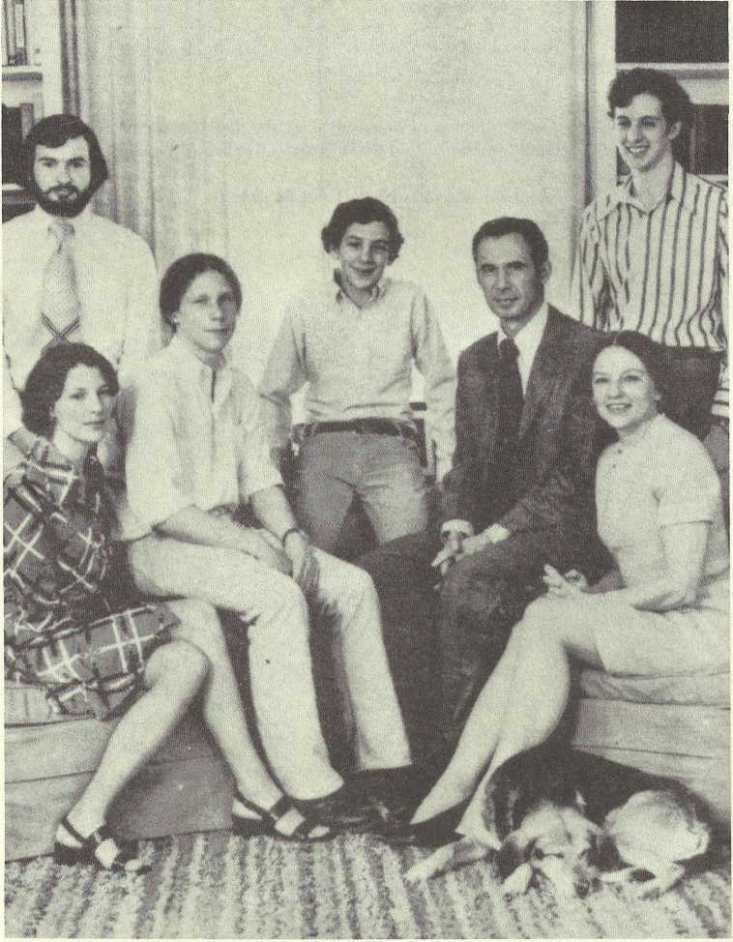

JUDITH CARY (14) BLAIR GREEN (Mrs. Joseph Norris Green) and family; she owns a portrait by Copley of her ancestor Judith Cary Bell; I. to r., standing: Gregory Malcom Hall (her son-in-law), James Montgomery Green (her son); seated: Virginia Mason Green Hall (wife of Gregory), Charles Alexander and Matthew Benjamin (her sons); Joseph Norris (her husband), and Judith Cary Blair Green, spring, 1974, at their home, Glendale, Ohio.

Cary Listings
The Virginia Carys are descendants of the Carys of Bristol, England, a family first mentioned in the“Doomsday Book”compiled in 1086 by order of William of Normandy, who conquered England in 1066. This book recorded the results of a complete survey of England, inventorying all acquisitions. It included every piece of land, its size, a description of the terrain, its value and, in many cases, whatever was on the land, including livestock. The original manuscript is now preserved at the Public Record Office in London. Even at that early date in history, the Carys (then spelled “Kari” and “Cari”) were landed gentry, with two manors - one in Devonshire and one in Somersetshire.

The first ancestor of record, William, served as sheriff and then as mayor of Bristol during the time of Henry VIII. The ‘‘Cary Appendix” which follows these listings, contains material about Henry VIII’s second wife,
Ann Boleyn, a cousin of the Carys, and mother of Elizabeth I.

William’s son, Richard, a draper, was a merchant and elder of the City of Bristol. Richard’s son, William, also a draper, followed in the footsteps of his grandfather, serving as sheriff and then mayor of Bristol. His son, John, a draper, married Alice Hobson, daughter of a Bristol mayor. Their son, Miles, was the original emigrant to Virginia.

Miles was born in 1622 in Bristol and emigrated to Windmill Point, Warwick County, Virginia, between 1640 and 1645. He married, not later than 1646, Anne Taylor, whose father, Thomas Taylor, owned large tracts of land in that area. Miles and Anne inherited her father’s holdings, which included a plantation known as ‘‘the Forest". He died in Warwick County, Virginia, in 1667.

Miles’ son, Henry, was a Master Builder, responsible for design and construction of many of the large public buildings of Colonial Williamsburg. In 1939, when the CARY-ESTES GENEALOGY was published, there were no identifiable traces of Henry Cary’s buildings. Since then. Colonial Williamsburg has been largely restored and we can now visit and browse about in the beautiful historic edifices which our ancestor Henry Cary built. The outstanding examples of his work are the Governor’s Palace and the First Capitol. He was also responsible for rebuilding William and Mary College after the fire in 1705. Details on all his buildings are in the “Cary Appendix” which follows these listings. Henry married Judith Lockey by May 24, 1671. He died in 1720.

Henry Cary, Jr., son of Henry and Judith, was born around 1675.
One of the earliest graduates of William and Mary College, he carried on his father’s contracting business. Much of his work was still standing in 1939 and has been restored and preserved by the Colonial Williamsburg Foundation. His descendants the Bells, Randolphs, Pages, and Harrisons, lived in Cumberland and Buckinham Counties on his land holdings for many years.

Judith Cary, daughter of Henry, Jr. and his second wife, Anne Edwards, married David Bell (captain in the French and Indian War). This lovely lady had her portrait painted by Copley. Judith and David Bell’s daughter, Elizabeth Cary Bell, born about 1758 in Chesterfield County, married Daniel Bates. (The CARY-ESTES GENEALOGY gives a brief history of the Bates Family on pp. 69-75). Elizabeth died in Kentucky in 1825. Sarah Langhorne Bates, daughter of Elizabeth and her husband Daniel, married Captain Joel Estes on Oct. 13, 1801. This marriage links the Carys of Bristol, England and Colonial Virginia to our branch of the Estes family. Sarah and Joel migrated to Haywood County, Tennessee in 1823, and some of their descendants have lived on and farmed the same land ever since.

Several of Judith Cary Bell’s children, in addition to Elizabeth, Sarah’s mother, were listed in the CARY ESTES GENEALOGY on pp. 58-68.
New information was available on the descendants of Judith Cary Bell’s namesake, called here “Judith Cary Bell, II”. She married Colonel Nathaniel Gist of Virginia, who served in the Revolutionary War. Partial listings were received from another line of Miles Cary descendants ; their incomplete listings are included in the “Cary Family Appendix. ”

John (4) Cary md. Alice Hobson. Children: vi Henry; vii Matth ew; viii Richard; ix Miles; x Alice; xi Honor; xii Mary.

ix Miles (or Myles) (5) Cary, the original immigrant from Bristol, England, b. 1622; d. 1667, Windmill Pt., Warwick Co., Va.; md. (not later than 1646), Va., Anne Taylor, b. 1621; d. 1685, Va. Children: 1 Thomas; 2 Anne; 3 Henry; 4 Bridgett; 5 Elizabeth; 6 Miles; 7 William.

3 Henry (6) Cary, b. ca. 1650; d. 1720; Master Builder of Williamsburg; md. by 24 May 1671, Judith Lockey. Children: i Judith; ii Anne; iii Henry, Jr.; iv Elizabeth; v Miles.

iii Henry (7) Cary, Jr., b. ca. 1675; d. 1749; carried on father’s contracting business; md. (1) ca. 1710, Sarah Sclater, b. ca. 1695; d. before 1719. Children:
Mary; 2 Doyley; 3 Henry, III.

Henry (7) Cary, Jr., md. (2) Anne Edwards, b. —; d. ca. 1740. Children: 4 Anne; 5 Archibald; 6 Judith; 7 Sarah.

6 Judith (8) Cary, b. 12 Aug. 1726, Henrico Co., Va.; d. 16 Apr. 1798, Lynchburg, and is buried there; md. 1744, Henrico Co, David Bell, b. ca.
1716; d. 8 Nov. 1806. Children: i Henry Cary; ii Judith Cary, II; iii Sarah; iv Elizabeth Cary.

ii Judith Cary (9) Bell, II; b. 1750; d. 1833; md. Col. Nathaniel Gist of Va.; Rev. War officer; son of Christopher Gist of Md.; had large land grants after war for worthy service; moved to Ky. Children: 1 Henry Cary; 2 Thomas Cecil;
Sarah Howard; 4 Ann; 5 a daughter; 6 Elizabeth Violet.

6 Elizabeth Violet (10) Gist, b. 1793; d. 1876; md. (1) 22 July 1812, Francis Preston Blair, b. 12 Sept. 1791, Abington, Va.; d. 18 Oct. 1876. Children: i Montgomery; ii Juliet; iii Elizabeth; iv James; v Francis Preston, Jr.

i Montgomery (11) Blair, b. 10 May 1813, Frankfort, Ky.; d. 27 July 1883, Silver Spring, Md.; md. (1) Caroline Buckner; d. 11 Jan. 1844. Children: 1 Lucy; 2 Elizabeth; 3 Caroline; 4 Minna.

Montgomery (11) Blair md. (2) Mary Elizabeth Woodbury, b. 22 Aug. 1821, Portsmouth, N.H.; d. 27 Jan. 1887, Wash., D.C. Children: 5 Woodbury; 6 Montgomery; 7 Maria; 8 Gist.

Children of Montgomery (11) Blair and Caroline Buckner:
1 Lucy (12) Blair, b. 16 Apr. 1839; d. 12 Aug. 184
2 Elizabeth (12) Blair, b. 25 Apr. 1841; md. C.M. Comstock.
3 Caroline (12) Blair, b. and d. same day, 11 Jan. 1844.
4 Minna (12) Blair, b. 28 May, 1850; d. 12 Sept. 1919; md. Dr. Stephen O. Richey.

Children of Montgomery (11) Blair and Mary Elizabeth Woodbury:
5 Woodbury (12) Blair, b. 1 Sept. 1852; md. Emily Neville Wallach.
Montgomery (12) Blair, b. 14 Mar. 1855, Wash., D.C.; d. 28 Apr. 1944, Wash., D.C.; md. 26 Feb. 1895, Edith Draper, b. 18 Feb. 1874, Hopedale,
Mass.; d. 7 Nov. 1939, Mt. Kisco, N.Y. Children: i Edith; ii Minna; iii
6 Montgomery, Jr.; iv Virginia; v William Draper; vi Ellen; vii Charles Woodbury.

i Edith (13) Blair, b. 6 Sept. 1896, Wash., D.C.; md. 28 July 1917, Silver Spring, Md., Adolphus Staton; b. 28 Aug. 1879, Tarboro, N.C.; grad. USNA, 1902; naval officer; was Rear Admiral at retirement. Child: 1 Lucy.

1 Lucy (14) Blair, b. 6 Mar. 1928, Wash., D.C.; d. May 1973; bur. in Mt. Auburn Cemetery, Cambridge, Mass.

ii Minna (13) Blair, Englewood, Fla., b. 20 Nov. 1897, Wash., D.C.; d. 1975; md. Richard Carmichael Hollyday. Children: 1 Edith Draper; 2 Minna Blair;
3 Richard C., Jr.; 4 James.

1 Edith Draper (14) Hollyday, Takoma Park, Md., md. Louis Kirkland. Children: i and ii, twins, Blair and Lucy; iii Louise Richardson, “Riki”; iv Edith Hollyday, “Holly”; v Catherine, “Kitty”. This marriage ended in divorce. Edith resumed her maiden name.
2 Minna Blair (14) Hollyday, “Blair”, San Pedro, Calif., b. 1925, N.Y. City; md. Arthur Gray. Children: two boys and a girl.
3 Richard Carmichale (14) Hollyday, Jr., Wilton, Conn., md. Jane —. Children: i girl (name unknown); ii Richard J.
4 James (14) Hollyday, New Canaan, Conn., md. Carol. Children: seven (names unknown).

6 Montgomery (13) Blair, Jr., b. 9 Nov. 1898, Wash., D.C.; d. 28 Nov. 1974, Wash., D.C.; md. 9 Feb. 1929, Augusta Virginia Mason, b. 24 July 1905, Wash., D.C. Children: 1 Beatrice; 2 Judith Cary; 3 Elizabeth Woodbury; 4 Edith Draper.

1 Beatrice (14) Blair, The Rev., New York, N.Y.
2 Judith Cary (14) Blair, Glendale, Ohio, b. 30 Oct. 1931, Wash., D.C.; social work; agency director; md. July 1950, Elkton, Md., Joseph Norris Green, b. 12 Sept. 1928, Princeton, N.J.; grad. Princeton Univ., class of 1950; marketing mgr., Drackett Co. Children: i Virginia Mason; ii James Montgomery; iii Charles Alexander; iv Matthew Benjamin.

i Virginia Mason (15) Green, Baltimore, Md., b. 16 Apr. 1951, Cincinnati, Hamilton Co., Ohio; md. 22 June 1973, Gregory Malcolm Hall; a medical doctor.
ii James Montgomery (15) Green, Chicago, Ill., b. 16 July 1953, Cincinnati; Research Asst, and Ph.D. candidate, Dept. of Physics, Univ. of Chicago.
iii Charles Alexander (15) Green, b. 15 Apr. 1956, Cincinnati; college student.
iv Matthew Benjamin (15) Green, b. 8 Sept., 1958, Cincinnati; college student.
Elizabeth Woodbury (14) Blair, b. 28 Aug. 1937, Wash., D.C.; md. (1) 8 Sept. 1956, Wash., D.C., Thomas N. Tveter, b. 14 Sept. 1932, Mt. Vernon, N.Y.; d. 20 June 1974; was rancher. Child: 1 Blair Lee.

Elizabeth Woodbury (14) Blair md. (2) 28 Feb. 1975, Idaho Falls, Ida., Victor Douglas, b. 28 Nov. 1927, Great Falls, Mont.; logger, farmer; there are six Douglas stepchildren living at home.

Child of Elizabeth Woodbury (14) Blair and Thomas N. Tveter:
1 Blair Lee (15) Tveter, b. 19 Nov. 1960, Minn., Minn.

4 Edith Draper (14) Blair, b. 4 June 1940, Wash., D.C.; Asst. Mgr., Blair House (Protocol Officer, State Dept.)

iv Virginia Draper (13) Blair, b. 21 Dec., 1899, Wash., D.C.; md. 1925, Robert Clymer Brooke, b. 1898, Birdsboro, Pa. Children: 1 Virginia; 2 Robert.

1 Virginia Blair (14) Brooke, b. 1927, Bryn Mawr, Pa., md. Ramsey Pennypacker. There are two adopted children.
2 Robert Clymer (14) Brooke, Jr., Denver Colo., b. 1929, East Hampton, N.Y.; geologist; md. —; Children: two boys and one girl.

x William Draper (13) Blair, Wash., D.C., b. 13 Dec. 1902; md. Mary Eula Mason. Child: 1 William Draper, Jr.

1 William Draper (14) Blair, Jr., Chevy Chase, Md.; Deputy Asst. Sec’y for Public Relations, U.S. State Dept.; md. Jane Coleman. Children: i Jenny; ii Elizabeth.

vi Ellen Woodbury (13) Blair, b. 1905, Wash., D.C.; d. 1965; md. 1925, Benjamin Lowndes (14) Jackson; realtor. Children: 1 Ellen; 2 Benjamin Lowndes, III.

1 Ellen (14) Jackson, N.H., b. Wash., D.C.; md. — Daniels.
2 Benjamin Lowndes (14) Jackson, III, b. 1927, Wash., D.C.; md. Jillaine, “Jill” Ginsdorf. Children: i Benjamin Lowndes, IV; ii Samuel Morse; iii Bladen.

i Benjamin Lowndes (15) Jackson, IV was killed in a car accident.

vii Charles Woodbury (13) Blair, md. Rose —. Child: 1 Charles Woodbury, Jr.

1 Charles Woodbury (14) Blair, Jr., md. Children: two girls and three boys.

Elizabeth Violet (10) Gist md. Francis Preston Blair. We continue with the listings of their second child, Juliet:
ii Juliet (11) Blair, b. 22 Feb. 1816; d. 30 Oct. 1819. Elizabeth (11) Blair, b. 20 June 1818, Lexington, Ky.; d. 24 Dec. 1903, Wash., D.C.; md. 27 Apr. 1843, Samuel Phillips Lee, son of Francis Lightfoot and Jane Lee of Va.; b. 13 Feb. 1812; d. 1897; was Adm. in Civil War, U.S.N.; family lived in Silver Spring, Md. Child: 1 Blair.

1 Blair (12) Lee, b. 9 Aug. 1857, Silver Spring, Md.; d. 25 Dec. 1944, Sandy Spring, Md.; A.B. Princeton, 1880, A.M. 1883; LL.B., Columbian (now George Washington U.), 1882, LL.M., 1883;Md. state senator 1905-13; U.S. Senator 1913- 17; Pres. Soc. Lees of Va.; Member (Va.) Soc. of the Cincinnati; md. 1 October 1891, Birdsboro, Pa., Anne Clymer Brooke, dau. of Edward Brooke of Birdsboro, Pa., b. 28 Mar. 1870, Birdsboro, Pa.; d. 24 Dec. 1903. Children: i E. Brooke; ii Phillips Blair.

i E. Brooke (13) Lee, B. 23 Oct. 1892; attended Princeton Univ.; Law Degree from George Wash. Univ.; Major 115th Inf., 29th Div., AEF, 1917-1919, WWI; Distinguished Service Cross; Croix de Guerre (France); Order of Leopold (Belgium); later Lt. Col. Md. Nat’l Guard; then State Comptroller; on State Planning Commission; Md. Sec’y of State and Speaker of House of Delegates; md. 13 Apr. 1914, Elizabeth Wilson. Children: 1 Francis Preston Blair, III;
2 Edward Brooke, Jr.; 3 Elizabeth Somerville.

E. Brooke (13) Lee md. (2) 1935, Mrs. Thelma Llewellyn Lawson Crawford; md. (3) Mrs. Nina G. Poole.

Children of E. Brooke (13) Lee and Elizabeth Wilson:
1 Francis Preston Blair (14) Lee, III, “Blair Lee”, b. 19 May 1916, Silver Spring, Md.; B.A. Princeton, 1938; Editor Md. News, 1945-49; member Md. Nat. Cap. Park and Planning Commn., 1949-54; member Md. House of Delegates 1954-62; on State Planning Commn.; member of Md. Senate 1966-69; sec’y of state 1969-70; Md. Lt. Gov. 1970; acting Governor during Mandell legal case; on Bd. of Trade, Silver Spring, Md., Pres. 1948-19; delegate to Dem. Nat’l Conv. 1948, 1960, 1964, 1972, 1976; md. 6 July 1944, Mimi Boal. Children: i Blair Lee, IV;
Pierre Boal; iii Joseph Wilson; iv Christopher; v Frederick Brooke; vi Philip Ludwell.
2 Edward Brooke (14) Lee, Jr., Phila., Pa., b. 25 Oct. 1917; grad. Princeton Univ.; Lt. U.S. Army, Airborne, WW II; md. 15 April 1944, Camilla Edge. Children: i Camilla Edge; ii Edward Brooke, III; iii Kaiulani Sewall; iv Katherine Blair; v Richard Henry.
3 Elizabeth Somerville (14) Lee, b. 15 June 1923; md. 1 Aug. 1942, David Scull. Children: i David Lee; ii Elizabeth Blair.

ii Phillips Blair (13) Lee, Phila., Pa., b. 27 Dec. 1895, Wash.,
D.C.; grad. Princton Univ.; steel foundry business, Birdsboro, Pa.; realtor, Silver Spring, Md.; banker, Phila., Pa.; Capt. Inf. U.S. Army, 317th Inf., 80th Div. A.E.F. 1917- 19; Purple Heart; md. 24 Apr. 1926, Elizabeth Bucknor Wayne. Children: 1 Anne Brooke; 2 Laura Wayne; 3 J. Wayne.

1 Anne Brooke (14) Lee, b. 18 Feb. 1927, Wash., D.C.; grad. Univ. of Penna.; md. 24 June 1949, Robert A. Reath. Children: i Robert Andrews; ii David Brooke; iii Elizabeth Wayne; iv Nancy Lee; v Susan Blair.

i Robert Andrews (14) Reath, “Andrews”, b. 13 June 1951, Phila., Pa.
ii David Brooke (14) Reath, b. 18 Mar. 1953, Phila., Pa.; md. Aug. 1976, Wendy Hitt.
iii Elizabeth Wayne (14) Reath, b. 11 June 1955, Phila., Pa.
iv Nancy Lee (14) Reath, b. 24 June 1960, Phila., Pa.
v Susan Blair (14) Reath, b. 24 June 1960, Phila., Pa.

2 Laura Wayne (14) Lee, b. 18 Feb. 1927, Wash., D.C.; md. 18 June 1948, Paul Thompson, II. Children: i Paul, III; ii Laura Lee; iii Blair Lee.

i Paul (15) Thompson, III, “Timmy”, b. 16 May 1949, Phila., Pa.
ii Laura Lee (15) Thompson, b. 13 Feb. 1951, Phila., Pa.
iii Blair Lee (15) Thompson, b. 30 July 1952, Phila., Pa.

3 J. Wayne (14) Lee, b. 28 Mar. 1932, Chestnut Hill Hosp., Phila., Pa.; grad. Univ. of Penna. 1956; 2nd Lt. U.S.A.R.; md. 28 Dec. 1957, Anne Willing Dulany. Children: i Anne Willing; ii Joseph Wayne, Jr.; iii Henry Rozier.
i Anne Willing (15) Lee, b. 6 Aug. 1957, Damascus, Md.
ii Joseph Wayne (15) Lee, Jr., b. 14 Dec. 1962, Phila., Pa.
iii Henry Rozier (15) Lee, b. 3 May 1966, Phila., Pa.

ELIZABETH VIOLET (10) Gist md. Francis Preston Blair. We continue with the listings of their 4th child, James.
iv James (11) Blair, b. 7 Oct. 1819; d. 15 Dec. 1852, San Francisco, Calif.; was Lt. in Navy; practiced law in St. Louis, Mo. with brother, Montgomery; md. 14 Jan. 1846, Mary Serena Eliza Jessup, b. 1827, dau. of Gen. Sydney Jessup; lived at “Moorings” in Silver Spring. Children: 1 Ann Jessup; 2 Violet; 3 Jessup; 4 Lucy.

1 Ann Jessup (12) Blair, b. 10 Dec. 1846; d. 18 Mar. 1847.
2 Violet (12) Blair, b. Aug. 1848; d. 1933; President of the National Soc. of the Colonial Dames of America in D.C. 1914-1933.
3 Jessup (12) Blair, b. 13 Feb. 1853; d. 1 Apr. 1902; unmd.
4 Lucy (12) Blair, b. 26 Dec. 1855; d. 4 Feb. 1902; md. Major George M. Wheeler of the U.S. Army.

v Francis Preston (11) Blair, Jr., b. 19 Feb. 1821, Lexington, Ky.; d. 9 July 1875, St. Louis, Mo.; md. 8 Sept. 1847, Woodford Co., Ky., Apolline Alexander. Children: 1 Andrew Alexander; 2 Christine Biddle; 3 Janies Lawrence; 4 Francis Preston; 5 George Madison; 6 Cary Montgomery; 7 Caroline Martin; 8 William Alexander.

1 Andrew Alexander (12) Blair, b. 20 Sent. 1848: d. Jan. 1932; md. 1871, Anna S. Biddle. Child: adopted Frank P., son of his brother, Cary Montgomery.
2 Christine Biddle (12) Blair, b. 5 Apr. 1852, md. 1884, Benjamin B. Graham. Child: i Christine.
3 James Lawrence (12) Blair, b. 2 Apr. 1854; d. 16 Jan. 1904; md. 1883, Apolline M. Alexander, b. 1860. Children: i Perry A.; ii Francis P.
i Perry A. (13) Blair, b. 1883.
ii Francis P. (13) Blair, b. 1888.

4 Francis Preston (12) Blair, b. 18 Oct. 1856; md. 1882, Florence Price, b. 1861. Child: i Emily Hockaday.

i Emily Hockaday (13) Blair, b. 1885.

5 George Madison (12) Blair, b. 18 Apr. 1860; d. 1881.
6 Cary Montgomery (12) Blair, b. 3 Mar. 1868; md. 1890, Emily Johnson. Child: 1 Frank P. Blair (adopted by Cary’s brother Andrew).
7 Caroline Martin (12) Blair, b. 22 Aug. 1870; d. 1876.
8 William Alexander (12) Blair, b. 8 June 1872; d. 1893.

CARY FAMILY LISTINGS APPENDIX
Mrs. Miles Cary, Sr. (Virginia Bernard Graves Cary), of Richmond, Va., supplied the following information on her sons, Miles Cary, Jr. and Charles Graves Cary, direct descendants of Miles (5) Cary, the original immigrant,
through his son Miles (6) Cary. She herself is a Miles (5) Cary descendant through his daughter Bridgett (6). Not enough data was provided to trace these lines back to Miles (5) so they could appear in their chronological places in the listings.

Alfred Shields Cary md. Stuart Bradley. Child: (only one known)
Miles Cary.

i Miles Cary, b. 26 Feb. 1903, Richmond, Va., d. 30 Oct. 1976,
Richmond, Va.; md. Virginia Bernard Graves. Children: 1 Miles, Jr.; 2 Charles Graves.

1 Miles Cary, Jr., b. 13 May 1933, Richmond, Va.; attorney; md. 15 Aug. 1959, Scarsdale, N.Y., Ann Baum, b. 20 Mar. 1935. Children: i Virginia Holmes; ii Miles Cary, III.

i Virginia Holmes Cary, b. 19 Mar. 1961, Richmond.
ii Miles Cary, III, b. 4 July 1967, Richmond.

2 Charles Graves Cary, b. 10 Oct. 1935, Richmond, Va.; Sr. Vice- President, Bank of Virginia; md. 16 Feb. 1963, Richmond, Elizabeth Hotchkiss, b. 4 Sept. 1938, Richmond. Children: i Stuart Bradley; 2 Elizabeth Taylor.

i Stuart Bradley Cary, b. 6 July 1966, Richmond.
ii Elizabeth Taylor Cary.

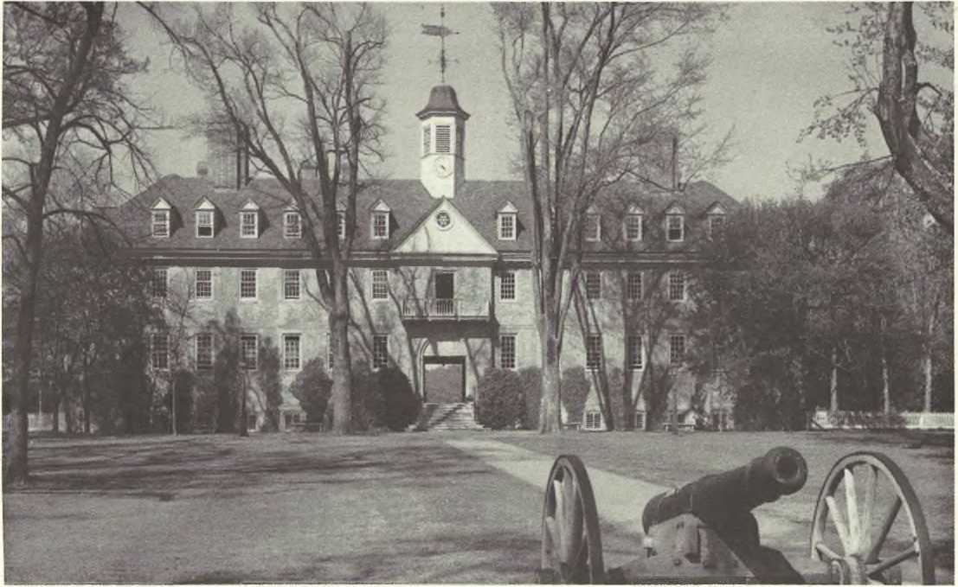

SIR CHRISTOPHER WREN BUILDING, campus of William and Mary College, Williamsburg, Va.; built by Henry Cary, Sr., in 1695; the oldest academic building in continuous use in the U.S. (Photo by Thomas L. Williams, Williamsburg, Va.; courtesy of the Earl Gregg Swem Library of William and Mary College.)

Cary History and Legends

THE CARY FAMILY IN ENGLAND

The Cary family has been documented back to 1086, when two of their homes were listed in the “Doomsday Book. ” This book was compiled by edict of William of Normandy to take stock of his booty after he conquered England.

The Bristol Carys, from whom our branch of American Carys are descended, have been decreed by the Royal College of Heralds to be the same as the Devonshire Carys and are privileged to bear the Cary coat-of-arms.
The first Cary to whom we can directly and without interruption trace our descent is William (1) Cary of Bristol, born in 1500 (some sources give 1492).

Queen Elizabeth I was very close to her Cary cousins from Devonshire. These were the children of her mother’s sister, Mary Boley n, wife of William Cary (a different William, not our direct ancestor) of Devonshire. Her affection for them was strong enough to prompt her to order the Royal College of Heralds to record the Cary Pedigree, showing their connections with the “noble houses of Beaufort, Somerset, Spencer, Bryan, Tulford and so forth. ” There is a hiatus between these Devonshire Carys and our Bristol Cary ancestors. Future research may turn up the missing ancestors.

When the CARY-ESTES GENEALOGY was published, in 1939, there were three Cary lines still existing in England: (1) Falkland;
(2) Cockingham and Torre Abbey; and (3) Somersetshire. Sir Robert Archibald Cary, Viscount Falkland, Lord Cary, of Cornwall, (member of the House of Lords), sent his genealogical chart and his and his son’s listings from BURKE’S PEERAGE AND BARONETAGE.

Burke’s Peerage, Ltd., London, England, reports on the other two Cary lines (the Cockingham and Torre Abbey and the Somersetshire) in their letter to us dated 29 May 1980, “As far as our research can tell, both the Cary lines you inquired about are still extinct. ” (signed)
Felicity Mortimer.

From THE COMPLETE PEERAGE, 1926, pp. 139-145:

FALKLAND
Vicountcy
I. HENRY CAREY (c. 1575-1633), son and heir of Sir
I. 1620
Edward Carey, of Aldenham and Berkhampstead, Herts... at Newmarket, 14 Nov. 1620, cr. VISCOUNT OF FALKLAND and LORD CARYE (S.) to him and his heirs male bearing the name of Carye, which was confirmed by a pat. of naturalization, 18 Sept. 1627, as if he and they had been natives of Scotland. He, though a Scots peer, was Member of Parliament for Herts 1620-22.
LORD DEPUTY OF IRELAND, 1622-29.
II. 1633 | 2. LUCIUS (CAREY), VISCOUNT OF FALKLAND, son and heir (1610-1643).
III. 1643 | 3. LUCIUS (CAREY), VISCOUNT OF FALKLAND, son and heir (1632-1649).
IV.1649 | 4. HENRY (CAREY), VISCOUNT OF FALKLAND, brother and heir (1634-1663).
V. 1663 | 5. ANTHONY (CAREY), VISCOUNT OF FALKLAND, only son and heir (1656-1694).
VI. 1694 | 6. LUCIUS HENRY (CARY), VISCOUNT OF FALKLAND,  2nd cousin and heir, being only son and heir of Edward  Cary, of Caldicot Co. Monmouth... (1687-1730).
VII. 1730 | 7. LUCIUS CHARLES (CARY), VISCOUNT OF FALKLAND, son and heir (c. 1707-1785).
VIII. 1785 | LUCIUS FERDINAND CARY, MASTER OF FALKLAND, only son and heir (7--1780).  8. HENRY THOMAS (CARY), VISCOUNT OF FALKLAND, grandson and heir, being son and heir of the Hon. Lucius Ferdinand Cary, Master of Falkland,(1766-1796).
IX. 1796 | 9. CHARLES JOHN (CARY), VISCOUNT OF FALKLAND, only brother and heir (1768-1809).
X. 1809 | 10. LUCIUS BENTINCK (CARY), VISCOUNT OF FALKLAND, son and heir (1803-1884).  LUCIUS WILLIAM CHARLES AUGUSTUS FREDERICK (CARY), MASTER OF FALKLAND (1831-1871).
XI. 1884 | 11. PLANTAGENET PIERREPOINT (CARY), VISCOUNT OF FALKLAND, brother and heir (1806-1886).

XII. 1886 12. BYRON PLANTAGENET (CARY), VISCOUNT OF FALK
LAND and LORD CARYE, nephew and heir, being son and heir of Capt. the Hon. Byron Charles Ferdinand Plantagenet Cary (1845- )

LUCIUS PLANTAGENET CARY, 1st son and heir ap. (1880- ).

FAMILY ESTATES - These, in 1883, consisted of 3,011 acres, Co. York, worth 4 4,461 a year. Scutterskelfe, near Yarm, Co. York, the family seat, and the Yorkshire estates were sold by the 12th Viscount about 1900.

The present Viscount of Falkland, Sir Robert Archibald Cary is the thirteenth of the line. His biographical sketch and that of his son, from BURKE’S PEERAGE AND BARONETAGE, 1975, follow:

SIR ROBERT ARCH I BALD CARY, 1st Bt., of Withington, Co. Lancaster,
Pari. Priv. Sec. to Civil Lord of the Admiralty 1939-42 and to Sec. of State for India and Burma 1942-45, Asst. Gov. Whip 1944-45, a Junior Lord of the Treasury May-July, 1945, Pari. Priv. Sec. to Lord Privy Seal and Leader of the House of Commons 1951-55, M.P. for Eccles, Nob. 1935-June 1945, and for Withington Div. of Manchester from Oct. 1951, served in World War I 1916-18, with 4th Dragoon Guards, and in World War II 1939-45 with Royal Dragoon Guards, Chm. Lancashire United Transport Ltd., Chm. J. Compton Sons and Webb Ltd., cr. Kt. Bach. 1945 and Baronet 12 June 1955 b. 25 May 1898, educ. Ardingly, and R.M.C. Sandhurst, m. 30 April 1924, Hon. Rosamond Mary, yr. dau. of late Col. Hon. Alfred Nathaniel Curzon (see SCARSDALE V.), by his wife Henrietta Mary, dau. of Hon. Spencer Dudley Montagu, 4th son of 4th Baron Rokeby (see 1883 Edn.) and has issue,

ROGER HUGH, Producer, Overseas Services, B.B.C. 1951-56, Talks-Writer, European Services, B.B.C. 1956-58. Dep. Editor THE LISTENER 1958-61, Management Training Organizer, B.B.C. 1961-66, Assist. Secretariat B.B.C. from 1966. Lieut. Gren. Guards (Res.), Salzburg Scholar in American Studies 1956, Assoc. Royal Hist. Soc.(23 Bath Road, Chiswick, W 4; Carlton and Pratt's Clubs, b. 8 Jan. 1926, Eton and New Coll. Oxford (B.A. 1949).

THE CARY FAMILY IN AMERICA
The American Carys who settled in Virginia brought the tradition of their British heritage with them. The tombstone of our original immigrant ancestor, Miles Cary, which is still extant at Windmill Point in Warwick County, Virginia, bears the Cary Coat-of-Arms.

Much data supplementary to that in the CARY-ESTES GENEALOGY has been accumulated in our research of the early Virginia Carys and their descendants. We chose several items here as samples of their contributions to America, something of how they lived, and what kind of people they were.

The first item in this section is from a genealogy book, listing the Carys among those early Virginia settlers who had vested rights to use coats-of-arms.

The proof that the original Miles Cary owned a building in Old Jamestown is excerpted from a book published by the National Park Service, Washington, D.C.

A newspaper article from the Baltimore SUN tells about Miles Cary’s tombstone and the Cary Coat-of-Arms.

Miles’ son and grandson, Henry Cary, Sr., and Jr., were prominent citizens and builders of Williamsburg, Va. Henry Cary’s public buildings have been completely restored since publication of the CAR Y-ESTES GENEAL- OG Y (1939) and much has been written about these Cary builders and their work. They were the most outstanding of our colonial Cary ancestors.

Also included here is a request for help in having the United States Postal Service issue a stamp commemorating Henry Cary, Sr., “Master Builder” of Colonial Williamsburg.

An excerpt from an architectural book published bv Colonial Williamsburg documents Henry Cary’s building of the Capitol.
Two other items deal with Henry Cary’s building of the Governor’s Palace (a jewel among the Colonial Williamsburg buildings) and the Gaol (jail house).

To indicate typical obligations of an 18th century construction work, we include a specimen of an indenture contract between an apprentice and his master.

Henry (3) Cary, Jr. built several large homes in Colonial Virginia, and two, “Ampthill” and “Wilton” are still standing, beautifully restored, in Richmond, on the James River. “Ampthill” is privately owned. “Wilton ” is the Virginia Headquarters of the National Society of Colonial Dames of America. We report on a visit to these two landmarks.

The President’s House at William and Mary College was built by Henry Cary, Jr., and an item from the College library files tells an interesting architectural fact about the building.

A book on early eighteenth century Virginia houses, also published by Colonial Williamsburg, tells that the Brush-Everard House was lived in by Henry Cary, Jr.

A newspaper article tells about Archibald Cary (brother of Estes ancestor Judith), a strong, flamboyant, colonial patriot. Several sources state that, without his financial support the Revolutionary War would have failed.
Four items deal with “Bellmont", home of Judith Cary and David Bell. It is still standing, restored, in Buckingham County, Virginia.

Judith Cary Bell, the lady of “Bellmont”, had her portrait painted by Copley. It was hanging in Blair House, Washington, D.C., when the CAR Y-ESTES GENEALOG Y was published in 1939. A Cary descendant, Major Gist Blair was the owner of the House and the painting at that time. We learned where the painting is today and tell how its whereabouts was discovered.

There was a romance between a Virginia Cary lady and George Washington. The writer quoted here thinks the outcome of Washington’s proposal of marriage to her might have changed the course of United States history. We include it here as an interesting and romantic tale
about a Cary lady from a collateral line.

Two Cary documents are included here which are important to proof of direct descendancy from Miles Cary. These are needed for those wishing to join patriotic societies requiring that one have an ancestor who was a prominent citizen and high official in America before 1700.

The Blair family of Washington, D.C. and Silver Spring, Maryland, are descendants of the Carys. They share with us common ancestors Judith Cary Bell and her husband, David. Many Blairs have played prominent roles in American history, and one of their family homes, Blair House, is the guest house of the President of the United States. Excerpts from a history book written for children tell some stories and legends about the Blairs of Washington and Maryland.

THE CARY FAMILY IN VIRGINIA
The Virginia Carys are among the early distinguished families which inhabited the Peninsula between the James and York Rivers, and are highly praised in numerous historical accounts. Several of these accounts are quoted in the CARY-ESTES GENEALOGY. Another is included here to let Cary descendants know that they have inherited this much-heralded blood, and to remind us all to strive to live up to and be worthy of it.

The following passage is from VIRGINIA GENEALOGIES by Rev. Horace Edwin Hayden, M.A., p. xiii:

Whilst I heartily endorse the just sentiment of the poet-laureate:
'Tis only noble to be good!
Kind hearts are more
Than coronets
And simple faith than
Norman Blood!

yet it is true that according to one test there is more evidence preserved of gentle lineage in Virginia than in any other of the original American colonies. The list of families in the colony who invested right used coat-armor, as attested in examples of such use on tombstones, preserved bookplates, and impressions of seals is more than 150. The virtue of such family investment by royal favor may appear somewhat in the fact that the Virginia rebels Claiborne, Bacon, Washington and Lee, were all armigers, and among others were the Amblers, Archers, Armisteads, Banisters, Barradalls, Beverleys, Blands, Bollings, Byrds, CARYS, Carringtons, Cloptons, Claytons, Corbins. . . .

MILES (5) CARY
Miles, the original Cary immigrant, jointly owned the “old State House” in Jamestown, Va., and its adjoining buildings. When he acquired it, it was in ruins. There is a picture of the block restored in TYLER’S CRADLE OF THE REPUBLIC, p. 167.

The following item documents Miles Cary’s ownership of this structure.
It comes from ARCHEOLOGICAL EXCAVATIONS AT JAMESTOWN,
VA, by John L. Cotter, Archeological Research Series, Number Four,
National Park Service, U.S. Dept. of the Interior, Washington, D.C.,
1958:

The VIRGINIA MAGAZINE OF HISTORY AND BIOGRAPHY (Gregory 1935) July 1935 quotes data on Ownership. It gives the owners of the western section of the actual First Statehouse group of three houses as Richard Bennett from William Berkeley, March 30, 1655; Theoderic Bland, son-in-law of Bennett and Speaker of the Assembly; Berkeley (again); Henry Randolph; Thomas Ludwell and Thomas Stegg, before January 1, 1667. For the middle and eastern sections: The colony from John Harvey, April 7, 1641; Thomas Woodhouse, ordinary Keeper, October 17, 1655; Anne Talbot, September 1, 1657; George Marable, February 25, 1663; Henry Randolph of Henrico; Nathaniel Bacon and the Executors of Miles Cary (Middle Structure); and Thomas Swann of Surrey (eastern structure; April 7, 1671. .. .

THE TOMBSTONE OF MILES (5) CARY
Miles Cary’s tombstone has been restored since the writing of the
following article. There is a photo of the ceremony celebrating its
restoration opposite p. 36 of the CARY-ESTES GENEALOGY.
\
From the column “Virginia Heraldry” by Jane Griffith Keys,
the Baltimore SUN, Nov. 25, 1906:

...Col. Miles Cary, the immigrant and founder of the Carys in Virginia, has on his tombstone an inscription which gives the name of his father, mother and maternal grandfather. The ancestry of this branch of the ancient family of Cary has been derived from a pedigree registered in 1699 in Heralds College, London, by John Cary, of Bristol, England, gentleman, and his brother, Richard Cary, Alderman, of London ...

With the pedigree are filed copies of wills, etc., proving it. A confirmation of arms was duly granted in 1699, setting forth that the branch of the family seated at Bristol had "time out of mind" borne the arms of the Cary family of Devonshire, vis, argent, on a bend, sable; three roses argent, with a silver swan for their crest. This coat-of-arms is carved on the tombstone of Col. Miles Cary, the immigrant.
Thus the three lovely roses of France, which had their birth in Arragon and were carried to England by the Knight of Arragon, have for the last 300 years lent their bloom and sweetness to old Virginia.

HENRY (6) CARY
Miles’ son, Henry Cary, Sr., Master Builder, contributed greatly to early Virginia history by constructing many of Williamsburg’s public buildings. And his son, Henry, Jr., followed in his father’s profession. The word “profession” is used because both are reported to have been “supervising architects” in several sources. One such source is THE PUBLIC BUILDINGS OF WILLIAMSBURG, AN ARCHITECTURAL HISTORY, published by Colonial Williamsburg in 1958. On page 40, Marcus Whiffen, the author, used this term for Henry Cary, Sr., with reference to his building of the first Capitol. Photos of several of their buildings appear elsewhere in this book.

Efforts are being made to honor this long-overlooked historical figure, Henry Cary, Sr., by a Commemorative Stamp, culminating with a Cary Family Reunion at Williamsburg on the Day of First Issue. Henry Cary’s descendants will be notified if and when the authorities of the U.S. Postal Service decide to single out Henry Cary for such an honor.

Your support would help convince them. Please write to: Jack Williams, Coordinator, Citizen’s Stamp Advisory Committee, Office of Stamps, U.S. Postal Service, Wash., D.C. 20260; or telephone (202)245-4000. Contacting your senators, congressman or other political figures would also help.

HENRY (6) CARY'S BUILDINGS
Henry Cary built the Court House of York Co., Va.; the Fort on the York River, Va.; and, in Williamsburg -- the Wren Building of William and Mary College, and reconstruction of the college after the fire there in 1705; the first Capitol; and the Governors Palace, started by him in 1706 and’finished by his son, Henry Cary, Jr., in 1723.

Colonial Williamsburg, Inc., gave permission to reprint here the following passaged from THE EIGHTEENTH-CENTURY HOUSE OF WILLIAMSBURG, by Marcus Whiffen, published by the Colonial Williamsburg Foundation:

THE CAPITOL p. 40. . . . it is not until November (1701) that we find the first mention of the eventual "overseer", which goes as follows:

A petition of Mr. Henry Cary to his Excllcy to be Imployed to Oversee the building of the Capitol and by his Excell refer’d to the Consideration of the Committee, being considered The next day being the 10th of the sd Instant Ober the Comtee desired the said Henry Cary to agree with any Capeable pson to make 500000 bricks for the Capitol at 18s. per M and at the same time promised to pay him for all Such Trouble as he should be at in makeing bargains for the Comtee as they directed according to the Merit of his Service. (From P.R.O., C.O. 5/1312, being The report of "the Committee Appointed to Inspect the Act directing the building of the Capitol &c. and to examine the proceedings of the Committee appointed by the said Act to oversee the building of it).

... his (Henry Cary's) home was The Forest, in Warwick County - the house has gone -- and in 1704 he owned a comfortable 670 acres (as against the 600 of his brother Miles) We first hear of him engaged in building works in 1697, when he built the first Courthouse at Yorktown and was paid for a platform at the fort there.

In England the term overseer. . . was rarely used in connection with building works. In the plantation it had of course a special meaning, but it was probably applied to x x x Cary as a translation, so to speak, of the term surveyor:

. ... It should be understood that Henry Cary was not the "undertaker" of the Capitol. His position was rather that of the modern supervising architect, with authority to enter into contracts on behalf of his client. At first, as the passage quoted above shows, he was on trial; in April 1701 he was given 50 pounds "for his particular attendance and service upon the business of the Capitol til that time." and in July that year he agreed with the building committee for a salary of 100 pounds perannum. Ibid. P.43

In 1703 Henry Cary Sent a report (signed by him) to England giving information on when the Court first sat in the new building:

That parte that the Corte sitts in is Compleatly finnished on the outside except the balcony over the Grate doore Comming in on the west side & the lower flower are finished for that the Corte sate there in Aprill last. (Op. cit. 5/1313)

P.46 As a rule the "finishing" of public buildings is an indeterminate affair, and the Capitol provides no exception. If one must have a date to answer August 8, 1701, when the foundation was laid, one might choose November 30, 1705; on that day the four master keys that had been in the keeping of Cary and others concerned with the work of construction were broken in the presence of the Speaker of the House of Burgesses. On December 5 Cary was officially discharged from the position of overseer. (Nevertheless he continued to be employed about the building from time to time during the period in which he was chiefly engaged on the Palace, carrying out some alterations of an unspecified nature as late as 1710.)

The following item, documenting that Henry Cary, Sr. built the Governor’s Palace in Williamsburg, comes from THE PUBLIC BUILDINGS OF WILLIAMS BURG, AN ARCHITECTURAL HISTORY. (Permission granted for reprint here).

THE PALACE p. 54-5 In his first message to the Assembly, in October 1705, (Governor) Nott told them that he was "by the Royal Command to Recommend Earnestly to you Gentlemen. . . the Building a house fit for the Reception of your Governor.". . . THE ACT OF 1702. . .

And be it further enacted. That Henry Cary be appointed, and he is hereby appointed an overseer to inspect, oversee, and provide for the building aforesaid, with full power to begin, carry on, and finish the same. . .

pp. 61, 65 The class of house to which it belonged was. . ."double pile."

Two rooms deep, compact and block-like, the double pile was fundamentally different from the houses of the older Elizabethan-Jacobean tradition. . . . Both as the first double pile in Virginia and as the official residence of the representative of the Crown, the Palace could scarcely fail to affect the subsequent development of architecture in the colony. . . .

...In 1720. . . November the Burgesses appointed a committee to ask the Governor what he thought should be done for "the finishing the Governours House Gardens and other works which he is Impowered by Law to finish."

. ... So three of the Burgesses, accompanied by Henry Cary, Jr., were sent to inspect the Palace and its gardens, the Magazine, and the Gaol. . . . Before Christmas an Act had been passed to enable Cary to finish the building that his father had begun more than fourteen years before.

pp. 106 THE BRAFFERTON In 1723 the College received its first additional building, known today as Brafferton Hall or the Brafferton, but at first simply as Brafferton. It was built as an Indian school
p. 107. . . The date of the Brafferton, 1723, is established by an inscribed brick to the right of the window on the west side of the south door. The available records do not tell us who built it, but Henry Cary, Jr., is a safe guess. He had taken over the completion of the Palace three years before; in the course of the next ten he was to build the President's House and the Chapel at the College. If he was the builder, he was probably the designer too.

Excerpts from brochures distributed by the Colonial Williamsburg Foundation, May 1977. (Permission granted for reprint here).

THE GOVERNOR'S PALACE
The Governor's Palace is Williamsburg's most elegant and imposing building. Its life spanned no more than seventy-four years, with but sixty of actual occupancy.

In this brief period the Palace witnessed events that in any nation would have been considered momentous. Virginians, sure that they could govern themselves better than king and Parliament were doing, worked out in Williamsburg the basic principles and statements of democratic thought. In front of the Palace - as well as at the Capitol and before the Courthouse on Duke of Gloucester Street - American independence was proclaimed on July 25, 1776, amidst the acclamation of townsfolk and the firing of cannon and muskets. From the English lion and the Scottish unicorn chiseled in stone above the wrought-iron entrance gate to the coat of arms of George II carved in the outside pediment of the supper room wall, the Palace recalls vividly the power and prestige of the British crown during Virginia's colonial period.

The Palace served both as residence and office for one of the most remarkable successions of able men ever to govern a British colony: Alexander Spotswood, Hugh Drysdale, William Gooch, Robert Dinwiddie, Francis Fauquier, Norborne Berkeley (baron de Botetourt), and, finally, John Murray, earl of Dunmore. The last, a nobleman of Scottish birth, fled its halls before dawn one June morning in 1775, thus ending for all time British rule in Virginia. The structure later served as the executive mansion for the first two governors of the state of Virginia, Patrick Henry and Thomas Jefferson. . ..
The "Bodleian Plate", as it became known, remains perhaps the most spectacular single discovery by Colonial Williamsburg historians who combed documentary and archival respositories on both sides of the Atlantic. This engraved copper plate was found in the Bodleian Library of Oxford University. Among other Williamsburg views, it revealed the facade of the Palace between 1732 and 1747, its Advance buildings, and some of the garden areas. This plate indicated, too, locations of windows, the iron balcony, chimneys, roof pitch, and cupola - details that could only have been conjectured from documerits or excavated remains. The plate is now in the Colonial Williamsburg collections.

[The reconstructed Palace, furnished according to the inventories of Governors Fauquier, Botetourt and Dunmore, is open to the public daily for tours and special programs.]

THE PUBLIC GAOL

ERECTED IN 1703-1704 BY HENRY CARY, who simultaneously supervised the building of the Capitol, this original brick structure served the colony of Virginia as a prison for over seventy-five years. Its clientele during this period included pirates, murderers, thieves, mental patients, runaway slaves, and a British governor. When the capital moved to Richmond in 1780, the Commonwealth of Virginia turned over the Gaol (pronounced jail) to the city of Williamsburg. The city, as well as James City County, utilized this building as a prison until 1910.

The Gaol functioned primarily as the prison for the General Court. A prisoner scheduled to appear before the court, which convened in the Capitol nearby, was held here until his trial and, if convicted, remained to await the execution of his sentence.

Customary punishments in colonial Virginia did not include long periods of confinement. Rather than maintain prisoners for lengthy terms at the expense of the taxpayers, punishments of varying degrees of severity were meted out quickly. Depending on the crime, these included hanging, branding a forehead or hand with an identifying mark, such as the "T" for thievery, banishment from the colony, whipping, and the assessment of fines.

[Now over 276 years old, the Gaol is exhibited to the public by the Colonial Williamsburg Foundation.]

APPRENTICESHIP OF WILLIAMSBURG
CONSTRUCTION WORKERS
To give a flavor of how the first Williamsburg buildings were erected, from the angle of the laborers, a “specimen indenture” of an apprentice to one of the “Masters”, under our ancestor, Henry Cary, Master Builder, is reprinted here from THE EIGHTEENTH-CENTURY HOUSES OF WILLIAMSBURG, by Marcus Whiffen, published by the Colonial Williamsburg Foundation. (Permission granted for reprint here).

This indenture Witnesseth that John Webb an Orphan hath put himself, and by these Presents doth voluntarily and of his own free Will and Accord put himself apprentice to William Phillips of Williamsburg Bricklayer to learn his Art, Trade and Mystery; and after the Manner of an Apprentice to serve the said William Phillips from the day of the date hereof for and during and unto the full end and term of five years next ensuing during.all which Term, the said Apprentice, his said Master faithfully shall serve, his Secrets keep, his lawful commands at all Times readily obey; He shall do no damage to his said Master, nor see it be done by others, without giving Notice thereof to his said Master. He shall not waste his said Master's Goods nor lend them unlawfully to any. He shall not commit Fornication, nor contract Matrimony within the said Term. At Cards, Dice or any other unlawful Game he shall not play whereby his said Master may have damage. With his own Goods, nor the Goods of others without Licence from his Master he shall not buy or sell. He shall not absent himself day or night from his said Master's Service, without his Leave, nor haunt Alehouses, Taverns, or Play Houses, but in all Things behave himself as a faithful Apprentice ought to do during the said Term, And the said Master shall use the utmost of his Endeavours to teach, or cause to be taught or instructed the said Apprentice in the Trade or Mystery of a Bricklayer and procure or provide for him sufficient Meat Drink Cloaths, Washing and Lodging fitting for an Apprentice during the said Term of five years and for the true Performance of all and singular the Covenants and Agreements aforesaid the Parties bind themselves, each unto the other by these Presents. In Witness whereof the said Parties have interchangeably set their Hands and Seals hereunto dated the 21st day of June in the Second year of the Reign of our Sovereign Lord George the third King of Great Britain Anonque Domini one thousand seven hundred and sixty two.

John Welch
William Phillips.

The things enjoined on and forbidden to the apprentice varied hardly at all, whatever the master's trade, although the form of words might vary: Henry Johnson of Elizabeth City County, binding himself to Nathaniel Hook of York County, carpenter, in 1709, undertook not to "keep Company with any Lewd Woman," while Henry Burradall, binding himself to Matthew Burradall of the same county and trade in 1750, was not to "Haunt bad Suspected Houses". . .

HENRY (7) CARY, JR.'S BUILDINGS
Henry Cary, Jr. moved to Williamsburg, Va. in 1721; finished the Governor’s Palace (as mentioned above), built the Brafferton Building, the President’s House, and the Chapel (south wing of the Wren Building), all on the campus of William and Mary College there. A photo of a plaque over the inside of the Chapel’s entrance door appears elsewhere in this book. The plaque lists his grandfather as “Miles Cary, Gent.”.

Henry, Jr. also built the public gaol, the Magazine (according to some architectural authorities), also in Williamsburg; and several churches and court houses, among which are St. Paul’s Hanover and St. John’s Hampton, both in Virginia. A graduate of William and Mary College, Henry, Jr., was one of its earliest students; was a Justice of the Peace of Warwick Co., Va.; a vestryman of Bruton Church in Williamsburg (look for plaques naming him, one on the wall above his pew and the other at the pew entrance); and a keeper of the Magazines.

AMPTHILL
“Ampthill” was built in 1732, in Chesterfield County, opposite Richmond, near where the Appomattox River joins the James. In 19-27, the E.I. du Pont de Nemours Co. bought “Ampthill” with the purpose of building a rayon mill on the site. Before proceeding, they donated the house to Mr. Hunsdon Cary, a lawyer of Richmond, Va., and a descendant of a son of Henry Cary named Miles (7). Hunsdon had the old house moved, brick by brick, and reerected on a hill overlooking the James River in Richmond.

When in Williamsburg in the spring of 1977 on a research trip for this book, we learned from Paul Buchanan, Head Research Architect at Williamsburg, that “Ampthill” was still standing and privately owned. We headed straight for Richmond to see and photograph it. He told us to also see “Wilton”, a neighboring mansion which he believed to be a Henry Cary building, although other authorities disagreed. He could give us no definite directions, but a visit to the Virginia Historical Society in Richmond provided the information to get us there within a few minutes of their headquarters.

“Ampthill” is located on Ampthill Rd., just down from its intersection with Cary St. Rd. (named for Archibald Cary). We took the first photos at the juncture of Cary St. Rd. and Ampthill Rd., and also shot a plaque right by the street sign, explaining “Ampthill’s” historical significance. These pictures appear elsewhere in this book.

Overwhelming in size, “AmpthilT’looms up as you enter its long winding driveway through two huge iron gates. Privately owned by Mr. and Mrs. David Tennant Bryant, it is not open to the public; but we were given a tour because of the importance of this historic home to our genealogy. First we took some exterior pictures. It was impossible to get the entire house in center views because of the building’s huge facade. All shots had to be taken at angles. Then we toured the interior, and had the exhilarating experience of being in this lovely mansion built by and lived in by our ancestor, Henry Cary, Jr. in the 1700’s.

We learned that all the original second floor paneling had been removed by vandals while it sat, abandoned, in disrepair, in the pre-du Pont days, and that it was used as a brothel by American soldiers in WW I.

WILTON
The next stop after “Ampthill” was “Wilton”, the mansion that had been its neighbor on the James River. As mentioned above, although some architectural historians disagree, Paul Buchanan, Head Research Architect at Williamsburg, indicated that it is very likely that Henry Cary, Sr. was the builder. His opinion is based particularly on the back entrance doorway. Keep in mind, this is an elegant door facing the steet side (the front faces the James River). The entrance doorway of “Ampthill” and that of “Wilton” are identical. (Photos of both appear elsewhere in this book). This Henry Cary building is open to the public and is the Museum and Headquarters of the National Society of the Colonial Dames of America in the Commonwealth of Virginia.

ARCHIBALD (8) CARY
Archibald, brother of Judith (8) Cary Bell, inherited the family home, “Ampthill”, and built “Bellmont” for Judith and her husband, David. (“Bellmont” is covered later in this section).
Archibald was called “The Wheelhorse of the Revolution” because of his great financial support and enthusiasm for the Colonial cause.

The following items testify to his support for America’s fight for independence and also tell of his great strength of character, which some think earned him a second sobriquet, “Old Iron.” The following excerpts come from the BALTIMORE SUN, Nov. 25, 1906, “Virginia Heraldry” by Jane Griffith Keys. (Permission granted for reprint here).

Bishop Meade says of Archibald Cary: "He was among the very foremost patriots of Virginia. It was from his lips, as Chairman of the Committee of the Whole, that the words of the resolution of Independence of the Declaration of Rights and a plan of government first fell upon the public ear" ...

... Col. Archibald Cary married Mary, daughter of Richard Randolph, of Curies, and his wife, Miss Bolling, a descendant of Pocahontas...

Mr. Grigsby says that this branch of the Cary family has been denominated the "Iron Carys" from the fact that Archibald Cary was called "Old Iron", either because of his capacity of physical endurance or his indomitable courage, or because he had an iron furnace and mill at Falling Creek... Cary's mill was burned by Colonel Tarleton, of the British Army, in the American Revolution of 1776.

THE BRUSH-EVERARD HOUSE
The following item documents that Henry Cary, Jr. lived in the “Brush- Everard House” in Colonial Williamsburg. It is reprinted here by permission of Colonial Williamsburg, Inc., from THE EIGHTEENTH-CENTURY HOUSES OF WILLIAMSBURG, by Marcus Whiffen, published by the Colonial Williamsburg Foundation:

pp. 108-109: When the house (Brush-Everard) was equipped with the woodwork that makes its interior one of the richest in that respect in the town is a matter for speculation. The character of this woodwork suggests a date in the second quarter of the century, and tempts one to suppose that it was installed during the ownership of the house by HENRY CARY, JR., the builder of the President's House at William and Mary. Of Cary's ownership we know only that it ended in 1742, when he sold the house to William Dering, a dancing master. . ..

BELLMONT

“Bellmont”, home of Judith Cary Bell, and her husband, David, built for them by Judith’s brother, Archibald, is standing today, fully restored. It was owned by Mr. and Mrs. Lloyd A.W. Ownby and was for sale in the fall of 1979. Here is the description in the advertisement for its sale in the DAILY PROGRESS, Charlottesville, Va., Sept. 15, 1979. (Permission granted for reprint here).

309 Acre Farm "Belmont" [historic sources spell it "Bellmont"] Historic Home, Circa 1770.

AUCTION
Saturday, Octboer 12th, 2:30 P.M.
BUCKINGHAM COUNTY - This is a unique place, approx 100 Acres open land, access to 35-Acre Lake, approx. 100 acres timber, modern poultry facilities. All within one hour's drive of Richmond, Lynchburg, or Charlottesville. "Belmont" home, recently modernized. Will be offered in two tracts and as a whole (timberland separate from farm).

1 mi. S. of Hatcher Creek, .5 mi. N. of Rt. 667, .3 mi. NE of intersection of Rt. 667 and Rt. 650. Frame with clapboarding, 44'-0" (five-bay front) x 28' 5" with side wing, 114 stories, gable roof with shed dormers, two interior end chimneys; T-shaped hall with four rooms; side wing addition destroyed. Lloyd A. Ownby Owner, OWNBY AUCTION & REALTY CO., Richmond, Va.

The next item on “Bellmont” tells about the land on which it is built.
It is from THE BELLS IN U.S.A. and ALLIED FAMILIES 1650-1977
by Getha Gina Bell, 1977:

David Bell joined by Joseph Bell, Archibald Cary, and Walter King were given a Land Grant of 60,000 acres along Peters Creek in Patrick County [now Buckingham Co.], Virginia, in 1748. Source: Researched by Mrs. Joan Farr from LDS Library, Salt Lake City, Utah.

The following information, from HISTORIC VIRGINIA HOMES AND CHURCHES by Robert A. Lancaster (J.B. Lippincott Co., Phila., Pa.) is reprinted by permission of Harper and Rowe, New York:

Tradition says that quaint Bellmont, in Buckingham County,was the first frame dwelling in that section of the country - the pioneer settlers there having hitherto contented themselves with log-houses. Its dormer windows, little square porch and big chimneys are indications of its age. Ancient trees form an arch high above the house which looks sedately forth from a yard filled with old-fashioned shrubs and flowers.

... It was inherited by Colonel and Mrs. Bell's daughter, Mrs. Harrison, [probably Judith's third child, Sarah, who married Cary Harrison], who left it to her daughter, Mrs. Ligon. The Ligons sold it to Mr. I.C. Gannaway.

The Buckingham Co., Va. Courthouse burned, destroying all documents on our ancestor Judith Cary Bell and her husband, David, executed while they were living at “Bellmont.” To prove Judith’s generation for membership in patriotic organizations requiring ancestors in high colonial positions, such as her father and grandfather, Henry Cary, Jr. and Sr., and greatgrandfather, Miles Cary, all of whom were members of the Va. House of Burgesses, the indenture agreement, which appears under “Cary Documents” in this section, is acceptable proof.

Here are excepts from THE COURTHOUSE BURNED - BUCKINGHAM COUNTY, by Margaret A. Pennington and Lorna S. Scott, by permission of the authors, courtesy of Jones Memorial Library, Lynchburg,
Va.

From the Introduction:

A clipping from the Richmond Whig 1869: "Burning of the Buckingham C.H. and Clerk's Office. The work of an incendiary. The large and excellent courthouse building of Buckingham County, in the village of Maysville was last night burnt to the ground, the fire being discovered about one o'clock. NOT ONE PAPER WAS LEFT." ...

Buckingham was born a short time before the American Revolution.
Thomas Jefferson, possibly the greatest of all Americans, had family ties in Buckingham. He influenced the architecture by designing the Courthouse and possibly influencing the design of Bellmont, a country estate of the Cary family.

From the main text:
. . . . The two wings are gone today and only the central portion remains. Arched doorways originally led from the central part to the wings. These arches are of brick and the chimneys from fireplaces in two adjoining rooms meet over the doorways. Their arrangement reminds one of the famous doorway at Ash Lawn, the home of James Monroe, which was designed by Thomas Jefferson.

The doors in the house are large and have six panels. Four of these doors are believed to have been imported from England. The windows are small paned and rather large.
Theodrick Gannaway was owner of this house at one time and it is believed that he, with several of his friends, planned the construction of Buckingham Female Institute during a conversation held in the room to the right of the main entrance.

A unique feature of this place was an underground spring. It was 17 steps down and was built with shelves so that milk and butter and meats could be stored in hot weather.
Mr. and Mrs. Lloyd A. Ownby own the property today and they prize the old trees and shrubs among which is a very old magnolia.

JUDITH (8) CARY BELL
Judith Cary Bell’s portrait by Copley appears opposite page 58 in the CARY-ESTES GENEALOGY. Beneath it is written, “The original painting ... is in the possession of Major Gist Blair, Washington, D.C. The white rose in her hand is the emblem of the Cary family, as shown in the Cary Coat-of-Arms.” Where could this portrait be found today?

The late Major Gist Blair’s home is now Blair House, the President’s guest house, across the street from the White House on Pennsylvania Avenue in Washington. Montgomery Blair, the father of Major Gist Blair, was the Postmaster General under Lincoln, and the Blair name is very well-known in the area of Silver Spring, Md., which borders on Washington, D.C. (The author’s husband, Richard Warren Seltzer, Sr. grew up in that area. He graduated from Montgomery Blair High School, and his family home was closeby the Jessup Blair Mansion,
Blair Park, and Blair Road.)

A search of the Washington, D.C. phone book turned up a Dr. Montgomery Blair, and a letter to that address brought a response from his widow, the former Augusta Virginia Mason, dated April 18, 1977.
In the letter, she told that her daughter, Judith Cary Blair Green is the present owner of Judith Cary’s portrait by Copley. The daughter now lives in Glendale, Ohio.

Mrs. Blair also put us in touch with her daughter, Elizabeth Blair Douglas of Victor, Montana, a Mormon and the genealogist of that family branch. Elizabeth supplied many family facts and put me in touch with another sister, Edith Draper Blair, Assistant Manager of Blair House, now under the aegis of the State Department.

MARY (SALLY) CARY AND GEORGE WASHINGTON

Washington Irving wrote about George Washington’s first love, “Mary” Cary, and intimated that the General held affection for her throughout his life.
We have unearthed still another version of this romance, written by Jane Griffith; Keys, in her column, “Virginia Heraldry”, in the Baltimore SUN, Dec. 9, 1906:

... The heroine of this pretty romance was Miss Mary Cary, daughter of Wilson Cary, Es. of Ceely's, Elizabeth City County, Va. Miss Cary, who afterward became the wife of Edward Ambler, son of Richard and Elizabeth Jaqueline Ambler, was at that time staying at the house of her sister, Mrs. George William Fairfax, when she captivated the affections of a young officer, who paid her his addresses and made an offer of his hand and heart, which were promptly rejected by Miss Cary. This young man afterward became known to the world as General George Washington, the first President of the United States.
Bishop Meade tells us that when young Washington asked permission of Mr. Cary to address his daughter "the reply of the old gentleman was,
'If that is your business here, sir, I wish you to leave the house, for my daughter has been accustomed to ride in her own coach."' [Bishop Meade goes on]... "It has been said that this answer of Mr.
Cary to the stripling Washington produced the independence of the United States and laid the foundation of the future fame of the first of heroes and the best of men -- our immortal Washington -- as it is more than probable that had he obtained possession of the large fortune which it was known Miss Cary would carry to the altar with her, he would have passed the remainder of his life in inglorious ease."

CARY DOCUMENTS

The following indenture agreement from 1779 documents the marriage of Elizabeth Cary (9) Bell to Daniel Bates and also the marriage of Elizabeth’s parents, Judith (8) Cary and David Bell. Proof of these marriages is necessary to establish descendancy from Miles Cary, the original immigrant, for membership in a patriotic organization requiring a colonial ancestor in the seventeenth century who was an official in the government. Miles was a Member of the House of Burgesses of Virginia 1659-60, as documented by the Colonial Virginia Register, p. 17, and he was a Member of Council in 1665, documented by the same Register, p. 39.

From Bedford Co., Va., Deed Book 6, 1778-1780, Reel 3, pp. 240-241, the following “indenture” passes title of property from Henry Bell to his brother David Bell:
THIS INDENTURE made on the Twenty second day of May in the year of our Lord Christ one Thousand Seven hundred and Seventy Nine Between Henry Bell of the County of Buckingham and Parish of Tillotson of the one part and David Bell of the same County and Parish of the other part Witnessed that the said Henry for the Love and affection which he bears his Brother but more Especially for and in Consideration of the sum of five shillings Current Money to him in hand paid Doth Grant Bargain and Sell to the said David and his Heirs one Tract or parcel of Land in the County of Bedford on Mollies Creek Containing one Thousand Acres and Bounded by the Lines of Richard Stith Georgfi Cock John Strange and from then thence anew line to Crop-Mollies Creek below my mill to Such Part of the old line as will Include the said quantity Together with the Eight following Negro Slaves Viz Ben Amey Kettey, Carter Letty, Isaac Ioe, Ned and Will. TO HAVE AND TO HOLD the said Tract of one Thousand Acres with all the Appertenances thereunto Belonging and the said Eight Slaves with all their Increase to the said David and his Heirs - forever and the said Henry for himself and his Heirs Doth Covenant with the said David and his Heirs that he the said Henry and his Heirs the same Tract or parcel of Land Together with the said Eight Slaves and their Increase to the said David and his Heirs shall and will forever, Warrant and Defind. Provided all ways that Incase the said David should Die without Lawfull Issue then the whole of the aforesaid Granted Lands and slaves with their Increase shall revert and return to the said Henry and his Heirs and be the same as if the Deed had never been made. In Witness whereof the said Henry hath hereunto Subscribed his name and affixed his Seal the day and year first above written

SIGNED SEALED AND
DELIVERED IN THE PRESENCE OF
(Signed)'Danl. Bates, Eliza. Bates, Judith Cary Bell

At a Court held for Bedford County 26 July 1779
This Deed of Gift was Acknowledged by Henry Bell Party thereto and Ordered to be Recorded - - Teste J. Steptoe C (?)
(May be County Clerk)

The CARY-ESTES GENEALOGY (1930) gives on p. 62 a series of references substantiating the marriage of Elizabeth Cary Bell to Daniel Bates. The items referenced to, however, contain no such information. In particular, as noted in the “Errata” of our reprint of that book, p. 243, the Chesterfield Co., Va., Deed Book 13, p. 449 was found to deal with a different marriage, that of Elizabeth’s daughter, Judith Cary (10) Bates, to John Friend. The full text of that document follows:

Agreement Bates & Friend

ARTICLES OF AGREEMENT made and agreed to this twenty-first day of May in the year of Christ one thousand seven hundred and ninety six Between Daniel Bates of the county of Chesterfield County of the one part and John Friend of the other part Whereas a marriage is shortly to take place between the said John Friend and Judith Cary Bates daughter of the said Daniel Bates and the said Daniel Bates as an advancement to his said daughter in consideration of the said marriage taking effect as aforesaid Hath agreed and doth hereby agree to give to the said John Friend and his heirs forever the following Negro Slaves to wit one negro woman named Flora with her two children Jacob and Richard and one negro woman named Fanny also one feather bed and furniture and also one equal third part of the tract of land whereon the said Daniel Bates now lives situate in the said county of Chesterfield and containing three hundred and eleven acres and a half, more or less reserving however to the said Daniel Bates and Elizabeth Bates his wife the use of the said Land for and during then- natural lives and no longer. In Witness whereof the said Daniel Bates and John Friend have hereunto set their hands and seals the Day and year aforesaid.
Sealed & Delivered
In presence of Daniel Bates (seal)
Edward Friend, Sr.
William Flournoy, Jr. John Friend (seal)
Edward Friend, Jr.
Chesterfield County July Court 1796 This agreement was acknowledged by the parties thereto and ordered to be recorded.
Teste
F. Watkins clk

THE BLAIR FAMILY

Judith (8) Cary married David Bell, and their daughter, Judith Cary (9) Bell married Col. Nathaniel Gist of Va., Revolutionary officer. Their daughter, Elizabeth Violet (10) Gist, married Francis Preston Blair. This Francis Preston Blair and his sons, Francis Preston (11) Blair, Jr. and Montgomery (11) Blair, are all prominent figures in American history. The following brief biographies of them come from the NEW COLUMBIA ENCYCLOPEDIA (1975). (Permission granted to reprint here).

BLAIR, FRANCIS PRESTON, 1791-1876, American journalist and politician, b. Abingdon, Va. Through the Frankfort, Ky., journal ARGUS OF WESTERN AMERICA, which he edited with Amos Kendall, Blair was an ardent supporter of Andrew Jackson. At William T. Barry’s suggestion, he traveled to Wash, and established the Washington (D.C.) GLOBE in Dec., 1830, which exerted great political influence as the Jacksonian “court journal” until 1841. Along with Kendall, Blair also was one of the leading members of the Kitchen Cabinet. In Washington he also founded the CONGRESSIONAL GLOBE (now the CONGRESSIONAL RECORD), in which the daily proceedings of Congress were recorded. When James K. Polk became President, Blair, a Van Buren Democrat, was forced to sell his interest in the Washington GLOBE to Thomas Ritchie. Later, because of his antislavery views, Blair was one of the founders of the Republican party, and he presided over its first national convention in 1856. In 1865 he engineered the futile HAMPTON ROADS PEACE CONFERENCE. An influential adviser to President Lincoln during the early years of the Civil War, he eventually returned to the Democratic party because he was opposed to radical Republicanism. See W.E. Smith, THE FRANCIS PRESTON BLAIR FAMILY IN POLITICS (1933); AJM. Schlesinger, Jr., THE AGE OF JACKSON (1945); B.J. Hendrick, LINCOLN’S WAR CABINET (1946).

BLAIR, FRANCIS PRESTON, 1821-75, American political leader and Union general in the Civil War, b. Lexington, Ky., son of Francis Preston Blair (1791- 1876). A St. Louis lawyer, Blair led the Free-Soil party in Missouri in 1848, served as state legislator (1852-56), and as Congressman (1857-59); June, 1860; 1861-62. In Congress he attacked slavery as harmful to the interests of poor whites and became an energetic Lincoln supporter in 1860. Instrumental in keeping Missouri loyal to the Union by seizing, with Nathaniel Lyon, secessionist Camp Jackson and the U.S. arsenal early in 1861, he was appointed major general of volunteers (Nov. 1862) and served in the Vicksburg, Chat- anooga, and Atlanta campaigns. After the Civil War, Blair was denied political preferment by the radical Republicans and in 1868 ran for Vice President on the unsuccessful Democratic ticket with Horatio Seymour. He helped overthrow the radicals in Missouri in 1870 and was elected to the state legislature, which, in turn, sent him to the U.S. Senate (1871-73). See W.E. Smith, THE FRANCIS PRESTON BLAIR FAMILY IN POLITICS (1933): B.J. Hendrick, LINCOLN’S WAR CABINET (1946).

BLAIR, MONTGOMERY, 1813-83, U.S. Postmaster General (1861-64), b. Franklin Co., Ky., son of Francis P. Blair (1791-1876). He resigned from the army 1836 after serving against the Seminole Indians and settled in St. Louis as the legal and political protege of Senator Thomas H. Benton. A successful lawyer and mayor of St. Louis (1842-43), he moved to Washington, D.C. where he was the first U.S. solicitor in the Court of Claims and made many appearances before the U.S. Supreme Court, including one as counsel for Scott in the famous Dred Scott Case. His antislavery views brought him to the Republican party, and he became Postmaster General in the Lincoln cabinet. To appease the radicals in the cabinet, the President forced his resignation before the election of 1864. Opposed to radical Republicanism, he returned to the Democratic party and was one of Samuel Tilden’s counsel in the disputed election of 1876.

BLAIR FAMILY HISTORY & LEGENDS
The following legends come from the Appendix to OSCAR, THE REDHEADED MOUSE, by Mrs. Carl H. Roeder of Silver Spring, Md. This is a book written for children about Washington and its environs. It gives a light touch and a sense of the people invovled as human beings, rather than just cold historic facts. (Mrs. Roeder granted permission for reprinting this information here.)

FRANCIS PRESTON BLAIR, SR.
Francis Preston Blair, Sr. was friend, advisor, and confidant to Presidents Van Buren, Polk, Fillmore, Pierce, and Lincoln. He was a firm advocate of the solidarity of the Union and consistently opposed slavery. Friends from the North and South were equally welcome at his home...

THE SILVER SPRING MANSION
In 1844 the Honorable Francis Preston Blair, Sr., built a beautiful Mansion which he called "The Silver Spring" in Maryland, across the line from the District of Columbia. It was a three-story brick structure with twenty rooms, four baths, and nine fireplaces, each with a white marble mantle. President Lincoln visited in this home often with the Blairs and enjoyed resting by the cool waters that bubbled from the beautiful fountain-like Spring near the Mansion.

The name "Silver Spring" was given by Mr. Blair to his Estate because of the Spring he discovered with its silver-like waters that flowed unceasingly over a bed of rock and sun-kissed mica. Just HOW and WHY there was such a beautiful Mansion is a legend that has been handed down for almost one hundred fifty years. It was something like this:

Mr. Blair, who lived in the Blair House across the street from the White House in Washington, D.C., was riding one Spring morning with his daughter through the beautiful woodland and spacious meadows in Maryland just across the District of Columbia line when suddenly, without warning, the horse on which Miss Blair was riding lunged forward, throwing her from her saddle and broke into a hard, fast fun. Mr. Blair, on his horse, Selem, recovered the runaway horse a short distance away, where it had stopped to drink from a Spring. Mr. Blair was enthralled by the silvery glint from the sun on the mica in the Spring. He said he had NEVER seen a Spring SO beautiful, and decided at once to buy all the land "as far as the eye could see" and build a home which he would call'The Silver Spring". So in 1844 the Honorable Francis Preston Blair built his dream home near the Spring. Subsequently there was an acorn-like dome place by the Spring with comfortable benches where many a President sat to rest and relax while visiting in the Mansion with the Blairs.

Mr. Blair spent his summers at this home and evetually his retirement years. The beautiful Mansion was razed in 1955 and the Blair Station an annex to the Silver Spring Post Office was erected on the site.

JESUP BLAIR HOUSE and JESUP BLAIR PARK

The Jesup Blair House was built by James Blair, second son of Francis Preston Blair, Jr. in Silver Spring, Maryland, just across the D.C. line at Georgia Avenue and Blair Road. The land was given by Francis Blair to his son, James, who was a sailor in the U.S. Navy. After he resigned from the service he went to California and put the first steamboat on the Sacramento River. During the gold rush he became wealthy transporting miners, freight and food on the River. Out of his wealth he built the Jesup Blair House -- which he named "The Moorings". He married Miss Jesup, daughter of General Jesup of the Seminole War.

They had two children, Violet and Jesup. [There were four children. See listings.] James Blair died at the age of 35 years and his wife and children lived at the family home for the remainder of their lives. The home and estate was bequeathed to the State of Maryland by the will of Mrs. Violet Blair Janin with the request that the state maintain it as a community park. The name Jesup Blair was given the park in memory of her brother, Jesup Blair, born in 1842.

FALKLAND MANOR

This lovely 21-room Mansion, now destroyed, and its land occupied by modern apartments, was built by Montgomery Blair, Postmaster General in President Lincoln's Cabinet.

During the Civil War Falkland Manor was taken over and occupied by Gen. Jubal A. Early and his Confederate forces while planning an attack on Washington, D.C. When it was found by the Confederate forces that their plans for a successful attack on the Capitol City were defeated, they burned the Mansion, which was subsequently rebuilt by Mr. Blair.

There is a legend that the costly delay by General Early's Southern forces was lengthened when the Confederate troops found the well- stocked wine cellar at Falkland. The long pause in the wine cellar gave the Union Forces time to move into defensive positions at Fort Stevens and Washington, D.C. was saved.

NOTE — Coincidentally, the one Cary line in England that we were able to update in this book is that of the Viscount of Falkland, Lord Cary.

BLAIR MANSION INN

... In 1890, a descendant of the Pierce family (George Pierce granted land by King Charles II of England in 1685), Abner Shoemaker, gave twenty acres of this land to his niece, Abigail, and her husband, Charles Rider Newman, as a wedding gift. A home was built for the young couple on the northern corner of this tract which extended just over the District of Columbia boundary line into Maryland... The land bordering on the North and West belonged to the Blair family, after whom may landmarks in Montgomery County have been named. The warm friendship that developed between the two families made it seem fitting to name Abigail's dream house "Blair Mansion"...
GRACE EPISCOPAL CHURCH

... Among the early parishioners of Grace Church was Montgomery Blair, of Falkland Manor, President Lincoln's Postmaster General, whose descendants were active in Grace Church affairs for nearly a century.

THE BLAIR HOUSE

[Blair House] is a stately mansion built in 1824 by Surgeon General Joseph Lovell. It was purchased by Francis Preston Blair, in 1836, and became a gathering place of Presidents and diplomatic guests. Montgomery Blair, son of Francis Preston Blair, also lived in this house with his family. When Francis Preston Blair's daughter, Elizabeth, married Lt. Samuel Phillips Lee, her father built her a home adjoining the Blair House, hence the name "Blair-Lee House". The Blair family sold the home to the United States Government in 1942 for a modest sum.

MONTGOMERY BLAIR

... [Montgomery Blair] attended West Point and studied law with Thomas Hart Benton. He came to Washington in 1839, and as a lawyer... helped with the defense of John Brown of Harper's Ferry. On March 9, 1861 he was named as Postmaster General in Lincoln's Cabinet. He was active in Maryland political life and practiced law in association with his three sons, Gist, Montgomery, and Woodbury...

The Blair family has continued to distinguish itself in service to America in peace and in war. Blair (12) Lee, grandson of Preston Blair and Elizabeth Violet (10) Gist, served as a U.S. senator.

Blair Lee's son, E. Brook (13) Lee, served in WW I and was honored for his bravery, not only by the United States, but bv France and Belgium.

He served as a Maryland Secretary of State and as a Speaker of the Maryland House of Delegates.
E. Brook Lee's son, Francis Preston Blair (14) Lee, III, "Blair Lee", has been prominent in the Maryland political scene since 1949, and has served as Lt. Governor and as Acting Governor.

Phillips Blair (13) Lee, "Blair Lee", another grandson of Preston and Elizabeth Blair, was a Captain in WW I, served in the infantry overseas (1917-1919) and received the Purple Heart.
William Draper (14) Blair, Jr., a great-grandson of Montgomery Blair, Postmaster General under Lincoln, is at present the Deputy Asst.

Secretary for Public Relations in the U.S. State Department

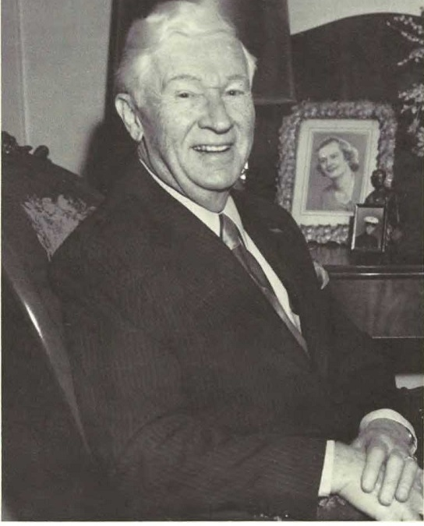

CHARLES WARNER (7) WILSON, of Memphis, Term., researcher and compiler of the Moore segment of this genealogy.
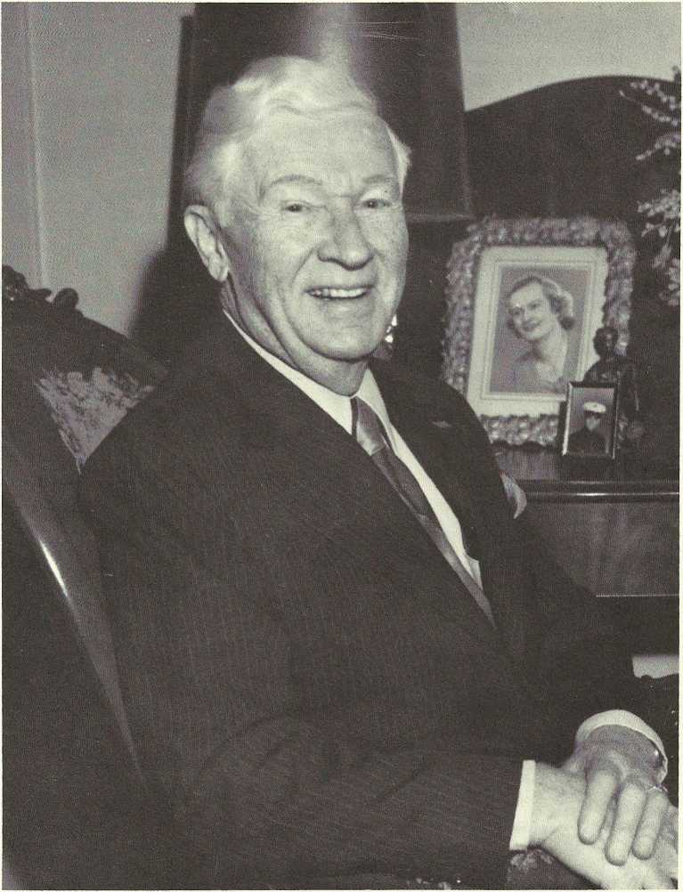

Moore Listings
The Moore family segment of this book consists mainly of material researched and compiled by Charles Warner (7) Wilson and duplicated and distributed by him to family members, starting in January 1965, updated in December, 1976, and again in May 1978. The information from all three versions has been rearranged and edited and is used here with his permission. Charles Warner Wilson dedicated his work to the memory of his grandparents, Dr. Warner Moore and Mourning Ella Leak Moore.

It is highly probable that the name, “Moore”, has its origin from the moors of Scotland, the place inhabited by the families of that name before they migrated from Scotland to Ireland and Wales during the reign of King James I of England (1603-1625). The English spelling, first used about five hundred years ago, is Moore; the Celtic is More; while the original Welsh is Mwr:

Sr. Thomas More (1478-1535) was an ancestor of the Moore Family here recorded. Richard Moore came to America on the Mayflower; James Moore was governor of South Carolina (1700-1702) and Maurice Moore and his son, Alfred, of North Carolina, were active in the Revolutionary War.

SHIELDS (1) MOORE, the original ancestor of record in America, immigrated to Maryland from Wales in 1725; md. Blandana Risdon; they later moved to N.C. There were several children, two of whom were: Smith W.; Risdon.
Risdon (2) Moore, b.—; d. 1779; md. (1)—; md. (2), in N.C., Mary Smith; they migrated to E. Tenn. in 1831. One of their children was: John.

John (3) Moore, b. 7 Feb. 1768; d. 8 Jan. 1846; md. 20 April 1797, Elizabeth “Eliza” Hill, dau. of Green Hill and his second wife, Mary Seawall, b. 22 Sept. 1777; d. 29 Apr. 1833. They had eleven children; among these were: Green; Mark, Calvin; Albert; John Risdon; Smith William.

Green Moore, the eldest, b. 1798; d. 1885; was a layman of the Lower Creek Bapt. Church, Lenoir, N.C. The next three sons, Mark, Calvin, and Albert, were Methodist preachers, John Risdon Moore, b. 1816; d. 1856; was a medical doctor; practiced first in Johnston Co., Tenn., later in Taylorsville, Maury Co., Tenn.

Smith William (4) Moore, b. 1 Nov. 1818, Stokes Co., N.C. d. 2 Feb. 1872, Whiteville, Tenn.; md. 24 July 1844, Giles Co., Tenn., the Rev. William Wilkes officiating, Mary Ordalia Yates, known as “Mary O.”, dau. of Warner Mister Yates and Mildred Menefee, b. 29 Dec. 1820, Culpepper Co., Va.; d. 10 July 1906, Brownsville, Tenn.; both Smith William and Mary O. Yates are buried in Oakwood Cemetery, Brownsville, Tenn. After their marriage they lived at numerous places in middle Tenn., Northern Ala., Western Tenn., Ky. and Northern Miss.

Mary O. Yates Moore was an ideal minister’s wife; was very prominent in the work of the Methodist Episcopal Church; appointed as one of a committee of two women to organize a Women’s Foreign Missionary Society -- 1878 General Conference.

Smith William Moore moved with his family to East Tenn. when 13 years old; after his mother’s death went to live with and worked as a clerk for his uncle, the Hon. Wm. Hill, Secretary of State of N.C., in Raleigh; there he was converted to Methodism at a revival, June 1837. Feeling the call to preach, he attended Randolph Macon College, Va.; matriculated there until 1842; was admitted to the Tenn. Conference in the fall of 1844; was ordained Elder by Bishop Soule of Nashville in 1846. The Tenn. Conference comprised north Miss., west Tenn., and west Ky. He was a Trustee of Vanderbilt Univ.; Co- Editor of the Christian Advocate; Agent of the Book Society of the Methodist Church in Memphis and President of these church colleges: Athens College, Athens, Ala., Bascom Female Seminary, Grenada, Miss., and Andrew College, Trenton, Tenn. Children: 1 John Warner; 2 Eliza Mildred; 3 Smith William, Jr.

John Warner (5) Moore, b. 12 June 1845; d. 3 Mar. 1909, Ripley, Tenn.; bur. in Maplewood Cemetery; md. 17 Dec. 1868, at her plantation home, “Tippah Home”, in Tippah Co., nr. Salem, Miss., the Rev. Wm. Wilkes officiating, Mourning Ella Leak, dau. of Col. Francis Terry and Martha Jane Malone Locke Leak. Col. Francis Terry Leak (about whom see more in the Leak Family section of this book) was a prominent wealthy plantation owner, with property and slaves both in Miss, and on the White River in Ark., Mourning Ella Leak d. 6 Sept. 1916, Paris, Tenn. She was reared in luxury, had her own body servants, and graduated from State Female College, Memphis, Tenn., but she selected the austere life of a Methodist preacher’s wife. A dainty, small woman, beautiful of countenance, always immaculately groomed, her husband’s pet name for her was, “M’Nell”. This was the source of the name “Nell”, given their oldest daughter. Mourning Ella Leak Moore’s well-worn and favorite passage marked in her Bible eloquently expresses her prayer for her children, grandchildren, and all her descendants:

For this cause I bow my knees unto the Father of our Lord Jesus Christ, of whom the whole family in heaven and earth is named, that he would grant you, according to the riches of his glory, to be strengthened with might by his spirit in the inner man; that Christ may dwell in your hearts by faith, that ye, being rooted and grounded in love, may be able to comprehend with all saints what is the breadth, and length and depth, and height; and to know the love of Christ which passeth knowledge, that ye might be filled with all the fullness of God. Now unto him that is able to do exceeding abundantly above all that we ask or think, according to the power that worketh in us, unto Him, be glory in the church by Christ Jesus throughout all ages, world without end. Amen. Ephesians 3:14-21

John Warner Moore, hereafter known as “Warner Moore”, moved with his father and mother as they transferred from place to place; discontinued his studies at Southern Univ. to enlist in the Confederate Army at the start of the Civil War; joined an artillery unit, the Stanford Battery. At enlistment he had to choose between being known as John W. or Warner Moore, selected the latter, and continued using this name on into his civilian life. He was wounded three times felt the call to the ministry, and after the war pursued this career, becoming Warner Moore, A.M., D.D., Ph. D. He was admitted to the Memphis Conference at Jackson, Tenn. ; ordained Deacon at the Annual Conference, Paducah, Ky.; and was made an Elder at Paris, Tenn., Nov. 1869. His first pastorate was the Coldwater, Miss, circuit; and he served from the smallest to the largest churches in this conference for almost forty-five years. Besides being a pastor, he was Presiding Elder (now called District Superintendent) of several Districts; served as Conference Secretary and was a delegate to the General Conference. A devout Christian gentleman of the highest caliber, universally respected and loved by all who knew him, or knew of him, Warner Moore deeply loved all his kinfolk from the closest to the most distant cousins. A handsome, stalwart man, he was also a hunter, a fisherman, a musician, a Mason, and a Shriner. His grave is marked by a splendid monument, erected out of love by the people of Ripley, Tenn. Symbolic of his life and his Godlike faith is the inscription on the stone, his last earthly words: “I have taken my soundings, my faith holds.”

Children of Warner Moore and Mourning Ella Leak Moore: i Warner, Jr.; ii Smith William; iii Nell; iv Albert; v Frank; vi Yates; vii Mary.

i Warner (6) Moore, Jr., b. 5 Apr. 1870, Tippah Co., Miss.; d. 21 Jan. 1946, Fort Worth, Tex.; md. (1) 4 Dec. 1895, Agnes Rudolph of Milburn, Ky., b.—; d. 9 July 1897.

Warner Moore, Jr. attended many universities; graduated from Memphis Law School 1886; did newspaper work; practiced law; had the call to be a Methodist preacher; Dec. 19, 1891 was licensed to preach; was subsequently ordained a.Deacon; then became an elder in 1896. Child: Warner Rudolph.

1 Warner (7) Rudolph Moore, b. 5 Dec. 1896; d. 17 Dec.
1973, Bonham, Tex.

Warner Moore, Jr. md. (2) 11 May 1904, Fulton, Ky., Lena Owen, his first cousin, b. 24 June 1880, Ashland, Miss.; d. 3 Jan. 1929, Fort Worth, Tex. Child: 2 Lena.

2 Lena (7) Moore, Shirley, Ark., b. 11 June 1905, Ashland, Miss.; md. 25 Dec. 1930, Riverside, Ft. Worth, Tex., Allen Boyd Manning. Lena Moore Manning is a graduate of Tex. Wesleyan College; has a Master’s Degree from W. Tex. State Univ.; taught many years in the Mineral Wells Independent School Dist, Mineral Wells, Tex. Lena and Boyd Manning, now retired, live in the Ozark Mountains, north of Shirley, Ark.

Warner Moore, Jr. and family moved to Texas; he reentered the ministry; held pastorates in Ft. Worth and other west Texas towns. During his lifetime he was also a lawyer, a newsman, a Farm Bureau organizer, a civil engineer, and an independent oil operator. Among the many states in which he lived, are: Ky., Miss., Tenn., Tex., and Ark.

ii Smith William (6) Moore, II, b. 5 Dec. 1871, Trenton, Tenn.

iii Nell (6) Moore, b. 31 May 1873, Stanton, Tenn.; bapt. 23 Sept. 1873, her grandfather, the Rev. Smith William Moore officiating; d. 4 Aug. 1961, bur. beside her husband in Maplewood Cemetery, Paris, Tenn.; a graduate of Huntsville Female Academy; md. 6 June 1900, Charles Lee Wilson, son of W.S. and Sara Ann Lee Wilson, b. 6 May 1874; killed 7 Feb. 1907, in a railroad accident nr. Cumberland City, Tenn.; bur. Maplewood Cemetery, Paris, Tenn. Charles Lee was employed as a freight conductor on the Louisville and Nashville R..R.

Nell Moore Wilson was very active in the Meth. Church, especially in the Missionary Society; was charter member of Eastern Star, second Worthy Matron of the Martha Chapter; was elected to Life Membership in 1947. Universally loved by all who knew her, she spent her life unselfishly doing for others. Child: 1 Charles Warner.

1 Charles Warner (7) Wilson, Memphis, Tenn., b. 21 July 1904, Paris. Tenn.; md. 26 Mav 1934, the Rev. Plome Jordan officiating, Ruth de Nevers Daniels, dau. of James C. and Emma Miller Daniels, of Paris, Tenn. He attended public schools m Ripley, Messick, Buntyn, and Paris; was valedictorian of his graduating class at Grove High School; received a Civil Engineering Degree from I.C.S.; attended the Univs. of Ky. and Ala.; was employed by the Louisville and Nashville R.R. (Transportation Dept); in 1951 became Superintendent of Memphis Union Station Co.; and was President of this company at the time of his retirement in May 1967.

Charles Warner Wilson is the researcher and compiler of most of the material in the Moore section of this genealogy. He has given of himself in these efforts for many years, periodically having copies of his work duplicated and distributing them to all of the cousins. He is revered and loved by his many friends and relatives. Child: i Patricia Ann.

i Patricia Ann (8) Wilson, b. and d. 3 Apr. 1940; bur. Louisville, Ky.
Albert (6) Moore, b. 2 Nov. 1875, Buntyn, Tenn.; bapt., Paris, Tenn., 22 Apr. 1876, his grandfather, the Rev. Smith William Moore officiating; d. 13 Jan. 1946; bur. Elmwood Cemetery, Memphis, Tenn.; md. 5 Mar. 1903, Dr. Warner Moore officiating, Corrie Page Collier, dau. of Dabney and Kittie E. Collier, b. 21 Jan. 1876; d. 30 June 1916.

Albert Moore enlisted in the US Army during the Spanish American War; was a 1st Sgt. under Capt. J.C. Travis of the Fourth Regiment Tenn. Volunteers; left for Cuba 28 Nov. 1898; mustered out at Savannah, Ga. 6 May 1899; he and his family lived in Buntyn, now Memphis, Tenn.; Albert was a reporter for the Commercial Appeal of Memphis; then he was City Editor; managed the Collier land holdings; was active in the National Guard, the Masons, and the Meth. Church; he later changed membership to the Bapt. Church. He served during WW I as an instructor in Artillery Battalions; reached the rank of Captain; returned to Memphis after the War; sold the Collier Estate. Children: 1 Albert Dabney; 2 Corrie Eugenia; 3 Mary Ella; 4 Yates Collier.

1 Albert Dabney (7) Moore, b. 1 Jan. 1904, Buntyn, Tenn.; d. 18 Dec. 1967; bur. Valhalla Memorial Park, N. Hollywood, Calif., Westlake Masonic Lodge officiating; md. 3 June 1925, Shreveport, La., Elenora “Jim” Harrison, b. 25 Apr. 3 899, Shreveport, La.

Albert Dabney Moore, known as “Dabney” and “Al”, was employed in the sales and repair of office machine equipment in Tenn., La., Ill., Ariz., and Calif.; later moved to Los Angeles and founded A.D. Moore, Distributor Co. (office supplies and fixtures); lived in Northridge, Calif. Child: Jerry Albert.

i Jerry Albert (8) Moore, b. 11 Nov. 1926; md. 29 May 1954, Los Angeles, Calif., Essee Melisse Boyd, b. 28 June 1925, San Jose, Calif. Child: Dennis Albert.

1 Dennis Albert (9) Moore, “Denny”, Silver Springs, Nev. b. 28 Jan. 1955, Culver City, Calif.; md. 19 Sept. 1977, Debra Bevins, “Debbie”, b. 5 Jan. 1954, —, Mich.

Jerry Albert Moore and family live in Nevada between Las Vegas and Silver Springs. He is employed at a Las Vegas hotel.

2 Corrie Eugenia (7) Moore, “Genia”, Greer’s Ferry, Ark., b. 28 Apr. 1906, Buntyn, Tenn.;md. 27 Aug. 1925, Herbert Thomas Allen, son of H.B. and Sarah Glass Allen, b. 6 Mar. 1906; was in construction business; Allen Materials. Corrie Eugenia and Herbert Thomas Allen are now retired. Children: i Herbert Thomas, Jr.; ii Albert Donald.

i Herbert Thomas (8) Allen, Jr., “Tommy”, Memphis, Tenn., b. 21 Dec.
1926; md. 25 Dec. 1944, Martha Jean Eikner, “Jean”, dau. of James E. and Aslene W. Morgan Eikner, b. 14 Aug. 1927; he was prominent in Lusk Accoustical and Supply Co.; is a special deputy on the Shelby Co. Sheriffs force, a Sunday School Teacher, and a Deacon in the Park Ave. Bapt. Church. Jean Eikner is active in the Evangelical Christian School: is a substitute art teacher, and a volunteer in the school’s arts and crafts activities. Children: 1 Cathy Jean; 2 Herbert Thomas, III; 3 Holly Carol.

1 Cathy Jean (9) Allen, Memphis, Tenn., b. 14 Apr. 1949, Memphis; a grad, of Memphis State Univ.; before marriage was an eighth grade teacher in Evangelical Christian School; md. (1) 16 May 1971, Joel Woods Gregory, b. 27 Oct. 1949; d. 16 Apr. 1976. Joel Woods Gregory, “Woody”, was killed in a traffic accident; he was a securities salesman with Maryland Casualty Co.; a Deacon in Park Ave. Bapt. Church, had a very pleasing personality and a host of friends.

Cathy Jean Allen, md. (2) 6 Jan. 1978, Memphis, Tenn. Charles Jonathan Housholder, “Jon”, son of Dr. and Mrs Charles Hobart Housholder, b. 2 June 1947; John works with Young Life, Inc., a Christian youth oriented organization; is a grad, of Vanderbilt Univ.; is now working on his Master’s Degree in school administration at Memphis State Univ.

2 Herbert Thomas (9) Allen, III, “Ty”, Memphis, Tenn., b. 22 Mar. 1955; md. 15 Nov. 1974, Memphis, Park Ave. Bapt. Church, Deborah Lynn Alberson, b. 24 Apr. 1956, Memphis. Ty is a truck mechanic at Chip B'arwick Chevrolet, Memphis. Child: Carol Michelle.

i Carol Michelle (10) Allen, “Michelle”, b. 6 Nov. 1977.

3 Holly Carol (9) Allen, Memphis, Tenn., b. 19 Nov. 1961, Memphis.

ii Albert Donald (8) Allen, “Don”, Memphis, Tenn., b. 24 Nov. 1929, Memphis; md. 31 Aug. 1946, Hernando, Miss., Jo Ann Allen, dau. of JamesCampbell and Mary E. Huggins Allen (no relationship), b. 6 Aug. 1929. Don is a partner in Ace Fixture Industries, specializing in store interiors, redecorating; is active in East Park Bapt. Church; a Deacon and a Sunday School Teacher; chaired Building Committee for a new church and private school structures. Jo Ann is engaged in church activities; is diligently caring for her elderly mother. Children: 1 Sharon Kay; 2 Donald Keith; 3 Mark Timothy; 4 Michael Paul; 5 Barbara Jo.

1 Sharon Kay (9) Allen, Durant, Miss., b. 5 Sept. 1947, Memphis, Tenn.; attended Memphis State Univ.; md. 13 Sept. 1968, Memphis, Tenn., at East Park Bapt. Church, Aaron Dale Aldridge, son of Kenneth Ross and Billie Jo Geriner Aldridge. Aaron served in the U.S. Navy; was stationed at Millington, Pensacola and Jacksonville; after separation from service the family settled in Durant, Miss.; he is a maintainer for the telephone company. Children: i Amanda Jo; ii Andrea Kay.

i Amanda Jo.(10) Aldridge, “Mandy”, b. 14 Nov. 1974, Durant, Miss,
ii Andrea Kay (10) Aldridge, b. 13 June 1977.

2 Donald Keith (9) Allen, “Keith”, Memphis, Tenn. b. 24 Apr. 1950; attended Memphis State Univ. and Memphis Vocational School; md. 20 June 1969, Memphis, Tenn., at East Park Bapt. Church, Linda Yvonne Smith, dau. of Don Hall and Billie Christine Elinor Smith, b. 26 June 1950. Keith served in US Air Force; was stationed at San Antonio, Biloxi, and Blytheville; after discharge, Keith and Yvonne returned to Memphis; he is employed at Ace Fixtures, Memphis. Child: Brandon Keith.

i Brandon Keith (10) Allen, b. 9 Dec. 1976, Memphis.

3 Mark Timothy (9) Allen, b. 11 Apr. 1953; md. 3 Dec. 1977, Memphis, Tenn., at East Bapt. Church, Bettie Jo Hays, “B.J.”, dau. of Mr. and Mrs. Earl Hays of Cottage Grove, Tenn., b. 6 Mar. 1954; he worked for the US Postal Service; attended Memphis State Univ.; is now employed at Ace Fixtures, Memphis. Bettie Jo Allen is a technician at Lebonheur Hosp., Memphis.

4 Michael Paul (9) Allen, “Mike”, b. 24 Apr. 1957; attended Memphis State Univ.; is now a Dept. Mgr. at Service Merchandise, Memphis.

5 Barbara Jo (9) Allen, b. 14 Sept. 1960.

3 Mary Ella (7) Moore, “Ella”, Memphis, Tenn., b. 2 Jan. 1908 Buntyn, Tenn.; md. (1)6 Apr. 1928, Memphis, Tenn., W.J. Clark, “Sonny”, b. —; d. Dec. 1930; sans issue; md. (2) 19 Jan. 1932, Memphis, Tenn., Alton Lamar Lawrence, son of J. P. and Katherine Hooker Lawrence, b. 7 July 1904; he is a retired Postal employee; spring and summer their grounds are adorned with lovely flowers; a veritable fairyland. Children: i James Albert; ii Corrie Jean.

i James Albert (8) Lawrence, “Jim”, Memphis, Tenn., b. 27 Oct. 1934; a grad, of Memphis State Univ.; was a Radar Controller in the US Air Force 1957-59; md. 20 Aug. 1959, Las Vegas, Nev., in Chapel of Nellis Air Force Base, Nancy Ann Purcell, dau. of Gerald Marion and Florence Ruth Heyman Purcell, b. 8 Dec. 1933, Deshler, Ohio; they met on a flight between Japan and Taiwan; she was a secretary in the US Embassy at Taiwan; they returned to Memphis; he worked for an insurance company and earned his law degree at night at Southern Law School; is now a practicing attorney. Children: 1 Mark Jefferson; 2 Joel Bradley.

1 Mark Jefferson (9) Lawrence, b. 8 Jan. 1961; was a counsellor at Kia Kima, a Boy Scout camp, summer 1978.
2 Joel Bradley (9) Lawrence, “Jody”, b. 10 Sept. 1965.

ii Corrie Jean (8) Lawrence, “Jean”, Ormand Beach, Fla., b. 20 Dec. 1938; md. 16 Oct. 1958, Memphis, Tenn., at Rebecca Memorial United Meth. Church, James Lewis Wilson, son of Gaither Weldon and Naomi Lewis Wilson of Memphis, b. 10 Dec. 1934; he is a grad, of Christian Brothers College, majored in electrical engineering; is now an employee of Gen’l Elec. Co.; travels extensively. Corrie Jean Lawrence Wilson does volunteer work for a Daytona Boys Club; is employed by Volusia Co., Fla.

4 Yates Collier (7) Moore, b. 21 Jan. 1910, at home in Buntyn,
Tenn.; grad. Memphis State Univ.; was a test chemist for Ga. State Highway Dept.; d. 26 Aug. 1976, College Park, Ga.;md.
13 Nov. 1939, Altadena, Calif., Mattie Ruth Martin, dau. of James Thomas and Mattie Luvinia Winson Martin, b. 20 Dec. 1906; d. 26 Aug. 1976. Yates Collier Moore had retired and was in poor health when their home caught fire early morning of 26 Aug. 1976; both he and his wife are bur. in the Martin Family plot of the College Park Cemetery, College Park, Ga.

Albert (6) Moore, md. (2) 29 Jan. 1918, Memphis, Tenn., Virginia Ruth Simmons of Memphis, Tenn., dau. of Wm. Albert and Anne Columbus Winborn Simmons, b. 18 Aug. 1894, Moscow, Tenn.; after Albert’s death, Ruth graduated from Memphis State College, earned her teaching certificate; taught in Memphis City School until retirement; was continuously active in Southern Ave. Bapt. Church; is now a member of and sings in choir of Ridgeway Bapt. Church and maintains a keen interest in her family. Children: 5 William Winbom; 6 Warner Francis; 7 Claude Daniel; 8 Marion Robertson; 9 Virginia Ruth.

5 William Winborn (7) Moore, b. 9 Apr. 1919, Memphis, Tenn.; d. 2 Nov. 1935, Memphis, Tenn.; killed in crossfire of feuding negro tenants while accompanying his father in rent collecting; this event impaired his father Albert Moore’s health, resulting in breathing difficulty the rest of his life.

6 Warner Francis (7) Moore, Germantown, Tenn., b. 20 Aug. 1920, Memphis, Tenn.; served in the US Air Force, WW II; saw active service in the Pacific; md. 9 Oct. 1943, Plainview, Tex., Elizabeth Joan Hinds, dau. of Vemer Monroe and Nellie S. Nottingham Hinds, b. 28 Sept. 1922. Warner Francis Moore reenlisted in the Air Force after WW II; the family lived many places, including Okinawa; Goose Bay, Labrador; Conn.; and Ohio; retired with the rank of Lt. Col.; is now an estimator with National Dry Wall Corp., his hobby is furniture building, and he has built several pieces for his home, a large color TV set, and is now constructing an airplane; the family is active in the Second Presbyterian Church. Children: i Warner Francis, Jr.; ii John William; iii Francys Joanne.

i Warner Francis (8) Moore, Jr., Memphis, Tenn., b. 12 Oct. 1945; grad, from Memphis State Univ.; md. 14 June 1968, Memphis, Tenn., at the Second Bapt. Church, Charlynn Ann Ballew, dau. of Mr. and Mrs. Charles A. Ballew, b. 2 July 1945, Memphis, Tenn.; he served in the US Air Force and the family lived many places, among them San Antonio, Tex., and Blytheville, Ark.; he also served in Vietnam; now a civilian, he is a buyer of men’s clothing at James Davis. Children: 1 Ashley Durant; 2 Robin Winbom.

1 Ashley Durant (9) Moore, b. 26 Aug. 1971.
2 Robin Winborn (9) Moore, b. 11 July 1975.

ii John William (8) Moore, “Bill”, b. 21 Feb. 1951; d. 10 Aug. 1970; a grad, of White Station High School, 1969, and a member of Second Presbyterian Church, John William Moore attended Belhaven College, Jackson, Miss. He was killed on a summer vacation job at a power substation; was critically burned as the result of a massive shortage. Burial was from the Second Presbyterian Church, with interment in Memorial Park, Memphis, Tenn. He was a fine, handsome boy who had planned to become a clergyman.

iii Francys Joanne (8) Moore, “Missy”, b. 17 Sept. 1952; attended the Univ. of Tenn.; grad, from Memphis State Univ., 1975; teaches at Evangelical Christian School.

7 Claude Daniel (7) Moore, Napa, Calif., b. 16 Dec. 1921; served in the US Air Force during WW II; received rank of 1st Lt. after the war settled in Napa, Calif.; md. 9 Nov. 1952, Reno, Nev., Lorraine Florence Sousa (Conkell), dau. of Frank and Melle Brazil Sousa, a widow with two children: (Sharon Lorraine and Michael Frank Conkell) b. 3 June 1920. Claude was a partner in a sporting goods business; then sold insurance; is now a pilot (Capt.) with Saturn Airlines, a freight and cargo carrier. Children: i Albert Daniel; ii Charles Hobart; iii Claude William; iv Donald Avery.

i Albert Daniel (8) Moore, “L’il Moe”, b. 5 May 1954, md. 15 Jan. 1977, Reno, Nev., Dominique Armstrong, “Nikki”, dau. of James and Marilyn Armstrong, b. 27 Dec. 1958, Vallejo, Calif.; has completed a tour of duty with the US Marine Corps; is enrolled in Pacific Union College; expects to qualify for a pilot’s license, as well as a degree in Business Administration. Child: Daniel James.

1 Daniel James (9) Moore, b. 15 Mar. 1978, Napa, Calif., at Queen of the Valley Hospital.

ii Charles Hobart (8) Moore, b. 2 Feb. 1957; employed by Napa School Dist. in maintenance Dept.; is in charge of the sprinkler systems.
iii Claude William (8) Moore, b. 29 Apr. 1959.
iv Donald Avery (8) Moore, b. 21 Feb. 1961.

8 Marion Robertson (7) Moore, Memphis, Tenn., b. 24 Dec. 1923, Memphis; served in WWII; did pre-med at Memphis State Univ.; received his M.D. at the Univ. of Tenn., Medical Branch; md. 22 June 1948, Winifred Sarah Saunders, “Billie”, dau. of William Hardin and Winifred Sarah Argali Saunders, b. 23 June 1924, Denver Co.; before marriage she was a medical technician. Marion Robertson Moore engaged in general practice; specialized in pediatrics; and then specialized in psychiatry. At present he is both a general practitioner and a psychiatrist. His hobby is dressing and mounting semi-precious stones. Children: i Charlene Saunders; ii Jane Ellen; iii Becky Sue; iv William Robertson.

i Charlene Saunders (8) Moore, Panama City, Fla.; b. 11 May 1951, Memphis, Tenn.; md. 19 Nov. 1977, Paul Robert Kinkaid, “Ken”, son of Mr. and Mrs. Paul R. Kin- kaid, Sr., b. 30 May 1940; she attended Millsaps College, Jackson, Miss.; grad, from Va. Polytechnic Institute. Ken is in the insurance business; Charlene teaches grades 7 - 9 in Panama City.
ii Jane Ellen (8) Moore, b. 6 Dec. 1952, Memphis, Tenn. md. 3 Sept. 1977, Memphis, at Wesleyan Hills United Meth. Church, James Aubrey Crawford, son of Mr. and Mrs. James Y. Crawford, of Nashville, Tenn.; attended Univ. of Tenn. (Martin); grad, of Univ. of Tenn. (Knoxville); received a Master’s Degree from the Univ. of Tenn. (Knoxville).
iii Becky Sue (8) Moore, b. 17 July 1955; grad, pre-med. Hendrix College; joined U.S. Navy; has rank of Ensign; through the Navy is attending Harvard Univ. and specializing in oral surgery.
iv William Robertson (8) Moore, “Bill”, b. 17 Jan. 1957; has a B.S. from Memphis State Univ. in Electrical Engineering; plans to go into medical engineering; awarded a Justin Potter medical scholarship for four years at Vanderbilt Univ.

9 Virginia Ruth (7) Moore, “Sis”, Bristol, Va., also known as “Ginny”; b. 24 July 1925, a grad, of Memphis State Univ.; was an airline stewardess; md. 20 Mar. 1949, Lawrence Joseph Hardiman, III, son of Lawrence Joseph, Jr. and Katherine Loretta Swingley Hardiman, b. 9 Jan. 1923; they first lived in Norfolk; then moved to Wilson, N.C.; Ginny has an M.A. from East Carolina Univ.; now live in Bristol, Va.; at one time Ginny was Dean of Women at King College, Bristol. Children: i Virginia Ruth; ii Terry Moore; iii Patty Winborn; iv Lawrence Joseph, IV.

i Virginia Ruth (8) Hardiman, “Ginger”, Alpharetta, Ga., b 21 Mar. 1951; B.A. in Philosophy, N.C. State Univ.;md. 14 Oct. 1973, Raleigh, N.C., at Pullen Memorial Bapt. Church, Robert Lee Merlin, Jr., “Lee”; Ginger is an executive with Bank Bldg. Corp., Atlanta, Ga.; Lee is employed as a salesman for Unit Computer System, Atlanta.
ii Terry Moore (8) Hardiman, Atlanta, Ga., b. 25 Oct. 1952; attended Univ. of Tex. (Austin); majored in education of the deaf; acted as a house parent Tex. School for the Deaf; is now payroll clerk for the Atlanta Braves (baseball) and the Atlanta Hawks (basketball) teams; attends college at night.
iii Patty Winborn (8) Hardiman, Atlanta, Ga., b. 10 May 1954, attended King College, Bristol, Va.; now doing public relations work with Atlanta Hawks; attends college at night.
iv Lawrence Joseph (8) Hardiman, IV, “Larry”, Ram- stein, Germany, b. Aug. 1956; is an Airman 1st Class, US Air Force, stationed in Ramstein, Germany.

v Frank (6) Moore, b. 29 Aug. 1877; d. 2 Jan. 1936, St. Petersburg, Fla., in the Veterans Hosp.; md. 3 Oct. 1904, the Rev. Dr. Warner Moore officiating, Pauline LaRue Clopton, dau. of Mr. Clopton and Mrs. Joe Dumas of Paris, Tenn., b. 26 June 1882; d. 24 Sept. 1960; enlisted in US Army at the onset of Spanish- American War, 4th Regiment under Capt. G.T. Fitzhugh, on 18 June 1898; left for Cuba 28 Mar. 1899; mustered out at Savannah, Ga. 6 May 1899; returned home to Paris 9 May 1899; held rank of Second Sgt.; in mid-twenties family moved to Miami, Fla.; Frank sold real estate; then bought a service station, residence and tourist facilities on Tamiami Trail. Children: 1 Francis Clopton; 2 Nelle Malone.

1 Francis Clopton (7) Moore, “Frank”, b. 24 Sept. 1905, Paris, Tenn.;d. 17 Sept. 1961. Married twice; sans issue.
2 Nelle Malone (7) Moore, b. 20 Mar. 1908; md. 28 Feb. 1927, Jessie Woodfin Cooke; ended in divorce; lived with her mother; she worked for Tooley-Myron Photography Studio, Miami, Fla.; now retired, she lives with daughter, Pat. Child: Patricia Ann.

i Patricia Ann (8) Moore, “Pat”, b. 30 Mar. 1928, Miami, Fla.; md. (1) 22 Nov. 1949, Frederick Y. Denson; ended in divorce, Pat having custody of the child; Child: James Allen.

1 James Allen (9) Denson, “Jim”, now legally changed to James Allen Whittington, b. 5 Nov. 1950; enlisted in the US Marines; served many places, including Vietnam; lives in San Diego, Calif.

Patricia Ann Moore md. (2) 26 Nov. 1952, Elam Elzie Whittington, “Jack”, of Miami, Fla.;b.—;d. 20 Feb. 1976; Jack legally adopted Jim; Jack was Office Mgr. with Rex of Fla., a metal treating plant in Ft. Lauderdale, Fla. Child: 2 Lawrence Victor.

2 Lawrence Victor (9) Whittington, “Vic”, b. 29 Aug. 1955; attended aviation school in Daytona Beach, Fla.; enlisted in the US Air Force; plans to be a commercial pilot; is a Pfc. in Army Intelligence; stationed in Frankfurt, Germany.

vi Yates (6) Moore, b. 10 Jan. 1880, Ripley, Tenn.; d. 17 Dec. 1964, Memphis, Tenn.; bur. Stanton Cemetery, Stanton, Tenn., a town where he was especially loved and respected; md. 3 Nov. 1908, Stanton, Tenn., in Stanton Meth. Church, his father Warner Moore officiating, Lila Belle Hunt, dau. of Fenton Edward and Mary Eliza Black Hunt, b. 7 Nov. 1888; d. 16 Feb. 1969, bur. Stanton Cemetery, Stanton, Tenn., beside her husband.

Yates Moore was a merchant and a planter; was called to the ministry; licensed at LaGrange, Tenn., 14 July 1900; admitted on trial to Memphis Conference of Meth. Church, Nov. 1900; received into full connection and ordained Deacon, Paris, Tenn., 23 Nov. 1902; B.A. Vanderbilt Univ. 21 June 1905; ordained elder 18 Nov. 1906, Ripley, Tenn.; also taught school in Stanton; Lila was one of his pupils; served various churches; was also District Superintendent; completed fifty years of service before retirement; a fellow minister expressed how Yates lived his religion: “Yates Moore lived closer to Heaven than anyone I have ever known.” Children: 1 Nelle Elizabeth; 2 Noble Hunt.

1 Nelle Elizabeth (7) Moore, b. 29 Aug. 1909, Newbern, Tenn.; grad, of Lambuth College; M.A. Duke Univ.; taught at several schools* including Campus School, Memphis State; was Asst. Prof. Dept. of Curriculum and Instruction, Memphis State Univ.; worked in counseling and placement of teachers; now retired; lives in Memphis, and is active in church and in the Ornithological Society; travels extensively; unmd.

2 Noble Hunt (7) Moore, b. 11 Apr. 1914, Milan, Tenn.; md.
27 May 1944, Ripon, Wis., Patricia Grace Gerrie, dau. of Chester A. and Isabel Patton Gerrie, b. 10 July 1914, Fort Huron, Mich.; Noble received his B.S. in Chemical Engineering, Univ. of Tenn. (Knoxville); founded N.-Hunt Moore, Assoc., Inc., engineering and sales, vegetable and cotton seed oil extraction. Children: i Jack Gerrie; ii Katheryn Hunt;
Robert Fenton.

i Jack Gerrie (8) Moore, b. 12 Mar. 1946, Ripon, Wis.; md. 5 Apr. 1968, Memphis, Tenn., at Trinity United Meth. Church, Shirley Ann Paddison, dau. of Mr. and Mrs. Norwood Giles Paddison, Jr., of Memphis, b. 2 Jan. 1947, Memphis, Tenn.; attended Drew Univ.; grad, of S.M.U.; enlisted in US Air Force; stationed a number of places, including San Antonio, Austin and Ft. Worth, Tex., and Denver, Colo.; also served at DaNang, South Vietnam; after discharge settled in Memphis; joined his father’s business, N. Hunt Moore, Assoc.; now V.P.; working towards an engineering degree at Memphis State Univ.; is a member of the Memphis Rotary Club. Children: 1 Scott Paddison; 2 Kimberly Gerrie.

1 Scott Paddison (9) Moore, b. 9 June 1974; christened 20 Oct. 1974, Christ United Meth. Church.
2 Kimberly Gerrie (9) Moore, “Kim”, b. 16 Nov. 1977, Memphis, Tenn., Meth. Hosp.; christened 16 Apr. 1978.

ii Katheryn Hunt (8) Moore, Arlington, Tex.; b. 30 Aug. 1947, Ripon, Wis.;md. 26 June 1971, Bartlett, Tenn.,St. Luke’s United Meth. Church, Kendrick Gibbons Stevens, “Ken”, son of Mr. and Mrs. B. Milton Stevens, b. 26 Aug. 1947, Bartlett, Tenn.; Katheryn taught elementary grades Memphis City Schools; now teaches kindergarten, Christ Meth. Day School; Ken attended Memphis State Univ.; at present is Personnel Placement Officer, Alcon, Inc., Arlington, Tex., a pharmaceutical firm. Child: Brian Kendrick.

1 Brian Kendrick (9) Stevens, b. 14 June 1977; christened 26 Nov. 1977, Christ United Meth. Church, Memphis, Tenn.

iii Robert Fenton (8) Moore, “Bob”, b. 18 Aug. 1955; attended Millsaps College, Jackson, Miss.; now matriculating at Memphis State Univ., majoring in Bus. Management; was associated with his father’s business, N.Hunt Assoc.; is now V.P. of Vazo, Inc., a new company which manufactures plastic mixing machinery.

vi Mary (6) Moore, b. 22 July 1882, Memphis, Tenn., in the Hernando St. parsonage; d. 18 Mar. 1946, McKenzie, Tenn., bur. Forest Hill Cemetery, Memphis; md. 17 Dec. 1901, Buntyn, Tenn., in the Meth. Church, Eugene Watson Crump, son of Jack Moorman and Missouri Ann Tennessee Baggett Crump, of Marshall Co., Miss., b —; d. 24 Apr. 1948, Memphis, Tenn., bur. in Forest Hill Cemetery. Eugene Watson Crump received a law degree from Univ. of Tenn. (Knoxville); practiced law; then was called to preach; was admitted to the Memphis Conference of the Meth. Church; preached in Oklahoma, Indian Territory; returned to Memphis Conference; served in towns in Tenn. and Ky. Mary was never physically strong, but was a helpful preacher’s wife and loving mother. Children: 1 Mary Ella; 2 Nell Louise; 3 Warner Moorman; 4 Ruth; 5 Gladys; 6 Eugenia; 7 Lida.

1 Mary Ella (7) Crump, b. 30 July 1903; d. 21 Aug. 1910.
2 Nell Louise (7) Crump, b. 6 June 1909, Ramsey, Tenn.; d. same day.
3 Warner Moorman (7) Crump, b. 12 Sept. 1910; d. 7 Dec. 1910.
4 Ruth (7) Crump, b. 9 Jan. 1914; d. 13 Mar. 1915.
5 Gladys (7) Crump, Williston, Tenn., b. 22 Dec. 1915, Paris, Tenn.; md. 6 Sept. 1947, at Chelsea Ave. Meth. Church, James Humphreys Lazenby, son of David Lee and Esther Humphreys Lazenby; b. 16 May 1917, Memphis, Tenn.; grad, from Lam- buth College; was employed for six years at the Univ. of Tenn., Medical Branch. They raise cattle and James is a painting con- contractor. Sans issue.
6 Eugenia (7) Crump, Oxford, Miss., b. 8 Apr. 1917, Bells, Tenn., in the parsonage; attended Blue Mt. College in Miss, and Bethel College, McKenzie, Tenn.; grad, from Univ. of Tenn. in 1938; md. (1) 14 Feb. 1938, Charles Raulstone McGehee, in the parsonage at Lexington; ended in divorce; sans issue; md. (2) 3 Feb. 1968, Cleveland, Tenn., in the Broadstreet Meth. Church, Ralph Edgar Biddle, b. 4 Apr. 1921; Eugenia Crump has retired after years of teaching; Ralph Edgar Biddle is Director of Products Engineering for Chambers Corp., a div. of Rangaire; designs stoves, microwave ovens; they attend the Presbyterian Church. Sans issue.
7 Lida (7) Crump, Collierville, Tenn., b. 7 Jan. 1919, Newbern, Tenn.; attended Bethel College, McKenzie, Tenn., and business college in Memphis; is now secretary to the principal of Collierville High School; md. 3 Dec. 1939, Memphis, Springdale Meth. Church, Henry Oren Coates, son of Mr. and Mrs, O.B. Coates, b. 29 Sept. 1905; he is Administrator of Care Inn Nursing Home, Collierville, Tenn. Children: i Mary Jo; ii Henry Armistead, III.

i Mary Jo (8) Coates, “Jo”, Collierville, Tenn., b. 4 Aug. 1940; attended Memphis State Univ. and then business college; md. 2 May 1965, Collierville, Tenn., at the Meth. Church, the Rev. Frank L. McRae officiating. James Malone Thompson, son of Mr. and Mrs. Z.B. Thompson, of Selmer, Tenn., b. 21 Feb. 1929; he is a senior member of the Engineering Dept. of Allen and Hosall, consulting engineers.

ii Henry Armistead (8) Coates, III, b. 14 Jan. 1951; was Production Control Supervisor of Day and Night Mfg. Co. on the air conditioner assembly line; is now with Carrier Air Conditioning Corp.; md. 23 Dec. 1970, Marion, Ark., Beverly Earnest, dau. of Mr. and Mrs. L.W. Earnest of Collierville, Tenn.; she is a dental assistant.

2 ELIZA MILDRED (5) MOORE, “Lily”, md. DR. LOUIS POWHATAN ESTES’ This marriage connects the Moore family to the Estes of Virginia and Tennessee and to the Carys of Virginia. For information on the descendants of Eliza Mildred Moore, see the Estes section of this book.

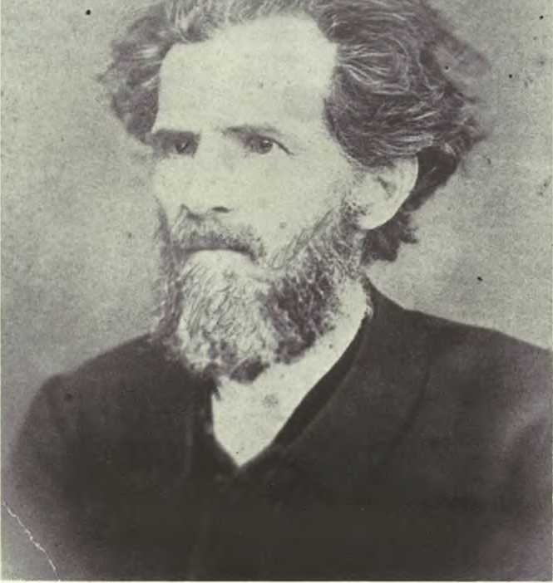

THE REV. DR. SMITH WILLIAM (4) MOORE in his later years.
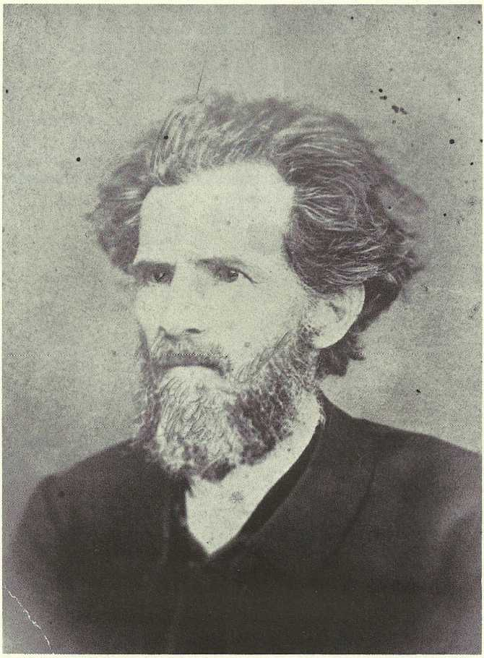

Moore History and Connections
The “Moore Family History and Family Connections” was compiled by Charles Wilson, of Memphis, Tenn., with the exception of some supplementary items on Green Hill, a very prominent Moore ancestor of colonial times. Some items have been edited and rearranged.

The marvelous, up-lifting faith of the Moore family permeates these items chosen from Charles Wilson’s comprehensive collection of historical and documentary data. The eulogies written about Charles’ grandparents, the Rev. Dr. Warner (5) Moore and his wife, Mourning Ella Leak Moore, are testimony to their strong Christian faith. It never faltered, even on their death beds.

Warner Moore’s mother, Mary Ordalia Yates, “Mary 0” brought the Yates family into the Moore line and also the Masons of Virginia.
We included a brief history of the Yates family.

Green Hill was an illustrious figure. A founding father of the Methodist Church, he was a major in the Revolutionary War, and took part in the first meeting in the colonies to plan for independence. There are three long articles on him, each of which gives a little more information on the same event: the First Annual Conference of Organized Episcopal Methodism.

Mourning Ella Leak, Warner Moore’s paternal grandmother, came from a life of ease and wealth on a large plantation. She sacrificed it all gladly to become the wife of an itinerant preacher. There is a family history, some statistics from the family Bible and a chart giving the wives and children of Mourning Ella Leak’s grandfather.

John Warner (5) Moore, “Warner Moore ” was the brother of Eliza Mildred (5) Moore, who married Dr. Louis Powhatan Estes, connecting the two families. He was nurtured in the Methodist faith throughout his life. His father, Dr. Smith William (4) Moore was a Methodist minister, who felt the call to preach while he was serving in the Confederate forces during the Civil War. After the war, he studied for the ministry and quid Warner Moore felt the call to preach while serving in the Confederate forces during the Civil War. After the war, he studied for the ministry and quickly rose in the ranks of the church, becoming a deacon, then an elder, and received an honorary Doctor of Divinity from Southern University. His personal record from his Bible is copied here, including the schedule of his travels, to give some idea of the grueling life he led to spread the Gospel.

Two eulogies are included here because each one honors Warner Moore in a different way for different qualities.

WARNER (5) MOORE

PERSONAL RECORD OF WARNER MOORE, COPIED FROM HIS BIBLE

Warner Moore, son of Smith W. and'M.O. Moore, was born in Pulaski, Giles County, Tennessee, June 12, 1845.

Baptized by Reverend A.M. Driscoll at Courtland, Alabama, August 1845. Converted at a meeting held in the Army, near Kingston, Georgia, by Reverend John B. McFerrin, February 7, 1864.

Licensed to preach by the Quarterly Conference of Grenada Station, Mississippi, November 28, 1864, Reverend Turner P. Holman, Presiding Elder.

Admitted on trial in Memphis Conference at Jackson, Tennessee, November 1866.

Ordained Deacon by Bishop Paine at Paducah, Kentucky, November 1867. Ordained Elder by Bishop H.N. McTyeire at Paris, Tennessee, November 29, 1868.

Graduate of Southern University, A.M.

Received honorary degree of D.D. from Southern University 1894.

DR. WARNER MOORE'S ITINERARY ASA PREACHER

In 1865 he was a supply preacher at Coldwater Ct.; in 1866-7 Salem Ct.; in Huntingdon 1867-8; Covington St. 1868-9; Sardis Ct. 1869-70; Whiteville Ct. 1870-2; Stanton Ct. 1872-4; Springdale Ct. 1874-5; Paris Sta. 1875-7; Ripley Sta. 1877-80; Hernando St., Memphis, 1880-3; Humboldt Sta. 1883-5; Jackson Dist. 1885-7; First Church, Memphis 1887-9; Mayfield Sta. 1889-93; Paducah Dist. 1893-7; Paris Sta. 1897-9; Springdale & Buntyn 1899-1902; Spring Hill Circuit 1902-05; Ripley Sta. 1905-09.

EULOGY TO DR. WARNER MOORE by W.T. Bolling, D.D.

I desire to pay my tribute to the memory of my friend:

He filled his place ever with credit to himself and his Church as an itinerant preacher, serving circuits, stations, and districts; and on his record there is not a single blot. Dr. Moore had a vigorous and well-furnished mind, trained to thought; and his convincing logic and earnest style won for him the attention of his audiences and especially the more cultured.

In the home he was the genial compainion and ever Christian gentleman, pleasant, cordial, but never indulging in the familiarity which among cultured people "breeds contempt;" and from his lips fell no word which was not chaste and worthy to be uttered in any company, even in the presence of purest womanhood. He was a modest man, never given to self-seeking in any degree, and hence he did not occupy always the place his talent and ability deserved. His was a character molded of that element which "vaunted not itself and is not puffed up," but withal a massive character, which, like a mountain peak, rose granite-based and symmetrical from base to summit, crowned with the golden light of spiritual beauty.

He was as tender as a woman, stern as a Roman senator, and immovable when principle was involved. He was a Christian soldier, courteous as Bayard, and yet as brave as Coeur de Lion; and with what he believed to be wrong he made no compromise, governed by principle and a stranger to all questionable policy. Genuine himself as purified gold, he had no alloy in his make-up; and hence, loving the genuine, he despised a sham; and as steady as the North Star in his friendship, he made no pretense in relation to one in whom he could not believe.

I know no richer legacy than for forty years Warner Moore was my friend; and, knowing me as he did, in the light of our unbroken friendship, I find a comment which I value beyond all the wealth the world could make in relation to me. Two years ahead of me in the Conference, he gave me welcome when I came in; and from that day unto this our friendship remained unbroken; and that silent form both held a soul of one whom I loved as brother in the flesh and in Christ; and hence I came to lay a brother's tribute at his coffin in the last rites over the body which held as Kingly a soul as ever blessed the world and left it to make it poorer and give added wealth to the realm of light beyond the mystic sea. Stricken suddenly, with no warning, of the coming end his life, so open, so consistent, becomes the guarantee of his perfect readiness to answer the call of the Master: "Come up higher."

The sun has gone down, but has left its golden glow upon the clouds; and while love sits with tear-dimmed eyes, she sees the afterglow of blessed promise and in her sobbing agony chants the measures of consolation's anthem and looks with hope beyond the coffin and the clay. When the end came, to the faithful woman who through sunshine and shadow had ever walked by his side, he said: "I know I am going; I have sounded the depth, and my faith holds." So as he had come to St. Paul, the enemy, death, came to our brother. But the Christian soldier was on post, armed with faith and ready. Like another - a dying poet -- he could say:

And now the bitterness of death is past.
This soul's untwisting is the last.
Angels bring near the chariot; my work is done;
Step in my soul; the battle is fought, the victory's won.

APPRECIATION OF DR. WARNER MOORE by J.W. Blackard, D.D.

"Ulysses is off on his wanderings and there is not one in Ithaca who can draw his bow."

I am deeply grieved at the going away of my old time friend Dr. Warner Moore. My first real acquaintance with him began in 1886 when he became my presiding elder. Although he was my senior by a number of years and my superior in rank and otherwise too as for that - nevertheless our acquaintance grew to warm personal friendship which has known no break through all of these years until death severed the golden cord. Ah, I am wrong in the exception. Death has separated us, but has not broken our friendship. Somewhere past the grave and beyond the "sunset's radiant glow" there shall be a meeting and the golden cords which have bound us in the past shall bind us there. Love and friendship are eternal.

Warner Moore was a born gentleman, a choice spirit. He missed greatness only by a small margin. Nay, wrong again; he did not miss greatness. He missed the wide celebrity and the applause that come to many great men; but he was truly great - great in faith, great in patience, great in love, great in friendship. No man was more devoted to his friends than he.

This scribe had a long letter from him just a little while ago in which he spoke pathetically about the loneliness that sometimes came to him at conference when he could see none of the "old guard," Johnson, Harris,

A.R. Wilson and others. He did not say so but he was doubtless feeling a little homesick for heaven, knowing not that he was nearing the time to join the "old guard" beyond the river. His life work is done. His gentle, brave, spirit has gone. We shall see his face no more in this world nor hear his voice. He will not answer the roll call at conference. He has been "transferred" by our Great Bishop to a larger and better field. We who knew him intimately and loved him will miss him oh, so much. Who can fill his place in our hearts? When shall we see his like again?

He was a man of many gifts and many noble qualities. He was capable of filling any position in the gift of the church, yet he was always content to work where ever he was assigned.

He was generous to a fault and self-sacrificing, always preferring others to himself. In a recent letter to this writer he was unfolding some of his plans and added: "This will not benefit me personally. My day has past but I am working for our younger men, such as yourself."

It has been fifteen years since he traveled the Paducah District as presiding elder, but his tracks here are still many and his friends legions. There has perhaps never been a presiding elder among us whose preachers loved him more than did the preachers in Moore's District. He had no porcupine quills but took the humblest brother close to his heart. The now sainted Newell once said to this writer that the unfeigned love displayed between Moore and the preachers of his district at one of his District Conferences was one of the most beautiful things he had ever seen on the earth.

May his mantle fall upon his sons and the blessings of God be with his faithful widow and the memory of his noble life be cherished by his brethren in the conference till we all meet in that land where the rainbow never fades and the flowers bloom eternally!

MOURNING ELLA LEAK MOORE (md. Warner (5) Moore)

A TRIBUTE TO SISTER MOORE

Written by Mrs. Lillie McSwain Foreman shortly after Grandmother Moore's death in September, 1916.

I cannot remember when I did not have the utmost respect and love for a minister and his family. My early training, by the best father and mother that ever lived, taught me that a minister was called of God. He was set apart from other men, he was Christ's representative here and he and his were to be honored. So one November evening about 20 years ago when with some friends I was standing in a store on the Square "wondering what our new preacher looked like" a perfectly splendid looking, tall, broadshouidered, white haired man stepped in the door and introduced himself as Dr. Warner Moore, our new pastor, who with his genial smile and pleasant manner won the hearts of the crowd of young people in a few minutes. And later when I went into the home and met his dear, sweet wife and splendid family my old standard of the minister and his home was raised higher. There began at that time an association with his family as friends and neighbors that has lasted through these 20 years, and the bond of love that exists between these friends and myself is second only to that of my own by blood and to try to speak of this good woman as a friend is next to trying to say something of what my own Mother is to me. Sister Moore, as I've always called her, was raised in a Southern home where a servant was at hand to do even to the very smallest service. As a girl she never knew anything of housekeeping and its many, many duties. Just a little dainty needlework and embroidery was the most practical knowledge she had of housekeeping. But like the true great woman she was, as I have so often heard her say, "If you love your husband and home and want to learn, you certainly can." And she surely mastered the art of homemaking and housekeeping.

Her love for her husband and his work was second only to that of the Master she served and in all his 40 years of labor in the Methodist Church, he found in her a strong support. Altho many, many times in the early itinerant work, when even the very barest necessities were not available, she never waivered in her faith and purpose and I doubt if she ever spoke of it until years later, when in conversation we would ask questions of her or possibly complain and feel like we were having a hard time. Then she would speak of some of these experiences of hers and it would put us to shame. To tell of the sacrifices she made to rear her family of six children, to care for them in the home, cook, sew, keep up with the many demands they made on her time and strength and still keep up with the work required and expected of her as a minister's wife would take hours and a vocabulary that is not mine to command. For then not only did it mean the work of a minister's wife of today, but actually to go into the homes and nurse day and night and for hours and hours try to lessen the pain and one time actually taking home with her for a while a tiny babe whose mother's life went out to give it birth. Such things came into her life to make up the sacrifices of years of labor throughout the Methodist Conference, for their pastorates were from the circuit with many appointments and few dollars to the very highest appointments in the Memphis Conference and then from small church to large and large to small; yet never a murmur as to change. To her God guided the Bishop and his Cabinet in making these appointments and it was her prayer to the end that He would always do so. I could write pages and then not halfway tell of the sacrifices of those years as a Minister's wife. Were they sacrifices to her? No; it was her pleasure "For she was about her Master's business."

May I speak of her home life? All who knew the loving husband and wife felt that their lives were ideal. Just during her last illness a friend of hers said to me in her home "I always thought they were an ideal couple." How she loved Dr, Moore and when he was taken from her seven years ago, almost that gentle spirit followed his, for hours her children thought she would never regain consciousness. And when she did her question was "Oh, why didn't You let me go too?" And from that time on, although she met bravely the battles of life without him, still she only lived for the call to come to take her home. And in these years, with her needle and thimble and scissors, with her crochet and tatting. I've spent hours listening to her sweet voice as she told me of so many, many blessings that had been hers. How her faith was made stronger each day, how good her children were to her, how true God's word was. I never went to her with a burdened heart that I did not come away comforted. "Have more faith" she would so often say to me. Friend? I thank God for such a friend. She was always thoughtful of her friends. Altho during all these years she suffered physically, she never complained and when I'd stop in and ask "How are you?" "All right for me" would be her answer. The flowers that are around her little home speak of her love of the beautiful and for two years she has been planting these flowers that would, to use her words, "Would be there to bloom for Nell when I'm gone." And how many, many times she sent to sick friends some of those beautiful flowers and a message of love with them and even just a few days before she went away, she had some carried to two of her friends who were sick, always thinking of someone else.

Can you imagine how her children loved her? And how she loved them? Always interested in them and in their families and in their work. Their joys and sorrows were truly hers and when sorrow came into the homes of those away from her, she always forgot her own suffering to go to them, or if she could not go herself, sent such messages of comfort as only a loving mother could send. And just a few weeks ago, when her soldier boy telephoned from Memphis that the physician had just told him that his wife could live only a few hours, she said "O! How gladly I would go in Corrie's place. Albert needs her and her little children need her, but God knows best." And again when racked with pain she said "I do not know why I am spared, but I would not presume to tell God when it is time for me to go, I only pray that I may be patient and have strength to bear the pain." And surely God gave her both, for during those last three weeks, when she was unable to take a morsel of food or drink, save a little water, and was continually in pain, she never murmured. And in the midst of this physical agony, when she would speak at all, she would begin "Bless the Lord! 0 my soul and all that is within me bless His Holy Name," or "The Lord is merciful and gracious, slow to anger and plenteous in mercy." And day or night when she could be heard at all, her voice was lifted to Him for His many blessings.

During these weeks it was beautiful to see the devotion of her children who ministered to her. Altho there seemed nothing could be done to ease that pain, still day and night those three stalwart sons and two daughters worked untiringly, trying to make her more comfortable, and always she would think of them and tell each one, "You must get some rest, you will wear yourself out," and to another, "You must not stand so long, your little baby will need you, go rest a while." To me, the last time her face lighted up with pleasure when I entered the room, she said "You must not come so often, you will tire yourself out and Nell will need you later on." And again.late into the night, when I gave her some water, she looked up with that sweet smile, "Haven't I driven you home yet?" Unselfish? Yes to the end. How her prayer reached out to her oldest son, a Preacher out in Texas, who was deprived of the pleasure of being with his Mother in these last hours. But the assurances of love and faith growing stronger each day, that came to her from him, made her face light up with pleasure and from her lips came the blessing "The Lord bless him and keep him faithful and bring him safe home." And then the grandson, whom she had reared as her own and whom she had loved so tenderly, because as she said he had never known a Mother's love, to him, down on the Mexican border, went those last letters of loving advice and back came the answer "I expect to live so that I'll meet you in Heaven." These years of sacrifice were bringing in their harvest. For days before she went away after she had gotten too weak to finish her scripture, she would look at her Preacher boy, who was with her, and would take up the passage and finish it for her, and when nothing else seemed to quiet her, she would listen to his voice, as he repeated to her these blessed promises on which her whole life had been built and her spiritual triumph over the physical was complete. And the last morning we had her with us, I shall never forget the scene it was my privilege to witness, for truly these things bring us near the Eternal Truth. One who for days and days had been coming to sing for her the hymns she loved, was sitting by her singing "We Are Almost Home" and truly Sister Moore must have heard those voices on the Other Shore singing, for when the song was finished, again came that voice, almost a whisper "Bless the Lord."

And in a few hours the Life that for years had been shut in,

"Shut in, shut in from the ceaseless din
Of the restless world, and its want and sin;
Shut in from its turmoil, care and strife.
And all the wearisome round of life.

Shut in with tears that are spent in vain,
With the dull companionship of pain;
Shut in with the changeless days and hours,
And the bitter knowledge of failing powers.

Shut in with the dreams of days gone by.
With buried joys that were born to die;
Shut in with hopes that have lost their zest.
And leave but a longing after rest.

Shut in with a trio of angels sweet:
Patience and Grace all pain to meet.
With Faith that can suffer and stand and wait.
And lean on the promises, strong and great.

Shut in with Christ! Oh, wonderful thought!
Shut in with the peace his sufferings brought;
Shut in with love that wields the rod;
Oh, company blest! Shut in with God."

this spirit went Home triumphantly to be in His Presence.

Sister Moore as a friend? I feel that I have not finished until I tell you that we carried her to Ripley to have her little body there by Dr. Moore. And that there we found scores of friends with their beautiful flowers to bring with them their messages of love to the living and pay their last tribute of love to this dear, good woman who had lived with them.

Smith William (4) Moore married MARY ORDELIA YATES, “Mary O”, daughter of Warner Mister Yates, who was the son of Charles and MARY MASON YATES, sister of GEORGE MASON of Gunston Hall,
Lorton, Va.

THE YATES FAMILY

Warner M. (Mister) Yates, the son of Charles and Mary Mason Yates, was born in Virginia on April 27, 1795. There is a record showing him as being named “William Mason Warner Minor Yates” but later accounts show him as being Warner M. Yates. Mary Mason Yates was, [by family tradition] a sister [but possibly the niece of] George Mason of Virginia (1725-1792) author of the Declaration of Rights adopted by Virginia Convention of May, 1776, and later used by Thomas Jefferson as a basis for the Bill of Rights added to the original Federal Constitution as amendments. He was also a sponsor of George Rogers Clark’s expedition to the Northwest Territories.

Warner M. Yates married Mildred Menefee in Virginia on December 30, 1819. Rev. Lewis Conner performed the ceremony.

Warner M. and Mildred Menefee Yates had 11 children, they being:

Ordalia Mary Frances Yates bom in Culpepper County, Virginia, on December 29, 1820. She was our great-grandmother, and was known as Mary O. Yates.

Carolina (Carrie) Matilda Yates, bom August 26, 1822. She married Benjamin Hendron on May 23, 1838, Reb. H.H. Brown officiating. They moved from Columbia, Tenn., to Grenada, Miss, in 1853, where Mr. Hendron died in 1856. They had two daughters, one of whom later married Dr. C.P. Levy of Trenton, Tennessee. On Jan. 16, 1872 Carrie married Rev. A.T. Scruggs, a Methodist Minister and a physician. They lived in Tennessee and Missouri. She died in Grenada on Oct. 2, 1879. Dr. Scruggs was bom July 18, 1815 and died July 23, 1880.

C. Jane Elizabeth Yates, bom August 29, 1824. She married William I. Short on January 3, 1844.

John Randolph Yates, bom June 12, 1826.

Virginia Tennessee Yates, born July 2, 1828.

Robert William Yates, bom July 30, 1830. He married Laura Reavy, daughter of Dr. Reavy of Texas. She was widowed and later married a Mr. Y arrington.

Sarah Goodloe Yates, bom January 26, 1833. She was married to John P. Mitchel on February 28, 1854, Rev. S.W. Moore officiating.

Catherine (Kate) Barbour Yates, bom April 27, 1835. She was married to Major J.K. Connelly on Oct. 18, 1855, by the Rev. M. Colbuin. She later married Capt. G.P. Lake of Mississippi and died near Elliott, Miss. March 27, 1876.
Charlie Edward Yates, b. Mary 19, 1839.

Mildred Warner Yates, bom Jan. 19, 1842. Died at age of 12.

Clay Yates, bom Oct. 24, 1844. He died December 9, 1848.

The family moved to Giles County, Tennessee sometime in 1833. Warner M. Yates was known as a scholar and educator in and about Pulaski, Giles County, Tennessee. He must have died sometime in mid 1861. This based upon a letter written to Smith William Moore by Charlie Yates dated Sept. 2, 1861. It is evident that Mildred Menefee Y ates continued to live until the close of the Civil War and after, mention being made of “Grandmother” in letters Warner Moore wrote his parents while he was in Confederate forces, the last one bearing date of April 7, 1865.

Mary O. Yates married Smith William Moore in Pulaski, Giles County, Tennessee, on July 24, 1844. There were 3 children, Warner, Lily and Smith William, Jr., who died in infancy. Mary O. Yates died in Haywood County, Tennessee, July 10, 1906, and was buried in Brownsville, Tenn.

Smith William (4) Moore was the son of John (3) Moore, who married ELIZA HILL.

THE GREEN HILL FAMILY

A history of the Green Hill family gives details on the family members and tells of their activities in North Carolina and then in Tennessee where our ancestor, Green Hill, Jr. emigrated in the late 1700’s. They were very active in the founding of the Methodist Church, first in North Carolina and then in Tennessee.

ELIZA HILL, the wife of John Moore, the mother of Smith William Moore, was a daughter of Green Hill, Jr. and his second wife Mary Seawall Hill. Although after her marriage she joined the Baptist church with husband John Moore, it is evident that her father’s zeal in behalf of the Methodist Church influenced her life. Of the eleven children they had, several were Baptist preachers, while several, at least two were Methodist preachers, such as Mark Moore and our own ancestor, Smith William Moore, who was the youngest son. Also John Risdon Moore, a doctor, was a Methodist.

Elizabeth (Eliza) Hill Moore, was a great granddaughter of Robert Hill, who with his wife, Mary, emigrated to Virginia in 1642, they being property owners in Isle of Wight County, Va. Among their children was Richard Hill (1684-1724) who married Hannah Briggs about 1713. Of their four children, the oldest was Green Hill, Sr., of Surrey County, Va. He inherited from his father 300 acres o.f land, which he sold as soon as he came of age. Green Hill then moved to Bertie (later Northampton) County, North Carolina. There he bought land, met and married Grace Bennett, daughter of early settlers and substantial land owners on the north side of the Roanoke River in Northampton County. The marriage was in 1739. Green Hill, Sr., a faithful churchman of the Anglican Church, prospered in cultivation of his land and was known as one of the most substantial citizens of the region. They had four sons and five daughters; two of the sons were distinguished members of North Carolina Legislative Assemblies. One of the sons was GREEN HILL,JR. born Nov. 8, 1741. He was married two times, first to Nancy Thomas; they had five children; she died after nine years. He then married MARY SEAWALL, the mother of eight children including, ELIZA HILL. They lived in a large three story house on the outskirts of Louisburg, N.C. located on ample acreage to support the large family. Green Hill had slaves who tilled his acreage. Although he was born into the Anglican Church, when he was about thirty, he joined the Methodist Church and was a life-long friend of Bishops Asbury and Coke, pioneers in the American development of the Methodist Church.

On April 20, 1785, the first Annual Conference in America of the Methodist Episcopal Church was held in the attic (later called “Liberty Hall”) of Green Hill’s home, “Moorland”, also known as “Green Hill House”, near Louisburg, N.C. Prior to this time, Green Hill had been ordained a Methodist preacher. This conference embraced a territory covering Virginia and North and South Carolina. Twenty preachers from thirty-one circuits were present, all finding room to sleep on the floor of the house and being entertained by the Hills. It was reported that since December ‘1784, 991 members had been added to the church and the work of the Methodist Church had been extended into Georgia. For the first time, to have such an officer, Phillip Bruce was named Presiding Elder. Subsequently, at least three more Annual Conferences were held in the home of Green Hill and his wife Mary Seawall Hill.

Just a little prior to the State of Tennessee being created out of the western part of North Carolina, the Governor granted to Green Hill large acreage in territory that is now Williamson County, Tn., near Brentwood. In 1796, Green Hill and his wife made a brief trip to look over the land he had been granted and to decide if he wanted to move his family there. This was, to say the least, an arduous trip, mountains and hills - no roads. Some three years later the Green Hill family left their comfortable home and acreage in North Carolina to move to their new home at Brentwood, a long and dangerous journey through Cumberland Gap, over rivers, creeks, mountains, reaching finally the little village of Lebanon, Tn., a brief stop for rest there, before journeying on to their land at Brentwood. There he built a home, named it “Liberty Hill”, and also, nearby, built a church named “Liberty Hill Methodist Episcopal Church.”

Always Green Hill continued to preach at every opportunity afforded him. He and his wife continued to entertain the annual Methodist Conferences. The first Annual Conference of Tennessee in the fall of 1808 - Bishop Wm. McKendree’s first conference, was held at the Hill’s, the family entertaining some 70 circuit riding preachers for a week. The guests stayed in his house, in the hay barns and other shelter on his land, all being fed by his wife and children.

Green Hill continued to preach the gospel, as well as enlarging his farming interests. He was ever in the forefront in organizing new congregations and assisting in construction of new church buildings. Incidentally, he was a prominent Mason from his early days in North Carolina. Mary Seawall Hill died March 29, 1821. (She was born in North Carolina August 1, 1751, the daughter of Col. Ben J. Seawall.) The Rev. Green Hill died Sept. 11, 1826. They are buried in the Hill family Cemetery, located just off Concord Road in the 16th District of Williamson County, Tn. It is the property of and maintained by the Tennessee Conference of the Methodist United Church and identified by a historical marker erected by the Tennessee Historical Commission.
From the United Methodist Historical Society of Northern Virginia Records. (Permission granted for reprint here).

THE FIRST ANNUAL CONFERENCE OF ORGANIZED EPISCOPAL METHODISM

At the beginning of 1785 there were fewer than eighteen thousand Methodists in America. There were hardly one hundred preachers. Coke had been sent by John Wesley across the Atlantic. The famous Christmas Conference of 1784 had been held and Episcopal Methodism, altogether independent of the Established Church, had become an organized force. The time had come for the holding of the first Annual Conference of organized Episcopal Methodism. The place had been selected. There was no directory showing the homes of the preachers. There was no need of any directory. There was only one home for all the preachers, and that was the home of Green Hill. It was one of those plain, story-and-a-half houses so common at that day. Yet then it was considered a mansion. It was built of massive timbers, having five rooms in the basement, four on the second floor and two in the attic. It still stands in a remarkable state of preservation.

Green Hill was married twice. Both wives were wealthy and represented the best blood in the State. So he enjoyed not only acquired wealth but inherited wealth. He was a large slave holder... Green Hill married (1) Nancy Thomas, on October 13, 1763; [there were five children of this marriage]... Green Hill was married (2) to Mary Seawell [also spelled "Seawall"], daughter of Hon. Benjamin Seawell of Old Bute County, N.C. The children of this marriage were Green Hill, III, who died in Alabama, leaving a large family of children; Lucy Hill, who married Rev. Joshua Cann. (They moved to Tennessee and settled in Williamson County, leaving a number of descendants, and John Hill [our ancestor, whose daughter Eliza, married John Moore]; Thomas Hill, who, having married... settled in Rutherford County, Tenn., and died in Haywood County, leaving one son, Richard Hill, who afterwards became a Methodist preacher; Joshua Hill, who moved with his father to Tennessee and afterward married Lemiza Lanier of Beaufort County, N.C. He was a local preacher in the Tennessee Conference, but died young in 1827, leaving a son, John L. Hill who for years was a member of the Tennessee Conference. The daughter of Joshua C. Hill married Rev. William Burr of Tennessee Conference. A descendant is Mrs. Laura Burr Ferguson, widow of the late Gen. F.D. Ferguson of Birmingham,
Ala. In Mrs. Ferguson's possession is the original Bible of Green Hill...

The United Methodist Historical Society of Northern Virginia supplied the following material and gave permission for its use in this book. The material comes from GREEN HILL, by Thomas Neal Ivey, edited with genealogical note by J. Edward Allen, (privately printed).

Green Hill, the second... was the son of the elder Green Hill, the earliest member of the Hill family of whom there is available any authentic information... his father was Robert Hill of Halifax County. The first Green Hill was a prominent citizen of the state, public-spirited and influential. Grace Bennett, wife of the elder Green Hill, was the daughter of "William Bennett, Gentleman," of Northampton County, North Carolina.

The records of Blandford Bute Lodge of Masons, which were rediscovered in 1914, show that this lodge was in existence as early as 1766. They show that Green Hill, Henry Hill, and William Hill, were members of the lodge. These lodges were, during the Revolutionary period, really Committees of Deliberation on the State of the Country, and, therefore, the minutes cease for the period of the war.

When the first Colonial Assembly of North Carolina, described as the first popular Convention of any Colony in America, was held in New Bern on August 25, 1774, Green Hill was among the delegates present. It is declared that no such Convention had ever preceded this in America, except by royal authority or approval. It met in defiance of the Crown and its royal Governor and his proclamations, there being seventy members present, representing almost all of the thirty-five counties.

Chief Justice Clark, editor of the North Carolina Colonial Records, said of this Convention that it "never had a superior from that day to this, and doubtless never will in all time to come. Scarcely a name prominent in the annals of the day is wanting."

The second Provincial Congress was held at Hillsboro, on August 25,
1775, and Green Hill was again present.

Green Hill, the elder, had four sons and four daughters. Facts are available from a number of sources, among these being two Hill Bibles. One of these was formerly owned by Mrs. Mary Foy, or Ivy, of St. Louis; the other is now owned by Mr. Hill Ferguson, of Birmingham, Alabama. The four sons were Henry, born in 1740; Green, born in 1741; Bennett, born in 1745; William, born in 1750. The daughters were Mary, born in 1754; Sarah, born in 1756; Temperance,born in 1761, and Elizabeth, born in 1763. All of these married and had large families, their descendants being found in practically every Southern state today.

Additional material from the same source as above:

YIELDING TO THE CALL OF PATRIOTISM The first Provincial Assembly in North Carolina was made up of delegates elected by the people... It was the first assembly of the people of North Carolina in a representative character in opposition to the Royal King. It is not strange to find as a delegate to this great meeting our local Methodist preacher, Green Hill. He ... [was a delegate] from Bute County, which will ever be known in North Carolina as the county in which there were "no Tories". It would have been as difficult for Green Hill to refrain from participating in this conflict as from becoming a local preacher of Methodism after the great light had broken into his soul. That constuctive element in his nature with the strong ethical impulse made him a forceful leader in the ranks of those who established the American Republic and in the ranks of the white bannered host that established American Methodism.

The Second Provincial Congress met at New Bern on April 3, 1775... There is record of Green Hill's having been a member of this Second Provincial Congress. The Third Provincial Congress met at Hillsboro on the 20th of August, the same year. At this Congress momentous action was taken severing relationship with the Crown. A kind of provincial government was established, an army was placed in the field and provision was made for the issue of necessary currency. Green Hill was a member of this Third Provincial Congress. He was appointed to serve on one of the most important committees -- that of Privileges and Elections...

Green Hill was a member of the Fourth Provincial Congress which met in April, 1776, at Halifax, as was also his brother-in-law, Benjamin Seawell (spelled Seawall elsewhere). The crowning work of this Congress was to affirm the province's absolute independence of the mother country. Thus North Carolina led all the colonies in affirming this independence.
At this Congress Green Hill received a military title - that of Major of the Militia. He was known later in life as "Colonel Hill", but if he received any other title than Major I have not been able to find the record. He was placed on a committee to regulate the militia... He was also designated as one of the signers of the bills of credit issued by Congress. The highest testimony to his influence and ability was his appointment on a committee to prepare a civil constitution...

Green Hill... [was] an active member of the Assembly of 1777. He represented Franklin County in the Assembly of 1779. Bute County was no more. From it had been formed Franklin and Warren Counties. In this Assembly of 1779 he presented a bill for making better provision for the poor, and so far as records show he was the pioneer in the movement to establish public institutions for the indigent in the Old North State.

In 1781 Green Hill enlisted as Chaplain of the 10th regiment, Sharp's Company, and saw service the same year as far west as Salisbury, when our armies were on a retreat.

On November 30, 1782, the Treaty of Paris was signed and American independence was a fact forevermore. It would seem that the time had come for Green Hill to retire to his large landed estate on the Tar near Louisburg, the county seat of Franklin, and leave others to assume the burden of public duties. He had taken a strenuous and prominent part in establishing the independence of his State and the country. But the idea of retirement had not entered his mind. It was unsuited to his temperament. He was only a little over forty years old. He was too useful a man to cease his functions as a burden bearer. In 1783 he was elected Treasurer for the District of Halifax... He was also elected one of the Councillors of State, which position he continued to hold until some time in 1786, as is shown in a letter written him by Governor Caswell.

John Warner (5) Moore, "Warner Moore”, grandson of John (3) Moore and Eliza Hill, married MOURNING ELLA LEAK.

THE LEAK FAMILY

The history of the Leak family is fascinating, particularly the life of Col. Francis Terry Leak, father of Mourning Ella, a child to his third wife, Martha Jane Malone (Locke), formerly a widow. The Colonel had a price placed on his head as a result of his staunch support of the Confederate cause. He was forced to flee to the deep south to hide from the Union Forces, where he died, far away from home and loved ones.

The family record of Col. Francis Terry Leak contains much data on the family, and then a chart lists his three marriages and his children.

The earliest record of the Leak family shows that William Leak came over from England and located in Goodland Co., Virginia, in 1685. This William Leak married Mary Bostick. Although it is not clear, it must be that they had a son, also named William, who married Judith Moseley. William Leak and Judith Moseley Leak had children, among them Walter Leak who was bom at Buckingham, Va., Nov. 30, 1761. While a small boy his father moved to Anson Go., N.C., locating on Pee Dee River about 20 miles above Rockingham, N.C. Walter was a soldier in Revolutionary War. On Aug. 23, 1783, he married Hannah Pickett, who was bom in Anson Co., N.C., July 20, 1766. Hannah Pickett was a class leader in the Methodist Church. The family owned the Hannah Pickett Leak Cotton Mills at Rockingham, N.C., one of, if not the first, cotton mill in North America. They had 5 children, 4 sons and a daughter.
Francis Terry Leak, Sarah Child Leak, Walter Leak, Tom Leak, and James Pickett Leak. Hannah Pickett Leak died on Nov. 1, 1809. Walter Leak Sr. died in Anson Co., N.C., July 3, 1844. Both are buried in the Leak Cemetery in Rockingham, N.C.

Francis Terry Leak, our great grandfather, was the oldest child of Walter and Hannah Pickett Leak. He was bom in Rockingham, N.C. on Aug. 28, 1802. [He married twice before marrying Martha Jane Malone (Locke), from which marriage the Warner Moore family line is descended.]

The family had previously moved from North Carolina to Tippah Co., Miss, and Col. Francis Terry Leak had large land holdings, w&s a slave owner, and very prominent politically having represented his district in the State House of Commons. He also had large land holdings in Arkansas. He kept such accurate and detailed records of his operations that because of their historical value in connection with Southern Plantation period of American history, the University of North Carolina has published his records in book form. [His second wife died in Miss, in 1838.]

Col. Francis Terry Leak married a third time, and this was to Martha Jane Malone Locke on June 30, 1840. She was a widow, Mrs. Hugh S. Locke, and had one child, a daughter at the time of her marriage. (This daughter later married a Mayo). Martha Jane Malone was born in Huntsville, Madison, Co., Ala., on Nov. 5, 1815. She was the daughter of George Booth Malone, a Methodist minister, and Margaret Norsworthy. Her father made a gift of $25,000 to a college at Taylor’s Chapel, Tenn., the gift serving to make Col. Francis Terry Leak and his wife, Martha Jane, charter life members of the Foreign Missionary Society of the M.E. Church South. She was our great grandmother. To this marriage were born 10 children, namely:

Eliza Jane, Francis Terry, Jr. Martha Annah, Donna Malone, James Pickett, Mourning Ella, Henry Booth, Judie Fannie, Ada, and Robert M. Because of his prominence and financial aid contributed to the Confederacy, Col. Francis Terry Leak, Sr., had a price upon his head during the Civil War. To keep from being captured by Union forces, he had to leave his home in North Mississippi and go further south to stay behind the Confederate lines. He died near Selma, Ala. on Jan. 27, 1863.

His widow, Martha Jane Malone Leak, returned to the family home following the end of the Civil War and continued to live there until her death. She was an invalid from about 1870 on. She continued her interest in her church and her children until she died at Tippah Home, near Salem, Miss., on Dec. 12, 1875.

Eliza Jane Leak was bom Mar. 26, 1842. In 1867 she married Col. Wm. M. Strickland of Holly Springs, Miss. She was his second wife. They had 5 children: Perle, who late in life married Gerard Badow, Frank, Jane, Jacob, and Claude. The Strickland Place, one of the ante bellum homes of Holly Springs, was a social and cultural center furnished with works of art and heirloom furniture, Entertained such famous Southern Statesmen as Jefferson Davis, L.Q.C. Lamar, and Edward Cary Walthall and was a home on display in Holly Springs Pilgrimage up to a few years ago. Is now tom down. Perle Strickland Badow died in 1948 at the ancestral home in Holly Springs.

Francis Terry Leak, Jr., was bom July 1, 1843. He married Lula Earl Lumpkin, daughter of W.B. and J.J. Lumpkin on Feb. 25, 1874. There were 7 children: Lucille, W--, Gertrude, Lumpkin, Georgia, Francis Terry III, and Earl.

Martha Annah Leak was bom July 31, 1845. She died April 17, 1847.

Donna Malone Leak was bom Jan. 31, 1847. She married Robert Jesse Owen, son of Jesse and Caroline McDonald Owen, on Feb. 21, 1866. She died at Ashland, Miss, on Oct. 1, 1929. There were 10 children, namely: (l)Walter Terry born Feb. 26, 1867, died Mar. 2, 1867; (2) Olena, bom Feb. 4, 1868, died Oct. 2 1870; Bonnie Jean, born Oct. 13, 1869, died in 1931. She married Dixie R. Allen Dec. 25, 1894. There were 3 children; (4) Janie Leak, bom Apr. 14, 1871, married Dr. Oliphant and had 5 children; (5) Donna bom Mar. 16, 1873, unmarried; (6) Bob Malone bom Apr. 14, 1875, married Mrs. Lila Daniels, had 1 daughter; (7) Clarence born Aug. 17, 1877, died in Tunica, Miss.; (8) Lena bom June 24, 1880, died Jan. 3. 1929. She married her first cousin, Warner Moore, Jr., May 11, 1904, and they had one child, Lena Moore, who is now Mrs. Allen Boyd Manning; (9) Freddie Mayo, bom Sept. 25, 1881, died in infancy; (10) Lida, born May 21, 1885, married Aubrey Porter and later Joe Winburn and died in Ashland, Miss, in Dec. 1937.

James Pickett Leak was bom Nov. 2, 1848. He died in Eakensack, Ark. unmarried, date unknown.

Mourning Ella Leak, bom June 26, 1850. Married Dec. 17, 1868 to Warner Moore. She died Sept. 6, 1916. They had 7 children, namely: Warner, Jr., Smith William, Nell, Albert, Frank, Yates and Mary.

Henry Booth Leak, bom Sept. 11, 1852, died Feb. 17, 1853.

Judie Fannie Leak, born May 5, 1854. Married James Terry Stricklin Oct. 8, 1875. They had 2 children, Ellie and Jim (died as an infant). She later married Jeff J. Drennan. They had 4 children, Jim, Will, Henry, and Leak.

Ada Leak Leak, bom Feb. 23, 1857. Married Frank Morgan on Jan. 4, 1883. Settled in Oklahoma. Had 2 daughters, Mabel ( (1884-1885) and Mary.

Robert Malone Leak, bom Dec. 20, 1858. Died in infancy at Ashland, Mississippi.
William Leak —
William Leak —
Walter Leak —
Francis Terry Leak -
Mourning Ella Leak —
Mary Bostick
Judith Mosely
H annah Pickett Martha Jane Malone Locke Warner Moore
William Leak Mary Bostick
William Leak Judith Mosely
Walter Leak H annah Pickett
Francis Terry Leak - Martha Jane Malone Locke
Mourning Ella Leak - Warner Moore
COPIED FROM FAMILY RECORD OF COL. FRANCIS TERRY LEAK

MARRIAGES

Francis Terry Leak, son of Walter and Hannah Leak, in the twenty-fourth year of his age, and Mary Duke Crawford, daughter of Thomas and Harriet Crawford, in the seventeenth year of her age, intermarried on Wednesday evening, the 19th of April eighteen hundred and twenty-six - 19 April 1826.

F.T. Leak and Harriett Marsh intermarried Thursday evening, the sixteenth (16) May, eighteen hundred and thirty-three (1833).

F.T. Leak and Martha J. Leak were married on Tuesday, the 30th June 1840. Francis Terry Leak, son of F.T. and M.J. Leak, in the thirtieth year of his age, and Lula Earl Lumpkin, daughter of W.B. and J.J. Lumpkin, intermarried on Wednesday morning at 10% o'clock A.D. 25th of February 1874.

James T. Stricklin and Judie Fannie Leak were married October 8th, 1873, Wednesday evening.
Frank N. Morgan and Addie L. Leak married January 4th, 1883 by H.F. Lifford.

BIRTHS

Francis Terry Leak was born the twenty-eighth (28th) August, eighteen hundred and two (1802) 28 August 1802.

Mary Duke Crawford was born the twenty-fifth (25th) October, eighteen hundred and nine (1809) 25 October 1809.

Harriet Marsh was born the twenty-third (23rd) March, eighteen hundred twelve (1812) in Putney, Vermont, whence her parents removed into New Hampshire and then into Northampton, Mass. 23 March 1812.

Martha Jane Malone was born Saturday night about 8 o'clock the 5th November 1815. 5th November 1815.

Eloise Jane Leak was born Friday, about sunrise, the twenty-second of February, eighteen hundred and twenty-eight. 22nd Feby 1828.

William P. Leak was born Thursday morning, just before breakfast, twenty- second April, eighteen hundred and thirty, 22nd April 1830.

*See above. Owing to the death of my wife, I have changed the above name of my only daughter to that of her dear mother. She will, therefore, be known by the name of Mary Louisa Leak.

Walter John Leak was born in the afternoon of Thursday the twenty- seventh of February, one thousand eight hundred and thirty-four. 27 Feby 1834.

Harriet Frances Leak was born Monday, the twenty-ninth May one thousand eight hundred and thirty-seven, about 8 o'clock P.M. 29th May 1837.

Eliza Jane Leak was born Thursday, the 26th March in the year eighteen hundred and forty-two, abut 8’/a o'clock P.M. 26 March 1842.

Francis Terry Leak was bom Saturday, the 1st of July in the year eighteen hundred and forty-three, about 4 o'clock P.M. 1 July 1843.

Martha Annah Leak was born Thursday, the 31st July, in the year eighteen hundred and forty-five about 8-1/2 o'clock A.M. 31 July 1845.

Donna Malone Leak was born Sunday night, about 9 o'clock, the 31st January 1847. 31 Jan'y 1847.
James Pickett Leak was born Thursday evening about half after 9 o'clock, the 2nd November 1848. 2nd Novermber 1848.

Mourning Ella Leak was born Wednesday morning about 6 o'clock the 26th June 1850.

Henry Booth Leak was born Saturday about 12 o'clock M. the 11th September 1852.

Judie Fannie Leak was born Friday morning, about 9 o'clock the 5th May 1854.

Ada Leak was bom Monday evening about 1 o'clock the 23rd February 1857.

Robert M. Leak was born Monday morning about 5 o'clock the 20th of December 1858.

Mabel Pauline Morgan was born March 2nd, 1884, at 6 o'clock Sunday Eve. Died 17th September 1885.

DEATHS

Mary D. Leak, my beloved wife, died Tuesday night about 8 o'clock the 30th August 1831. She had professed the religion of Jesus Christ for about three years,and is now, I humbly believe, consumately happy at the right hand of God. God grant it and Grant 0 God, that her presence in heaven may constitute a pledge of the safe arrival there also of her poor, unworthy hudsband.

William P. Leak, my only son, died about 12 o'clock M. on Wdnesday the 7th of September, 1831.

A pleasing thought, my dear little boy.
That soothes thy father's heart of pain.
Thy fathers grief is they mother's joy,
His transient loss is they lasting gain.

Harriet M. Leak, my beloved wife, departed this life near Salem, Tippah County, Mississippi, Saturday morning, about half after 12 o'clock, the 23rd, June 1838.

Martha Annah Leak died about 3 o'clock Saturday morning, the 17th of April 1847.

Mary Louisa Leak died about 6 o'clock. Tuesday morning, the 25th July 1848. Hers was the happiest death I ever witnessed. The most enrapturing visions were constantly before her eyes for about 12 hours before her death. Her mother, and other friends, and last of all, her Saviour, appeared to her, filling her heart with such a transport of joy as rendered her at once the happiest and loveliest being I ever beheld. Her last words, uttered but a moment before her death, were, "All's bright. All's bright."

Henry Booth Leak died Thursday evening about 4 o'clock the 17th February 1853.

Francis Terry Leak, Sr., my beloved father, died Tuesday, about 7 AM the 27th of January 1863. A better and truer man never lived and at last may we, his children, and wife, all meet him in heaven to part no more. Amen.

Martha J. Leak, my beloved mother, departed this life near Salem, Sunday evening about 4 o'clock the 12th December 1875. God let me meet her.

LEAK FAMILY

(From records of Mrs. Perle Strickland Badow)
Col. Francis Terry Leak, b. 1802 in Anson Co., N.C.; d. 1863; md. (1) Mary Jane Crawford, 1831. Children: 1 Mary Louisa ;
Walter Pickett.

1 Mary Louisa Leak, b. 1828; d. 1848; md. Frederick H. Mayo. Child: Frederick Hugh.

i Frederick Hugh Mayo md. Janie Sherwood of Little Rock, Ark.
Walter Pickett, b. 1830;d. 1831.

Col. Francis Terry Leak md. (2) Harriet Marsh. Children: 3 Walter John; 4 Harriet F.

3 Walter John Leak, b. 1834; d. 1872; md. (l)Mary Jane Haven. Children: i Walter; ii Sallie.

i Walter Leak md. Fanny Duprey McDonald. Children: 1 Gracie; 2 Kenneth.

1 Gracie Leak md. Joe Bass.
2 Kenneth Leak md. Miss Treadwell.

ii Sallie Leak md. John R. McDonald. Children: 3 girls, 2 boys.

Walter John Leak md. (2) Amelia McCarroll. Children: iii Wade (d. in infancy); iv Betsy.

iv Betsy Leak md. Edgar Francisco.

4 Harriet F. Leak, b. 1837; d. 1882; md. Charles C. Terry. Col. Francis Terry Leak md. (3) Martha Jane Malone 1875. Children: 5 Jane; 6 Francis Terry, Jr.; 7 Anna; 8 Donna M. 9 James P.; 10 M’Ella; 11 H.B.; 12 Judith; 13 Ada L. 14 Robert M.

5 Jane Leak, b. 1842; d. 1917; md. Maj. Wm. M. Strickland. Children: i Perle; ii Francis Leak; iii Jacob Leonidas; iv Janie L. (d. in infancy); v Claude.

i Perle Strickland md. Gerard Badow.
iii Jacob Leonidas Strickland md. Ruth Legrand Seay. Child: 1 Ruth Legrand.

1 Ruth Legrand Strickland md. R.A. Weir. Child: i William Strickland.

v Claude, d. 1903; unmd.

6 Francis Terry Leak, Jr., b. 1843; md. M. Lou Lumpkin. Children: seven.

7 Anna Leak, b. 1845; d. 1847.
8 Donna M. Leak, b. 1847; d. 1919; md. Robert Owen. Children seven.
9 James P. Leak, b. 1848; unmd.
10 M’Ella Leak, b. 1850; d. 1916; md. Dr. Warner Moore.
11 H.B. Leak, b. 1852; d. 1853.
12 Judith Leak, b. 1854; md. (1) James Stricklin. Children: one girl.

Judith Leak md. (2) Jefferson Drennan. Children: four boys.

13 Ada L. Leak, b. 1857; md. Morgan of Texas. Children: several.
14 Robert M. Leak, b. 1858; unmd.

Family Album
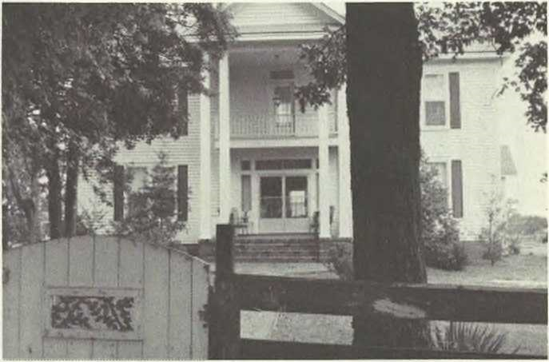
REPLICA OF "ESTES HALL", Haywood Co., Tenn., built in 1825 by Capt. (War of 1812) Joel (4) Estes. (Photo by Helen Estes Seltzer).

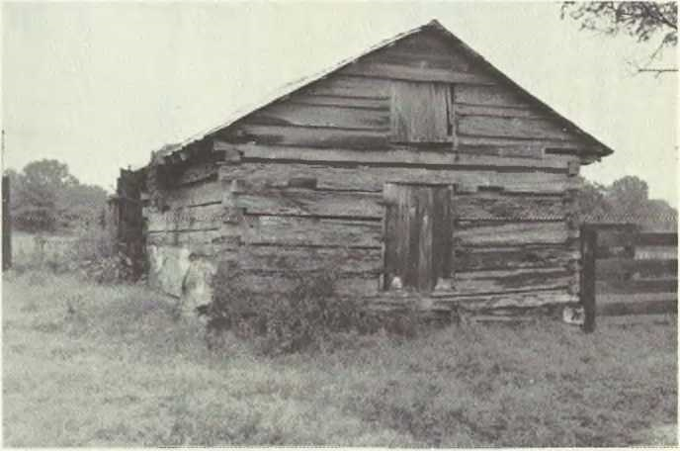SLAVE QUARTERS. one of several on grounds of "Estes Hall". (Photo by Helen Estes Seltzer).

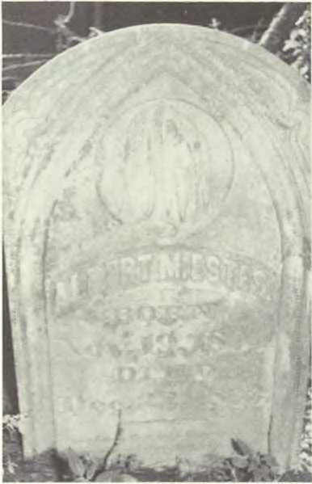
TOMBSTONE OF ALBERT MONROE (5) ESTES, in Pickett Family Burial Grounds on farm of Jamie Elder, Lauderdale Co., Tenn. (Photo by Richard W. Seltzer, Sr.)

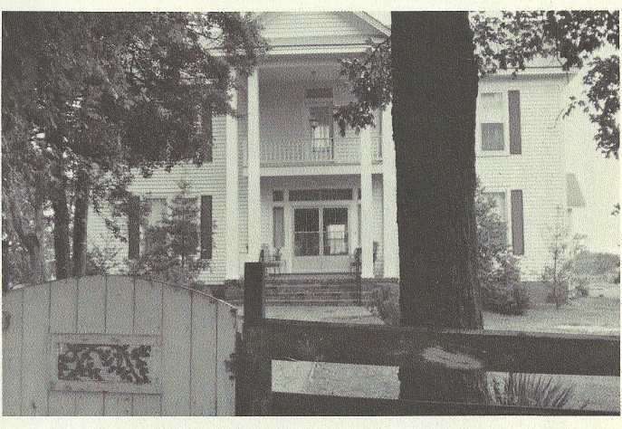
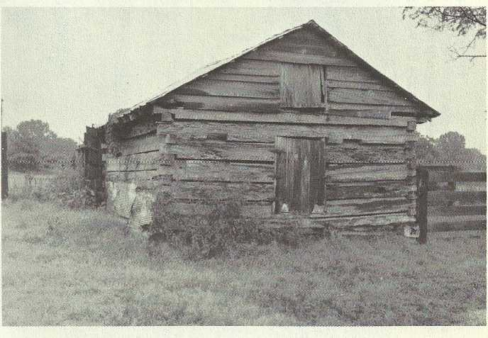
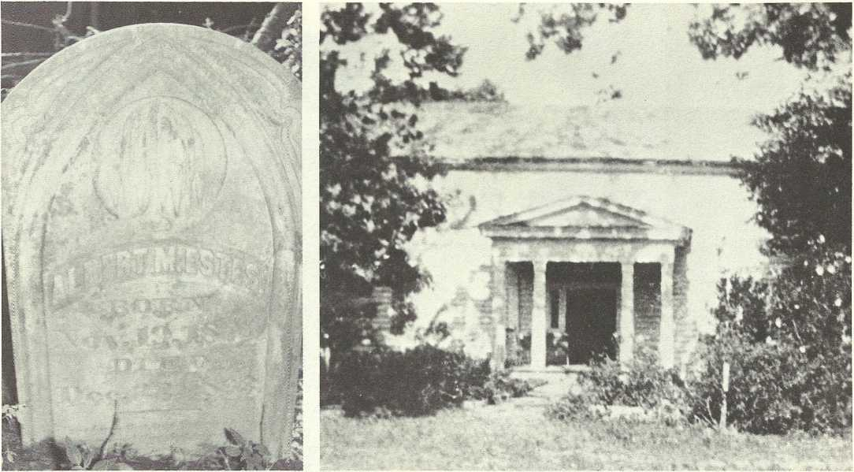
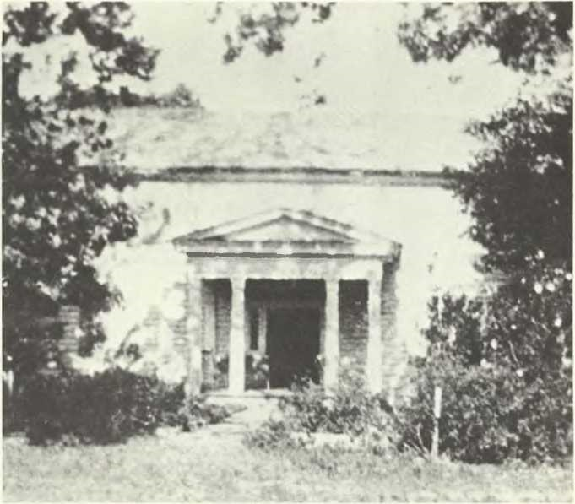ALBERT MONROE (5) ESTES PLANTATION, no longer standing. Life there during Civil War described in autobiography of William Lawrence (6) Estes in "Estes Activities and Accolades." (Photo courtesy of Mrs. H .F. Ambrose, Nashville, Tenn.)
328FAMILY ALBUM/Estes
REPLICA OF "ESTES HALL", Haywood Co., Tenn., built in 1825 by Capt. (War of 1812) Joel (4) Estes. (Photo by Helen Estes Seltzer).
SLAVE QUARTERS, one of several on grounds of "Estes Hall". (Photo by Helen Estes Seltzer).
TOMBSTONE OF ALBERT MONROE (5) ESTES, in Pickett Family Burial Grounds on farm of Jamie Elder, Lauderdale Co., Tenn. (Photo by Richard W. Seltzer, Sr.)

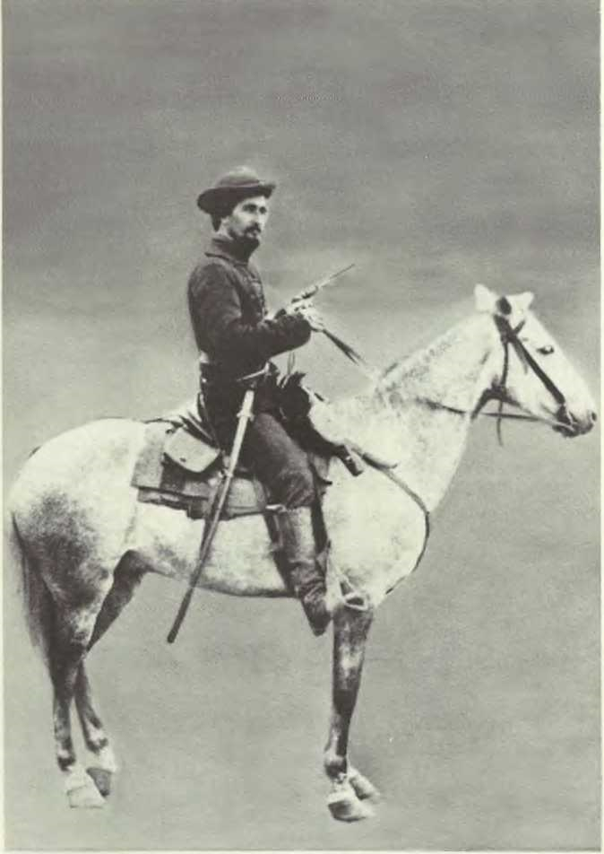

ALBERT MONROE (6) ESTES in Civil War uniform. (Photo copied by Ches Hamby Studio, Ripley, Tenn.; negative on file there.)
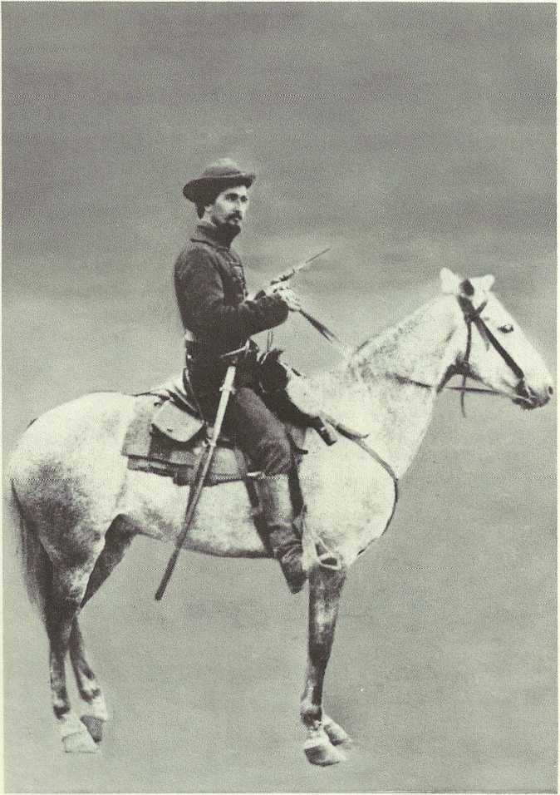
PHOTOS FROM ALBERT MONROE (5) ESTES FAMILY REUNION, 1977

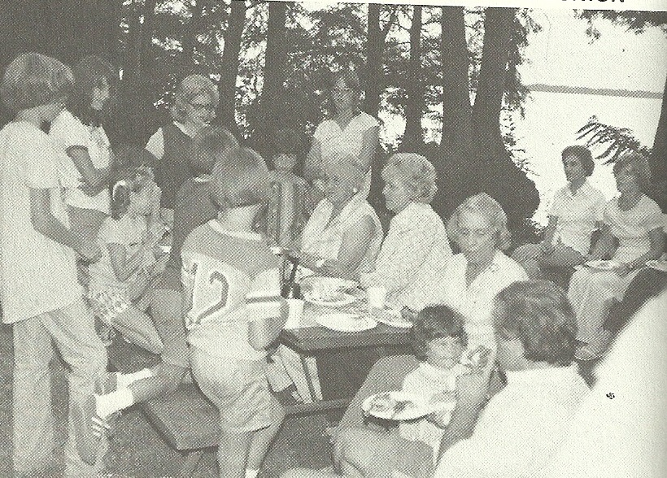
COOK-OUT AT REELFOOT LAKE, Albert Monroe (5) Estes Family Reunion, Aug. 1977. Seated: l. to r., Sallie (7) Estes, Helen (8) Estes Seltzer, and Frances Henry Dykes (wife of the late James Minos (7) Dykes) surrounded by family members. (Photo by Richard W. Seltzer, Sr.)

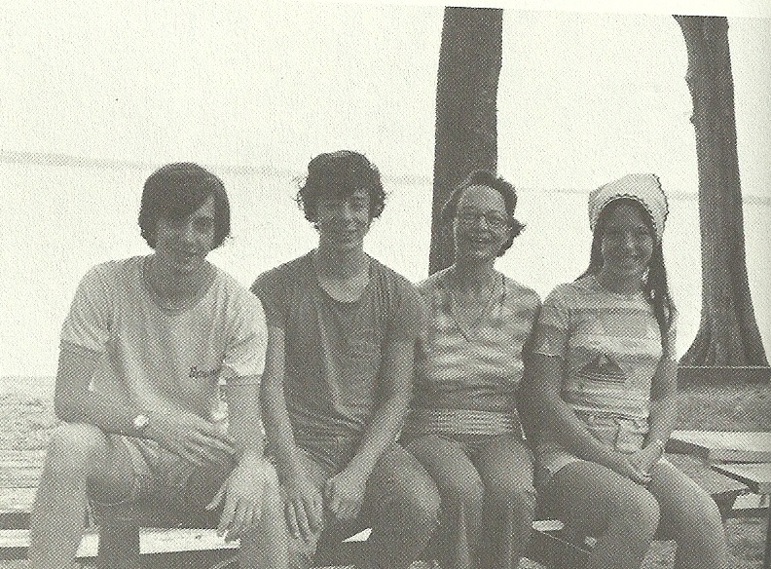
MARTHA JOY (9) PARKER WINTERMUTE AND CHILDREN, of Durham, N.C.; l. r. Philip, Walter, Martha Joy, and Elizabeth.

NORMAN AND EVANGELIN E SMITH, of Winston Salem, N.C. and SALLIE (7) ESTES, of Orysa, Tenn.
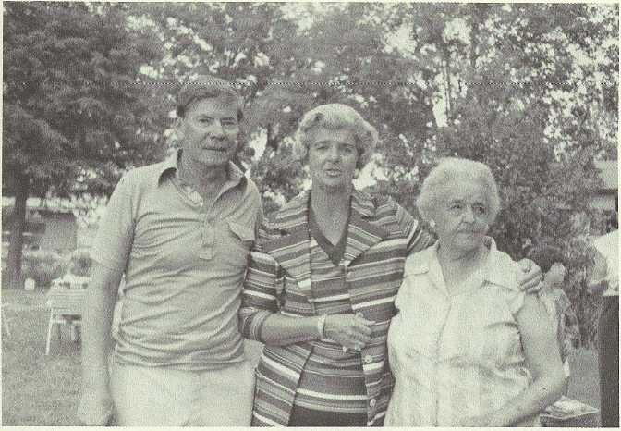
NORMAN AND EVANGELINE SMITH, of Winston Salem, N.C. and SALIE (7) ESTES, of Orysa, Tenn.

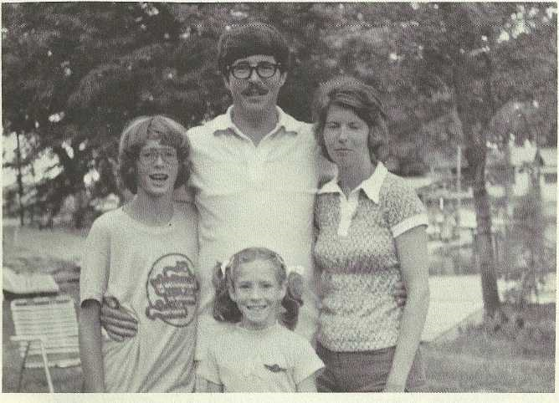
NORMAN ESTES (9) SMITH FAMILY, of Atlanta, Ga„ wife Ann and children, Eric and Betsy.

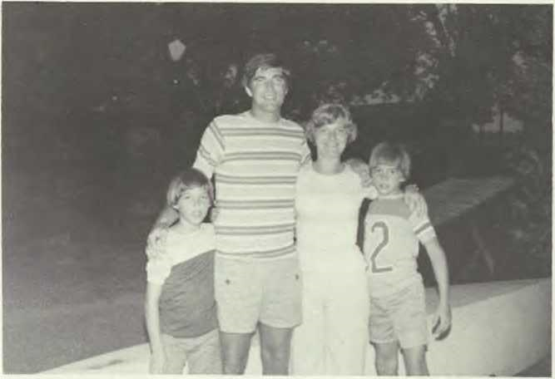
THE HARRY (9) SMITH FAMILY, of Eden, N.C.; l. to r., Scottie, Harry, Joy (his wife), and Jimmie.

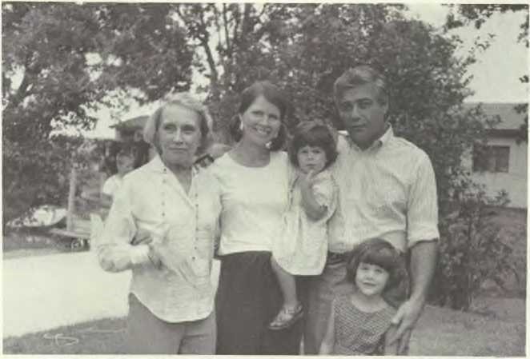
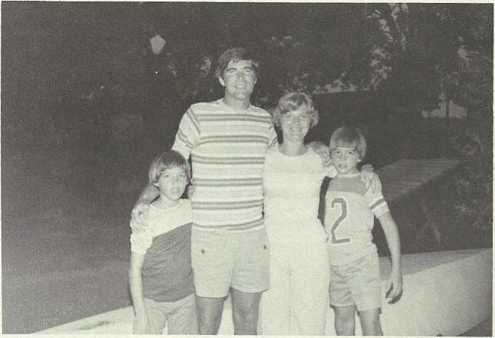
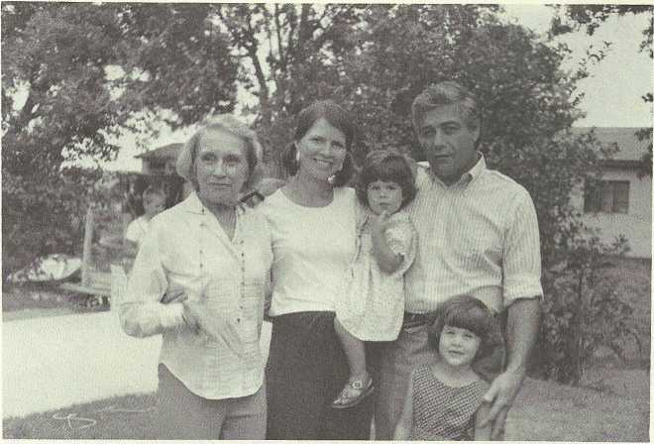
BETSEY (9) DYKES LEITZES, of Irvington, N.Y., her mother and family; I. to r., her mother, Frances Dykes, of Chapel Hill, N.C.; daughter, Sarah Bosley; husband, Gerald; and daughter, Cary Estes.
PHOTOS FROM ALBERT MONROE (5) ESTES FAMILY REUNION, 1977
THE HARRY (9) SMITH FAMILY, of Eden, N.C.;I. to r„ Scottie, Harry,
Joy (his wife), and Jimmie.
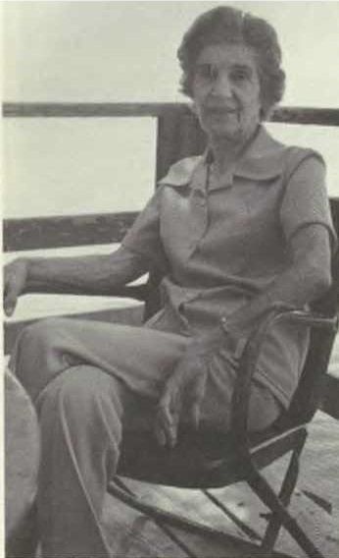
MIRIAM (8) EVANS CARSON, of Nashville, Tenn.

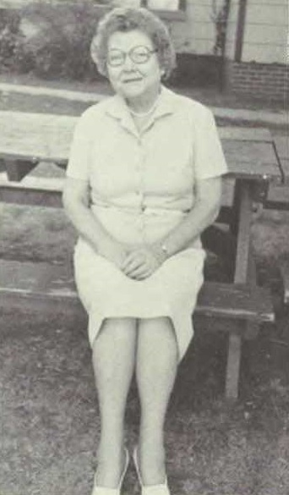
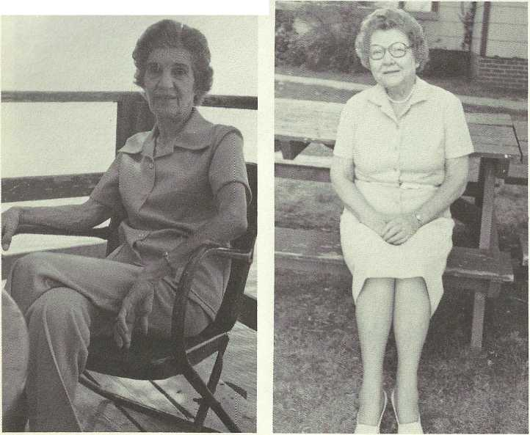
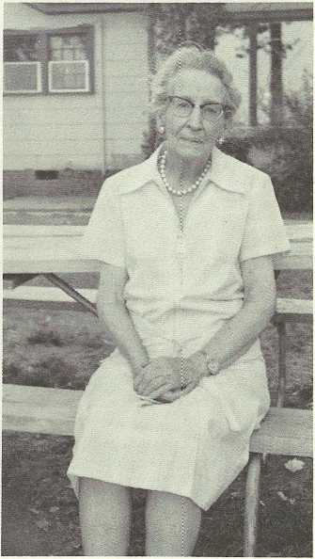
ALICE ANDERSON (8) RICE (of Moreau Pinckney (5) Estes Line), of Lauderdale Co., Tenn.
FAMIL Y ALBUM/ Estes333
MIRIAM (8) EVANSCARSON, of Nashville, Tenn.

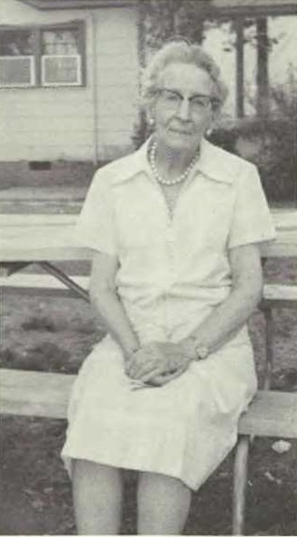
MYRA LANDRUM BACON RICE (Mrs. Ralph Estes (7) Rice) (husband in Moreau Pinckney Estes Line), of Dyersburg, Tenn.

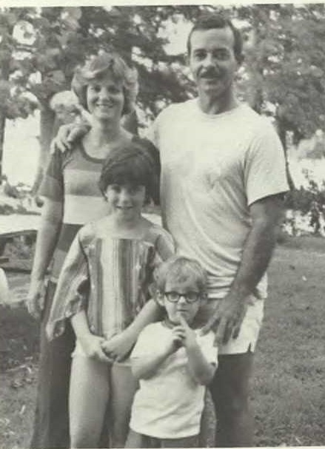
NANCY DYKES (9) & CLAUDE RYAN & CH I LD R EN, Pamela and Scott, of Waldorf, Md.
SALLIE ESTES (9) DYKES WALKER AND DAUGHTERS; I. to r., Travis, Sally Estes, and Allison.
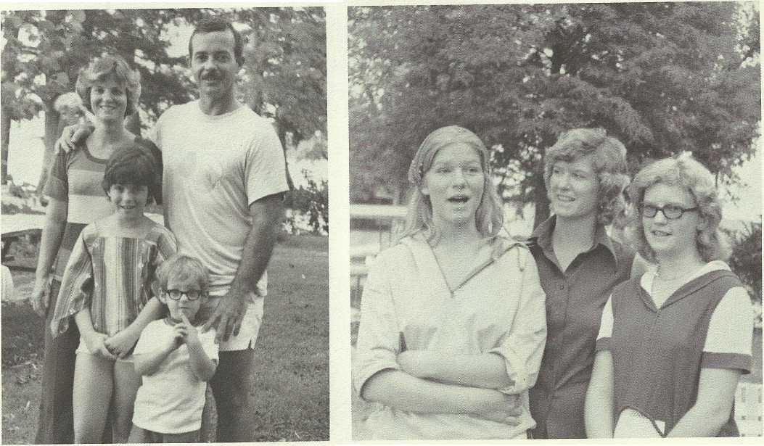
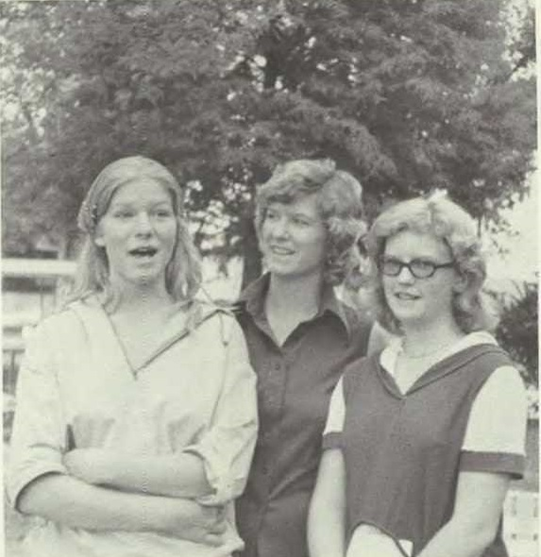
SALLIE ESTES (9) DYKES WALKER AND DAUGHTERS; l. to r., Tavis, Sally Estes, and Allison.
[end of reunion photos]

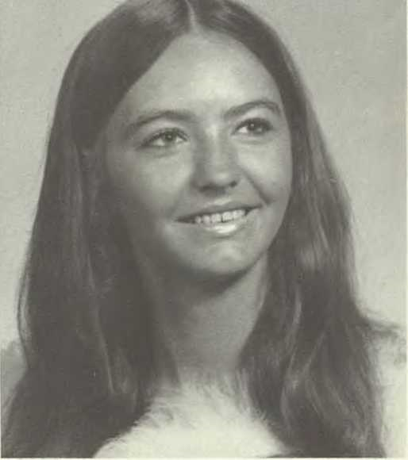
ELIZABETH ANN (10) PARKER, Ripley, Tenn. (Photo by Ches Hamby Studio, Ripley, Tenn.)

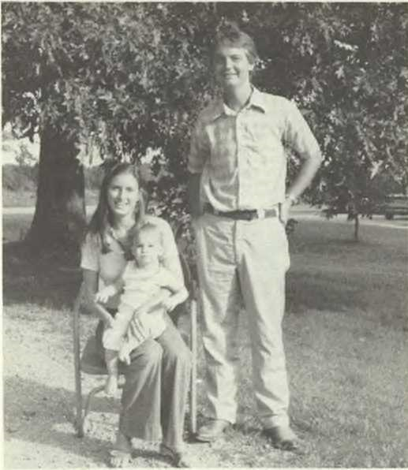
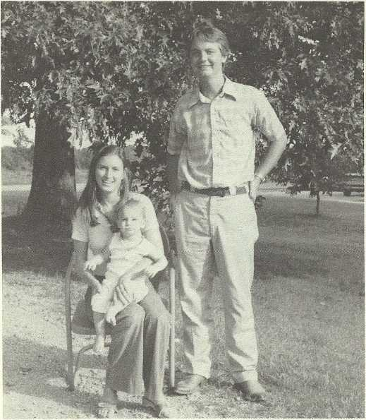
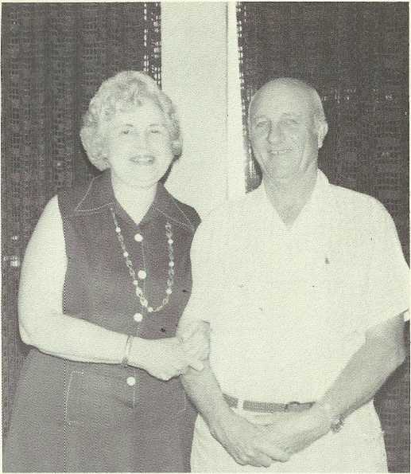
ANDREW (10) PARKER FAMILY; I. to r., wife, Mary Anne, son Franklin Andrew, and Andrew, Aug. 1977. (Photo by Helen Estes Seltzer).
336FAMIL Y A LBUM/ Estes

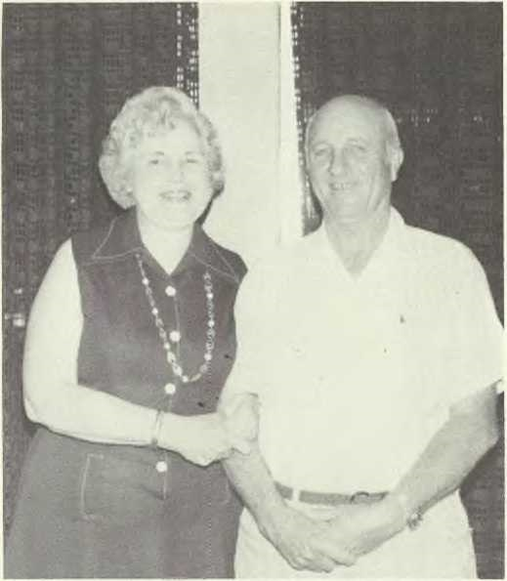
MARGARET & RUSSELL GASTON (8) EVANS, JR., Dyersburg, Tenn., Aug. 1977. (Photo by Helen Estes Seltzer).

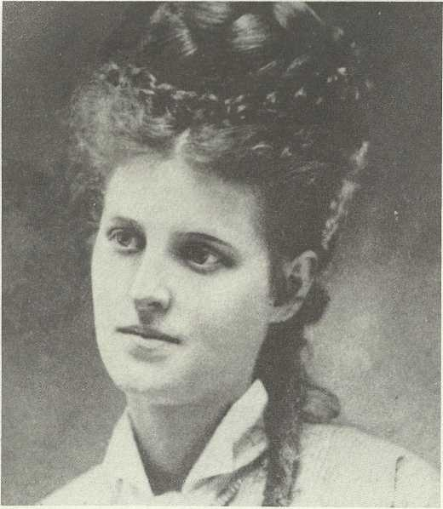
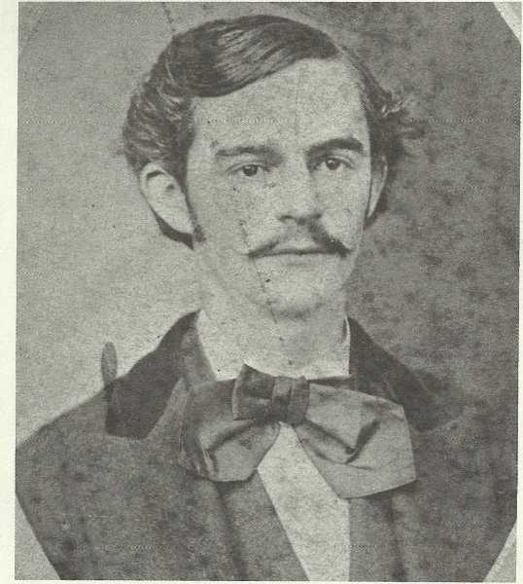
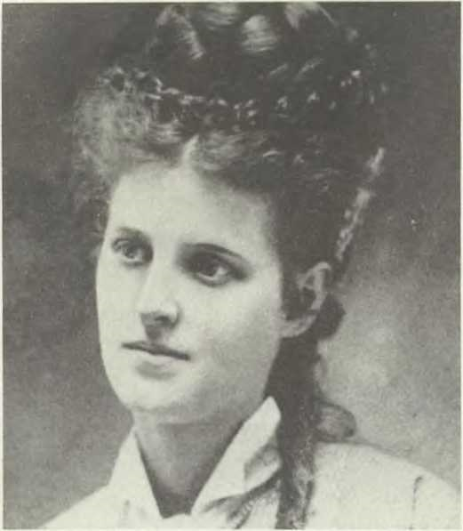
FAMIL Y A LBUM/ Estes33 7
ELIZA MILDRED (5) MOORE, "Lily," age about 16. She became wife of Dr. Louis Powhatan (6) Estes. She connects the Moore and Estes families. (Photo copied by Ches Hamby Studio, Ripley, Tenn.; negative on file there.)

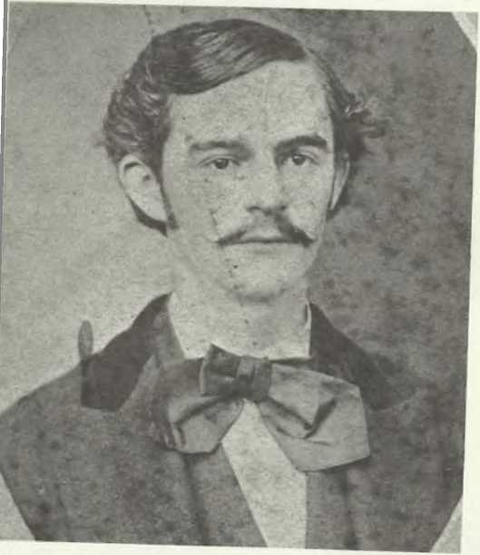
DR. LOUIS POWHATAN (6) ESTES, about 1874. (Photo copied by Ches Hamby Studio, Ripley, Tenn.; negative on file there).

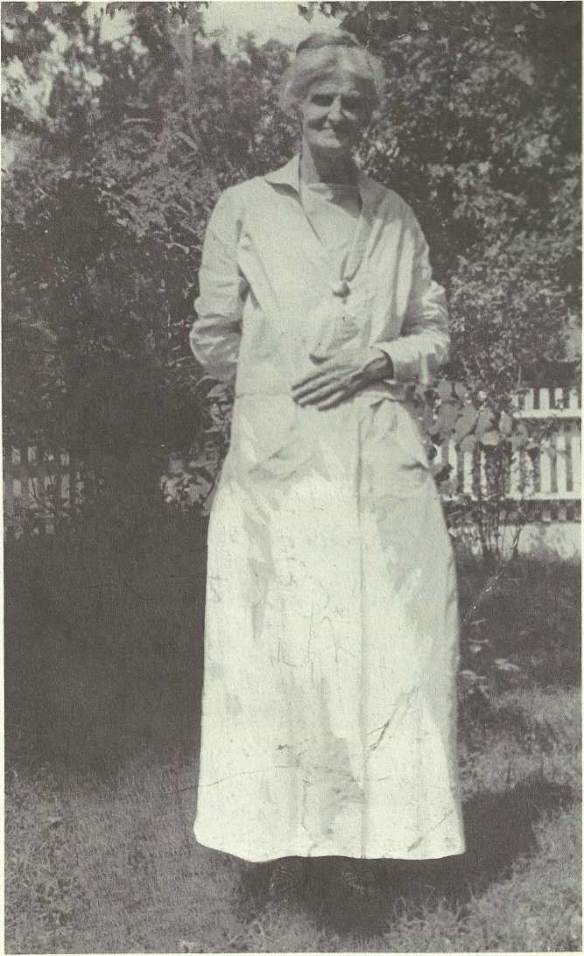

ELIZA MILDRED (5) MOORE ESTES, at "Oaklawn," Haywood Co., Tenn.

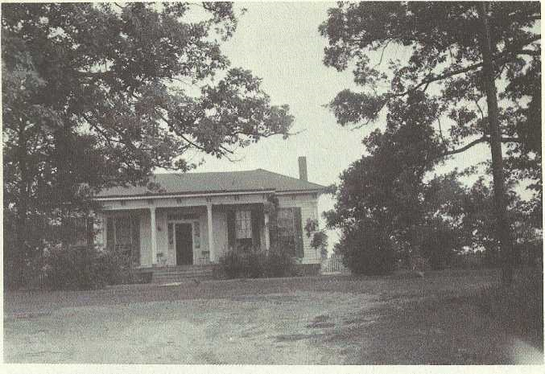

"OAKLAWN," Haywood Co., Tenn., started in 1865, finished in 1868; home of Dr. Louis Powhatan (6) and Eliza Mildred (5) Moore Estes; now home of Warner Moore (8) and Joanne Estes.

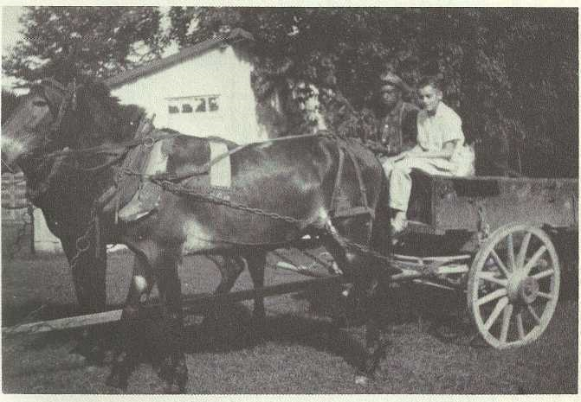
MOWING THE LAWN AT "LYN NG ATE," home ofSallie (7) Estes, Haywood Co., Tenn., July 1959; I. to r.. Whicker and Richard W. (9) Seltzer, Jr.

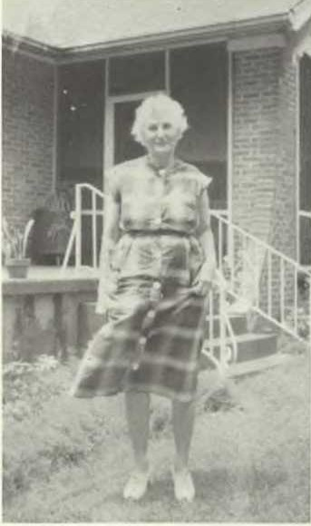
MARY (7) ESTES EVANS, in front of "Lynngate," Haywood Co., Tenn., July 1959

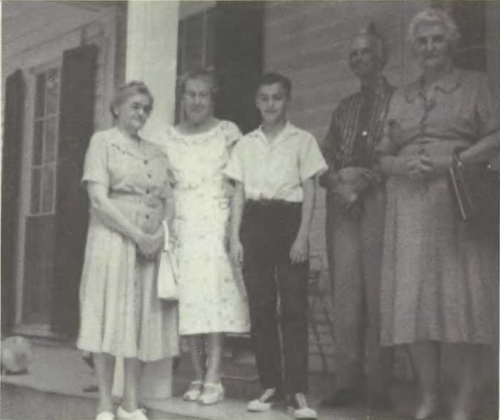

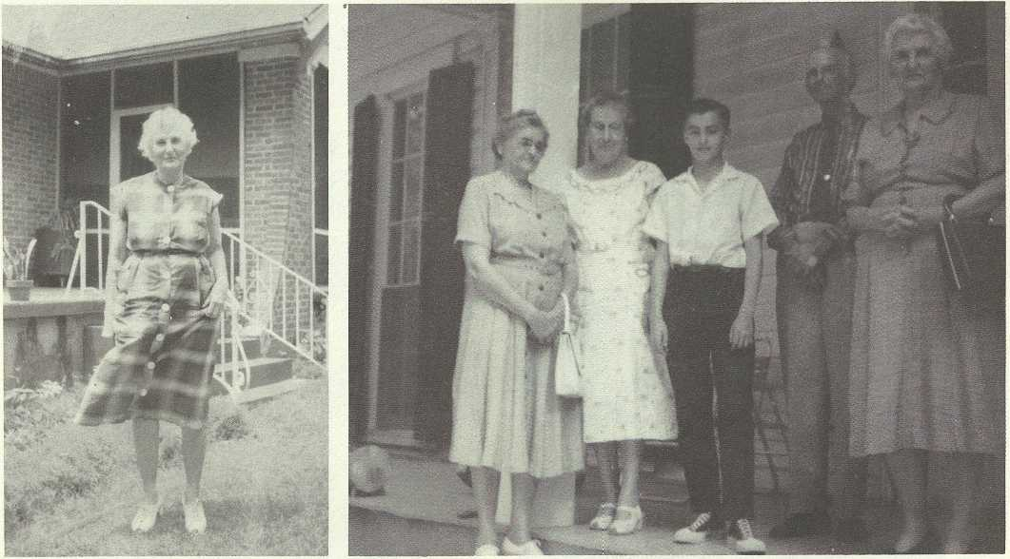
ESTES FAMILY GROUP ON VERANDA OF "OAK LAWN," July 2, 1959; l. to r., Sallie (7) Estes (Mrs. Albert Monroe (7) Estes); Lidy Kate Estes (Mrs. Laurence B. (7) Estes); Richard W. (9) Seltzer, Jr.; Laurence B. (7) Estes; and Mary (7) Estes Evans (Mrs. Russell G. Evans, Sr.)
340FAMIL Y A LBUM/ Estes
MARY (7) ESTES EVANS, in front of "Lynngate," Haywood Co., Tenn., July 1959.
(Photo by Richard W. Seltzer, Sr
.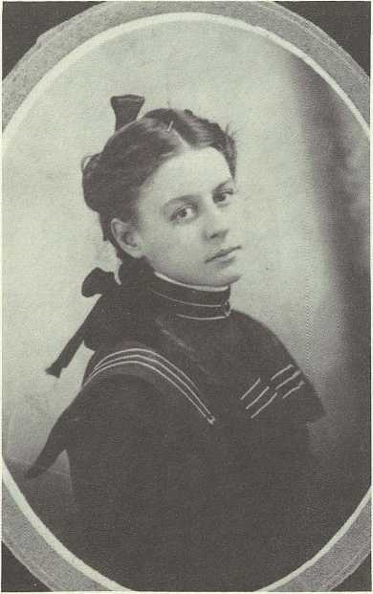
MAE GRIFFITH, age 16, 1899. She later married Smith William (7) Estes.

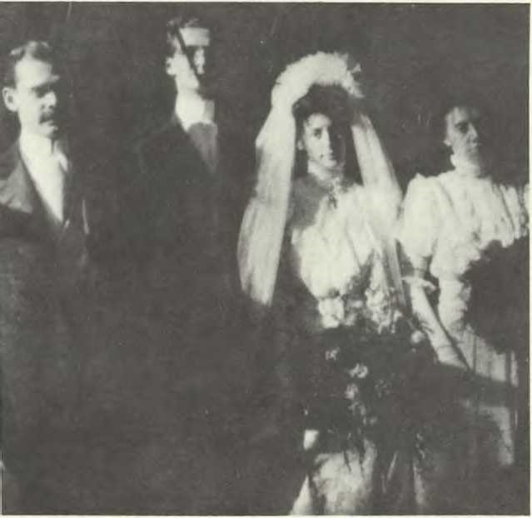

WEDDING OF SMITH WM. (7) AND MAE GRIFFITH ESTES, Nov. 29th (Thanksgiving Day) 1906; I. to r., best man (name unknown). Smith William, Mae, and her sister (maid of honor) Lillian Griffith.

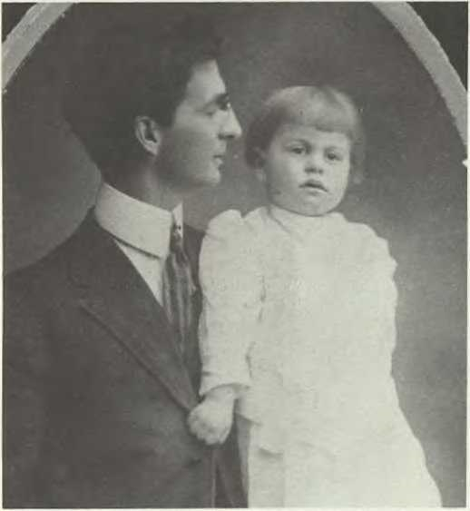
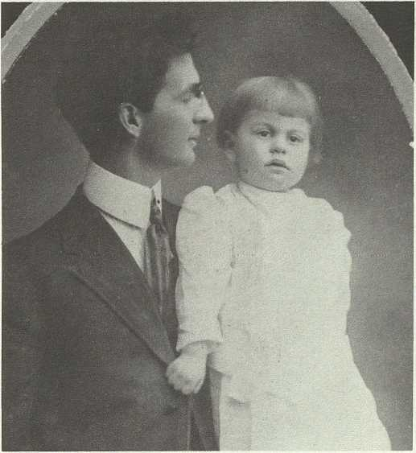
SMITH WILLIAM (7) ESTES AND ELDEST SON, JACK, about 1909, Philadelphia, Pa.
342FA MIL Y A LBUM/ Estes

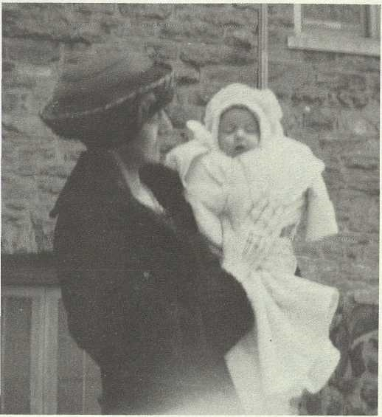
MAE GRIFFITH ESTES AND DAUGHTER HELEN (8) ESTES, christening, Redeemer Lutheran Church, Philadelphia, Pa., spring, 1920.

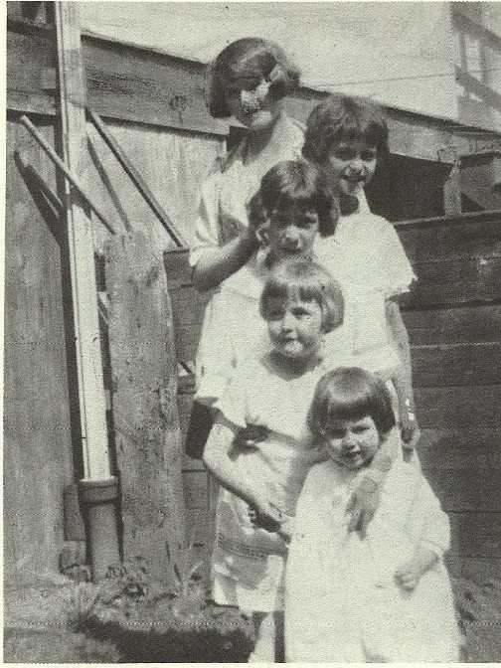
DAUGHTERS OF SMITH WILLIAM (7) AND MAE GRIFFITH ESTES, Philadelphia, Pa., about 1925. Top to bottom, Lily, Virginia, Agnes, Helen, and Mildred.

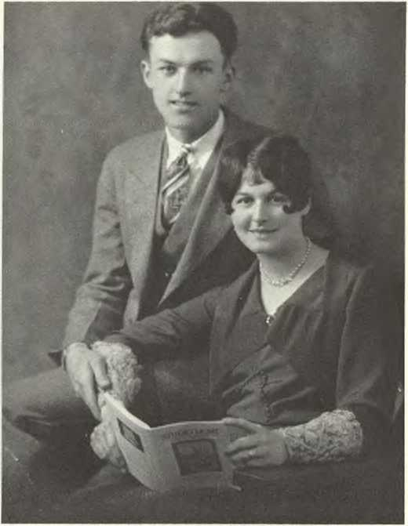
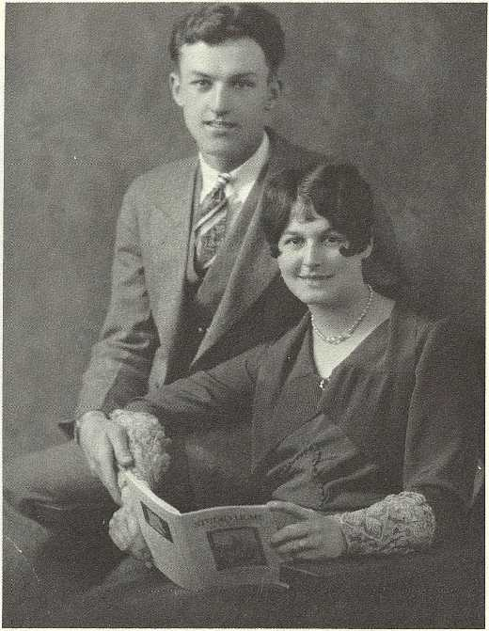
WILLIAM NORRIS AND LILY MARGARET (8) ESTES MOYER, "Lillian," Philadelphia, Pa., Oct. 1929.
FAMIL Y A LBUM/ Estes343

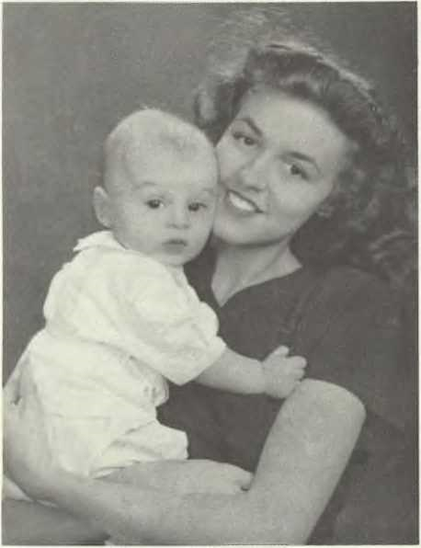
HELEN (8) ESTES SELTZER AND SON, Richard, Aug. 1946.

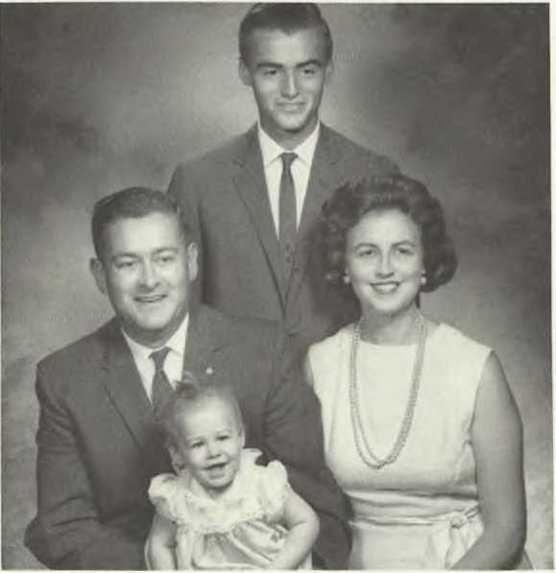
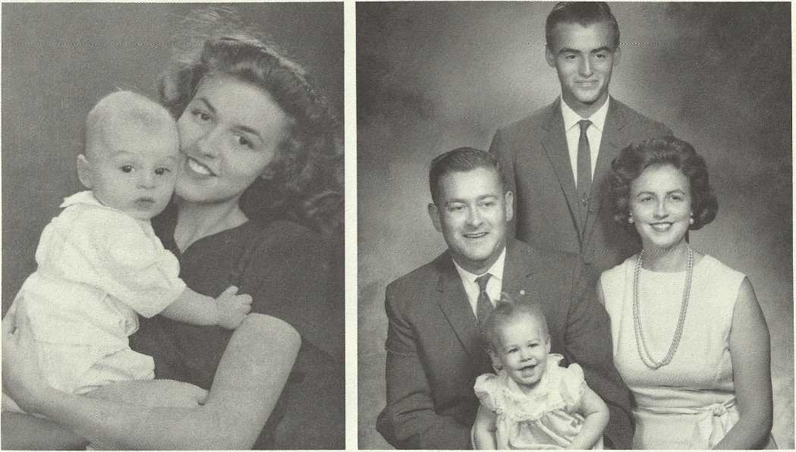
344FAMIL Y A LBUM/ Estes
THE RICHARD W. SELTZER, SR. FAMILY, summer, 1964, Aug. 1946. Bristol, Pa.; back, Richard, Jr.; middle, R ichard, Sr. and Helen (8) Estes; front, Sallie. (Photo by Bristol Photographers)

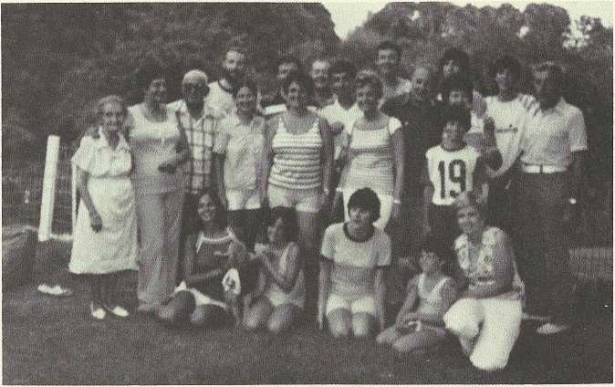

SMITH WILLIAM (7) ESTES FAMILY REUNION, garden of Virginia (8)
Estes Jacoby, Abington, Pa., Aug. 1977; I. to r., back row: Wayne (9) Jacoby, Ricky Brown, Dick Seltzer, Billy (9) Moyer, Charles Coffman, Craig (10) Moyer; middle row: Kathryn Jacoby, Mildred (8) Estes Kleiner, Jim Kleiner, Joyce (9) Rowland Brown, Ginger (9) Jacoby Coffman, Betty Jane (9) Moyer Knittel, Agnes (8) Estes Meyers, Scott (10) Moyer, Lillian (8) Estes Moyer, Bill Moyer; seated: Gay (9) Rowland, April (10) Coffman, Joanne Jacoby, Amy (10) Coffman, and Blanche Moyer.

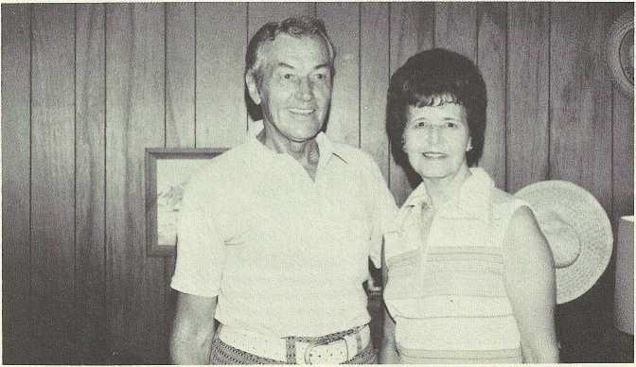

BILL AND LILLIAN MOYER

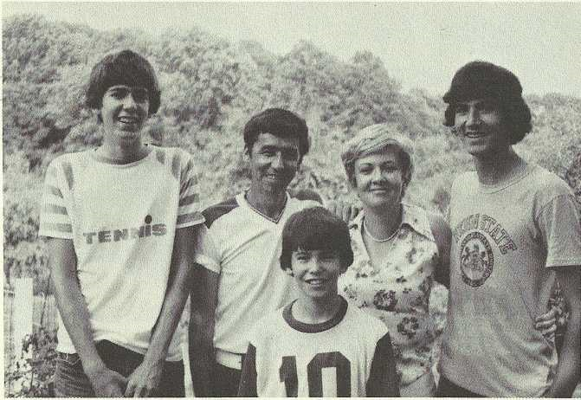
THE WILLIAM ("BiLLY") MOYER, III FAMILY: I. to r., backrow: Craig, Billy, Blanche, and Billy, IV; front: Scott.

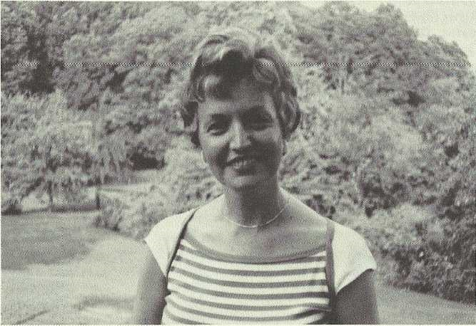
BETTY JANE (9) MOYER KNITTEL

SMITH WILLIAM (7) ESTES FAMILY REUNION, 1977
VIRGINIA (8) ESTES JACOBY

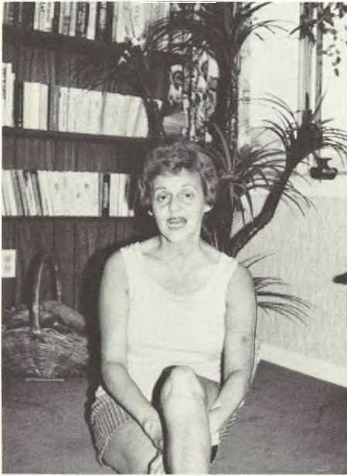

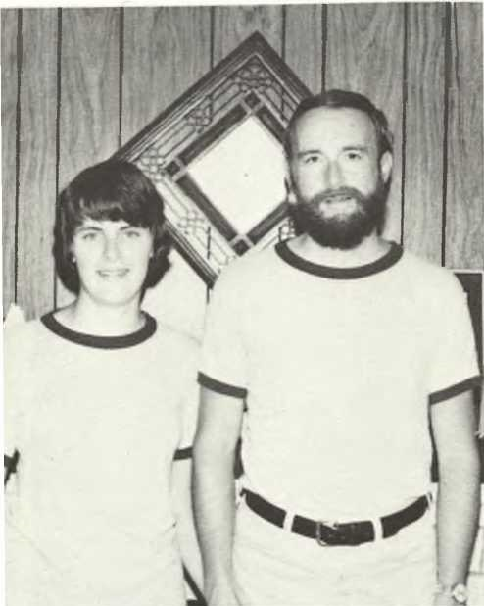
JOANNE AND WAYNE (9) JACOBY
\

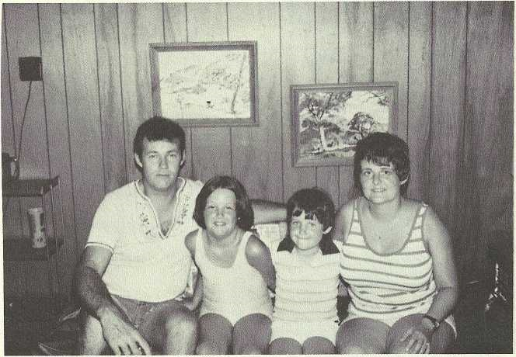
THE CHARLES COFFMAN FAMILY, I. to r., Charles, April, Amy, and Ginger (9) Jacoby Coffman.

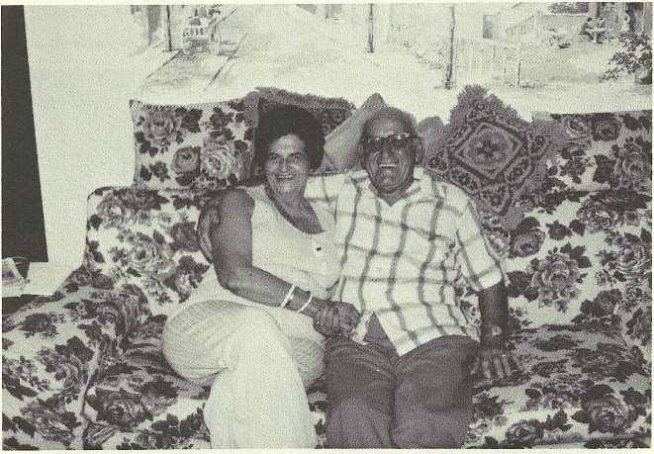
JAMES AND MILDRED (8, ESTES KLEINER

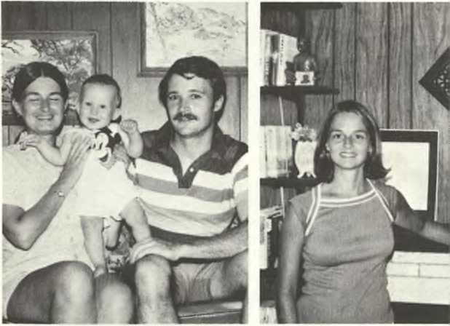
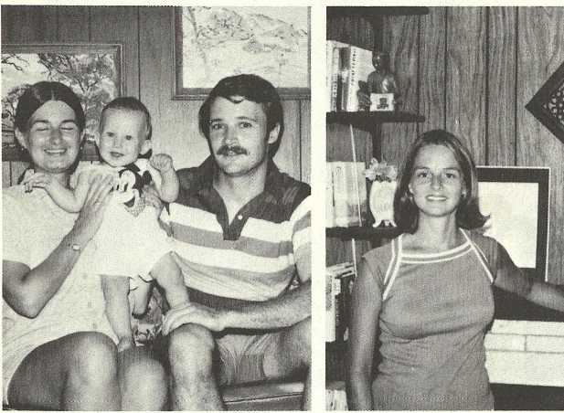
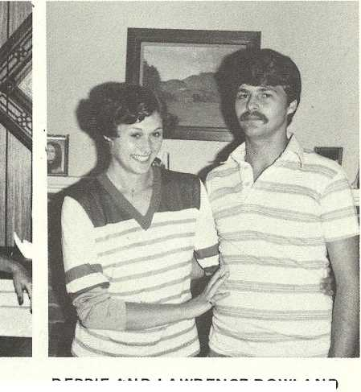
THE RICHARD BROWN FAMILY, I. to r., Richard ("Ricky"), Keith, and Joyce Rowland Brown. and GAY ROWLAND
FA MIL Y A LBUMj Estes349
GAY (8) ROWLAND
DEBBIE AND LAWRENCE ROWLAND

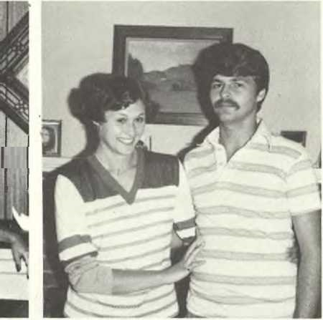
DEBBIE AND LAWRENCE ROWLAND

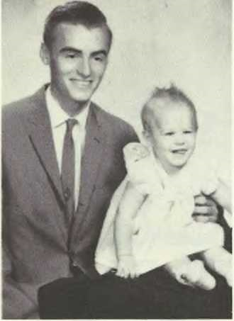
RICHARD (9), AND RAVEN [SALLIE ESTES] (9) SELTZER. 1964.

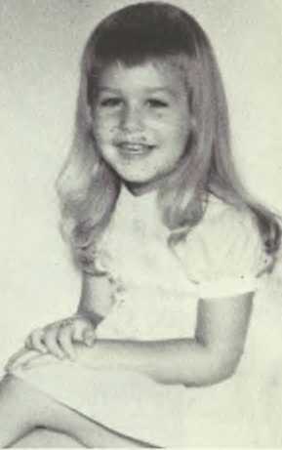

RAVEN [SALLIE ESTES] (9) SELTZER, Huntingdon Valley, Pa., 1967.

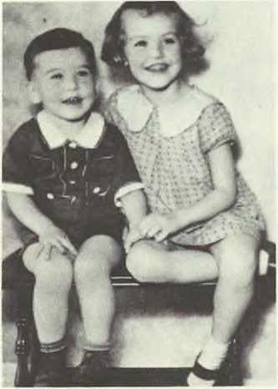
BILLY AND BETTY JANE (9) MOYER, ca. 1936.

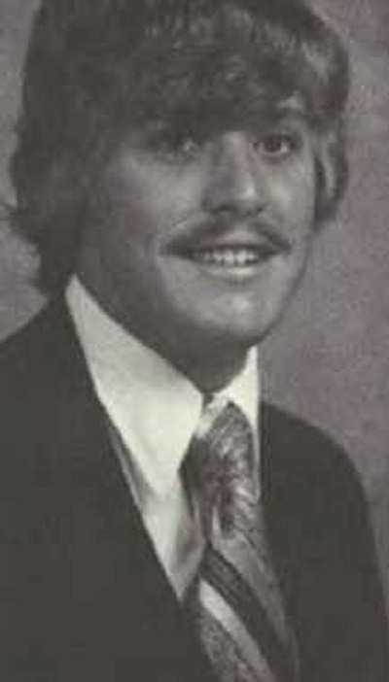
PAUL (10) KNITTEL, Philadelphia, Pa., 1979.

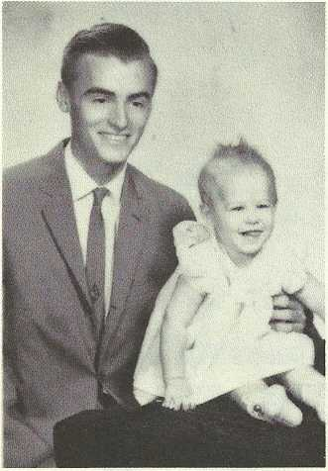
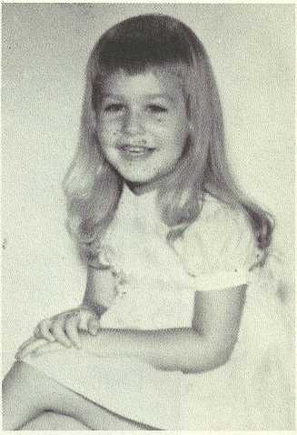
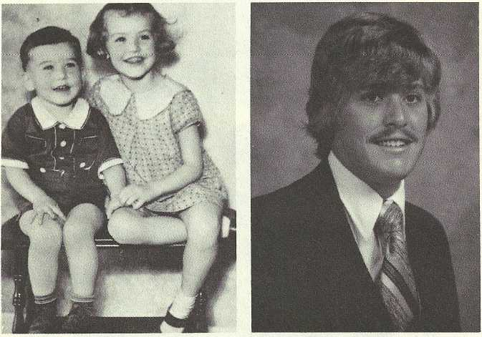
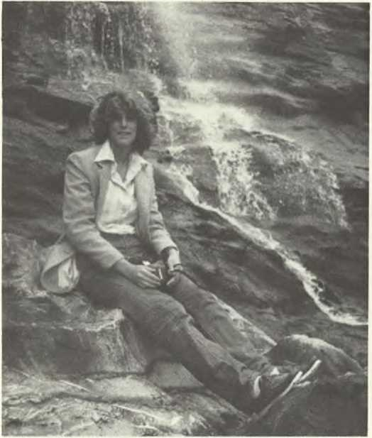
RAVEN (SALLIE ESTES) (10) SELTZER, Tintagel, Cornwall, England, summer 1979.

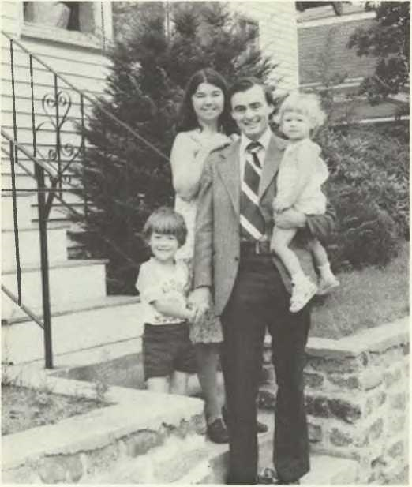
THE RICHARD WARREN (9, SELTZER, JR. FAMILY, I. to r.: Bobby (10), Barbara, Richard (9), and Heather (10), West Roxbury, Mass., Oct. 1979.

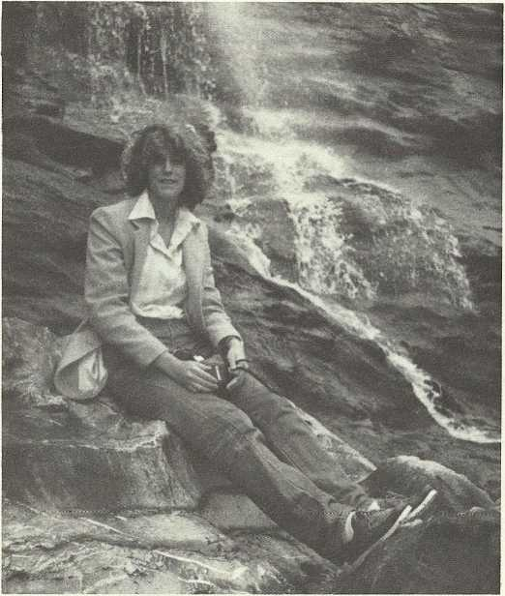
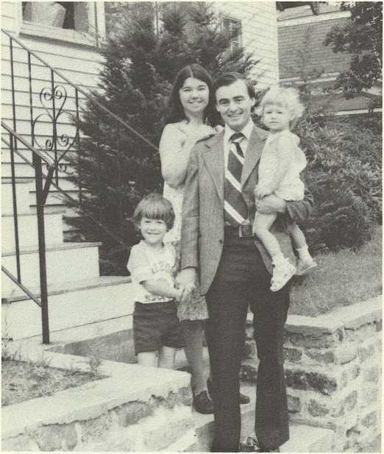
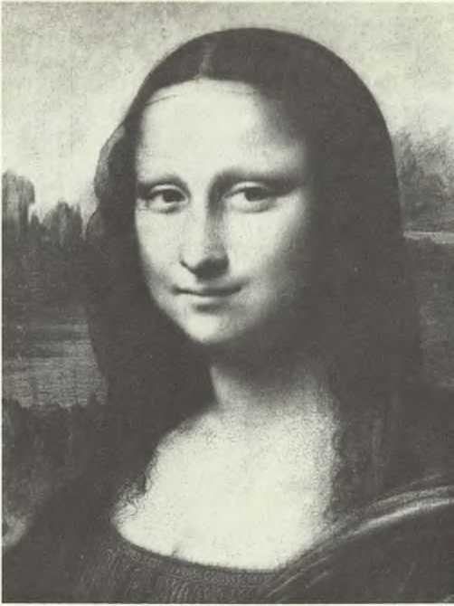
THE MONA LISA (perhaps Isabella d'Este). (Photo courtesy of the Louvre, Paris, France).

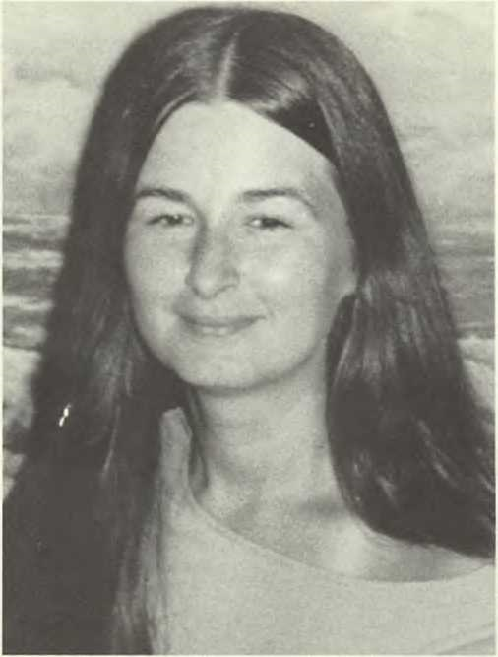
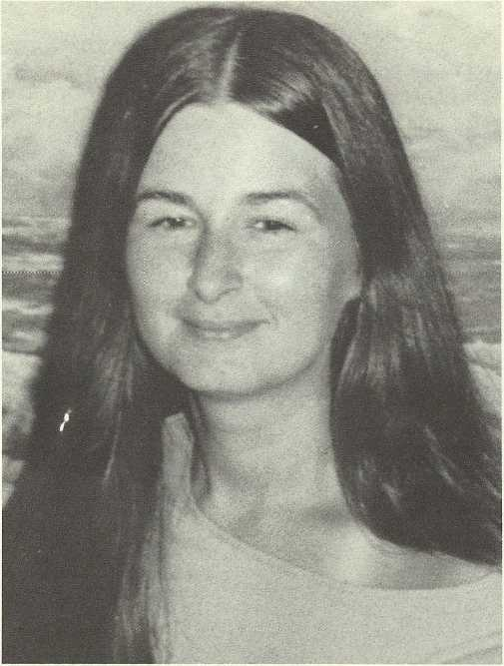
MONA LISA LOOK-ALIKE: Joyce (9) Rowland Brown, a present-day Este (Estes).
SMITH WILLIAM (7) ESTES FAMILY, I. to r.: Lillian, Virginia, Lewis, Agnes, Mildred, and Helen, Ocean City, N.J., 1975, at wedding of Joyce Rowland and Richard Brown.

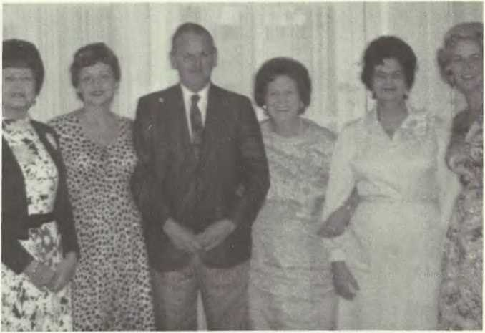

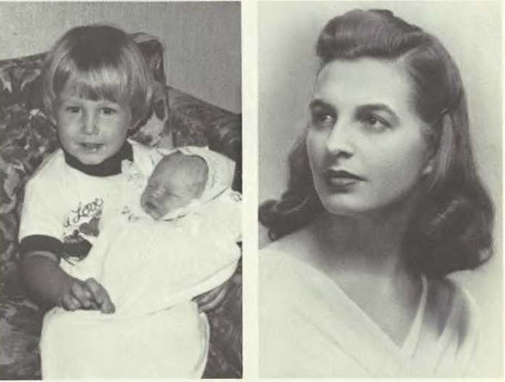
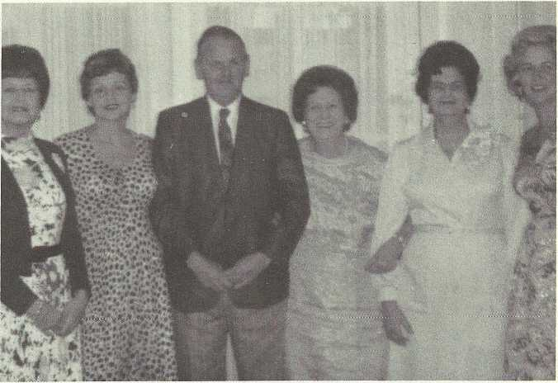
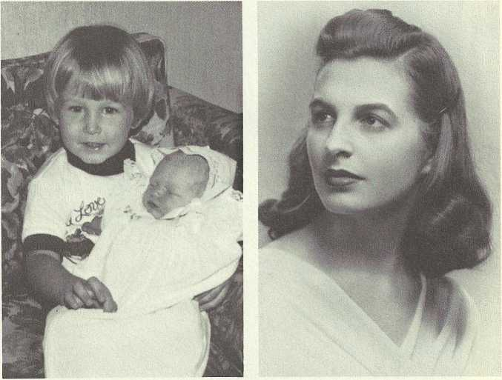
KEITH (10) AND PAMELA (10) BROWN, Sept. 21, 1979. MILDRED (8) ESTES, Philadelphia, Pa., 1940

BELLE (7) ESTES (DYKES) BROCK, Washington, D.C., 1930.LOUISE AND ALBERT (8) DYKES, Nashville, Tenn., Feb. 1974.
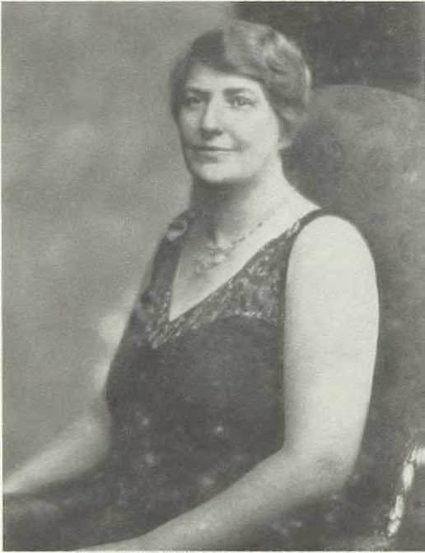
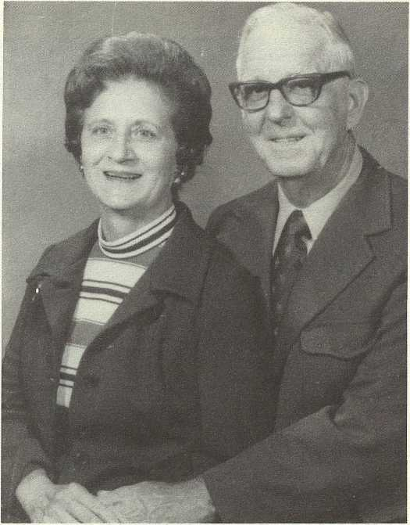

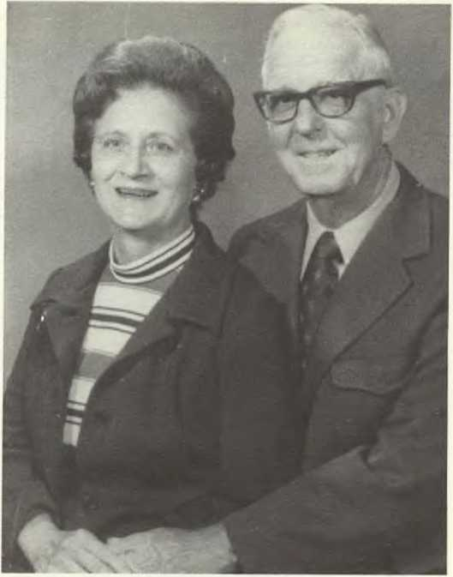
LOUISE AND ALBERT (8) DYKES, Nashville, Tenn., Feb. 1974.

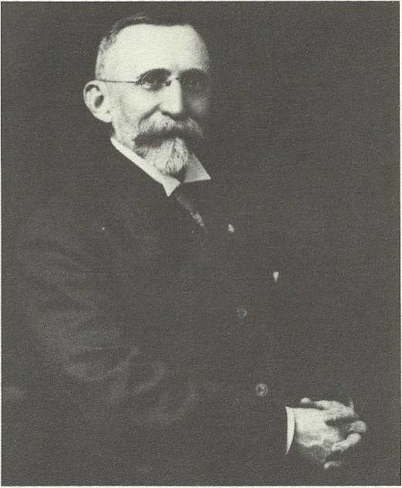
WILLIAM LAWRENCE (6) ESTES, SR., M.D., Bethlehem, Pa. (Photo courtesy of the William Lawrence Estes Library, St. Luke's Hospital, Bethlehem, Pa.)

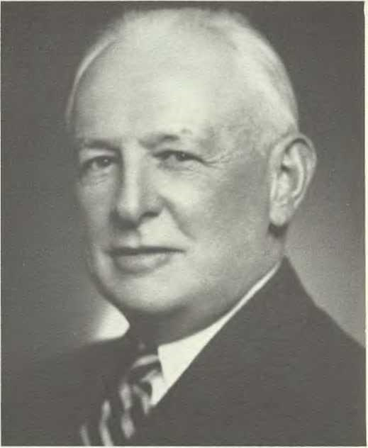
355
WILLIAM LAWRENCE (7) ESTES, JR., M.D., Bethlehem, Pa. (Photo courtesy of the William Lawrence Estes Library, St. Luke's Hospital, Bethlehem, Pa.)

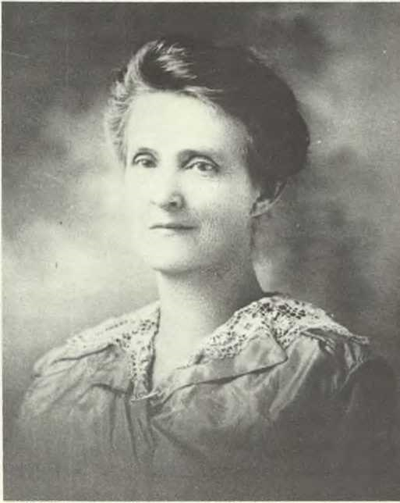
MARY NOEL (7) ESTES MOODY
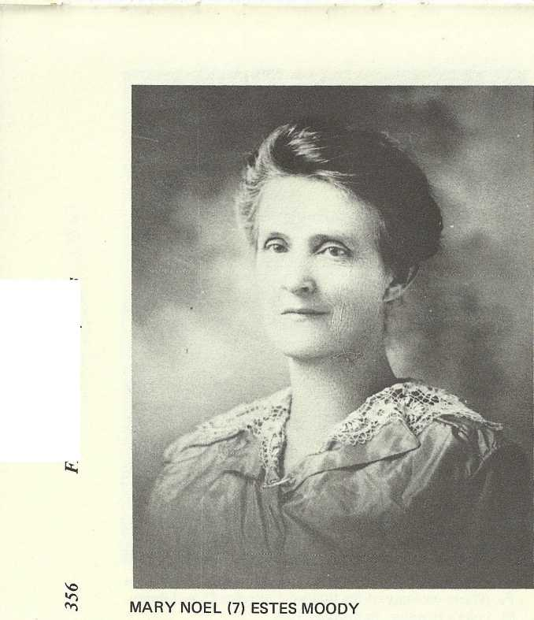
A MIL Y A LBUM/ Estes
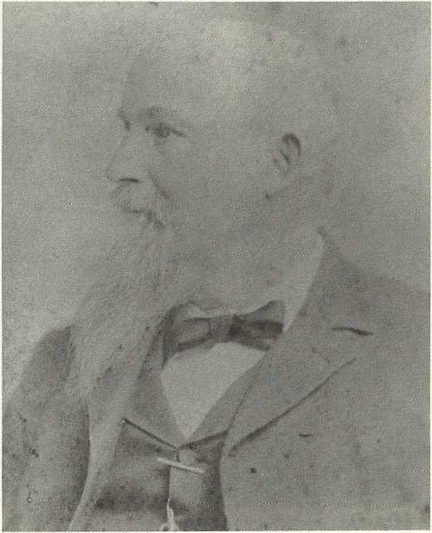
JOEL HENRY (6) ESTES, Haywood Co., Tenn.

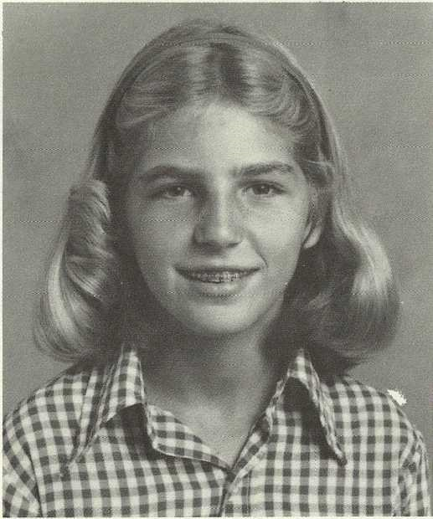
ALLISON BEARE COX, Sept. 1977

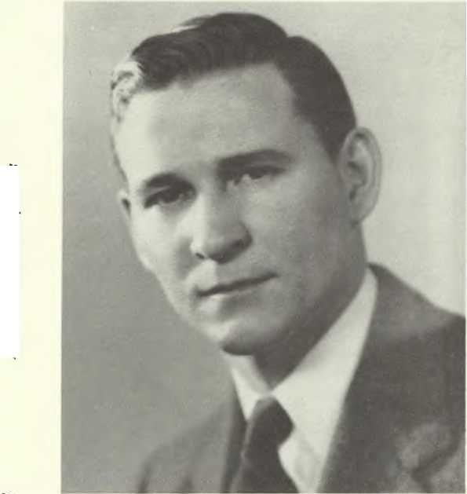
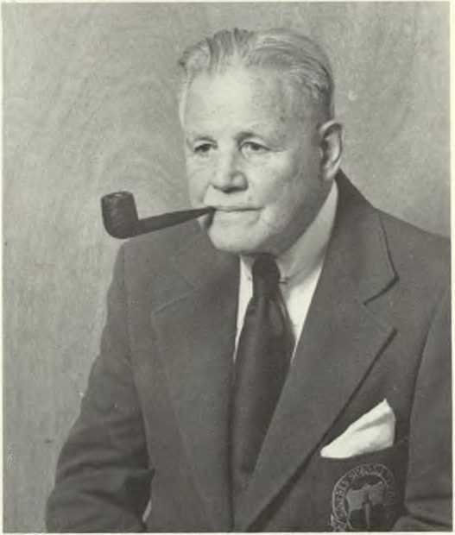
REAR ADMIRAL WINSTON ESTES PILCHER (8) FOLK, USN ret.

JAMES MINOS (8) DYKES, JR., Washington, D.C., 1935.

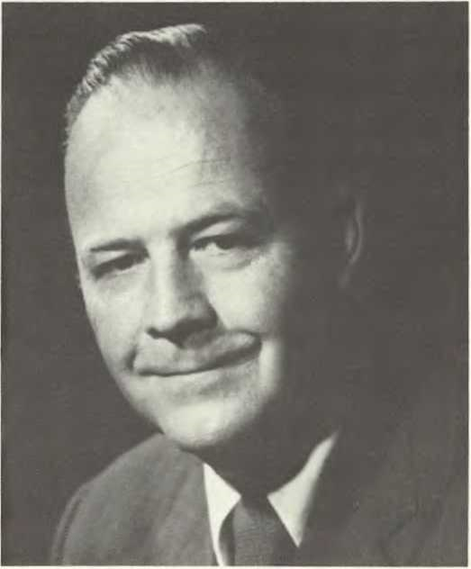
WILLIAM REECE (9) SMITH, JR., Tampa, Fla.
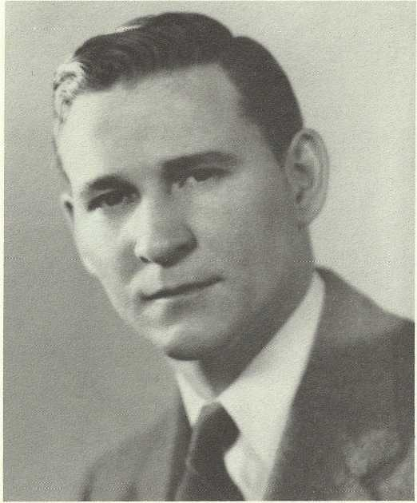
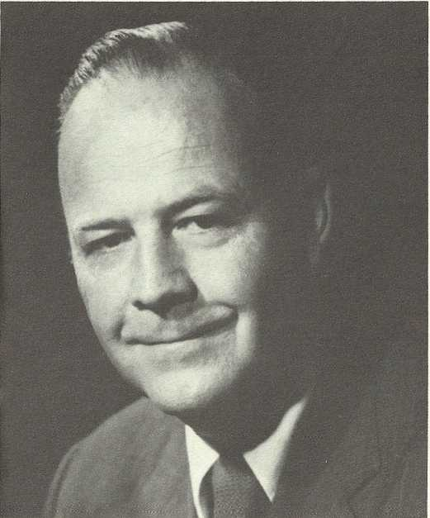
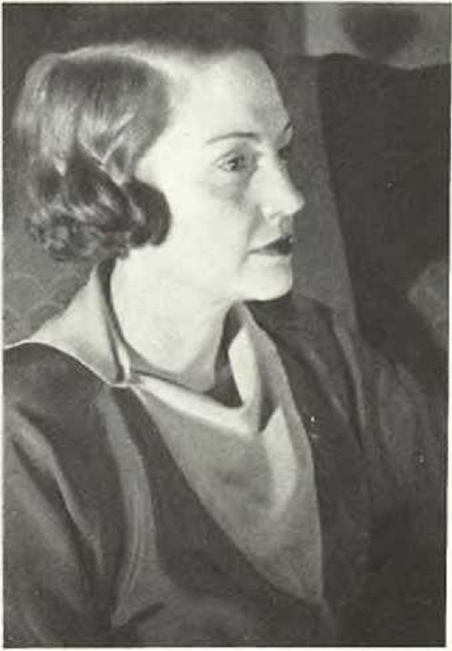
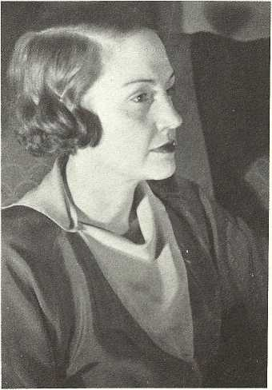
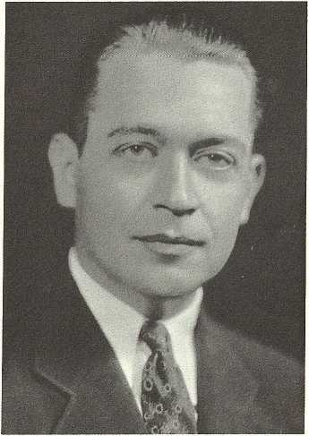
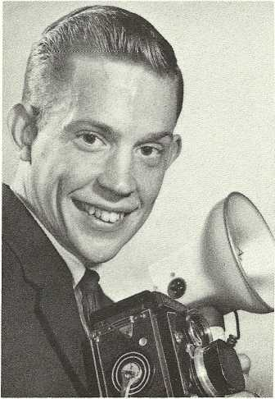
KATHERINE ESTES (8) RICE LOWE, Nashville, Tenn., 1934.
FA MIL Y A LBUM/ Estes359

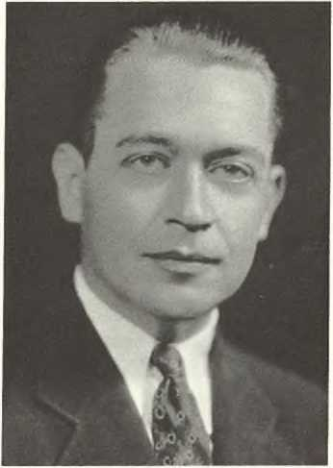
HAROLD GLADSTONE LOWE, Nashville, Tenn.

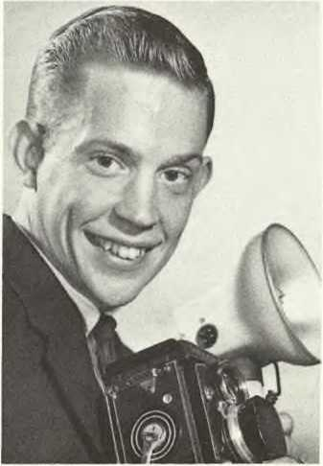
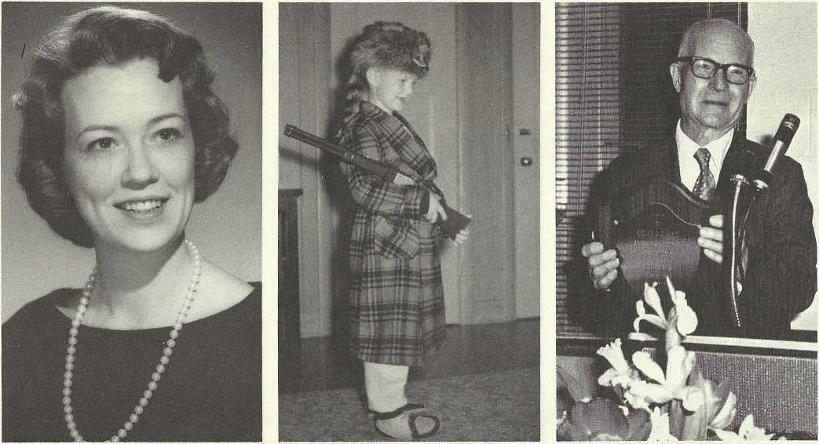
HAROLD GLADSTONE (9) LOWE, JR., Nashville, Tenn., 1963.
360FA MIL Y A LBUM/ Estes
KATHERINE RICE (9) LOWE- EBERSOLE. (Photo by Schofield, Nashville, Tenn. 1964).

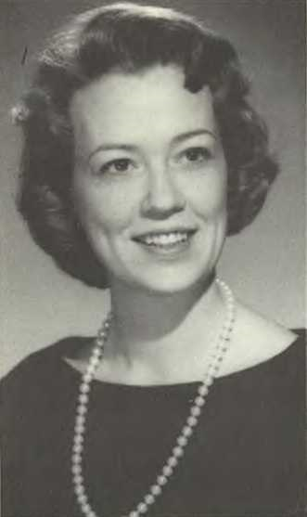
KATHERINE RICE (9) LOWE-EBERSOLE. (Photo by Schofield, Nashville, Tenn. 1964)
DONALD RICE (10) EBERSOLE (name now changed to Lowe), in Coonskin cap sent to him by cousin Senator (Carey) Estes (8) Kefauver, Nashville, Tenn., 1961.

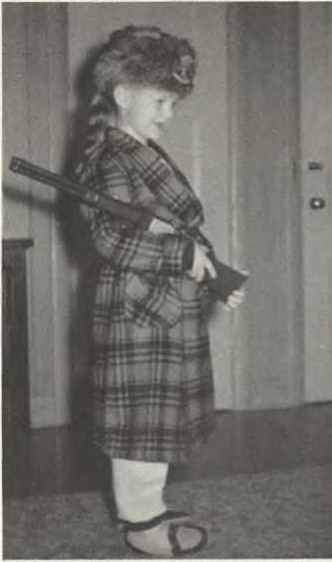

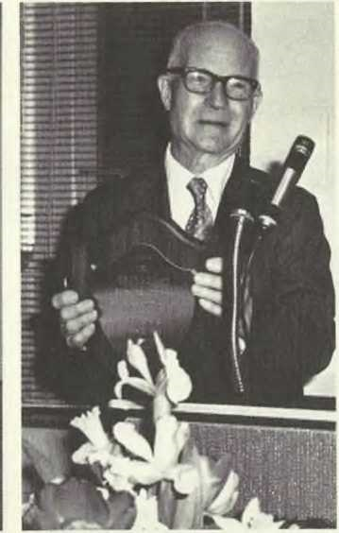
THOMAS JEFFERSON (8) WALKER, holding plaque honoring him at "Thomas Jefferson Walker Day", Dyersburg, Tenn., March 22, 1973.

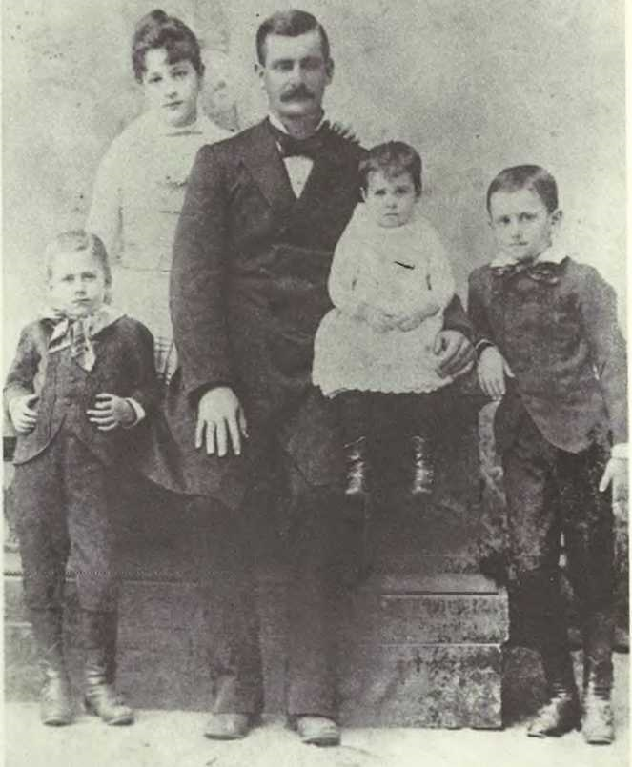
ALBERT CAREY (6) ESTES FAMILY, after passing of wife Lenora Perry Mann; I, to r.: Jefferson (7), Phredonia (7), Nora (7), and Albert Carey (7), Jr.
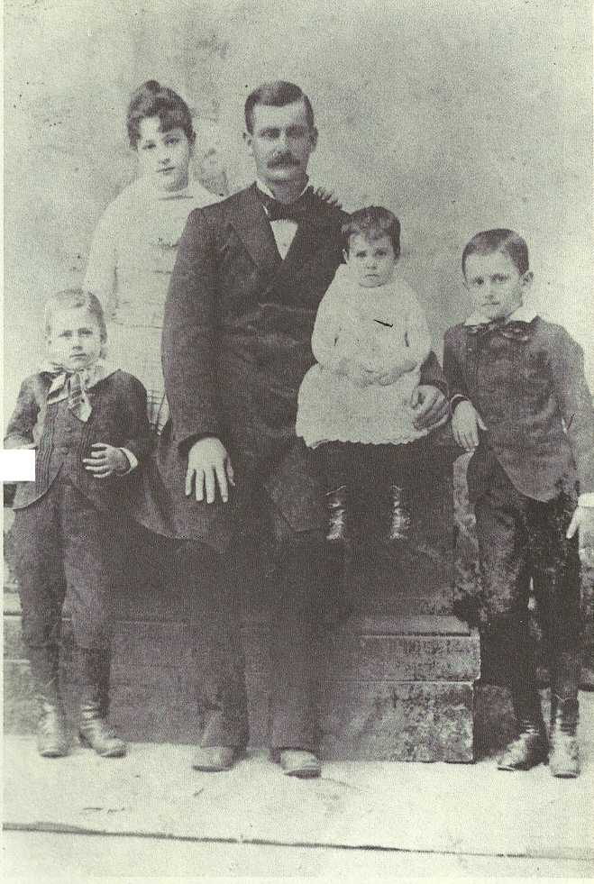
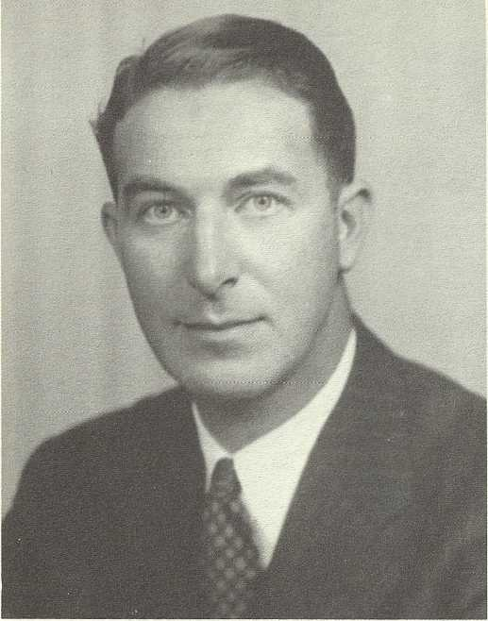
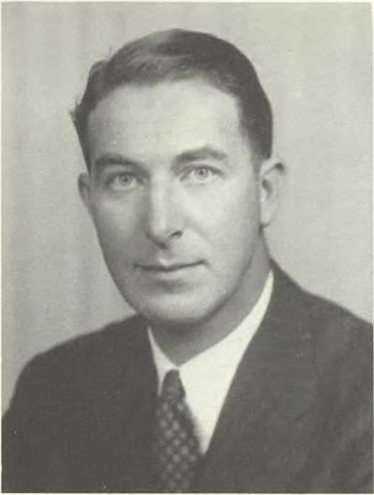
362FAMILY ALBUM/ Estes
SENATOR (CAREY) ESTES (8) KEFAUVER, as a young man.

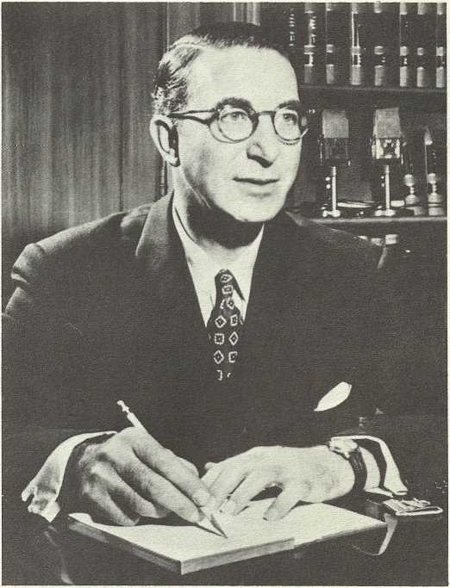
SENATOR (CAREY) ESTES (8) KEFAUVER, Washington, D.C. (Photo by Moss Photo Service, Inc., N.Y., N.Y.)

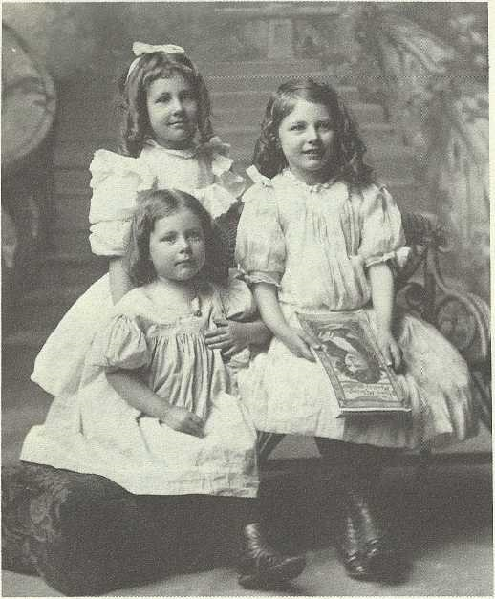
THE JEFFERSON MANN (7) ESTES CHILDREN, I. to r., standing: Ruby Grace; seated: Mary Leila and Ada Virginia, ca. 1910.

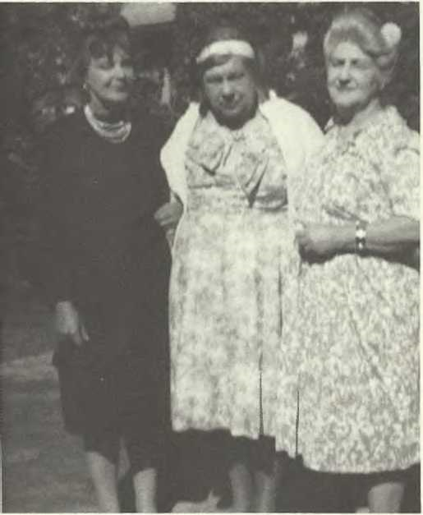
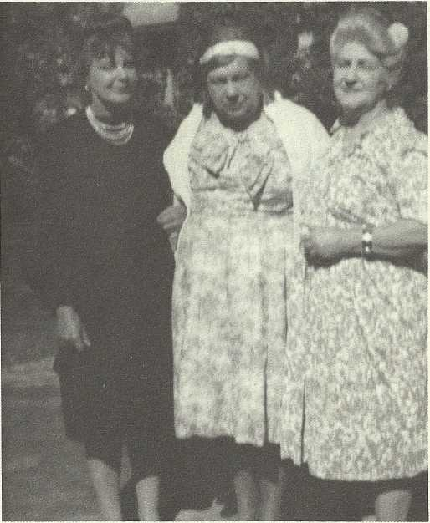
ADA VIRGINIA (8) ESTES LYONS, stage name "Virginia Bradford," with Mary Leila (8) Estes, and Ruby Grace Estes (Cannons) Jensen, Studio City, Calif.
FAMIL Y A LBUM I Estes363

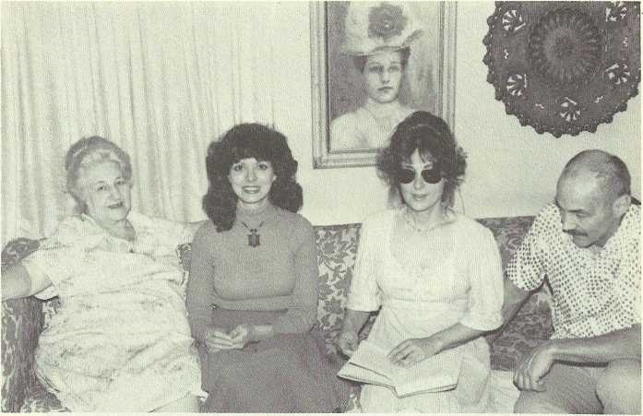

RUBY GRACE (8) ESTES (CANNONS) JENSEN, NANCY (9) FOOSHEE, MARY (9) CANNONS, AND WILLIAM (9) LYONS, N. Hollywood, Calif., Feb. 1980. (Photo by Helen Estes Seltzer).

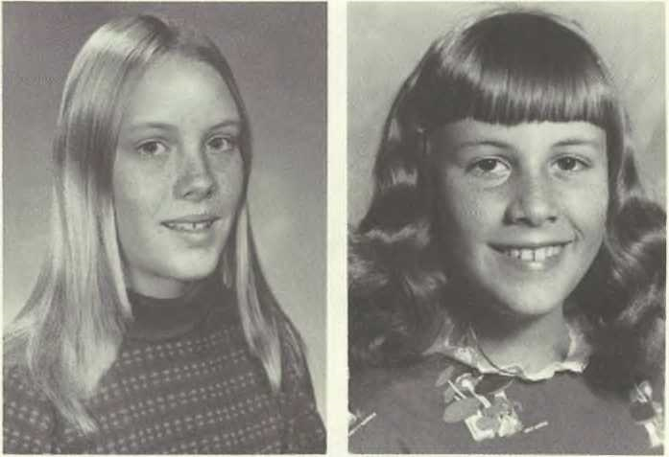
KATE LYNN (10) MANLEY AND JOANNE (10) MANLEY

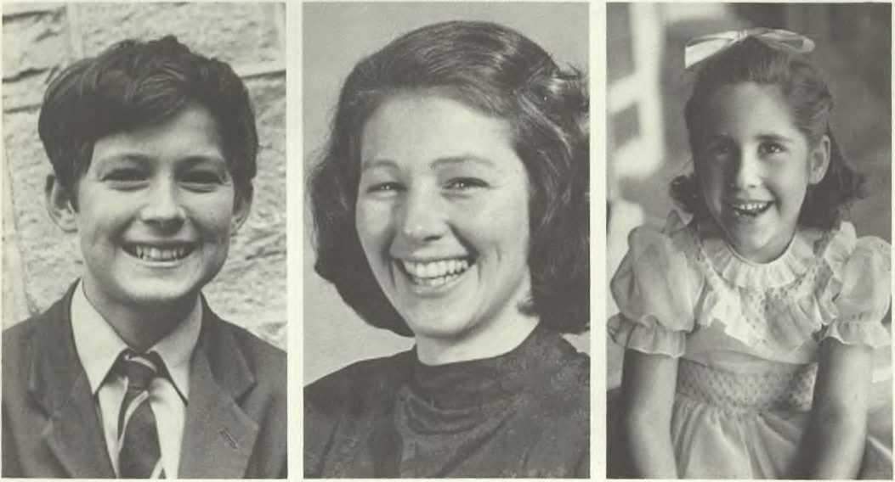
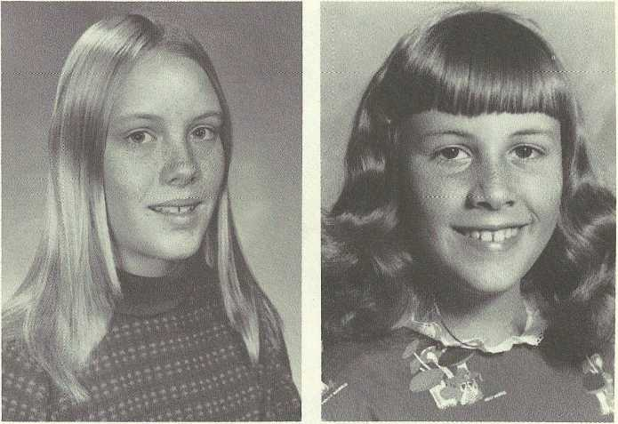
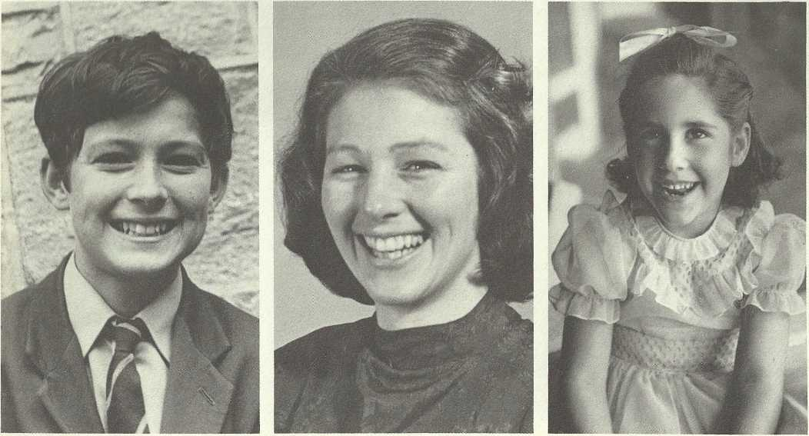
JULIAN (10) BALL, Liskeard, Cornwall, England. ANNIE MAE (9) CANNONS BALL, Liskeard, Cornwall, England, and ALICE (10) WARD, Wiltshire, England
FA MIL Y A LBUM/ Estes365
KATE LYNN (10) MANLEY.
JOANNE (10) MANLEY.

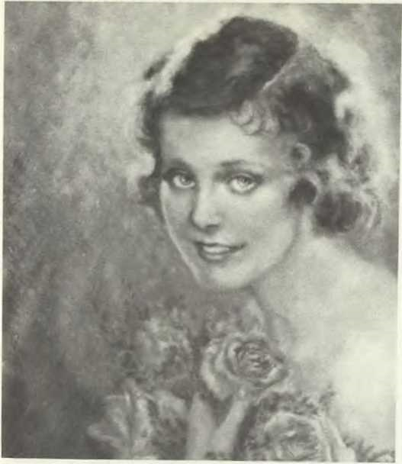
ADA VIRGINIA (8) ESTES, stage name "Virginia Bradford," silent movie actress, Hollywood, Calif., ca. 1928. (Photo of oil portrait by her son, William Estes (9) Lyons of N. Hollywood, Calif.)

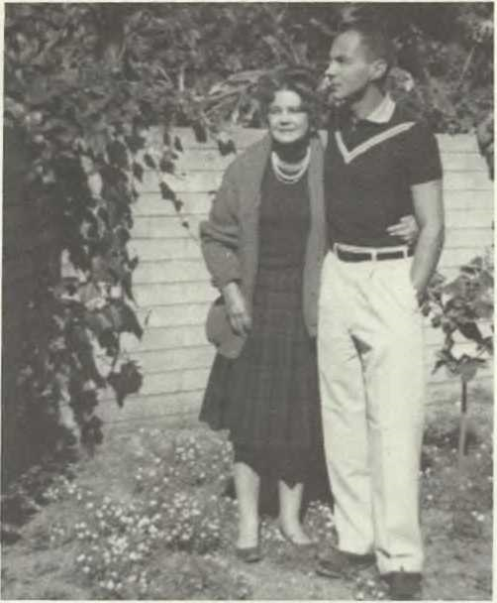
ADA VIRGINIA (8) ESTES AND WILLIAM ESTES (9) LYONS, her son.

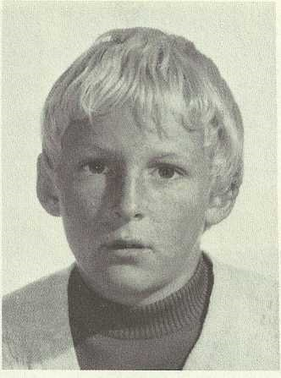

FERGUS (10) CANNONS, Cadiz, Spain.

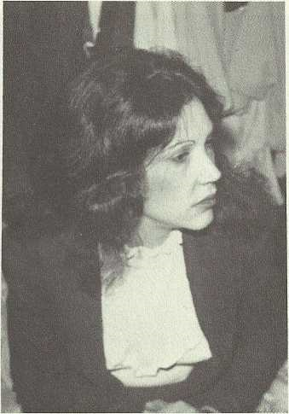

MARY ISABEL (10) WARD

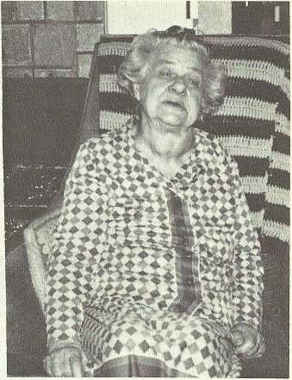

MARY LEILA (8) ESTES, at home. Studio City, Calif., Feb. 1980. (Photo by Helen Estes Seltzer).

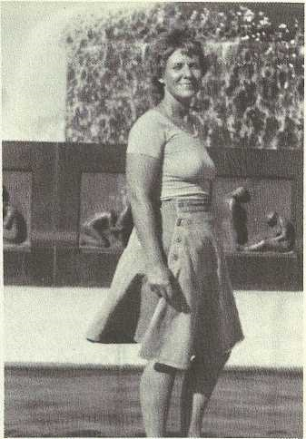

VIRGINIA GREY (9) JENSEN FIER
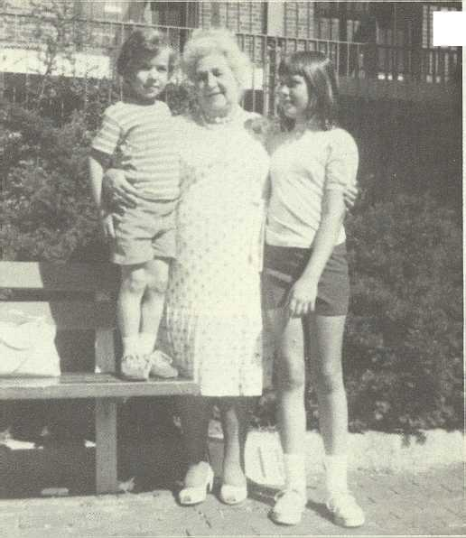
368FAMIL Y A LBUM/ Estes
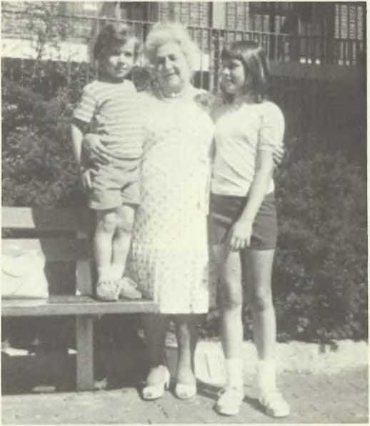
BOP (10) FIER, JOANNE (10) MANLEY, AND RUBY GRACE (8) ESTES CANNONS, their grandmother.

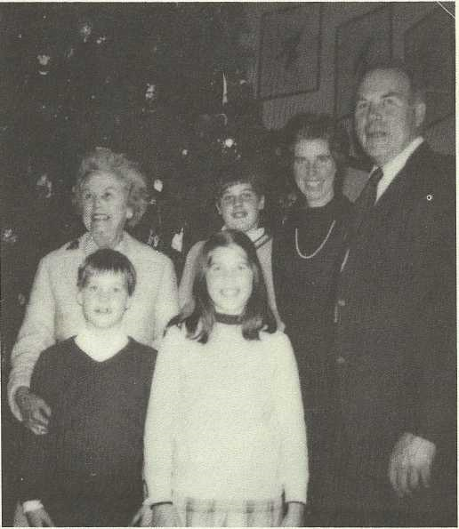
JAMES RUTLAND (8) MOORE AND FAMILY,!, to r., back row: James "Jim," his wife Edith, Jimmy, his mother, Frances; front row: Anne and John.

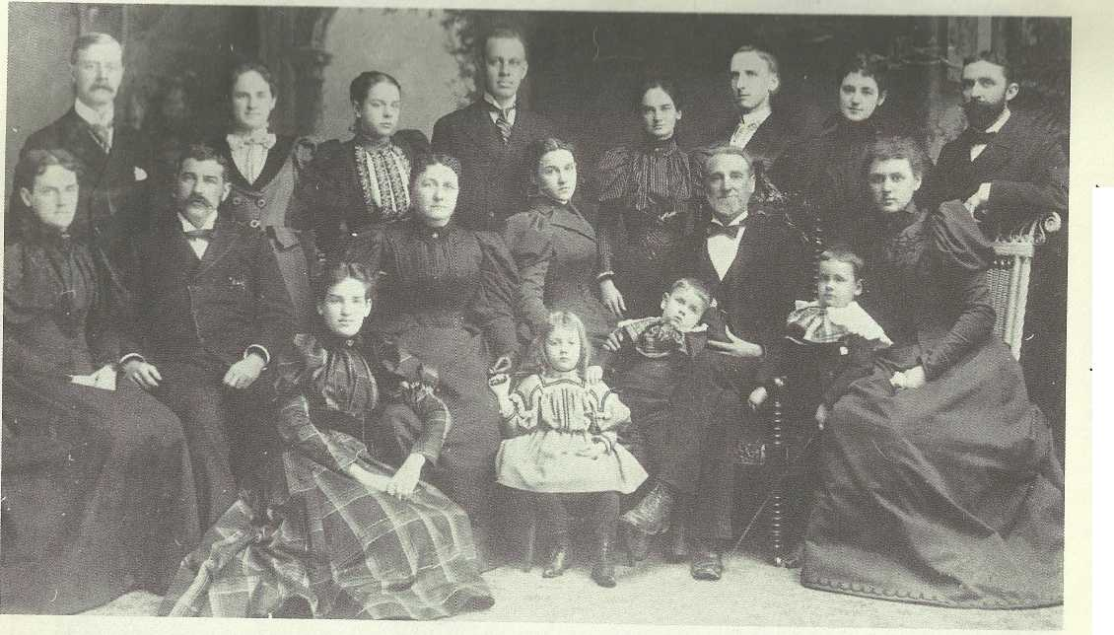
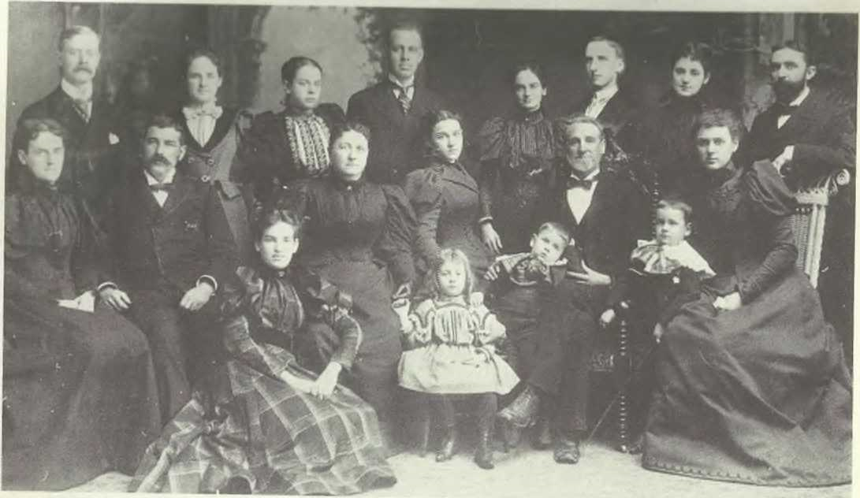
FAMIL Y ALBUM/ Estes369
FAMILY OF JUDGE BEDFORD MITCHELL (6) ESTES, back row: W.H. Paton, Kate (7) Estes Paton, Flora (7) Estes Greer, W.J. Dodd, lone (7) Estes Dodd, Henry (7) Estes, Sallie (7) Estes Bell, Harry Armstrong; middle row: Emily Alston (7) Estes Snedecor, the Rev. James George Snedecor, Elizabeth Guion (7) Estes, Blanche (7) Estes, Judge Estes, Lizzie (7) Estes Armstrong; front row: Elizabeth Alston (8) Snedecor, Katharin (8) Bell, Guion (8) Armstrong, and Estes (8) Armstrong. Memphis, Tenn., ca. 1897. (Henry Estes was not present — his picture was dubbed into the original to include entire family).

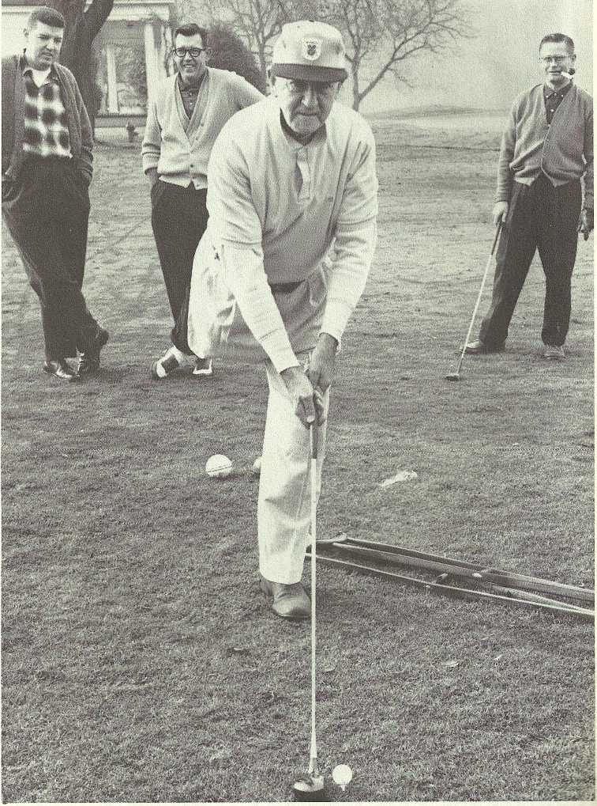
ESTES (7) SNEDECOR AND TWO SONS, Estes in foreground; in background, I. to r.: his sons Philip Alston and Estes, Jr., at Waverley Country Club, Portland, Oregon, Dec. 21,1962. (Estes, Sr.'s 75th birthday).

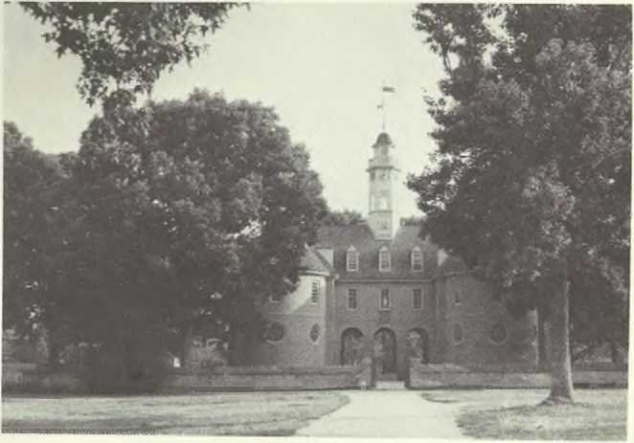
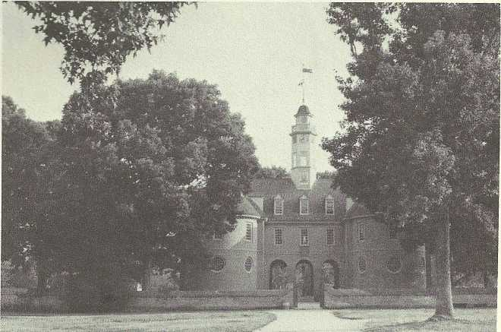
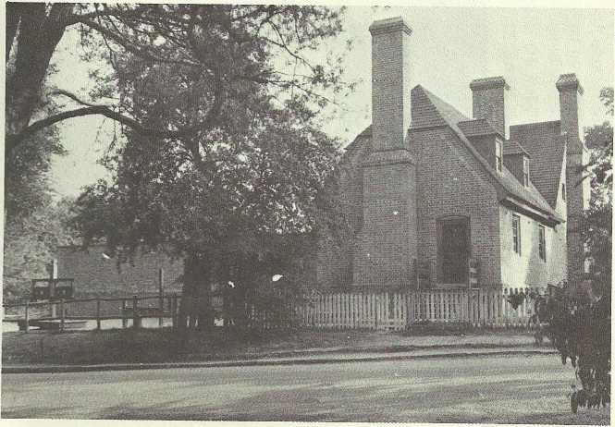
THE RECONSTRUCTED CAPITOL OF WILLIAMSBURG, original built by Henry Cary, Sr., 1701-1703. (Photo by Helen Estes Seltzer, 1977).

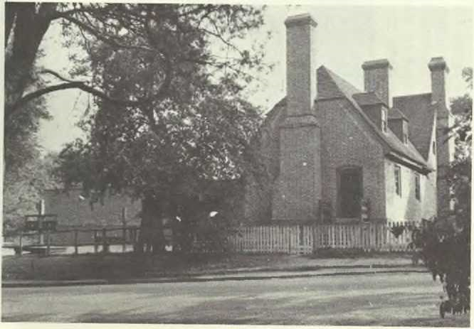
THE RECONSTRUCTED PUBLIC GAOL, Williamsburg, Va.;the original built by Henry Cary, Sr., 1703-1704. (Photo by Helen Estes Seltzer, 1977).
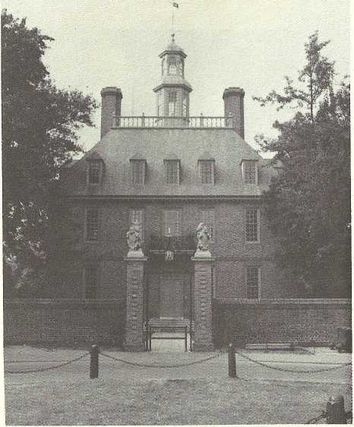
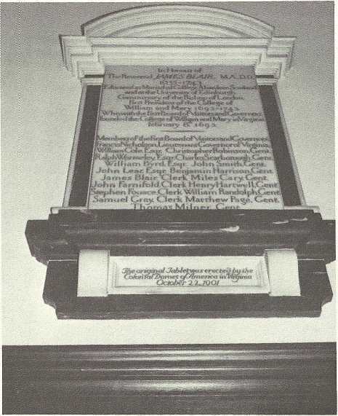
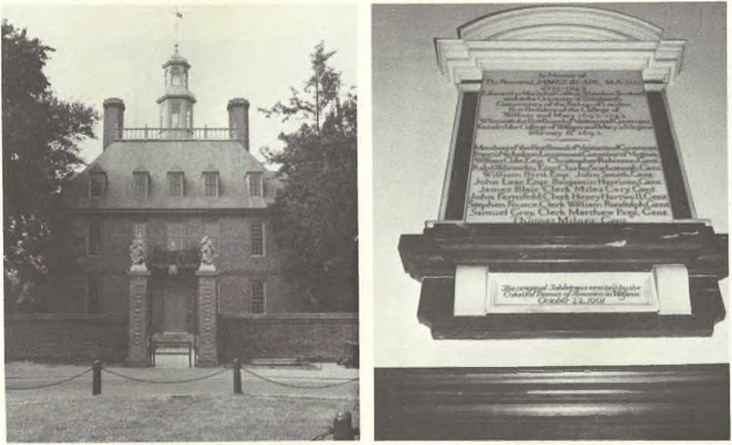
3 72FA MIL Y A LBV Ml Cary
THE RECONSTRUCTED GOVERNOR'S PALACE, Williamsburg, Va.; original built by Henry Cary, Sr., 1706-1710. (Photo by Helen Estes Seltzer, May 1977).

PLAQUE OVER INSIDE OF MAIN ENTRANCE OF CHAPEL OF WILLIAM AND MARY COLLEGE, Williamsburg, Va.; chapel is a wing added to the Wren Buil ding (built by Henry Cary, Sr.), built 1729-32 by Henry Cary, Jr.; note his grandfather, our original Cary ancestor, "Miles Cary, Gent." listed fifth row from the bottom. (Photo by Helen Estes Seltzer, May, 1977).
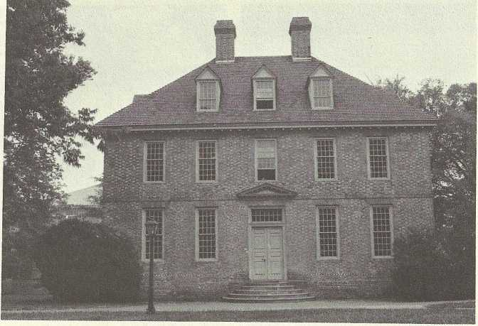
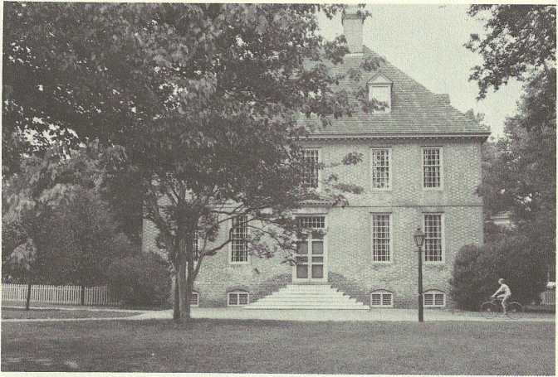

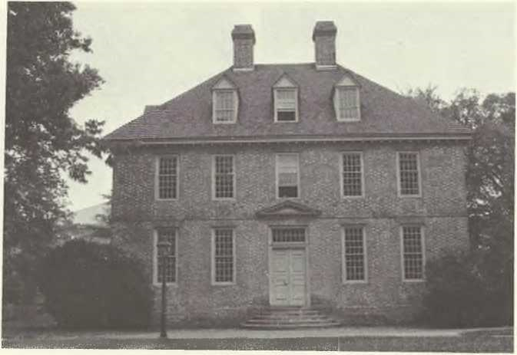
TH E BRAFFERTON BUILDING, campus of William and Mary College, Williamsburg, VA., built in 1723 by Henry Cary, Jr. (Photo by Helen Estes Seltzer, May 1977).

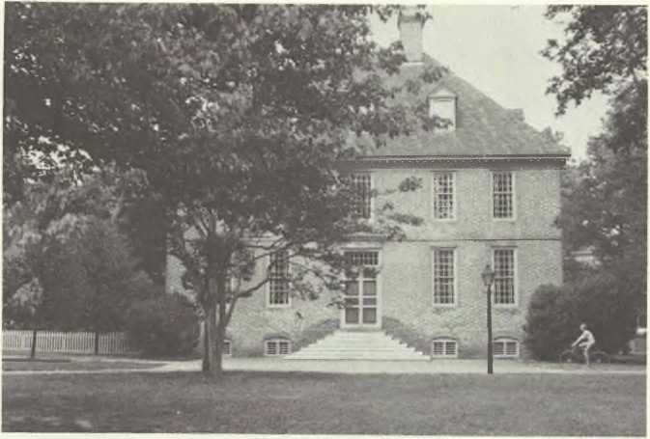
THE PRESIDENT'S HOUSE, William and Mary College, Williamsburg, Va.; built by Henry Cary, Jr. 1729-1732. (Photo by Helen Estes Seltzer, May 1977).
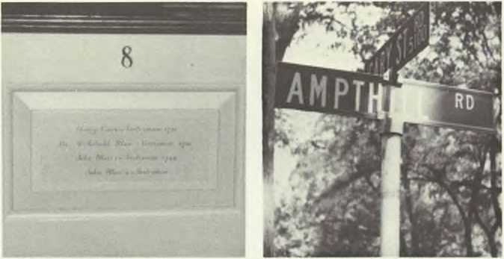
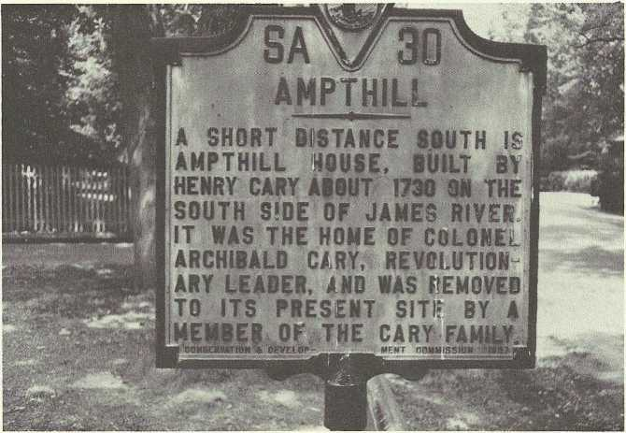
1977.)
BRUTON CHURCH INTERIOR, Williamsburg, Va.; Henry Cary's pew, no. 8; plaque on wall commemorates Henry Cary, Jr., and at end of pew, "Henry Cary [Jr.] --vestryman 1731" is first name listed on the plaque. (Photo by Helen Estes Seltzer, May

STREET SIGN ON "ROAD TO AMPTHILL", CARY ST. RD.AND AMPTHILL RD., Richmond, Va. (Ampthill historical marker is beneath it). (Photo by Helen Estes Seltzer, May 1977.)AMPTHILL HISTOR ICAL MAR KER, at Cary St. Rd. and Ampthill Rd., Richmond, Va. (Photo by Helen Estes Seltzer).

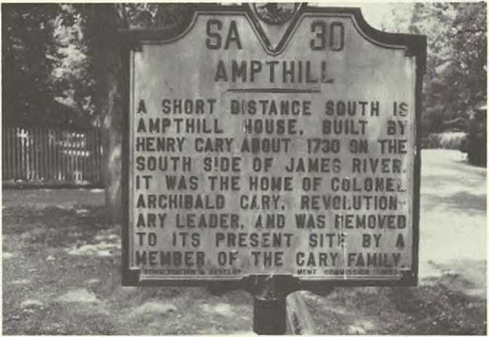
AMPTHILL HISTORICAL MARKER, at Cary St. Rd. and Ampthill Rd., Richmond, Va. (Photo by Helen Estes Seltzer).

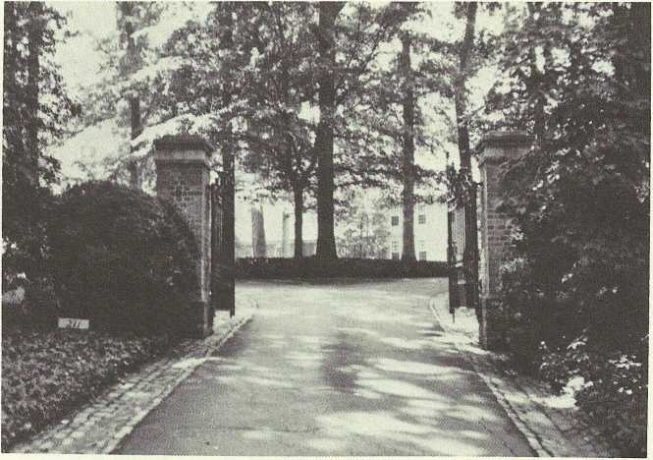
ENTRANCE GATE, "AMPTHILL," Richmond, Va. (Photo by Helen Estes Seltzer).

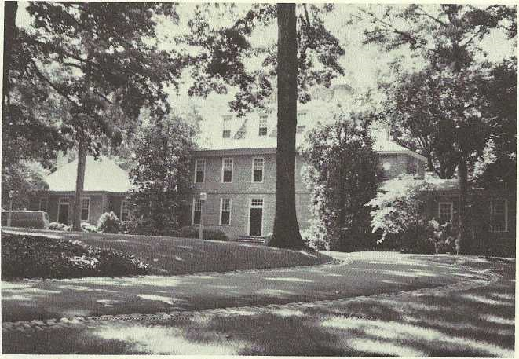
"AMPTHILL," rear (street side) view (front faces James River), Richmond, Va. restored; built by Henry Cary, Jr., 1732; present owners: Mr. and Mrs. Robert Tennant Bryan. (Photo by Helen Estes Seltzer, May 1977).

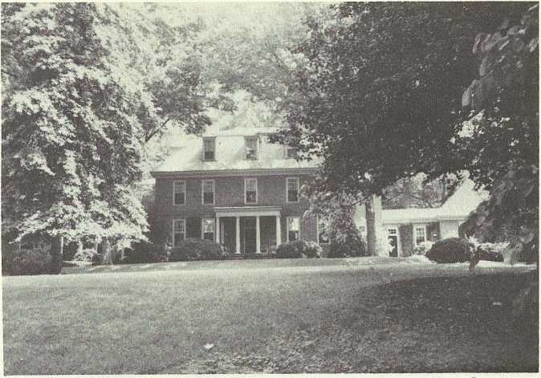
"AMPTHILL," front (riverside) view, Richmond, Va., on the James River, restored; built by Henry Cary, Jr., 1732. (Photo by Helen Estes Seltzer, May, 1977). Cf. photo before restoration opposite p. 46 in CARY-ESTES GEN.

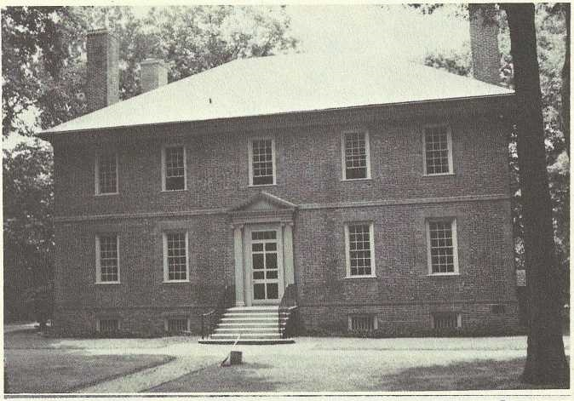

"WILTON," on the James River, neighboring "Ampthill," Richmond, Va.; museum and headquarters of National Society of the Colonial Dames of America in the Commonwealth of Va.; built ca. 1751 by Henry Cary, Jr., according to two architectural experts of Colonial Williamsburg Foundation, Williamsburg, Va. (Photo by Helen Estes Seltzer, May 1977).

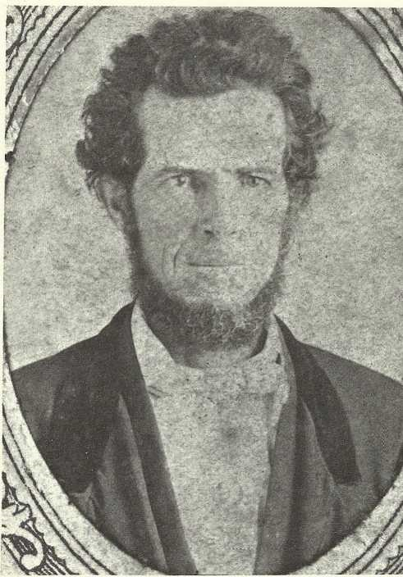

THE REV. DR. SMITH WILLIAM (4) MOORE as a young man.
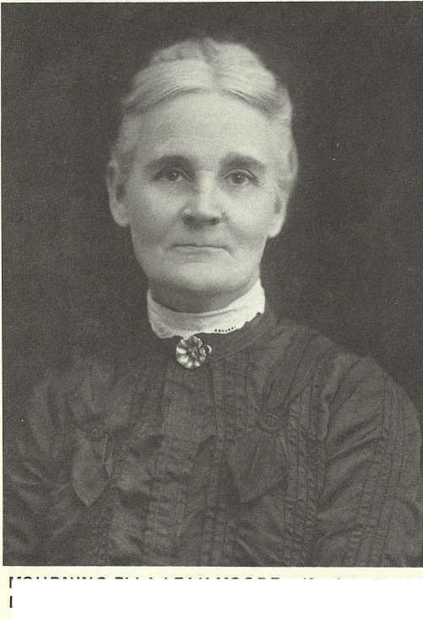
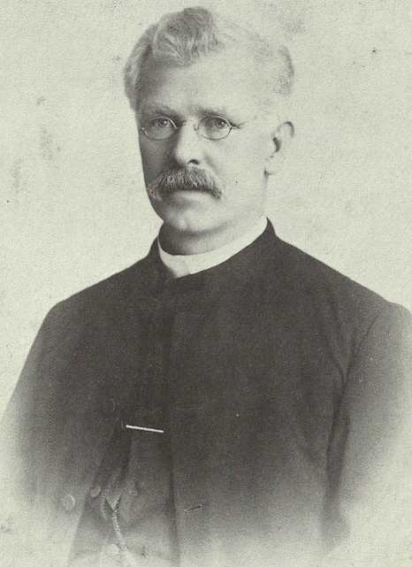

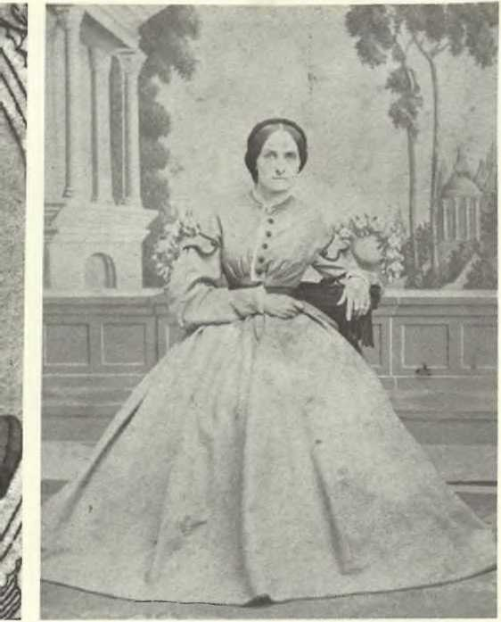
MARY ORDALIA YATES MOORE, wife of the Rev. Dr. Smith William (4) Moore; ca. 1860.

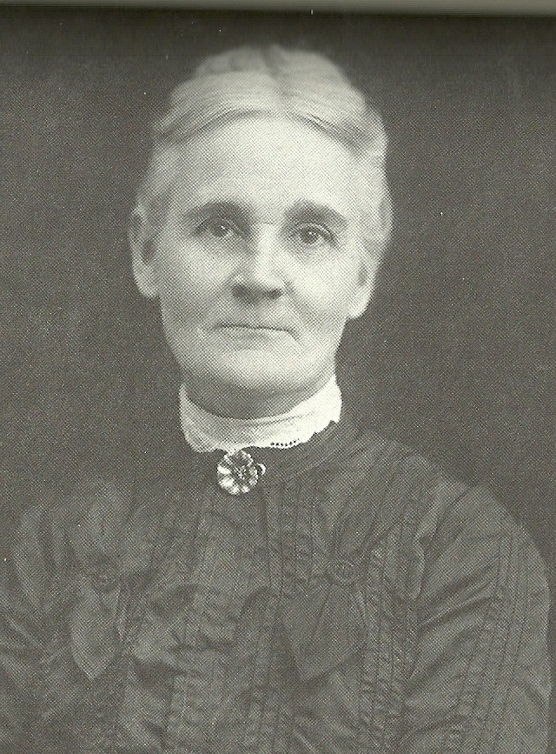
MOURNING ELLA LEAK MOORE, wife of the Rev. Dr. Warner (5) Moore.

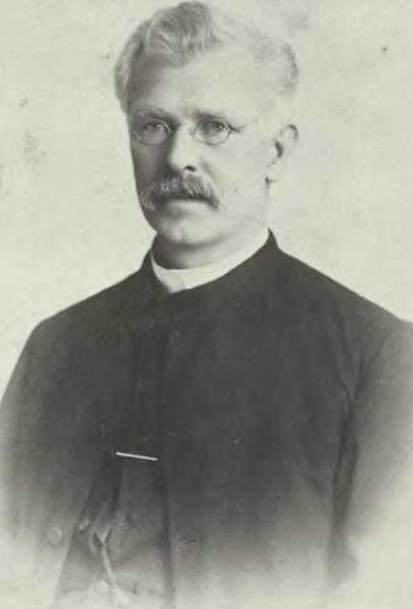
THE REV. DR. WARNER (5) MOORE in his middle years.

Bibliography
Bell, Getha Gina, THE BELLS IN THE U.S.A. AND ALLIED FAMILIES 1650-1977: privately published.

Bellonci, Maria, THE LIFE AND TIMES OF LUCRECIA BORGIA: Harcourt, N.Y., N.Y., 1953; abridged ed. of English translation of 1939.

Bruton, Quintilla Geer, and Bailey, D.E., Jr., PLANT CITY:
ITS ORIGIN AND HISTORY: Valkyrie Press, Inc., St. Petersburg, Fla., 1977.

BURKE’S PEERAGE: Burke’s Peerage, Ltd., London, England.
Bury, J.B., A HISTORY OF THE ROMAN EMPIRE FROM ITS
FOUNDATION TO THE DEATH OF AURELIUS: American Book Co., Div. of Litton Educational Publishing, Inc., N.Y., N.Y., 1907.

“Carey, Sir Robert, Memoirs of Himself’; ed. by F.H. Mares, from STUDIES IN TUDOR AND STUART LITERATURE: Oxford University Press, 1972.

Civil War Centennial Commission, TENNESSEANS IN THE CIVIL WAR, PART II: Nashville, Tenn., 1965.

Coffin, David R., “Pirro Ligorio and Decoration of the Late Sixteenth Century at Ferrara,” ART BULLETIN V.37, 1955: Art Bulletin, N.Y., N.Y.

Colonial Williamsburg Foundation, COLONIAL WILLIAMSBURG GUIDEBOOK AND MAP, 7th ed.: Colonial Williamsburg, Inc., Williamsburg, Va., 1972.

COLUMBIA ENCYCLOPEDIA: Columbia University Press, Morningside Heights, N.Y., 1975, pp. 308-09.

COMPLETE PEERAGE: St. Catherine Press, Ltd., London, England, over a number of years from 1910.

Cotter, John L„ ARCHEOLOGICAL EXCAVATIONS AT JAMESTOWN, VA., Archeological Research Series Number 4, National Park Service, U.S. Dept. of the Interior: U.S. Government Printing Office, Wash., D.C., 1958.

Craven-Johnson, THE UNITED STATES, EXPERIMENT IN DEMOCRACY: Ginn & Co., N.Y., N.Y., 1957.

Crozier, William Armstrong, ed., SPOTSYLVANIA COUNTY RECORDS, 1721-1800: Duffield, N.Y., N.Y., 1905-13.

Dorsey, Jean Muir, and Dorsey, Maxwell Jay, CHRISTOPHER GIST OF MARYLAND AND SOME OF HIS DESCENDANTS 1679-1957: John S. Swift Co., Inc., Chicago, Ill., 1958.

DuBellett, Louise Perquet, SOME PROMINENT VIRGINIA FAMILIES: J.P. Bell, Lynchburg, Va., 1907.

Dumas, Alexander, CELEBRATED CRIMES: H.S. Nichols, London, England, 1896.

Editors of Realites, THE GREAT HOUSES OF ITALY: G.P. Putnam’s Sons, N.Y., N.Y., 1968.

Egerton, John, NASHVILLE - THE FACES OF TWO CENTURIES 1780-1980: Plus Media, Inc., Nashville, Tenn., 1979.

Erlanger, Rachel, LUCREZIA BORGIA - A BIOGRAPHY: Hawthorn books, Inc., N.Y., N.Y., 1978; orders to: E.P. Dutton, N.Y., N.Y.

Estes, Charles, ESTES GENEALOGIES 1097-1893: E. Putnam, Salem, Mass., 1894.

Estes, Carl O., ESTES BROTHERS - KENTUCKY TO IOWA AND THEIR DESCENDANTS: privately published, Storm Lake, Iowa, 1973.
Estes, William Roscoe Greene, ESTES FAMILY: Argus, Skowhegan, Me., 1892.

Fontenay, Charles L., ESTES KEFAUVER: A BIOGRAPHY: University of Tennessee Press, Sept. 1980.

GOODSPEED HISTORY OF TENNESSEE: Southern Historical Press, Easley, S.C., 1978; a reprint of the Goodspeed Publishing Co., Nashville, Tenn., 1887 ed.

Greaves, Frank, “Founded Over 110 Years Ago; Named after Thomas Durham,” TENNESSEE HISTORICAL CHRONICLE; publisher: Business Review Editions, Montgomery, Ala.; printers and editors: Waggener-Walker Newspapers, Columbia, Ky., week of March 28, 1977.

Green, John W., LAW AND LAWYERS: McCowat-Mercer Press, Jackson, Tenn., 1950.

Greer, George Cabell, EARLY VIRGINIA IMMIGRANTS 1623-1666: Richmond, Va., 1912.

Hallum, John, THE DIARY OF AN OLD LAWYER: Southwestern Publishing House, Nashville, Tenn., 1895.

Harrison, Fairfax, THE DEVON CARYS: The DeVinne Press,
N.Y., N.Y., 1920.

Harrison, Fairfax, THE VIRGINIA CARYS: The DeVinne Press,
N.Y., N.Y., 1919.

Hayden, Horace Edwin, VIRGINIA GENEALOGIES: The Rare Book Shop, Wash., D.C., a reprint of'an E.B. Yorty, Wilkes Barre, Pa., 1891 edition.

Hendrick, Burton J., LINCOLN’S WAR CABINET: Peter Smith, 1946.
Ivey, Thomas Neal, GREEN HILL: edited, with genealogical note by J. Edward Allen: The United Methodist Historical Society of Northern Va., Alexandria, Va.

Jenkins, Elizabeth, ELIZABETH THE GREAT: Coward-McCann, N.Y., N.Y., 1959.

Kefauver, (Carey) Estes, CRIME IN AMERICA: Doubleday, 1951.

Kefauver, (Carey) Estes, Eulogy of Patrick Mann Estes, Sr., given
by Congressman Kefauver before U.S. Congress: THE CONGRESSIONAL RECORD, Appendix, 1947, p. A877.

Kefauver, (Carey) Estes, IN A FEW HANDS: MONOPOLY POWER: Pantheon Books, N.Y., N.Y., 1965.

Kefauver, (Carey) Estes and Levin, Jack, A TWENTIETH CENTURY CONGRESS: Buell, N.Y., N.Y., 1947.

Kennedy, William J., Secretary of State of Ohio, 1937, STATE OF OHIO OFFICIAL ROSTER - FEDERAL, STATE, COUNTY OFFICES, 1937: Consolidated Press & Printing Co., state printers, Cleveland, Ohio, 1937. pp. 604-05.

Lancaster, Robert A., HISTORIC VIRGINIA HOMES AND CHUR CHES: J.B. Lippincott Co., 1915.

Lox, the Rev. James Reed, PIONEERS AND PERFECTERS OF OUR FAITH: Tennessee Annual Conference, United Methodist Church: The Parthenon Press, Nashville, Tenn., 1976.

MARYLAND HISTORICAL MAGAZINE, Vol. 11, 1916: Maryland Historical Society, Baltimore, Md.

McAllister, Edward N. and Annabelle C., ESTES FAMILIES OF OLD CLAY COUNTY, MISSOURI: THEIR ANCESTORS AND DESCENDANTS: privately printed, late 1970’s.

McCown, Mary Hardin, and Burns, Inez E., compilers, SOLDIERS OF THE WAR OF 1812 BURIED IN TENNESSEE: The Tennessee Society, United States Daughters of 1812, Johnson City, Tenn., 1959.

Mcllwaine, H.R., ed., JOURNALS OF THE HOUSE OF BURGESSES OF VIRGINIA 1619-1776: Colonial Press, E. Waddy & Co., Rich mond, Va., 1915.

Moore, John Trotwood, Editor, Foster, Austin Pi, A.M., TENNESSEE
THE VOLUNTEER STATE 1769-1923, Vol. Ill: S.J. Clarke Publishing Co., Chicago, Ill. 1923.

NEW YORK TIMES FILM REVIEWS - 1913-1968: Amo Press, 1970.
Noonan, Annie, Longino, Helen Maxwell, and Maxwell, Annie Lou,

THOMAS MAXWELL OF VIRGINIA AND GEORGIA: Press of
J.W. Burke, Macon, Ga., 1956.

Pennington, Margaret A., and Scott, Loma S., THE COURT HOUSE BURNED - BUCKINGHAM COUNTY: Charles F. McClung, Printers, Waynesboro, Va., 1977.

Peters, Kate Johnston, Editor, LAUDERDALE CO. FROM EARLIEST TIMES, written by descendants of its pioneer citizens: Sugar Hill, Lauderdale Co. Library, Ripley, Tenn., 1957.

Roeder, Cecil Templin, and Guay, Regina, Appendix of OSCAR THE REDHEADED MOUSE, a history of Washington, D.C. and Maryland for children: self-published, 1978, Silver Spring, Md.

St. Louis National Historical Co., HISTORY OF CLAY AND PLATTE COUNTIES, MISSOURI: Nixon-Jones Printing Co., St. Louis, Mo., 1885.

Schreiner-Yantis, Nettie, GENEALOGICAL AND LOCAL HISTORY BOOKS IN PRINT: Braceland Press, Inc., Franconia, Va., Vol. 1, Nov. 1975; reprint of May 1975 edition.

Smith, Elbert B., FRANCIS PRESTON BLAIR: The Free Press, Div. of MacMillan & Co., N.Y., N.Y.. 1980.

Smith, William Ernest, THE FRANCIS PRESTON BLAIR FAMILY IN POLITICS, 2 vols.: Dacapo Press, Inc., N.Y., N.Y., 1969; a reprint of MacMillan, N.Y., N.Y., 1933 edition.

Speer, the Hon. William S., compiler and editor, PROMINENT TENNESSEANS: Albert B. Tavel, Nashville, Tenn., 1888.

Stanard, William G., ed., VIRGINIA MAGAZINE OF HISTORY AND BIOGRAPHY: Richmond, Va.

Stewart, Robert Armstrong, INDEX OF PRINTED VIRGINIA GENEALOGIES: Old Dominion Press, Richmond, Va., 1930.

Swados, Harvey, STANDING UP FOR THE PEOPLE: THE LIFE AND WORK OF ESTES KEFAUVER: E.P. Dutton and Co., Inc., 1972.

Templeman, Eleanor Lee, THE BLAIR-LEE HOUSE: GUEST HOUSE OF THE PRESIDENT: EPM Publications, McLean, Va., 1980.

Torrence, Clayton, WINSTON OF VIRGINIA AND ALLIED FAMILIES: Whittet & Shepperson, Richmond, Va., 1927.

Tuchman, Barbara, A DISTANT MIRROR: Knopf, N.Y., N.Y 1978.

Tyler, Lyon G., ed., WILLIAM AND MARY QUARTERLIES: Williamsburg, Va.

U.S. Bureau of the Census, HISTORICAL STATISTICS OF THE
UNITED STATES COLONIAL TIMES TO 1957: Dept. of Commerce, U.S. Government Printing Office, Wash., D.C., 1965

Wertenbaker, Thomas J., THE PLANTERS OF COLONIAL VIRGINIA. Princeton University Press, Princeton, N.J., 1922.

Whiffen, Marcus, THE EIGHTEENTH-CENTURY HOUSES OF WILLIAMSBURG: Colonial Williamsburg Foundation, 1968; distributed by Holt, Rinehart & Winston, Inc., N.Y., N.Y.

WHO’S WHO, 1956: MacMillan Co., N.Y., N.Y., p. 1619.

WHO’S WHO IN AMERICA, Vol. 30, 1958-59: Marquis Who’s
Who, Inc., Chicago, Ill., p. 1484.

WHO’S WHO IN THE EAST, 17th ed., 1929-1980: Marquis Who’s Who, Inc., Chicago, Ill., p. 727.

WHO WAS WHO, Vol. 6, 1961-70, St. Martin’s Press, Inc., N.Y., p. 618.

WHO WAS WHO IN AMERICA, Vol. 4, 1961-68, Marquis Who’s Who, Inc., Chicago, Ill., p. 515.

Williams, Joseph S., OLD TIMES IN WEST TENNESSEE: W.G. Cheeney, Memphis, Tenn., 1873.

Williams, Samuel Cole, L.L.D., BEGINNINGS OF WEST TENNESSEE: The Watauga Press, Johnson City, Tenn., 1930.

Wulfeck, Dorothy E., MARRIAGES OF SOME VIRGINIA RESIDENTS, 1607-1800: Naugatuck, Conn., 1961-67.

Yonge, Samuel, THE SITE OF OLD JAMESTOWN, 1607- 1698: Hermitage Press, Richmond, Va., 1907.

Tuchman, Barbara, A DISTANT MIRROR: Knopf, N.Y., N Y 1978.

Tyler, Lyon G., ed., WILLIAM AND MARY QUARTERLIES: Williamsburg, Va.

U.S. Bureau of the Census, HISTORICAL STATISTICS OF THE UNITED STATES⁴ COLONIAL TIMES TO 1957: Dept. of Commerce, U.S. Government Printing Office, Wash., D.C., 1965

Wertenbaker, Thomas J., THE PLANTERS OF COLONIAL VIRGINIA. Princeton University Press, Princeton, N.J., 1922.

Whiffen, Marcus, THE EIGHTEENTH-CENTURY HOUSES OF WILLIAMSBURG: Colonial Williamsburg Foundation, 1968; distributed by Holt, Rinehart & Winston, Inc., N.Y., N.Y.

WHO’S WHO, 1956: MacMillan Co., N.Y., N.Y., p. 1619.

WHO’S WHO IN AMERICA, Vol. 30, 1958-59: Marquis Who’s
Who, Inc., Chicago, Ill., p. 1484.

WHO’S WHO IN THE EAST, 17th ed., 1929-1980: Marquis Who’s Who, Inc., Chicago, Ill., p. 727.

WHO WAS WHO, Vol. 6, 1961-70, St. Martin’s Press, Inc., N.Y., p. 618.

WHO WAS WHO IN AMERICA, Vol. 4, 1961-68, Marquis Who’s Who, Inc., Chicago, Ill., p. 515.

Williams, Joseph S., OLD TIMES IN WEST TENNESSEE: W.G. Cheeney, Memphis, Tenn., 1873.

Williams, Samuel Cole, L.L.D., BEGINNINGS OF WEST TENNESSEE: The Watauga Press, Johnson City, Tenn., 1930.

Wulfeck, Dorothy E., MARRIAGES OF SOME VIRGINIA RESIDENTS, 1607-1800: Naugatuck, Conn., 1961-67.

Yonge, Samuel, THE SITE OF OLD JAMESTOWN, 1607- 1698: Hermitage Press, Richmond, Va., 1907.

NOTE: Mary Estes Beckham, Route No. 1, Box 373, Philadelphia, Mississippi 39350, compiler and editor of ESTES TRAILS, a quarterly pamphlet devoted exclusively to Estes Family genealogical materials, has a library of Estes books.
Historic Trails Library.

Published by Seltzer Books. seltzerbooks.com
established in 1974, as B&R Samizdat Express
offering over 14,000 books
feedback welcome: seltzer@seltzerbooks.com

